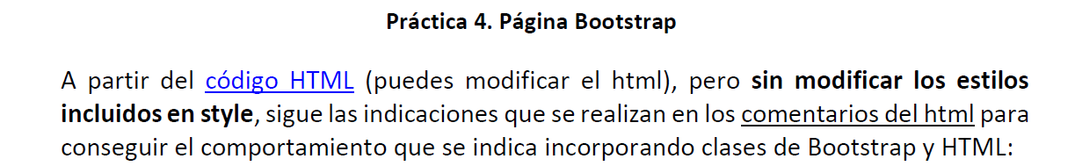

* <https://pgmonreal.github.io/DIW/U2/PRAC4/index.html>