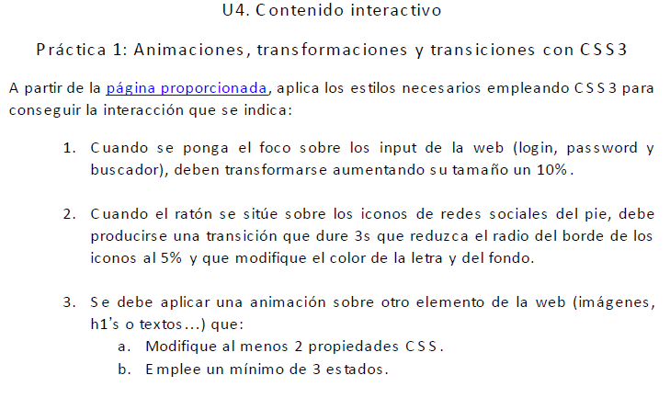

* <https://pgmonreal.github.io/DIW/U4/P1/index.html>