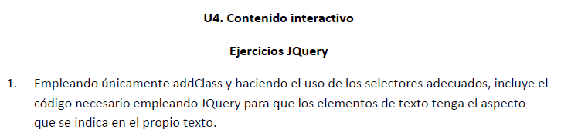

* <https://pgmonreal.github.io/DIW/U4/P2/E1/index.html>

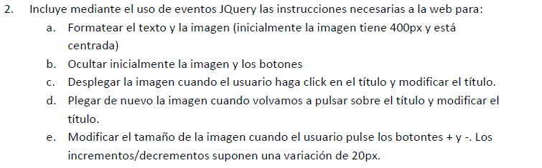

* <https://pgmonreal.github.io/DIW/U4/P2/E2/index.html>

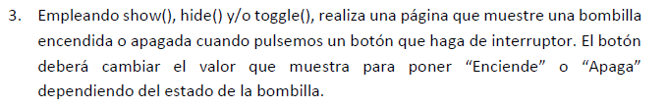

* <https://pgmonreal.github.io/DIW/U4/P2/E3/index.html>



* <https://pgmonreal.github.io/DIW/U4/P2/E4/index.html>

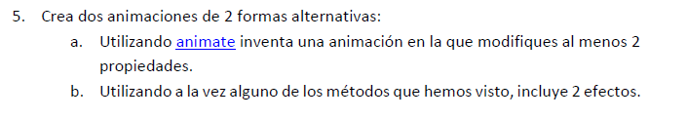

* <https://pgmonreal.github.io/DIW/U4/P2/E5/index.html>