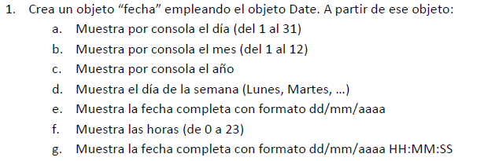

* <https://pgmonreal.github.io/DWEC/U2/P2/E1/index.html>

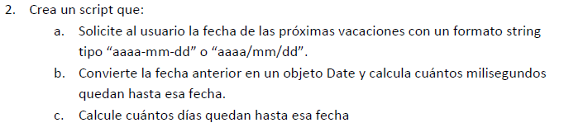

* <https://pgmonreal.github.io/DWEC/U2/P2/E2/index.html>

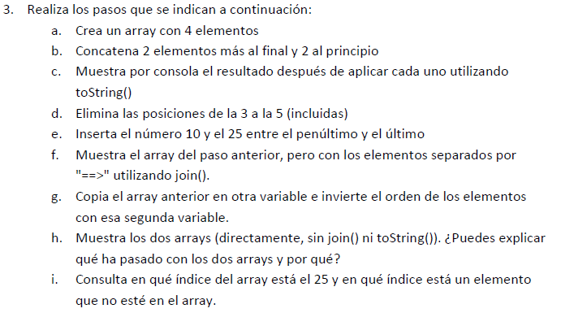

* <https://pgmonreal.github.io/DWEC/U2/P2/E3/index.html>

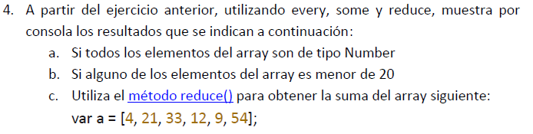

* <https://pgmonreal.github.io/DWEC/U2/P2/E4/index.html>



* <https://pgmonreal.github.io/DWEC/U2/P2/E5/index.html>

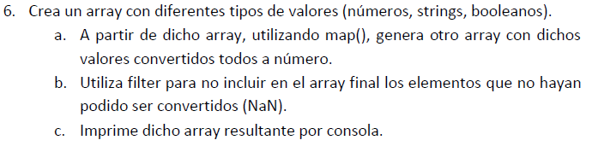

* <https://pgmonreal.github.io/DWEC/U2/P2/E6/index.html>

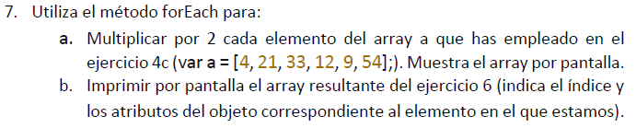

* <https://pgmonreal.github.io/DWEC/U2/P2/E7/index.html>

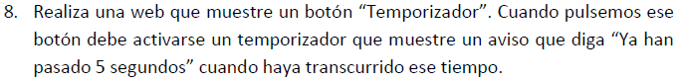

* <https://pgmonreal.github.io/DWEC/U2/P2/E8/index.html>



* <https://pgmonreal.github.io/DWEC/U2/P2/E9/index.html>

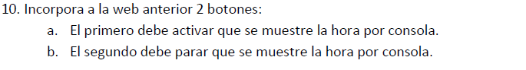

* <https://pgmonreal.github.io/DWEC/U2/P2/E10/index.html>