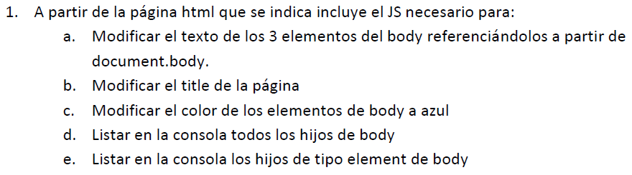

* <https://pgmonreal.github.io/DWEC/U3/P1/E1/index.html>

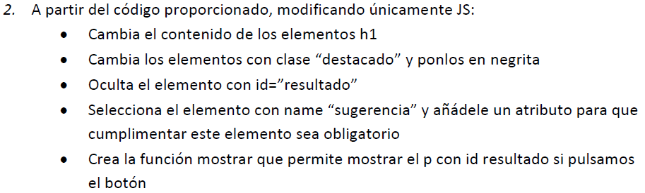

* <https://pgmonreal.github.io/DWEC/U3/P1/E2/index.html>

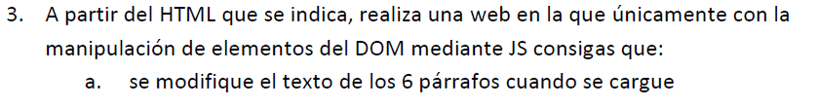

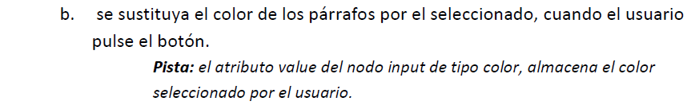

* <https://pgmonreal.github.io/DWEC/U3/P1/E3/index.html>

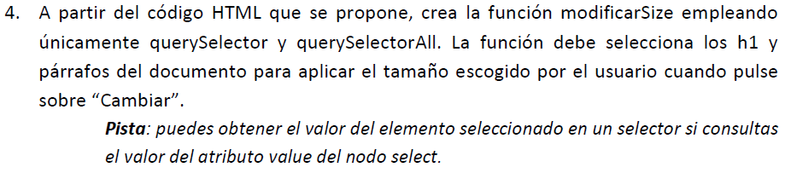

* <https://pgmonreal.github.io/DWEC/U3/P1/E4/index.html>



* <https://pgmonreal.github.io/DWEC/U3/P1/E5/index.html>



* <https://pgmonreal.github.io/DWEC/U3/P1/E6/index.html>