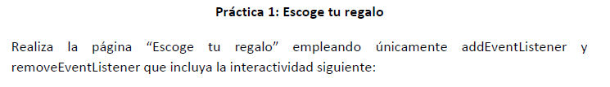

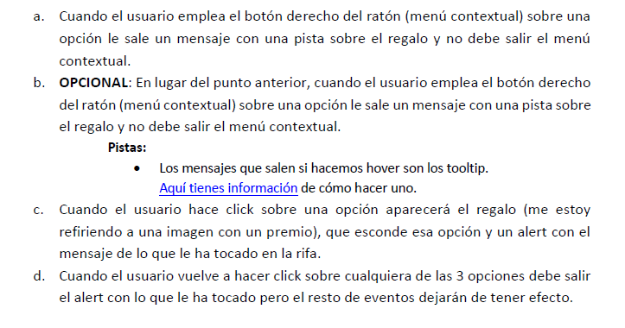

* <https://pgmonreal.github.io/DWEC/U4/PRAC1/index.html>