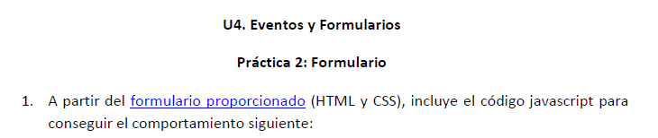

* <https://pgmonreal.github.io/DWEC/U4/PRAC2/index.html>