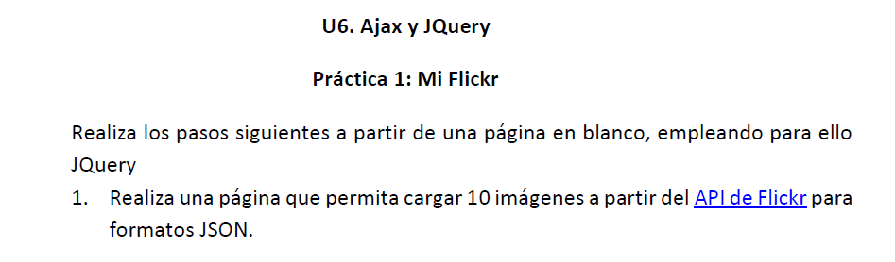

* <https://pgmonreal.github.io/DWEC/U6/P2/plantillaJQueryLocal.html>