Figure 1. Study selection flow diagram (PRISMA 2020)

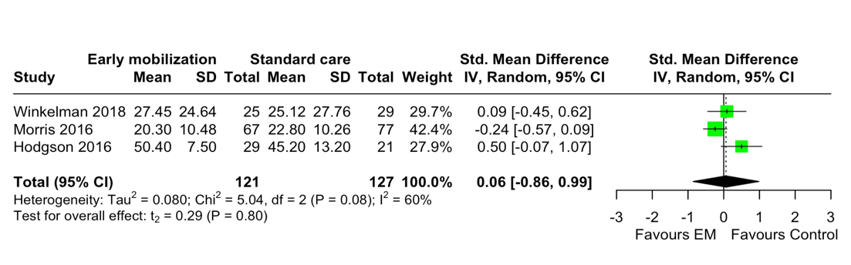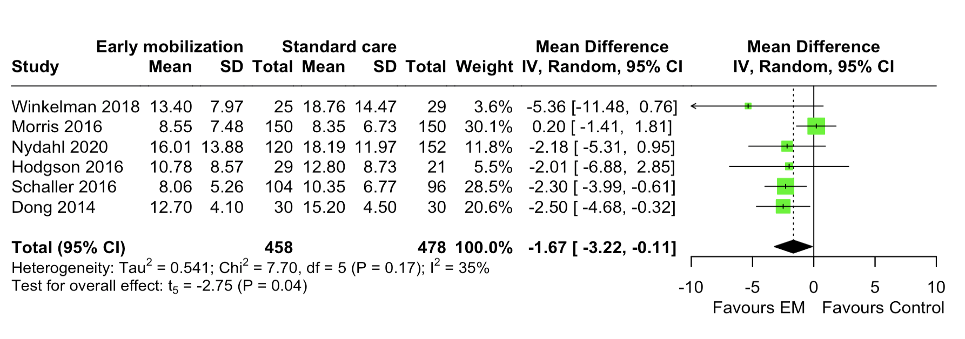

(a) muscle strength

(b) ICU length of stay

Figure 2. Forest plot of the effect size (a) muscle strength (b) ICU length of stay