Visulate Requirements
– Buyer Investment Analysis & Purchase
Peter Goldthorp, Feb 2009

Overview
Visulate provides investment analysis facilities for properties that the user already owns. This functionality should be extended to support analysis of properties that the user would like to purchase. This analysis can be done using a subset of the available screens. A new role should be created to support buyers.

Requirements

Functional Requirements

Data Entry
Buyers typically review and reject a number of properties before deciding to make an offer on one of them. Visulate is a multi-user system. It is possible that 2 people will be reviewing the same property at the same time. The current data model does not support this. It does not allow the same property to be recorded more than once.

Query/Search

Use Cases

Investment Analysis
- Broker assembles a list of candidate properties for and Investor (buyer) to review. This list includes details of the property and hypertext links to web pages that have additional details.
- They share this list with one or more investor clients.
- Investors review the property list and select the ones they would like to see.
- They visit the candidate properties and produce cash flow and repair estimates.

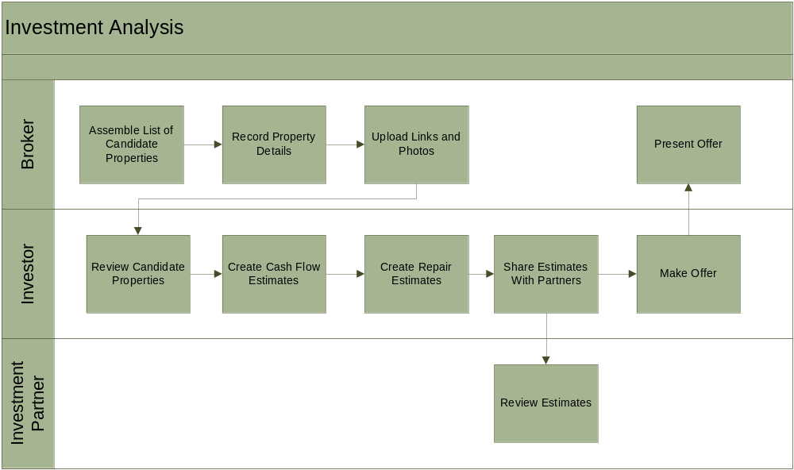

Public User
- Enter search criteria for required property
- Review property details.
- User bookmarks search results page.
- Contact property manager by phone or email.

Current Behavior
The advertise property functionality will impact other areas of the Visulate website. The current site has 2 distinct codelines. Data driven code is written in php and is only accessible to users who have logged into the system. Public pages are served using a combination of static html and cgi-bin Perl code. The smarty template files that render menus for the php based code (e.g. top.tpl) have a hard coded link to a static file http://visulate.com/index.html. Index.html is a static file that contains links to a number of cgi-bin Perl programs.
The Perl code needs to be re-written in php. This will simplify the integration between the search code and other public pages. It also introduces a potential security risk. We need to make sure public users are only able to access public screens.

Design

Data Model Schema Changes
Create a new table RNT_ZIPCODES and populated with seed data purchased from http://www.zipcodeworld.com/zipcodepremium.htm. The new table will have the following structure (but may have different datatypes). It will be joined to the existing RNT_PROPERTIES table using RNT_PROPERTIES.ZIPCODE as a foreign key.

RNT_ZIPCODES
Field Name | Data Type | Field Description
ZIP_CODE | nchar(5) | The ZIP Code of the city designated by the USPS.
CITY | varchar(35) | The name of the city designated by the USPS.
STATE | char(2) | The two-letter abbreviation for the state to that particular ZIP code.
AREA_CODE | varchar(40) | The telephone area code belonging to the particular postal code is located.
CITY_ALIAS_NAME | varchar(35) | The alias name for the ZIP Code. This may be a city name, postal entity, community or a municipality name.
CITY_ALIAS_ABBR | varchar(13) | This is a standard 13-character abbreviation for city alias name. This field is empty if names are less or equal to 13-character.
CITY_TYPE | char(1) | The field indicates the type of locale identified in the city alias name such as Post Office, station or branch.
COUNTY_NAME | varchar(25) | The name of the county or parish in which the 5-digit ZIP Code resides.
STATE_FIPS | nchar(2) | The FIPS code assigned to state.
COUNTY_FIPS | nchar(3) | The FIPS code assigned to given county or parish within a state.
TIME_ZONE | nchar(2) | The time zone number represents by the hours past the Greenwich Time Zone.
DAY_LIGHT_SAVING | char(1) | This flag indicates whether the city observe day light saving.
LATITUDE | numerical | The geographic coordinate of a point measured in degrees north or south of the equator.
LONGITUDE | numerical | The geographic coordinate of a point measured in degrees east or west of the Greenwich meridian.
ELEVATION | numerical | The counties average elevation.

New Columns

RNT_PROPERTIES
DESCRIPTION VARCHAR2(4000)

RNT_PROPERTY_UNITS
DESCRIPTION VARCHAR2(4000)

RNT_TENANCY_AGREEMENT
AD_PUBLISH_YN VARCHAR2(1) NOT NULL
AD_TITLE VARCHAR2(80)
AD_CONTACT VARCHAR2(80)
AD_EMAIL VARCHAR2(256)

