Visulate Requirements
– Lead Capture
Peter Goldthorp, Jan 2013

Overview
Visulate provides investment analysis facilities for properties that the user already owns. This functionality should be extended to support analysis of properties that the user would like to purchase. This analysis can be done using a subset of the available screens. A new role should be created to support buyers.

Requirements

Functional Requirements

Data Entry
Buyers typically review and reject a number of properties before deciding to make an offer on one of them. Visulate is a multi-user system. It is possible that 2 people will be reviewing the same property at the same time. The current data model does not support this. It does not allow the same property to be recorded more than once.

Query/Search

Use Cases

Investment Analysis
- Broker assembles a list of candidate properties for and Investor (buyer) to review. This list includes details of the property and hypertext links to web pages that have additional details.
- They share this list with one or more investor clients.
- Investors review the property list and select the ones they would like to see.
- They visit the candidate properties and produce cash flow and repair estimates.

Public User
- Enter search criteria for required property
- Review property details.
- User bookmarks search results page.
- Contact property manager by phone or email.

Current Behavior

Design

Data Model Schema Changes
Add 2 new tables:
SQL> desc rnt_leads

Name Null? Type

----------------------------------------- -------- ----------------------------

LEAD_ID NOT NULL NUMBER

PEOPLE_BUSINESS_ID NUMBER

LEAD_DATE DATE

LEAD_STATUS VARCHAR2(16)

LEAD_TYPE VARCHAR2(16)

REF_PROP_ID NUMBER

FOLLOW_UP NUMBER

UCODE NUMBER

CITY VARCHAR2(64)

MIN_PRICE NUMBER

MAX_PRICE NUMBER

LTV_TARGET NUMBER

LTV_QUALIFIED_YN VARCHAR2(1)

DESCRIPTION VARCHAR2(4000)

SQL> desc rnt_lead_actions

Name Null? Type

----------------------------------------- -------- ----------------------------

ACTION_ID NOT NULL NUMBER

LEAD_ID NUMBER

ACTION_DATE DATE

ACTION_TYPE VARCHAR2(16)

BROKER_ID NUMBER

DESCRIPTION VARCHAR2(4000)

User Interface
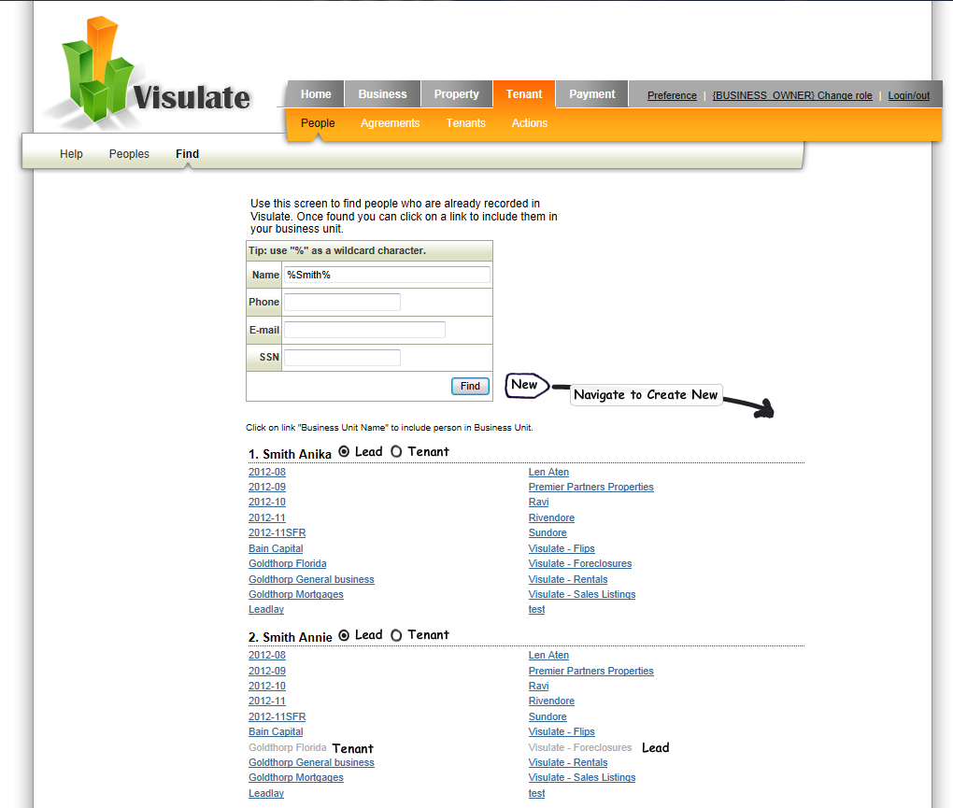

Record Actions:
