Visulate Requirements
– Dynamic Page Content
Peter Goldthorp, February 2010

Overview
The Visulate site is broken down into 2 separate areas: a public site that anyone can view and a secure site that is only visible to users who have logged in. The secure site is written in php and the public site is mostly Perl. The Dynamic Content project will re-write the public site to use php instead of Perl.

Requirements
- Modify the public site to use php instead of Perl.
- Modify the menu system to drive off database tables instead of a static array.
- Store html content for pubic pages in database tables instead of static html files.
- Create a screen that allows Administrative users to manage the menu system and create new content.
- Provide SEO (Search Engine Optimization) facilities for the public pages.

Functional Requirements

Public Site
The public site is used to advertise Visulate features and functionality. It contains a mixture of static html, javascript utilities and data driven content. Need the ability to edit this content and restructure the menu system without writing new code. The site should drive off data that is stored in the database.
The pages on the public site need to be discoverable by search engines. Search engines read data from the html header and use it to index content. For example, Google expects every page on a site to have a unique title element. It also favors pages where the url contains key words. For example the url “http://visulate.com/manage/investments.html” would have a higher page rank than a url with an embedded id like http://visulate.com?id=3212345

Secure Site
The menus for the secure site are currently defined in a static array. These should be data driven.

Use Cases
- Create New Public Page:
  - User logs in, selects the Administrator role and navigates to a new menu administration screen.
  - Selects an existing tab and sub-tab or creates a new one.
  - Creates menu entry and page content.
- Update or Delete Public Page
  - User logs in, selects the Administrator role and navigates to the menu administration screen.
  - Navigates to the page via a tree control.
  - Updates or removes the page.
- New Secure page
  - Develop screen using php and smarty
  - Create seed data script to register the page in the menu.

New Concepts

Accounts and Account Types
Double entry bookkeeping accounts as described in the chart of accounts. Each account is classified into one and only one account type. The list of account types is fixed. It includes assets, liabilities, equity, revenue, cost of goods sold and expenses. Users can create new accounts using the chart of account screen.

Data Model Changes
Create new tables
- RNT_MENU_TABS - Stores menu tab definitions. The config_menu.php program reads this table to build the menu array.
- RNT_MENU_ROLES - Controls access the menu tabs. The config_menu.php program should read this table to build an array of user roles that are able to access the menu tab.
- RNT_MENUS - Records details of L3 menus for display on the left of the screen
- RNT_MENU_PAGES - Records content of static html pages. Each page is identified by its location, page name and sub-page number. Sub-pages are used to limit the size of large pages. A page can be broken down into numbered sub pages
- RNT_MENU_LINKS - Stores hypertext links for inclusion in a menu
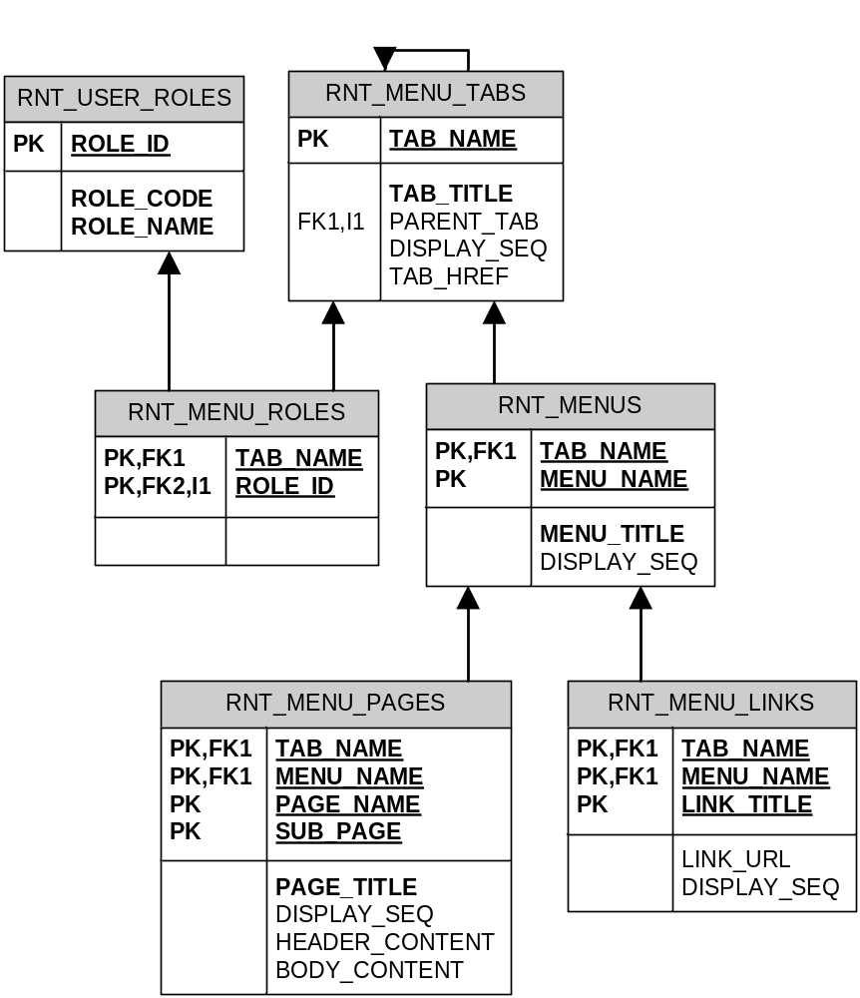

Tables Seed Data and pl/sql
The ddl for these tables and their supporting packages are in SVN:/visulate/visulate/code/datamodel/upgrade63_menus

Data Upgrade
- Migrate menu structures from config_menu.php and store in the database.
- Create a new “PUBLIC” role to identify pages that should be visible to anyone.
- Copy content from static html files

UI Changes
Two new screens are required.

Menu Admin Screen
Create a new screen to manage menus. See screen mockup SVN/Visulate/Visulate/specs/UI/v2/dynamic _menu.html

Dynamic Content Screen
Create a new screen dbcontent.php. It should read the RNT_MENUS, RNT_MENU_PAGES and RNT_MENU_LINKS tables and display the result. Rows in RNT_MENUS correspond to L3 menus on the left of the page. RNT_MENU_PAGES rows hold the content to display in the main body of the page. RNT_MENU_LINKS rows are hypertext links.
