Hangry Robots

# Overview

Working title: Hangry Robots

Genre: Tower defence / Sandbox

Concept: Build your own defence

# Game

Game goal: protect Headquoter (HQ) in the center of game area from enemies.

Player can build any type of defence buildings and adapt landscape to protect his HQ.

## Modes

2 modes are available in the game:

1. Constructor: Player can build aggregates here
2. Game area: Player can modify landscape, mine resources and place aggregates to protect it’s HQ

## Area

Primary area: 255x255 square cell area. HQ places at the center of this area. This is a primary player zone.

1. Camera can be mode only in this area
2. Terraform area: elevate or reduce height of any cell. terraforming require energy
3. Find and mine resources
4. Place any aggregates here

Secondary area: no mans land.

1. Player can’t navigate camera to this area, It’s invisible for camera
2. Player can observe the area by Radar objects
3. Enamies are coming from this area

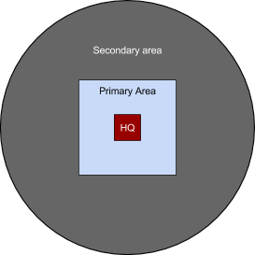

**Game zones**

## Constructor

Player can develop mechanisms in this mode. Player can create any type of constructions using available materials.

Constuctor has 2 modes:

1. parts/mechanisms development
2. aggregate assembly

Assembled aggregates can be placed anywhere on the Area.

## Aggregates

Aggregate is a complex structure with set of mechanic elements. Aggregates are:

1. HQ - primary aggregate. it produces energy and materia. Unique object, cannot be relocated or reconstructed. it is a primarystorage of energy and materia. Distruction of it fails the wave.
2. Consumer - consumes energy and/or materia: cannons/traps/shilds/power fields/radars etc.
3. Generators - produces energy and/or materia
4. Storages - accumulates resource for future needs.

Each Generator creates supply area. Consumer placed in the supply area of one generator has access to all resources generated by all generator of this type. If consumer placed outsude of supply area all functions that require this type of resource will be disabled.

Storages supplies aggregates that are plased on the supply area of the storage type. To work properly storages must be placed inside the supply area of corresponded type.

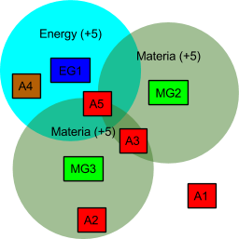

**Supply areas**.

Here:

* MGs are materia generators and materia supply area around them each generates 5 units of materia per second
* EG - energy generator and energy supply area around it
* A* - consumer aggregates
  + A1 is built outside of any supply areas. the aggregate is disabled, no mechanisms are working.
  + A2 and A3 has the same level of materia supplies. Each consumer of materia reduces global value of materia provided by generator. I.e. if A2, A3 and A5 consumes 3 units of materia per second, then total accumulation of materia will be +1 materia per second.
  + A4 aggregate consumes energy only and it cannot produce and convert materials,
  + A5 aggregate has full access to energy and materia

## Resources

Player have 2 prymary resource types

1. Materia/Metall, can be mined using mining aggregates or received from destroyed enemies
2. Energy, can be created from energy generators of any types.

### Materia

Solid resources / construction materials in order of durability:

1. Stone
2. Iron
3. Steel
4. wolfram
5. adamantium (?)
6. ...

Expendable solid materials

1. uranium - for nuclear power plants
2. iridium - for gravity power plants
3. ruby - for tokamak
4. ...

Liquid materials

1. oil
2. gasoline
3. acid
4. deuterium
5. ...

### Energy

Types of energy/energy generators

1. Wind
2. Gasoline
3. Nuclear
4. Gravity
5. Tokamak
6. ...

impacts

1. Kinetic
2. Termal
3. Chemical
4. Electrical
5. Magnetic
6. Nuclear
7. Gravity
8. …

## Enemies

Waves of enemies attack game area to destroy HQ.

Enemy types: discharged or partially destroyed robots. Each robot has it’s own type of weakness.

Player can destroy bots to protect HQ or to charge it. Charged bot will temporary protect HQ until it will be discharged, after discharge robot will be destroyed or continue attack HQ (random decision)

If robot accesses supply area of required type it starts to consume 1 unit of resource per second. Enemies has higher priority than aggregates, the more enemieas are in a supply area the more aggregates will be disabled. Aggregates will be disabled in random order. Storages are not affected by enemies, but aggregates may consume stored resources from storages if player enabled this function.