What is SparkSession?
- SparkSession is the entry point to working with Apache Spark using PySpark.
- It is the main object through which you create DataFrames, read and write data, execute SQL queries, and configure Spark applications.
- 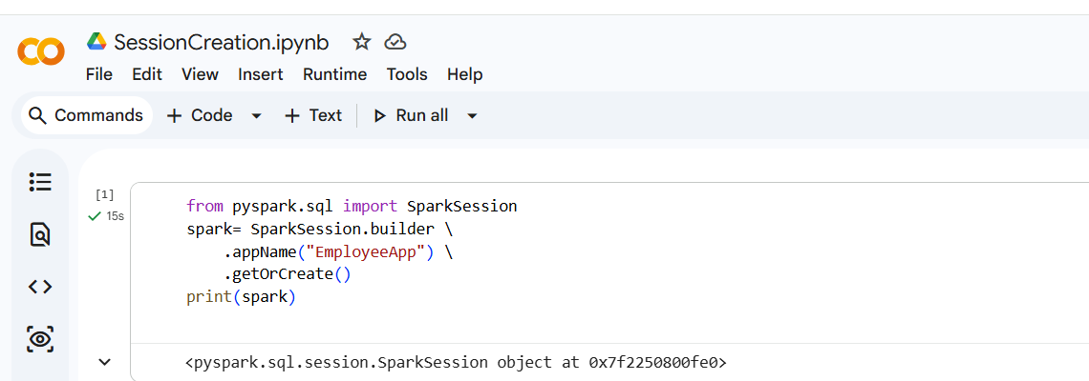
Explanation
- SparkSession: Imports the SparkSession class.
- builder: Creates a builder object to configure the session.
- appName("EmployeeApp"): Sets the application name, which appears in the Spark UI.
- getOrCreate():
  - Returns the existing SparkSession if one already exists.
  - Otherwise, creates a new SparkSession.
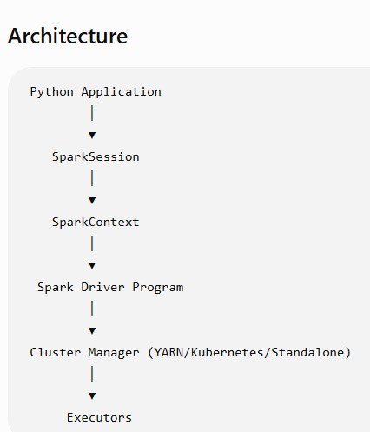
The SparkSession communicates with the Spark Driver, which coordinates work across executors in the cluster.

Why do we use SparkSession?
We use SparkSession to:
- Create DataFrames
- Read data from CSV, JSON, Parquet, ORC, and other formats
- Write processed data to storage
- Execute Spark SQL queries
- Configure Spark application settings
- Access the underlying SparkContext
- Work with Hive tables (when Hive support is enabled)
- Manage Spark jobs through a single interface

What is a DataFrame?
- A DataFrame is a distributed collection of data organized into rows and named columns, similar to a table in a relational database or an Excel spreadsheet.

DataFrames provide several advantages:
- Store structured and semi-structured data.
- Process large datasets in parallel.
- Support SQL-like operations.
- Optimized by Spark's Catalyst Optimizer.
- Support various file formats like CSV, JSON, Parquet, and ORC.
- Easier to use than RDDs.
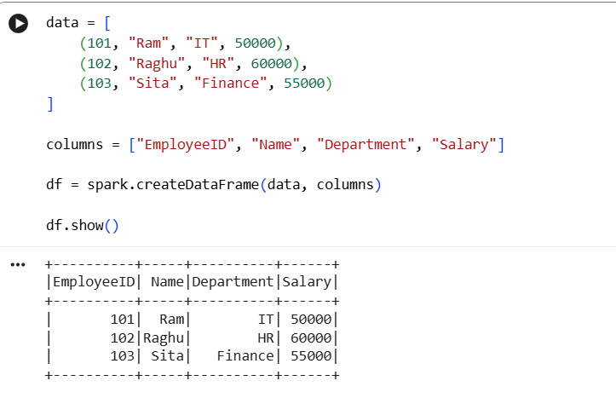

Common DataFrame Operations
1. Display Data
df.show()
Displays the first 20 rows by default.
2. View the Schema
df.printSchema()
The printSchema() method is used to display the schema (structure) of a DataFrame.
A schema includes:
- Column names
- Data types
- Whether each column allows NULL values (nullable)
It helps you understand the structure of your data before performing transformations or analysis.

3. Select Columns
df.select("Name", "Salary").show()
4. Filter Records
df.filter(df.Salary > 55000).show()
5. Add a New Column
from pyspark.sql.functions import col
df = df.withColumn("Bonus", col("Salary") * 0.10)
df.show()
6.Count Rows
df.count()

What is Schema in Spark?
A Schema in Spark is the blueprint or structure of a DataFrame. It defines:
- Column names
- Data types of each column
- Whether a column can contain NULL values (nullable)
Just as a database table has a predefined structure, every Spark DataFrame has a schema.

Difference between InferSchema and Explicit Schema?
Types of Schema

1. Inferred Schema
Spark automatically determines the data types by inspecting the input data.
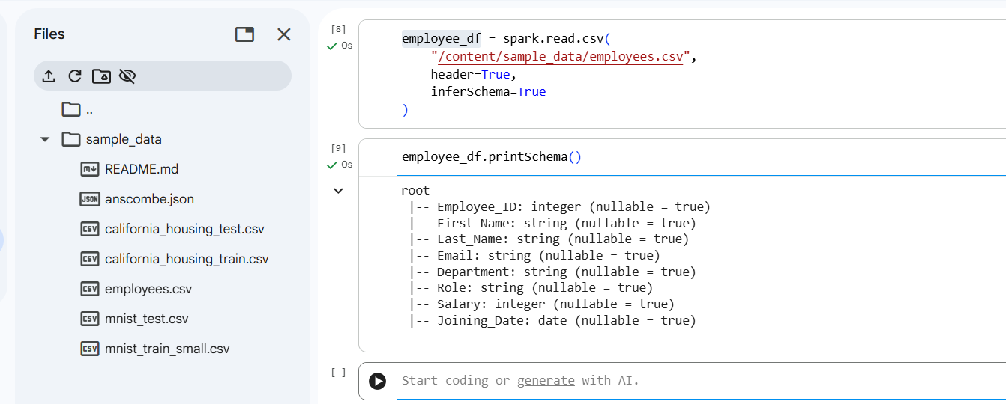
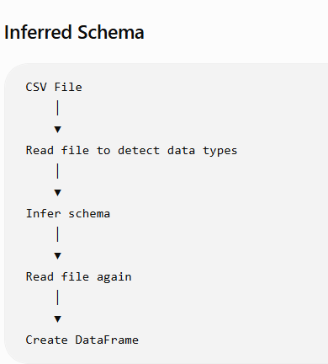
2. Explicit Schema
You define the schema manually before reading the data.
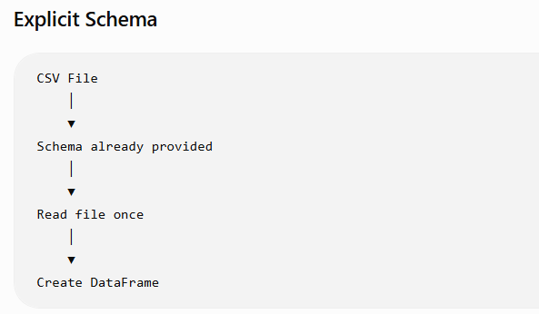
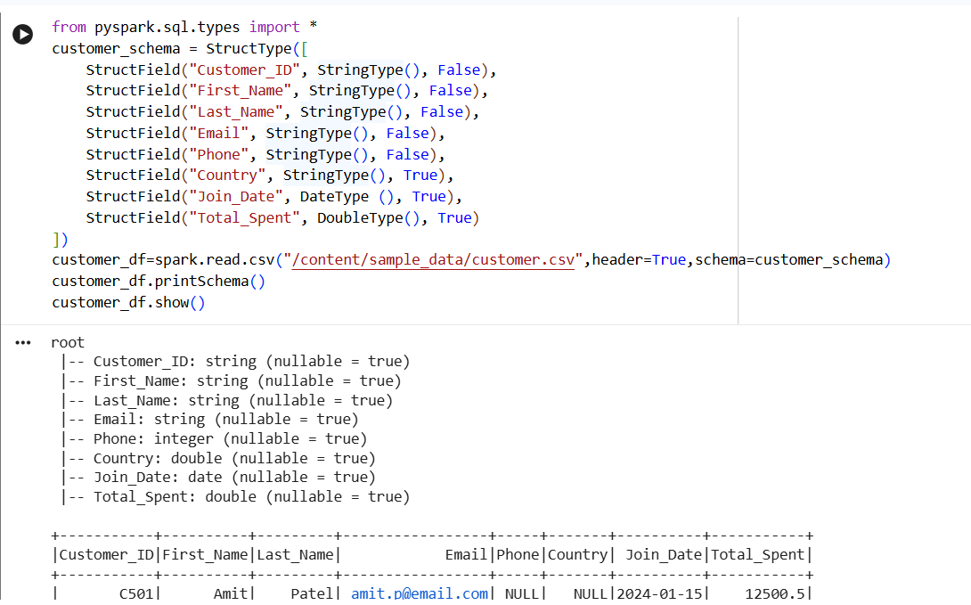

The CSV data source in Spark does not enforce the nullable property. Even if a schema specifies nullable=False, Spark marks CSV columns as nullable because CSV files do not contain schema metadata and fields may be missing. To enforce non-null constraints, additional validation or filtering is required after reading the data

Feature | Inferred Schema | Explicit Schema
Data types | Automatically detected | Manually defined
Performance | Slower | Faster
Accuracy | May infer incorrect types | Exact types are guaranteed
Coding effort | Less | More
Best for | Learning, quick analysis | Production ETL pipelines
Use Inferred Schema when:
- Exploring a new dataset.
- Learning PySpark.
- Working with small files.
- Building quick prototypes.
Use Explicit Schema when:
- Building production ETL pipelines.
- Working with large datasets.
- Data types are known in advance.
- Performance and consistency are important.

Why is Explicit Schema faster?
- With an explicit schema, the developer defines the schema using StructType and StructField.
- This is faster because Spark skips schema inference, ensures consistent data types, and is the preferred approach for production ETL jobs.

Difference between CSV, JSON, Parquet, and Text?

Difference between describe() and summary()?
Feature | printSchema() | describe() | summary()
Purpose | Displays DataFrame structure | Displays basic statistics | Displays detailed statistics
Shows | Column names, data types, nullable | Count, Mean, Stddev, Min, Max | Count, Mean, Stddev, Min, 25%, 50%, 75%, Max
Returns | None (prints schema) | DataFrame | DataFrame
Works on | All columns | Mainly numeric columns (and count/min/max for strings) | Numeric columns (and count/min/max for strings)
Used for | Verify schema | Basic EDA | Detailed EDA
Includes Percentiles | ❌ No | ❌ No | ✅ Yes
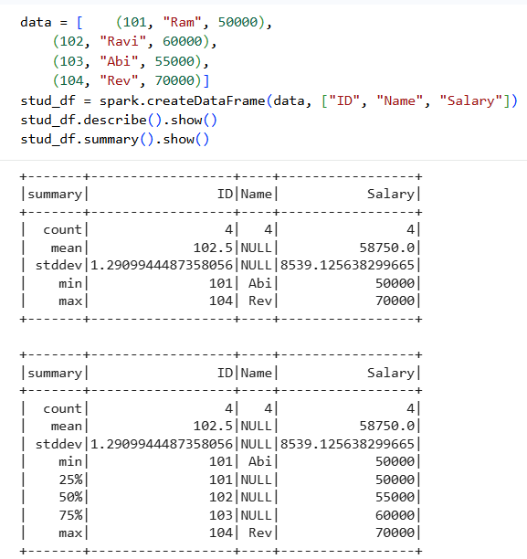

What does printSchema() do?
The printSchema() method is used to display the schema (structure) of a DataFrame.
It shows:
- Column names
- Data types of each column
- Whether each column can contain NULL values (nullable = true/false)
It does not display the actual data—only the DataFrame's structure.
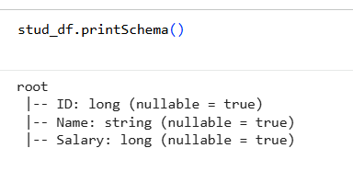

Difference between columns and dtypes?
- Both columns and dtypes provide information about a DataFrame's columns, but they return different details.
- columns returns only the column names.
- dtypes returns both the column names and their data types.

columns
- The columns attribute returns a list of column names.

- 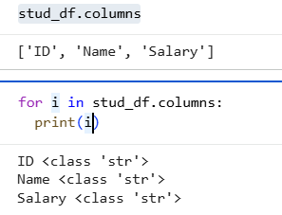

dtypes
- The dtypes attribute returns a list of tuples, where each tuple contains:
- Column name
- Data type
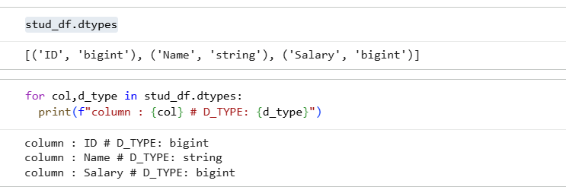

Data Type | Description
StringType() | Text values
IntegerType() | Whole numbers
LongType() | Large integers
DoubleType() | Decimal numbers
FloatType() | Floating-point numbers
BooleanType() | True or False
DateType() | Dates
TimestampType() | Date and time
ArrayType() | Array of values
StructType() | Nested structure
MapType() | Key-value pairs

What is the purpose of count()?
  - The count() method is used to return the total number of rows in a DataFrame.
  - It is an action in Spark, meaning it triggers the execution of all pending transformations (lazy evaluation).

  - stud_df.count()
Output: 4

Why is Parquet preferred over CSV in Spark?

