Day 1 – Big Data, Hadoop vs Spark, Spark Architecture, SparkSession
Concept Questions
Q1. What is Big Data? Explain the 5 Vs of Big Data with examples.
Big Data refers to extremely large and complex datasets that cannot be efficiently stored, processed, or analysed using traditional databases and single-server systems.

Characteristics of Big Data (5 Vs)
V | Description | Example
Volume | Huge amount of data | Petabytes of social media data
Velocity | Data generated at high speed | UPI Transactions works Fastly
Variety | Different data formats | Text, images, videos, JSON, XML
Veracity | Data quality and reliability | Duplicate or incomplete customer records
Value | Useful insights extracted from data | Customer recommendations

Q2. Differentiate Hadoop and Spark based on:
 | Hadoop | Spark
- Speed | Works slowly due to processing in disc | Works Faster because it processing in memory
- Processing Type
- Storage
- Memory Usage
- Ease of Use
Q3. Explain Spark Architecture using the following components:
- Driver
- Cluster Manager
- Worker Node
- Executor
- Task
Q4. Explain the role of SparkSession in PySpark.

Programming Questions
Q5.
Create a SparkSession named StudentApp.
Expected Output
SparkSession created successfully
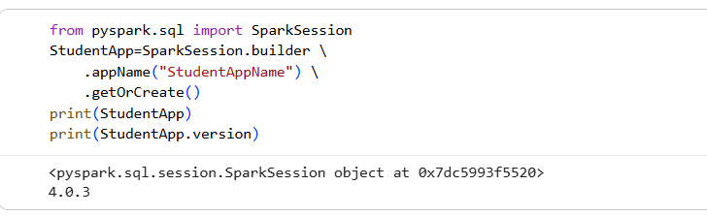

Q6.
Print the Spark version.
Expected Output
Spark Version: x.x.x
OP: print(StudentApp.version)

Q7.
Stop the SparkSession.
OP: StudentApp.stop()

Q8.
Create a SparkSession with the application name EmployeeManagement.
appName is the name assigned to a Spark application. It is used to identify the application in the Spark UI
from pyspark.sql import SparkSession
spark=SparkSession.builder \
.appName("EmployeeManagement") \
.getOrCreate()

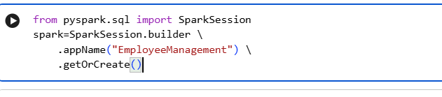

Q9.
Write a program to verify whether SparkSession is created successfully.
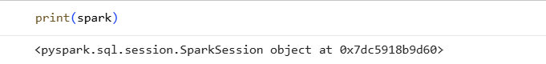

Q10.
Write a program that creates SparkSession, prints its application name, and stops it.

from pyspark.sql import SparkSession
spark=SparkSession.builder \
.appName("EmployeeManagement") \
.getOrCreate()
print(spark)
print(spark.sparkContext.appName)
spark.stop()
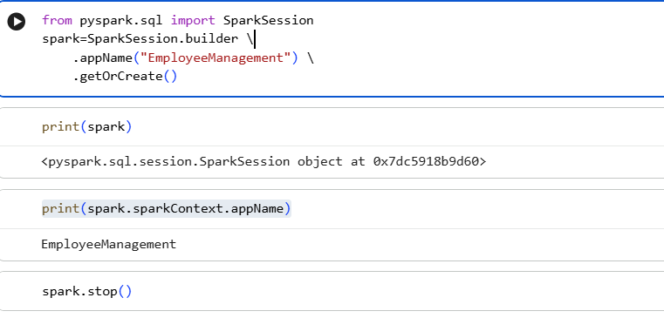

Day 2 – SparkSession, DataFrames, Schema
Use the following sample data.
[
(101,"Rahul",25,"Chennai"),
(102,"Priya",23,"Bangalore"),
(103,"Amit",27,"Mumbai"),
(104,"Sneha",24,"Hyderabad"),
(105,"John",26,"Delhi")
]
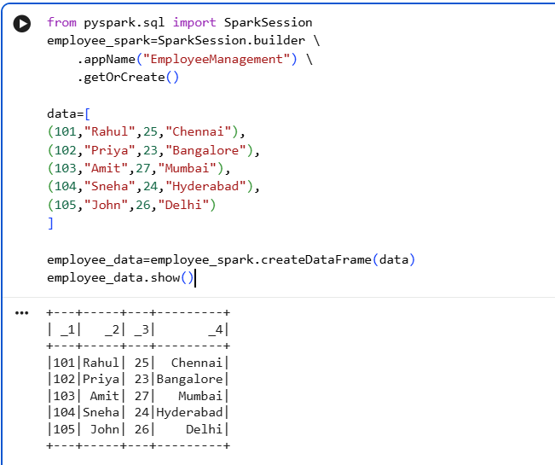
data=[
(101,"Rahul",25,"Chennai"),
(102,"Priya",23,"Bangalore"),
(103,"Amit",27,"Mumbai"),
(104,"Sneha",24,"Hyderabad"),
(105,"John",26,"Delhi")
]
columns=['id','name','age','city']
employee_data=employee_spark.createDataFrame(data,columns)
employee_data.show()

Q1.
Create a DataFrame without specifying a schema.
employee_data=employee_spark.createDataFrame(data,columns)

Q2.
Display all records.
employee_data.show()

Q3.
Print the schema of the DataFrame.
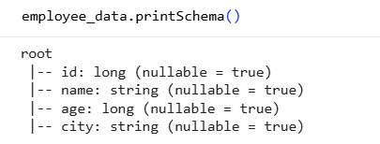

Q4.
Create the same DataFrame using an Explicit Schema.
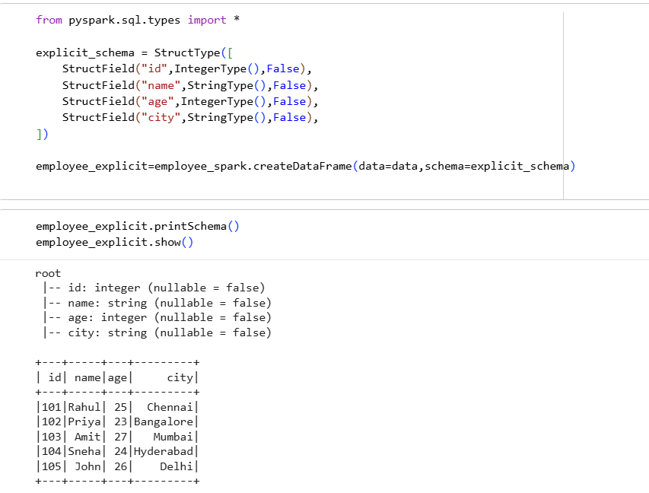

Q5.
Compare InferSchema and Explicit Schema by printing their schemas.
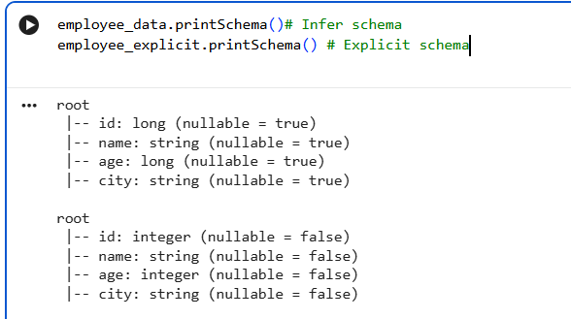

Q6.
Find the number of columns.
len(employee_data.columns)
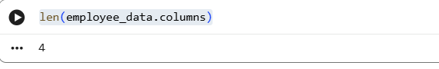

Q7.
Print the list of column names.
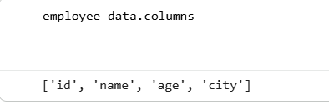

Q8.
Display only the first three records.
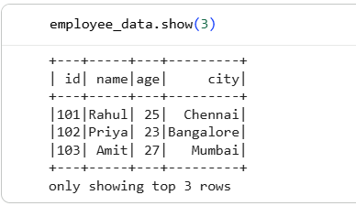

Q9.
Create a DataFrame with the following schema:
EmployeeID
EmployeeName
Age
Department
Salary

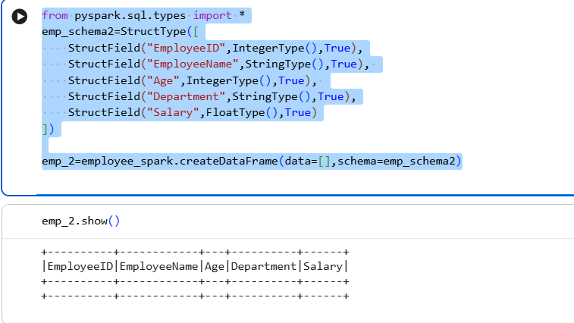

Q10.
Create a DataFrame containing your own 10 student records.
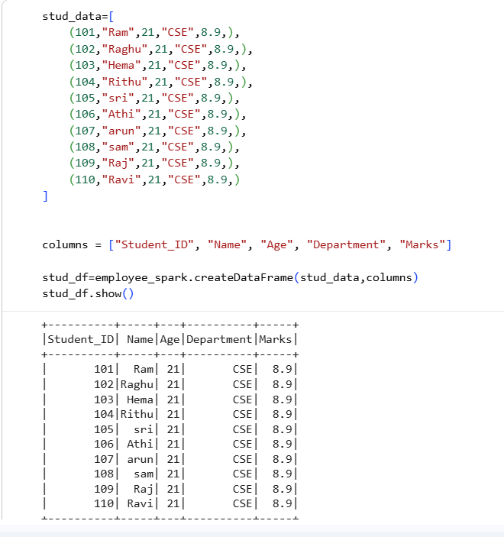

Day 3 – Reading CSV Files
Assume the file name is:
employees.csv

Q1.
Read the CSV file without header.
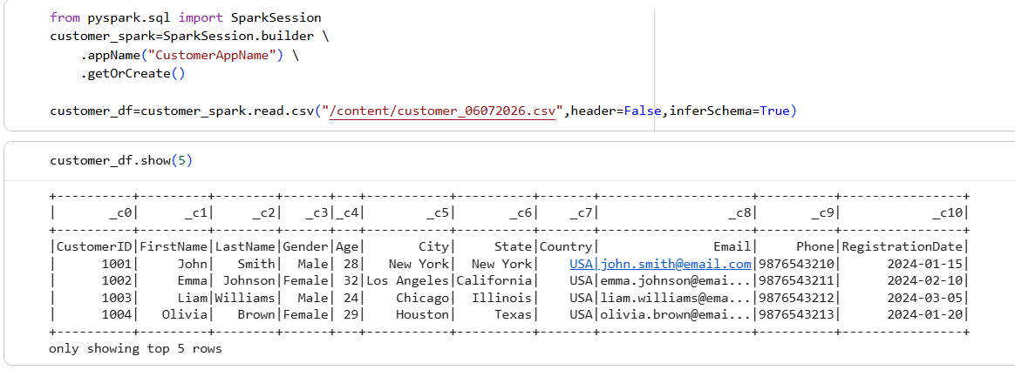

Q2.
Read the CSV file with header.
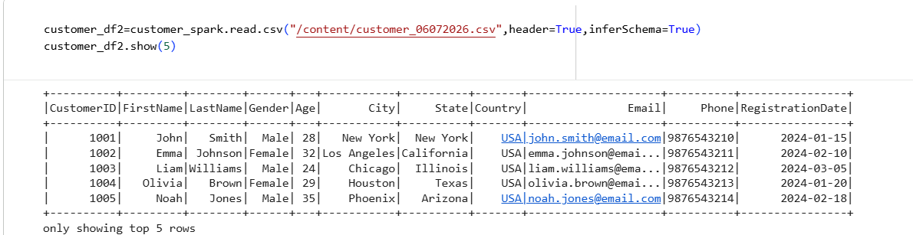

Q3.
Read the CSV file using InferSchema.


Q4.
Read the CSV file using Explicit Schema.
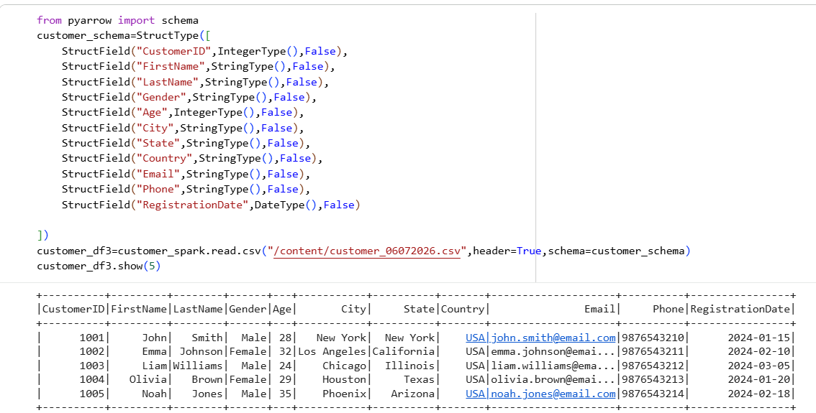

Q5.
Display the first five records.


Q6.
Print the schema.
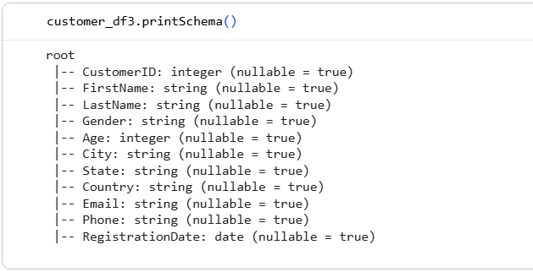

Q7.
Count the number of rows.
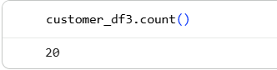

Q8.
Display only the first two rows.
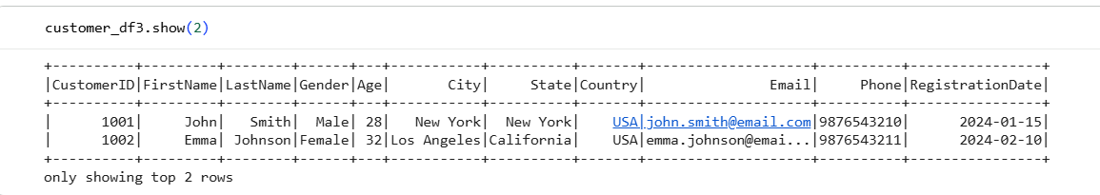

Q9.
Read a CSV file containing student details and print all records.
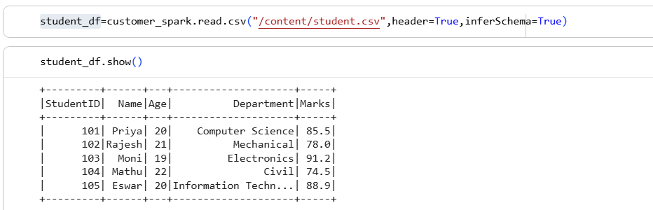

Q10.
Compare the output of:
- Without Header
- With Header
- InferSchema
- Explicit Schema

Day 4 – Exploring Data
Use Employee Data.
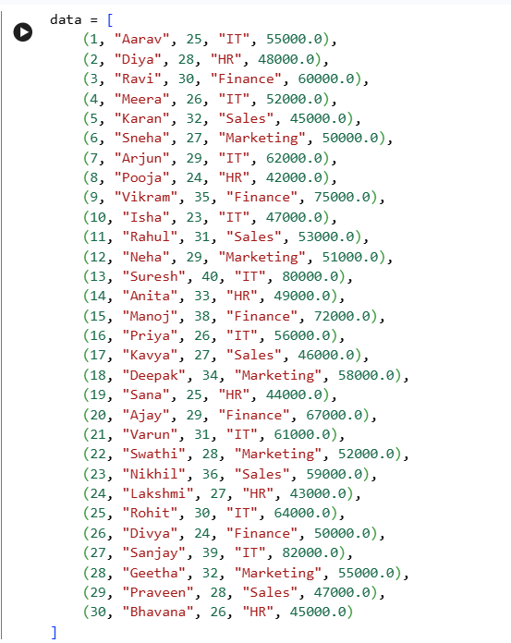
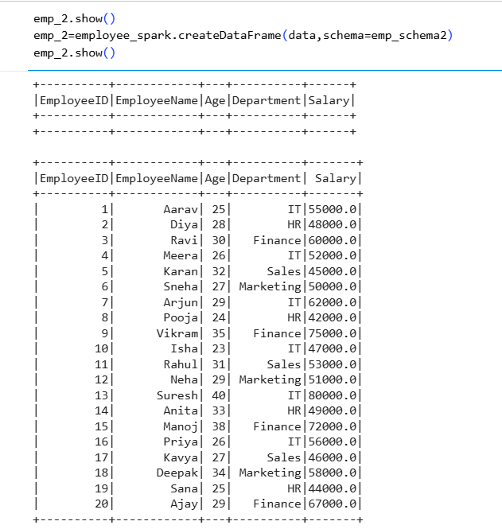

Q1.
Display all records using show().
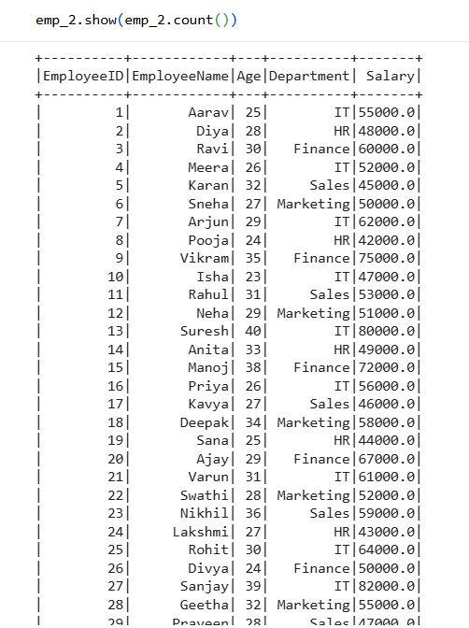

Q2.
Display only the first five rows.
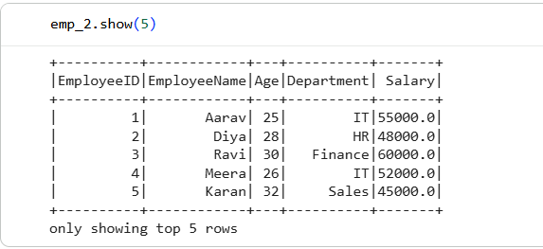

Q3.
Print the schema.
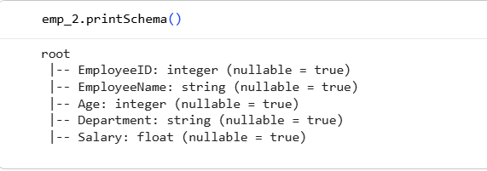

Q4.
Find the total number of records.
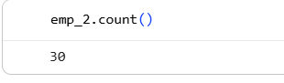

Q5.
Print all column names.
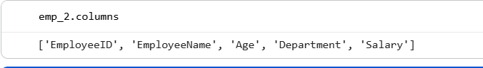

Q6.
Print the data types of all columns.

Q7.
Use describe() to display statistics.
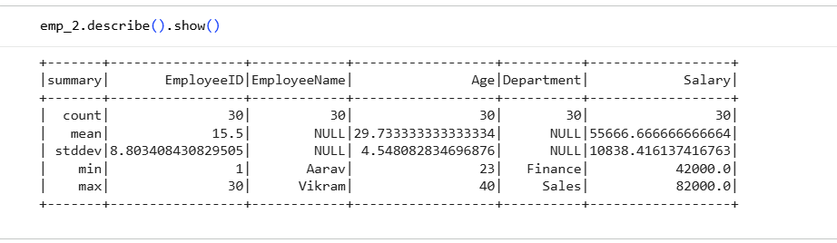

Q8.
Use summary() and compare the output with describe().
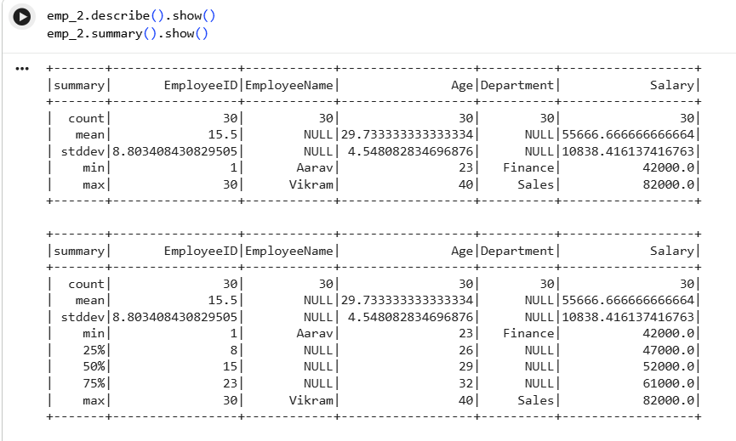

Q9.
Display only 3 rows without truncating long strings.
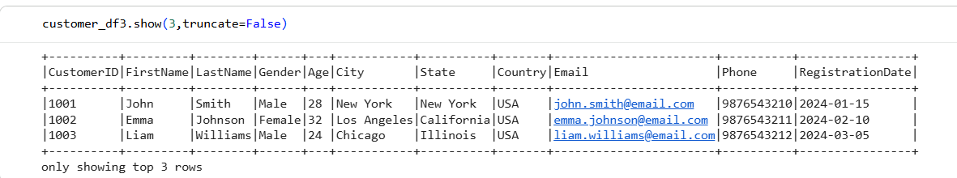

Q10.
Find:
- Number of rows
- Number of columns
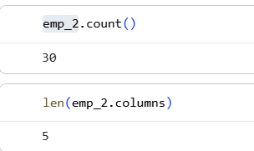

Q11.
Identify which columns are numeric.

Q12.
Display schema and data together.
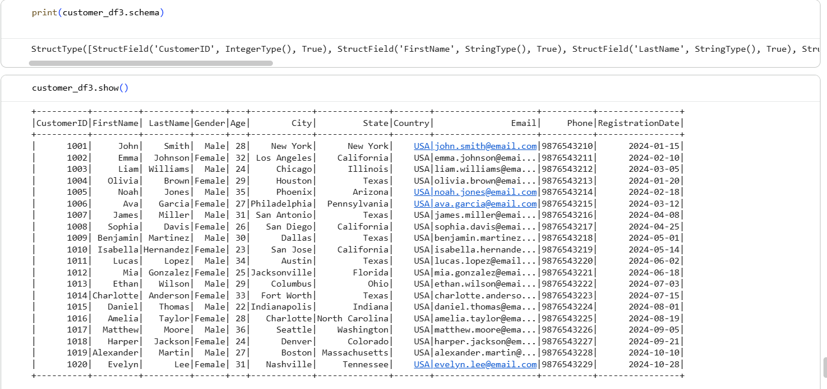

Day 5 – select() and withColumn()
Use Employee Data.

Q1.
Display only Employee Name.
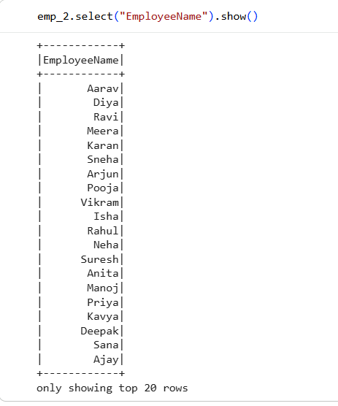

Q2.
Display Employee Name and Salary.
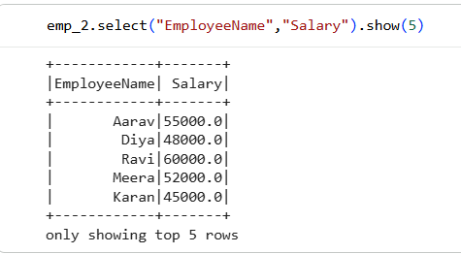

Q3.
Display Employee Name with Age.
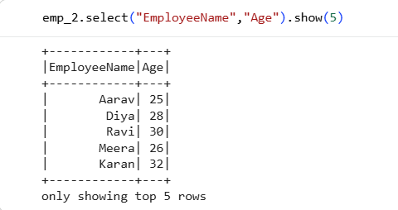

Q4.
Create a new column called Bonus.
Bonus = Salary × 10%

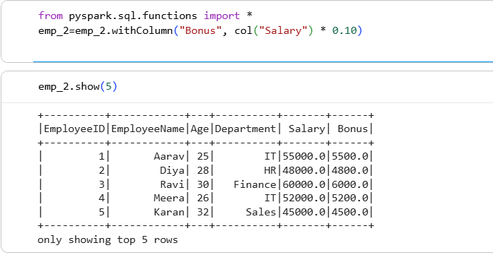
Q5.
Create a column called AnnualSalary.
AnnualSalary = Salary × 12
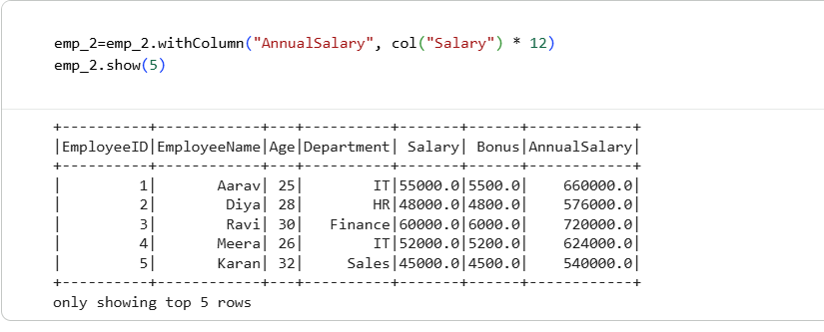

Q6.
Increase every employee's salary by ₹5,000 using withColumn().
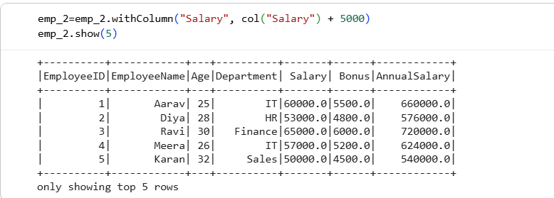

Q7.
Create a new column called Country with value India.

Lit(): literal is constant value to a column

Q8.
Convert all employee names to uppercase using withColumn().
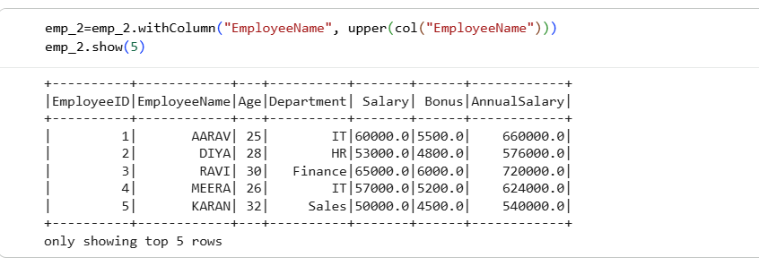

Q9.
Display Employee Name and Annual Salary only.
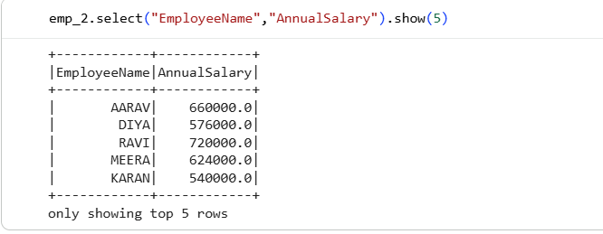

Q10.
Create a new column called ExperienceLevel.
Condition:
- Age < 25 → Junior
- Age 25–30 → Mid-Level
- Age > 30 → Senior

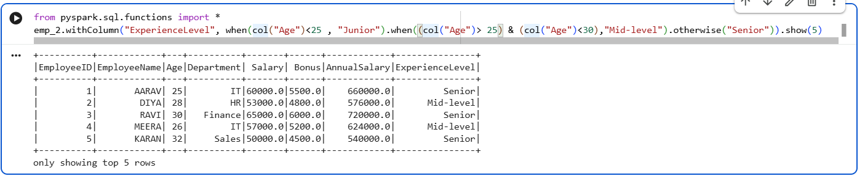

Mini Practice (Day 1–Day 5 Combined)
Task: Student Management System
Create a CSV file named students.csv with the following columns:
StudentID
Name
Age
Course
City
Marks
Perform the following operations:
- Create a SparkSession.
- Read the CSV file with header.
- Use an Explicit Schema.
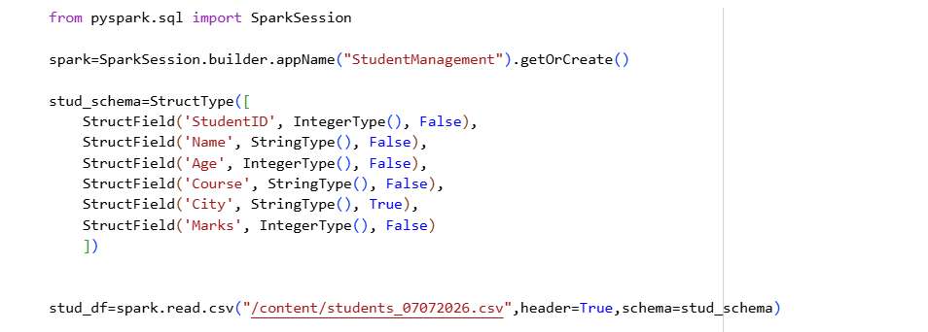
- Display all records.
- Print the schema.
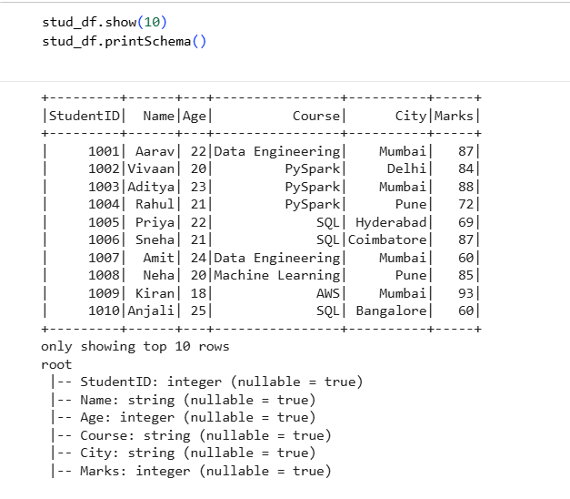
- Count the total number of students.
- Display only Name and Marks.
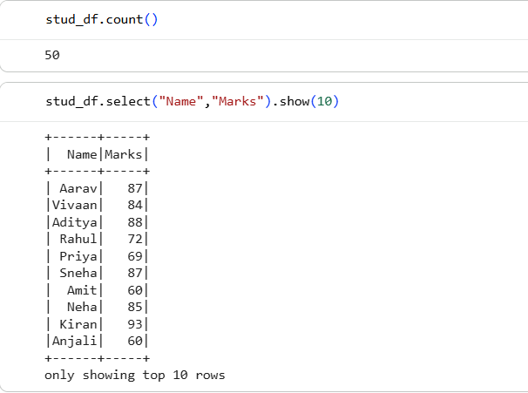
- Create a new column named Result.
  - Marks ≥ 50 → Pass
  - Marks < 50 → Fail
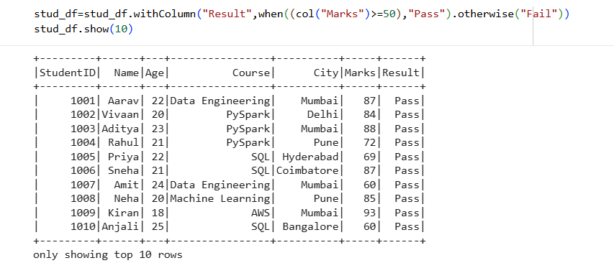
- Create another column named BonusMarks by adding 5 marks.
- Display the updated DataFrame.
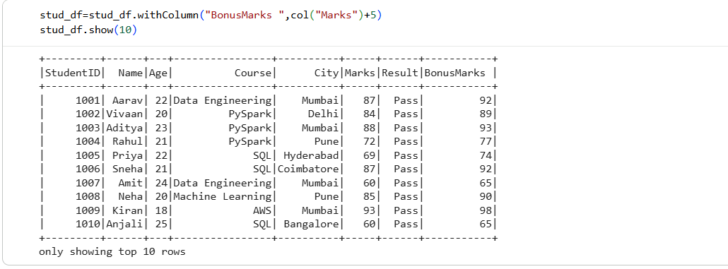

Challenge Questions (Medium Level)
- Create a DataFrame with 20 employee records and perform all exploration functions.
- Read a CSV file using an Explicit Schema and compare it with InferSchema.
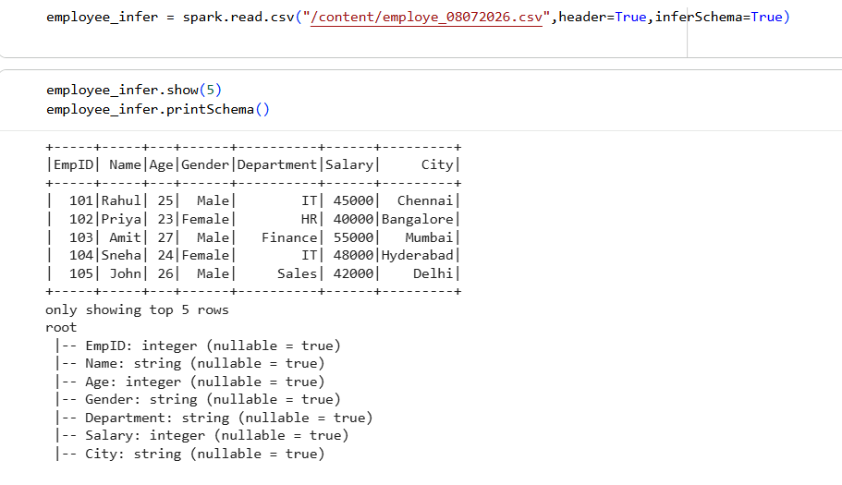
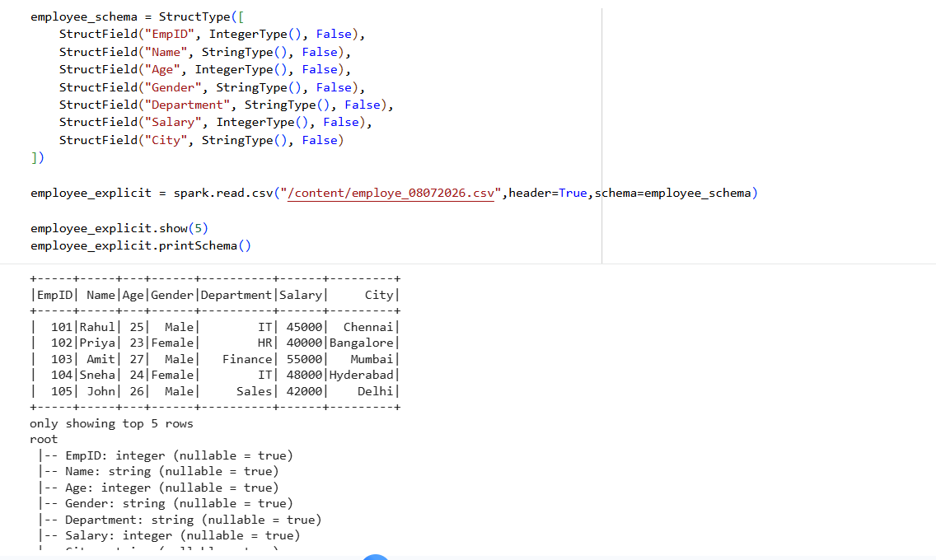
- Add three new columns:
  - HRA = Salary × 15%
  - DA = Salary × 8%
  - GrossSalary = Salary + HRA + DA
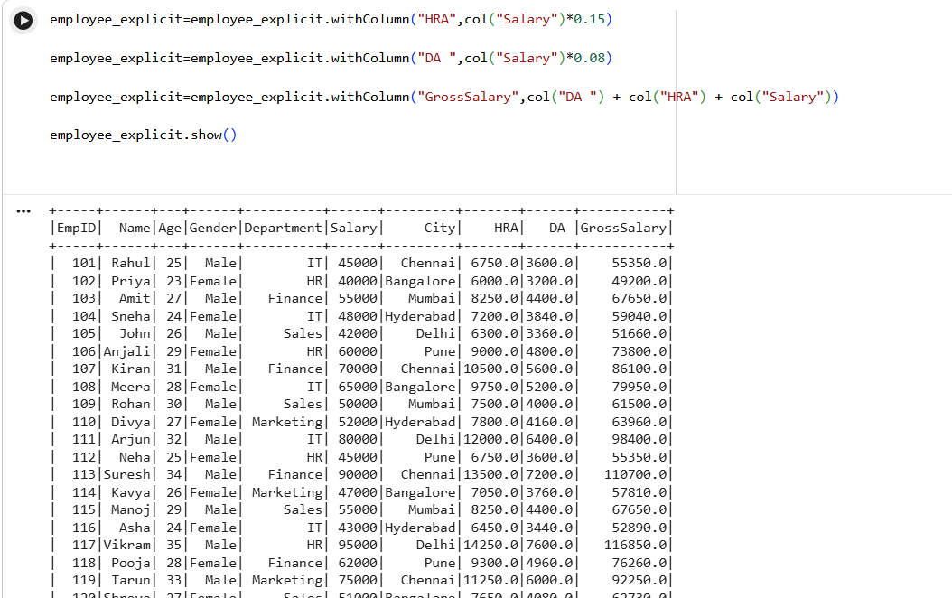
- Display only employees whose salary is greater than ₹50,000 (using select() after filtering, if students already know filter; otherwise, postpone filtering to a later lesson).
- Build a complete Employee DataFrame, explore it, and create new calculated columns using withColumn().
