What is Big Data?
Big Data refers to extremely large and complex datasets that cannot be efficiently stored, processed, or analyzed using traditional databases and single-server systems.

Characteristics of Big Data (5 Vs)
V | Description | Example
Volume | Huge amount of data | Petabytes of social media data
Velocity | Data generated at high speed | UPI Transactions works Fastly
Variety | Different data formats | Text, images, videos, JSON, XML
Veracity | Data quality and reliability | Duplicate or incomplete customer records
Value | Useful insights extracted from data | Customer recommendations

Hadoop
Hadoop is an open-source framework designed to store and process Big Data across a cluster of commodity machines.
It is built for:
- Distributed storage
- Distributed processing

Hadoop Components
1. HDFS (Hadoop Distributed File System)
- Stores large files across multiple machines.
- Splits files into blocks (typically 128 MB).
2. YARN (Yet Another Resource Negotiator)
Responsible for:
- Resource management
- Scheduling jobs
- Allocating CPU and memory
3. MapReduce
- A batch processing framework that processes large datasets in parallel.
- MapReduce is reliable but relatively slow because it frequently reads from and writes to disk.

Advantages of Hadoop
- Handles petabytes of data
- Fault tolerant
- Highly scalable
- Low-cost storage
- Open source

Disadvantages
- Slow for iterative and interactive workloads
- Disk-based processing
- Complex programming model
- Not ideal for real-time analytics

Apache Spark
Apache Spark is an open-source distributed data processing engine that performs large-scale data processing much faster than MapReduce by using in-memory computation whenever possible.
Spark Features
- In-memory processing
- Faster than MapReduce (often significantly faster for iterative workloads)
- Easy APIs (Python, Scala, Java, SQL, R)
- Batch and streaming support
- Machine learning support
- Graph processing support

Spark Architecture
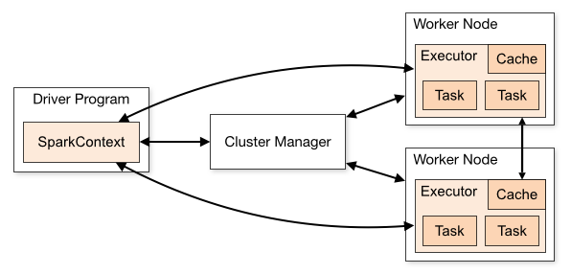

Components of Spark Architecture

1. Driver Program
The Driver is the brain of the Spark application.
Responsibilities
- Starts the Spark application.
- Creates the SparkSession and SparkContext.
- Converts user code into an execution plan.
- Builds the DAG (Directed Acyclic Graph).
- Divides jobs into stages and tasks.
- Requests resources from the Cluster Manager.
- Sends tasks to executors.
- Collects results from executors.

2. Cluster Manager
The Cluster Manager allocates resources for the application.
Supported cluster managers:
- Spark Standalone
- Hadoop YARN
- Kubernetes
- Apache Mesos
Responsibilities
- Allocate CPU cores.
- Allocate memory.
- Launch executors on worker nodes.
- Monitor cluster resources.

3. Worker Node
A Worker Node is a machine in the cluster.
It hosts one or more executors.

4. Executor
Executors perform the actual data processing.
Responsibilities
- Execute tasks.
- Read data from storage.
- Cache data in memory.
- Return results to the Driver.
Each executor has:
- CPU cores
- Memory
- Cache

Feature | Hadoop | Spark
Primary purpose | Distributed storage and batch processing | Distributed data processing
Processing engine | MapReduce | Spark Engine
Speed | Slower (disk-based) | Faster (in-memory)
Storage | HDFS | HDFS, S3, Azure Blob, databases, etc.
Real-time processing | Limited | Yes (Structured Streaming)
Machine Learning | External tools | Built-in MLlib
Programming | Java (primarily for MapReduce) | Python, Scala, Java, SQL, R
Fault tolerance | HDFS replication | RDD/DataFrame lineage
Ease of development | More complex | Simpler APIs

