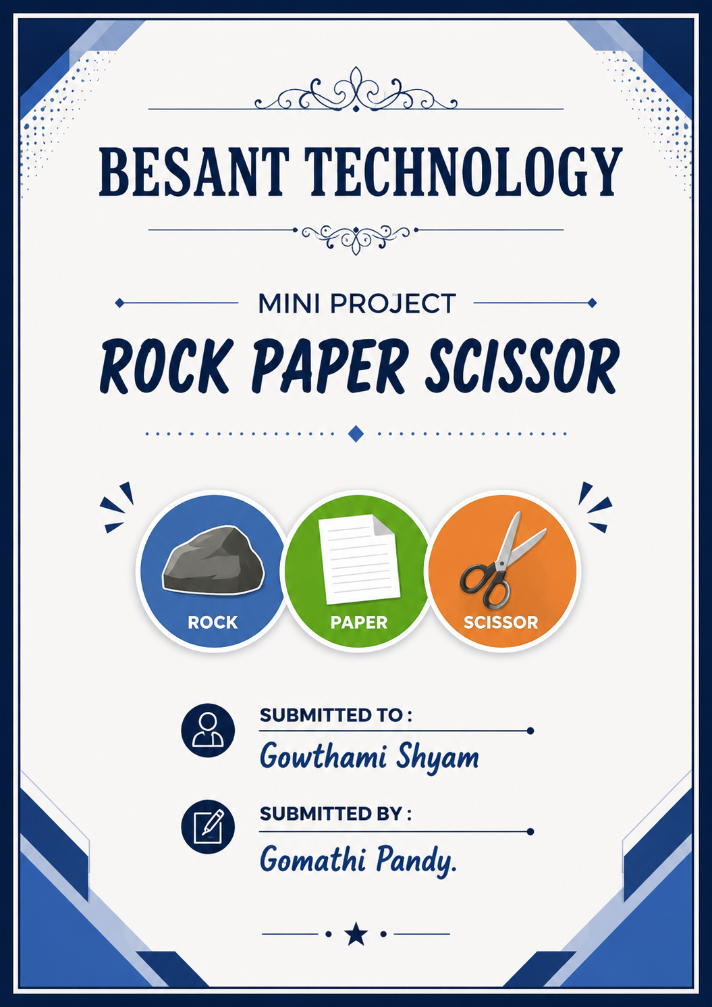

Acknowledgement

I would like to express my sincere gratitude to Mrs. Gowthami Shyam for her valuable guidance, encouragement, and continuous support throughout the development of this mini project titled “Rock Paper Scissor Game using Python.”
I am thankful to Besant Technology for providing the opportunity, resources, and learning environment to enhance my programming and software engineering skills.
I also extend my heartfelt thanks to all faculty members, friends, and well-wishers who directly or indirectly helped me in completing this project successfully.
This project helped me gain practical knowledge in Python programming, logical problem-solving, exception handling, and software development concepts

Index
Contents
Introduction to Python 4
Features of Python 4
Applications of Python 5
Python in Software Engineering 5
Advantages of Python 6
Project Overview 7
Rules and Regulations of the Rock Paper Scissor Game 7
9. Exception Handling 9
Concepts Used in the Source Code 10
1. Variables 10
2. Lists 10
3. Input Function 10
4. String Methods 10
5. Random Module 11
6. Conditional Statements 11
7. Logical Operators 12
8. Membership Operator 12
10. Output Statements 13
11. Program Flow Control 13
12. Comments 14
Source code : 15
Explanation of Source Code 16

Introduction to Python
Python is a high-level, interpreted, and general-purpose programming language developed by Guido van Rossum and first released in 1991.
Python is widely known for its:
Simple syntax
Easy readability
Beginner-friendly nature
Powerful libraries and frameworks
It allows developers to write programs with fewer lines of code compared to many other programming languages.

Features of Python
- Easy to Learn
Python uses simple English-like syntax, making it easy for beginners and professionals.
Example:
print("Hello World")

2. Interpreted Language
Python code is executed line by line using an interpreter, which simplifies debugging and testing.

3. Platform Independent
Python programs can run on:
- Windows
- Linux
- macOS
- without major modifications.

4. Object-Oriented Language
Python supports object-oriented programming concepts such as:
- Classes
- Objects
- Inheritance
- Polymorphism

5. Large Standard Library
Python provides built-in libraries for:
- Mathematics
- File handling
- Web development
- Data analysis
- Artificial Intelligence
- Machine Learning

Applications of Python
Python is used in many real-world applications:
Domain | Usage
Web Development | Websites and APIs
Data Science | Data analysis and visualization
Artificial Intelligence | Machine Learning and AI models
Automation | Task automation scripts
Game Development | Building games
Cyber Security | Security tools and testing
Software Development | Desktop and enterprise applications

Python in Software Engineering
In software engineering, Python is used for:
- Backend development
- Automation testing
- Scripting
- Data processing
- API development
- DevOps automation
- Cloud applications
Python helps developers build scalable and maintainable software systems efficiently.

Advantages of Python
- Benefits
- Simple and readable code
- Faster development process
- High productivity
- Strong community support
- Easy integration with other technologies
- Suitable for beginners and professionals

Project Overview
The Rock Paper Scissor Game is a simple command-line based mini project developed using Python. The project is designed to simulate the traditional Rock Paper Scissor game between a user and the computer.
In this application, the user selects one option among:
- Rock
- Paper
- Scissor
The computer automatically generates a random choice using Python’s built-in random module. The program then compares both choices and determines the winner based on predefined game rules.
This project demonstrates fundamental software engineering and programming concepts such as:
- User interaction
- Conditional statements
- Random number generation
- Input validation
- Exception handling
- Program flow control
The primary objective of this project is to develop a beginner-friendly interactive application while improving logical thinking and coding skills. The project also provides practical exposure to Python programming and helps in understanding how real-world software applications process inputs, apply business logic, and generate outputs.
Additionally, exception handling techniques are implemented to make the application more stable and user-friendly by preventing crashes caused by invalid inputs.
This mini project serves as a foundational step toward developing more advanced software applications such as games, automation tools, and interactive systems.

Rules and Regulations of the Rock Paper Scissor Game
Game Rules
The Rock Paper Scissor game follows a simple set of predefined rules between the player and the computer.

Basic Rules
Rule 1: Rock beats Scissor
- Rock can break Scissor.
- Therefore, Rock wins.
Example:
Rock vs Scissor → Rock Wins

Rule 2: Paper beats Rock
- Paper can cover Rock.
- Therefore, Paper wins.
Example:
Paper vs Rock → Paper Wins

Rule 3: Scissor beats Paper
- Scissor can cut Paper.
- Therefore, Scissor wins.
Example:
Scissor vs Paper → Scissor Wins

Tie Condition
If both the user and the computer select the same option, the game results in a tie.
Example:
Rock vs Rock → Tie
Game Logic Table:

User Choice | Computer Choice | Result
Rock | Scissor | User Wins
Rock | Paper | Computer Wins
Paper | Rock | User Wins
Paper | Scissor | Computer Wins
Scissor | Paper | User Wins
Scissor | Rock | Computer Wins

Concepts Used in the Source Code

The Rock Paper Scissor Game project uses several important programming concepts of Python. These concepts help in understanding the fundamentals of software development and problem-solving.

1. Variables
Variables are used to store data values in memory.
Example :
user = "rock"
computer = "paper"
Purpose in Project
- Store user choice
- Store computer-generated choice
- Store temporary data during execution

2. Lists
A list is a collection of multiple values stored in a single variable.
Example:
choices = ["rock", "paper", "scissors"]
Purpose in Project:
- Store valid game options
- Allow random selection
- Simplify validation logic

3. Input Function
The input() function is used to receive data from the user.
Example:
user = input("Enter rock, paper, or scissors: ")
Purpose in Project :
- Accept user interaction
- Make the game interactive

4. String Methods

a) lower()
Converts text into lowercase.
Example
user.lower()
Purpose in Project :
- Ensures input consistency.

Example:
ROCK → rock

b) strip()
Removes extra spaces from the beginning and end of a string.

Example
user.strip()
Purpose in Project :
- Prevents errors caused by unwanted spaces.

Example:
" rock " → "rock"

5. Random Module
- The random module generates random values.
- Before using the random module, it must be imported.
  - import random
- This gives access to all functions available inside the module.
- random.choice() function selects one random element from a list, tuple, or string.
Example
computer = random.choice(choices)
Purpose in Project :
- Generate computer moves randomly
- Ensure fair gameplay

6. Conditional Statements
Conditional statements are used for decision making.

Statements Used :
- if
- elif
- else
Example
if user == computer:

Purpose in Project :
- Compare choices
- Determine winner
- Validate inputs

7. Logical Operators
Logical operators in Python are used to combine multiple conditions and return either:
- True
- False
They are mainly used in:
- Decision making
- Conditional statements
- Validation logic

Types of Logical Operators
Python provides three main logical operators:
Operator | Meaning
And | Returns True if both conditions are True
Or | Returns True if at least one condition is True
Not | Reverses the condition

Example
(user == "rock" and computer == "scissors")
Purpose
- Check multiple conditions simultaneously.

8. Membership Operator
The Membership Operator is used to check whether a value exists inside a sequence such as:
- List
- Tuple
- String
- Dictionary
It returns:
- True
- False
depending on whether the value is present or not.

Types of Membership Operators
Python provides two membership operators:
Operator | Meaning
in | Returns True if value exists
not in | Returns True if value does not exist

Purpose in Project :
The membership operator is used for:
- Input validation
- Checking whether the entered value is valid

Example :
print(user in choices)

9. Exception Handling
Exception Handling is a mechanism used to handle runtime errors and prevent the program from crashing unexpectedly.
It allows the program to:
- Detect errors
- Handle errors gracefully
- Continue execution smoothly
Exception handling improves:
- Software reliability
- Stability
- User experience

Exception Handling Keywords
Python uses the following keywords:
Keyword | Purpose
Try | Contains risky code
Except | Handles errors
finally | Executes always
Raise | Generates custom exceptions

Example
try:
user = input()

except:
print("Error")
Purpose in Project:
- Handle invalid inputs
- Improve software reliability
- Prevent runtime crashes

ValueError Exception
ValueError occurs when invalid values are provided.

Example
raise ValueError("Invalid choice entered")
Purpose:
- Generate custom error messages for wrong user inputs.

10. Output Statements
The print() function displays output on the screen.

Example
print("You Win")
Purpose:
Display:
- User choices
- Computer choices
- Game results
- Error messages

11. Program Flow Control
Flow control manages the sequence of program execution.
Purpose in Project
The program follows this flow:
- Get input
- Generate random choice
- Compare choices
- Display result

12. Comments
Comments in Python are non-executable statements used to explain the code. They improve the readability and understanding of programs.
Comments are ignored by the Python interpreter during execution.
They are mainly used for:
- Explaining logic
- Improving code readability
- Documentation
- Debugging
- Maintenance

Types of Comments in Python
Python supports:
- Single-line comments
  - Single-line comments begin with the # symbol.
- Multi-line comments
  - Multi-line comments are used for longer explanations.
  - Python uses triple quotes:
  - ''' '''
  - """ """

Example :
# User input
user = input("Enter your name: ")
Purpose
- Explain logic
- Improve maintainability
- Help debugging

Source code :
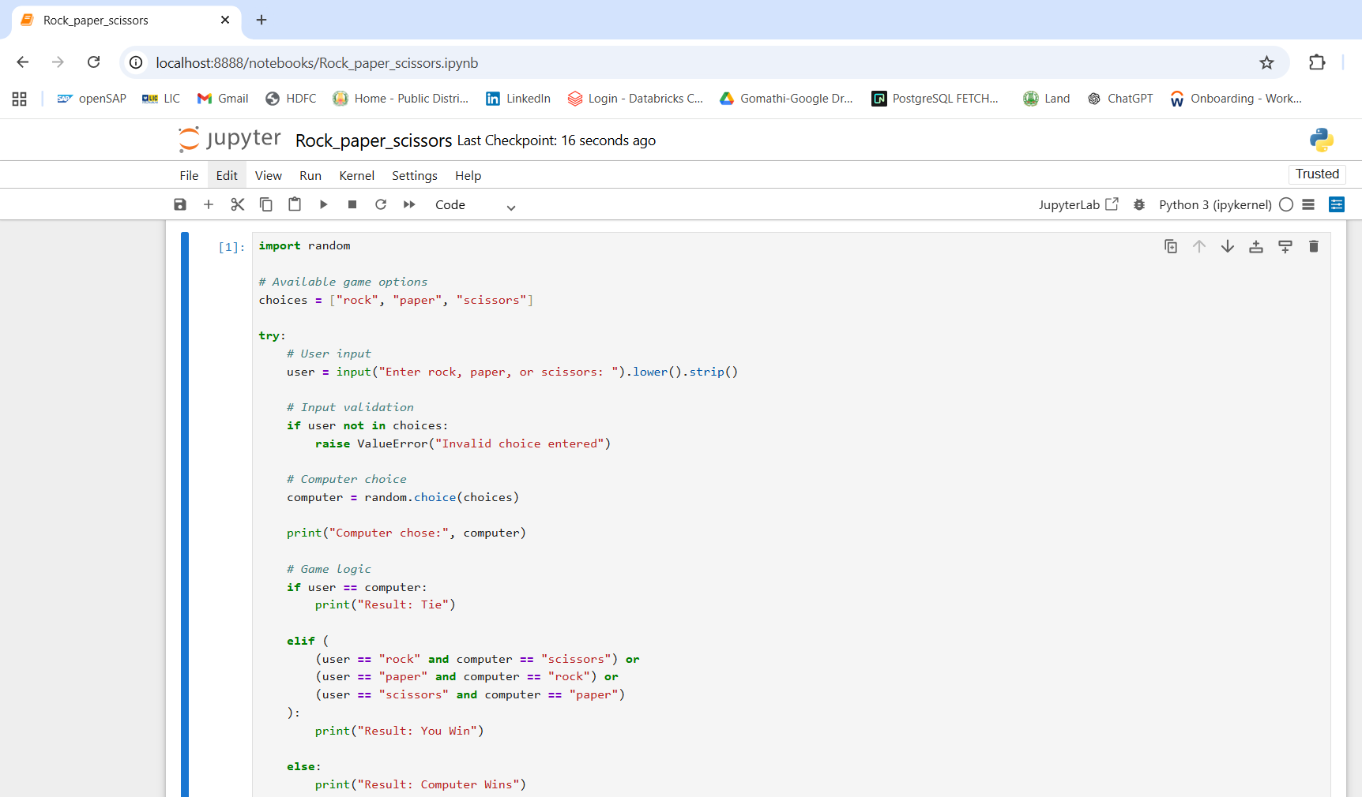
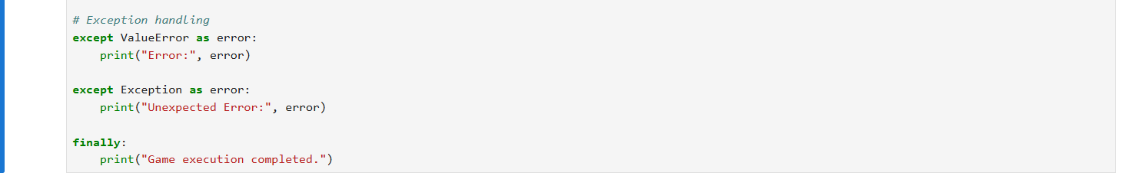

Explanation of Source Code
This program is developed using Python to implement the Rock Paper Scissor Game with proper exception handling and input validation.
The program allows the user to play against the computer, where the computer generates a random choice and the program decides the winner based on game rules.

1. Importing Random Module
import random
Explanation
- Imports Python’s built-in random module.
- Used to generate random computer choices.
Purpose
The computer should make unpredictable selections to ensure fair gameplay.

2. Creating Game Options List
choices = ["rock", "paper", "scissors"]
Explanation
A list named choices is created containing all valid game options.
Purpose
- Store valid inputs
- Help in random selection
- Simplify input validation

3. Try Block
try:
Explanation
The try block contains code that may generate errors during execution.
Purpose
- Prevent sudden program crashes
- Handle runtime exceptions safely

4. User Input
user = input("Enter rock, paper, or scissors: ").lower().strip()
Explanation
This line:
- Accepts input from the user
- Converts input into lowercase using: lower()
- Removes extra spaces using : strip()

Example
User Input
ROCK
After Processing
rock

5. Input Validation
if user not in choices:
Explanation
Checks whether the entered value exists in the valid options list.

Membership Operator Used
not in
Purpose
Detect invalid inputs.

6. Raising Custom Exception
raise ValueError("Invalid choice entered")
Explanation
Manually generates a ValueError exception when invalid input is entered.
Example Invalid Input
apple
Output
Error: Invalid choice entered

7. Computer Random Choice
computer = random.choice(choices)
Explanation
The computer randomly selects one value from:
- rock
- paper
- scissors
Function Used
random.choice()

8. Display Computer Choice
print("Computer chose:", computer)
Explanation
Displays the computer’s selected option on the screen.

9. Tie Condition
if user == computer:
Explanation
Checks whether:
- User choice
- Computer choice
are the same.
Result
Result: Tie

10. Winning Conditions
elif (
(user == "rock" and computer == "scissors") or
(user == "paper" and computer == "rock") or
(user == "scissors" and computer == "paper")
)
Explanation
Checks all possible user-winning combinations.

Logical Operators Used
AND Operator
and
Used to combine two conditions.
Example:
user == "rock" and computer == "scissors"

OR Operator
or
Used to check multiple winning possibilities.

11. User Wins
print("Result: You Win")
Explanation
Executes when any winning condition becomes true.

12. Computer Wins
else:
print("Result: Computer Wins")
Explanation
Executes when:
- It is not a tie
- User does not satisfy winning conditions
Therefore, the computer wins.

13. Exception Handling Block
except ValueError as error:
Explanation
Handles invalid input errors safely.
Example
apple
Output
Error: Invalid choice entered

14. Generic Exception Block
except Exception as error:
Explanation
Handles unexpected runtime errors that are not specifically handled earlier.
Purpose
Improves software stability and reliability.

15. Finally Block
finally:
print("Game execution completed.")
Explanation
The finally block always executes:
- Whether an error occurs or not
Purpose
- Cleanup operations
- Final status display
- Professional software practice

Output:
#User Wins
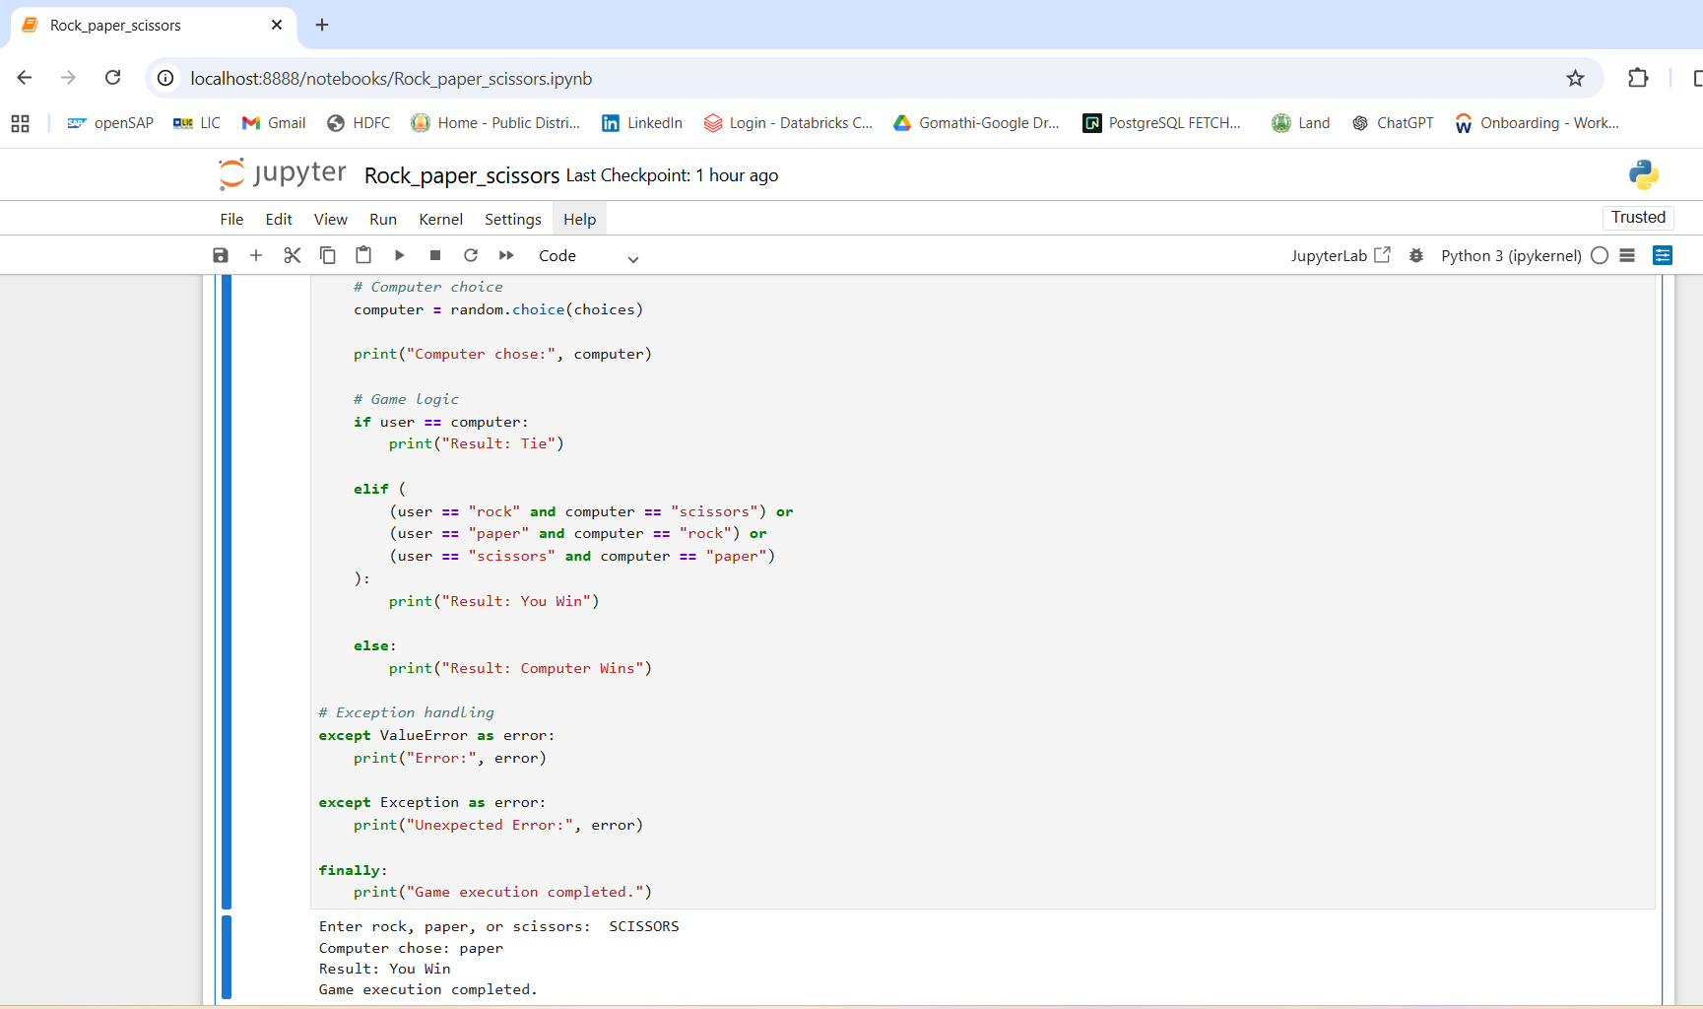

#Computer Wins
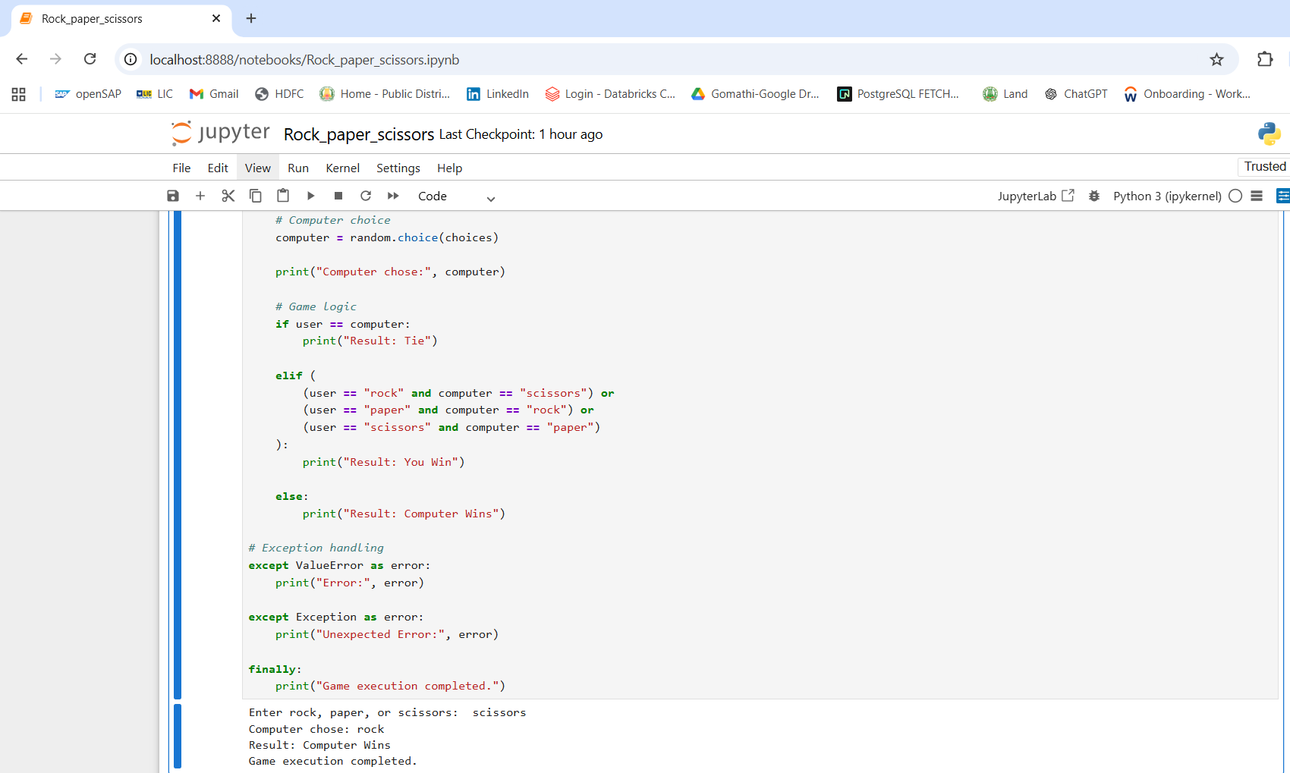

#Tie
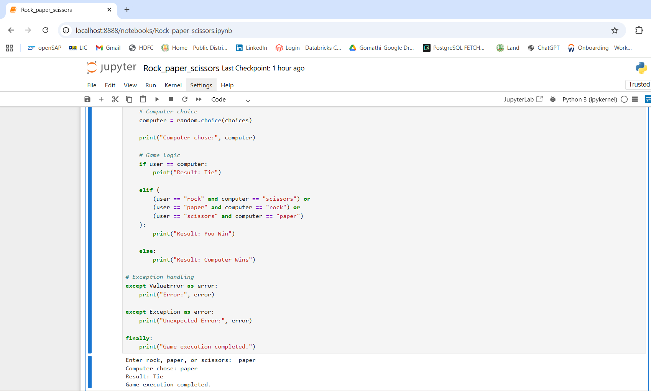

#INVALID INPUT(Instead of “ROCK”, User entered “ROCKS”)
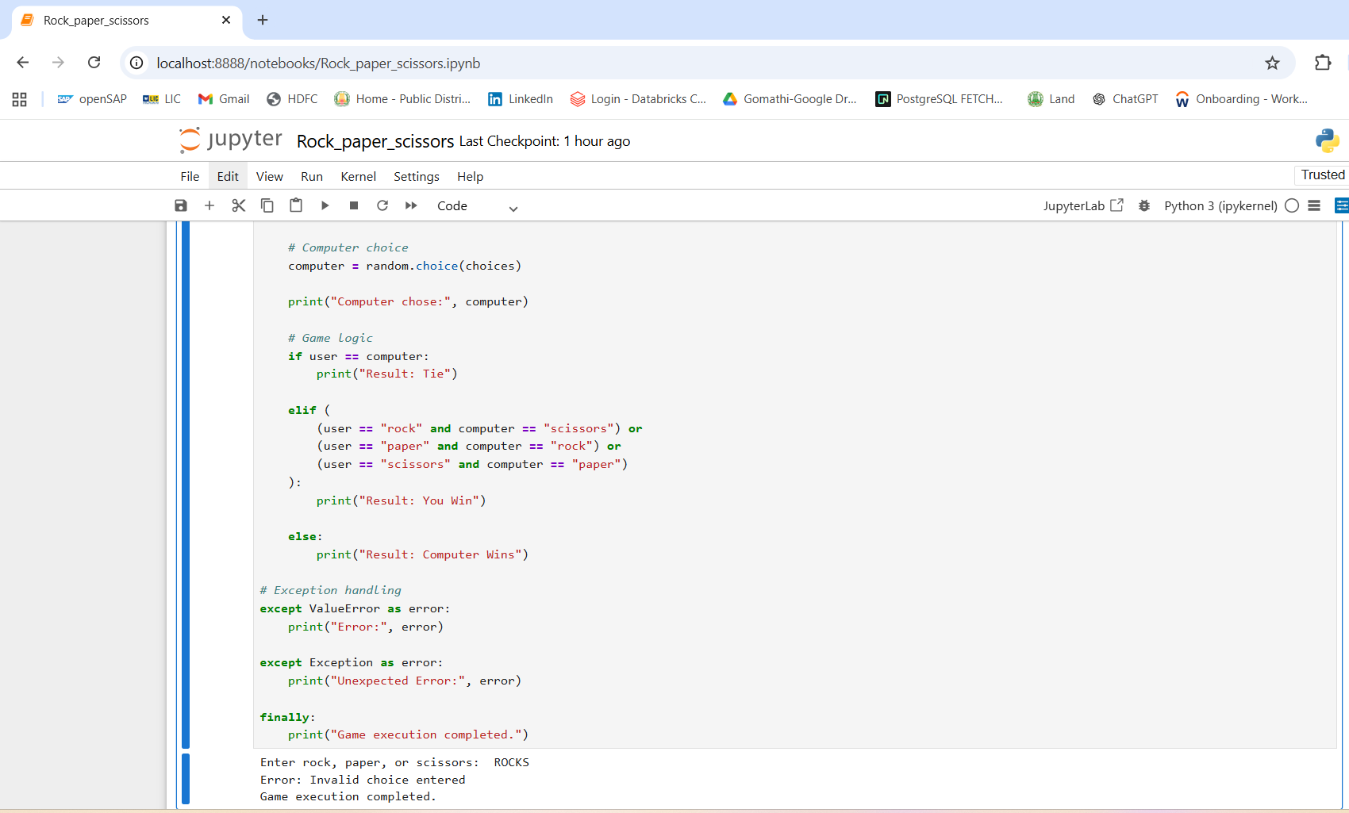

Conclusion
This source code demonstrates several important Python programming and software engineering concepts including:
- User interaction
- Randomization
- Decision making
- Input validation
- Exception handling
- Clean coding practices
The program is designed to be reliable, user-friendly, and easy to understand for beginners learning Python application development.
Limitations
- Text-based interface only
- No persistent score storage
- Single-round execution
- No multiplayer networking support
Future Enhancements
Proposed Improvements
- Graphical User Interface (GUI)
- Scoreboard system
- Multiplayer mode
- AI-powered prediction engine
- Database connectivity
- Web deployment

References
- Python Official Documentation
Used for understanding Python syntax, modules, exception handling, and programming concepts.
- Python Random Module Documentation
Referred for implementing random computer choices in the game.
- W3Schools Python Tutorial
Used for learning Python basics, operators, lists, and conditional statements.
- GeeksforGeeks Python Programming
Referred for programming concepts, exception handling, and coding examples.
- TutorialsPoint Python Tutorial
Used for understanding Python modules and software engineering concepts.
- Course materials and notes provided by Besant Technology.
- Personal coding practice and implementation using Python in Jupyter Notebook.

