KEM: Gestión de usuarios / KEM: User management
INDICE / INDEX
Pag 1: – Página Principal / Main Page
Pag 2: – Crear Departamentos / Create Departments
Pag 3: - Crear Usuarios / Delete Users
Pag 5: - Modificar Usuarios / Modify Users
Pag 6: - Modificar Departamentos / Modify Departments
Pag 7: - Eliminar Usuarios /Delete Users

Página principal / Main Page
Pare crear nuevos usuarios, primero necesitamos crear departamentos. Después podremos relacionar el nuevo usuario con un departamento.
To create new users, first we need to create departments. After that we will relate a new user with one department.

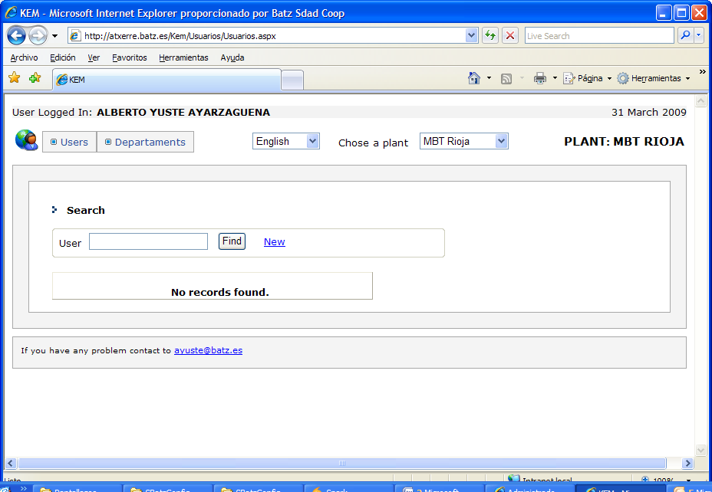
Creación de departamentos / Create new departments
1 – Click on “Departments”
2 – Click on ”Create Department”
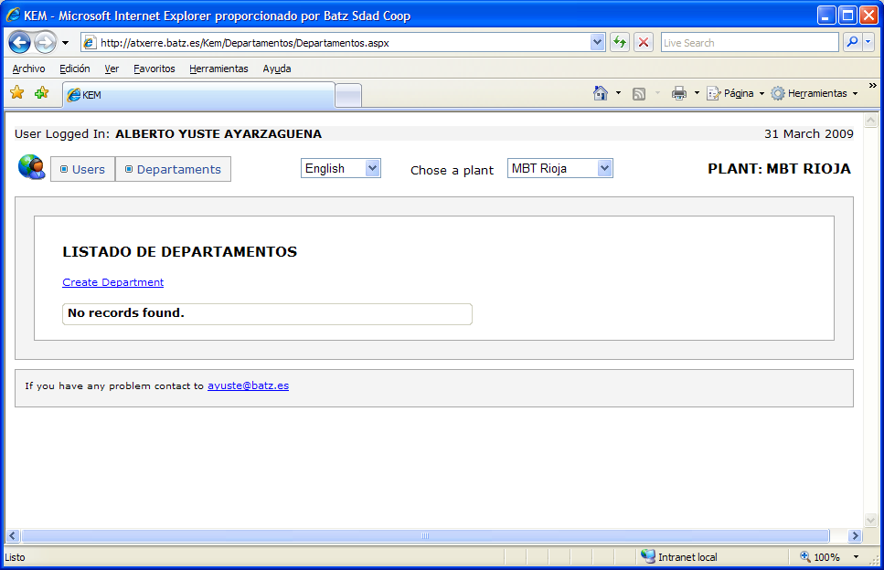
3 – Type the name of the new department
4 – Click “Save”
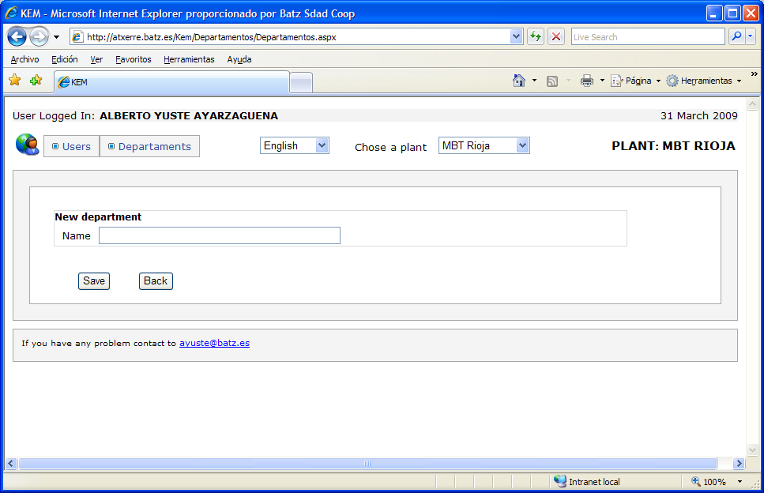
Creación de usuarios / Create new Users
1 – Click on ”users”
2 – Click on “New”
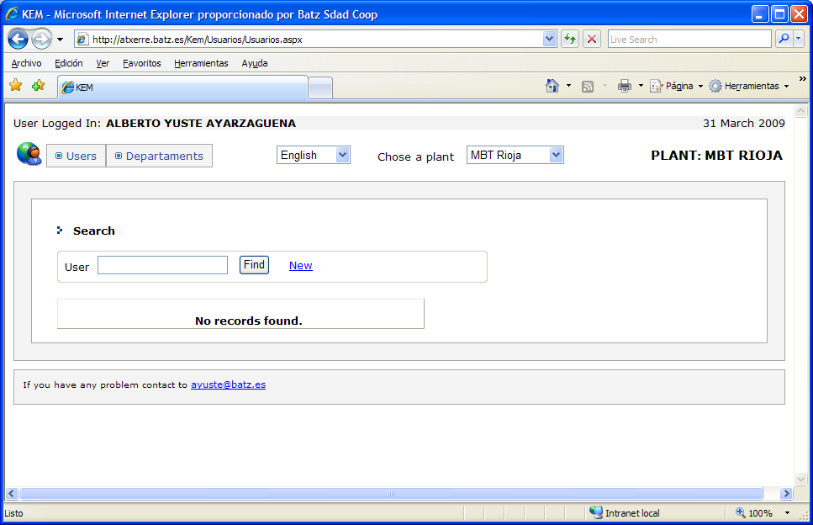
3 – type the windows user name. Example: vyustes
4 – click on “Find”. The application will try to find the user in the windows active directory
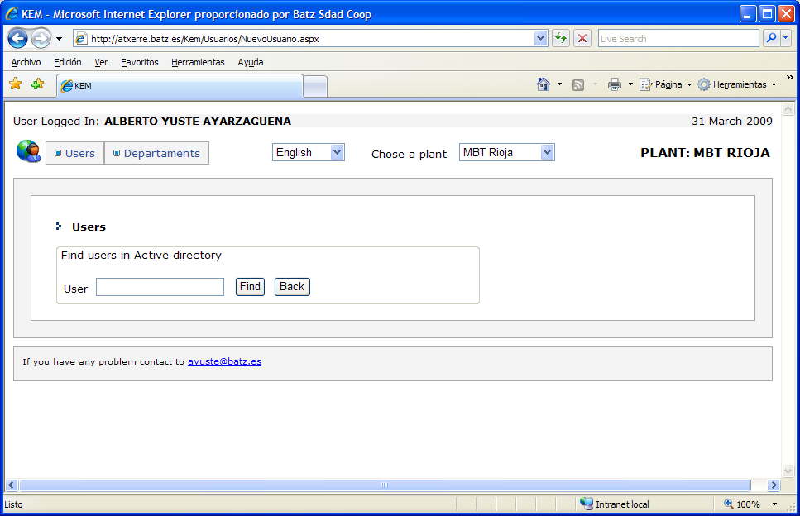
5 – If the user exists, the application will resolve the name and the email of the user. If you want to modify the name, surname,… you can do it.
6 – Then you have to select the department of the user.
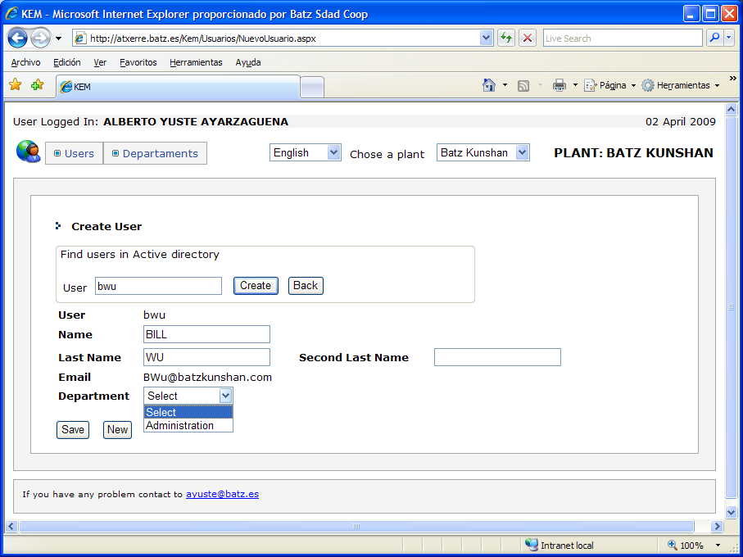
7 – Click on “Save”.

Modificación de usuarios / Modify Users
1 – Click on “users”
2 – Select the user you want to change
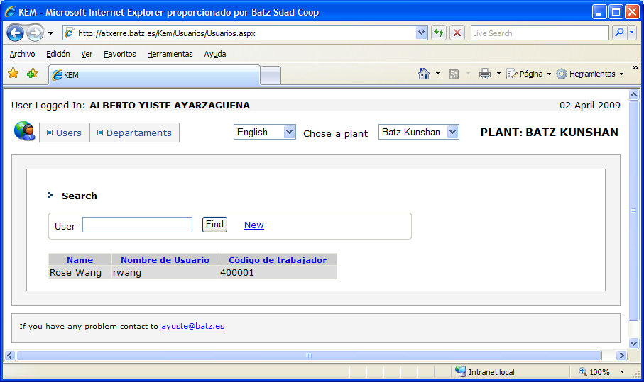
2 – Edit user Data
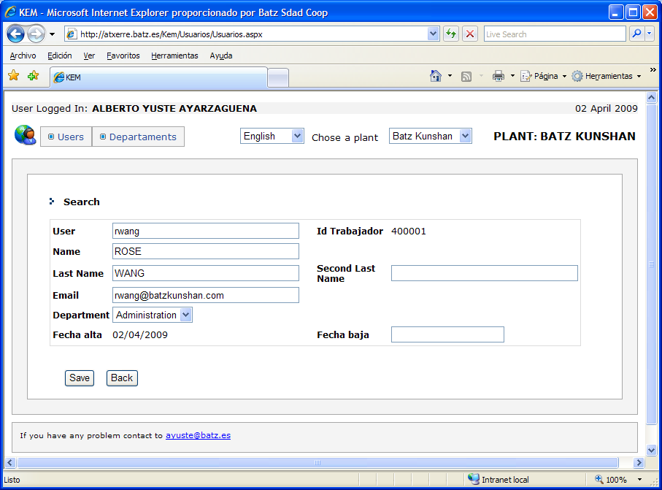
3 – Save your changes.
Modificar Departamentos / Modify departments
1 – Click on “Departments”
2 – Select de department you want to change
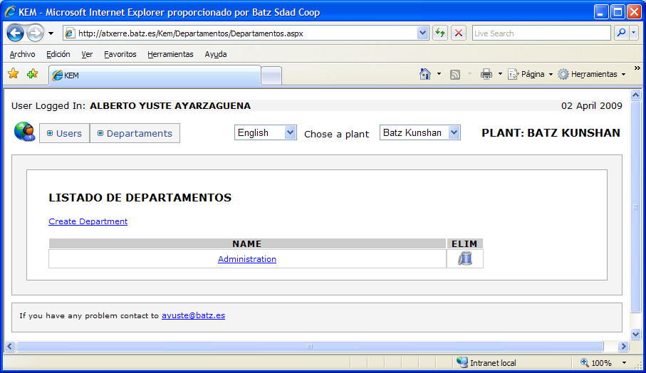
3 – You can edit the name of the department.
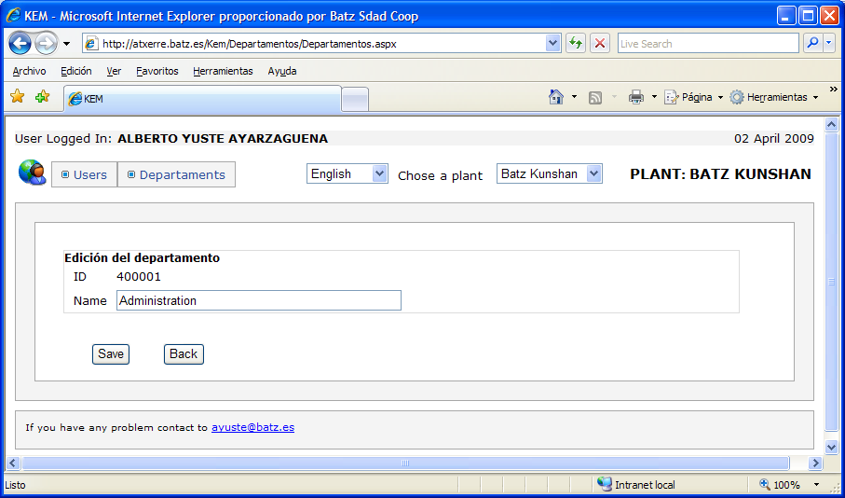
4 –Save changes

Eliminar Usuarios / Delete users
You can’t delete users, but you can modify the “end of contract“ date.
1 – Click on “users”
2 – Select the user you want to change

2 – Edit user Data
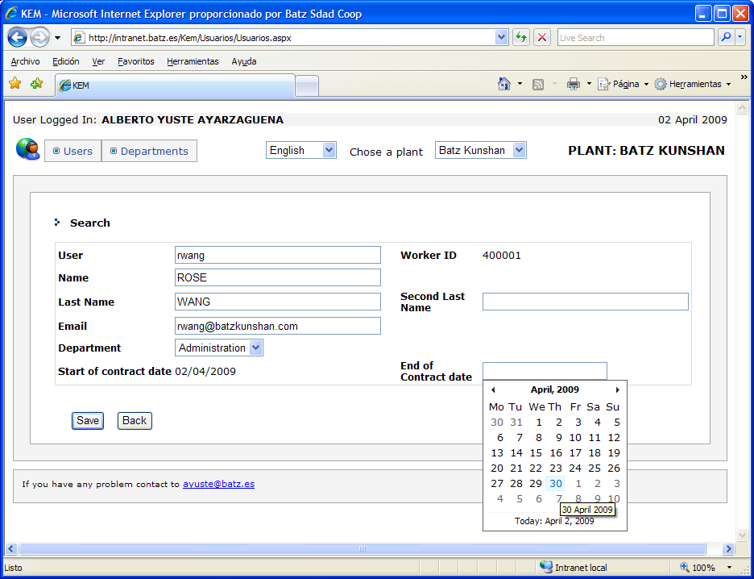
3 – Save Changes

