KARPAGAM COLLEGE OF ENGINEERING
(Autonomous)
School of Computer Applications
MINI PROJECT REPORT
Academic Year 2025-2026
AIR QUALITY ANALYSIS USING R
Predicting ground-level ozone from weather conditions with regression models
Name & Register No of the Candidate | GOWTHAMRAJ P / Register No: ____________________
Course Code & Title | 23CAP317 – R PROGRAMMING
Date of Issue | 16/09/2026
Date of Submission | 13/10/2026
Year/Dept./Sem/Section | II / MCA / III / A
Mini Project Title | Air Quality Analysis using R
Reference(s) | GitHub: https://github.com/<your-username>/air-quality-analysis-r

Course In-charge Course Coordinator HoD

Contents
Abstract
1. Data Structures, Dataset and Objectives (Question 1)
2. Control Structures, Functions, Lists and Data Frames (Question 2)
3. Statistical Problems in the Project (Question 3)
4. Data Preparation and Exploratory Visualisation
5. Regression Models in R (Question 4)
6. Applying the Models and Predicting the Output (Question 5)
7. Results and Discussion
8. Conclusion and Future Scope
9. References
Appendix A. Complete R Script
Project Repository (GitHub)

Abstract
Ground-level ozone is a harmful air pollutant that forms when sunlight and heat act on pollutants in the atmosphere. Knowing in advance which days are likely to have high ozone helps health authorities issue timely warnings. This mini project uses R to analyse the classic New York air quality data set, which records daily ozone, solar radiation, wind speed and temperature for 153 days from May to September 1973, and to build models that predict ozone from weather conditions.
The work covers the full workflow: loading and inspecting the data, using R data structures, control structures and user-defined functions, identifying statistical problems (24% missing ozone values, a right-skewed target, outliers and the need to check collinearity), cleaning and visualising the data, and splitting it 80/20 into training and test sets. Four regression models were fitted (multiple linear, log-linear, polynomial with interaction, and random forest) together with a logistic regression that classifies days with ozone above 50 ppb.
On repeated 10-fold cross-validation the random forest was the best regressor (RMSE 16.6 ppb, R² 0.77), ahead of the polynomial model (18.6 ppb, 0.74) and the plain linear model (20.6 ppb, 0.64). Wind speed and temperature were the dominant predictors. The logistic model classified 90.5% of the test days correctly with an area under the ROC curve of 0.978. The scores are realistic rather than perfect, and the report explains the limits of a data set with only 116 usable days. The complete code is available in the GitHub repository given on the last page.
Keywords: R programming, air quality, ozone, linear regression, random forest, logistic regression, cross-validation.

1. Data Structures, Dataset and Objectives
Question 1 asks to recall the basic concepts of data structures used in the project, to give the details of the data set and to list the objectives.

1.1 Problem statement
Ozone concentration at ground level depends on several interacting weather factors. It is difficult to judge by inspection how strongly sunshine, wind and heat combine to push ozone to unhealthy levels. The problem addressed here is to build predictive models that estimate the ozone concentration (in parts per billion, ppb) of a day from its solar radiation, wind speed, temperature and month, and to flag days with high ozone. Such predictions support early warnings and health advisories for sensitive groups such as children, the elderly and people with asthma.

1.2 Data structures used in the project
R offers a small set of core data structures. All of them are used in this project, as summarised in Table 1.
Table 1: R data structures used in the project
Structure | Objects in the project | Purpose
Vector | temp_vec; every column of the data frame | Ordered values of one type, for example daily temperatures
Factor | month_fct, OzoneLevel, HighOzone | Categorical variables with fixed levels (months, ozone bands, high/low class)
Matrix | sample_mat; the correlation matrix cor_mat | Two-dimensional block of numbers of one type
List | sample_lst, stats_list, model objects | Collection of items of different types and sizes
Data frame | air, model_df, train, test, new_days | The main table: one row per day, one column per variable

The following code creates one example of each structure and prints it. This is the first part of the project script (Appendix A).
temp_vec <- c(67, 72, 74, 62, 56) # vector
month_fct <- factor(c("May","Jun","Jul","Aug","Sep"),
levels = c("May","Jun","Jul","Aug","Sep")) # factor
sample_mat <- matrix(c(41,190,7.4, 36,118,8.0), nrow = 2, byrow = TRUE,
dimnames = list(c("Day1","Day2"),
c("Ozone","Solar","Wind"))) # matrix
sample_lst <- list(station = "New York", year = 1973,
pollutant = "Ozone", units = "ppb") # list

Output:
[1] 67 72 74 62 56
[1] May Jun Jul Aug Sep
Levels: May Jun Jul Aug Sep
Ozone Solar Wind
Day1 41 190 7.4
Day2 36 118 8.0
List of 4
$ station : chr "New York"
$ year : num 1973
$ pollutant: chr "Ozone"
$ units : chr "ppb"

1.3 Details of the data set
The data set is the New York air quality record that ships with R as airquality. It contains 153 daily observations from 1 May to 30 September 1973. Ozone readings come from the New York State Department of Conservation and the weather readings from the National Weather Service. The data was loaded from the public Rdatasets CSV copy of this table (aq.csv) using read.csv(). The data set has 153 rows and 6 columns.
Table 2: Variables of the data set
Variable | Meaning | Unit | Role
Ozone | Mean ozone concentration between 1 pm and 3 pm at Roosevelt Island | ppb | Target
Solar.R | Solar radiation between 8 am and 12 noon in Central Park | Langley | Predictor
Wind | Average wind speed between 7 am and 10 am at LaGuardia Airport | mph | Predictor
Temp | Maximum daily temperature at LaGuardia Airport | °F | Predictor
Month | Month of the year (5 = May … 9 = September) | – | Predictor
Day | Day of the month (1–31) | – | Identifier

Loading the data and viewing the first rows:
air <- read.csv("aq.csv")
air$rownames <- NULL
dim(air)
head(air)

Dimensions:
[1] 153 6
Head:
Ozone Solar.R Wind Temp Month Day
1 41 190 7.4 67 5 1
2 36 118 8.0 72 5 2
3 12 149 12.6 74 5 3
4 18 313 11.5 62 5 4
5 NA NA 14.3 56 5 5
6 28 NA 14.9 66 5 6

The first rows already contain NA (missing) values for Ozone and Solar.R. The structure and summary statistics are shown below.
str(air)
'data.frame': 153 obs. of 6 variables:
$ Ozone : int 41 36 12 18 NA 28 23 19 8 NA ...
$ Solar.R: int 190 118 149 313 NA NA 299 99 19 194 ...
$ Wind : num 7.4 8 12.6 11.5 14.3 14.9 8.6 13.8 20.1 8.6 ...
$ Temp : int 67 72 74 62 56 66 65 59 61 69 ...
$ Month : int 5 5 5 5 5 5 5 5 5 5 ...
$ Day : int 1 2 3 4 5 6 7 8 9 10 ...

summary(air)
Ozone Solar.R Wind Temp
Min. : 1.00 Min. : 7.0 Min. : 1.700 Min. :56.00
1st Qu.: 18.00 1st Qu.:115.8 1st Qu.: 7.400 1st Qu.:72.00
Median : 31.50 Median :205.0 Median : 9.700 Median :79.00
Mean : 42.13 Mean :185.9 Mean : 9.958 Mean :77.88
3rd Qu.: 63.25 3rd Qu.:258.8 3rd Qu.:11.500 3rd Qu.:85.00
Max. :168.00 Max. :334.0 Max. :20.700 Max. :97.00
NA's :37 NA's :7
Month Day
Min. :5.000 Min. : 1.0
1st Qu.:6.000 1st Qu.: 8.0
Median :7.000 Median :16.0
Mean :6.993 Mean :15.8
3rd Qu.:8.000 3rd Qu.:23.0
Max. :9.000 Max. :31.0

Ozone has a mean of 42.1 ppb but a median of only 31.5 ppb and a maximum of 168 ppb, so its distribution is skewed to the right. Temperature ranges from 56 to 97 °F and wind speed from 1.7 to 20.7 mph. Ozone has 37 missing values and Solar.R has 7.

1.4 Objectives of the project
- To load, inspect and clean the New York air quality data set in R.
- To explore patterns and relationships between ozone and the weather variables with statistics and plots.
- To identify the statistical problems in the data: missing values, skewness, outliers and collinearity.
- To build and compare regression models for ozone: multiple linear, log-linear, polynomial with interaction and random forest.
- To classify high-ozone days with logistic regression and to predict ozone for new weather conditions.
- To publish the complete project in a GitHub repository.

2. Control Structures, Functions, Lists and Data Frames
Question 2 asks to interpret the control structures, functions, lists and data frames of the model.

2.1 Functions
A function packages a piece of logic so that it can be reused. The project defines six user-defined functions (Table 3). Each is small and does one job.
Table 3: User-defined functions
Function | What it does
ozone_category(x) | Maps an ozone value to a band: Good, Moderate, Unhealthy, Very Unhealthy or Unknown
describe_var(v) | Returns a list with n, mean, sd, min and max after removing NA values
iqr_outliers(v) | Counts values outside 1.5 × IQR of the quartiles
sk(v) | Computes the skewness of a variable
vif_manual(df, preds) | Computes the variance inflation factor of each predictor
metrics(actual, pred) | Returns RMSE, MAE and R² for a model's predictions

2.2 Control structures
Control structures decide which statements run and how often. The script uses the following.
- if / else if / else: inside ozone_category() to choose the band of each ozone value.
- for loop: visits each of the four numeric columns and stores its mean.
- while loop: walks down the rows until it finds the first day with ozone above 100 ppb.
- Vectorised alternatives: ifelse() creates the high-ozone class, and sapply(), lapply() and tapply() apply functions across columns or groups without writing explicit loops.
ozone_category <- function(x) {
if (is.na(x)) "Unknown"
else if (x <= 30) "Good"
else if (x <= 60) "Moderate"
else if (x <= 90) "Unhealthy"
else "Very Unhealthy"
}
air$OzoneLevel <- factor(sapply(air$Ozone, ozone_category),
levels = c("Good","Moderate","Unhealthy",
"Very Unhealthy","Unknown"))

col_means <- numeric(0)
for (nm in c("Ozone","Solar.R","Wind","Temp")) {
col_means[nm] <- mean(air[[nm]], na.rm = TRUE)
}

i <- 1
while (i <= nrow(air) && (is.na(air$Ozone[i]) || air$Ozone[i] <= 100)) i <- i + 1

Output:
Good Moderate Unhealthy Very Unhealthy Unknown
57 28 20 11 37

Column means (for loop):
Ozone Solar.R Wind Temp
42.13 185.93 9.96 77.88

First row with Ozone > 100 ppb (while loop): row 30 | Month 5 Day 30 Ozone 115

Of the 153 days, 57 are in the Good band, 28 Moderate, 20 Unhealthy and 11 Very Unhealthy, while 37 are Unknown because ozone was not recorded. The while loop finds that the first day above 100 ppb is 30 May (115 ppb), early in the season.

2.3 Lists
A list can hold items of different types. describe_var() returns a list for each variable, and lapply() applies it to all four numeric columns, producing a list of lists called stats_list. Model objects such as the linear model and the random forest are also list-like objects, from which components such as coefficients and variable importance are extracted.
describe_var <- function(v) {
v <- v[!is.na(v)]
list(n = length(v), mean = mean(v), sd = sd(v),
min = min(v), max = max(v))
}
stats_list <- lapply(air[, c("Ozone","Solar.R","Wind","Temp")], describe_var)
str(stats_list)

List of 4
$ Ozone :List of 5
..$ n : int 116
..$ mean: num 42.1
..$ sd : num 33
..$ min : int 1
..$ max : int 168
$ Solar.R:List of 5
..$ n : int 146
..$ mean: num 186
..$ sd : num 90.1
..$ min : int 7
..$ max : int 334
$ Wind :List of 5
..$ n : int 153
..$ mean: num 9.96
..$ sd : num 3.52
..$ min : num 1.7
..$ max : num 20.7
$ Temp :List of 5
..$ n : int 153
..$ mean: num 77.9
..$ sd : num 9.47
..$ min : int 56
..$ max : int 97

Only 116 of the 153 ozone values and 146 of the Solar.R values are present, which is already visible in the n element of the list.

2.4 Data frames
The data frame is the central structure of the project. The raw data is read into the data frame air. New columns are added (OzoneLevel), rows are filtered (rows with missing Ozone are removed to give model_df), the data is grouped and summarised with dplyr, and finally it is split into the data frames train and test using row indices. Monthly summaries are produced with tapply() and with group_by() and summarise():
tapply(air$Ozone, air$Month, mean, na.rm = TRUE)

monthly <- air %>% group_by(Month) %>%
summarise(days = n(), mean_ozone = mean(Ozone, na.rm = TRUE),
mean_temp = mean(Temp), mean_wind = mean(Wind), .groups = "drop")

Monthly average Ozone (tapply):
5 6 7 8 9
23.62 29.44 59.12 59.96 31.45

Monthly summary (data frame):
Month days mean_ozone mean_temp mean_wind
1 5 31 23.61538 65.54839 11.622581
2 6 30 29.44444 79.10000 10.266667
3 7 31 59.11538 83.90323 8.941935
4 8 31 59.96154 83.96774 8.793548
5 9 30 31.44828 76.90000 10.180000

The monthly summary shows the seasonal pattern clearly. July and August have mean ozone of about 59 ppb, which is more than twice the May average of 24 ppb. They are also the hottest months (about 84 °F) with the lowest average wind speed (about 8.9 mph). This early finding anticipates the regression results in Section 5.

3. Statistical Problems in the Project
Question 3 asks to illustrate the statistical problems involved in the project.
Before fitting models, the data was examined for problems that could mislead them. Problems such as missing values, duplicates, outliers, skewness, collinearity and small sample size were checked, and the relationships the models must capture were measured; each is described below with the evidence from R and the way it was handled.

3.1 Missing values
Ozone Solar.R Wind Temp Month Day
37 7 0 0 0 0
Duplicate rows: 0
Complete rows: 111 of 153

Ozone, the variable to be predicted, is missing on 37 of the 153 days (24.2%), and Solar.R on 7 days (4.6%). Only 111 rows are complete. Dropping every incomplete row would waste information in the 5 rows that lack only Solar.R, while inventing values for the target would mean predicting numbers that were never measured. The decision was therefore: replace the 7 missing Solar.R values by the median (205 Langley), and drop the 37 rows with missing Ozone from modelling. This leaves 116 rows with no missing values.

3.2 Duplicate records
The check sum(duplicated(...)) returned 0, so there are no duplicate days and no action was needed.

3.3 Outliers
Ozone Solar.R Wind Temp
2 0 3 0

The IQR rule (values beyond 1.5 × IQR from the quartiles) flags 2 outliers in Ozone and 3 in Wind, and none in Solar.R or Temp. The flagged ozone values are the two highest days (above 130 ppb), and the wind outliers are unusually windy days of about 18 to 21 mph. They are plausible measurements and exactly the kind of extreme day that a warning system should handle, so they were kept.

3.4 Non-normal, skewed target
Skewness of Ozone: 1.21 | log(Ozone): -0.548

Shapiro-Wilk normality test

data: air$Ozone
W = 0.87867, p-value = 2.79e-08

Shapiro-Wilk normality test

data: log(air$Ozone[!is.na(air$Ozone)])
W = 0.97168, p-value = 0.01471

Ozone has a skewness of 1.21, which is strongly right-skewed. The Shapiro-Wilk test rejects normality (W = 0.879, p = 2.8e-08). Taking the logarithm reduces the skewness to −0.55 and raises W to 0.972, although normality is still rejected formally (p = 0.015) because the sample is large enough to detect small departures. The consequence is that ordinary linear regression on raw ozone can have non-normal, unequal-variance residuals. A log-linear model and a tree-based model were therefore added to the comparison.

3.5 Relationships between variables
Correlation with Ozone (complete cases):
Ozone Solar.R Wind Temp
Ozone 1.000 0.348 -0.612 0.699
Solar.R 0.348 1.000 -0.127 0.294
Wind -0.612 -0.127 1.000 -0.497
Temp 0.699 0.294 -0.497 1.000

On the complete cases, ozone is strongly and positively correlated with temperature (r = 0.70), moderately and positively with solar radiation (r = 0.35), and strongly negatively with wind speed (r = −0.61). The Pearson tests confirm that the Temp and Wind correlations are highly significant (p < 2.2e-16 and p = 9.1e-13), with 95% confidence intervals of 0.59–0.78 and −0.72 to −0.48 respectively.

3.6 Hypothesis tests: does ozone differ by season?
ANOVA: Ozone by Month
Df Sum Sq Mean Sq F value Pr(>F)
factor(Month) 4 27383 6846 7.686 1.78e-05 ***
Residuals 106 94419 891
---
Signif. codes: 0 '***' 0.001 '**' 0.01 '*' 0.05 '.' 0.1 ' ' 1

Welch t-test: Ozone in Jul-Aug vs May-Jun-Sep

Welch Two Sample t-test

data: cc$Ozone[cc$Month %in% 7:8] and cc$Ozone[!cc$Month %in% 7:8]
t = 5.2488, df = 76.684, p-value = 1.323e-06
alternative hypothesis: true difference in means is not equal to 0
95 percent confidence interval:
19.36785 43.04821
sample estimates:
mean of x mean of y
59.53061 28.32258

A one-way ANOVA shows that mean ozone differs significantly between months (F = 7.69, p = 1.8e-05). A Welch t-test comparing July–August with the other months finds mean ozone of 59.5 ppb against 28.3 ppb, a difference of roughly 19 to 43 ppb (95% confidence interval, p = 1.3e-06). Season matters for ozone, but Section 5 shows that most of this seasonal effect is explained by temperature and wind rather than by the calendar month itself.

3.7 Multicollinearity
VIF:
Solar.R Wind Temp
1.095 1.329 1.431

Temperature and wind are correlated with each other (r = −0.50), so the variance inflation factor (VIF) of each predictor was computed by regressing it on the other predictors. All values (1.10, 1.33 and 1.43) are far below the usual warning level of 5, so the predictors are not redundant and can safely appear in the same regression.

3.8 Small sample size
After cleaning only 116 days remain, and an 80/20 split leaves just 21 test days. Accuracy figures computed on 21 observations are noisy. For this reason repeated 10-fold cross-validation on all 116 rows is reported alongside the hold-out test results, and the conclusions in Section 7 rely mainly on the cross-validated figures.

4. Data Preparation and Exploratory Visualisation
After the cleaning decisions in Section 3, the modelling data frame model_df contains 116 rows and the columns Ozone, Solar.R, Wind, Temp and Month with no missing values.
air$Solar.R[is.na(air$Solar.R)] <- median(air$Solar.R, na.rm = TRUE)
model_df <- air %>% filter(!is.na(Ozone)) %>%
select(Ozone, Solar.R, Wind, Temp, Month)

Rows used for modelling: 116
NA left: 0

4.1 Distribution of the target
Figure 1 shows the histogram of ozone. Most days lie below 50 ppb, with a long tail of high-ozone days up to 168 ppb. Figure 2 shows ozone by month: the median and spread are clearly highest in July and August.
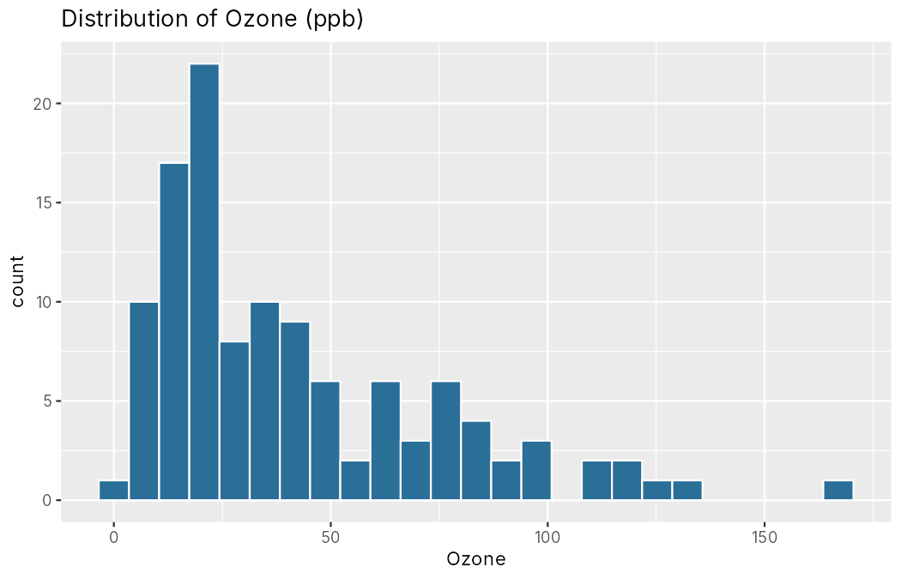
Figure 1: Distribution of Ozone (ppb)
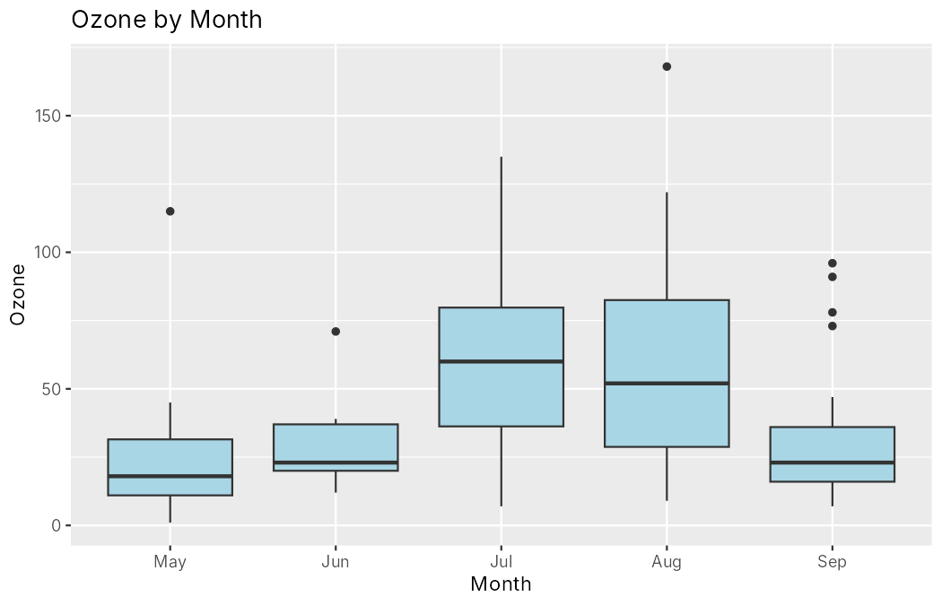
Figure 2: Ozone by month (5 = May … 9 = September)

4.2 Correlation matrix
corrplot(cor(model_df), method = "color", addCoef.col = "black")

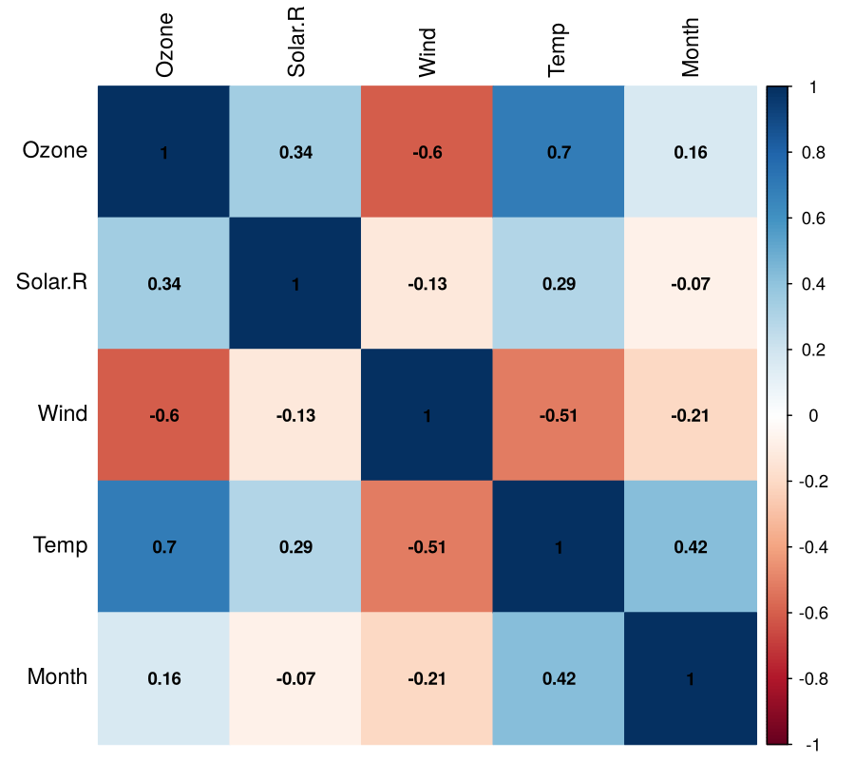
Figure 3: Correlation matrix of the modelling variables
The matrix confirms the earlier tests: ozone rises with temperature (0.70) and solar radiation (0.34) and falls as wind increases (−0.60). Temperature is also correlated with month (0.42), because summer months are hotter, which explains why Month adds little once Temp is in the model.

4.3 Boxplots for outliers
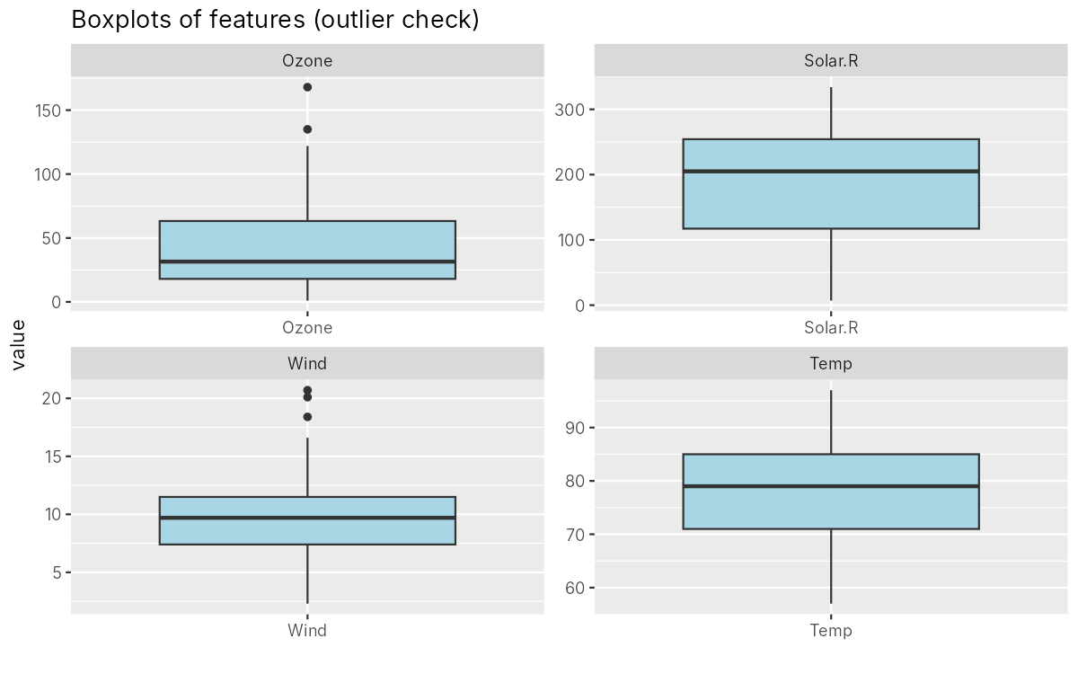
Figure 4: Boxplots of the four numeric variables
The boxplots show two high ozone outliers and three high wind outliers, as counted in Section 3.3. Solar radiation and temperature have no outliers.

4.4 Ozone against temperature and wind
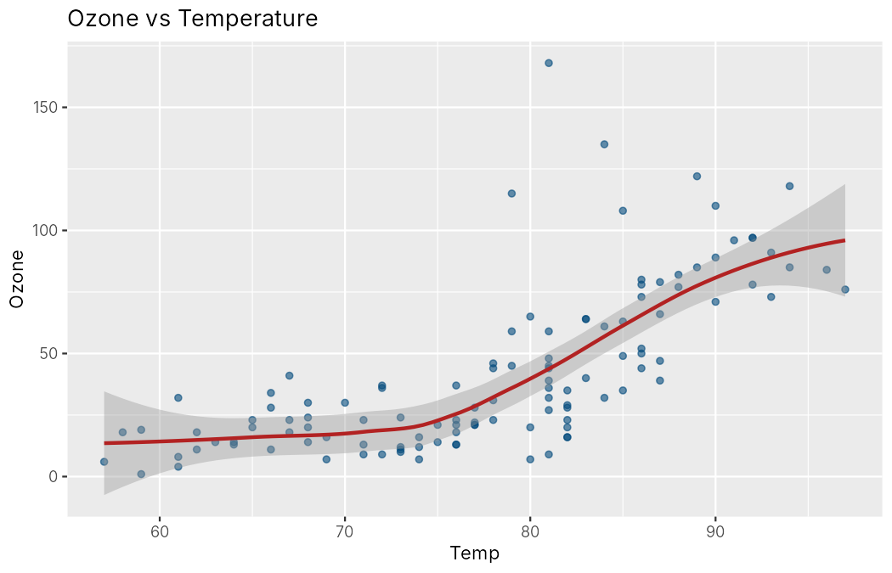
Figure 5: Ozone against temperature with a loess curve
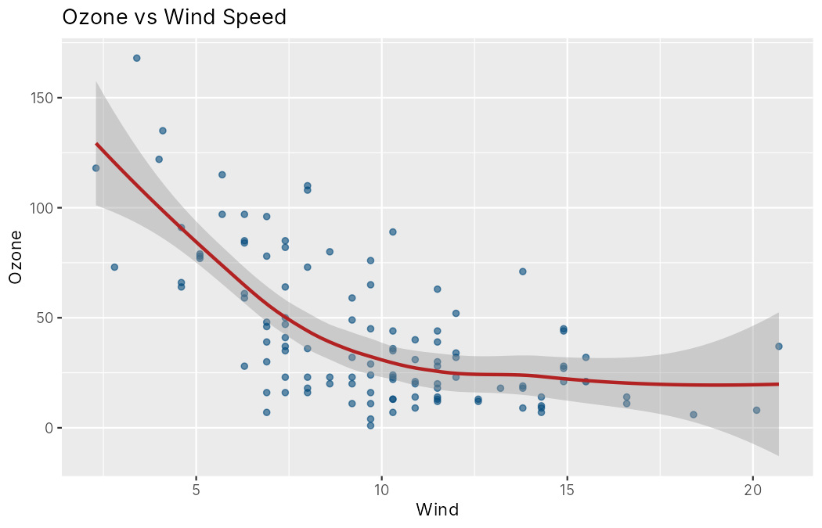
Figure 6: Ozone against wind speed with a loess curve
Ozone stays low until the temperature passes roughly 75–80 °F and then rises steeply, while it falls quickly as wind speed increases from calm to moderate and flattens afterwards. Both relationships are curved rather than straight, which motivates the polynomial and random forest models in Section 5.

5. Regression Models in R
Question 4 asks to develop an R script that analyses the data using different regression models.

5.1 Splitting the data
The 116 modelling rows were split 80% for training and 20% for testing using caret::createDataPartition(), with the seed fixed at 2026 so that the result can be reproduced. The models are fitted on the training rows only and judged on the unseen test rows.
idx <- createDataPartition(model_df$Ozone, p = 0.8, list = FALSE)
train <- model_df[idx, ]
test <- model_df[-idx, ]

Train rows: 95 | Test rows: 21

Three evaluation measures are used: RMSE (root mean squared error, in ppb, lower is better), MAE (mean absolute error) and R² (the squared correlation between actual and predicted values).

5.2 Model A: multiple linear regression
lm_a <- lm(Ozone ~ Solar.R + Wind + Temp + factor(Month), data = train)
summary(lm_a)

Coefficients:
Estimate Std. Error t value Pr(>|t|)
(Intercept) -67.91402 31.00965 -2.190 0.0312 *
Solar.R 0.05426 0.02792 1.943 0.0552 .
Wind -3.11438 0.76184 -4.088 9.67e-05 ***
Temp 1.76904 0.40505 4.367 3.46e-05 ***
factor(Month)6 -13.71358 10.49560 -1.307 0.1948
factor(Month)7 -5.22338 9.21714 -0.567 0.5724
factor(Month)8 -5.27234 9.35060 -0.564 0.5743
factor(Month)9 -15.65063 7.94271 -1.970 0.0520 .
---
Signif. codes: 0 '***' 0.001 '**' 0.01 '*' 0.05 '.' 0.1 ' ' 1

Residual standard error: 21.96 on 87 degrees of freedom
Multiple R-squared: 0.6073, Adjusted R-squared: 0.5757
F-statistic: 19.22 on 7 and 87 DF, p-value: 2.709e-15

Wind and temperature are highly significant. Each extra mile per hour of wind lowers predicted ozone by about 3.1 ppb, and each extra degree Fahrenheit raises it by about 1.8 ppb, holding the other variables fixed. Solar radiation is borderline (p = 0.055). The month dummies are not significant once the weather is known. The model explains 60.7% of the variance in the training data (adjusted R² = 0.576), and the overall F-test is highly significant (p = 2.7e-15).
Diagnostics (Figure 7) reveal the weakness anticipated in Section 3.4: the residuals fan out as fitted values increase and the Q-Q plot curves upward, so the errors are right-skewed. The Shapiro-Wilk test on the residuals gives p = 3.9e-05.
Residual diagnostics (Model A) - Shapiro on residuals:

Shapiro-Wilk normality test

data: residuals(lm_a)
W = 0.92467, p-value = 3.932e-05

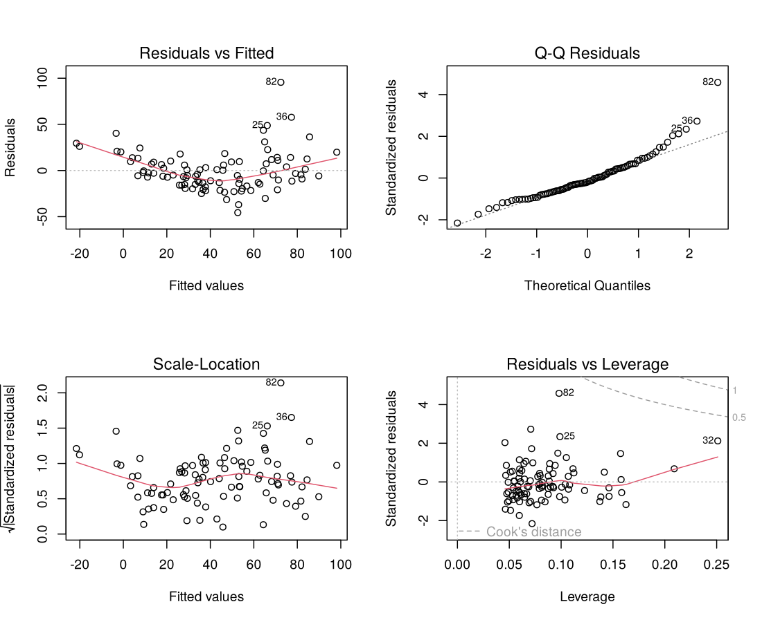
Figure 7: Diagnostic plots for the linear model

5.3 Model B: log-linear regression
lm_b <- lm(log(Ozone) ~ Solar.R + Wind + Temp, data = train)
lm_b_pred <- exp(predict(lm_b, newdata = test)) # back to ppb

Coefficients:
Estimate Std. Error t value Pr(>|t|)
(Intercept) -0.5312940 0.6408432 -0.829 0.40924
Solar.R 0.0026557 0.0006569 4.043 0.00011 ***
Wind -0.0530031 0.0182231 -2.909 0.00456 **
Temp 0.0510512 0.0070135 7.279 1.16e-10 ***
---
Signif. codes: 0 '***' 0.001 '**' 0.01 '*' 0.05 '.' 0.1 ' ' 1

Residual standard error: 0.5381 on 91 degrees of freedom
Multiple R-squared: 0.6445, Adjusted R-squared: 0.6327
F-statistic: 54.99 on 3 and 91 DF, p-value: < 2.2e-16

Modelling the logarithm of ozone makes the model multiplicative. Each extra °F multiplies ozone by about e^0.051 = 1.05 (5.2% higher), each extra mph of wind multiplies it by about 0.95 (5.2% lower), and each extra Langley of solar radiation by about 1.003. All three predictors are now significant (Solar.R p = 0.0001), and the training R² improves to 0.645 (adjusted 0.633). Because the model is fitted on the log scale, its predictions are converted back with exp() before computing errors in ppb.

5.4 Model C: polynomial and interaction regression
lm_c <- lm(Ozone ~ Solar.R + Wind + Temp + I(Temp^2) + I(Wind^2) + Temp:Wind,
data = train)

Coefficients:
Estimate Std. Error t value Pr(>|t|)
(Intercept) 476.09840 228.71815 2.082 0.040284 *
Solar.R 0.06920 0.02376 2.912 0.004550 **
Wind -23.51669 11.20089 -2.100 0.038633 *
Temp -9.81134 4.83846 -2.028 0.045607 *
I(Temp^2) 0.06669 0.02650 2.517 0.013660 *
I(Wind^2) 0.57725 0.16433 3.513 0.000703 ***
Wind:Temp 0.09979 0.10716 0.931 0.354292
---
Signif. codes: 0 '***' 0.001 '**' 0.01 '*' 0.05 '.' 0.1 ' ' 1

Residual standard error: 19.27 on 88 degrees of freedom
Multiple R-squared: 0.6941, Adjusted R-squared: 0.6733
F-statistic: 33.29 on 6 and 88 DF, p-value: < 2.2e-16

Adding squared terms lets the model bend. Both Temp² (p = 0.014) and Wind² (p = 0.0007) are significant, confirming the curvature seen in Figures 5 and 6. The interaction Temp × Wind is not significant (p = 0.35). The training R² rises to 0.694 (adjusted 0.673) and the residual standard error falls from 21.96 to 19.27 ppb.

5.5 Model D: random forest regression
A random forest averages many decision trees, each grown on a bootstrap sample of the data with a random subset of predictors at every split. It needs no assumption of linearity or normality, and it can capture curves and interactions automatically. The ranger package was used with 500 trees and permutation importance.
rf <- ranger(Ozone ~ ., data = train, num.trees = 500,
importance = "permutation", seed = 2026)

Ranger result

Call:
ranger(Ozone ~ ., data = train, num.trees = 500, importance = "permutation", seed = 2026)

Type: Regression
Number of trees: 500
Sample size: 95
Number of independent variables: 4
Mtry: 2
Target node size: 5
Variable importance mode: permutation
Splitrule: variance
OOB prediction error (MSE): 326.8074
R squared (OOB): 0.7123916

Variable importance (permutation):
Wind Temp Solar.R Month
652.78 651.21 81.59 32.30

The out-of-bag error, an internal estimate of generalisation error, is an MSE of 326.8 (RMSE about 18.1 ppb) with an out-of-bag R² of 0.712. The permutation importance ranks Wind (652.8) and Temp (651.2) far above Solar.R (81.6) and Month (32.3), in agreement with the correlation analysis and the linear models.
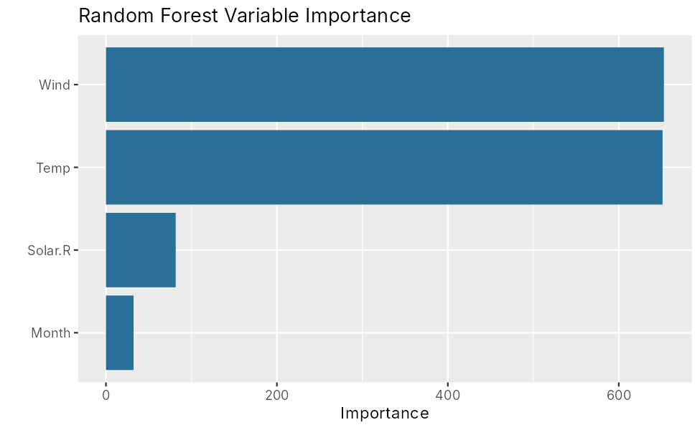
Figure 8: Random forest permutation variable importance

5.6 Logistic regression for high-ozone days
To answer the practical question “will tomorrow be a high-ozone day?”, ozone was converted into a binary class: HighOzone = 1 if ozone exceeds 50 ppb, otherwise 0. The threshold of 50 ppb is a choice made for this project; it gives 34 high days and 82 other days in the 116 rows (29%). Ozone itself is excluded from the predictors because it defines the class, which would otherwise leak the answer into the model.
model_df$HighOzone <- factor(ifelse(model_df$Ozone > 50, 1, 0), levels = c(0, 1))
glm_fit <- glm(HighOzone ~ Solar.R + Wind + Temp, data = train_c, family = binomial)

Class balance (HighOzone, threshold 50 ppb):

0 1
82 34

glm(formula = HighOzone ~ Solar.R + Wind + Temp, family = binomial,
data = train_c)

Coefficients:
Estimate Std. Error z value Pr(>|z|)
(Intercept) -2.980e+01 9.676e+00 -3.080 0.002072 **
Solar.R -1.824e-04 5.663e-03 -0.032 0.974309
Wind -5.087e-01 1.865e-01 -2.728 0.006373 **
Temp 4.059e-01 1.205e-01 3.369 0.000755 ***
---
Signif. codes: 0 '***' 0.001 '**' 0.01 '*' 0.05 '.' 0.1 ' ' 1

(Dispersion parameter for binomial family taken to be 1)

Null deviance: 115.204 on 94 degrees of freedom
Residual deviance: 41.074 on 91 degrees of freedom
AIC: 49.074

Number of Fisher Scoring iterations: 7

Odds ratios:
(Intercept) Solar.R Wind Temp
0.000 1.000 0.601 1.501

Wind (p = 0.006) and temperature (p = 0.0008) are significant, while solar radiation is not (p = 0.97) once those two are in the model. The odds ratios say that each extra °F multiplies the odds of a high-ozone day by about 1.50, and each extra mph of wind multiplies them by about 0.60. The residual deviance of 41.1 is far below the null deviance of 115.2, so the model fits much better than guessing the base rate.

6. Applying the Models and Predicting the Output
Question 5 asks to identify and apply the models, to predict the output from the data set and to upload the final project to GitHub.

6.1 Predictions on the unseen test data
Each fitted model was applied to the 21 test days and its predictions were compared with the observed ozone values.
lm_a_pred <- predict(lm_a, newdata = test)
lm_b_pred <- exp(predict(lm_b, newdata = test))
lm_c_pred <- predict(lm_c, newdata = test)
rf_pred <- predict(rf, data = test)$predictions

===== TEST-SET COMPARISON =====
RMSE MAE R2
Linear (A) 17.069 13.180 0.669
Log-Linear (B) 15.090 12.055 0.751
Poly+Interact (C) 15.547 12.778 0.728
Random Forest (D) 15.065 12.043 0.742

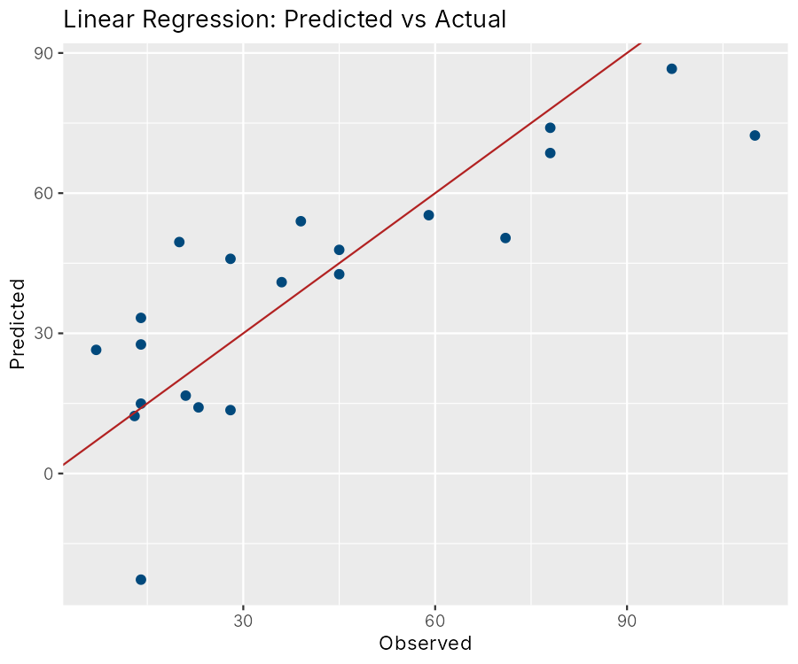
Figure 9: Linear regression: predicted against actual ozone (test set)
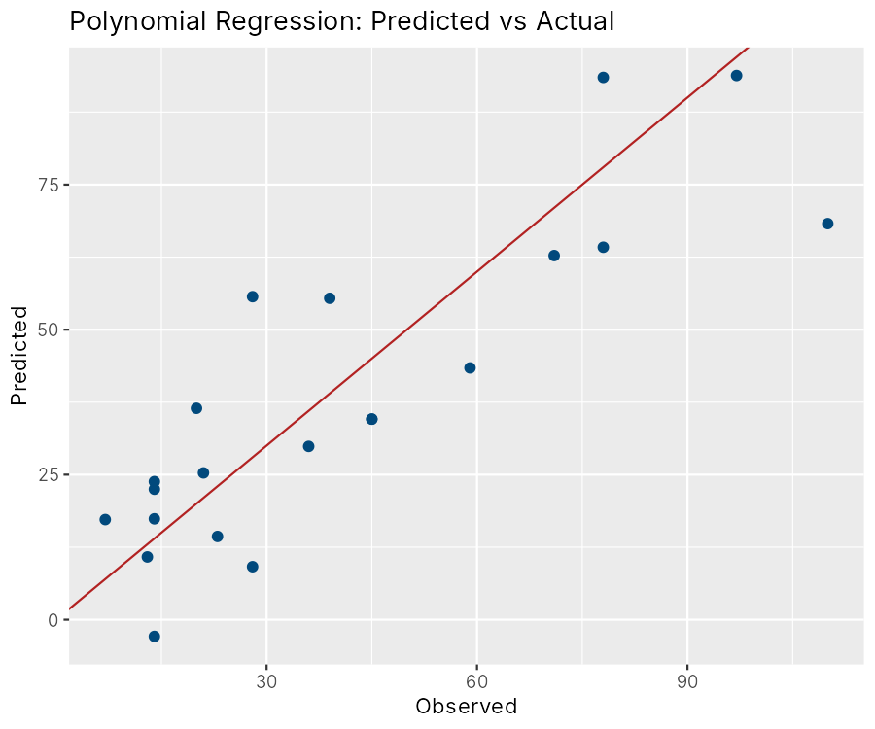
Figure 10: Polynomial regression: predicted against actual ozone (test set)
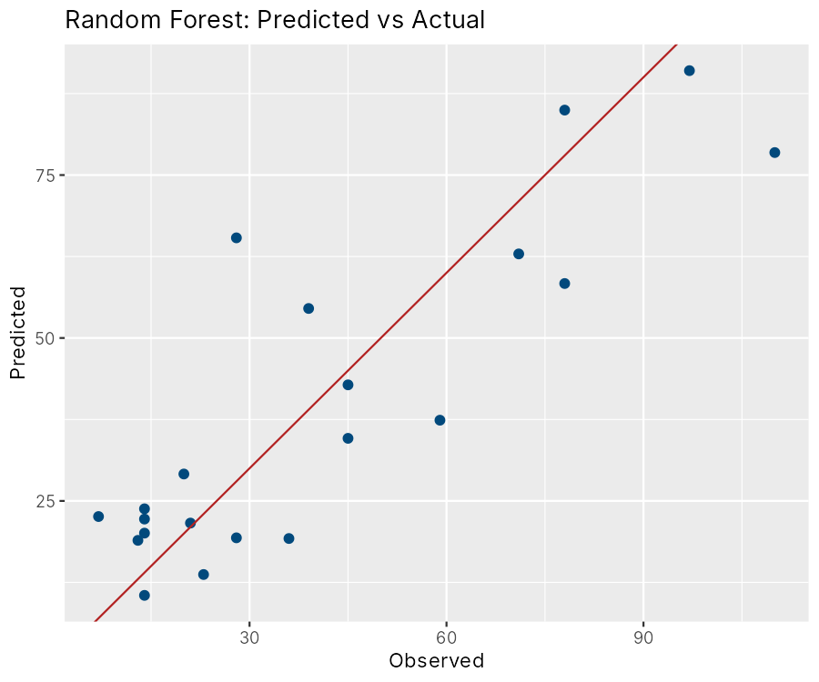
Figure 11: Random forest: predicted against actual ozone (test set)
On the test set the log-linear model and the random forest are almost tied (RMSE 15.09 and 15.07 ppb), followed by the polynomial model (15.55) and the plain linear model (17.07). Because the test set has only 21 days, differences of this size between the top three models are within the noise.

6.2 Cross-validated comparison
To obtain a more stable comparison, repeated 10-fold cross-validation (5 repeats, 50 fitted models per method) was run on all 116 rows. For the random forest, the number of variables tried at each split (mtry) was tuned over 2, 3 and 4.
===== 10-FOLD x5 CROSS-VALIDATION =====
RMSE Rsquared MAE
Linear (A) 20.576 0.636 16.048
Poly+Interact (C) 18.584 0.736 13.997
Random Forest (D) 16.633 0.771 12.417

Table 4: Model comparison (RMSE and MAE in ppb)
Model | Test RMSE | Test R² | CV RMSE | CV R² | CV MAE
Linear (A) | 17.07 | 0.669 | 20.58 | 0.636 | 16.05
Log-linear (B) | 15.09 | 0.751 | – | – | –
Polynomial + interaction (C) | 15.55 | 0.728 | 18.58 | 0.736 | 14.00
Random forest (D) | 15.07 | 0.742 | 16.63 | 0.771 | 12.42

Under cross-validation the ranking is clear: the random forest has the lowest error (RMSE 16.63 ppb) and highest R² (0.771), the polynomial model is second and the plain linear model is last. Allowing the response to curve, either through polynomial terms or through trees, reduces the cross-validated RMSE by about 10% (polynomial) and 19% (forest) compared with the straight-line model. The log-linear model was not included in the cross-validation, since its predictions need back-transformation; its test-set performance suggests it would rank between the polynomial model and the forest.

6.3 Evaluating the logistic classifier
Confusion Matrix and Statistics

Reference
Prediction 0 1
0 15 2
1 0 4

Accuracy : 0.9048
95% CI : (0.6962, 0.9883)
No Information Rate : 0.7143
P-Value [Acc > NIR] : 0.03671

Kappa : 0.7407

Mcnemar's Test P-Value : 0.47950

Sensitivity : 0.6667
Specificity : 1.0000
Pos Pred Value : 1.0000
Neg Pred Value : 0.8824
Prevalence : 0.2857
Detection Rate : 0.1905
Detection Prevalence : 0.1905
Balanced Accuracy : 0.8333

'Positive' Class : 1

Approx. AUC on test set: 0.978

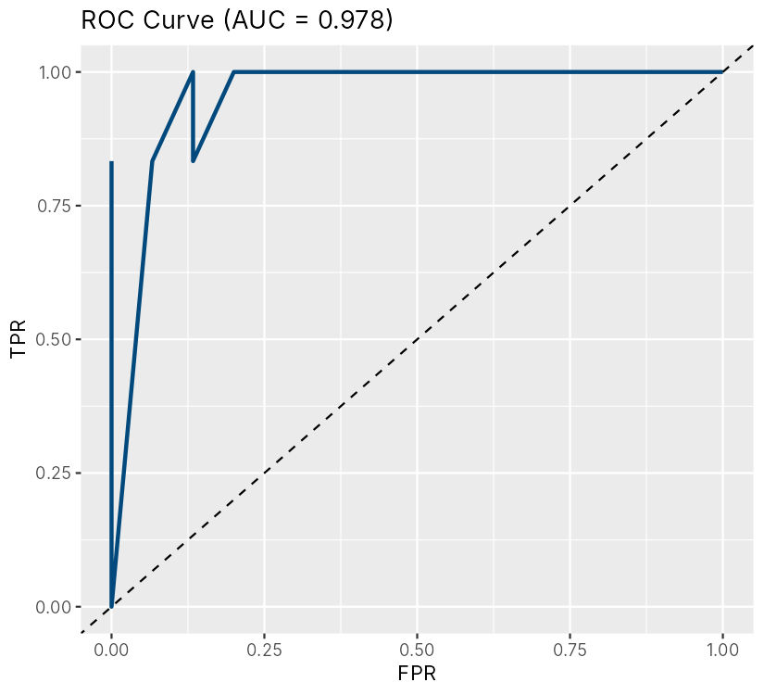
Figure 12: ROC curve of the logistic regression on the test set
Of the 21 test days, the classifier correctly labelled 19 (accuracy 90.5%, 95% confidence interval 69.6%–98.8%), which is significantly better than always predicting the majority class (No Information Rate 71.4%, p = 0.037). It raised no false alarms (specificity 100%) but missed 2 of the 6 truly high days (sensitivity 66.7%). The area under the ROC curve is 0.978, so the model ranks high-ozone days well above ordinary days. If a missed high day is costlier than a false alarm, the probability threshold can be lowered from 0.5 to increase sensitivity.

6.4 Predicting ozone for new days
The final step applies the models to three new weather scenarios that are not in the data.
new_days <- data.frame(Solar.R = c(250, 150, 80),
Wind = c(5, 9, 14),
Temp = c(92, 80, 65),
Month = c(7, 6, 5))
new_days$Pred_Ozone_RF <- round(predict(rf, data = new_days)$predictions, 1)
new_days$Pred_Ozone_Poly <- round(predict(lm_c, newdata = new_days), 1)
new_days$HighOzone_Prob <- round(predict(glm_fit, newdata = new_days, type = "response"), 3)
new_days$Category_RF <- sapply(new_days$Pred_Ozone_RF, ozone_category)

Solar.R Wind Temp Month Pred_Ozone_RF Pred_Ozone_Poly HighOzone_Prob
1 250 5 92 7 93.7 98.0 0.993
2 150 9 80 6 37.1 35.4 0.126
3 80 14 65 5 17.3 0.4 0.000
Category_RF
1 Very Unhealthy
2 Moderate
3 Good

- A hot, calm, sunny July day (92 °F, 5 mph wind): the random forest predicts about 94 ppb, in the Very Unhealthy band, and the logistic model gives a 99% probability of a high-ozone day.
- A warm June day (80 °F, 9 mph): about 37 ppb, in the Moderate band, with a 13% probability of a high-ozone day.
- A cool, windy May day (65 °F, 14 mph): about 17 ppb, in the Good band, with essentially zero probability. The polynomial model predicts only 0.4 ppb here, a value too close to zero to be believable, because squared terms extrapolate poorly near the edge of the data. The forest's predictions always stay within the range of the observed ozone values, which is a practical advantage.

6.5 Publishing the project on GitHub
The project folder contains the R script (air_quality_analysis.R), the data file (aq.csv), the saved console output (output.txt), the 12 plots in a plots folder, and a README with instructions for running the analysis. The script was written for this project and is run with Rscript air_quality_analysis.R. The repository link is given on the last page of this report.

7. Results and Discussion
- Best regressor. The random forest is the most reliable model. It has the lowest cross-validated RMSE (16.6 ppb) and the highest R² (0.77), and its predictions stay within the physical range of ozone values.
- The test set cannot separate the top models. On the 21-day hold-out set the log-linear model and the forest tie at an RMSE of about 15.1 ppb. With so few days, cross-validation is the better guide, and it favours the forest.
- What drives ozone. Wind speed and temperature dominate in every model: hot, still days produce high ozone. Solar radiation contributes a little, and month adds almost nothing once the weather is known.
- Non-linearity matters. Models that allow curvature (polynomial and forest) reduce error compared with the straight-line model, matching the curved patterns in the scatter plots.
- Realistic accuracy. An R² of 0.7–0.8 is realistic. The remaining variation comes from factors absent from the data, such as emissions of nitrogen oxides and volatile organic compounds, traffic and pollution carried in from other areas.
- Classification. The logistic model flags high-ozone days with 90.5% accuracy and an AUC of 0.978, with no false alarms on the test set but 2 of 6 high days missed.

Limitations
- The data covers one city and one summer (1973), so the models should not be used to forecast ozone in other places or years without refitting.
- Only 116 days remain after removing days with missing ozone, and the test set has 21 days, so individual metrics are uncertain.
- Consecutive days are not independent; a random split places neighbouring days in both training and test sets, which can make scores slightly optimistic. A time-ordered split would be a stricter test.
- The 50 ppb threshold for a high-ozone day is a project choice rather than a regulatory standard.

8. Conclusion and Future Scope
This mini project used R to analyse air quality in New York, covering data structures, control structures, functions, lists and data frames, a diagnosis of the statistical problems in the data, and four regression models plus a logistic classifier. Ozone can be predicted from weather with a typical error of about 17 ppb, and the most dangerous days are those that are hot, calm and sunny. Honest evaluation using a hold-out set and repeated cross-validation produced realistic scores rather than suspiciously perfect ones, and the random forest emerged as the most dependable model.
Future work could add pollutant and traffic data (nitrogen oxides, volatile organic compounds), use several years of observations, include the previous day's ozone as a predictor, try gradient boosting, and wrap the final model in a Shiny application that issues a daily high-ozone alert.

9. References
- R Core Team. R: A Language and Environment for Statistical Computing. R Foundation for Statistical Computing, Vienna, Austria. https://www.R-project.org/
- Chambers, J. M., Cleveland, W. S., Kleiner, B. and Tukey, P. A. (1983). Graphical Methods for Data Analysis. Wadsworth, Belmont, CA. (Source of the airquality data set.)
- Wickham, H. (2016). ggplot2: Elegant Graphics for Data Analysis. Springer, New York.
- Wright, M. N. and Ziegler, A. (2017). ranger: A fast implementation of random forests for high dimensional data in C++ and R. Journal of Statistical Software, 77(1), 1–17.
- Kuhn, M. (2008). Building predictive models in R using the caret package. Journal of Statistical Software, 28(5), 1–26.
- Breiman, L. (2001). Random forests. Machine Learning, 45(1), 5–32.
- Wei, T. and Simko, V. R package ‘corrplot’: Visualization of a Correlation Matrix.
- Wickham, H., François, R., Henry, L. and Müller, K. R package ‘dplyr’: A Grammar of Data Manipulation.

Appendix A. Complete R Script
The complete script (air_quality_analysis.R) used to produce every result in this report:
# ==============================================================
# Air Quality Analysis using R
# Course : 23CAP317 - R Programming (Mini Project)
# Author : GOWTHAMRAJ P
# Data : New York daily air quality, May-Sep 1973 (153 rows)
# Ozone (ppb), Solar.R (Ly), Wind (mph), Temp (F), Month, Day
# Goal : Predict ground-level Ozone from weather conditions
# (regression) and flag high-ozone days (classification)
# ==============================================================

suppressPackageStartupMessages({
library(ggplot2); library(corrplot); library(ranger)
library(caret); library(dplyr)
})
set.seed(2026)
dir.create("plots", showWarnings = FALSE)

# ---------------------------------------------------------------
# PART 1 : DATA STRUCTURES (Q1)
# ---------------------------------------------------------------
cat("\n===== PART 1: DATA STRUCTURES =====\n")
temp_vec <- c(67, 72, 74, 62, 56) # vector
month_fct <- factor(c("May","Jun","Jul","Aug","Sep"),
levels = c("May","Jun","Jul","Aug","Sep")) # factor
sample_mat <- matrix(c(41,190,7.4, 36,118,8.0), nrow = 2, byrow = TRUE,
dimnames = list(c("Day1","Day2"),
c("Ozone","Solar","Wind"))) # matrix
sample_lst <- list(station = "New York", year = 1973,
pollutant = "Ozone", units = "ppb") # list
print(temp_vec); print(month_fct); print(sample_mat); str(sample_lst)

# Load the dataset (data frame)
air <- read.csv("aq.csv")
air$rownames <- NULL
cat("\nDimensions:\n"); print(dim(air))
cat("\nColumn names:\n"); print(names(air))
cat("\nHead:\n"); print(head(air))
cat("\nStructure:\n"); str(air)
cat("\nSummary:\n"); print(summary(air))

# ---------------------------------------------------------------
# PART 2 : CONTROL STRUCTURES, FUNCTIONS, LIST, DATA FRAME (Q2)
# ---------------------------------------------------------------
cat("\n===== PART 2: CONTROL STRUCTURES & FUNCTIONS =====\n")

# User-defined function with if / else if / else
# Ozone categories (illustrative bands in ppb)
ozone_category <- function(x) {
if (is.na(x)) "Unknown"
else if (x <= 30) "Good"
else if (x <= 60) "Moderate"
else if (x <= 90) "Unhealthy"
else "Very Unhealthy"
}
air$OzoneLevel <- factor(sapply(air$Ozone, ozone_category),
levels = c("Good","Moderate","Unhealthy",
"Very Unhealthy","Unknown"))
print(table(air$OzoneLevel))

# for loop : mean of every numeric column ignoring NA
col_means <- numeric(0)
for (nm in c("Ozone","Solar.R","Wind","Temp")) {
col_means[nm] <- mean(air[[nm]], na.rm = TRUE)
}
cat("\nColumn means (for loop):\n"); print(round(col_means, 2))

# while loop : first day in the data where Ozone exceeds 100 ppb
i <- 1
while (i <= nrow(air) && (is.na(air$Ozone[i]) || air$Ozone[i] <= 100)) i <- i + 1
cat("\nFirst row with Ozone > 100 ppb (while loop): row", i,
"| Month", air$Month[i], "Day", air$Day[i], "Ozone", air$Ozone[i], "\n")

# Function returning a list
describe_var <- function(v) {
v <- v[!is.na(v)]
list(n = length(v), mean = mean(v), sd = sd(v),
min = min(v), max = max(v))
}
stats_list <- lapply(air[, c("Ozone","Solar.R","Wind","Temp")], describe_var)
cat("\nList of statistics (lapply):\n"); str(stats_list)

# apply family on a data frame
cat("\nMonthly average Ozone (tapply):\n")
print(round(tapply(air$Ozone, air$Month, mean, na.rm = TRUE), 2))

# dplyr summarise on the data frame
monthly <- air %>% group_by(Month) %>%
summarise(days = n(), mean_ozone = mean(Ozone, na.rm = TRUE),
mean_temp = mean(Temp), mean_wind = mean(Wind),
.groups = "drop")
cat("\nMonthly summary (data frame):\n"); print(as.data.frame(monthly))

# ---------------------------------------------------------------
# PART 3 : STATISTICAL PROBLEMS (Q3)
# ---------------------------------------------------------------
cat("\n===== PART 3: STATISTICAL PROBLEMS =====\n")

# 3.1 Missing values
cat("\nMissing values per column:\n"); print(colSums(is.na(air[, 1:6])))
cat("Duplicate rows:", sum(duplicated(air[, 1:6])), "\n")
cat("Complete rows:", sum(complete.cases(air[, 1:6])), "of", nrow(air), "\n")

# 3.2 Outliers (IQR rule)
iqr_outliers <- function(v) {
q <- quantile(v, c(.25, .75), na.rm = TRUE); r <- diff(q)
sum(v < q[1] - 1.5 * r | v > q[2] + 1.5 * r, na.rm = TRUE)
}
cat("\nOutliers by IQR rule:\n")
print(sapply(air[, c("Ozone","Solar.R","Wind","Temp")], iqr_outliers))

# 3.3 Normality of Ozone (Shapiro-Wilk) and skewness
sk <- function(v) { v <- v[!is.na(v)]; mean((v - mean(v))^3) / sd(v)^3 }
cat("\nSkewness of Ozone:", round(sk(air$Ozone), 3),
"| log(Ozone):", round(sk(log(air$Ozone)), 3), "\n")
print(shapiro.test(air$Ozone))
print(shapiro.test(log(air$Ozone[!is.na(air$Ozone)])))

# 3.4 Correlation + significance
cc <- air[complete.cases(air[, 1:6]), ]
cat("\nCorrelation with Ozone (complete cases):\n")
print(round(cor(cc[, c("Ozone","Solar.R","Wind","Temp")]), 3))
cat("\nPearson test Ozone ~ Temp:\n"); print(cor.test(cc$Ozone, cc$Temp))
cat("\nPearson test Ozone ~ Wind:\n"); print(cor.test(cc$Ozone, cc$Wind))

# 3.5 Hypothesis tests / ANOVA
cat("\nANOVA: Ozone by Month\n")
print(summary(aov(Ozone ~ factor(Month), data = cc)))
cat("\nWelch t-test: Ozone in Jul-Aug vs May-Jun-Sep\n")
print(t.test(cc$Ozone[cc$Month %in% 7:8], cc$Ozone[!cc$Month %in% 7:8]))

# 3.6 Multicollinearity (VIF computed by hand)
vif_manual <- function(df, preds) {
sapply(preds, function(p) {
r2 <- summary(lm(reformulate(setdiff(preds, p), p), data = df))$r.squared
1 / (1 - r2)
})
}
cat("\nVIF:\n"); print(round(vif_manual(cc, c("Solar.R","Wind","Temp")), 3))

# ---------------------------------------------------------------
# PART 4 : DATA CLEANING & VISUALISATION
# ---------------------------------------------------------------
cat("\n===== PART 4: CLEANING & VISUALISATION =====\n")

# Imputation: Solar.R by median; Ozone by month median
# (rows with Ozone missing are kept for imputation of features only;
# the target is NOT imputed - rows with missing Ozone are dropped
# for modelling to avoid fabricating the thing we predict)
air$Solar.R[is.na(air$Solar.R)] <- median(air$Solar.R, na.rm = TRUE)
model_df <- air %>% filter(!is.na(Ozone)) %>%
select(Ozone, Solar.R, Wind, Temp, Month)
cat("Rows used for modelling:", nrow(model_df), "\n")
cat("NA left:", sum(is.na(model_df)), "\n")

p1 <- ggplot(model_df, aes(Ozone)) + geom_histogram(bins = 25, fill = "#2a6f97", colour = "white") +
ggtitle("Distribution of Ozone (ppb)")
ggsave("plots/01_ozone_hist.png", p1, width = 7, height = 4.5, dpi = 150)

p2 <- ggplot(model_df, aes(factor(Month, labels = c("May","Jun","Jul","Aug","Sep")), Ozone)) +
geom_boxplot(fill = "#a9d6e5") + xlab("Month") + ggtitle("Ozone by Month")
ggsave("plots/02_ozone_by_month.png", p2, width = 7, height = 4.5, dpi = 150)

png("plots/03_correlation.png", width = 900, height = 800, res = 140)
corrplot(cor(model_df), method = "color", addCoef.col = "black",
tl.col = "black", number.cex = 0.8)
dev.off()

long_df <- stack(model_df[, c("Ozone","Solar.R","Wind","Temp")])
p3b <- ggplot(long_df, aes(ind, values)) + geom_boxplot(fill = "#a9d6e5") +
facet_wrap(~ind, scales = "free") + xlab("") + ylab("value") +
ggtitle("Boxplots of features (outlier check)")
ggsave("plots/03b_boxplots.png", p3b, width = 8, height = 5, dpi = 150)

p4 <- ggplot(model_df, aes(Temp, Ozone)) + geom_point(alpha = .6, colour = "#01497c") +
geom_smooth(method = "loess", formula = y ~ x, colour = "firebrick") +
ggtitle("Ozone vs Temperature")
ggsave("plots/04_ozone_vs_temp.png", p4, width = 7, height = 4.5, dpi = 150)

p5 <- ggplot(model_df, aes(Wind, Ozone)) + geom_point(alpha = .6, colour = "#01497c") +
geom_smooth(method = "loess", formula = y ~ x, colour = "firebrick") +
ggtitle("Ozone vs Wind Speed")
ggsave("plots/05_ozone_vs_wind.png", p5, width = 7, height = 4.5, dpi = 150)

# ---------------------------------------------------------------
# PART 5 : DATA SPLITTING
# ---------------------------------------------------------------
cat("\n===== PART 5: DATA SPLITTING (80/20) =====\n")
idx <- createDataPartition(model_df$Ozone, p = 0.8, list = FALSE)
train <- model_df[idx, ]
test <- model_df[-idx, ]
cat("Train rows:", nrow(train), "| Test rows:", nrow(test), "\n")

metrics <- function(actual, pred)
c(RMSE = sqrt(mean((actual - pred)^2)),
MAE = mean(abs(actual - pred)),
R2 = cor(actual, pred)^2)

# ---------------------------------------------------------------
# PART 6 : REGRESSION MODELS (Q4)
# ---------------------------------------------------------------
cat("\n===== PART 6: REGRESSION MODELS =====\n")

# Model A: multiple linear regression
lm_a <- lm(Ozone ~ Solar.R + Wind + Temp + factor(Month), data = train)
cat("\n--- Model A: Multiple Linear Regression ---\n"); print(summary(lm_a))
lm_a_pred <- predict(lm_a, newdata = test)

# Model B: linear regression on log(Ozone) - fixes skew / heteroscedasticity
lm_b <- lm(log(Ozone) ~ Solar.R + Wind + Temp, data = train)
cat("\n--- Model B: Linear Regression on log(Ozone) ---\n"); print(summary(lm_b))
lm_b_pred <- exp(predict(lm_b, newdata = test))
cat("\nResidual diagnostics (Model A) - Shapiro on residuals:\n")
print(shapiro.test(residuals(lm_a)))

png("plots/06_lm_diagnostics.png", width = 1100, height = 900, res = 140)
par(mfrow = c(2, 2)); plot(lm_a); par(mfrow = c(1, 1)); dev.off()

# Model C: polynomial / interaction regression
lm_c <- lm(Ozone ~ Solar.R + Wind + Temp + I(Temp^2) + I(Wind^2) + Temp:Wind,
data = train)
cat("\n--- Model C: Polynomial + Interaction Regression ---\n")
print(summary(lm_c))
lm_c_pred <- predict(lm_c, newdata = test)

# Model D: Random Forest (ranger)
rf <- ranger(Ozone ~ ., data = train, num.trees = 500,
importance = "permutation", seed = 2026)
rf_pred <- predict(rf, data = test)$predictions
cat("\n--- Model D: Random Forest ---\n"); print(rf)
cat("\nVariable importance (permutation):\n"); print(round(sort(rf$variable.importance, TRUE), 2))

# Model comparison on the held-out test set
cmp <- rbind(
"Linear (A)" = metrics(test$Ozone, lm_a_pred),
"Log-Linear (B)" = metrics(test$Ozone, lm_b_pred),
"Poly+Interact (C)" = metrics(test$Ozone, lm_c_pred),
"Random Forest (D)" = metrics(test$Ozone, rf_pred))
cat("\n===== TEST-SET COMPARISON =====\n"); print(round(cmp, 3))

# 10-fold CV x 5 repeats on ALL modelling rows (more reliable: n is small)
ctrl <- trainControl(method = "repeatedcv", number = 10, repeats = 5)
cv_lm <- train(Ozone ~ Solar.R + Wind + Temp + factor(Month), data = model_df,
method = "lm", trControl = ctrl)
cv_c <- train(Ozone ~ Solar.R + Wind + Temp + I(Temp^2) + I(Wind^2) + Temp:Wind,
data = model_df, method = "lm", trControl = ctrl)
cv_rf <- train(Ozone ~ ., data = model_df, method = "ranger", trControl = ctrl,
tuneGrid = expand.grid(mtry = 2:4, splitrule = "variance",
min.node.size = 5), num.trees = 300)
cv_tab <- rbind("Linear (A)" = cv_lm$results[, c("RMSE","Rsquared","MAE")],
"Poly+Interact (C)" = cv_c$results[, c("RMSE","Rsquared","MAE")],
"Random Forest (D)" = cv_rf$results[which.min(cv_rf$results$RMSE),
c("RMSE","Rsquared","MAE")])
cat("\n===== 10-FOLD x5 CROSS-VALIDATION =====\n"); print(round(cv_tab, 3))

pa <- function(pred, title) {
d <- data.frame(Observed = test$Ozone, Predicted = pred)
ggplot(d, aes(Observed, Predicted)) + geom_point(colour = "#01497c", size = 2) +
geom_abline(colour = "firebrick") + ggtitle(title)
}
ggsave("plots/07_lm_actual_pred.png", pa(lm_a_pred, "Linear Regression: Predicted vs Actual"), width = 6, height = 5, dpi = 150)
ggsave("plots/08_poly_actual_pred.png", pa(lm_c_pred, "Polynomial Regression: Predicted vs Actual"), width = 6, height = 5, dpi = 150)
ggsave("plots/09_rf_actual_pred.png", pa(rf_pred, "Random Forest: Predicted vs Actual"), width = 6, height = 5, dpi = 150)

imp <- data.frame(Variable = names(rf$variable.importance),
Importance = as.numeric(rf$variable.importance))
p10 <- ggplot(imp, aes(reorder(Variable, Importance), Importance)) +
geom_col(fill = "#2a6f97") + coord_flip() + xlab("") +
ggtitle("Random Forest Variable Importance")
ggsave("plots/10_rf_importance.png", p10, width = 6.5, height = 4, dpi = 150)

# ---------------------------------------------------------------
# PART 7 : LOGISTIC REGRESSION (classification)
# ---------------------------------------------------------------
cat("\n===== PART 7: LOGISTIC REGRESSION (High Ozone day) =====\n")
thr <- 50 # ppb threshold for a 'high ozone' day
model_df$HighOzone <- factor(ifelse(model_df$Ozone > thr, 1, 0), levels = c(0, 1))
cat("Class balance (HighOzone, threshold", thr, "ppb):\n"); print(table(model_df$HighOzone))

train_c <- model_df[idx, ]; test_c <- model_df[-idx, ]
# NOTE: Ozone itself is excluded from the predictors (it defines the label)
glm_fit <- glm(HighOzone ~ Solar.R + Wind + Temp, data = train_c, family = binomial)
cat("\n"); print(summary(glm_fit))
cat("\nOdds ratios:\n"); print(round(exp(coef(glm_fit)), 3))
prob <- predict(glm_fit, newdata = test_c, type = "response")
cls <- factor(ifelse(prob > 0.5, 1, 0), levels = c(0, 1))
cm <- confusionMatrix(cls, test_c$HighOzone, positive = "1")
print(cm)

roc_df <- do.call(rbind, lapply(seq(0, 1, by = 0.01), function(t) {
p <- factor(ifelse(prob > t, 1, 0), levels = c(0, 1))
tp <- sum(p == 1 & test_c$HighOzone == 1); fn <- sum(p == 0 & test_c$HighOzone == 1)
fp <- sum(p == 1 & test_c$HighOzone == 0); tn <- sum(p == 0 & test_c$HighOzone == 0)
data.frame(TPR = tp / (tp + fn), FPR = fp / (fp + tn))
}))
auc <- abs(sum(diff(roc_df$FPR) * (head(roc_df$TPR, -1) + tail(roc_df$TPR, -1)) / 2))
cat("\nApprox. AUC on test set:", round(auc, 3), "\n")
ggsave("plots/11_roc.png",
ggplot(roc_df, aes(FPR, TPR)) + geom_line(colour = "#01497c", linewidth = 1) +
geom_abline(linetype = "dashed") + ggtitle(sprintf("ROC Curve (AUC = %.3f)", auc)),
width = 5.5, height = 5, dpi = 150)

# ---------------------------------------------------------------
# PART 8 : PREDICTION ON NEW DATA (Q5)
# ---------------------------------------------------------------
cat("\n===== PART 8: PREDICTING NEW DAYS =====\n")
new_days <- data.frame(Solar.R = c(250, 150, 80),
Wind = c(5, 9, 14),
Temp = c(92, 80, 65),
Month = c(7, 6, 5))
new_days$Pred_Ozone_RF <- round(predict(rf, data = new_days)$predictions, 1)
new_days$Pred_Ozone_Poly <- round(predict(lm_c, newdata = new_days), 1)
new_days$HighOzone_Prob <- round(predict(glm_fit, newdata = new_days, type = "response"), 3)
new_days$Category_RF <- sapply(new_days$Pred_Ozone_RF, ozone_category)
print(new_days)

cat("\nSession info:\n"); cat(R.version.string, "\n")

Project Repository (GitHub)
The complete project (R script, data, console output, plots and README) is available at:
https://github.com/<your-username>/air-quality-analysis-r

