PUNJAB TECHNICAL UNIVERSITY JALANDHAR
Instructions regarding the filling of Examination Form
Note:- Use Internet explorer for best printing Quality.
Step-1 If you did not receive your UserID and Password from your institute, then you must contact your institute for your UserID and Password.
Step-2 Login into your Account at www.ptuexam.com .When you enter in your account then you have to click on Regular Exam. Form for May-2010 as show below:- | 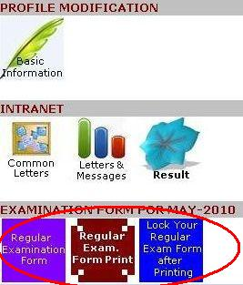

Step-3 Now you have entered the next Window that is Examination Form, where you have to find Section-A as show right:- | 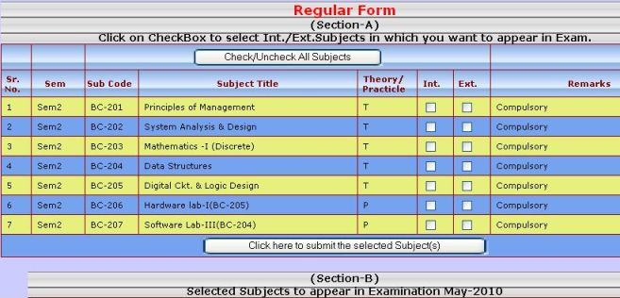

Step-4 Now you have to Select the Subjects in which you want to appear by Clicking the checkbox in Internal as well as External as show right:- | 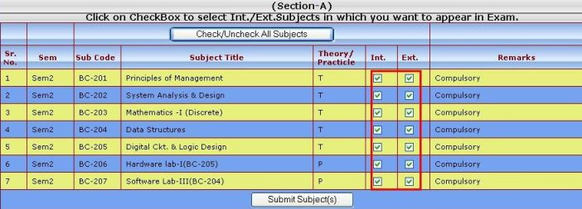  After this you have to click the Button as show below:- 

Step-5 The details of submitted Subjects have been added to Section-B as shown below |  | 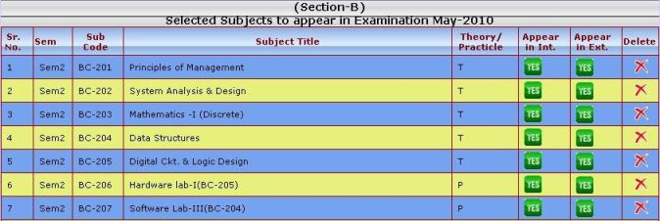
Step-6 Now you have to Click on 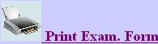
Step-7 Specimen Print of Examination Form is shown as below | 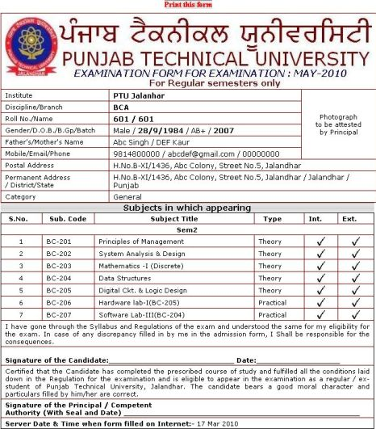
Note:- (1)Then you must verify your Personal Details and Subjects in the Printed Examination form. If you find the details to be correct, then must submit your form to your Institute after signing the form and pasting your Colored-Photograph in the area specified.
2. If any Information regarding your Personal detail is missing, then you have to fill/Edit in BASIC INFORMATION ICON (Refer Student Control Panel showing in Step-2) and then Reprint your Examination Form.
3. Manual Cutting/Over Writing on Examination form is not allowed your form is liable to be rejected.
Step-8 If all Entries in examination form are correct then, you have to lock the Examination form by clicking on icon No.3 below,
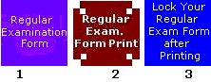
and next windows will be open as below click on 1st option then above icon No. 1&3 will be hidden automatically. Congratulation your Examination is filled successfully !! you can print Your form anytime,
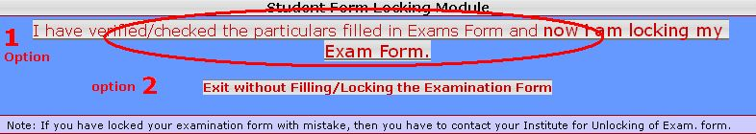

Note:- Examination fee is Rs.700/- per Semester and fee will be submitted in Institute in the form of Cash only. No form will be accepted in university directly, so the students are advised to avoid to submit the examination form in the university

In case of wrong entry of the subjects follow the following steps:
In case you forgot to select Int. or Ext. of a subject as shown right | 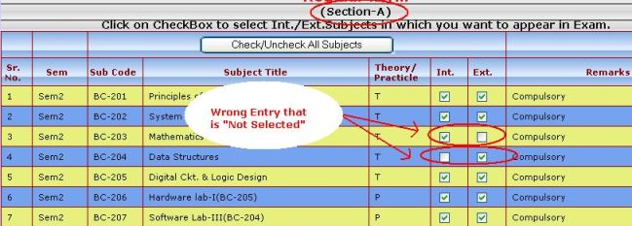
Step1: Delete the entry from section B by clicking on delete Icon in the last column as shown right | 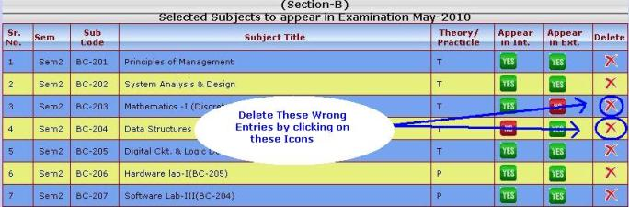
Step 2: After deleting the wrong entry from section B, then you must select the correct entry in section A and add the correct subject(s) again.

Note:- The additional query may be submitted through your login and students are advised to avoid to submit the same enquiry again and again.

