Sign Up & Login Page - Functional & UI Test Report
Module Name: Sign Up & Login Page - Functional & UI Test Cases
Test Case ID: gfg_01
Webpage URL: https://www.geeksforgeeks.org/

Scenario ID: 1a
Scenario: Sign up with all fields empty
Test Steps:
1. Open Sign Up modal on geeksforgeeks.org
2. Leave Username/Email, Password, and Institution fields blank
3. Click Sign Up
Screenshots:
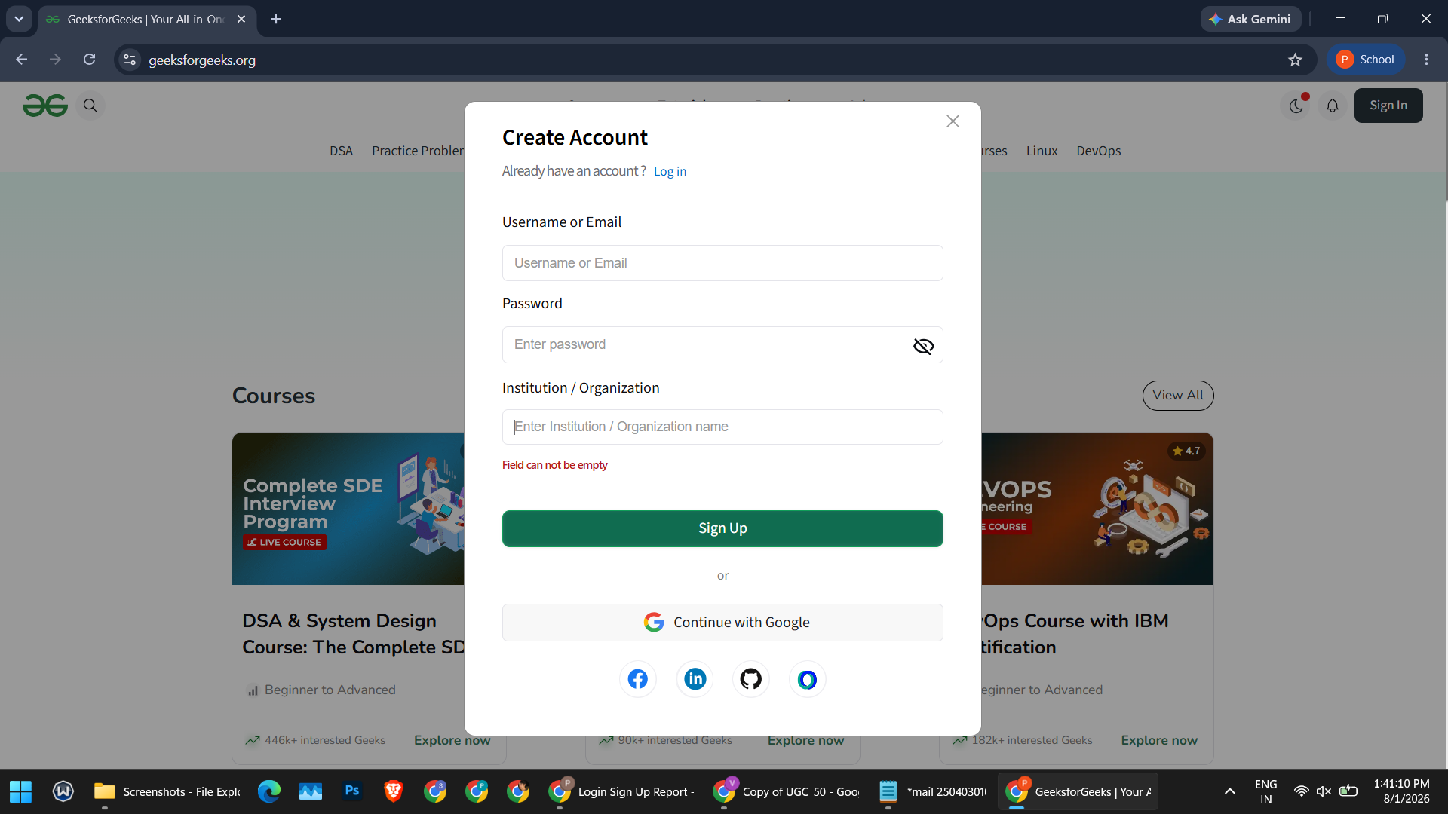

Scenario ID: 1b
Scenario: Sign up with weak/short password
Test Steps:
1. Open Sign Up modal
2. Enter valid Email and Institution
3. Enter a password with fewer than 8 characters
4. Click Sign Up
Screenshots:
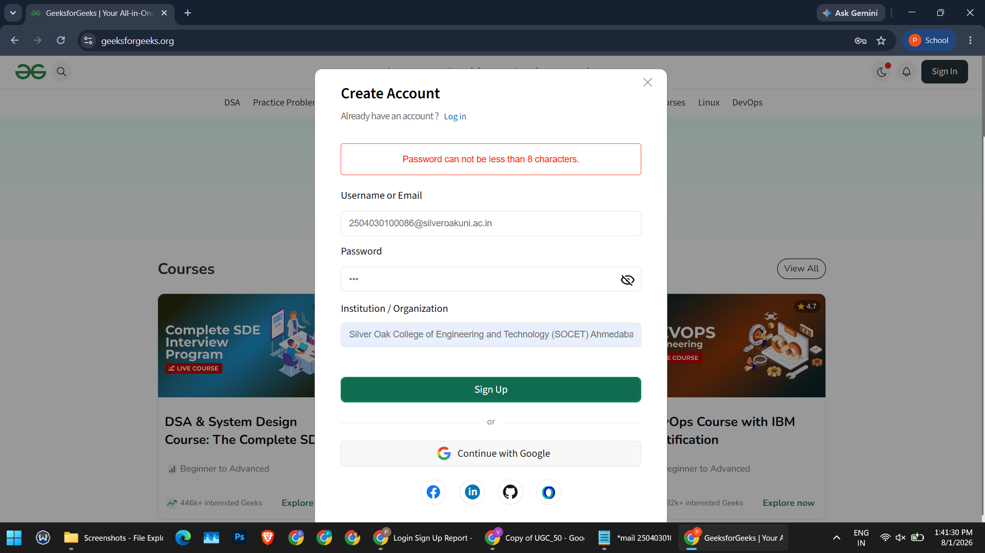

Scenario ID: 1c
Scenario: Check password visibility toggle & error message refresh
Test Steps:
1. After the short-password error appears, click the eye icon to reveal the password
2. Update the password to a valid one (Tester@123)
3. Observe whether the error message updates
Screenshots:
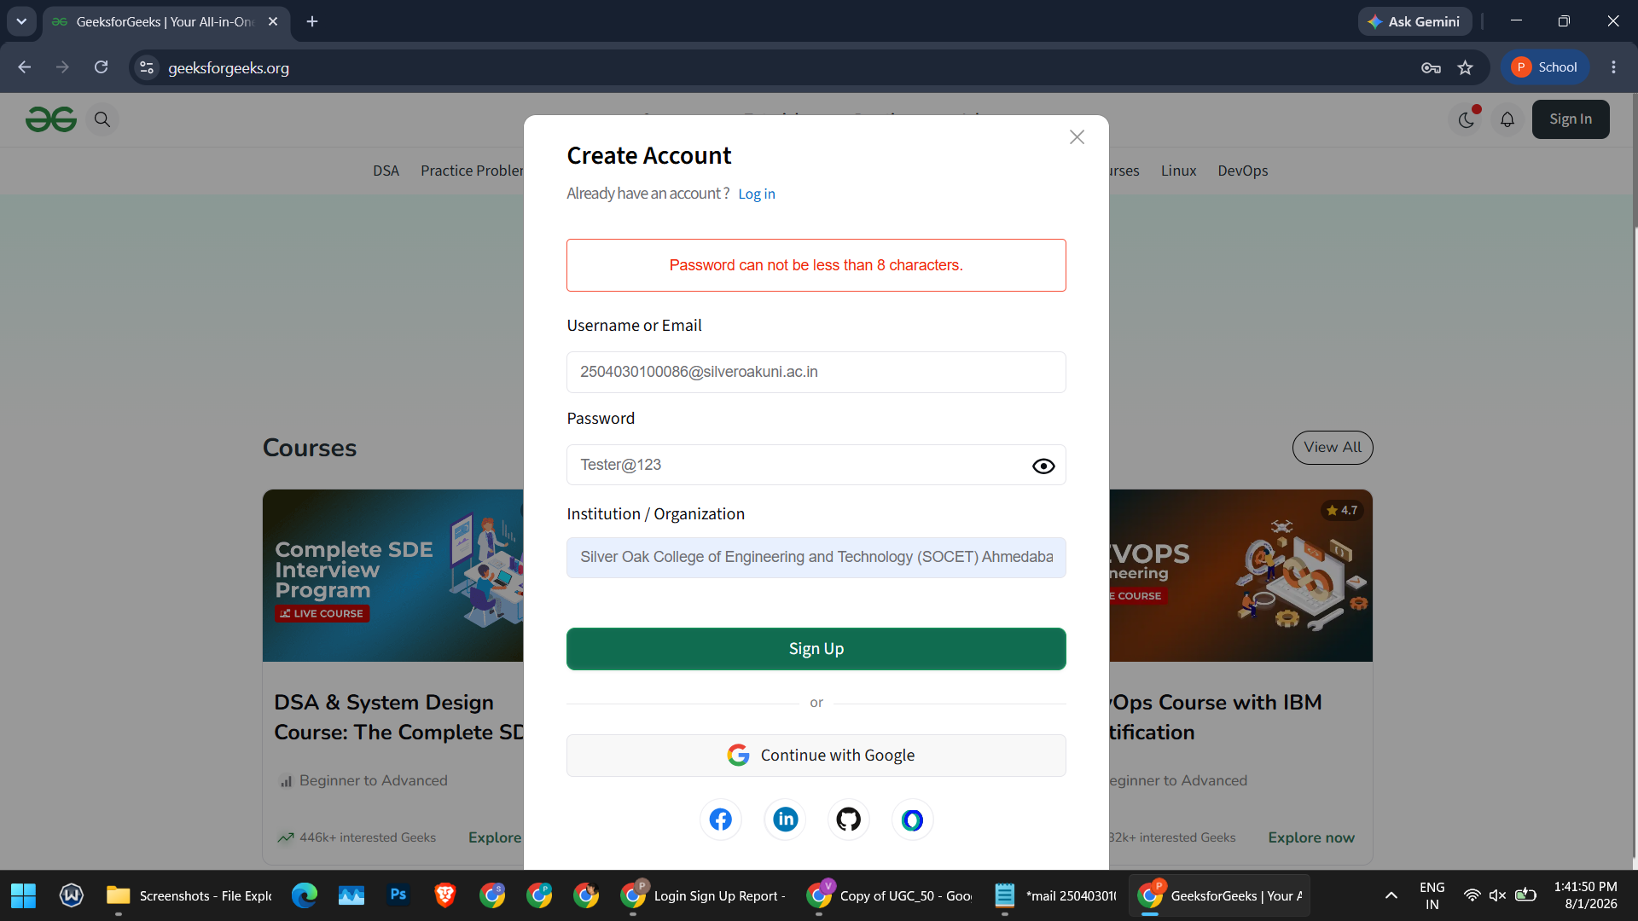

Scenario ID: 1d
Scenario: Sign up with invalid email format (double @)
Test Steps:
1. Enter an email containing two "@" symbols
2. Enter a valid password and institution
3. Click Sign Up
Screenshots:
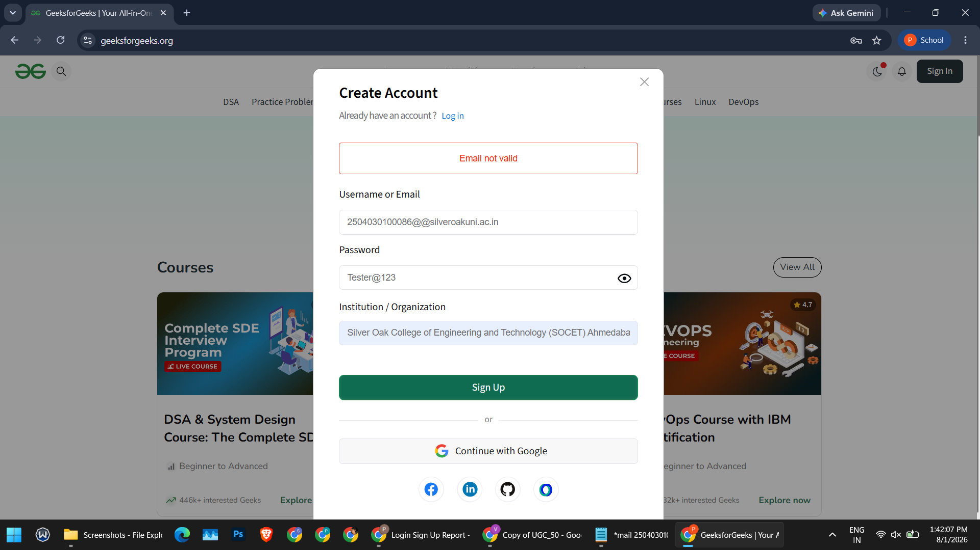

Scenario ID: 1e
Scenario: Sign up with Institution/Organization field empty
Test Steps:
1. Enter a valid email and password
2. Leave the Institution/Organization field blank
3. Click Sign Up

Screenshots:

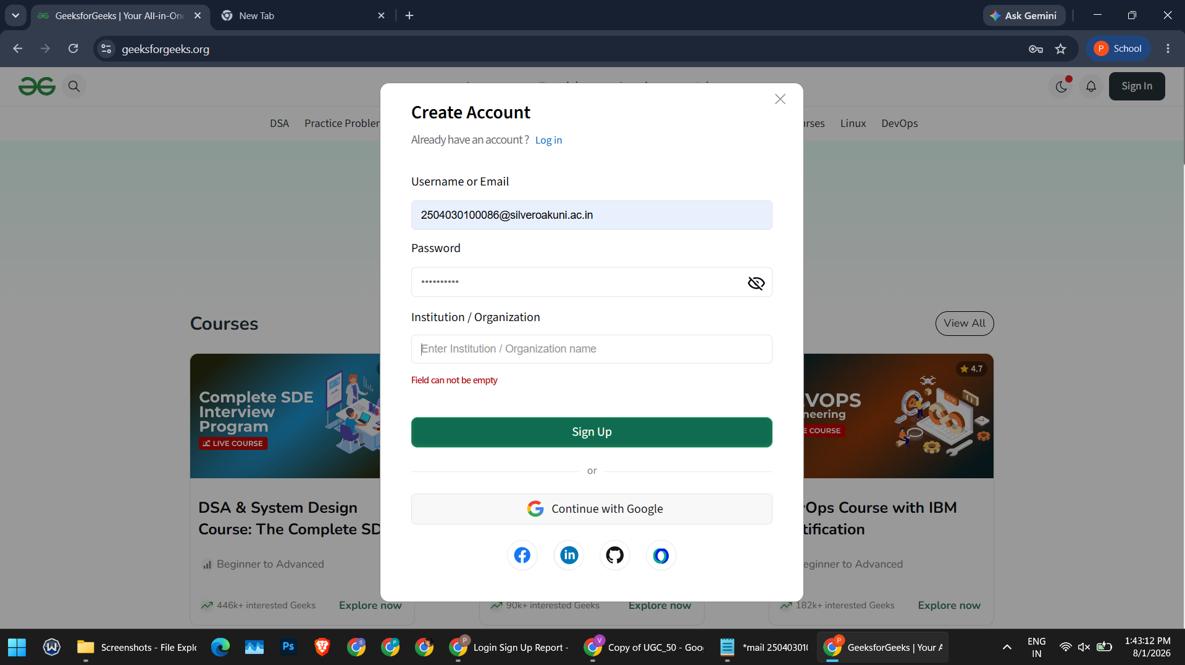

Scenario ID: 1f
Scenario: Sign up / Continue using Google (OAuth)
Test Steps:
1. Click "Continue with Google"
2. Choose a Google account from the account chooser
3. Review requested permissions on the Google consent screen
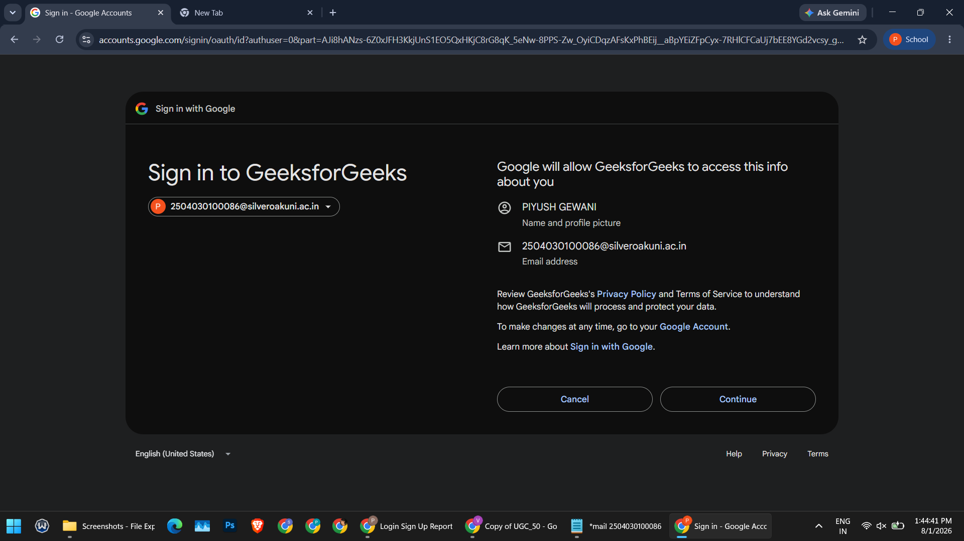
Screenshots:
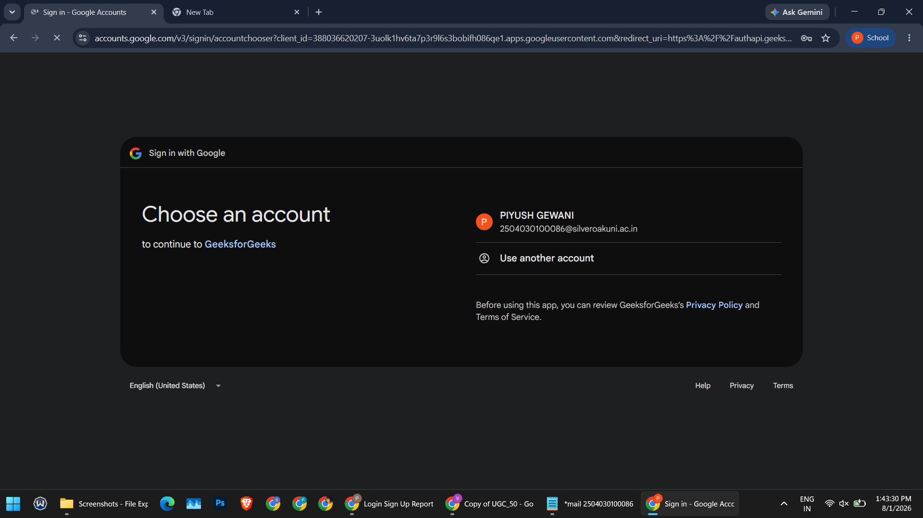

Scenario ID: 1g
Scenario: Sign up with valid credentials
Test Steps:
1. Enter a valid email
2. Enter a valid password (Tester@123)
3. Enter Institution name
4. Click Sign Up
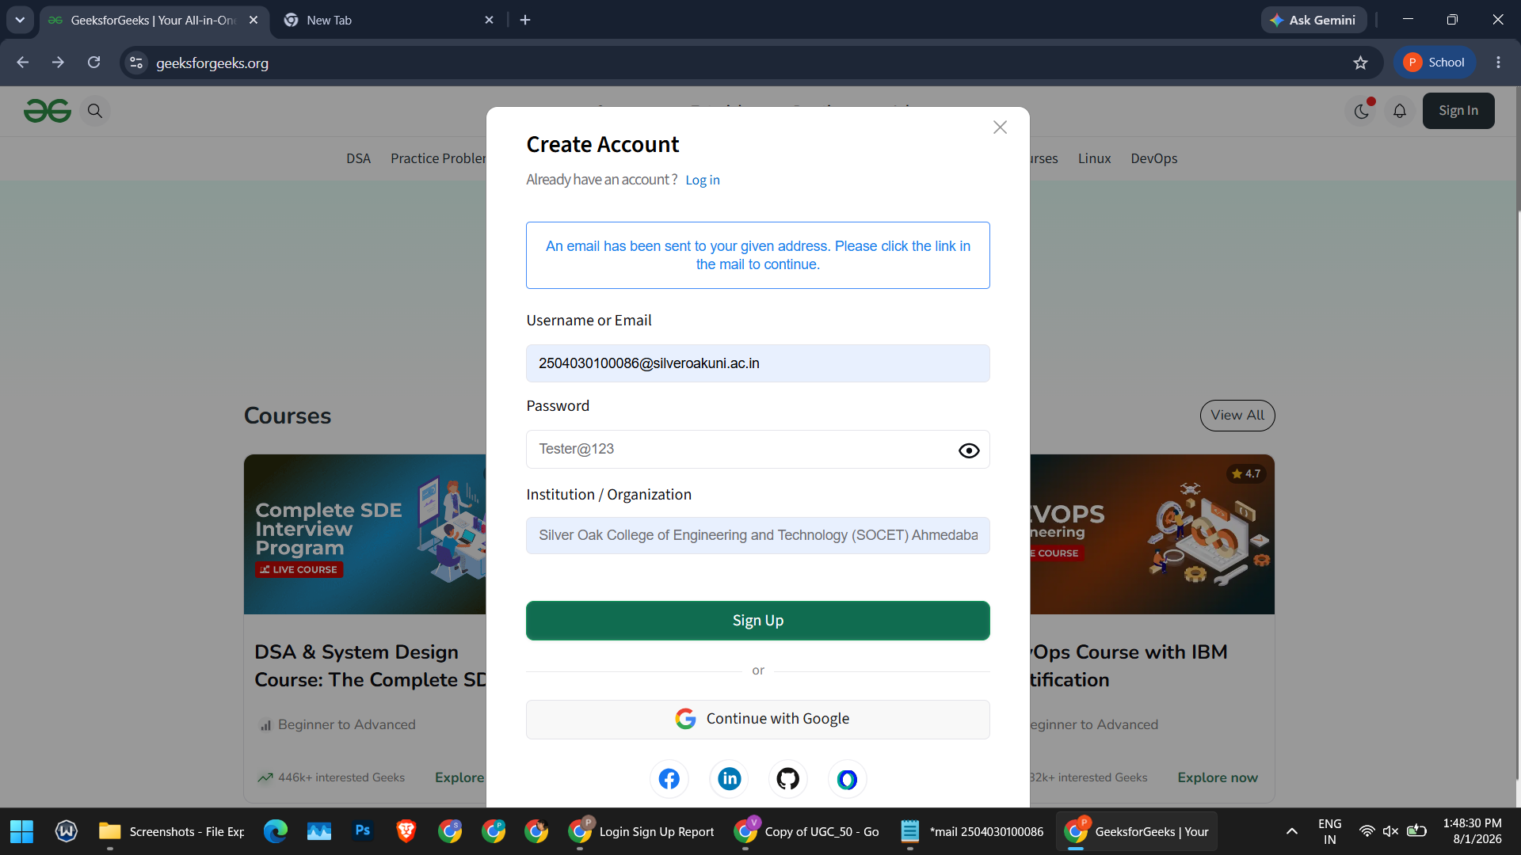
Screenshots:
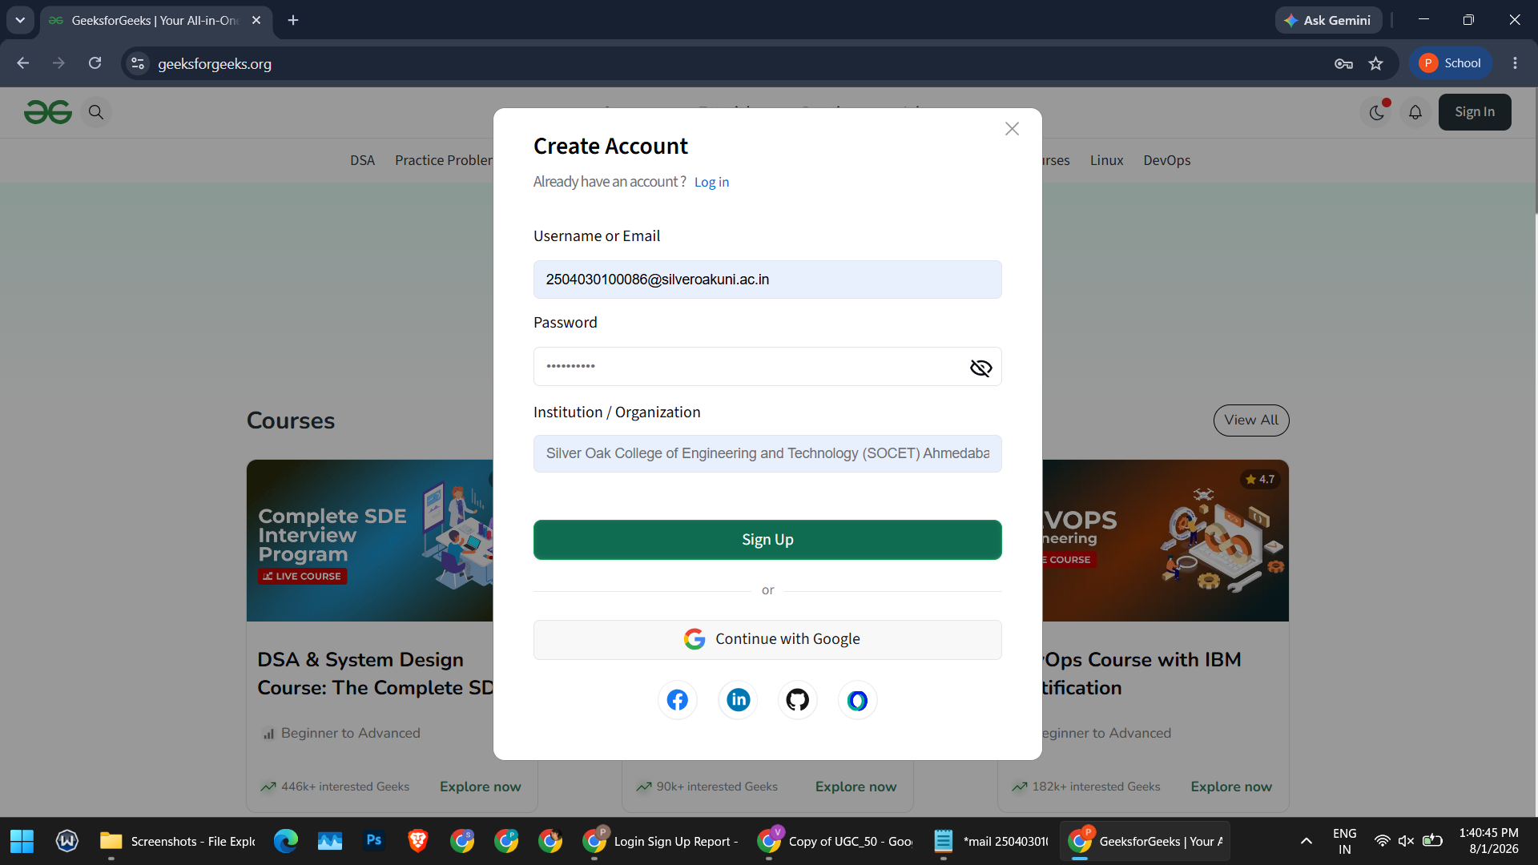

Scenario ID: 2a
Scenario: Email verification
Test Steps:
1. Open the registered email inbox (Gmail)
2. Locate the "Welcome to GeeksforGeeks" email
3. Click the "Verify Email" link
Screenshots:
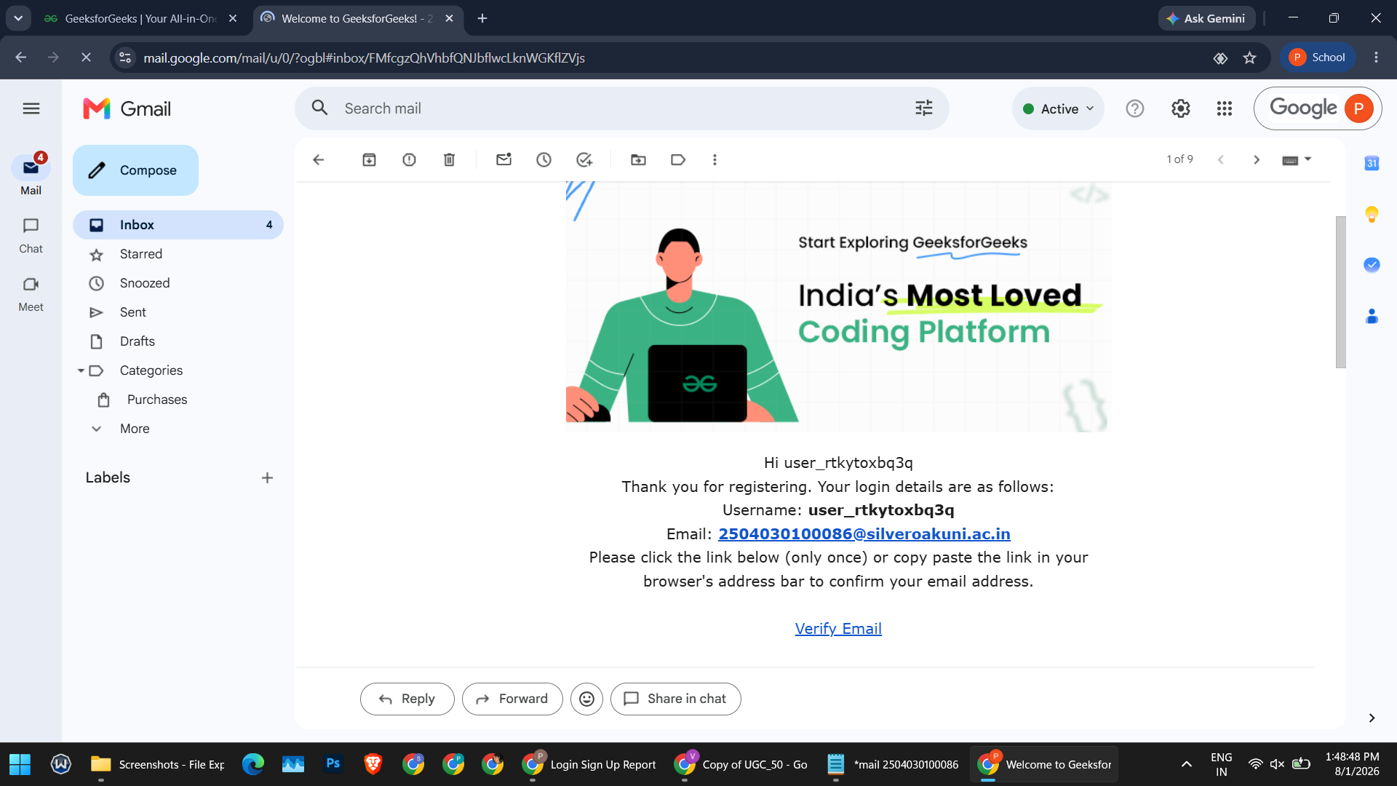

Scenario ID: 2b
Scenario: Login with valid credentials
Test Steps:
1. Navigate to the Sign In page (auth.geeksforgeeks.org)
2. Enter the registered Email and Password
3. Click Sign In
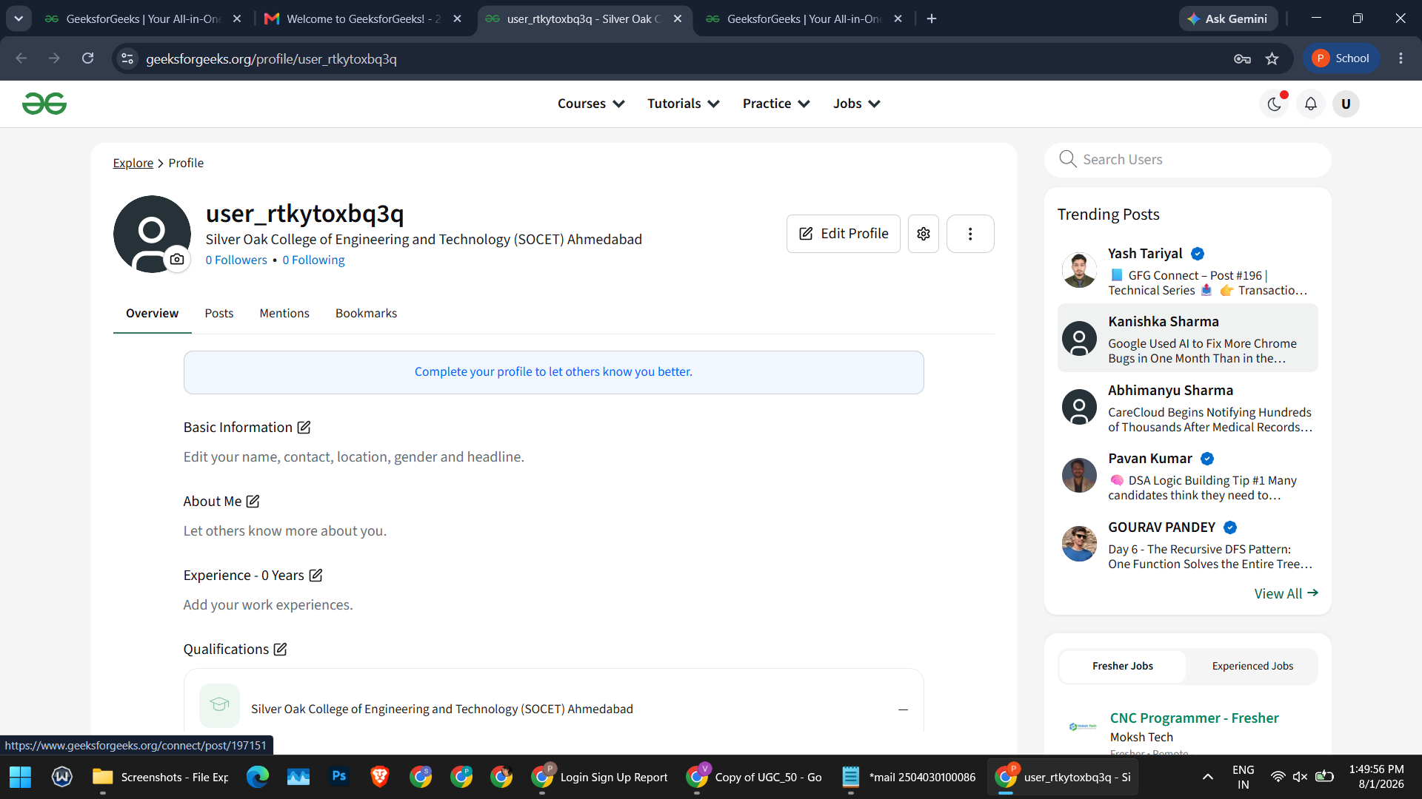
Screenshots:
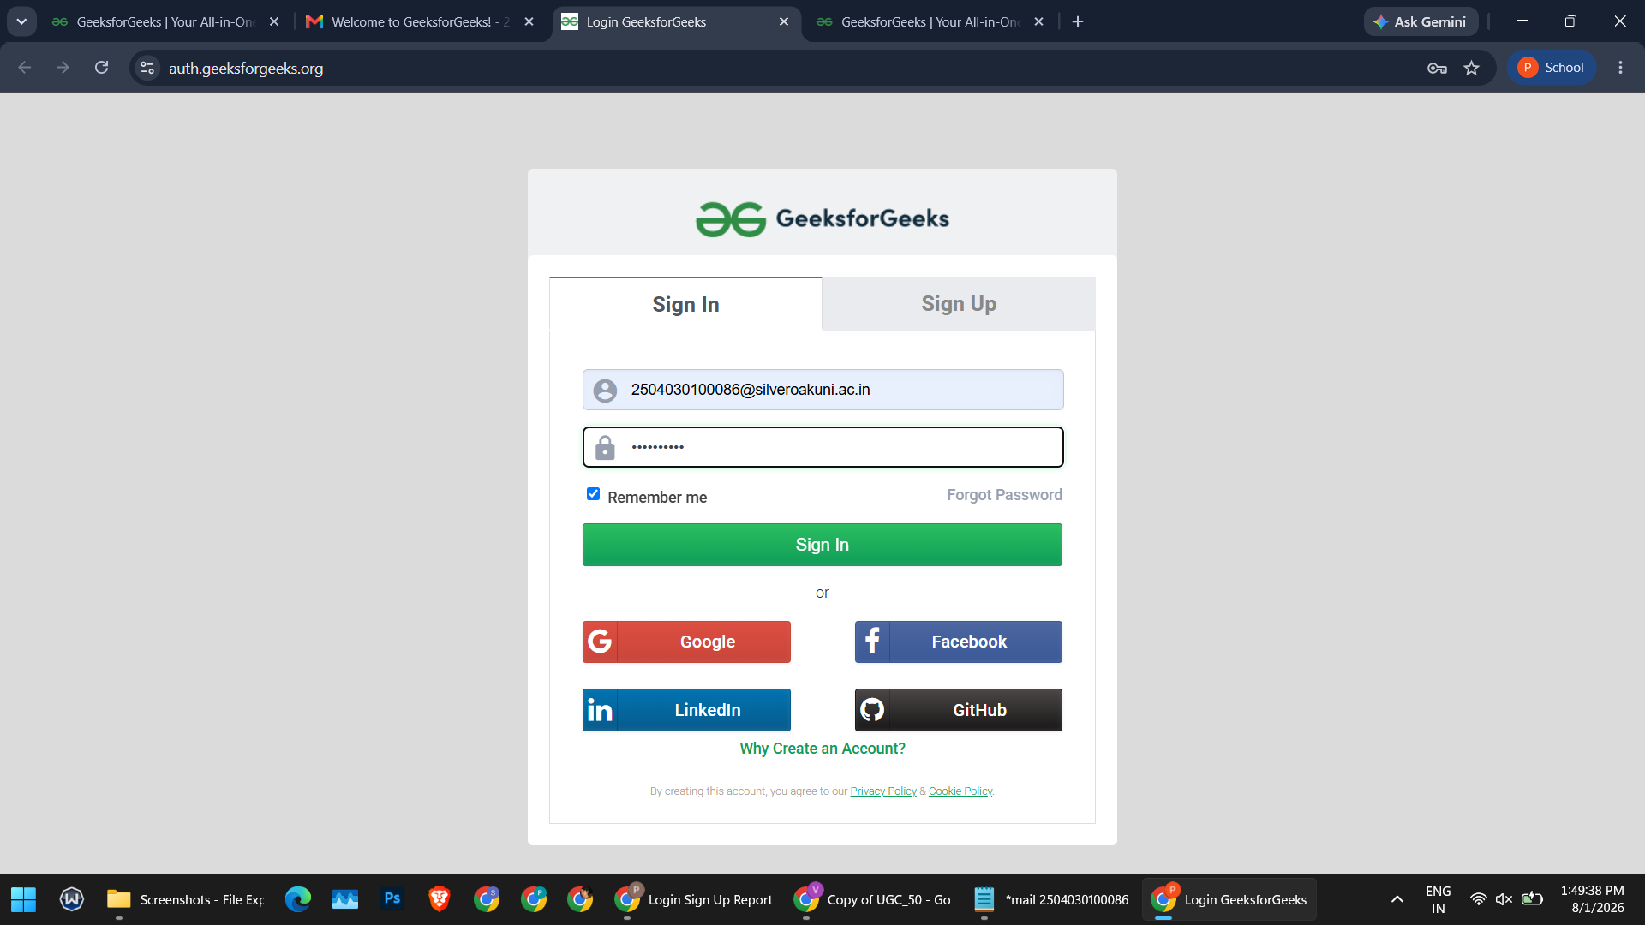

Summary Of Test Results:
Total Test Cases - 9
Passed - 8
Failed - 1
Pass % - 88.89%

Conclusion and Recommendations:
Pass Rate: 88.89% - Good, with one UX validation issue to address

Issues Found
1. Stale Validation Message (1c) - After correcting the password to meet the 8-character minimum, the "Password can not be less than 8 characters" error message remained on screen instead of clearing or re-validating live.

Recommendations
1. Add Live Field Re-validation - Clear or refresh the password error message as soon as the input satisfies the length requirement, instead of only re-checking on the next form submission.

Bug Reports:

Bug ID | BUG-1c
Title | Password validation error message does not refresh live
Module | Sign Up
Severity | Low
Steps to Reproduce | 1. Trigger the "Password can not be less than 8 characters" error 2. Update the password field to a valid, 8+ character password 3. Observe the error banner
Expected Result | Error banner clears or updates once the password meets the minimum length
Actual Result | Old error message remains visible even though the password is now valid
1.

