GeeksforGeeks Website
Test Plan, RTM & Test Strategy
Module Name: GeeksforGeeks Website
Test Case ID: TC_PLAN_001
Tester Name: Gewani Piyush C.
Webpage URL: https://www.geeksforgeeks.org/
Browser: Google Chrome
Test Cases
SCN-001 — Verify Home Page Loads
1. Open Google Chrome.
2. Navigate to https://www.geeksforgeeks.org/.
3. Wait for the page to load.
Status: Pass
Actual Result: Homepage loaded successfully with the 'Start Your Learning Today!' banner and course listings displayed.
Screenshot:
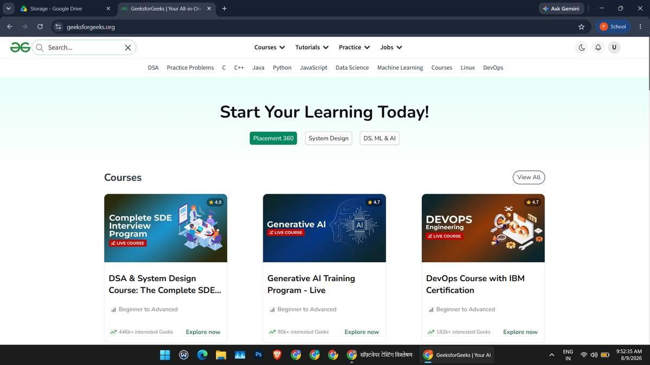
SCN-002 — Verify Search Functionality
1. Click the search box on the homepage.
2. Enter "Python".
3. Select a suggestion or press Enter.
4. Verify the search results page.
Status: Pass
Actual Result: Autosuggest showed "Pythons" while typing; the search results page returned relevant Python tutorial and article links.
Screenshot:
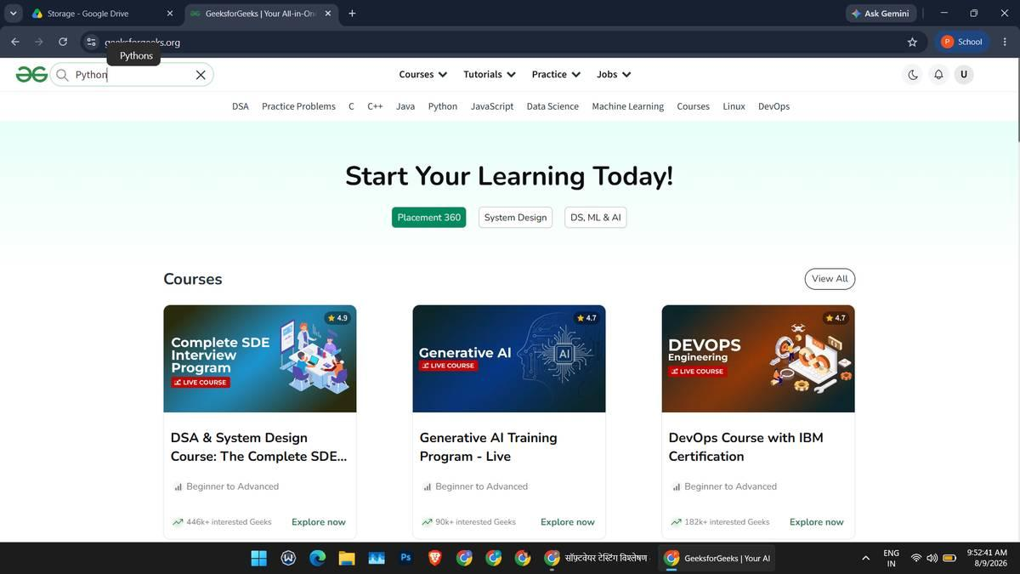
Search autosuggest while typing "Python"
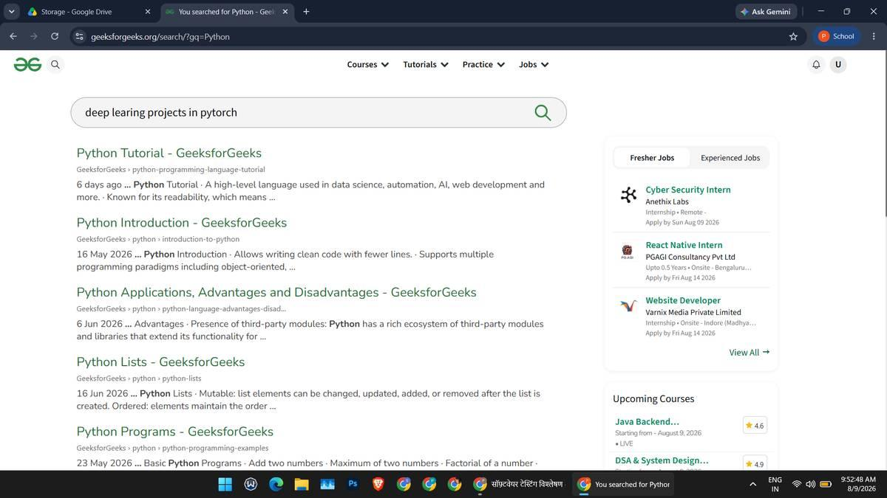
Search results page
SCN-003 — Verify Tutorial Page Opens
1. Open GeeksforGeeks.
2. Navigate to the Python Tutorial page.
3. Verify the tutorial content loads.
Status: Pass
Actual Result: Python Tutorial page opened successfully, showing the introduction, applications diagram, and topic sidebar.
Screenshot:
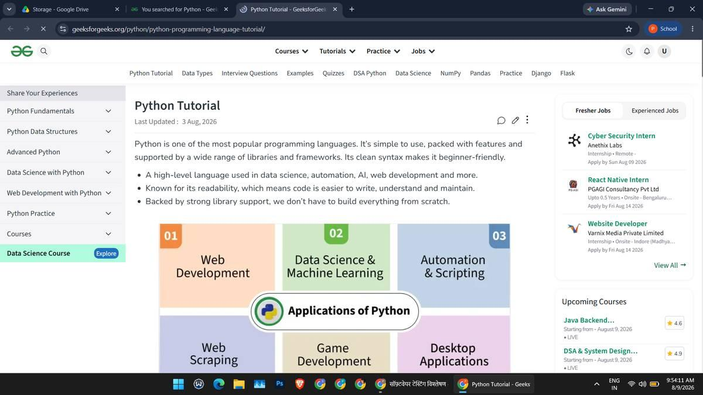
SCN-004 — Verify Practice Section Navigation
1. Click the Practice menu.
2. Verify dropdown options (Summer Skillup, Practice Coding Problems, Problem of the Day, Connect 1:1 with Experts).
3. Open the GeeksforGeeks Practice info page.
Status: Pass
Actual Result: Practice dropdown displayed all four options; the Practice info page loaded with platform details (GfG 160, Topic Wise practice, POTD).
Screenshot:
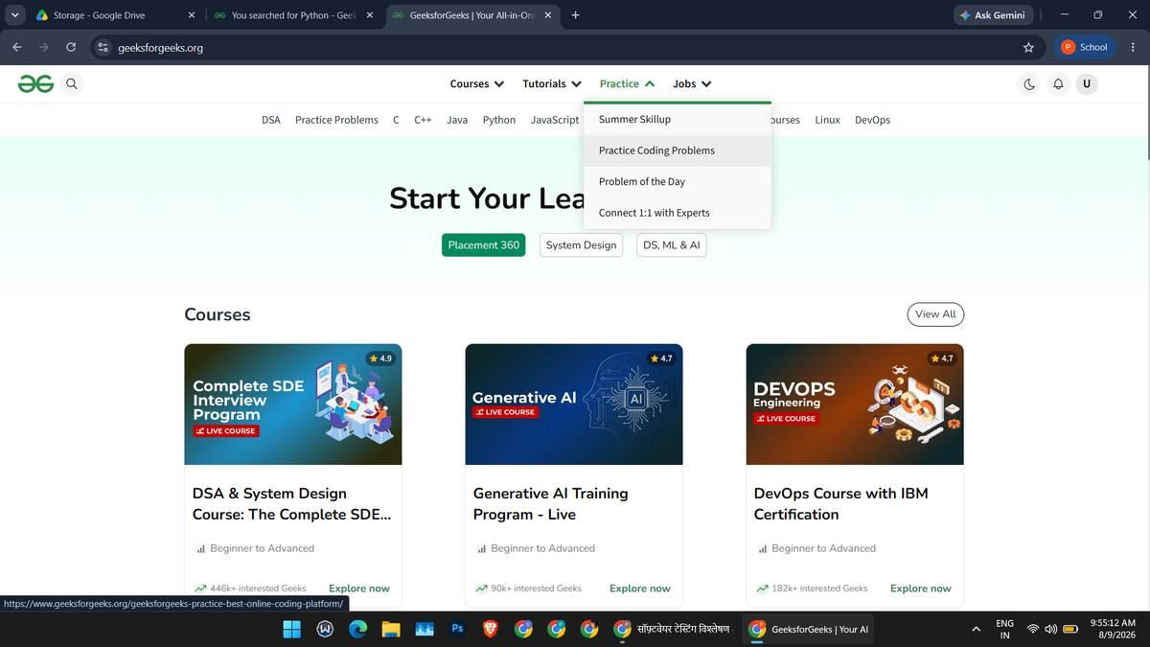
Practice dropdown menu
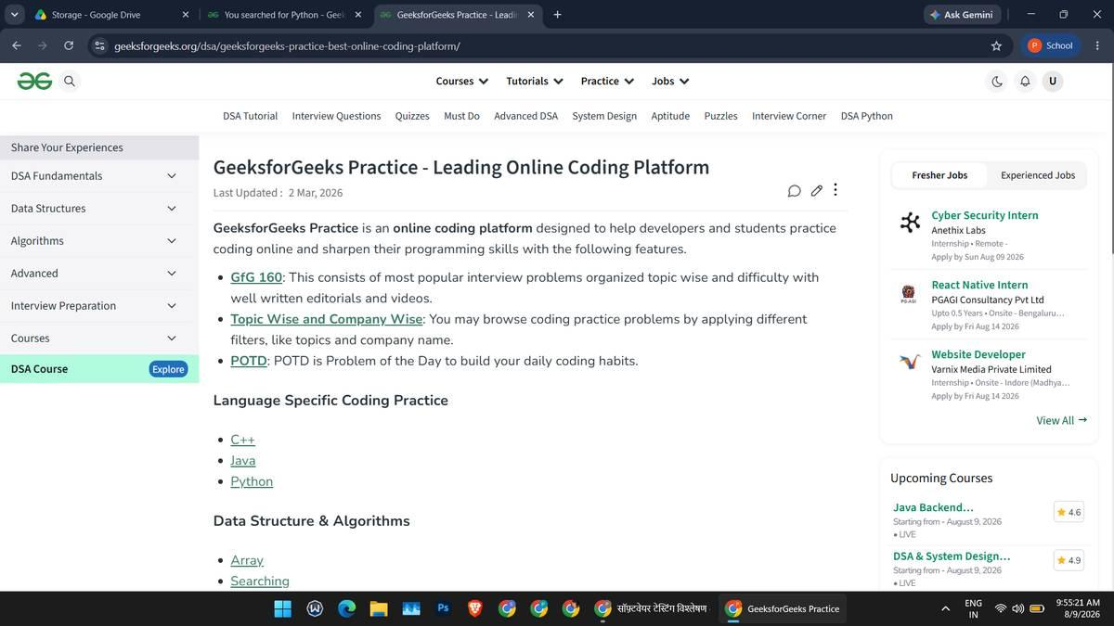
GeeksforGeeks Practice info page
SCN-005 — Verify Practice Problems Listing
1. Open Practice Coding Problems.
2. Filter problems by Category (Java).
3. Verify the problem list loads with difficulty and success rate.
Status: Pass
Actual Result: 'All Problems' list displayed with the Java category filter applied; 'Convert String to Lower Case' was visible with a 75.27% success rate.
Screenshot:
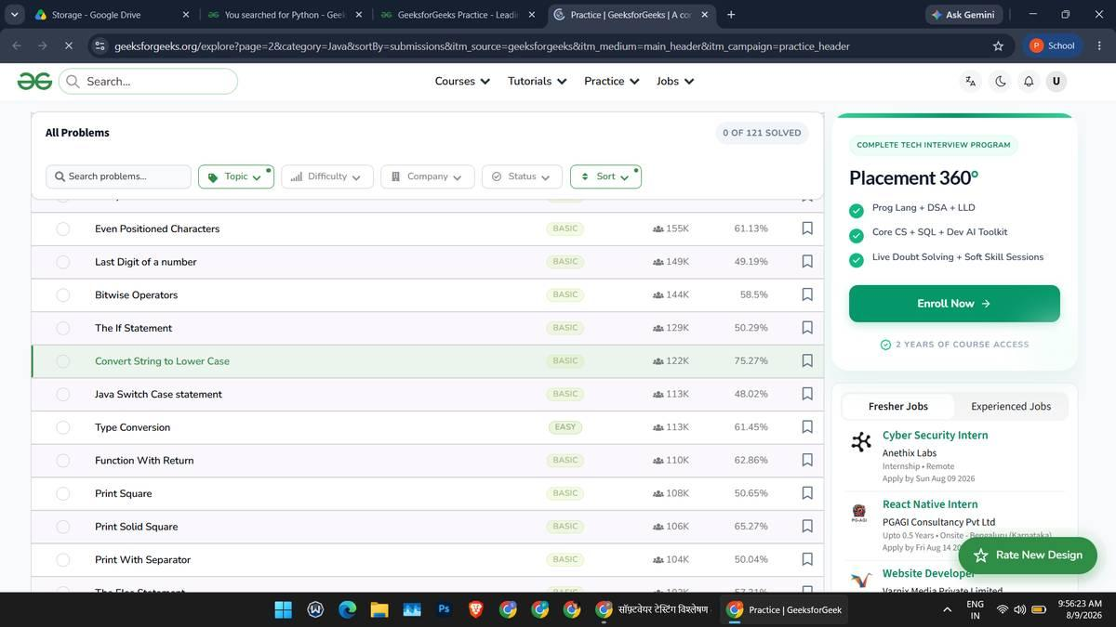
SCN-006 — Verify Coding Problem Execution — Correct Output
1. Open the 'Convert String to Lower Case' problem.
2. Write the correct Java solution using s.toLowerCase().
3. Click Compile & Run.
4. Verify the output against the expected output.
Status: Pass
Actual Result: Compilation completed successfully; Your Output "abcdde" matched the Expected Output "abcdde" for Case 1.
Screenshot:
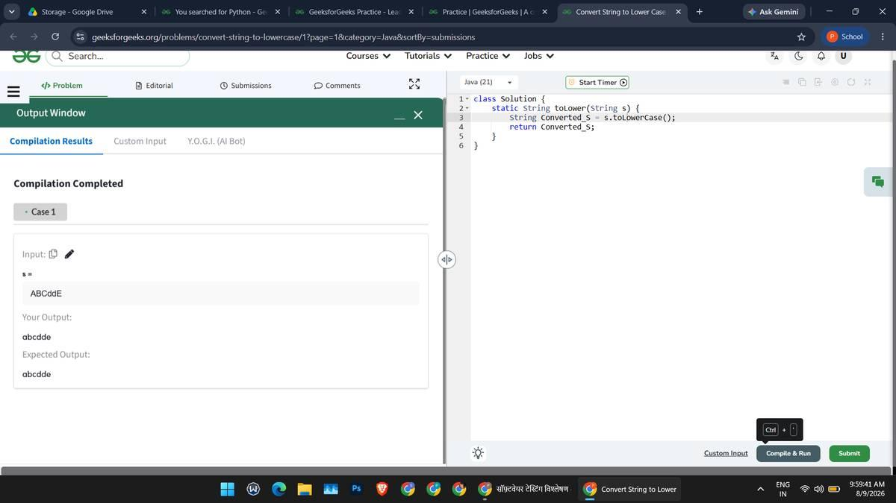
SCN-007 — Verify Compilation Error Handling — Case Sensitivity
1. Open the same problem.
2. Enter code with an incorrect method case: s.tolowerCase() instead of s.toLowerCase().
3. Click Compile & Run.
4. Verify the compilation error message.
Status: Pass
Actual Result: Compilation Error displayed: "cannot find symbol — method tolowerCase()", correctly identifying the case-sensitivity issue.
Screenshot:
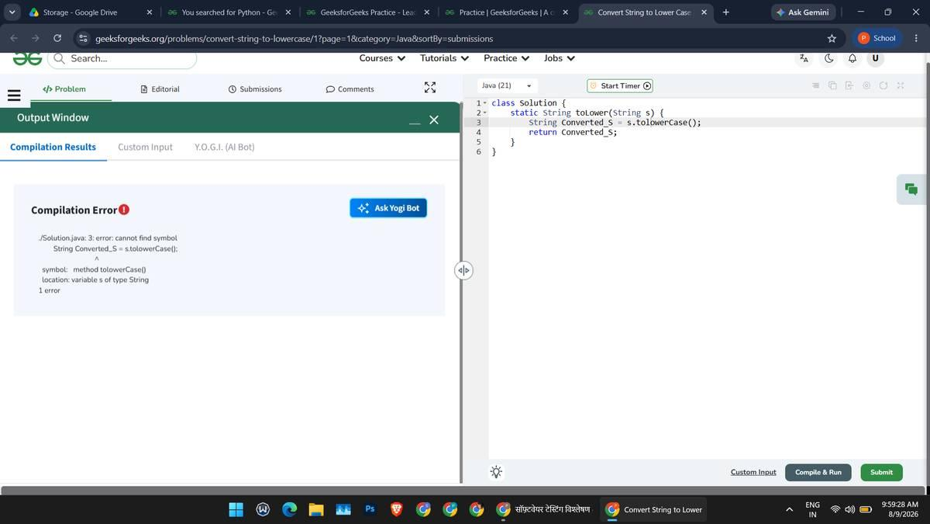
SCN-008 — Verify Compilation Error Handling — Wrong Language Selected
1. Keep the Java solution code in the editor.
2. Switch the language selector to C (gcc 5.4).
3. Click Compile & Run.
4. Verify the compilation error message.
Status: Pass
Actual Result: Compilation Error displayed: "unknown type name 'class'", correctly rejecting Java syntax under the C compiler.
Screenshot:
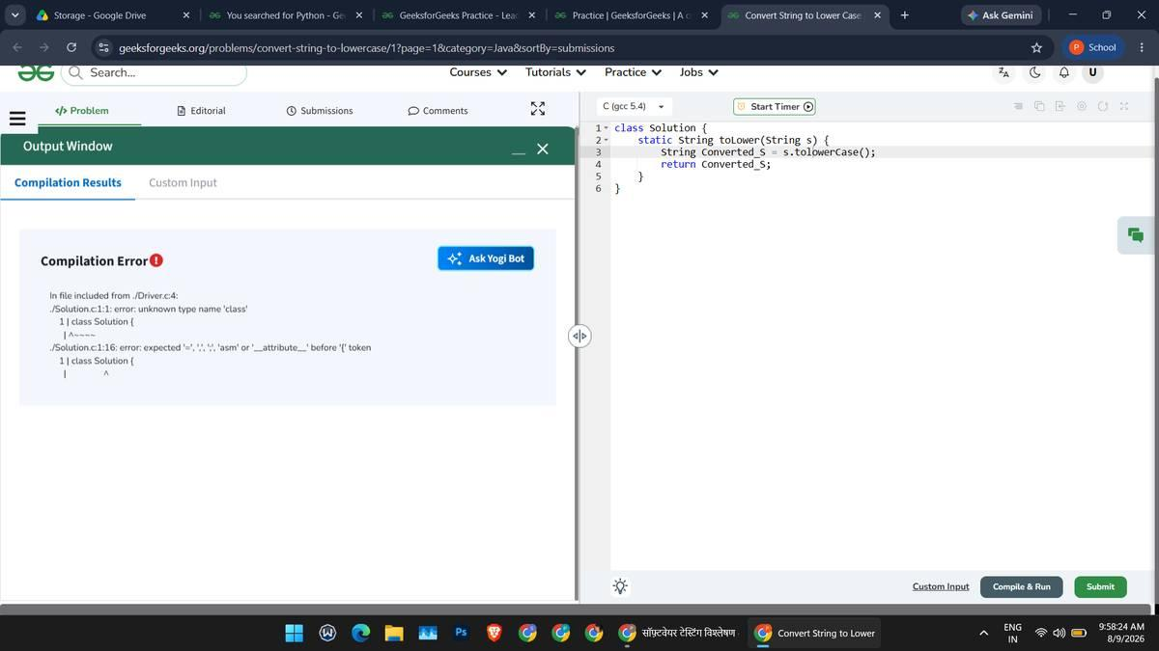
SCN-009 — Verify Courses Section
1. Click the Courses menu.
2. Verify dropdown categories (DSA/Placements, DA/Data Science & AI, Development, DevOps, GATE Prep, All Courses).
3. Open the Courses page.
Status: Pass
Actual Result: Courses dropdown displayed all six categories; the Courses page loaded showing the 'Popular Now' section with pricing and ratings.
Screenshot:
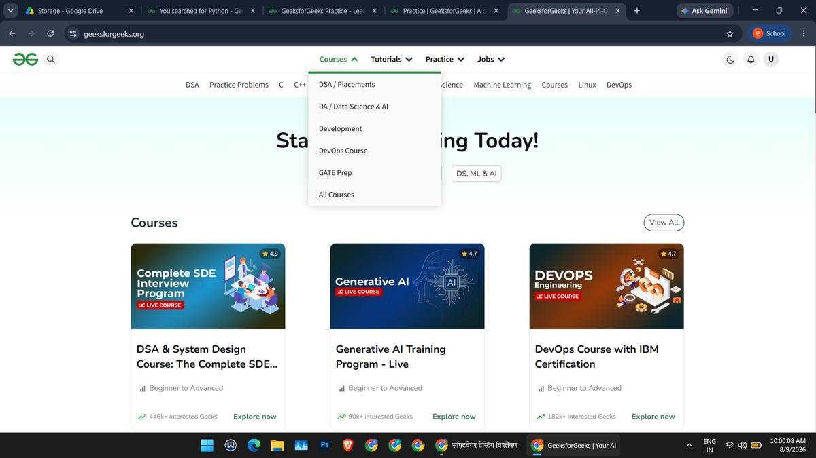
Courses dropdown menu
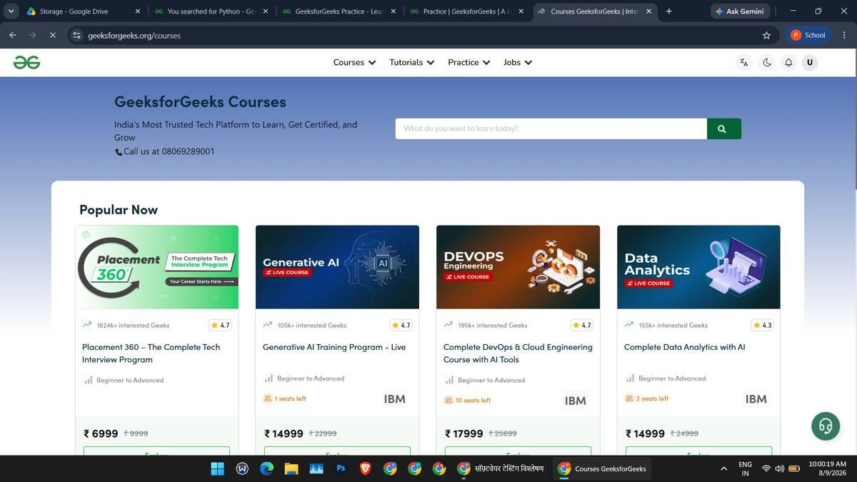
Courses listing page
SCN-010 — Verify Contact Us Page
1. Navigate to the About / footer section.
2. Click Contact Us.
3. Verify the Contact Us page opens with the feedback form and location map.
Status: Pass
Actual Result: Contact Us page opened successfully showing the 'Feedback and Queries' form fields and an embedded location map.
Screenshot:
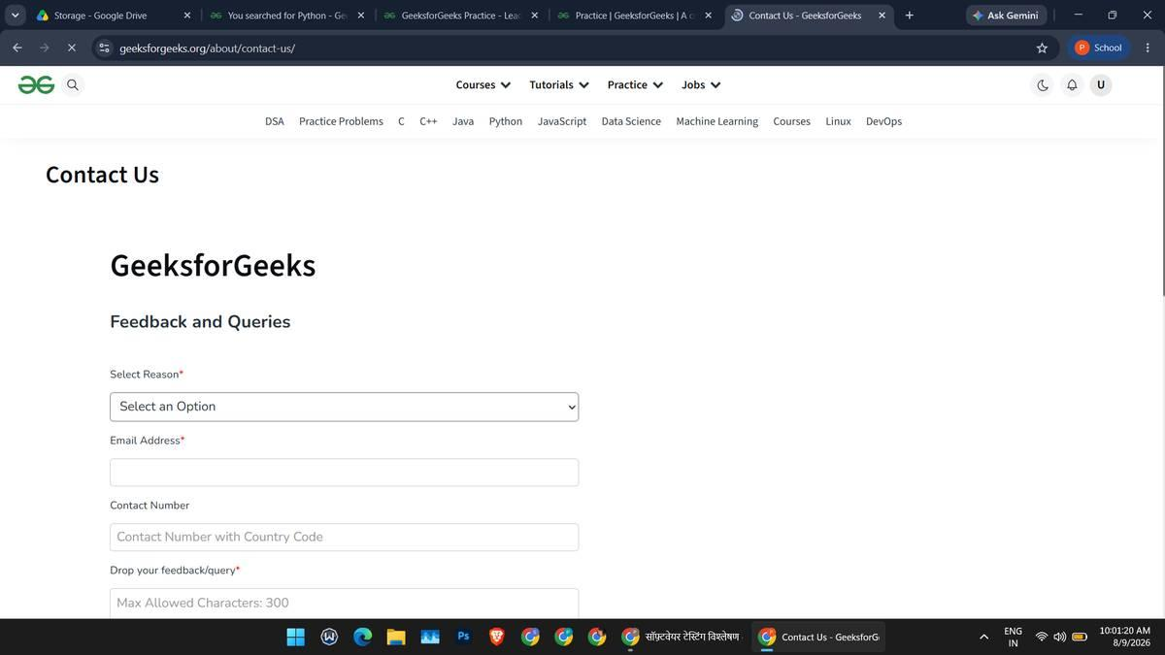
Contact Us page loading
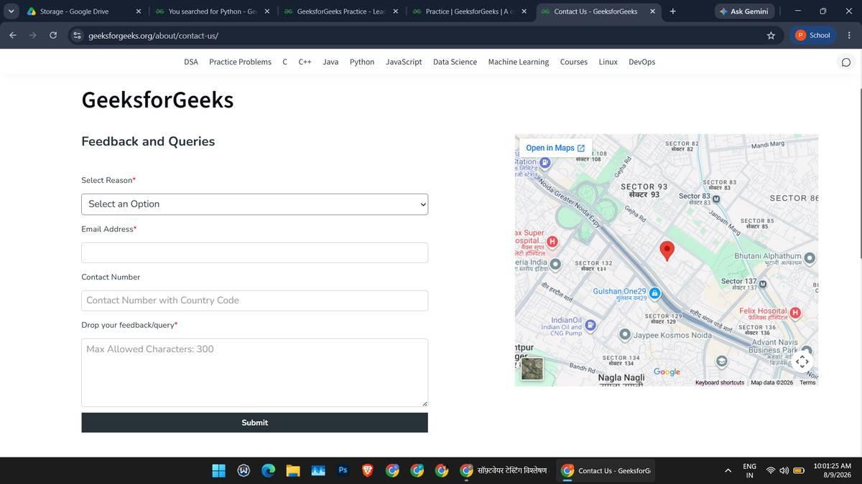
Contact Us page with map loaded
Summary of Test Results
Total Test Cases: 10
Passed: 10
Failed: 0
Pass %: 100%
All 10 planned test scenarios were executed successfully with a 100% pass rate, covering Home Page, Search, Tutorials, Practice navigation, Practice Problems listing, Coding Problem execution (including negative case-sensitivity and wrong-language error handling), Courses, and Contact Us functionality. Every requirement in the RTM is fully traced to an executed test case.

