SOFTWARE TESTING LAB REPORT
TUTORIAL – 11
Python Automation Testing

1. Aim
To analyze automation testing in Python for website navigation, forms, multi-page workflows, links, and regression testing scenarios.

2. Description
Automation testing uses software tools to execute test cases automatically. This practical uses Python and Selenium WebDriver in PyCharm with Google Chrome to automate navigation, login, product selection, cart operations, checkout, validation, and regression-related navigation.

3. Problem Statement
Develop and execute a Python Selenium script that opens a website, handles login, interacts with links and products, navigates through the cart and checkout pages, validates the workflow, and performs back/forward navigation.

4. Implementation Details
Parameter | Details
Project Name | Python Automation Testing
Application | SauceDemo Web Application
Module | Navigation, Forms, Links and Multi-Page Workflow
SDLC Model | Agile
Language | Python
IDE | PyCharm
Automation Tool | Selenium WebDriver
Browser | Google Chrome
Test Data | Username, password, product and checkout details

5. Software and Environment Requirements
Python 3.x, PyCharm IDE, Google Chrome, Selenium Python library, internet connection, and Selenium WebDriver. Install Selenium from the PyCharm terminal using:
pip install selenium

6. Procedure
- Open PyCharm and create a project named SoftwareTesting.
- Create a Python file named tutorial11.py.
- Install Selenium in the PyCharm terminal using: pip install selenium.
- Import WebDriver, locator, wait and expected-condition modules.
- Launch Chrome and open https://www.saucedemo.com/.
- Log in with standard_user and secret_sauce.
- Verify that the inventory/products page opens.
- Add Sauce Labs Backpack to the cart and open the cart.
- Proceed to checkout and enter first name, last name and postal code.
- Continue and verify the checkout overview page.
- Use browser back and forward navigation, then close the browser.

7. Source Code
The following code is a clean, report-ready implementation of the workflow described in the supplied tutorial. Run it in your own environment and record your actual results.
from selenium import webdriver
from selenium.webdriver.common.by import By
from selenium.webdriver.support.ui import WebDriverWait
from selenium.webdriver.support import expected_conditions as EC

driver = webdriver.Chrome()
driver.maximize_window()
wait = WebDriverWait(driver, 10)

try:
driver.get("https://www.saucedemo.com/")
print("Website opened successfully")

wait.until(EC.visibility_of_element_located(
(By.ID, "user-name"))).send_keys("standard_user")
driver.find_element(By.ID, "password").send_keys("secret_sauce")
driver.find_element(By.ID, "login-button").click()

wait.until(EC.url_contains("inventory"))
assert "inventory" in driver.current_url
print("Login Test: PASS")

wait.until(EC.element_to_be_clickable(
(By.ID, "add-to-cart-sauce-labs-backpack"))).click()
print("Product Selection: PASS")

driver.find_element(By.CLASS_NAME, "shopping_cart_link").click()
assert "cart" in driver.current_url
print("Cart Navigation: PASS")

driver.find_element(By.ID, "checkout").click()
wait.until(EC.visibility_of_element_located(
(By.ID, "first-name"))).send_keys("Student")
driver.find_element(By.ID, "last-name").send_keys("Testing")
driver.find_element(By.ID, "postal-code").send_keys("380001")
driver.find_element(By.ID, "continue").click()

wait.until(EC.url_contains("checkout-step-two"))
assert "checkout-step-two" in driver.current_url
print("Multi-Page Workflow: PASS")

driver.back()
driver.forward()
print("Back/Forward Navigation: PASS")
finally:
driver.quit()

print("Tutorial 11 completed")

8. Test Cases / Execution Plan
Test Case ID | Scenario | Test Data / Expected Result | Actual Result / Status
TC-11-01 | Open website | Login page is displayed | Record after execution
TC-11-02 | Valid login | Products page opens | Record after execution
TC-11-03 | Select product | Product is added to cart | Record after execution
TC-11-04 | Open cart | Cart page opens | Record after execution
TC-11-05 | Checkout form | Checkout overview opens after valid details | Record after execution
TC-11-06 | Back/forward navigation | Browser navigates between workflow pages | Record after execution

Note: Enter the actual result and Pass/Fail status after executing the script. The reports do not claim that the code was executed in your local environment.

9. Observations
- Website navigation and login are automated.
- A product is selected and verified through cart navigation.
- Checkout form fields are completed and the next checkout page is validated.
- Back/forward browser navigation is exercised.

10. Screenshot Evidence

11. Result
The test workflow is designed to verify the scenarios listed in this report. Record the final result after running the code and checking the browser and console output.

12. Conclusion
The practical demonstrates end-to-end web automation using Python and Selenium WebDriver, including login, product selection, cart and checkout navigation, assertions, and browser history navigation.
PyCharm — Python Automation Testing
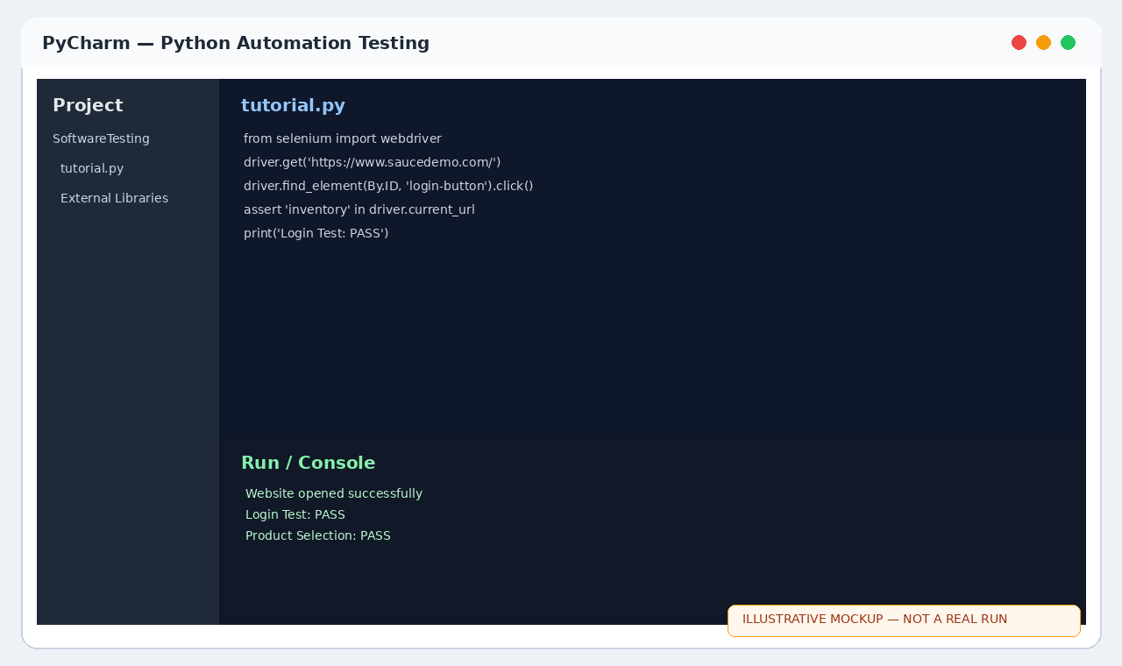
Chrome — SauceDemo Products
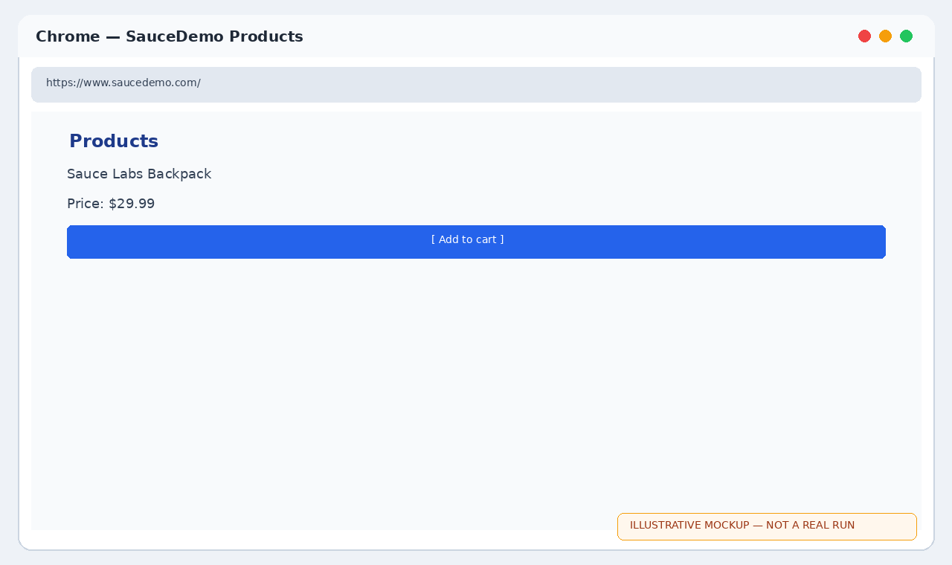
Chrome — SauceDemo Checkout
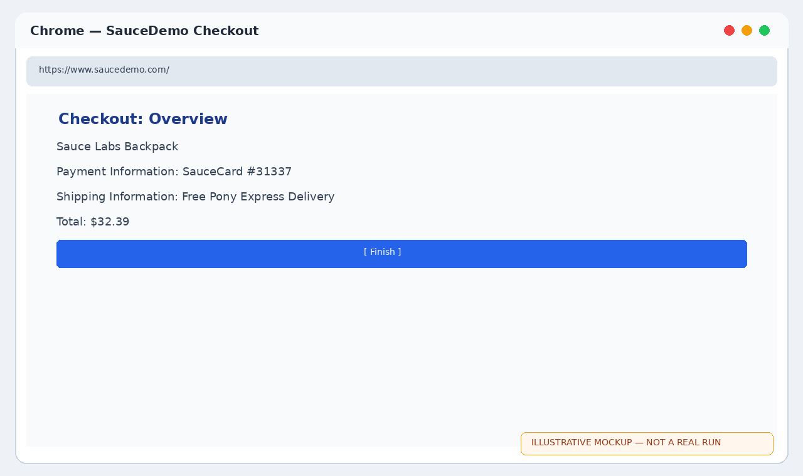
PyCharm — Tutorial 11 code and output
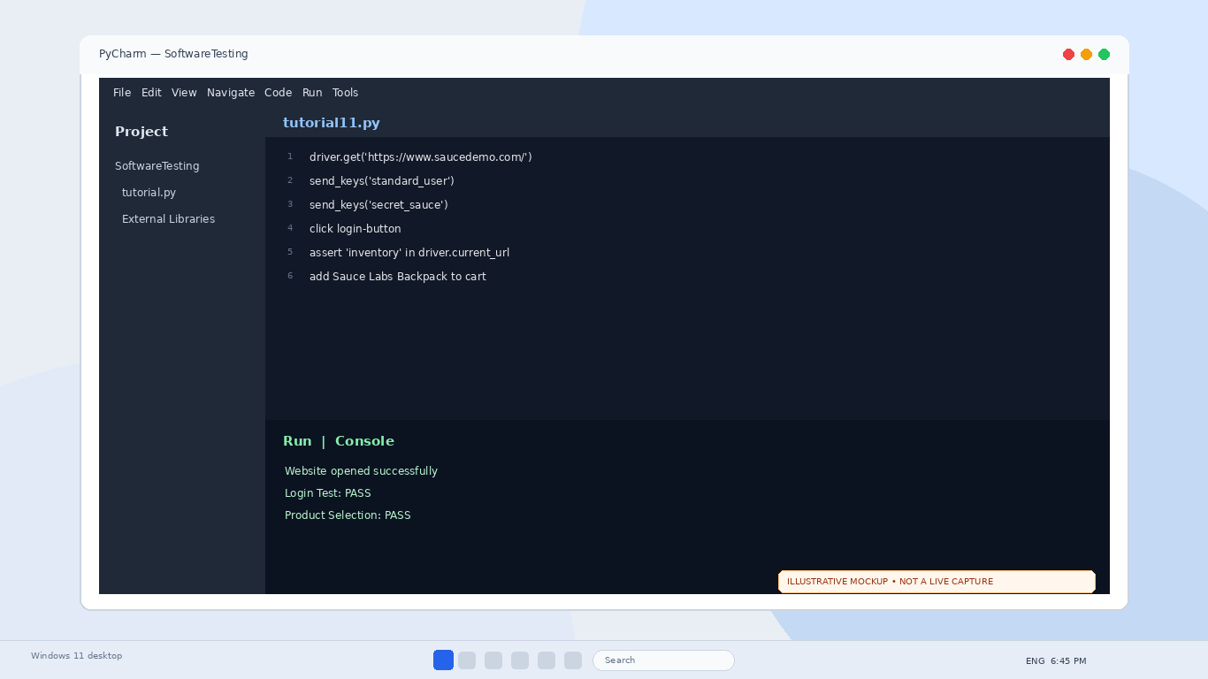
Chrome — SauceDemo cart
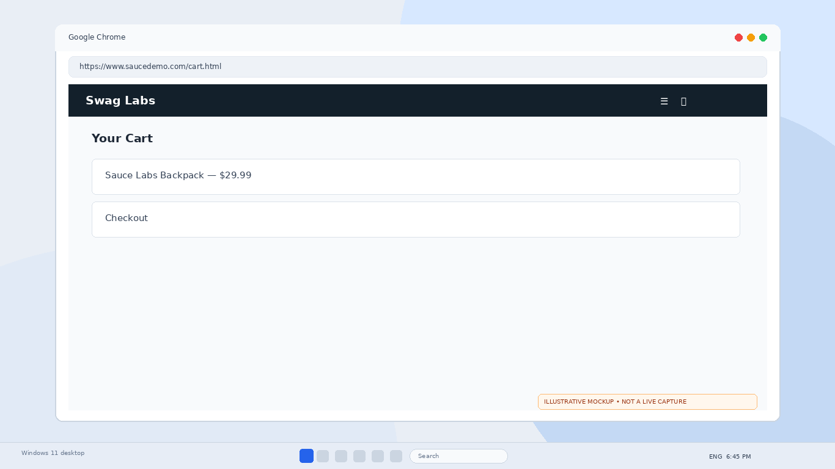
Chrome — Checkout information
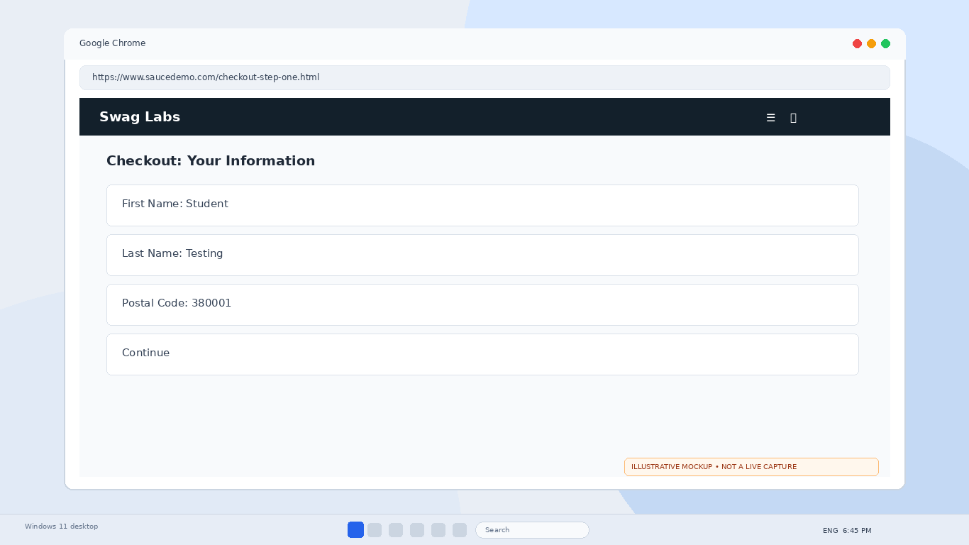
PyCharm — Tutorial 11
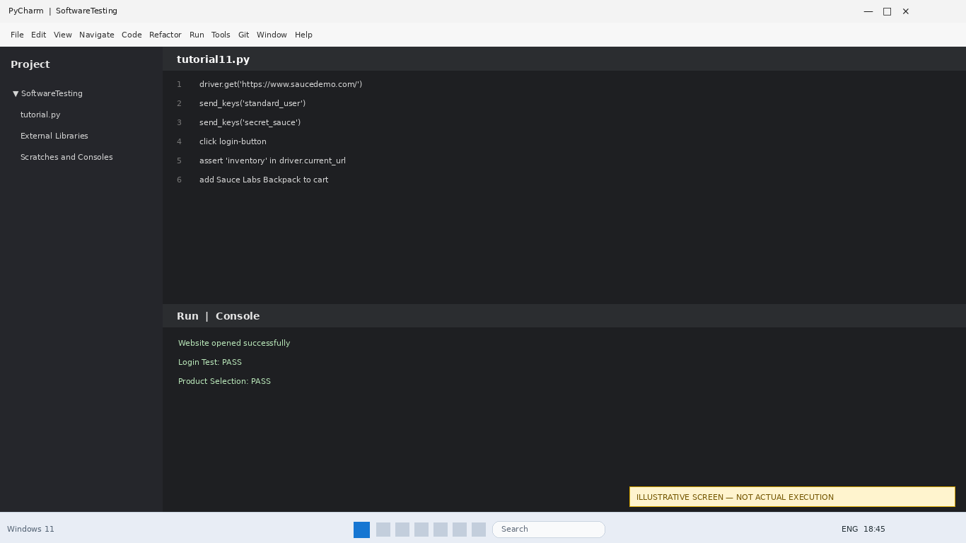
SauceDemo cart
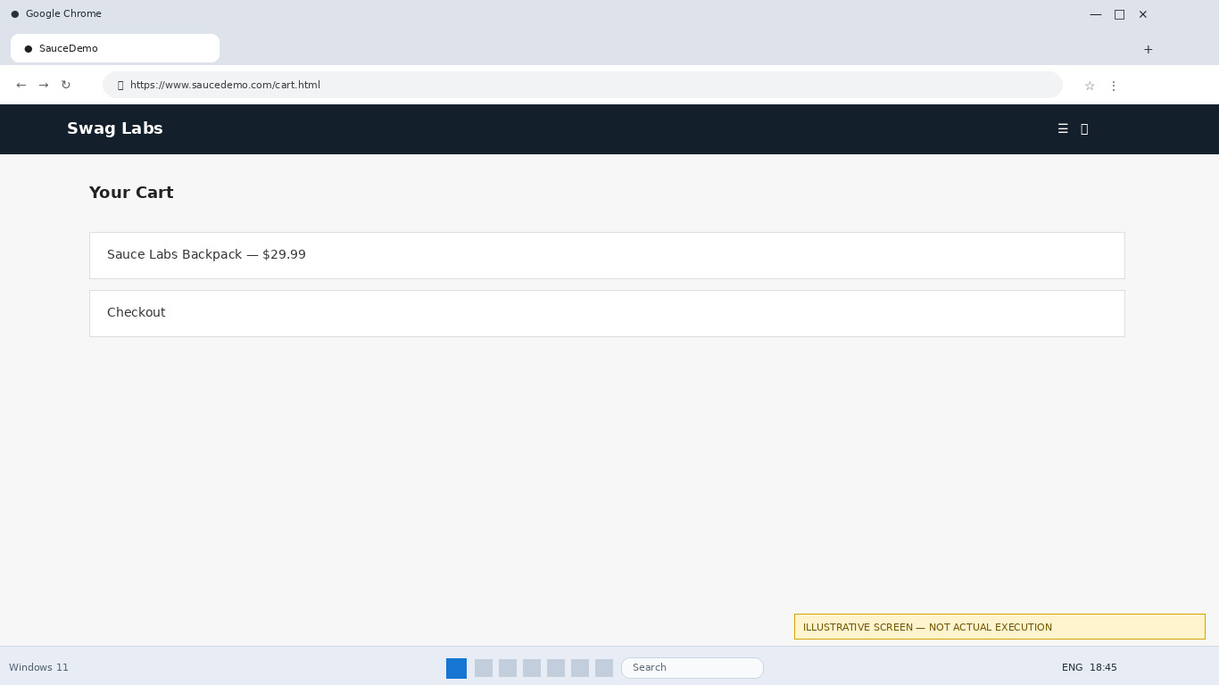
SauceDemo checkout
