SOFTWARE TESTING LAB REPORT
TUTORIAL – 12
AI-Powered Software Testing

1. Aim
To analyze AI-powered software testing and apply Generative AI for requirement analysis, test-case and test-data generation, defect prediction, Selenium script generation, review, execution, and regression planning.

2. Description
Generative AI can assist testers by proposing scenarios, test cases, test data, likely defect-prone areas, and automation scripts. AI-generated content must be reviewed and corrected by a human before execution.

3. Problem Statement
For a requirement that valid users can log in and invalid credentials must be rejected with an appropriate message, use Generative AI to analyze the requirement, generate positive and negative tests and data, identify defect-prone areas, prepare Selenium code, review it, execute it in PyCharm, and plan regression tests.

4. Implementation Details
Parameter | Details
Project Name | AI-Powered Software Testing
Application | SauceDemo
Module | Login and Authentication
SDLC Model | Agile
Language | Python
IDE | PyCharm
AI Tool | Generative AI
Automation Tool | Selenium WebDriver
Browser | Google Chrome
Target URL | https://www.saucedemo.com/

5. Software and Environment Requirements
Python 3.x, PyCharm IDE, Google Chrome, Selenium Python library, internet connection, and Selenium WebDriver. Install Selenium from the PyCharm terminal using:
pip install selenium

6. Procedure
- Open a Generative AI tool and provide the login requirement.
- Ask it to generate positive and negative test cases, test data, expected results, regression scenarios, defect-prone areas, and Selenium Python code.
- Review the generated scenarios, expected results, locators, Python syntax, assertions and exception handling.
- Create a PyCharm project and install Selenium using pip install selenium.
- Place the reviewed code in a Python file and execute it.
- Compare actual results with expected results and record observations.
- Retain important login scenarios for regression testing after changes.

7. Source Code
The following code is a clean, report-ready implementation of the workflow described in the supplied tutorial. Run it in your own environment and record your actual results.
from selenium import webdriver
from selenium.webdriver.common.by import By
from selenium.webdriver.support.ui import WebDriverWait
from selenium.webdriver.support import expected_conditions as EC

URL = "https://www.saucedemo.com/"

def check_login(username, password, should_pass):
driver = webdriver.Chrome()
driver.maximize_window()
wait = WebDriverWait(driver, 10)
try:
driver.get(URL)
wait.until(EC.visibility_of_element_located(
(By.ID, "user-name"))).send_keys(username)
driver.find_element(By.ID, "password").send_keys(password)
driver.find_element(By.ID, "login-button").click()

if should_pass:
wait.until(EC.url_contains("inventory"))
assert "inventory" in driver.current_url
print("Valid login: PASS")
else:
error = wait.until(EC.visibility_of_element_located(
(By.CSS_SELECTOR, "h3[data-test='error']")))
assert error.text
print("Negative login rejected: PASS")
finally:
driver.quit()

check_login("standard_user", "secret_sauce", True)
check_login("standard_user", "wrong123", False)
check_login("wrong_user", "secret_sauce", False)
check_login("", "", False)

8. Test Cases / Execution Plan
Test Case ID | Scenario | Test Data / Expected Result | Actual Result / Status
TC-12-01 | Valid login | standard_user / secret_sauce | Login succeeds
TC-12-02 | Invalid password | standard_user / wrong123 | Error message displayed
TC-12-03 | Invalid username | wrong_user / secret_sauce | Error message displayed
TC-12-04 | Empty username | Blank / secret_sauce | Validation/error message displayed
TC-12-05 | Empty password | standard_user / Blank | Validation/error message displayed

Note: Enter the actual result and Pass/Fail status after executing the script. The reports do not claim that the code was executed in your local environment.

9. Observations
- Requirement was translated into testable login scenarios.
- Positive and negative test data were identified.
- AI-generated code and test cases require human review before execution.
- Regression tests should repeat valid login, invalid login and error-message validation after changes.

10. Screenshot Evidence

11. Result
The test workflow is designed to verify the scenarios listed in this report. Record the final result after running the code and checking the browser and console output.

12. Conclusion
The practical shows how Generative AI can accelerate test design and automation preparation while emphasizing that testers must validate AI-generated outputs before relying on them.
AI Test Design — Login Requirement — illustrative mockup
PyCharm — Reviewed Selenium Script
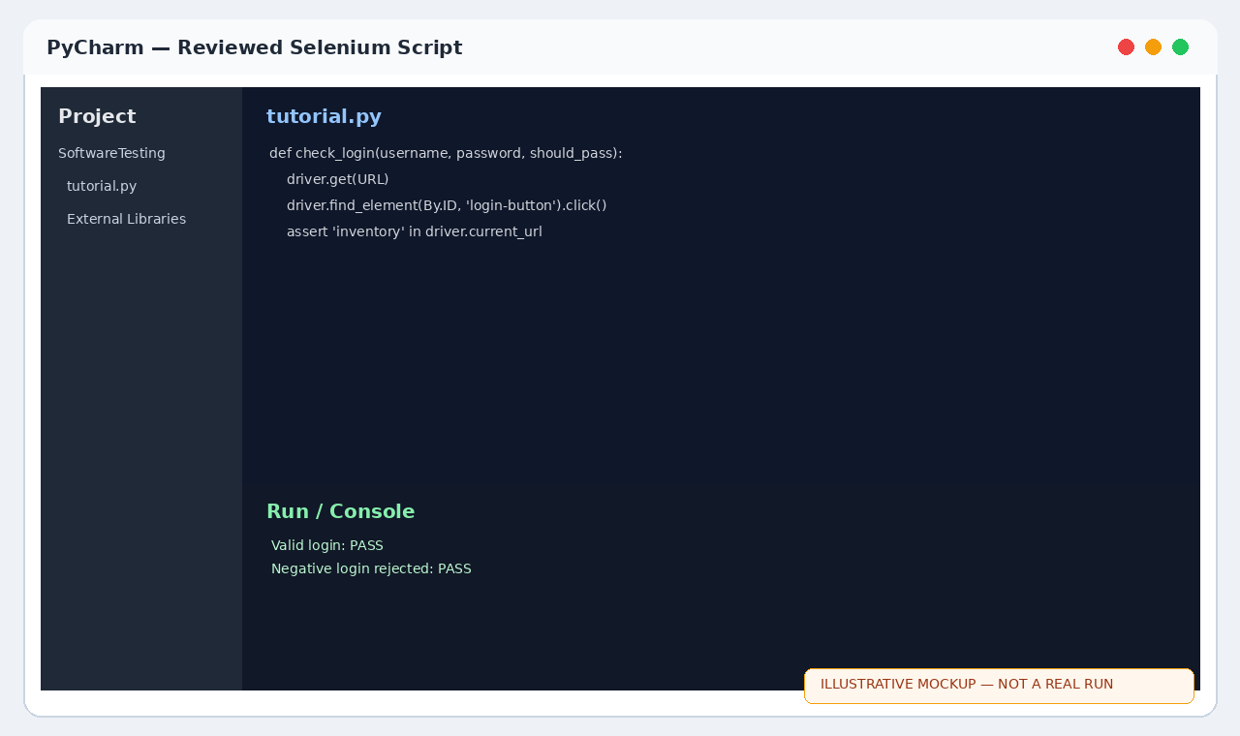
Chrome — Login Error Validation
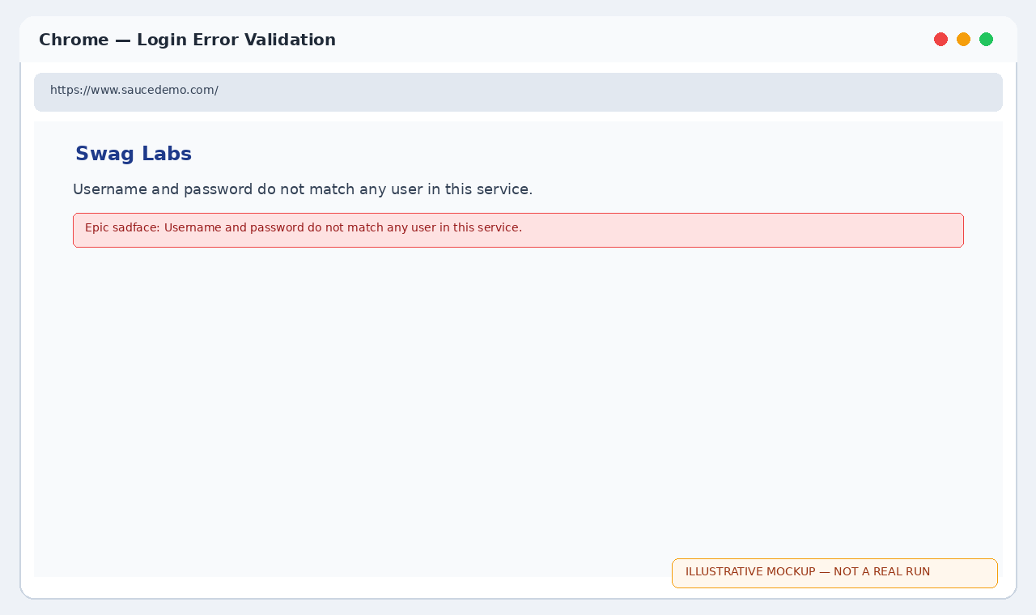
PyCharm — AI-generated test design
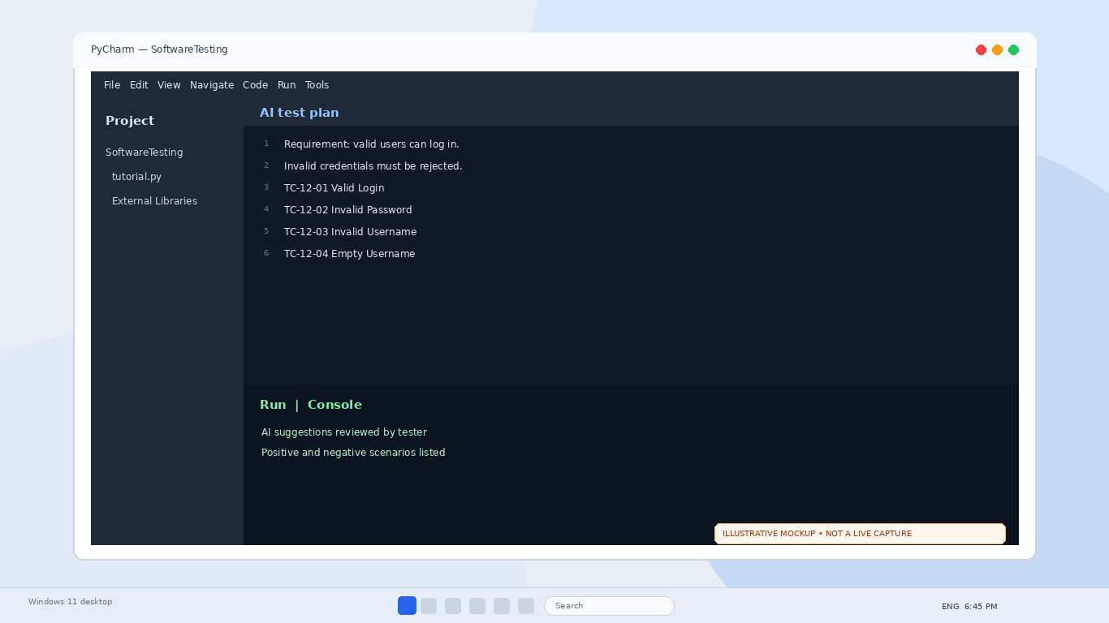
PyCharm — Selenium test execution
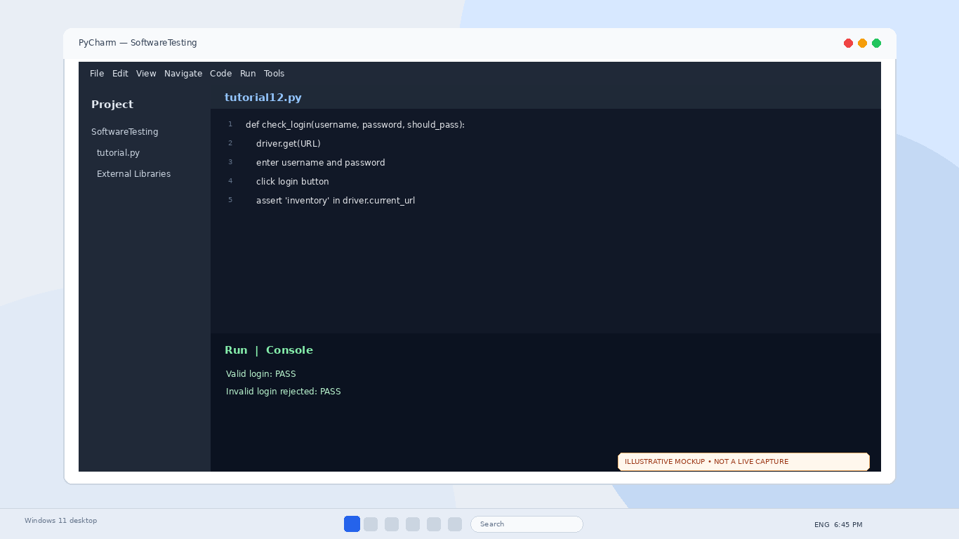
Chrome — Invalid credential message
AI test plan
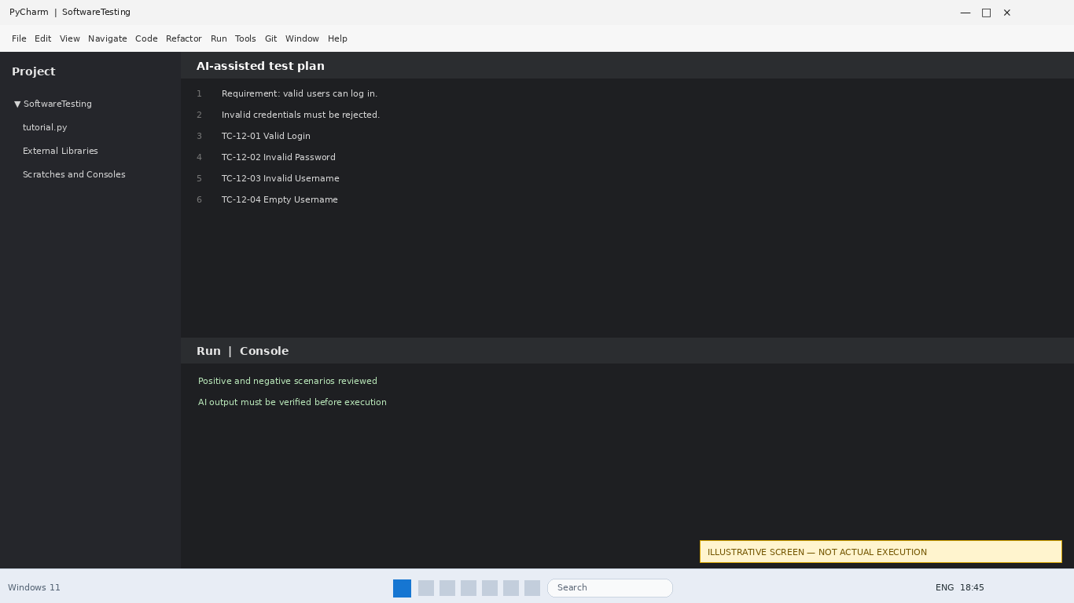
Selenium script
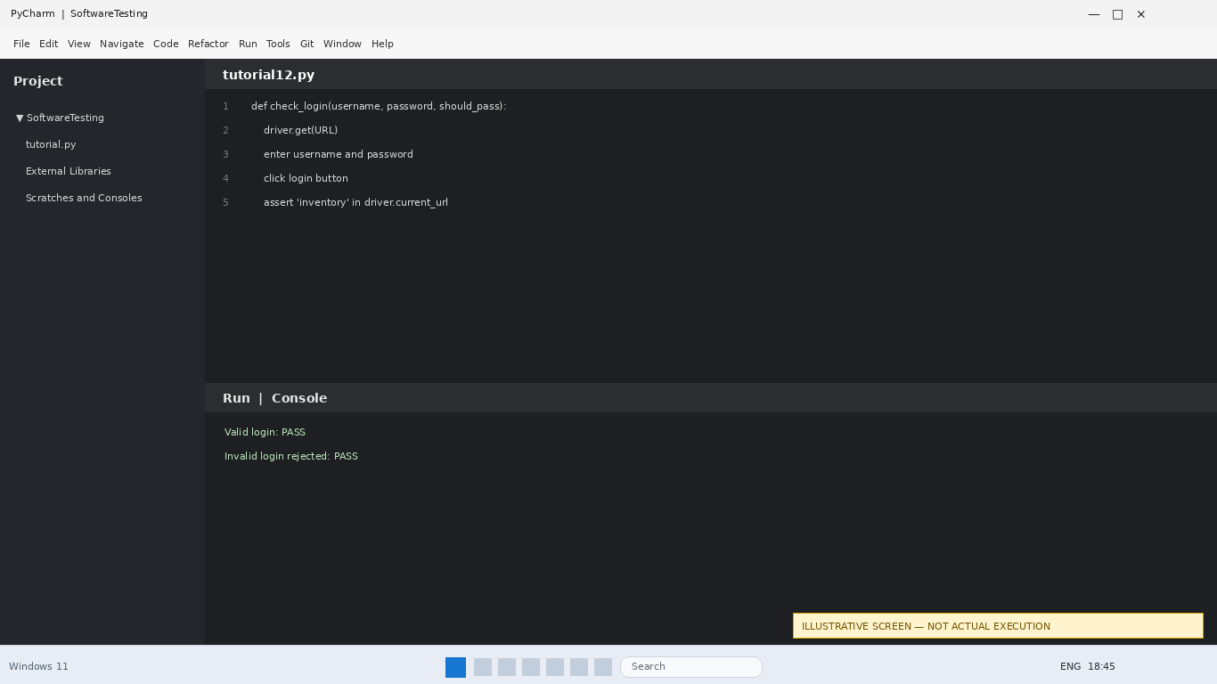
Invalid login
