SOFTWARE TESTING LAB REPORT
TUTORIAL – 13
Selenium Environment Setup

1. Aim
To configure Python, Selenium WebDriver, PyCharm IDE, browser drivers and automation libraries for Selenium testing.

2. Description
Selenium automation requires a programming environment, the Selenium library, a browser and WebDriver support. This practical configures the environment in PyCharm and verifies it by launching Chrome and opening a web page.

3. Problem Statement
Set up Python, PyCharm, Selenium WebDriver and Google Chrome, then execute a Python script that launches Chrome and opens the Selenium website.

4. Implementation Details
Parameter | Details
Project Name | Selenium Environment Setup
Application/Software | Selenium WebDriver
Module | Environment Configuration
SDLC Model | Agile
Language | Python
IDE | PyCharm
Browser | Google Chrome
Test Data | Website URL: https://www.selenium.dev/

5. Software and Environment Requirements
Python 3.x, PyCharm IDE, Google Chrome, Selenium Python library, internet connection, and Selenium WebDriver. Install Selenium from the PyCharm terminal using:
pip install selenium

6. Procedure
- Open PyCharm and create a project named SoftwareTesting.
- Select an available Python interpreter.
- Create tutorial13.py.
- Open the PyCharm terminal and run pip install selenium.
- Verify the installation using pip show selenium.
- Write the Selenium browser-launch script.
- Run tutorial13.py and observe Chrome opening the Selenium website.
- Check the PyCharm console for the title and current URL.

7. Source Code
The following code is a clean, report-ready implementation of the workflow described in the supplied tutorial. Run it in your own environment and record your actual results.
from selenium import webdriver

driver = webdriver.Chrome()
driver.maximize_window()
driver.get("https://www.selenium.dev/")

print("Browser launched successfully")
print("Page Title:", driver.title)
print("Current URL:", driver.current_url)

driver.quit()

8. Test Cases / Execution Plan
Test Case ID | Scenario | Test Data / Expected Result | Actual Result / Status
TC-13-01 | Launch Chrome using Selenium | Chrome opens and loads the website | Record after execution
TC-13-02 | Verify page title | Page title is displayed in console | Record after execution
TC-13-03 | Verify current URL | Selenium website URL is displayed | Record after execution
TC-13-04 | Close browser | Browser session closes successfully | Record after execution

Note: Enter the actual result and Pass/Fail status after executing the script. The reports do not claim that the code was executed in your local environment.

9. Observations
- Python interpreter and PyCharm project are configured.
- Selenium is installed through pip.
- Chrome is launched through WebDriver.
- The requested website title and URL are printed in the console.

10. Screenshot Evidence

11. Result
The test workflow is designed to verify the scenarios listed in this report. Record the final result after running the code and checking the browser and console output.

12. Conclusion
The practical verifies the basic Selenium environment and confirms that Python can control Chrome to open a website and retrieve browser information.
PyCharm Terminal — Selenium Setup
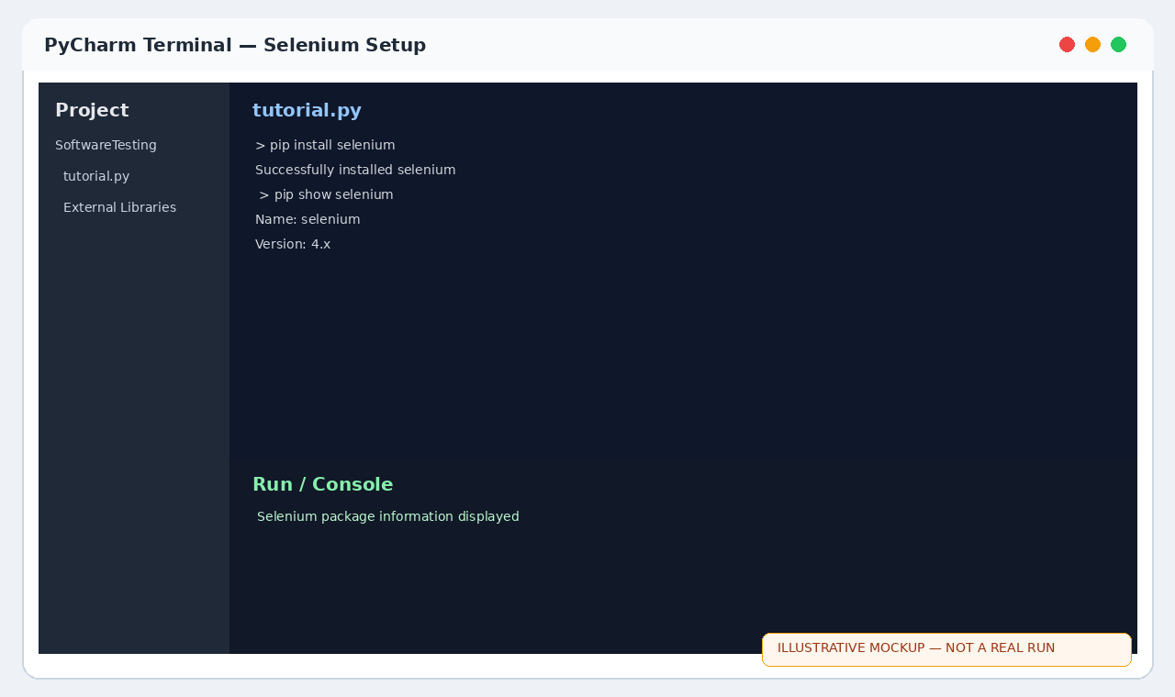
Chrome — Selenium Website
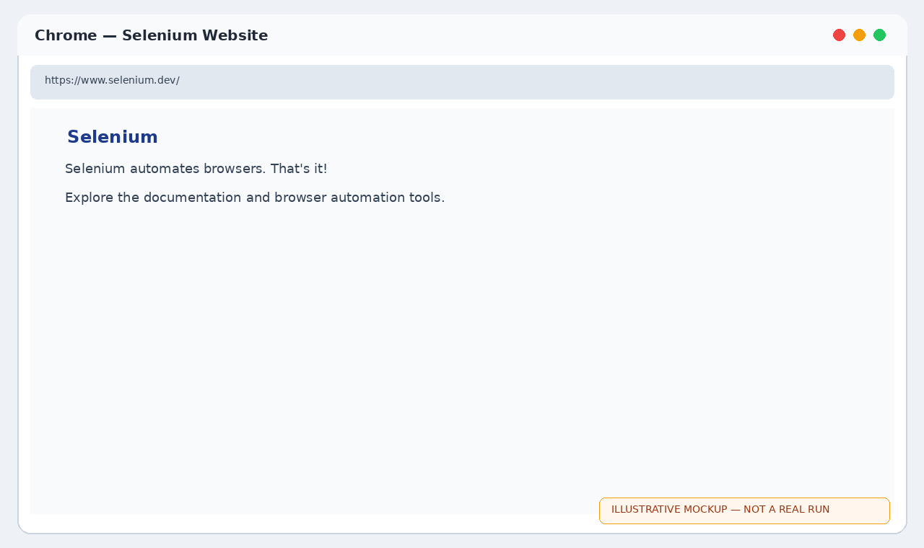
PyCharm Console — Environment Check
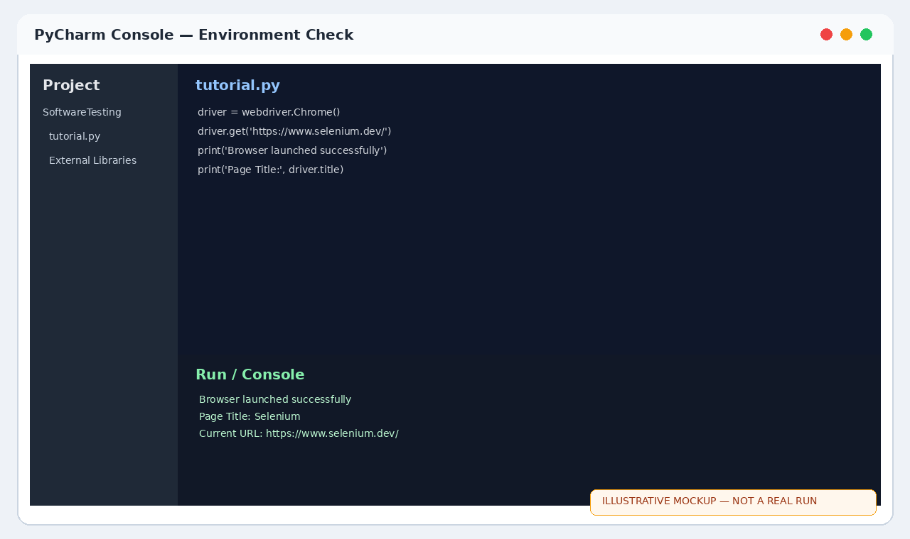
PyCharm — Selenium installation
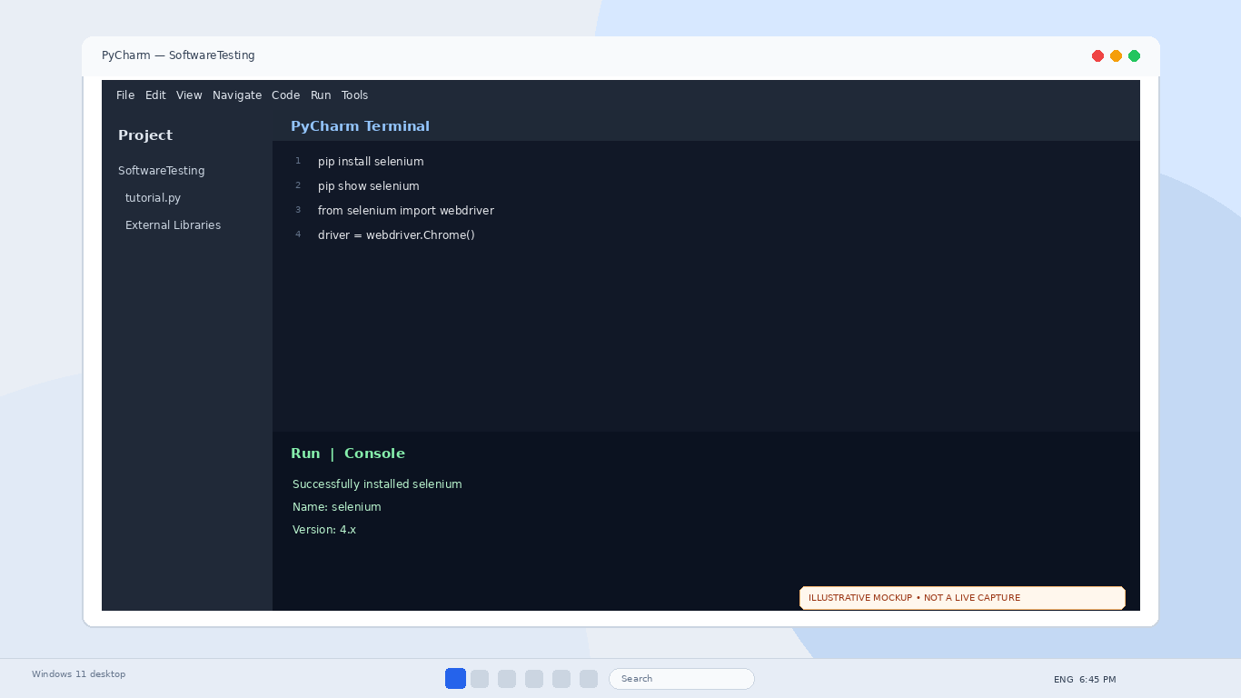
Chrome — Selenium website opened
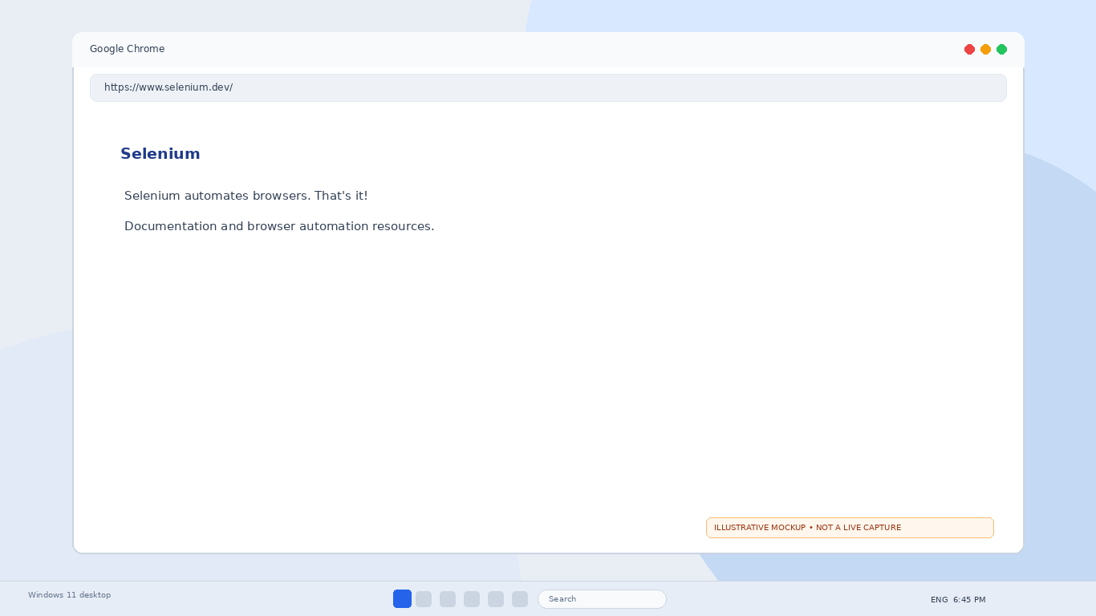
PyCharm — Environment verification output
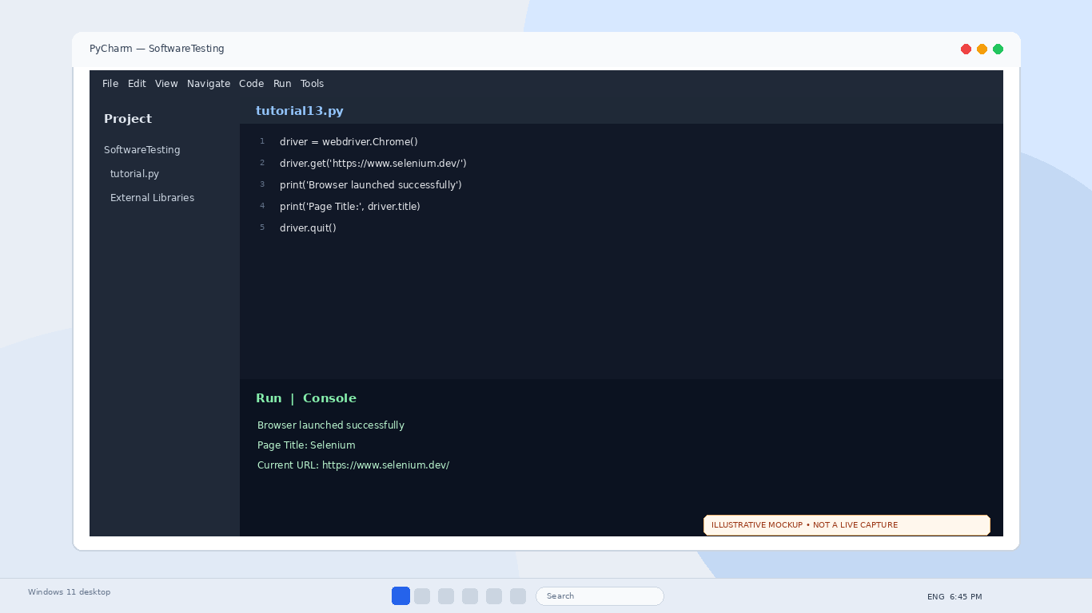
Selenium setup
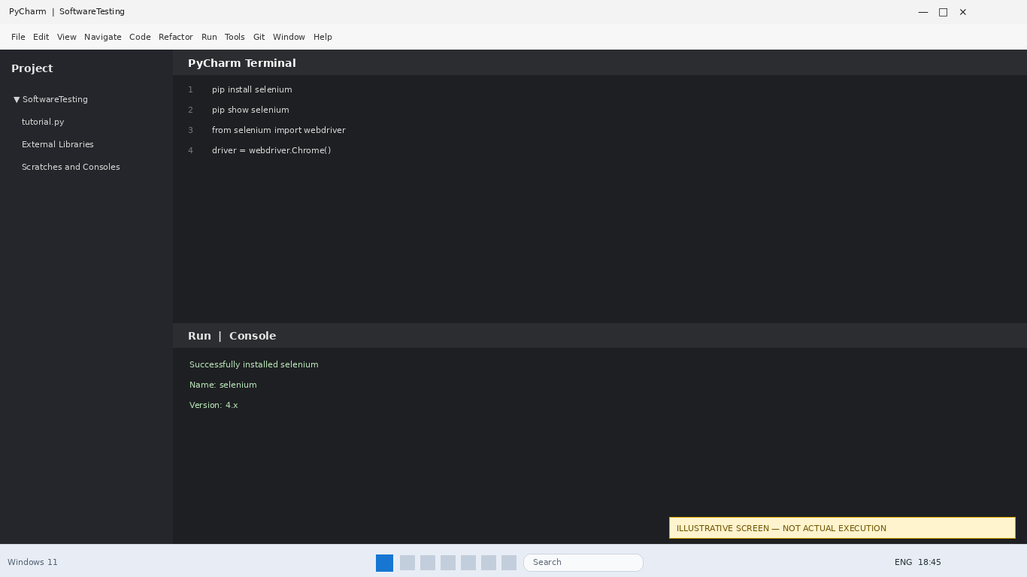
Selenium website
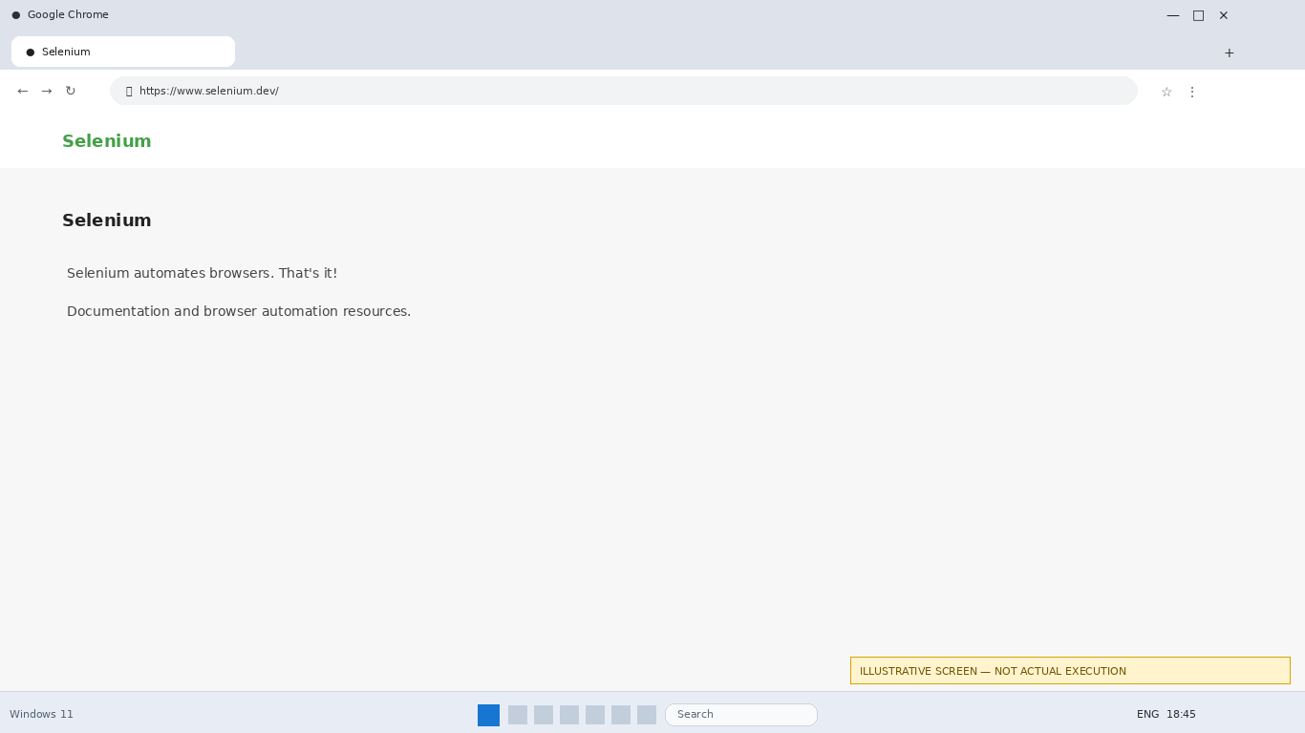
Environment output
