SOFTWARE TESTING LAB REPORT
TUTORIAL – 14
Selenium Web Automation

1. Aim
To create Selenium automation scripts in Python for browser navigation, form handling, web-element interaction and validation testing.

2. Description
Selenium WebDriver enables testers to automate web browsers using Python. This practical automates login to SauceDemo, interacts with the product page, adds a product to the cart and validates the URL and page navigation.

3. Problem Statement
Create a Selenium script that opens the website, enters login credentials, submits the login form, validates the product page, selects a product, opens the cart and checks the resulting URL.

4. Implementation Details
Parameter | Details
Project Name | Selenium Web Automation
Application | SauceDemo
Module | Login and Product Navigation
SDLC Model | Agile
Language | Python
IDE | PyCharm
Automation Tool | Selenium WebDriver
Browser | Google Chrome
Target URL | https://www.saucedemo.com/

5. Software and Environment Requirements
Python 3.x, PyCharm IDE, Google Chrome, Selenium Python library, internet connection, and Selenium WebDriver. Install Selenium from the PyCharm terminal using:
pip install selenium

6. Procedure
- Create a PyCharm project named SoftwareTesting.
- Create tutorial14.py.
- Install Selenium with pip install selenium.
- Import WebDriver, By, WebDriverWait and expected_conditions.
- Launch Chrome and open SauceDemo.
- Enter standard_user and secret_sauce, then click Login.
- Wait for the inventory URL and assert that login succeeded.
- Add Sauce Labs Backpack to the cart.
- Open the cart and verify that the cart URL is displayed.
- Close the browser using driver.quit().

7. Source Code
The following code is a clean, report-ready implementation of the workflow described in the supplied tutorial. Run it in your own environment and record your actual results.
from selenium import webdriver
from selenium.webdriver.common.by import By
from selenium.webdriver.support.ui import WebDriverWait
from selenium.webdriver.support import expected_conditions as EC

driver = webdriver.Chrome()
driver.maximize_window()
wait = WebDriverWait(driver, 10)

try:
driver.get("https://www.saucedemo.com/")
print("Page Title:", driver.title)

wait.until(EC.visibility_of_element_located(
(By.ID, "user-name"))).send_keys("standard_user")
driver.find_element(By.ID, "password").send_keys("secret_sauce")
driver.find_element(By.ID, "login-button").click()

wait.until(EC.url_contains("inventory"))
assert "inventory" in driver.current_url
print("Login Validation: PASS")

wait.until(EC.element_to_be_clickable(
(By.ID, "add-to-cart-sauce-labs-backpack"))).click()
print("Product Selection: PASS")

driver.find_element(By.CLASS_NAME, "shopping_cart_link").click()
assert "cart" in driver.current_url
print("Cart Navigation: PASS")
print("All Selenium Web Automation Tests Passed")
finally:
driver.quit()

8. Test Cases / Execution Plan
Test Case ID | Scenario | Test Data / Expected Result | Actual Result / Status
TC-14-01 | Open website | Login page opens | Record after execution
TC-14-02 | Enter credentials | Username and password are entered | Record after execution
TC-14-03 | Submit login | Products page opens | Record after execution
TC-14-04 | Add product | Selected product is added | Record after execution
TC-14-05 | Open cart | Cart page opens and URL contains cart | Record after execution
TC-14-06 | Validate page details | Title and URL are available for validation | Record after execution

Note: Enter the actual result and Pass/Fail status after executing the script. The reports do not claim that the code was executed in your local environment.

9. Observations
- SauceDemo opens through Selenium.
- Login form fields are located and populated.
- The inventory page and cart URL are validated using assertions.
- Product selection and cart navigation are automated.

10. Screenshot Evidence

11. Result
The test workflow is designed to verify the scenarios listed in this report. Record the final result after running the code and checking the browser and console output.

12. Conclusion
The practical demonstrates Selenium-based browser control, form handling, product interaction, cart navigation and URL validation in a web application.
Chrome — SauceDemo Login
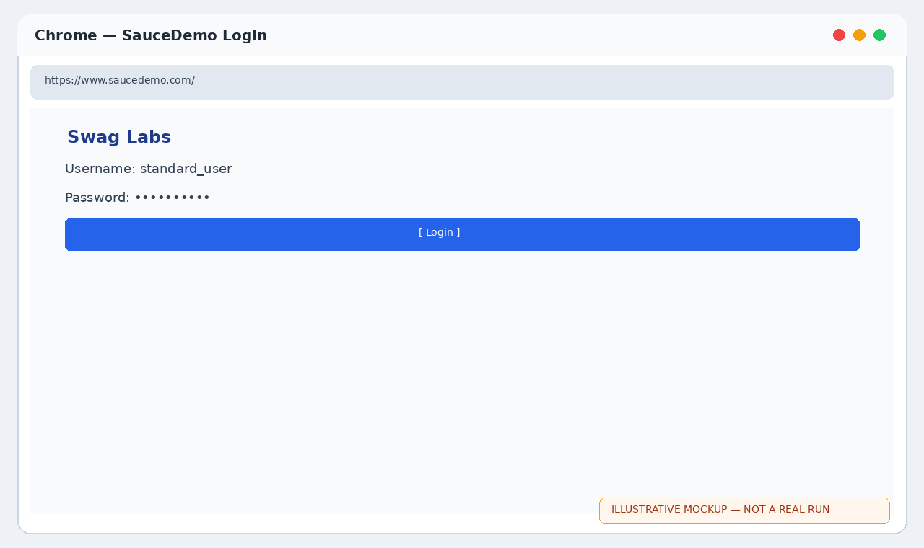
Chrome — Product Selected
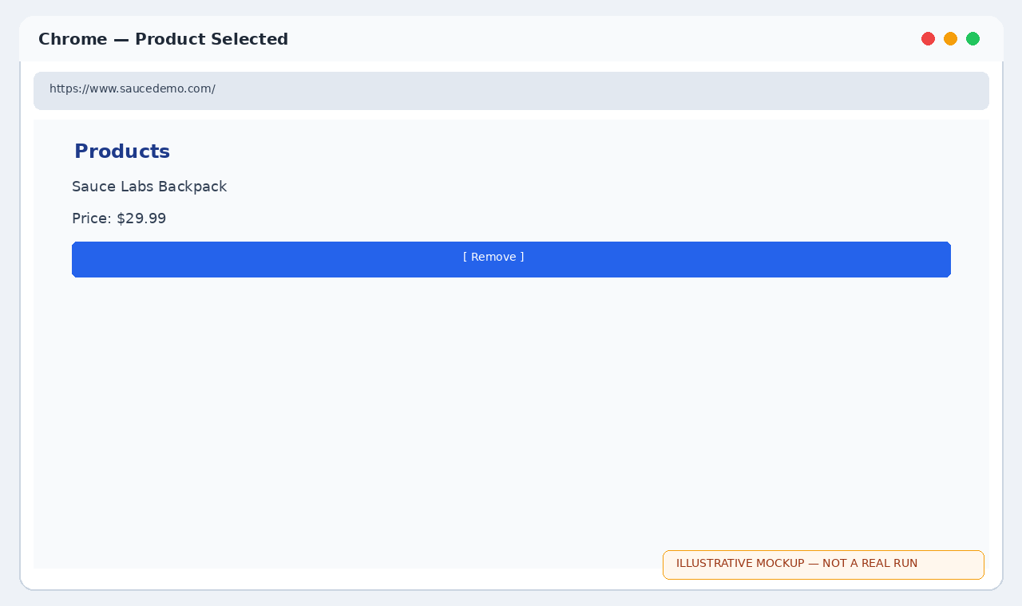
PyCharm Console — Automation Results
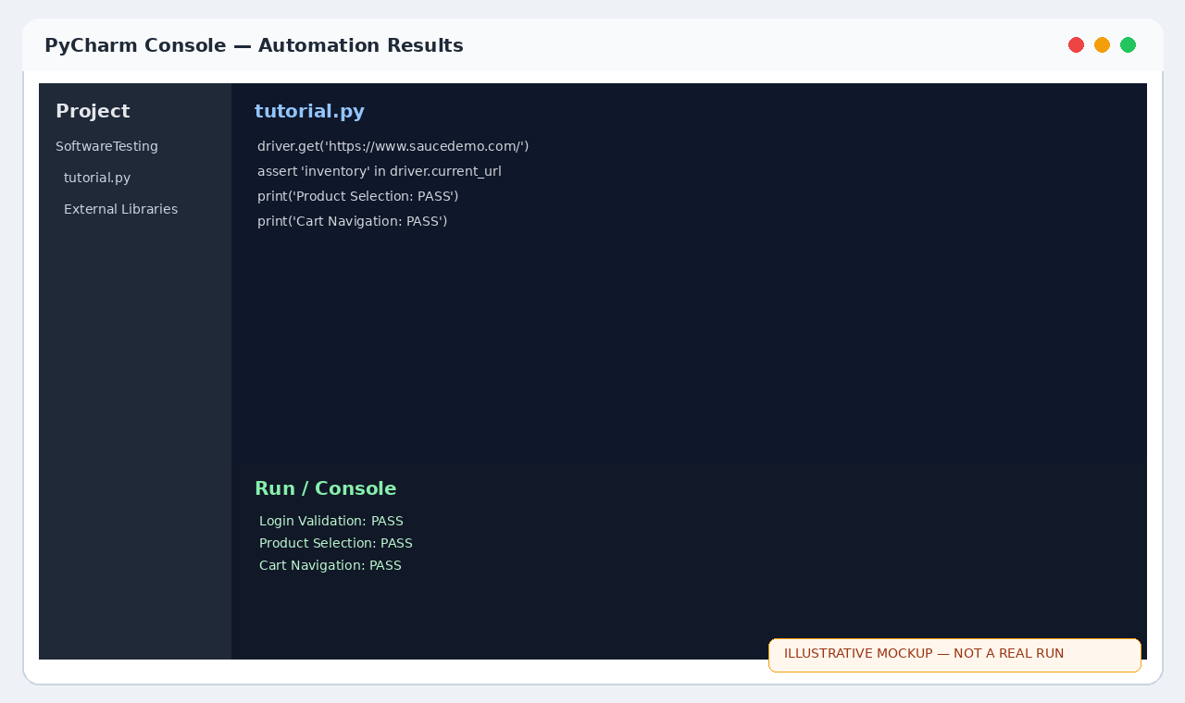
Chrome — SauceDemo login page
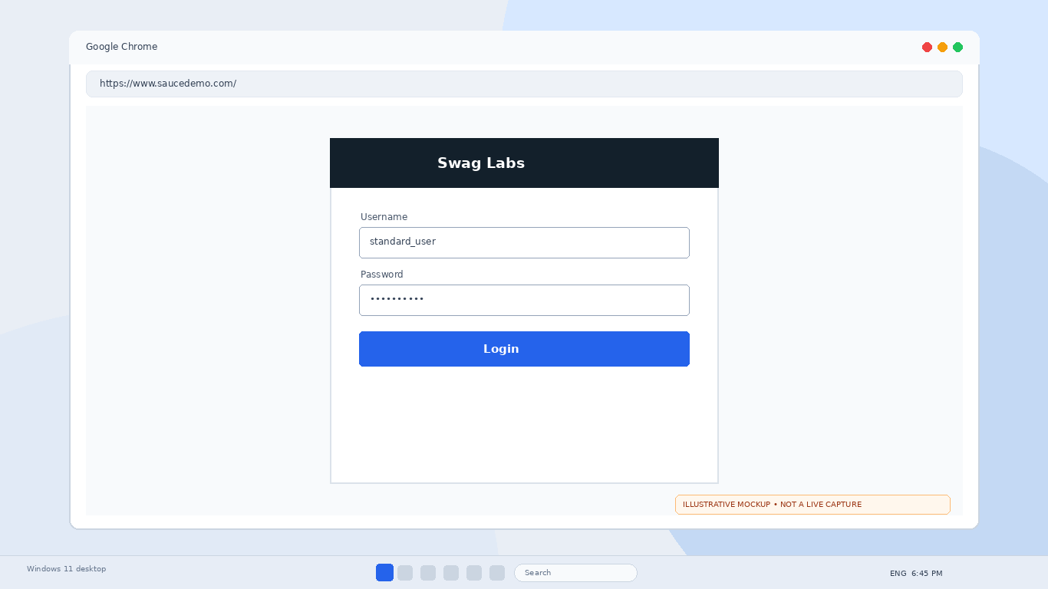
Chrome — Product page
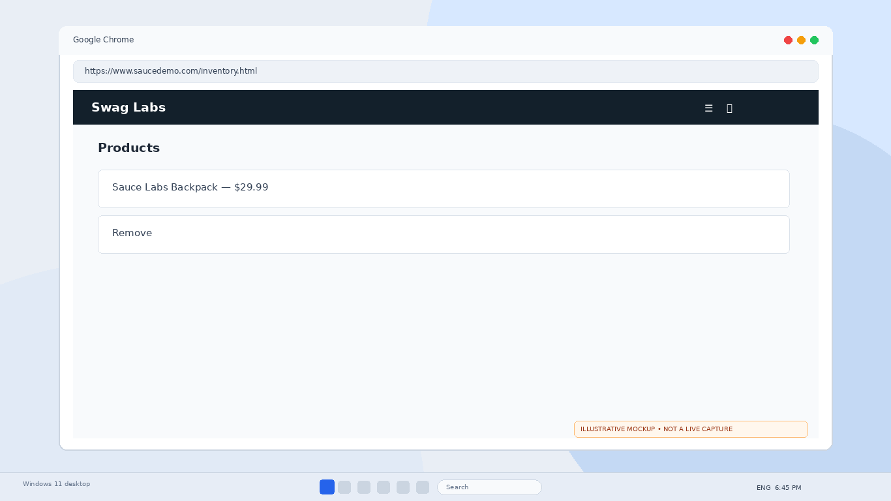
PyCharm — Automation validation
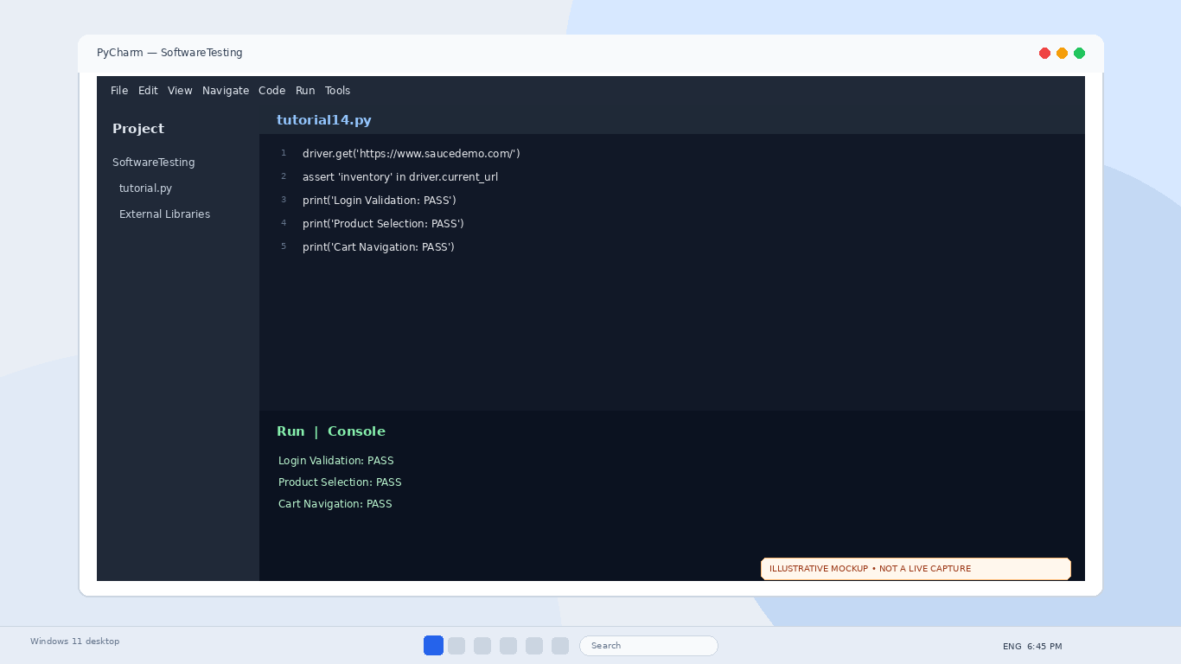
SauceDemo login
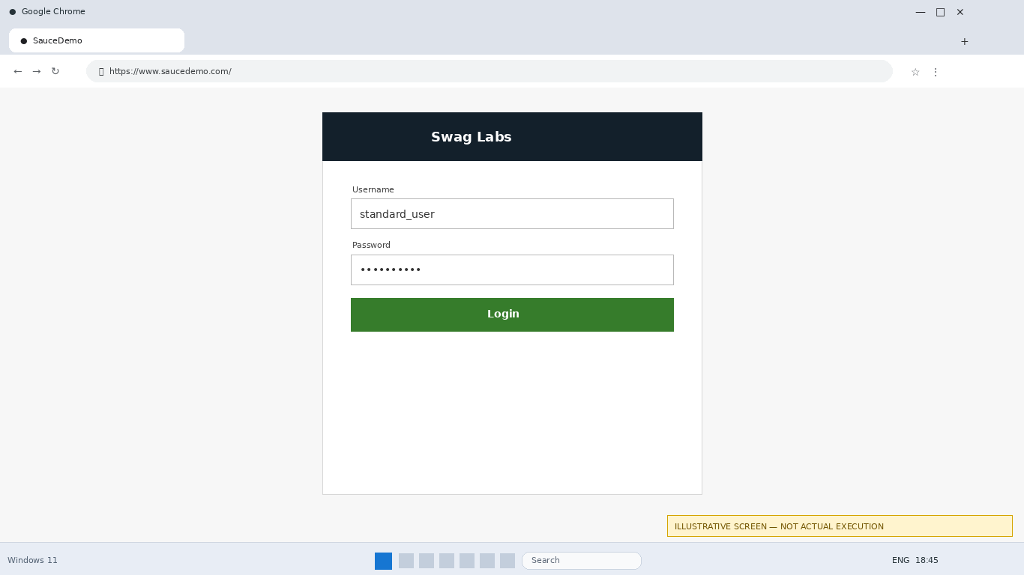
Products page
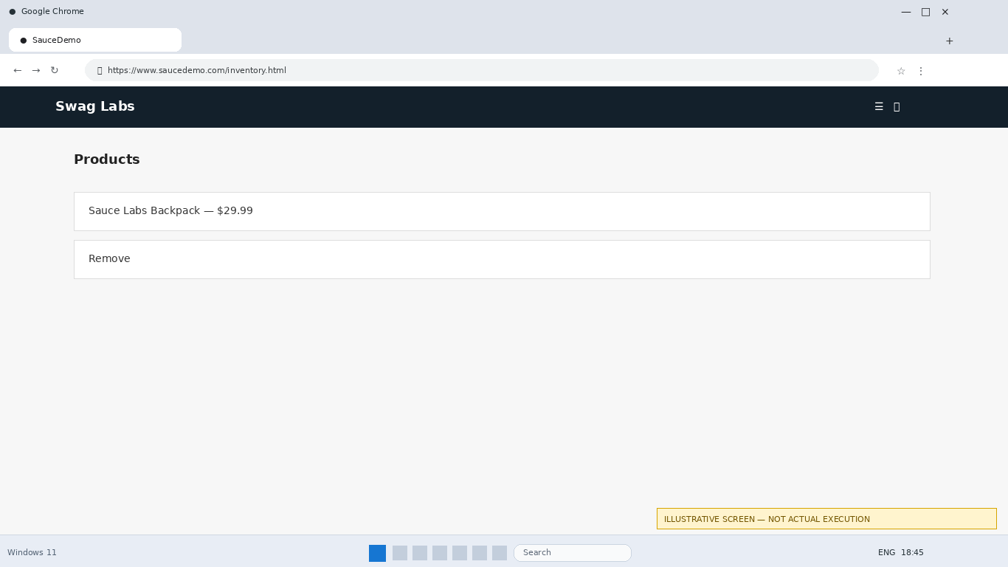
Automation output
