SOFTWARE TESTING LAB REPORT
TUTORIAL – 15
Automated Login Testing

1. Aim
To automate login functionality, authentication validation, assertions and exception-handling scenarios using Selenium WebDriver with Python.

2. Description
Authentication testing checks that valid users can access a system and invalid users are rejected. This practical tests valid login, invalid password, invalid username, empty credentials, error messages, assertions, logout and exception handling.

3. Problem Statement
Create an automated Selenium login-testing script covering valid login, invalid password, invalid username, empty credentials, authentication assertions, error-message validation, exception handling and logout.

4. Implementation Details
Parameter | Details
Project Name | Automated Login Testing
Application | SauceDemo
Module | Authentication/Login
SDLC Model | Agile
Language | Python
IDE | PyCharm
Automation Tool | Selenium WebDriver
Browser | Google Chrome
Target URL | https://www.saucedemo.com/
Test Data | Valid and invalid login credentials

5. Software and Environment Requirements
Python 3.x, PyCharm IDE, Google Chrome, Selenium Python library, internet connection, and Selenium WebDriver. Install Selenium from the PyCharm terminal using:
pip install selenium

6. Procedure
- Create the SoftwareTesting project in PyCharm and add tutorial15.py.
- Install Selenium using pip install selenium.
- Import WebDriver, locator, wait, expected-condition and exception modules.
- Create reusable browser-start and login functions.
- Test valid credentials and assert that the Products page opens.
- Test an invalid password and invalid username, then verify an error message.
- Submit empty credentials and verify the validation message.
- Log in successfully, open the menu and select Logout.
- Handle common Selenium exceptions and close each browser session.
- Review console results for each test case.

7. Source Code
The following code is a clean, report-ready implementation of the workflow described in the supplied tutorial. Run it in your own environment and record your actual results.
from selenium import webdriver
from selenium.webdriver.common.by import By
from selenium.webdriver.support.ui import WebDriverWait
from selenium.webdriver.support import expected_conditions as EC
from selenium.common.exceptions import TimeoutException, NoSuchElementException

URL = "https://www.saucedemo.com/"

def run_login_test(username, password, expected_success, label):
driver = webdriver.Chrome()
driver.maximize_window()
wait = WebDriverWait(driver, 10)
try:
driver.get(URL)
wait.until(EC.visibility_of_element_located(
(By.ID, "user-name"))).send_keys(username)
driver.find_element(By.ID, "password").send_keys(password)
driver.find_element(By.ID, "login-button").click()

if expected_success:
wait.until(EC.url_contains("inventory"))
assert "inventory" in driver.current_url
print(label + ": PASS")
driver.find_element(By.ID, "react-burger-menu-btn").click()
wait.until(EC.element_to_be_clickable(
(By.ID, "logout_sidebar_link"))).click()
assert URL.rstrip("/") in driver.current_url
print("Logout: PASS")
else:
error = wait.until(EC.visibility_of_element_located(
(By.CSS_SELECTOR, "h3[data-test='error']")))
assert error.text.strip() != ""
print(label + ": PASS (rejected as expected)")
except (TimeoutException, NoSuchElementException) as exc:
print(label + ": ERROR -", type(exc).__name__)
except AssertionError:
print(label + ": FAIL")
finally:
driver.quit()

run_login_test("standard_user", "secret_sauce", True, "Valid Login")
run_login_test("standard_user", "wrong_password", False, "Invalid Password")
run_login_test("wrong_user", "secret_sauce", False, "Invalid Username")
run_login_test("", "", False, "Empty Credentials")

8. Test Cases / Execution Plan
Test Case ID | Scenario | Test Data / Expected Result | Actual Result / Status
TC-15-01 | Valid login | standard_user / secret_sauce | Products page opens
TC-15-02 | Invalid password | standard_user / wrong_password | Error message appears
TC-15-03 | Invalid username | wrong_user / secret_sauce | Error message appears
TC-15-04 | Empty credentials | Blank username and password | Validation message appears
TC-15-05 | Logout | Log in, open menu, select Logout | Returns to login page
TC-15-06 | Exception handling | Simulate a missing element or timeout | Exception is handled and browser closes

Note: Enter the actual result and Pass/Fail status after executing the script. The reports do not claim that the code was executed in your local environment.

9. Observations
- Valid credentials are checked using URL assertions.
- Invalid credentials are expected to produce an error message.
- Empty credentials are tested as a negative scenario.
- The valid-login path includes logout verification.
- Common timeout and missing-element exceptions are handled, and the browser is closed in a finally block.

10. Screenshot Evidence

11. Result
The test workflow is designed to verify the scenarios listed in this report. Record the final result after running the code and checking the browser and console output.

12. Conclusion
The practical demonstrates positive and negative authentication testing with Selenium, assertions, error-message checks, logout verification and basic exception handling.
Chrome — Successful Login
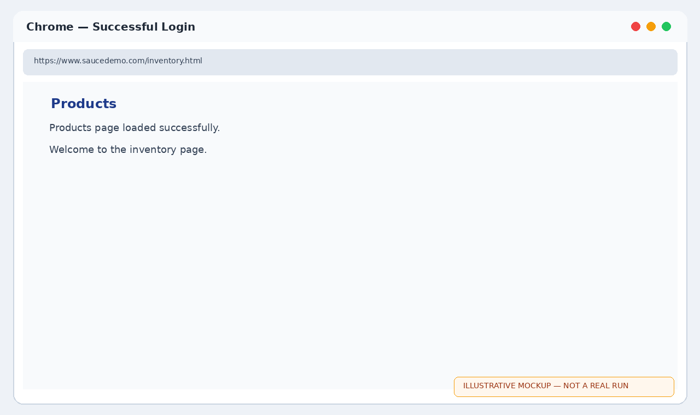
Chrome — Invalid Login Message
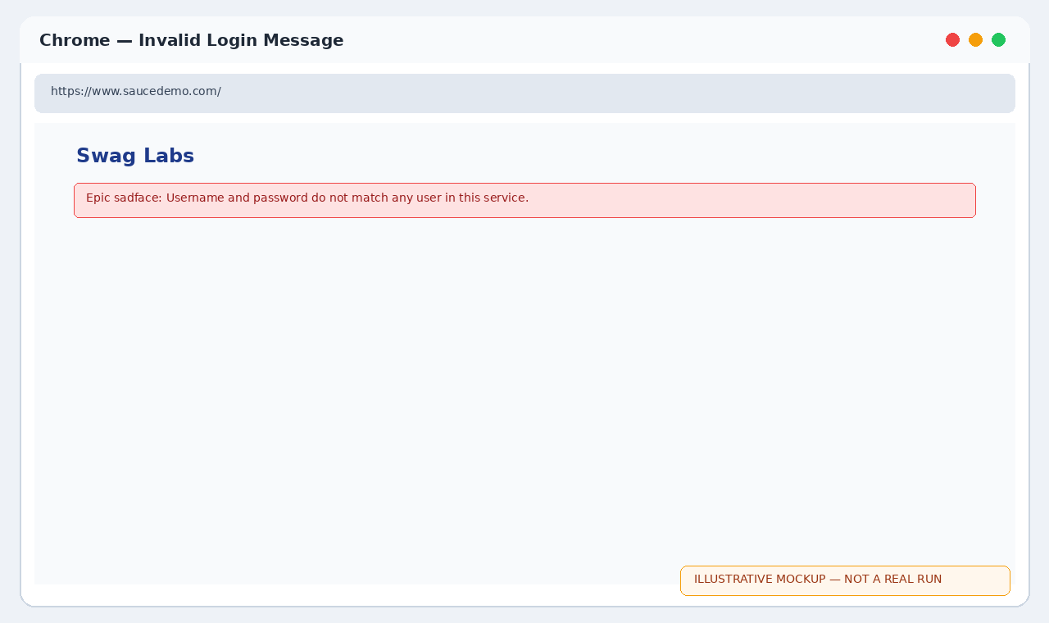
Chrome — Empty Credentials
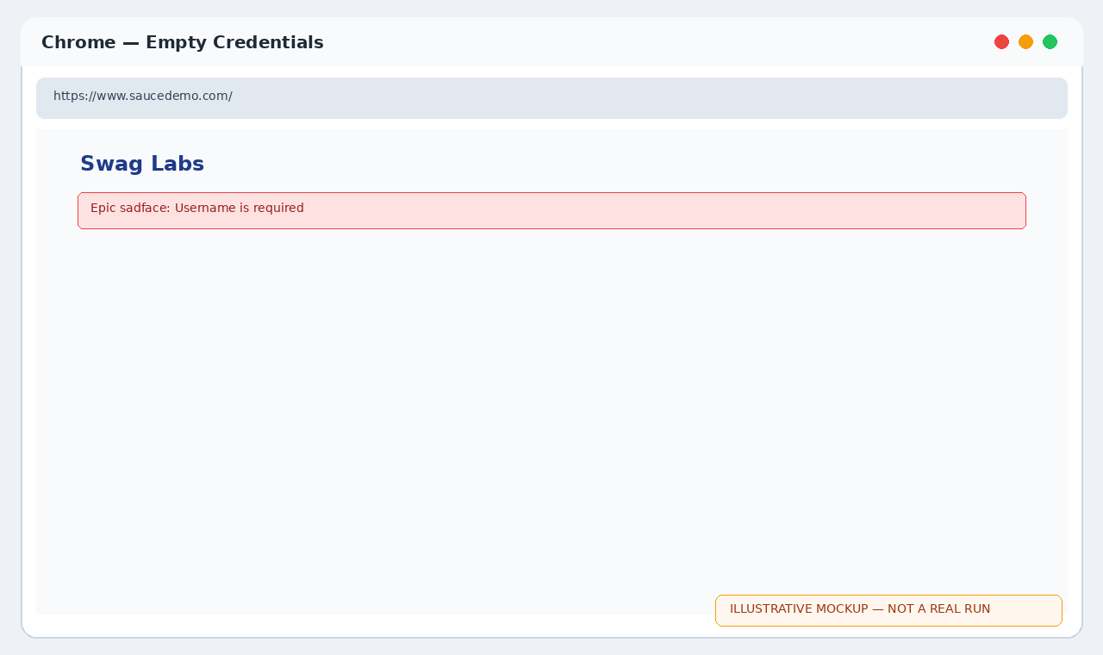
Chrome — Successful login
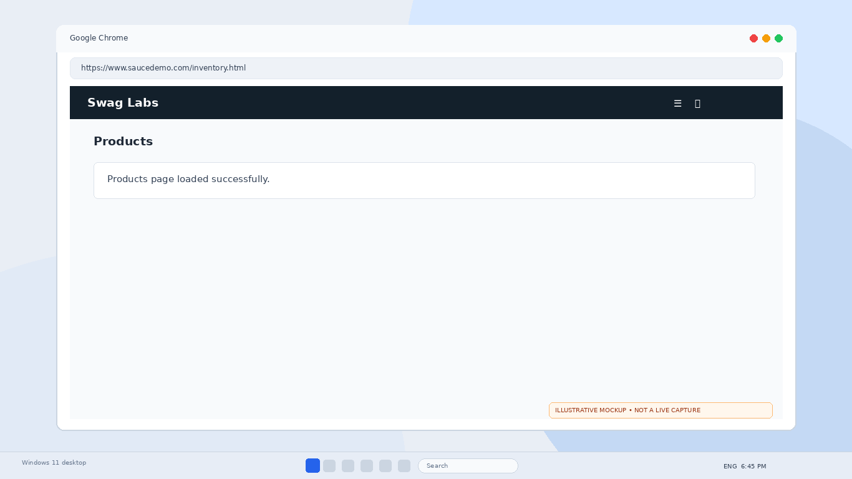
Chrome — Invalid password
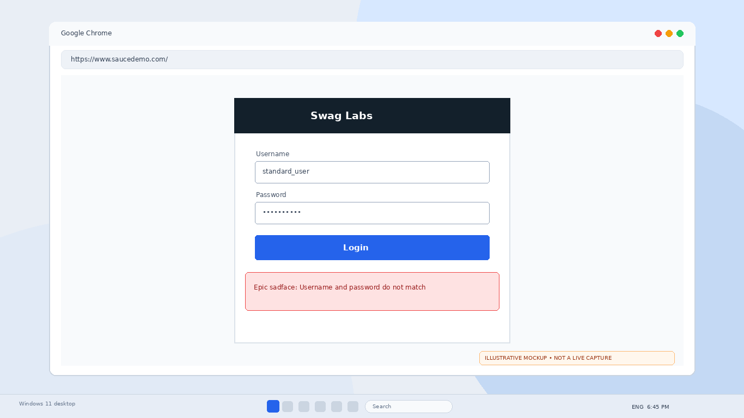
Chrome — Empty credential validation
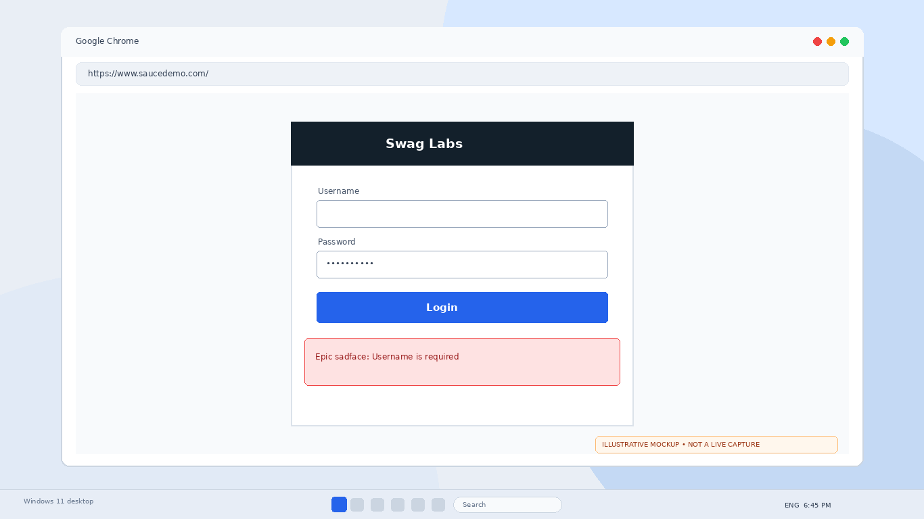
Successful login
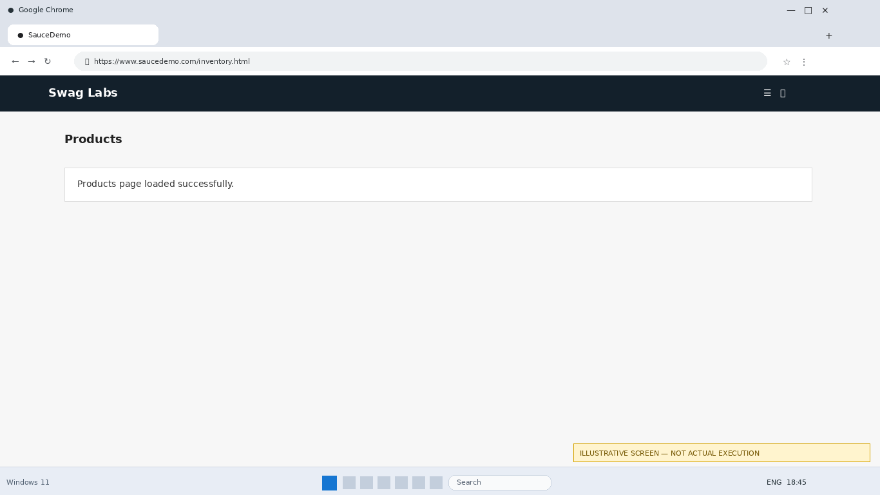
Invalid password
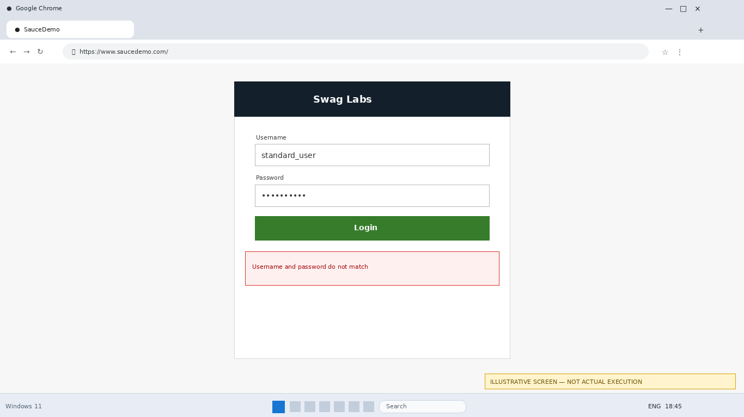
Empty credentials
