DEFECT REPORTING
Bug Reports for GeeksforGeeks Login Module | Tester: Prince | 10-08-2026

1. Aim
To identify software defects and prepare a professional Bug (Defect) Report including Bug ID, Severity, Priority, Environment, Screenshots, and Steps to Reproduce, using the GeeksforGeeks Login Module as the application under test.

2. Description
A software defect (bug) is an error or flaw that causes incorrect or unexpected results. Defect Reporting documents defects so developers can understand, reproduce, and fix them. A well-written bug report includes a clear summary, severity, priority, environment details, reproduction steps, and expected vs. actual results.

3. Problem Statement
Test the Login Module of GeeksforGeeks and identify software defects / gaps. Prepare professional Bug Reports with severity, priority, reproduction steps, and supporting evidence.

4. Parameter Details
Parameter | Details
Project | GeeksforGeeks – Online Learning Platform
Module | Login Module (Authentication)
Tester | Gewani Piyush C.
Environment | Windows 11, Google Chrome, https://www.geeksforgeeks.org
Date | 10-08-2026

5. Bug Report – BUG-001
Field | Details
Bug ID | BUG-001
Bug Summary | No validation message shown when login form is submitted with empty fields
Module | Login / Authentication
Severity | Medium
Priority | Medium
Environment | Windows 11, Google Chrome, https://www.geeksforgeeks.org
Steps to Reproduce | 1. Open GeeksforGeeks → Sign In2. Leave Email/Username field blank3. Leave Password field blank4. Click Login5. Observe – no validation message appears
Expected Result | Field-level validation messages (e.g. 'Email is required', 'Password is required') should be displayed
Actual Result | No validation/error message is shown; user gets no feedback on why login did not proceed
Status | Open
Retest Status | Not Yet Tested

6. Bug Report – BUG-002
Field | Details
Bug ID | BUG-002
Bug Summary | Generic error message shown for invalid password instead of a field-specific message
Module | Login / Authentication
Severity / Priority | Low / Low
Environment | Windows 11, Google Chrome
Steps to Reproduce | 1. Open Login2. Enter valid registered email/username3. Enter incorrect password4. Click Login5. Observe error message shown
Expected Result | Error message should clearly indicate that the password is incorrect
Actual Result | Generic error message shown, not specific to the password field
Status | Open

7. Bug Summary
Bug ID | Module | Summary | Severity | Priority | Status
BUG-001 | Login/Auth | No validation message for empty fields | Medium | Medium | Open
BUG-002 | Login/Auth | Generic error message for invalid password | Low | Low | Open

8. Evidence Screenshot
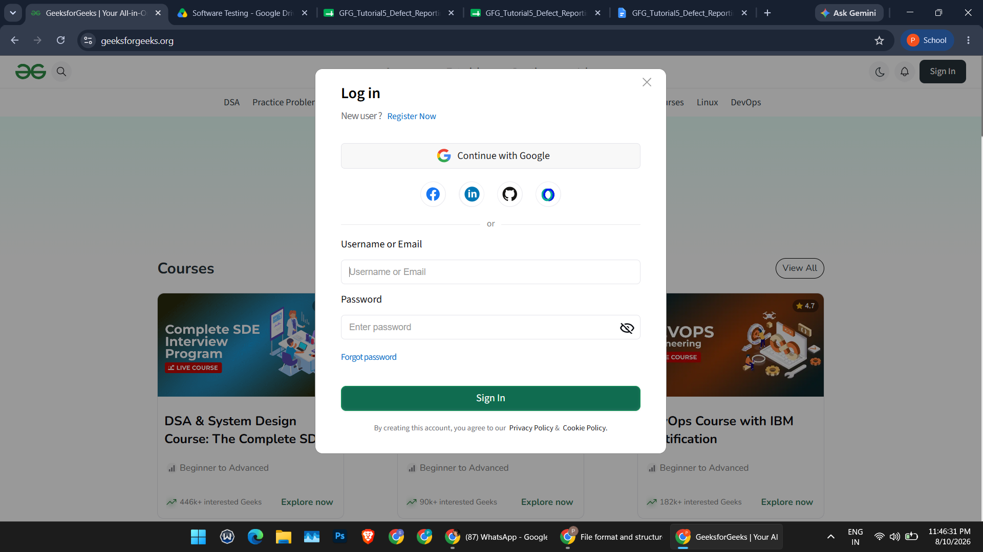
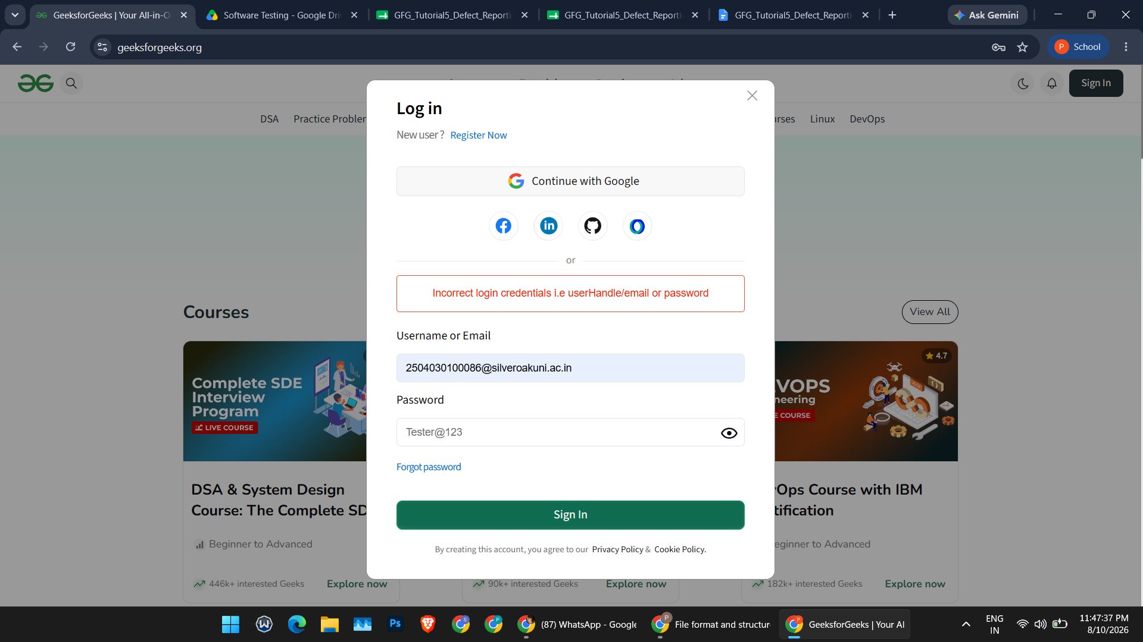

9. Observations
Sr. | Observation | Remarks
1 | Login works correctly with valid email + password | Pass
2 | Empty-field validation message missing | Defect (BUG-001)
3 | Invalid password shows only a generic error message | Defect (BUG-002)
4 | Forgot Password flow redirects correctly | Pass
5 | Password show/hide toggle works correctly | Pass
6 | Bug reports prepared with severity, priority, steps & evidence | Completed

10. Conclusion
- Understood software defects and the defect reporting process.
- Identified 2 usability/validation gaps in the GeeksforGeeks Login module.
- Prepared professional Bug Reports with ID, Severity, Priority, Steps and evidence.
- Gained practical experience in defect reporting using standard practices.
— End of Report —

