GeeksforGeeks
Requirement Review, Code Walkthrough, Inspection & Peer Review
Module Name: GeeksforGeeks – Requirement Review, Code Walkthrough, Inspection & Peer Review
Test Case ID: TC_REVIEW_001
Webpage URL: https://www.geeksforgeeks.org/
Review & Inspection Scenarios
SCN-001 — Verify Requirement Review
1. Open the GeeksforGeeks Software Requirement Specification (SRS).
2. Review all defined functional requirements.
3. Verify that the requirements are complete, clear and understandable.
Status: Pass
Screenshot:
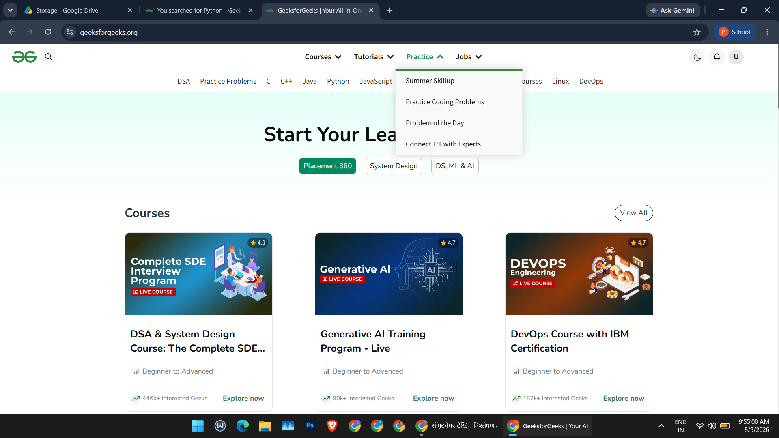
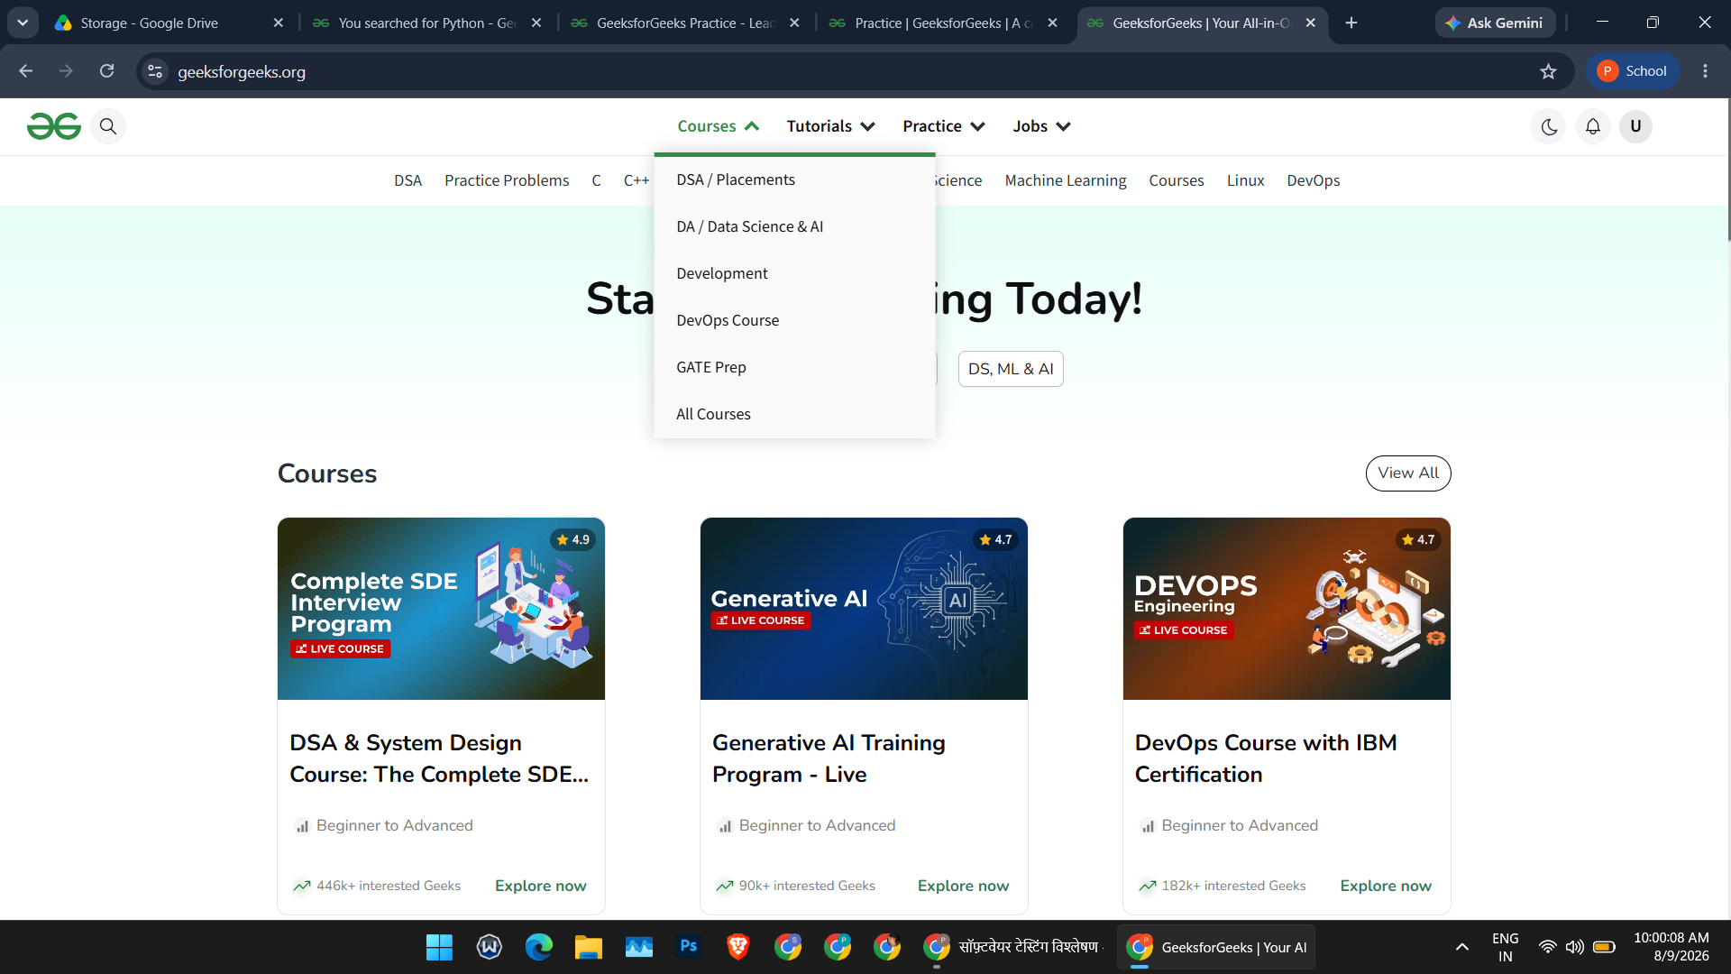

SCN-002 — Verify Search Module Requirements
1. Open the Search Module requirements.
2. Review the search functionality requirements.
3. Verify that the requirements are correct and complete.
Status: Pass
Screenshot:

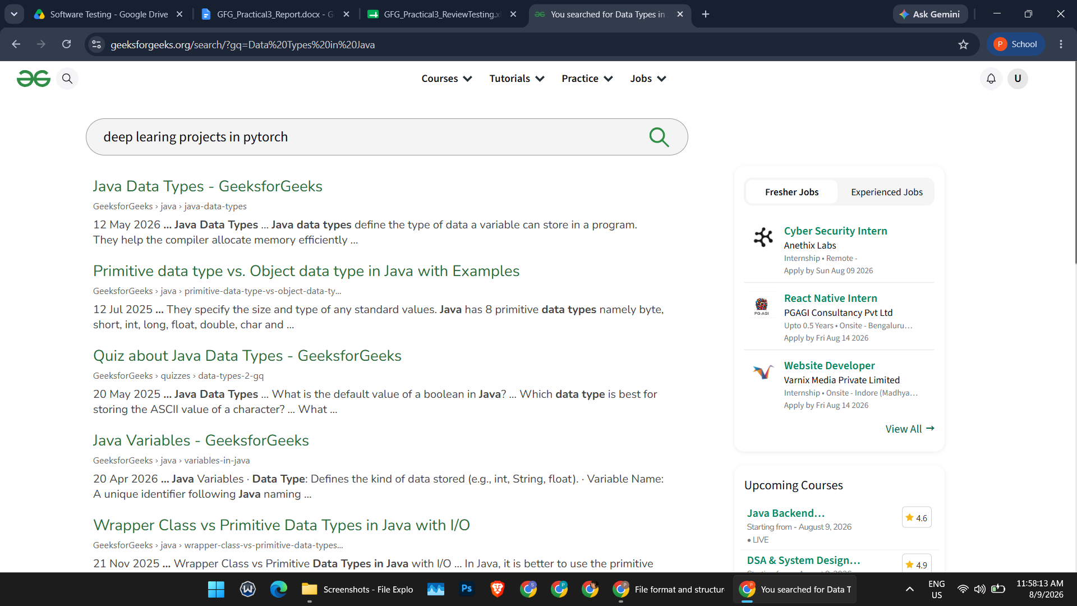

SCN-003 — Verify Tutorial Module Requirements
1. Open the Tutorial Module requirements.
2. Review the tutorial functionality requirements.
3. Verify that the requirements are complete and understandable.
Status: Pass
Screenshot:
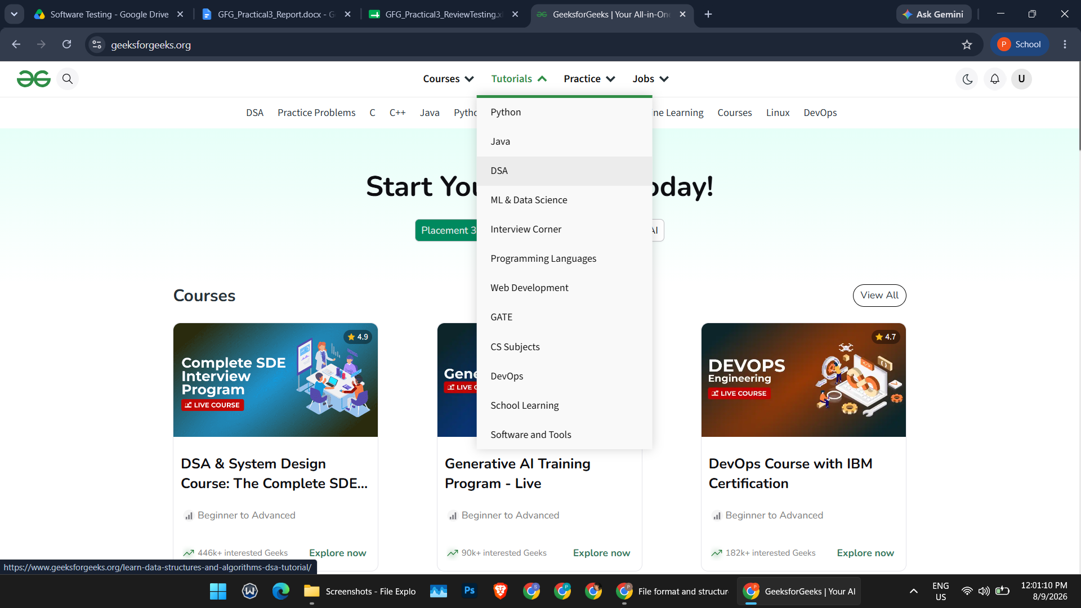
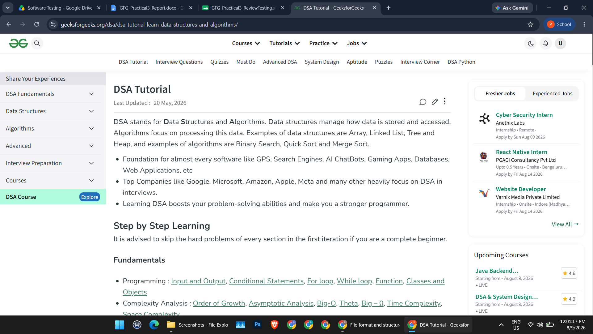
SCN-004 — Verify Practice Module Requirements
1. Open the Practice Module requirements.
2. Review the coding practice functionality requirements.
3. Verify that the requirements are complete and accurate.
Status: Pass
Screenshot:
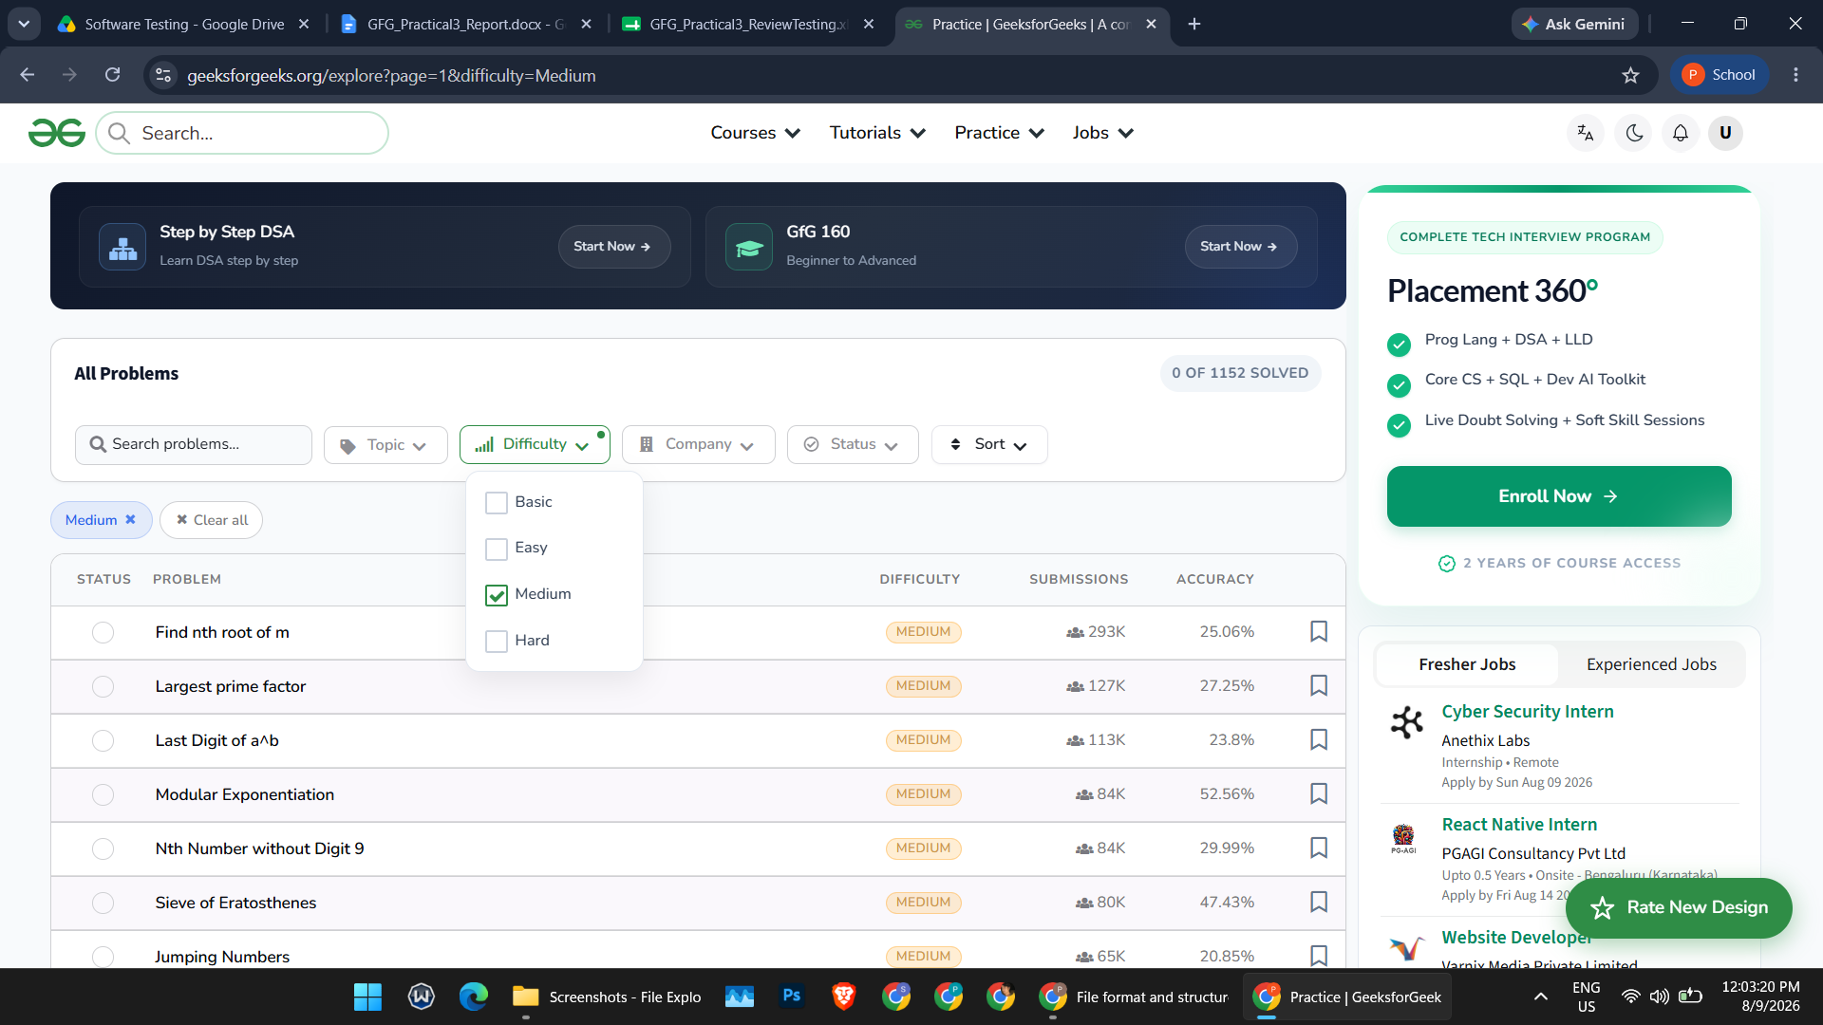

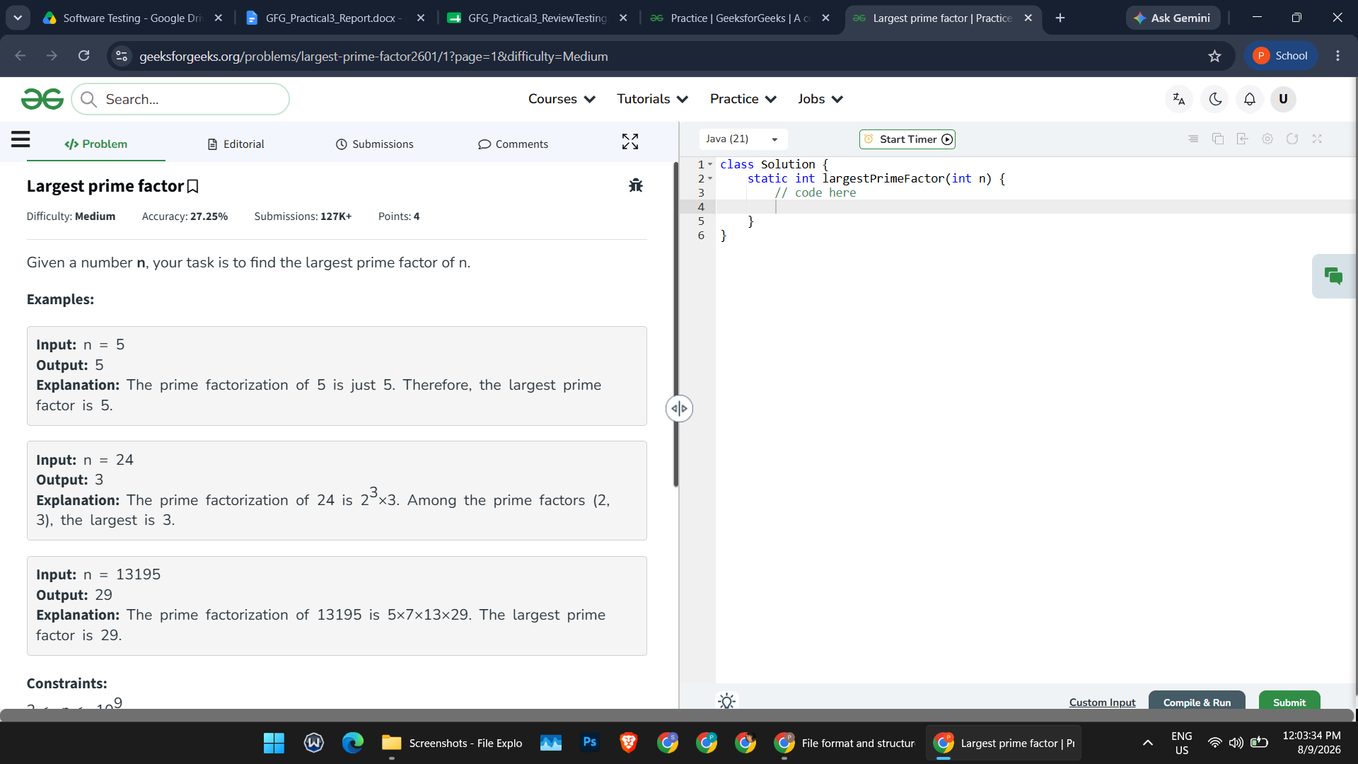
SCN-005 — Verify Code Walkthrough
1. Open the GeeksforGeeks-based project source code.
2. Review the code structure and major modules.
3. Verify the code logic and workflow.
Status: Pass
Screenshot:
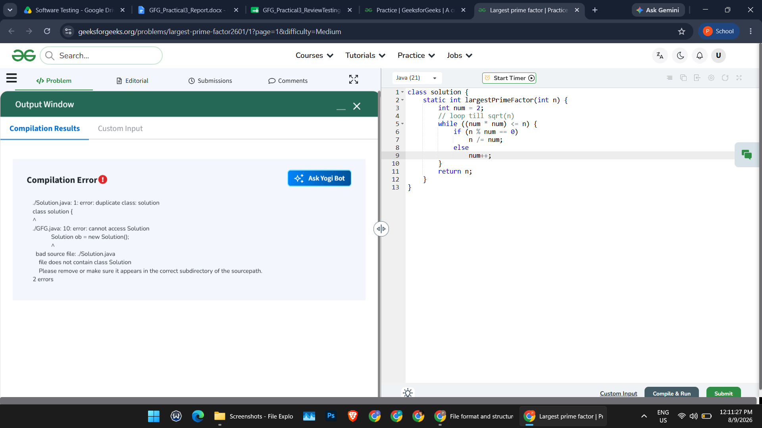
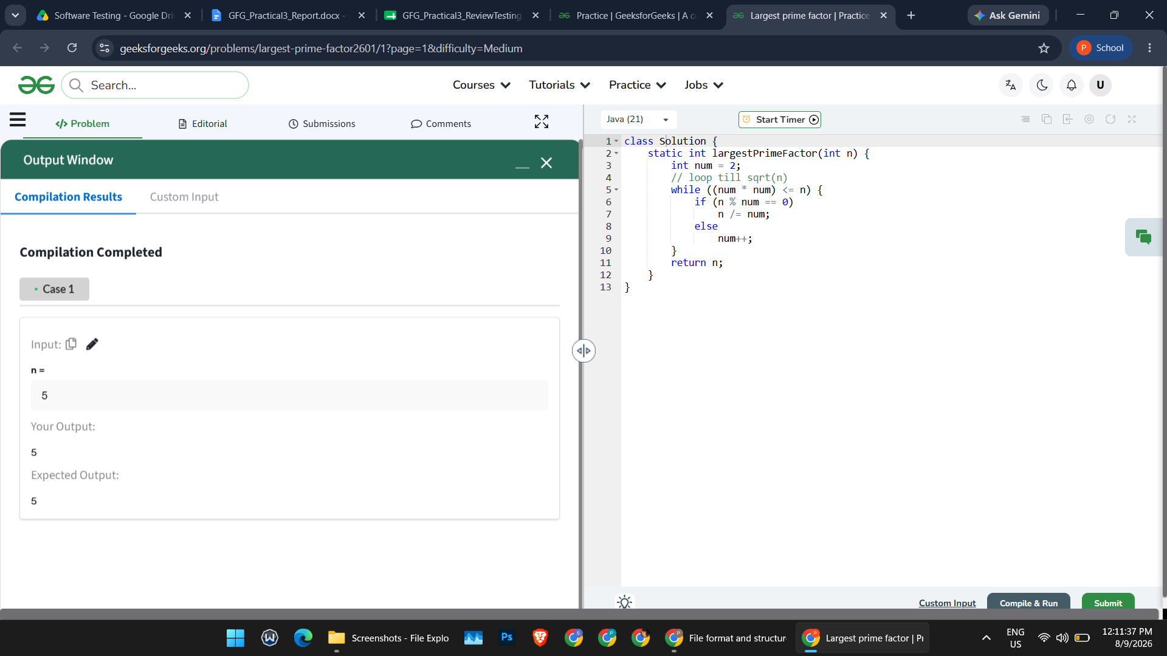
SCN-006 — Verify Document Inspection
1. Inspect the project documents.
2. Identify missing, unclear or inconsistent information.
3. Record the observations.
Status: Pass
Screenshot:
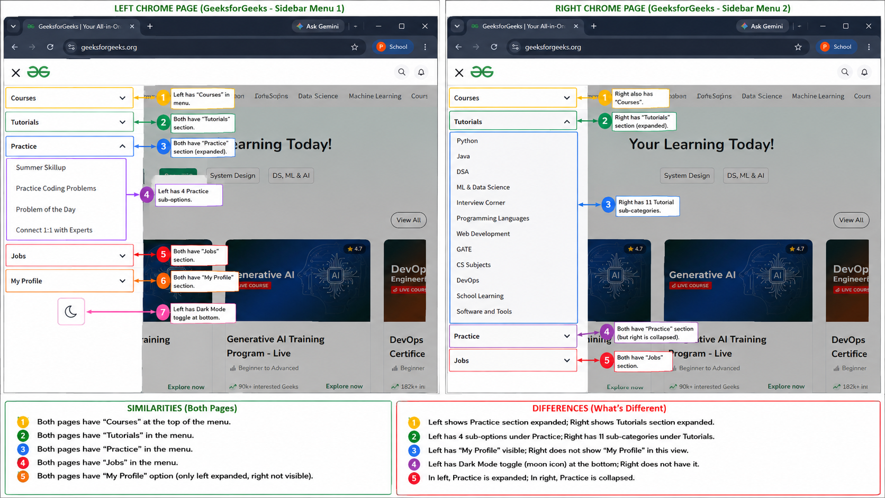
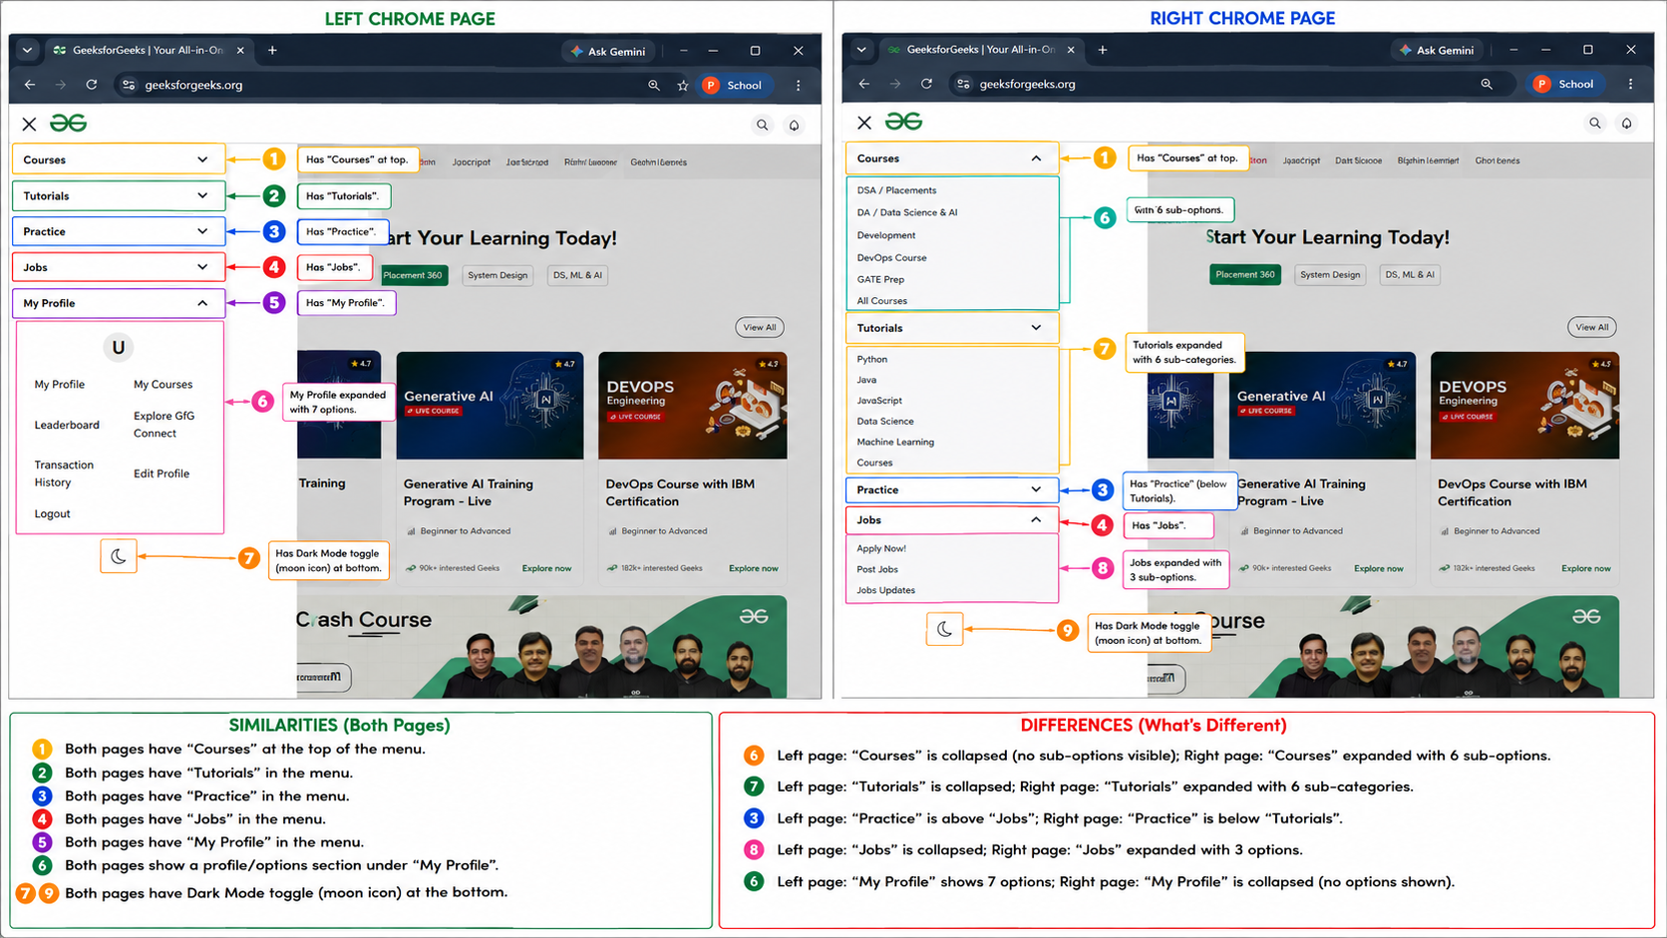
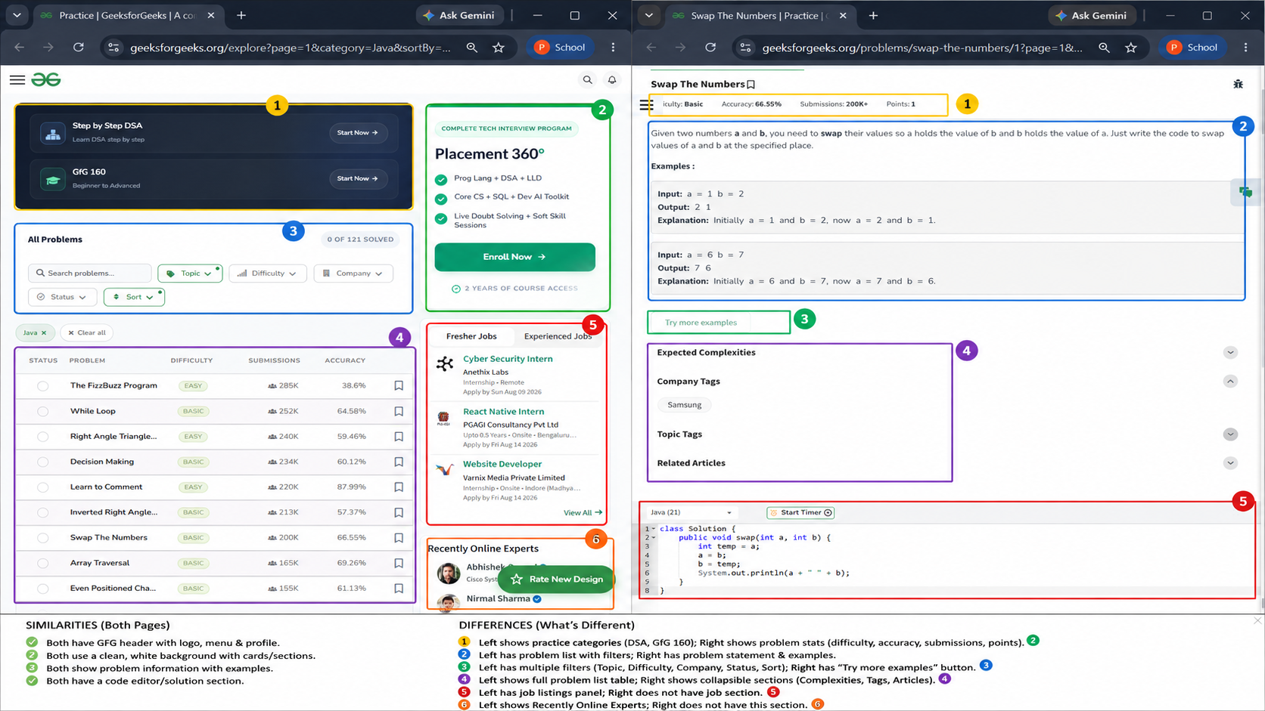

SCN-007 — Verify Peer Review
1. Conduct a peer review of the project documents.
2. Discuss the review comments and observations.
3. Document the review findings and recommendations.
Status: Pass
Screenshot:
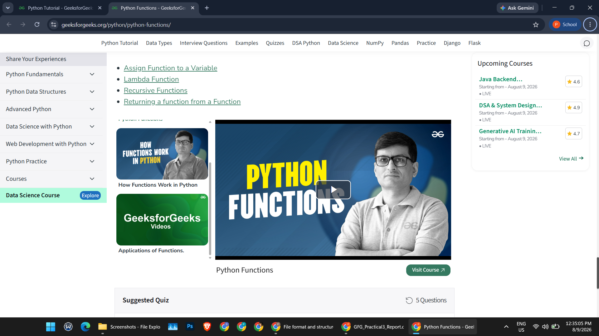
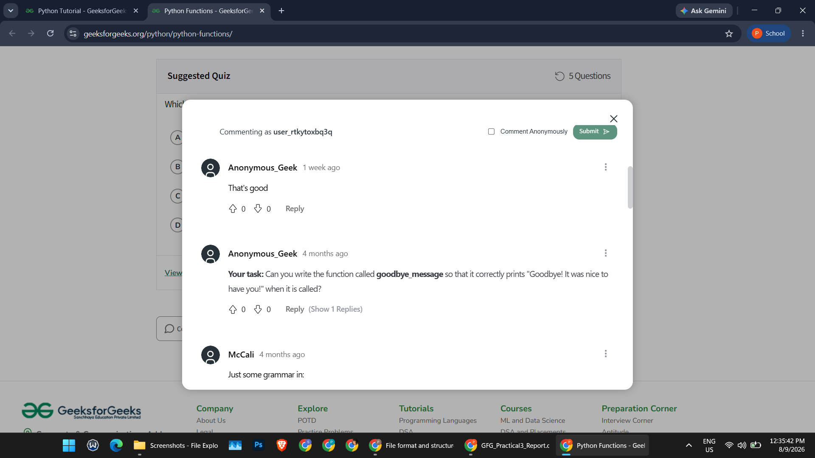
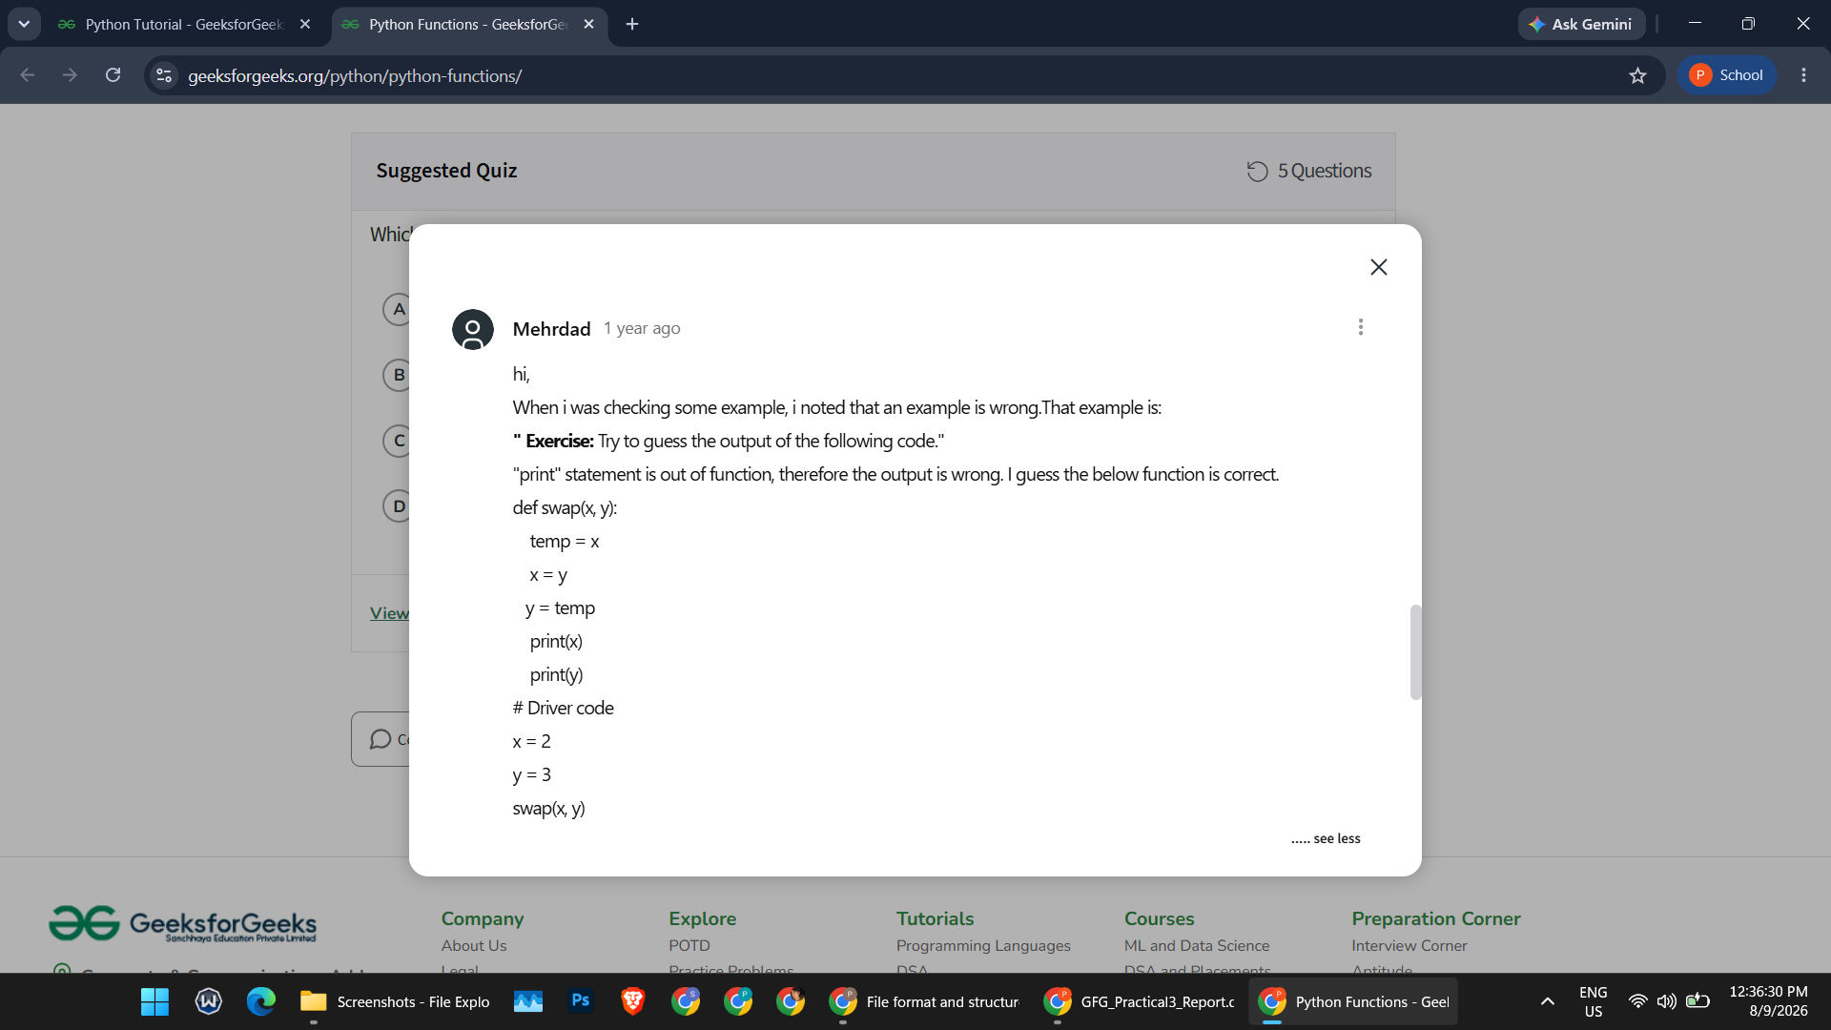
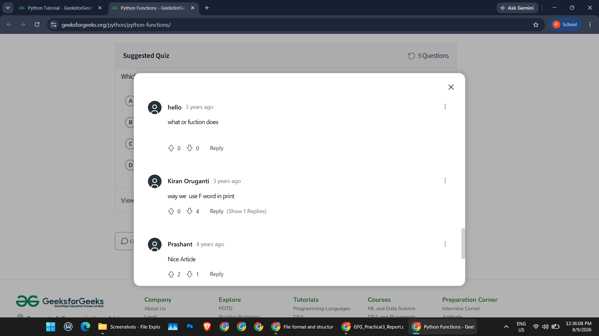
SCN-008 — Verify Review Findings
1. Collect all review observations.
2. Document the identified findings.
3. Verify that all findings are properly recorded.
Status: Pass
Screenshot:
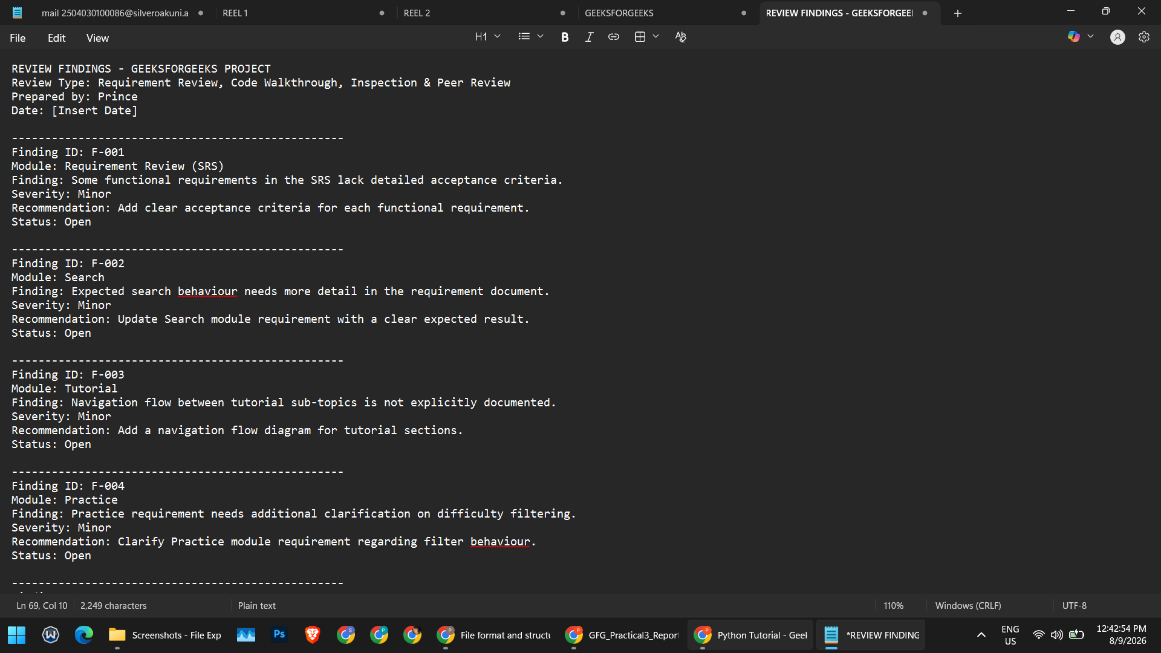
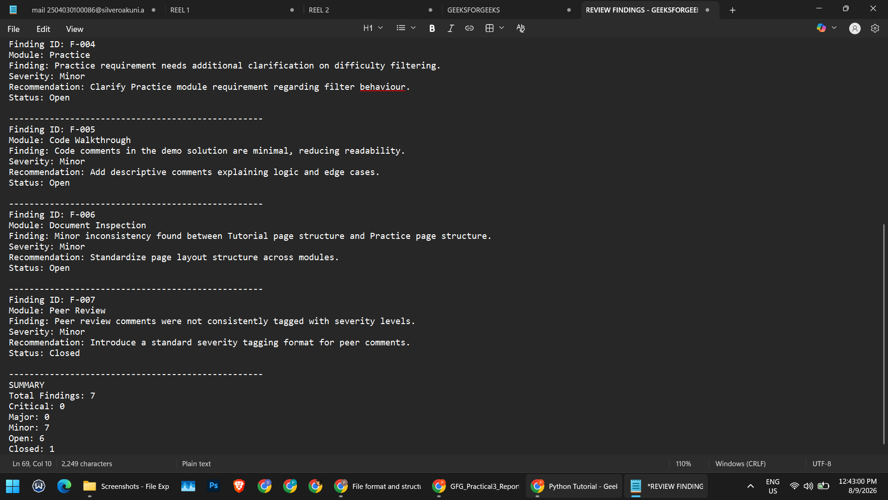

SCN-009 — Verify Issue Communication
1. Prepare the review findings report.
2. Share the findings with the concerned project/development team.
3. Verify that all identified issues are communicated.
Status: Pass
Screenshot:
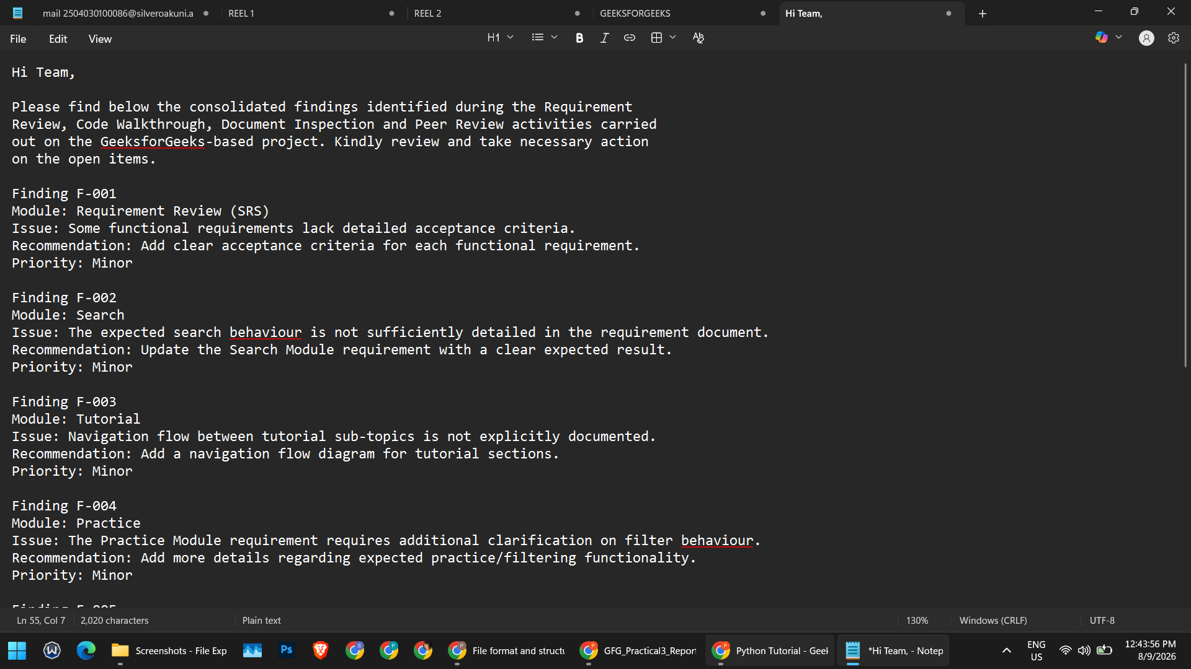
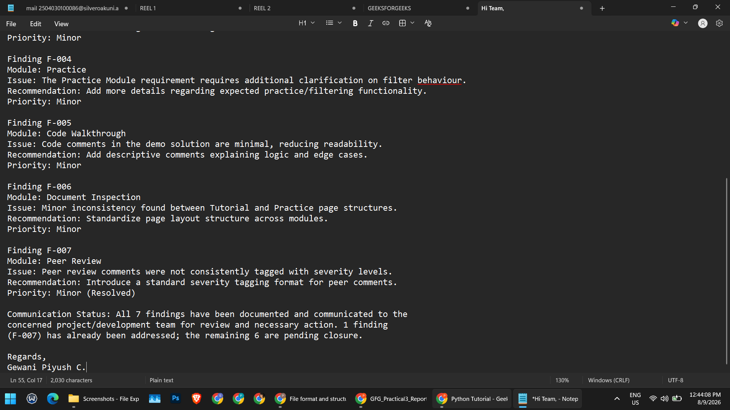

SCN-010 — Verify Final Review Report
1. Compile all review observations and findings.
2. Prepare the final review report.
3. Verify that the report is complete.
Status: Pass
Screenshot:
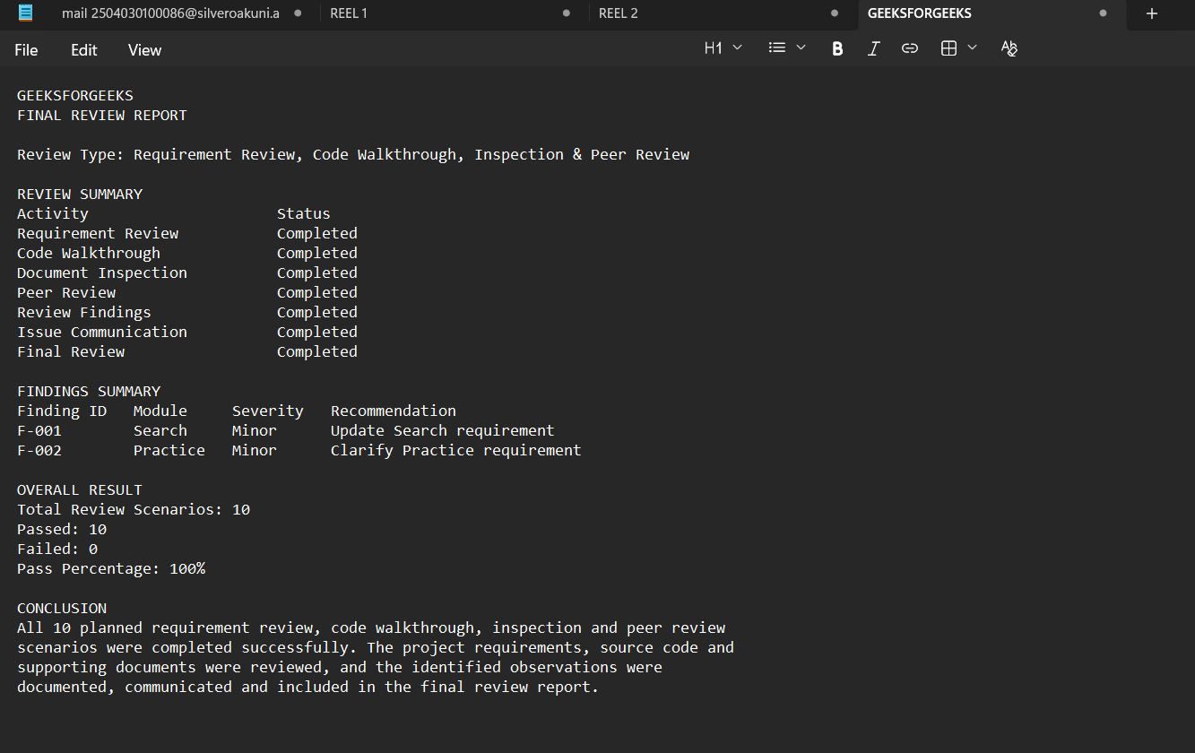
Summary of Review Results
Result | Value
Total Review Scenarios | 10
Passed | 10
Failed | 0
Pass Percentage | 100%
Final Conclusion
All 10 planned requirement review, code walkthrough, inspection and peer review scenarios were completed successfully. The requirements, source code and project documents were reviewed systematically. Review observations and findings were documented, communicated to the concerned team, and included in the final review report.

