GeeksforGeeks
Functional, Non-Functional, Positive & Negative Testing
Module Name: GeeksforGeeks – Functional, Non-Functional, Positive & Negative Testing
Test Case ID: TC_GFG_001
Webpage URL: https://www.geeksforgeeks.org/
Functional & Non-Functional Test Scenarios
SCN-001 — Verify Search with Valid Keyword
- Open the GeeksforGeeks website.
- Locate the search bar.
- Enter a valid keyword, e.g. "Python".
- Click Search / press Enter.
- Observe the search results.
Status: Pass
Screenshot:
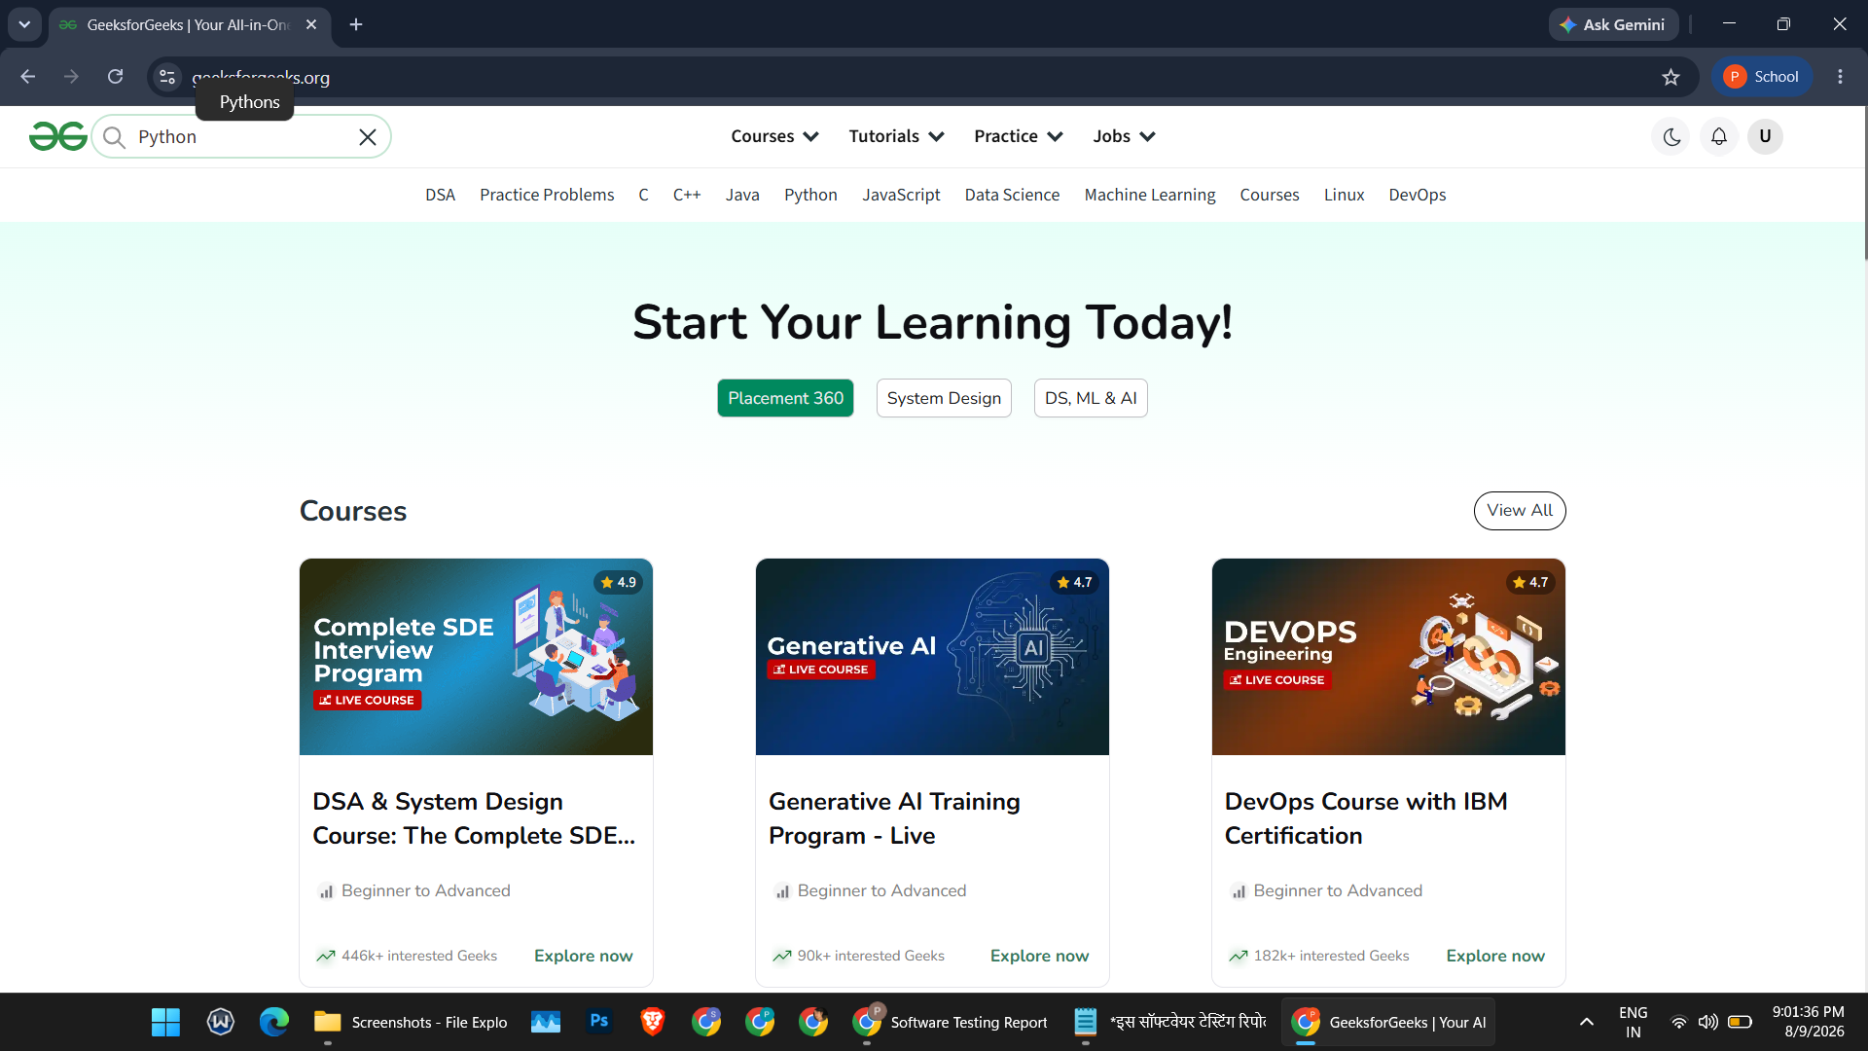
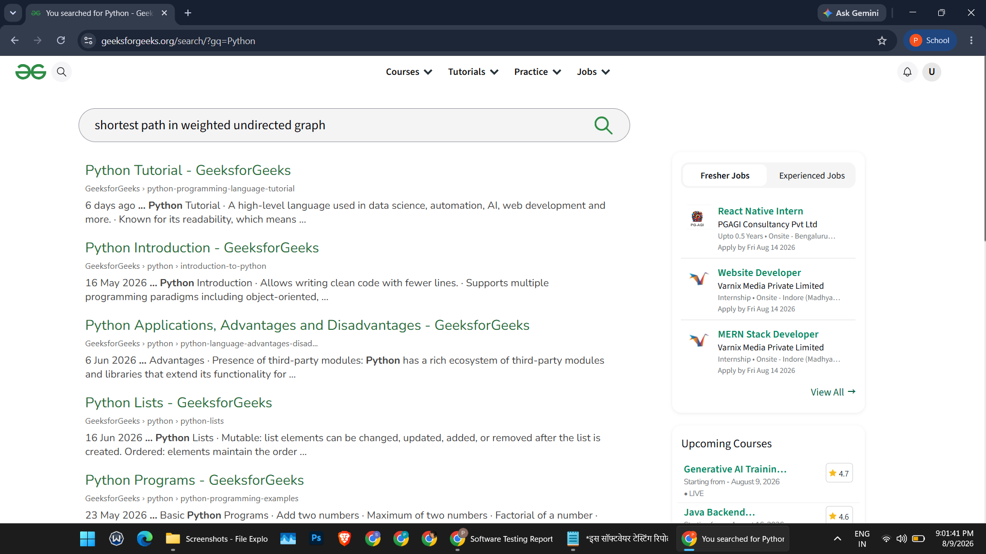:

SCN-002 — Verify Search with Invalid/Random Keyword
- Open the search bar.
- Enter a random/invalid keyword, e.g. "Piyush Gewani".
- Click Search / press Enter.
- Observe the response.
Status: Pass
Screenshot:
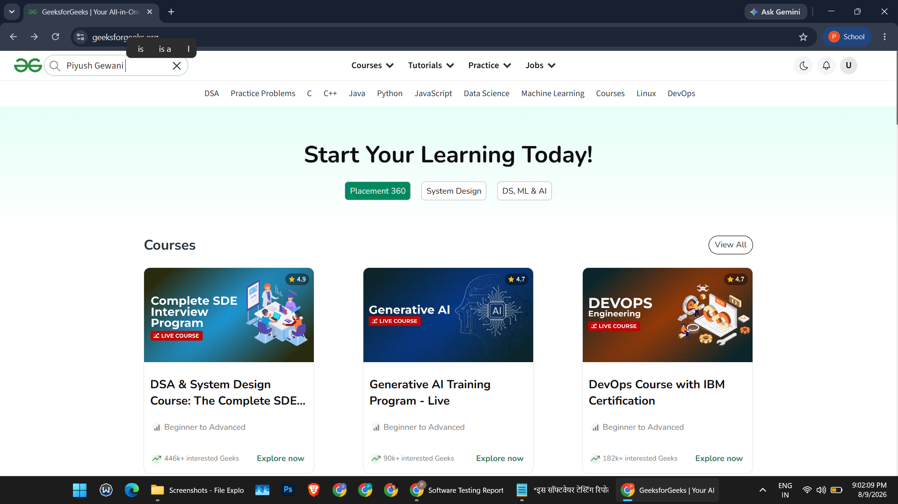
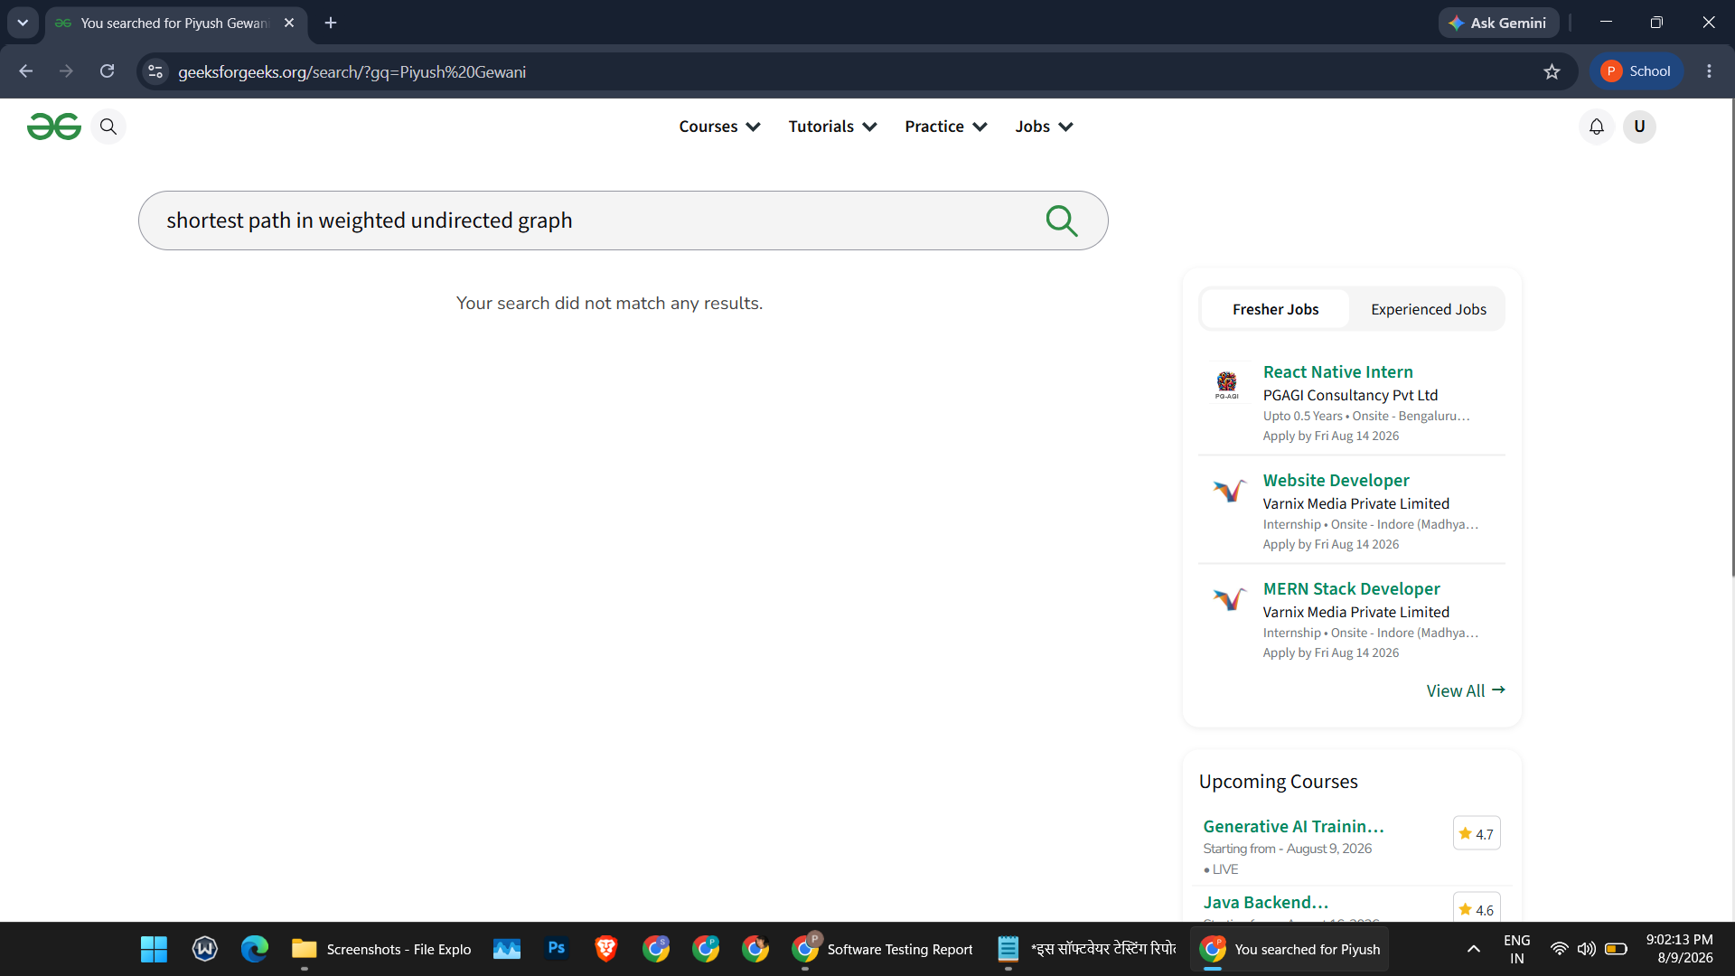:

SCN-003 — Verify Sign In with Valid Credentials
- Open the GeeksforGeeks website.
- Click Sign In.
- Enter valid email and password.
- Click Sign In / Login.
Status: Pass
Screenshot:
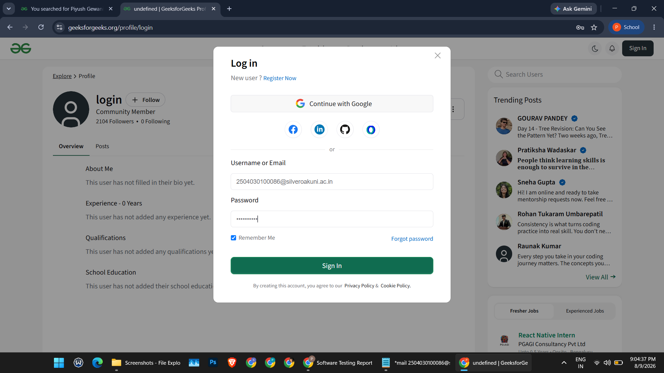
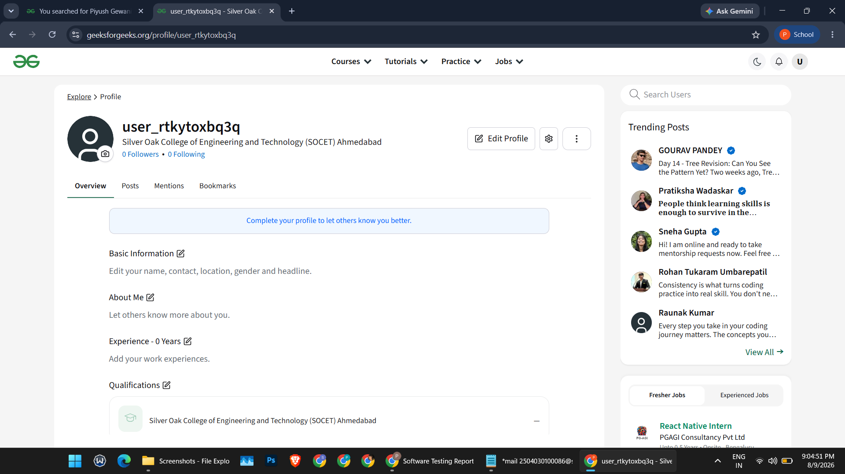:

SCN-004 — Verify Sign In with Invalid Credentials
- Open the Sign In page.
- Enter an invalid email or password.
- Click Sign In / Login.
Status: Pass
Screenshot:
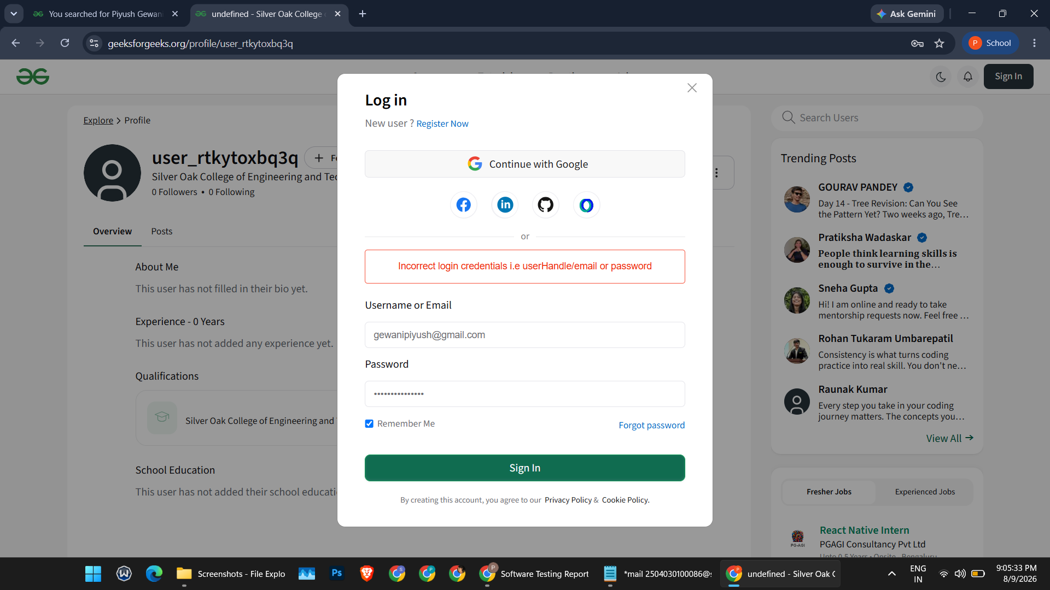
SCN-005 — Verify Navigation to Practice Problems
- Open the GeeksforGeeks homepage.
- Locate the Practice section.
- Click Practice Problems.
- Allow the page to load.
Status: Pass
Screenshot:
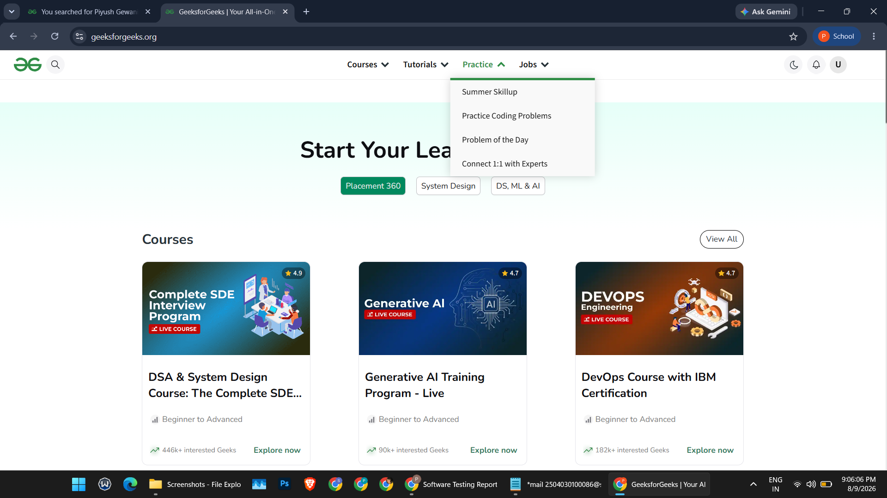
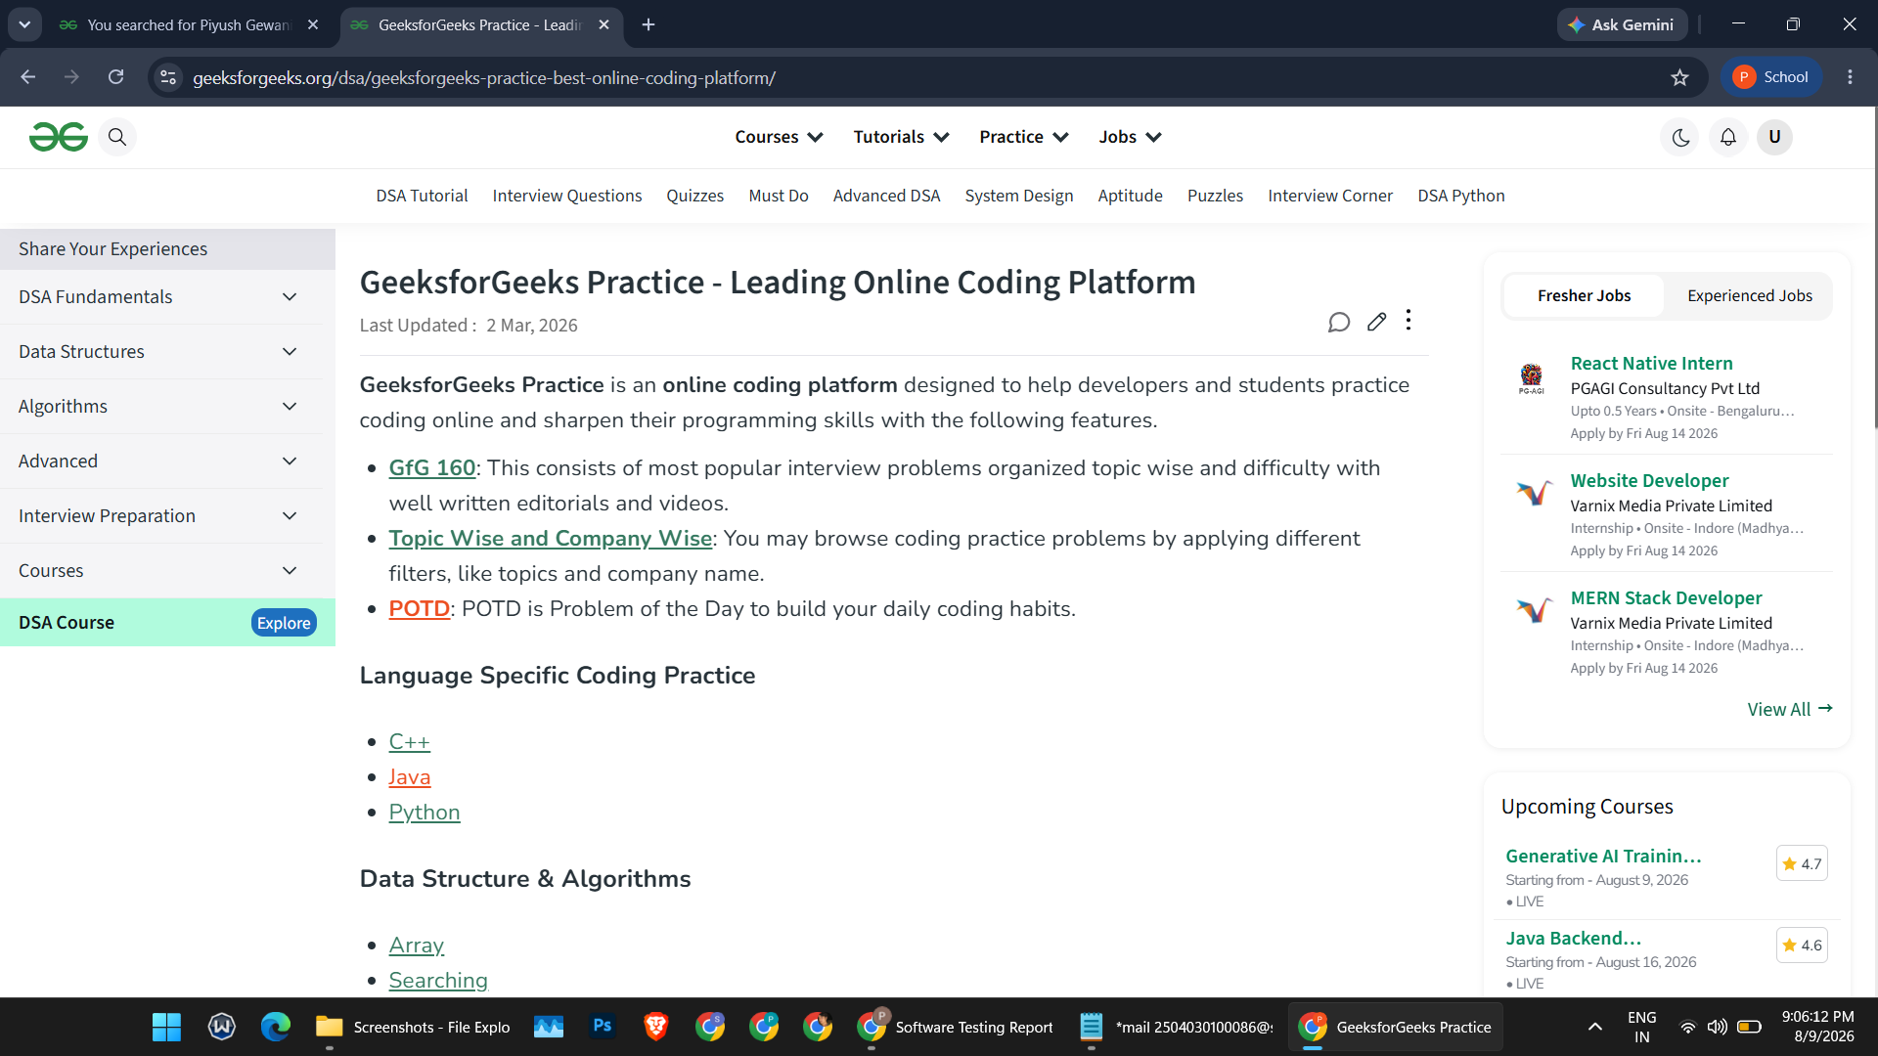:
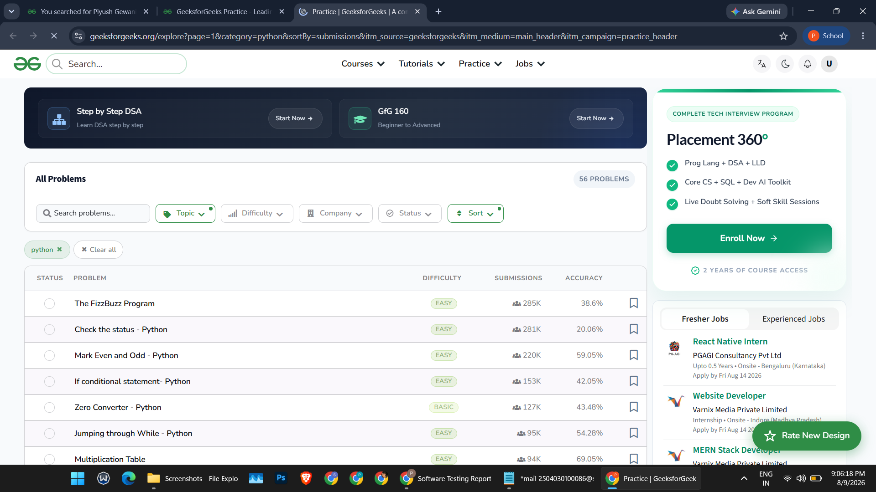:

SCN-006 — Verify Opening a Coding Problem
- Open Practice Problems.
- Select a coding problem (e.g. a basic/easy problem).
- Open the problem.
- Review the problem statement and coding/practice interface.
Status: Pass
Screenshot:
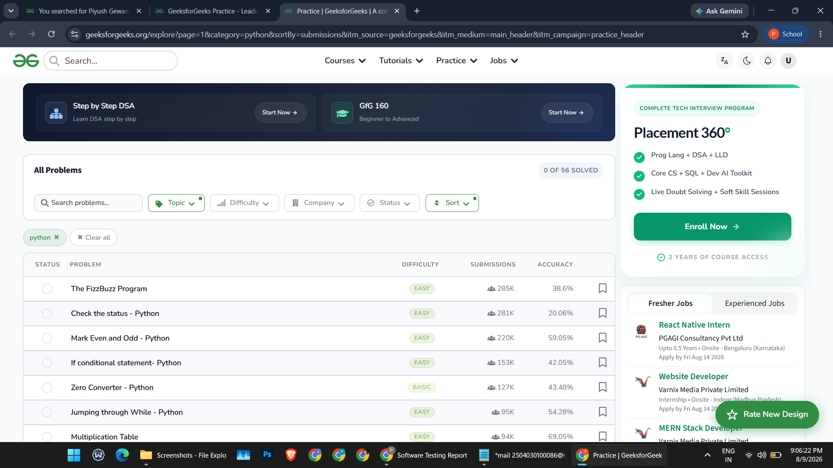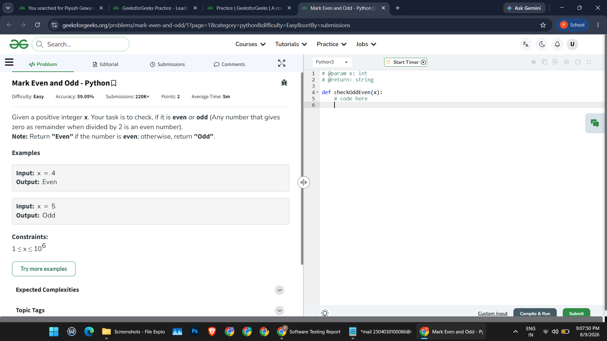
SCN-007 — Verify Page Response Time
- Open the Homepage.
- Open the Search Results page.
- Open the Practice Problems page.
- Open a Coding Problem page.
- Verify that all pages load within an acceptable time.
Status: Pass
Screenshot:
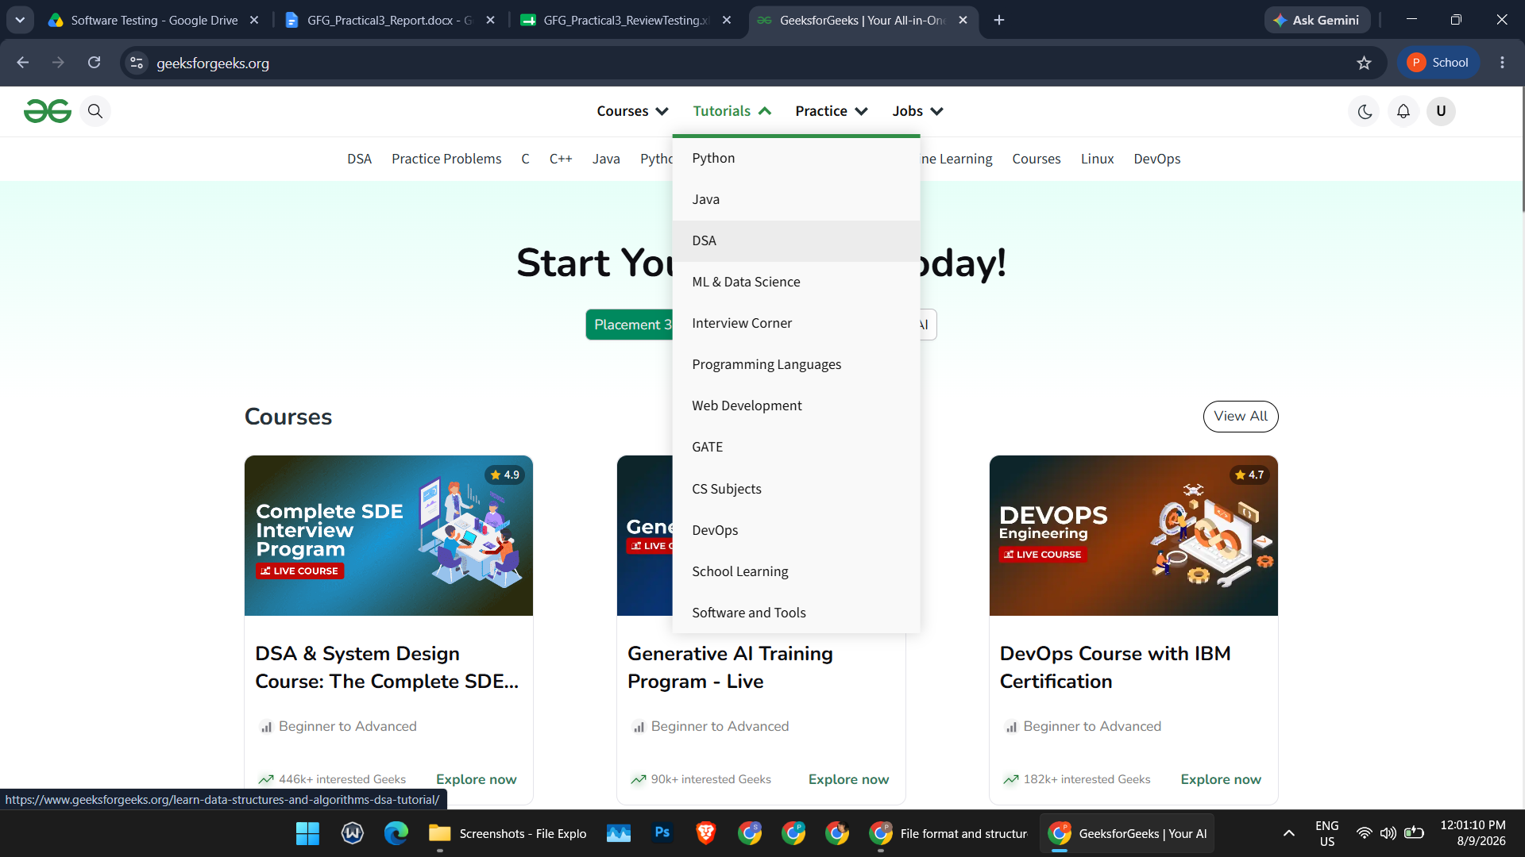
SCN-008 — Verify Website Usability and Navigation
- Navigate through Home, Search, Practice, and Problem pages.
- Verify that menus and buttons are easy to use.
- Confirm smooth, user-friendly navigation.
Status: Pass
Screenshot:
Screenshot Placeholder — Desktop Size (paste SCN-008 screenshot here)

SCN-009 — Verify Validation/Error Message
- Attempt Sign In with an invalid email and password.
- Submit the form.
- Verify that an appropriate validation/error message is displayed.
Status: Pass
Screenshot:
SCN-010 — Verify Overall Website Functionality
- Search for a topic.
- Open a relevant result.
- Navigate to Practice Problems.
- Open a coding problem.
- Verify the problem page loads correctly, completing the end-to-end flow.
Status: Pass
Screenshot:
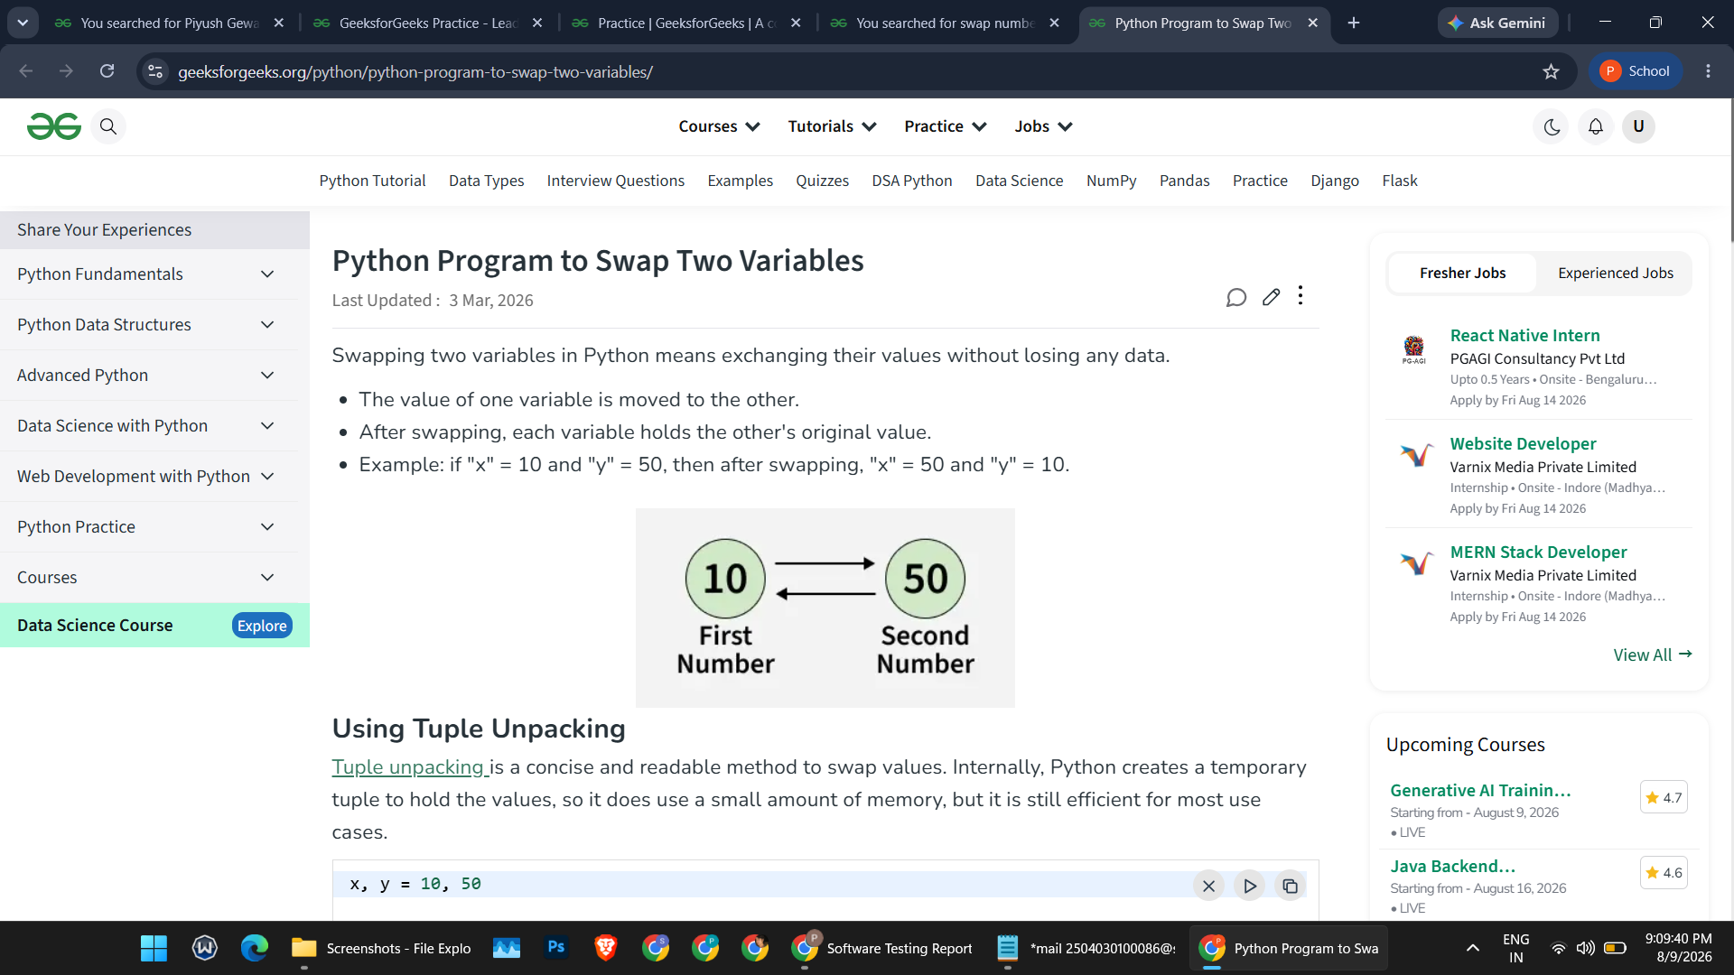
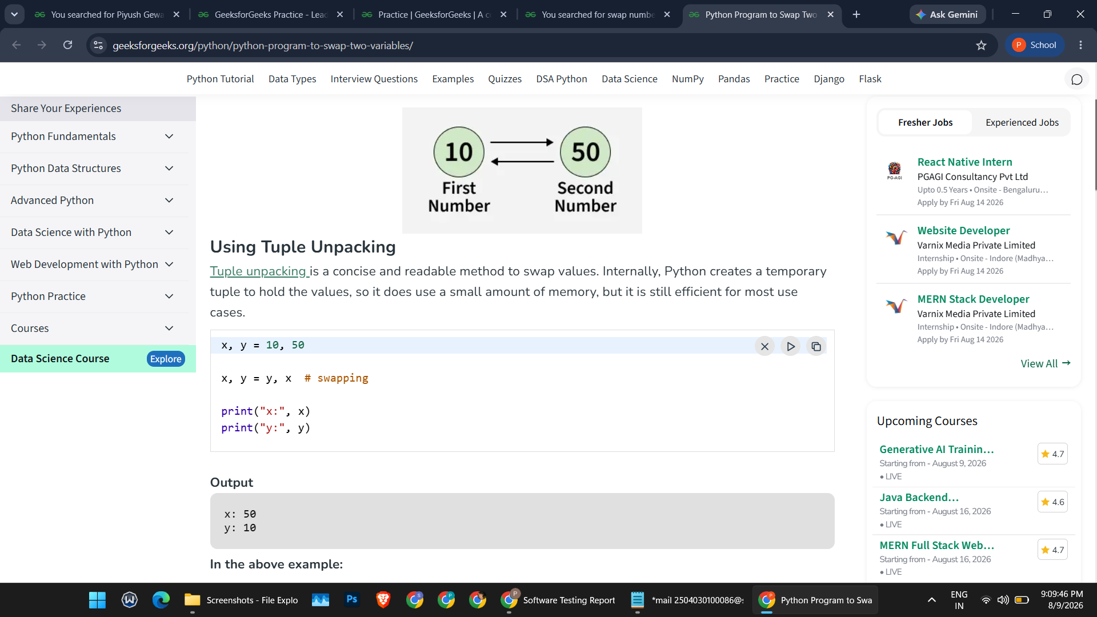

Summary of Test Results
Total Test Cases: 10
Passed: 10
Failed: 0
Pass Percentage: 100%
All 10 planned functional, non-functional, positive, and negative test scenarios were executed successfully with a 100% pass rate.

