GeeksforGeeks
Manual Test Execution using Multiple Input Conditions
Module Name: GeeksforGeeks
Test Case ID: TC_EXEC_001
Webpage URL: https://www.geeksforgeeks.org/
Manual Test Execution Scenarios

SCN-001 — Verify GeeksforGeeks Homepage

1. Open the GeeksforGeeks website.
2. Allow the homepage to load completely.
3. Verify that the main page loads properly.
4. Check that the header, navigation, and content are visible.
Status: Pass
Screenshot:
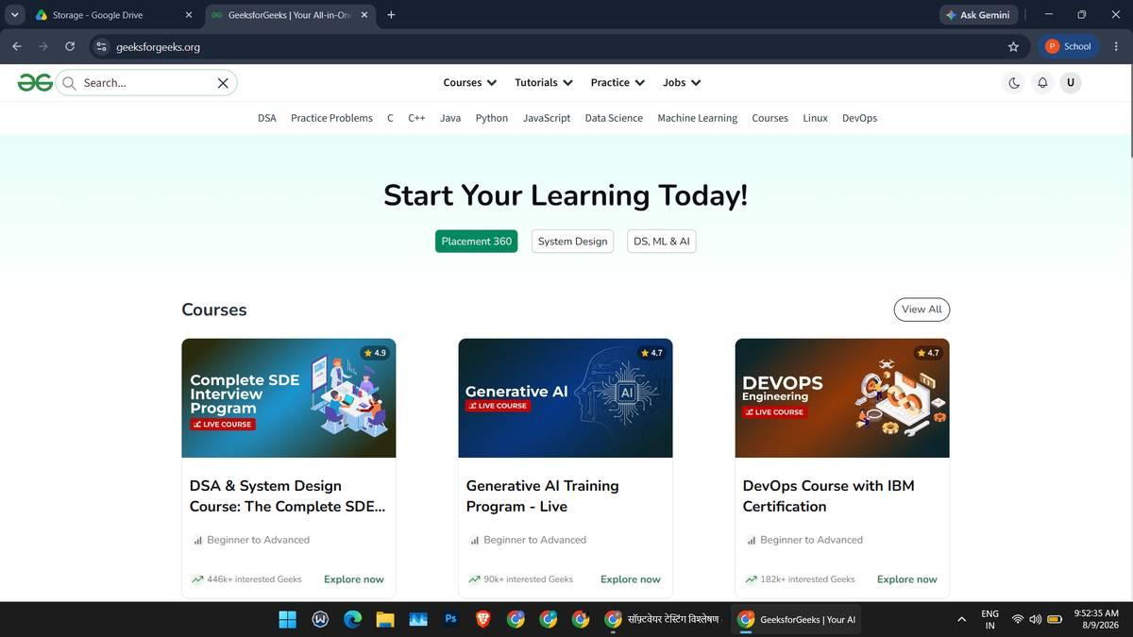
SCN-002 — Verify Search with Valid Keyword

5. Open the GeeksforGeeks homepage.
6. Locate the search box.
7. Enter "HTML" in the search box.
8. Perform the search.
9. Verify the displayed results.
Status: Pass
Screenshot:

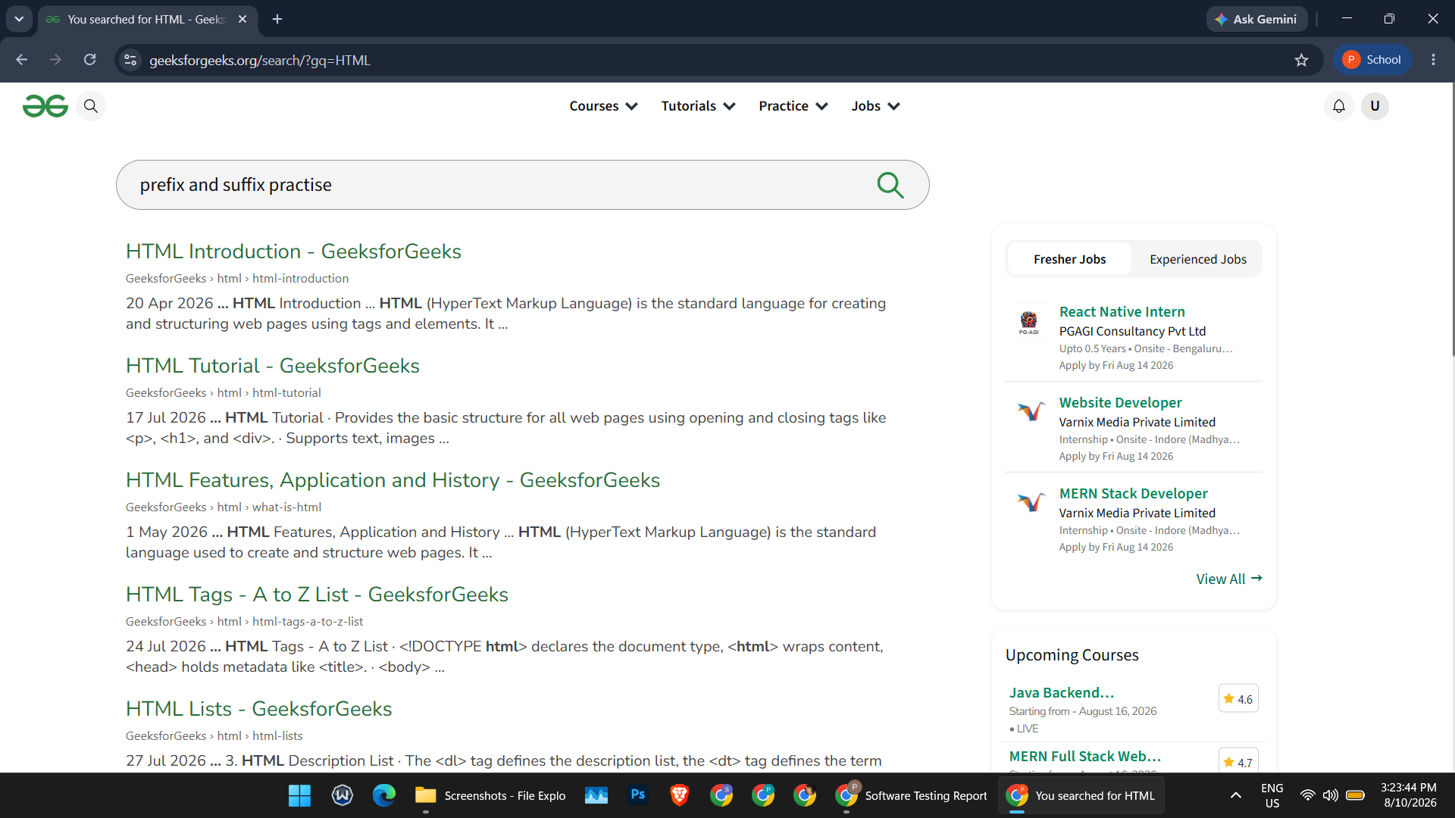

SCN-003 — Verify Search with Invalid Keyword

10. Open the search box.
11. Enter a random/non-existing keyword ("piyush gewani").
12. Perform the search.
13. Observe the result page.
Status: Pass
Screenshot:
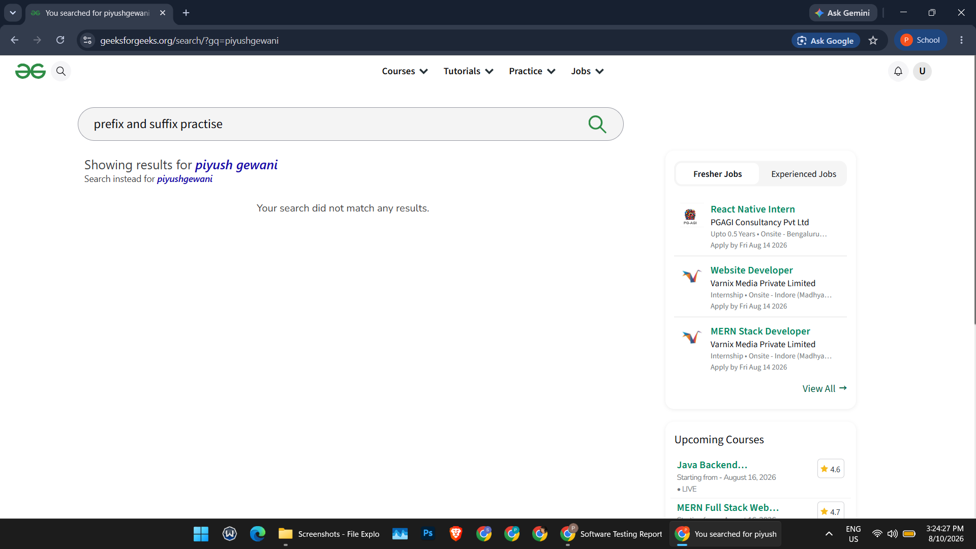

SCN-004 — Verify Search with Blank Input

14. Open the search box.
15. Do not type anything in the search field.
16. Perform the search action.
17. Observe the application response.
Status: Pass
Screenshot:


SCN-005 — Verify Valid Article/Tutorial Opens

18. Search for "HTML".
19. Open a relevant article/tutorial from the results.
20. Verify the page loads, title is visible, and content is displayed.
21. Verify navigation works with no loading/error issue.
Status: Pass
Screenshot:
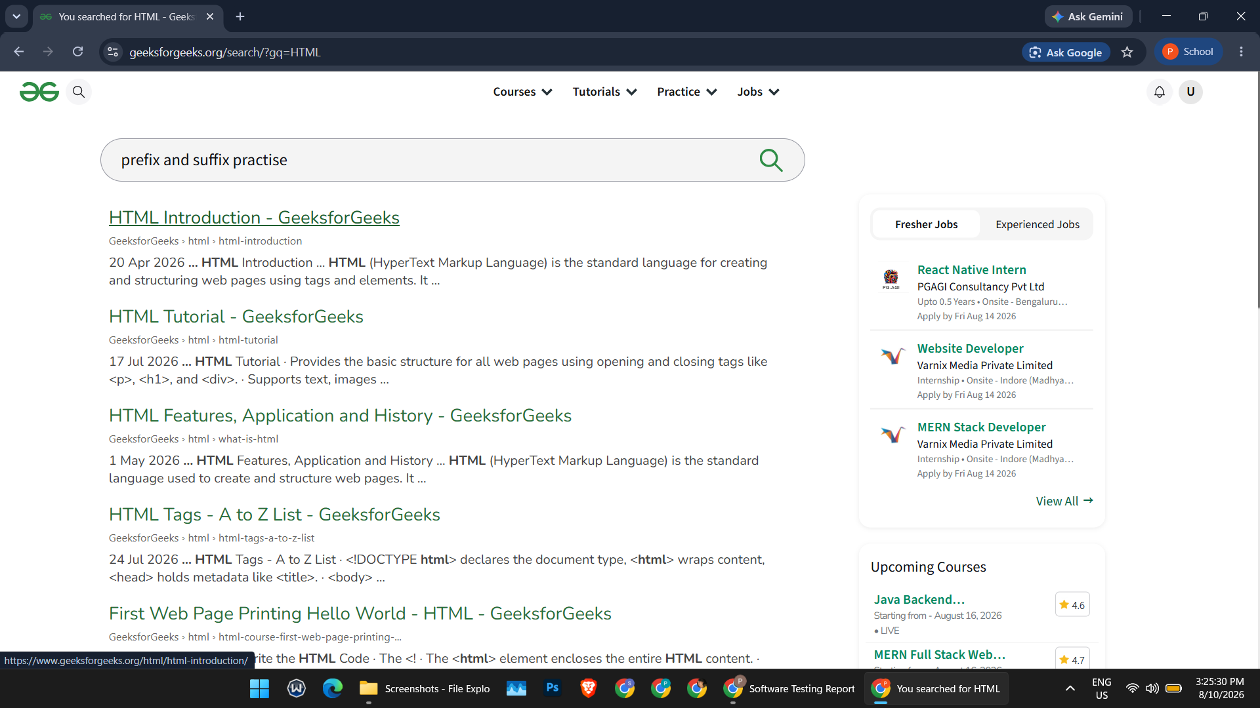
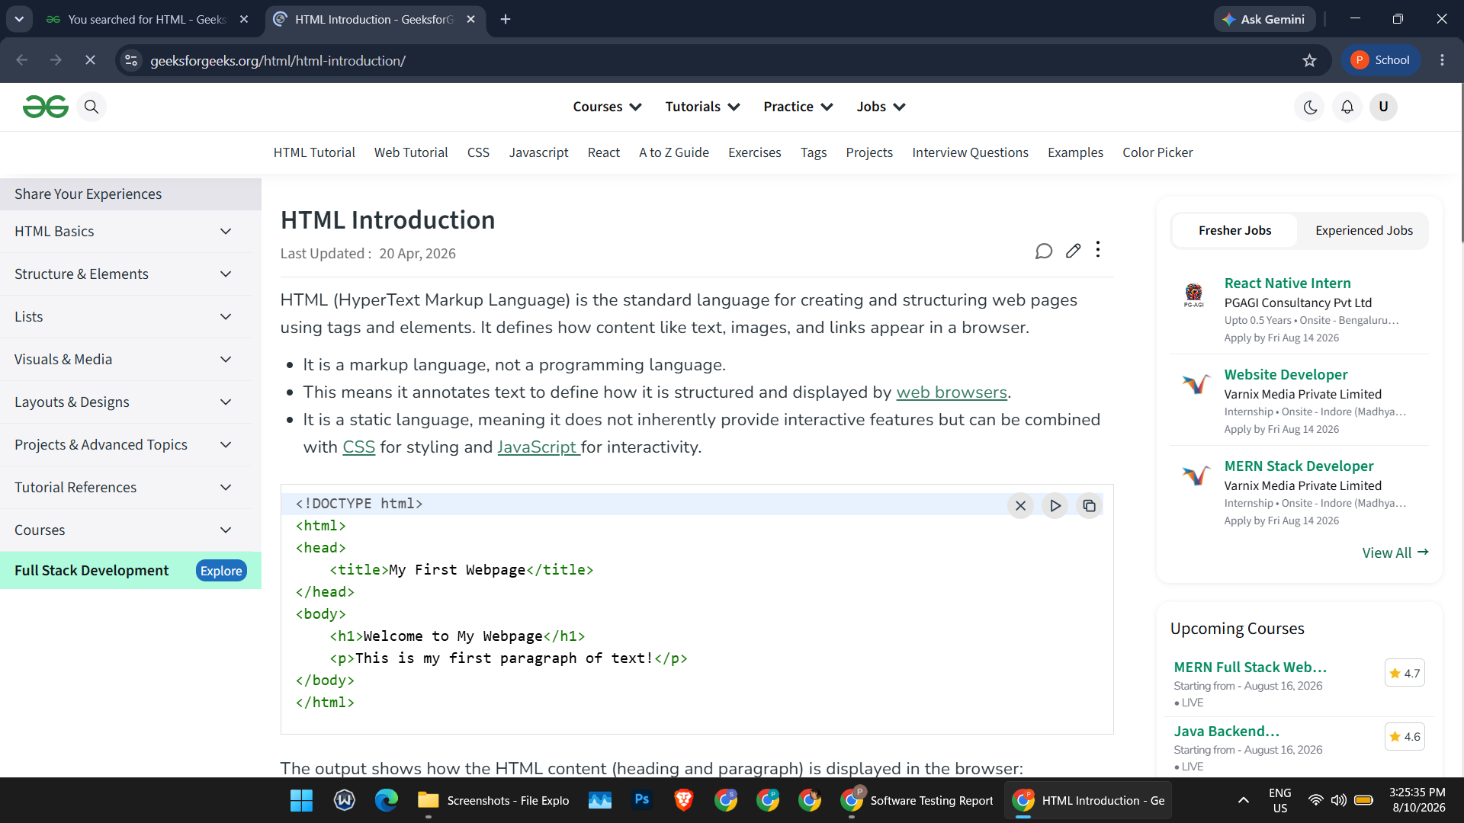
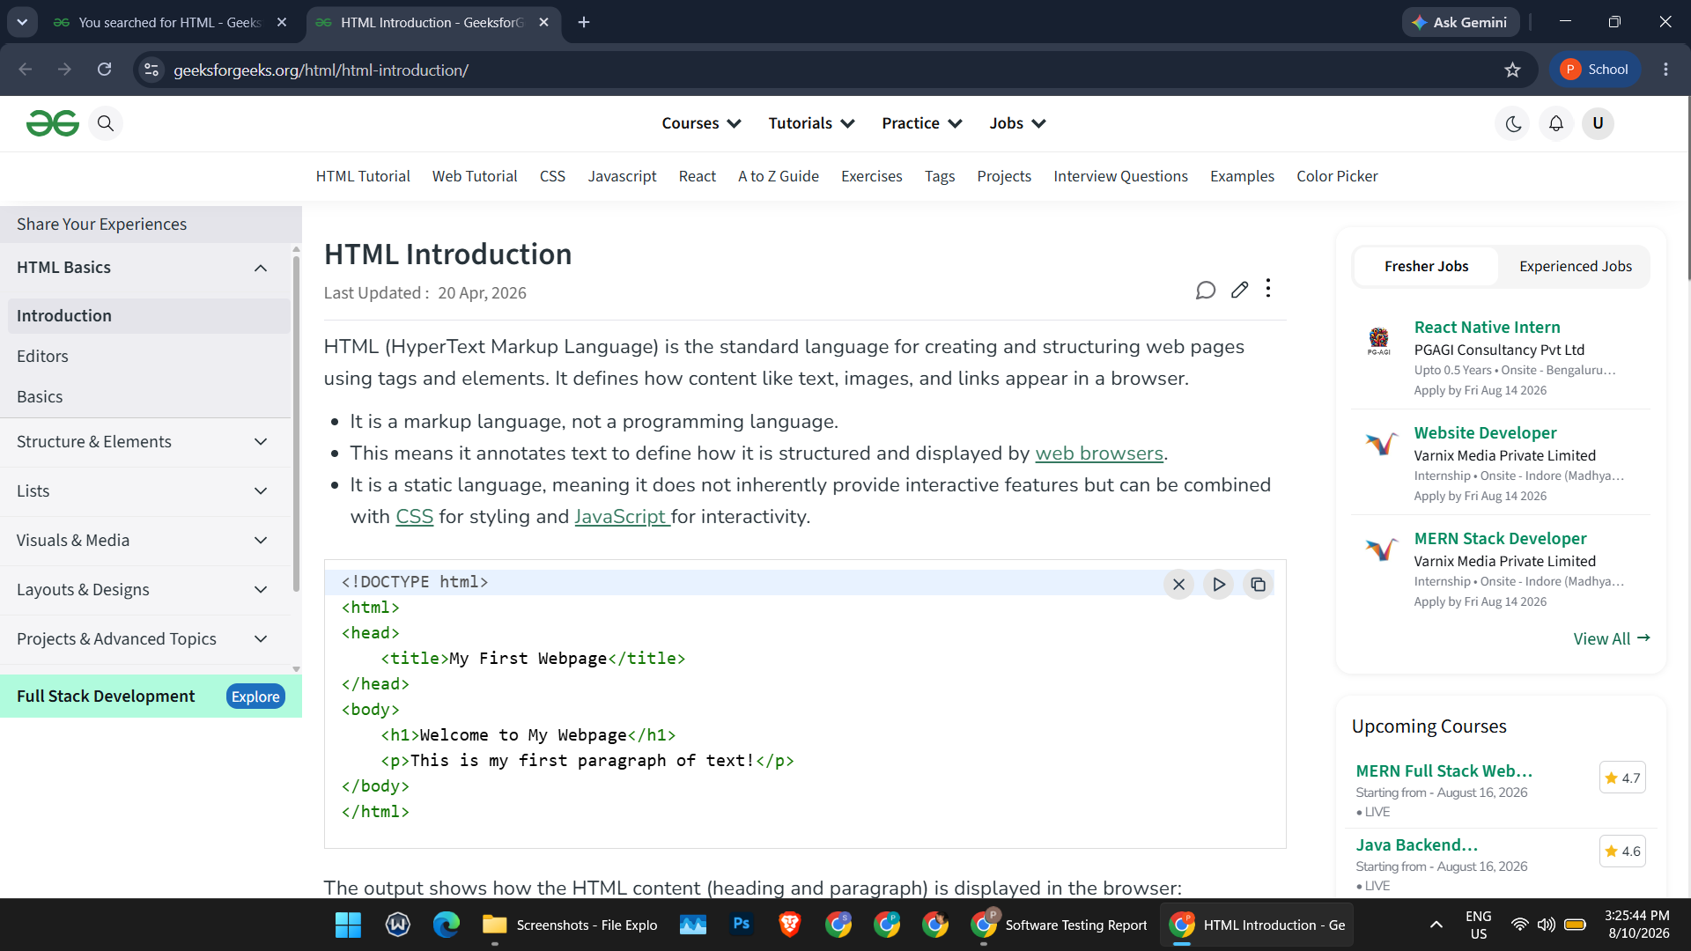
SCN-006 — Verify Search with Multiple Valid Inputs

22. Open the search box.
23. Search using multiple valid keywords: Python, Java, Data Structures, Machine Learning.
24. Verify relevant results are displayed for each keyword.
Status: Pass
Screenshot:
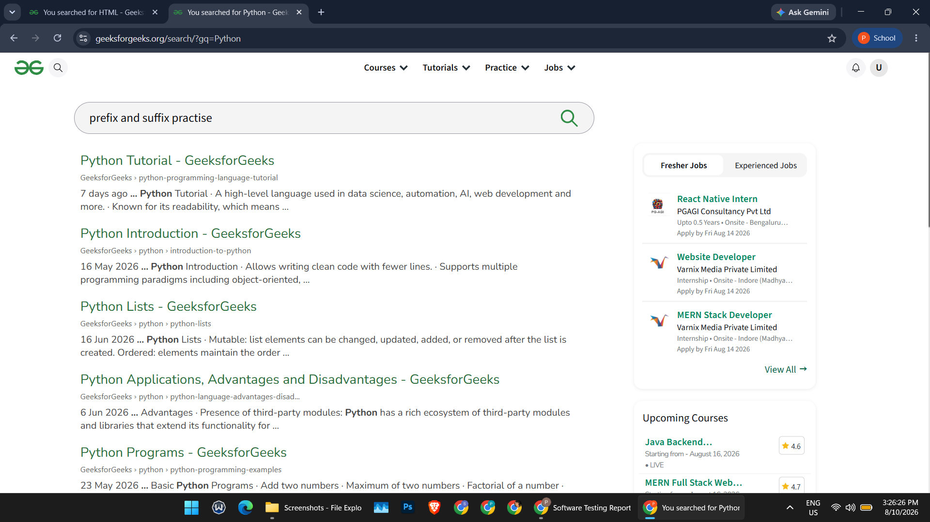
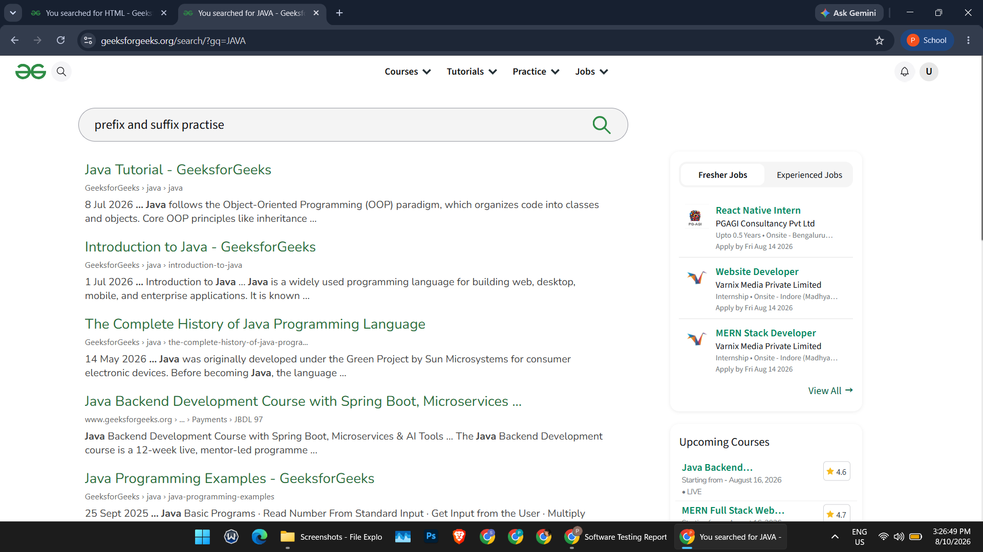
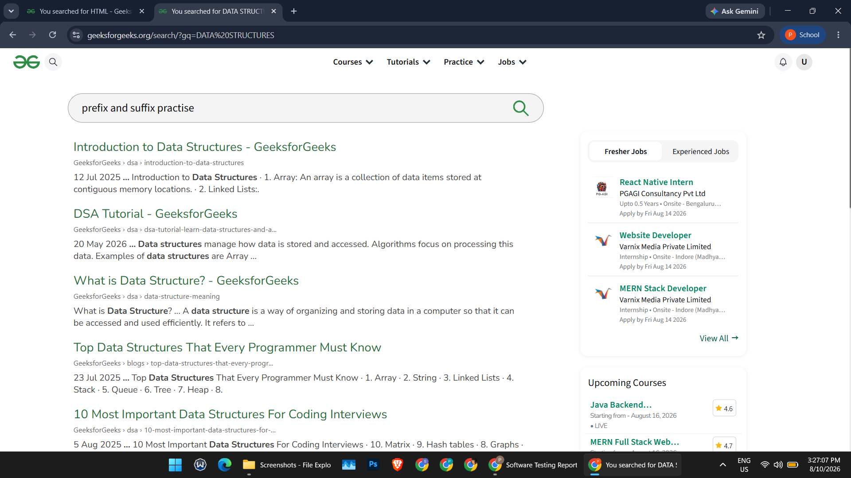
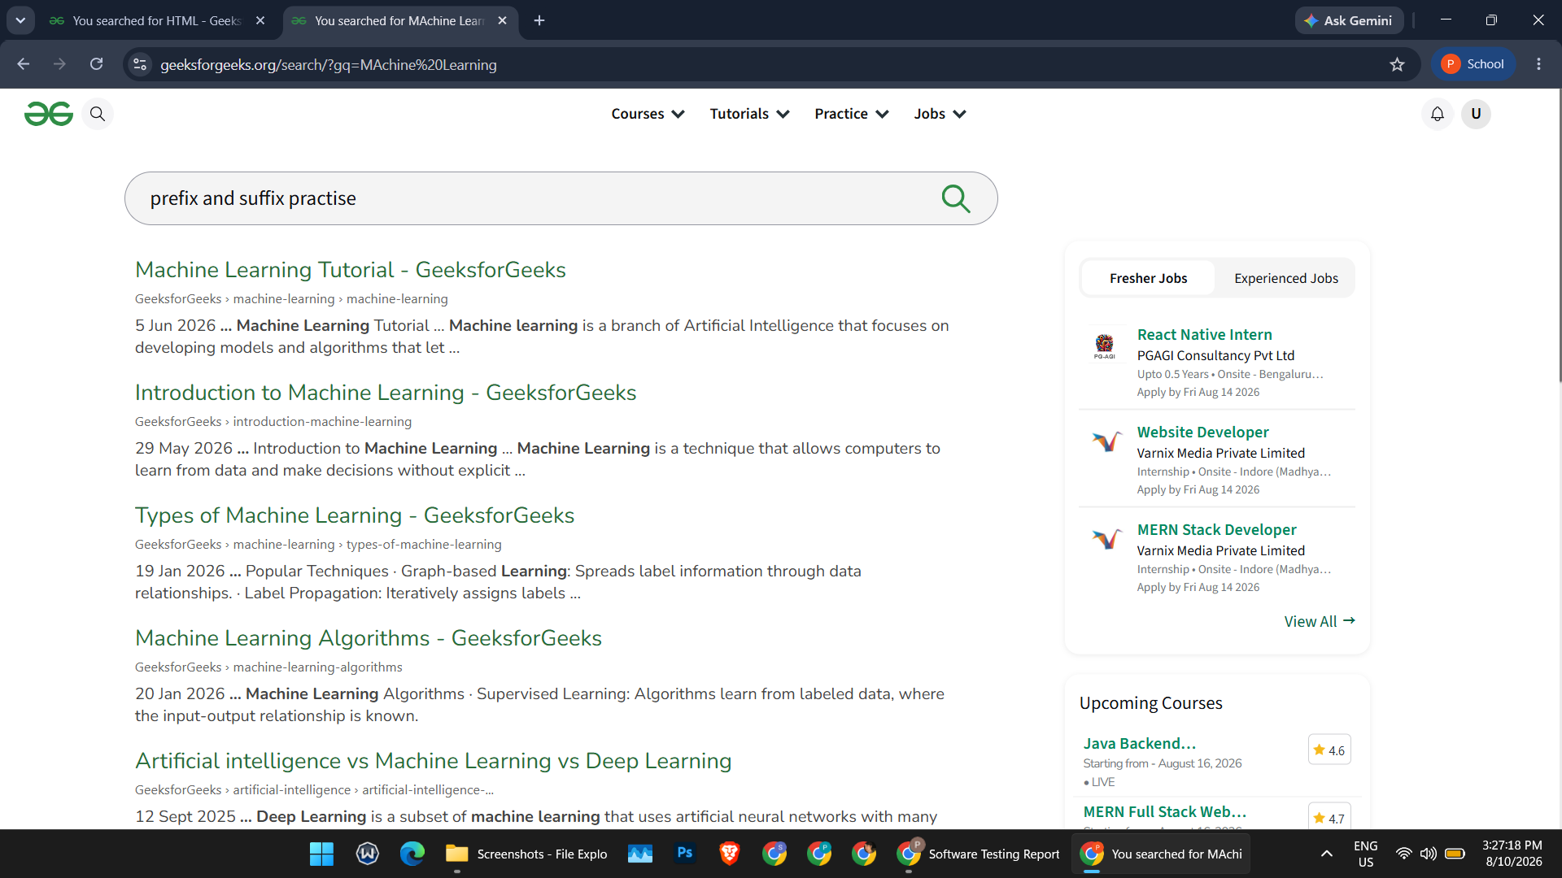
SCN-007 — Verify Search with Special Character Input

25. Open the search box.
26. Enter special characters ("@#$%").
27. Perform the search.
28. Verify the application does not crash and handles input appropriately.
Status: Pass
Screenshot:
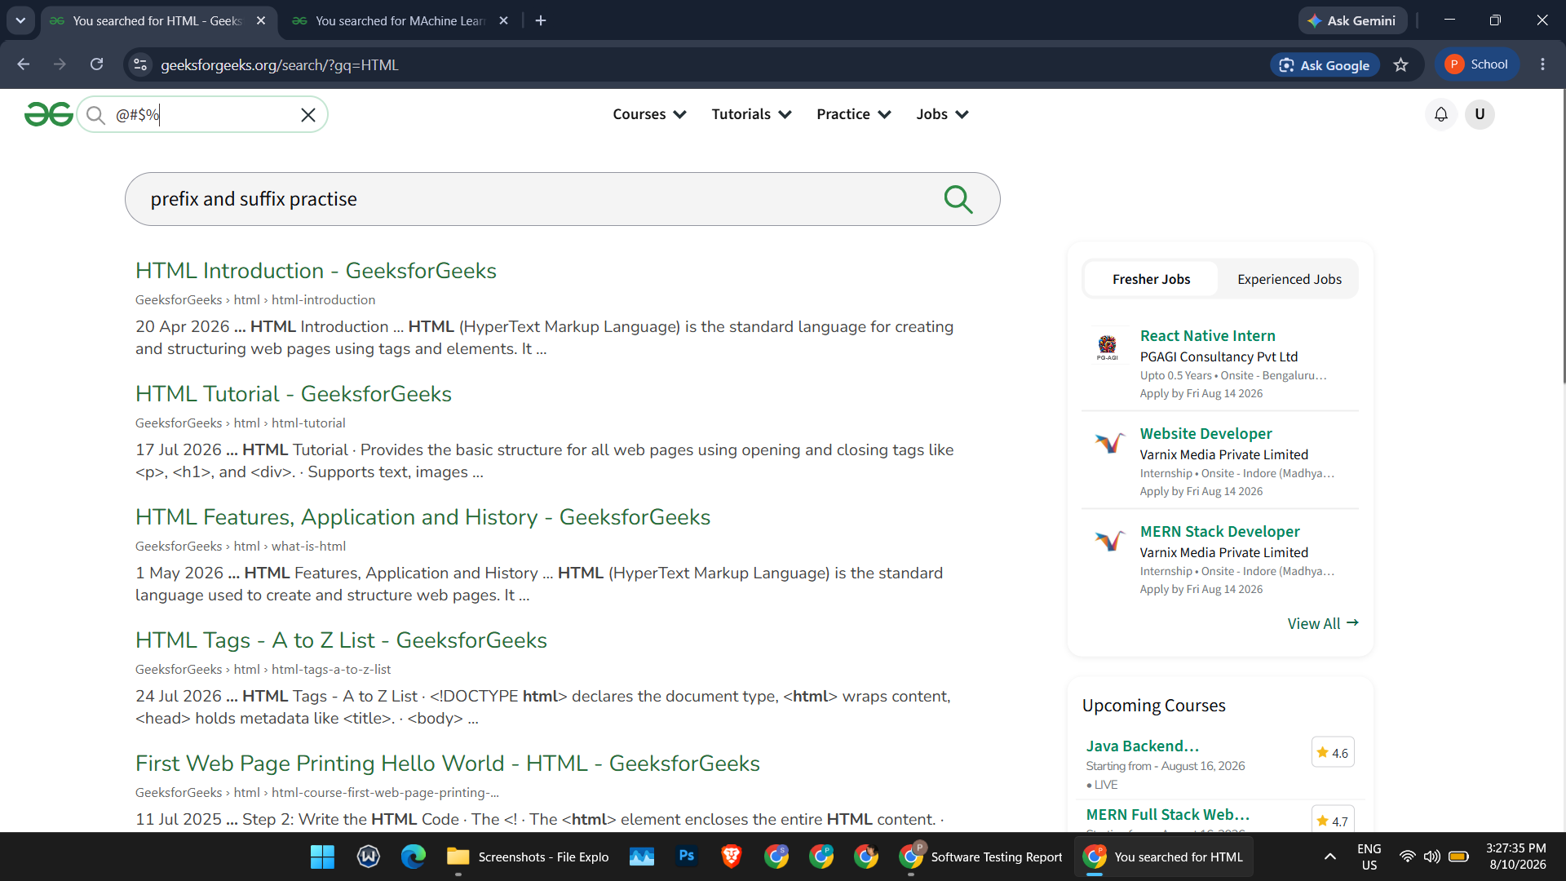
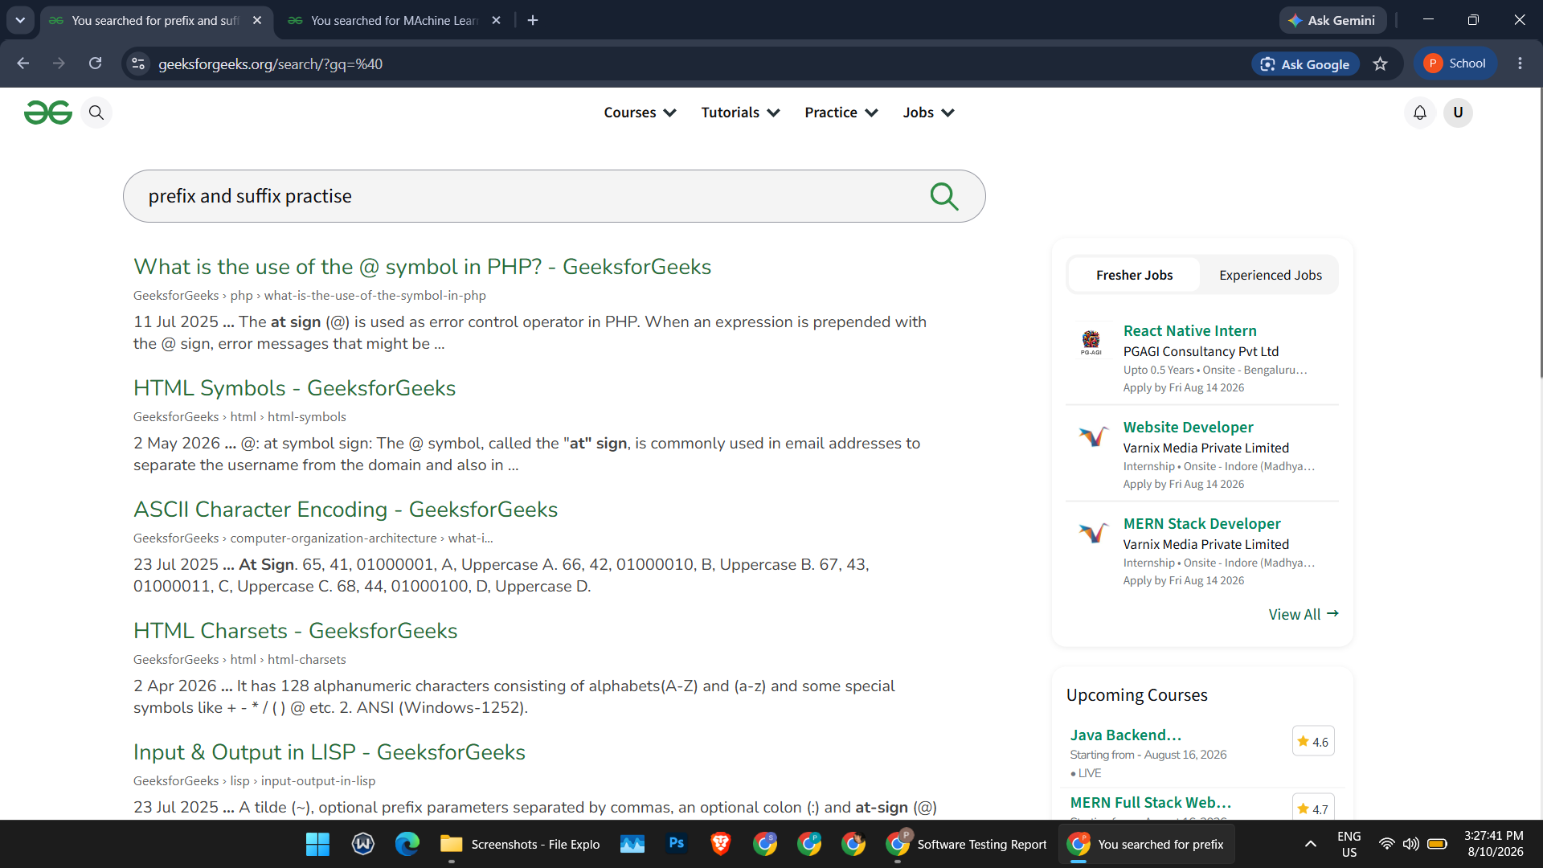

SCN-008 — Verify Search with Numeric Input

29. Open the search box.
30. Enter a numeric value ("123456789").
31. Perform the search.
32. Verify the application processes the input appropriately.
Status: Pass
Screenshot:
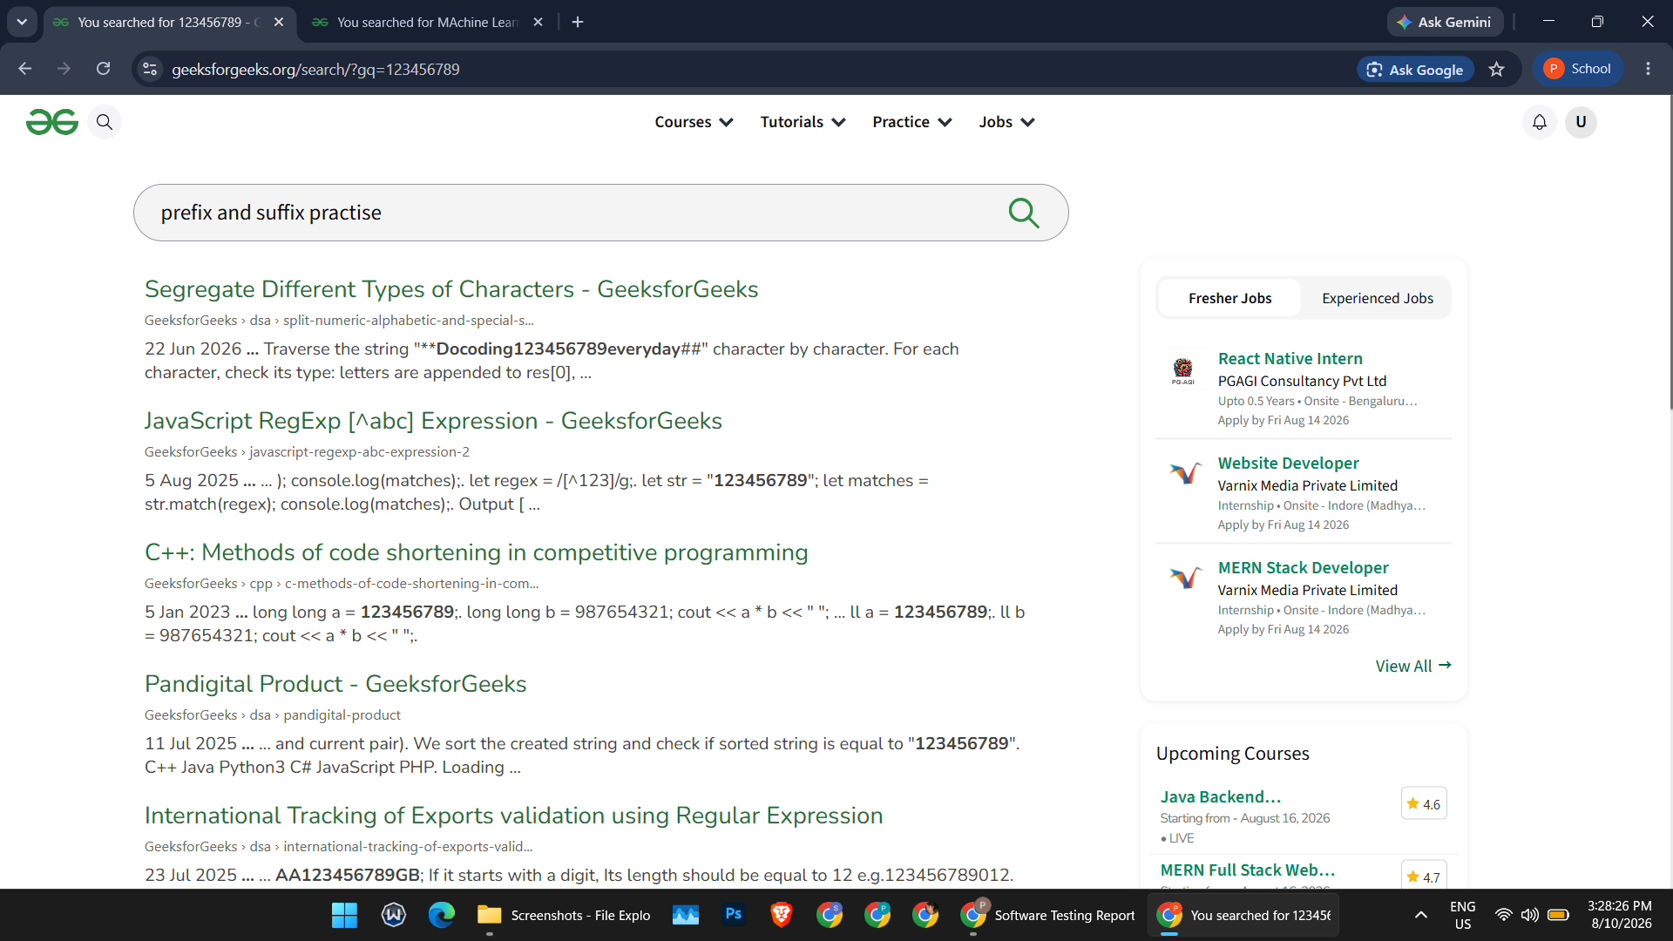
SCN-009 — Verify Boundary Input Condition

33. Open the search field.
34. Enter a very short input ("a") and a deliberately long input string.
35. Perform the search for each.
36. Observe the application response for boundary handling.
Status: Pass
Screenshot:
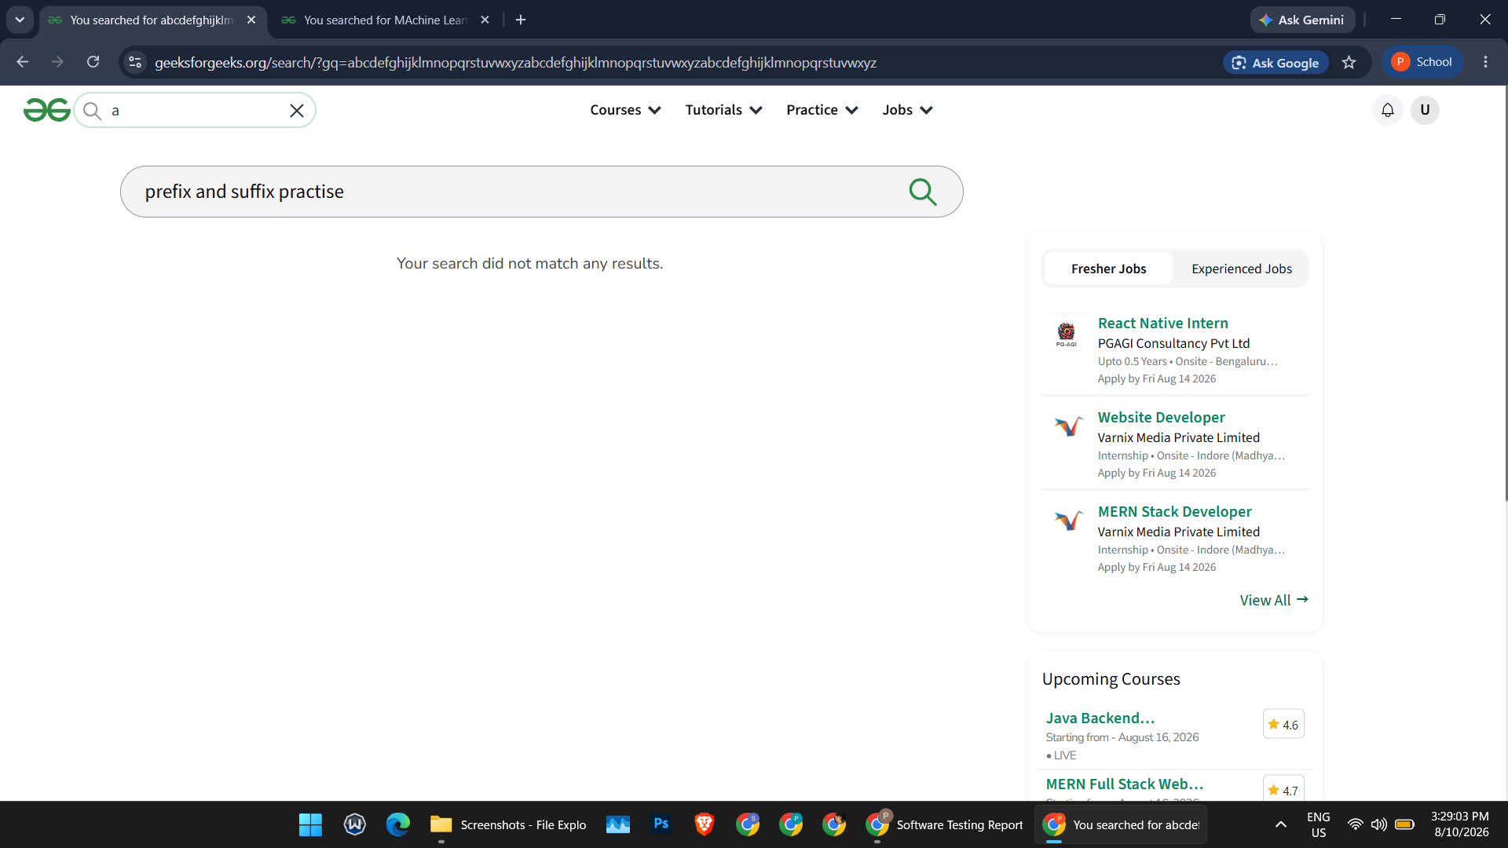
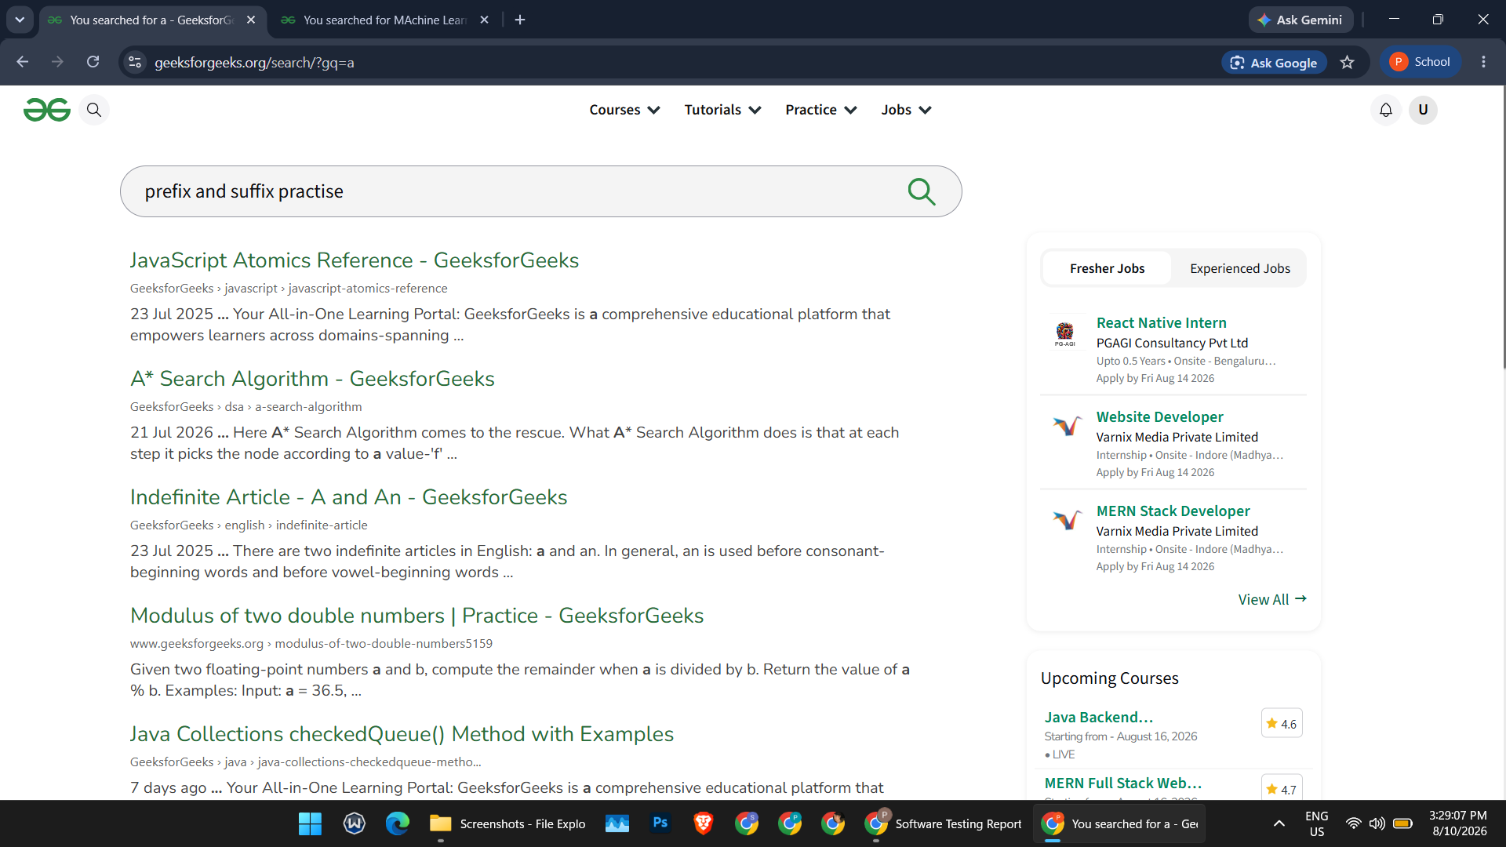
SCN-010 — Verify Test Execution Summary

37. Review all executed test cases.
38. Count Passed and Failed test cases.
39. Prepare the Test Summary Report.
Status: Pass
Screenshot:

Summary of Test Results

Total Test Cases: 10
Passed: 10
Failed: 0
Pass Percentage: 100%
All 10 planned manual test execution scenarios covering multiple input conditions were executed successfully on the GeeksforGeeks website with a 100% pass rate.

