Annex B
Location-Centric vs Asset-Centric Graph Representations
With the Cushing Terminal as a Worked Example and the Balancing Item in the Mass Balance Equation
Supporting material for Section 2.1 of the thesis

Summary
This annex develops the graph-representation framework used throughout the thesis, with the Cushing, Oklahoma crude-oil hub as a running example. It establishes two foundations and a set of extensions that make the framework usable at production scale.
The foundations, covered in Sections B.1 through B.6, are the asset-centric convention — every physical asset, including pipelines and vessels, is a node with its own inventory — and the universal mass balance with a balancing item that absorbs the systematic discrepancies endemic to commodity reporting. Together these give every node the same accounting equation and a stable adjacency matrix compatible with standard graph neural network architectures.
The extensions, covered in Sections B.7 through B.12, address the engineering problem the foundations leave open: how a framework designed for named physical assets accommodates data that arrives at heterogeneous, often administrative, resolutions. The framework separates the persistent asset graph from the scenario graph derived at load time; distinguishes geography metadata, which labels physical nodes, from the resolution hierarchy, which relates nodes representing the same physical system at different granularities; and enforces an observed/derived invariant that makes aggregation double-counting structurally impossible rather than merely detectable. The invariant is supported by coverage contracts that declare which level of each hierarchy is authoritative for a given scenario, allowing administrative aggregates to be promoted to authoritative status when no finer data is available and reverted to derived views when it is. Junction nodes whose variables cannot be distinguished at the current resolution are collapsed by the scenario loader, and the latent allocation of flows across such nodes becomes a concrete use case for attention-based temporal graph models.
The annex closes (B.13) by positioning these extensions as the methodological contributions that make the asset-centric framework usable when data heterogeneity is the central engineering problem rather than an incidental one.

B.1 Overview
A foundational decision in any graph-based model of a physical logistics network is what the nodes and edges represent. Two broad conventions exist in the literature. The location-centric convention treats fixed geographic sites — a terminal, a refinery, a field — as nodes, and the physical connections between them — pipelines, shipping lanes — as edges. The asset-centric convention treats every physical asset as a node, including the pipelines and vessels themselves.
This annex works through both conventions using the Cushing, Oklahoma crude oil hub as a running example, explains the practical difference for the model, and derives the mass balance equation with its balancing item — the correction term that absorbs the difference between calculated and observed inventory changes.
The annex is structured as follows:
- B.2 — Location-centric representation: pipelines as edges.
- B.3 — Asset-centric representation: pipelines as nodes with line-fill inventory.
- B.4 — Comparison: when each convention is appropriate.
- B.5 — The mass balance equation and the balancing item.
- B.6 — Implications for the GNN model in this thesis.
- B.7 — Persistent asset graph and scenario graph separation.
- B.8 — The observational aggregation layer.
- B.9 — Geography metadata and administrative aggregations.
- B.10 — Resolution hierarchy and forward compatibility.
- B.11 — Assignment tables, the observed/derived invariant, and coverage contracts.
- B.12 — Junction nodes, collapsed states, and latent allocation.
- B.13 — Summary and position in the thesis.

B.2 Location-Centric Representation
In the location-centric convention, each node in the graph represents a fixed geographic site. For the Cushing subnetwork, the five nodes are the Permian Basin production field, the Gulf Coast production field, the Cushing terminal, a Midwest refinery, and the Strategic Petroleum Reserve (SPR). The pipelines connecting them — the Longhorn, Seaway, and Ozark lines — are edges, not nodes. They carry attributes such as flow rate (barrels per day), transit time (days), capacity, and operational status, but they do not hold inventory of their own.
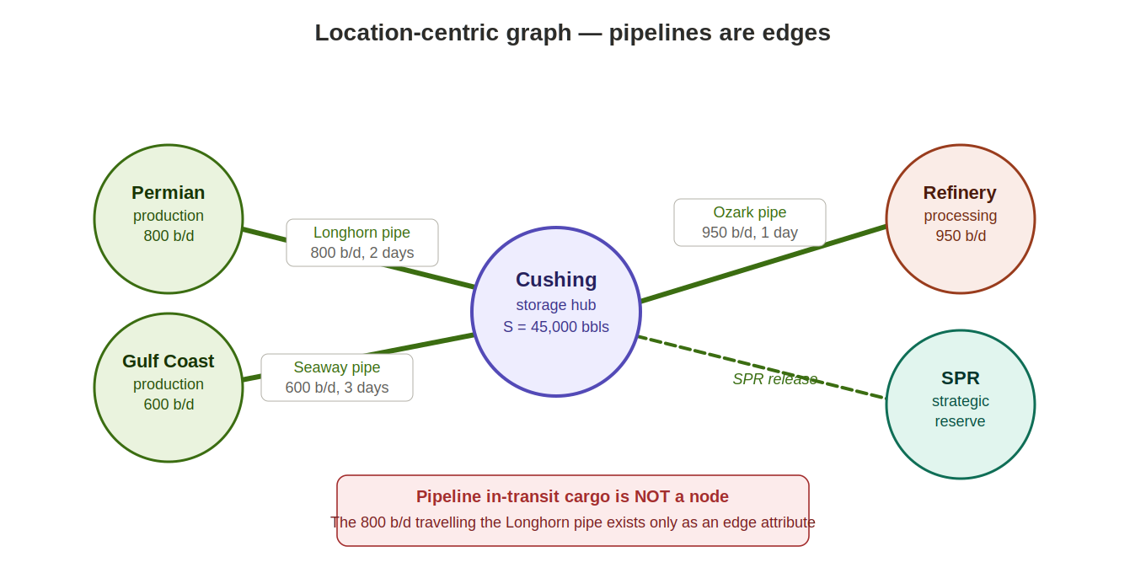
Figure B.1 — Location-centric graph of the Cushing subnetwork. Nodes are fixed sites; pipelines are edges carrying flow and transit-time attributes. Dashed edge indicates the SPR release route, which is inactive in normal operations.
This is the dominant convention in the traffic forecasting literature. DCRNN and STGCN, for example, represent road sensor networks with sensors as nodes and road segments as edges. It is also the convention used in the SupplyGraph benchmark for supply chain GNNs.
What is captured
- Inventory at fixed sites (Cushing stock level, SPR reserves).
- Flow rates on each pipeline (barrels per day arriving and departing).
- Transit time as an edge attribute — crude dispatched today arrives at Cushing after the pipeline transit delay.
- Capacity constraints on each route.
What is not captured
The crude oil physically inside the pipeline at any given moment — the line-fill — has no node. The Longhorn pipeline, operating at 800 b/d with a two-day transit time, contains about 1,600 barrels at any given moment. In the location-centric model, these barrels are invisible: they have left Permian (an outflow) but have not yet arrived at Cushing (no inflow yet). They exist only implicitly in the transit-time edge attribute.
For regional-level forecasting using weekly EIA data, this limitation is often acceptable — the pipeline line-fill is small relative to the storage volumes being modelled, and the transit lag is captured by the edge attribute. However, for maritime shipping, the in-transit cargo on a VLCC carrying two million barrels across the Atlantic is a significant inventory position that the location-centric model cannot track.

B.3 Asset-Centric Representation
In the asset-centric convention, every physical asset — including pipelines and vessels — is a node. Each node carries its own inventory variable. The Longhorn pipeline is a node with a stock level equal to its line-fill (flow rate multiplied by transit time). A VLCC tanker is a node with a stock level equal to its cargo. The edges in the asset-centric graph represent the connections between assets: loading events connect a terminal node to a vessel node; discharge events connect a vessel node to a destination terminal.
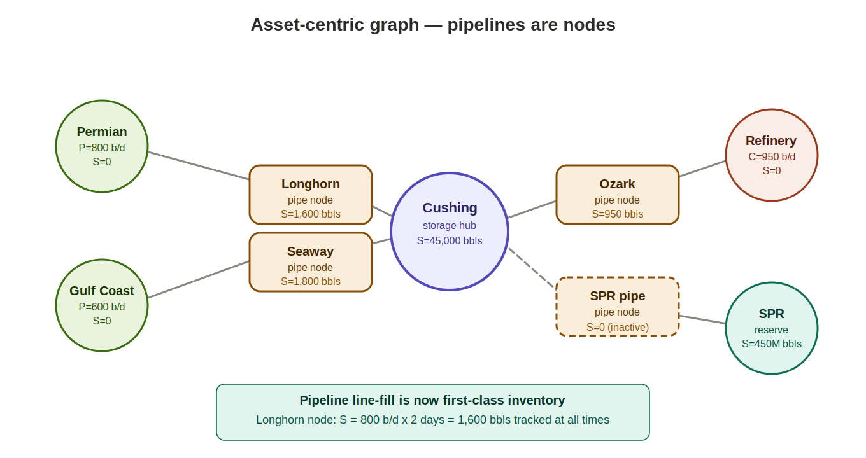
Figure B.2 — Asset-centric graph of the Cushing subnetwork. Pipelines become nodes (amber) with their own line-fill inventory. Edges represent flow connections between assets. The SPR pipeline node has S = 0 (inactive, zero-flow edge).
Stable topology through zero-flow edges
A potential concern with the asset-centric approach is that it appears to create a dynamic topology: a vessel node that is active one week may be idle the next, and connections appear and disappear. This concern is resolved by the zero-flow convention: all potential edges between asset pairs are defined permanently, and their flow time series is set to zero during periods of inactivity. The adjacency matrix remains fixed regardless of which routes are active.
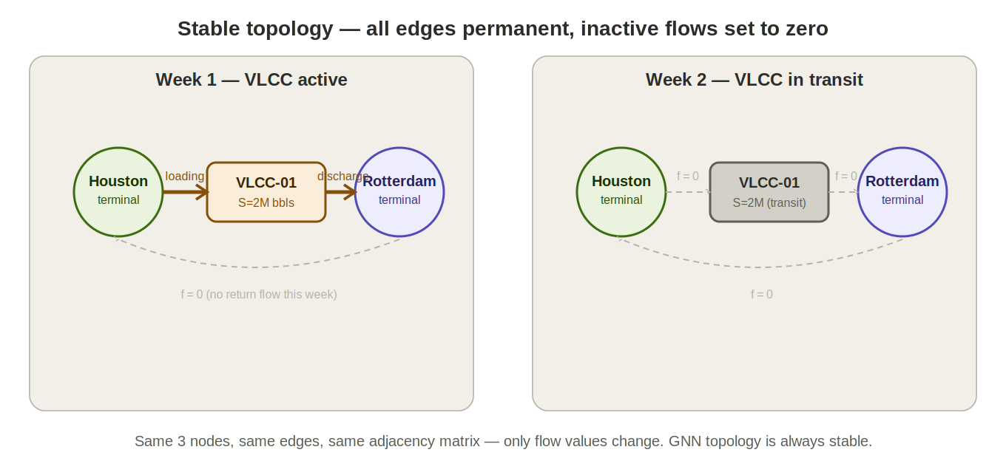
Figure B.3 — Topology stability under the zero-flow convention. In Week 1, VLCC-01 carries active flows on its loading and discharge edges. In Week 2, the vessel is in transit and all edge flows are zero. The graph structure — nodes and edges — is identical in both weeks. Only the flow values change.
This is the same principle applied to node feature vectors in Section 3.2 of the thesis: inapplicable variables are set to zero rather than being absent. The zero-flow convention for edges is the natural extension of this design choice. A GNN operating on this graph sees a fixed adjacency matrix at every time step and can apply standard architectures without modification.
What the asset-centric model additionally captures
- Line-fill inventory — the crude inside the Longhorn pipe (1,600 barrels at 800 b/d × 2 days) is a first-class tracked variable, subject to the mass balance constraint.
- Maritime cargo — a VLCC carrying 2 million barrels is a node with its own inventory, tracked from loading through transit to discharge.
- Extensibility — adding a new pipeline route or vessel class requires only introducing new nodes with zero-valued edges until the asset becomes active. No schema change is needed.
- Grade-level tracking — in future extensions, different crude grades can be treated as separate variable instances on each node, including pipeline and vessel nodes, consistent with the formula-implies-edge framework in Section 3.6.

B.4 Comparison
The table below summarises the key differences between the two conventions across the dimensions most relevant to this thesis.

Dimension | Location-centric | Asset-centric
Node definition | Geographic site or facility | Individual physical asset
Pipeline | Edge with flow attribute | Node with line-fill inventory
VLCC tanker | Implicit in shipping route edge | Node with cargo inventory
Topology | Fixed (locations don't move) | Fixed (zero-flow inactive edges)
New asset | New node or edge added | New node, edges exist at zero
In-transit cargo | Not trackable | First-class inventory variable
GNN compatibility | Standard architectures | Standard architectures
Data source match | EIA regional aggregates | EIA + AIS for full resolution
Extensibility | Limited by location granularity | Extends to any asset type

The asset-centric convention is adopted in this thesis because it is more principled, more extensible, and better suited to the physical structure of the crude-oil supply chain. The crude-oil network is defined by named, identifiable physical assets with distinct capacities and operational histories. Collapsing pipelines and vessels into edge attributes loses information that is operationally meaningful. The zero-flow convention resolves the apparent complexity of a dynamic topology, making the asset-centric graph fully compatible with standard GNN architectures.
In the current implementation, the pipeline and vessel nodes are populated from aggregate EIA import and export data at the terminal level, with asset-level granularity from AIS tracking data deferred as a future extension. This is a scoping decision, not a limitation of the framework.

B.5 The Mass Balance Equation and the Balancing Item
Every node in the asset-centric graph — whether a production field, a storage terminal, a pipeline segment, or a vessel — must satisfy the same universal mass balance constraint. The change in inventory at node i over time period t must equal the net of all flows into and out of that node:

ΔS(i,t) = P(i,t) + F_in(i,t) − C(i,t) − F_out(i,t)

where ΔS(i,t) = S(i,t) − S(i,t−1) is the change in stock, P(i,t) is production (non-zero only at wellhead and field nodes), C(i,t) is consumption (non-zero only at refinery and end-use nodes), F_in(i,t) is the sum of all inflows, and F_out(i,t) is the sum of all outflows.
B.5.1 The Cushing example
For Cushing terminal in a given week, the reported EIA data gives:
- Opening stock S(t−1) = 45,000 barrels
- Inflow from Longhorn pipeline: 800 b/d × 7 days = 5,600 barrels
- Inflow from Seaway pipeline: 600 b/d × 7 days = 4,200 barrels
- Outflow to Ozark pipeline (refinery): 950 b/d × 7 days = 6,650 barrels
- Outflow to SPR: 0 barrels
- Closing stock S(t) reported by EIA = 45,300 barrels

The calculated stock change is:
ΔS(calc) = F_in − F_out = (5,600 + 4,200) − (6,650 + 0) = +3,150 barrels
The observed stock change from the EIA weekly report is:
ΔS(obs) = 45,300 − 45,000 = +300 barrels
These do not match. The balancing item is the residual:
B(i,t) = ΔS(obs) − ΔS(calc) = 300 − 3,150 = −2,850 barrels
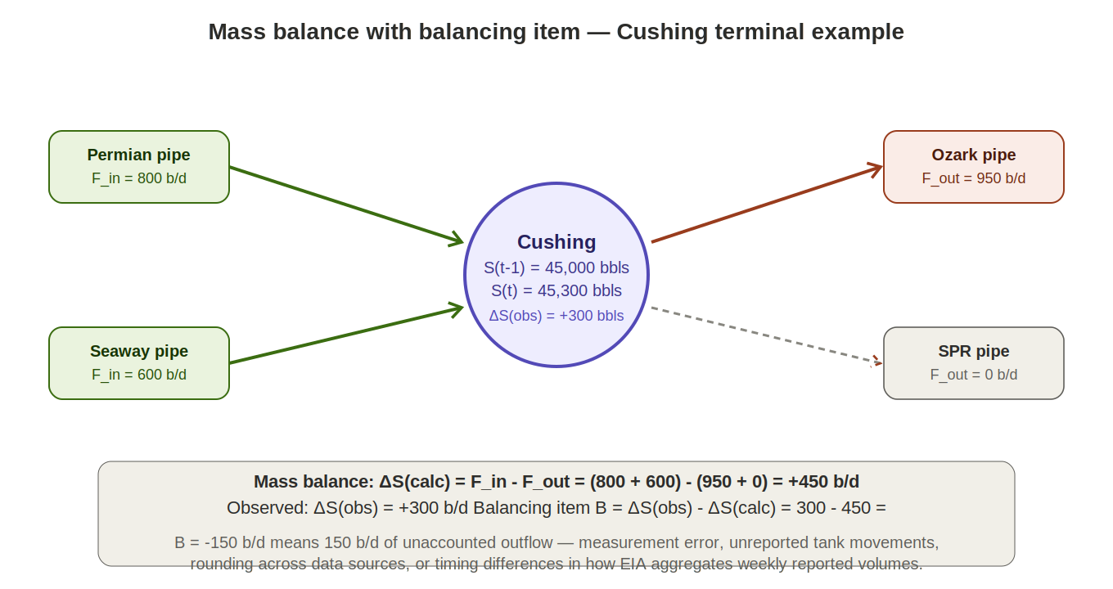
Figure B.4 — Mass balance at Cushing terminal. Inflows (green) and outflows (red) sum to a calculated ΔS of +450 b/d, but the observed ΔS from EIA data is only +300 b/d. The balancing item B = −150 b/d absorbs the discrepancy.
B.5.2 Why the balancing item exists
The discrepancy between calculated and observed inventory changes is endemic to commodity reporting and arises from several structural causes:
- Measurement timing — EIA reports weekly averages. A flow that begins on Thursday and ends on Monday straddles two reporting periods, creating apparent mismatches between opening and closing stocks and the reported weekly flows.
- Rounding and aggregation — EIA aggregates data from multiple operators and reporting entities. Each rounds independently before submitting, so the sum of rounded components differs from the rounded total.
- Unreported or delayed reports — some operators file revisions to prior weeks. The current week's stock change may reflect prior-period revisions not captured in the current-week flow data.
- Line-fill changes — in the location-centric model (and in many EIA reports), the crude inside pipelines is not separately tracked. If a pipeline is brought online or taken offline mid-week, its line-fill change appears as an unexplained discrepancy in the terminal inventory.
- Grade and quality adjustments — blending of different crude grades at a terminal can produce apparent volume gains or losses due to density differences that are not separately accounted for.
B.5.3 The full mass balance equation with balancing item
The complete equation used in this thesis is:

S(i,t) = S(i,t−1) + P(i,t) + F_in(i,t)
− C(i,t) − F_out(i,t) + B(i,t)

where B(i,t) is the balancing item, which can be positive (an apparent unaccounted inflow) or negative (an apparent unaccounted outflow). Rather than treating B as noise to be discarded, the framework retains it as a tracked variable on each node. The balancing item may carry predictive information: a node that consistently shows a negative B may have a systematic underreporting of outflows, which the GNN can learn to account for. A sudden large B may signal a data quality issue or an unreported operational event.
In the model, the balancing item is computed automatically as the residual after all other variables are populated. It serves three potential roles: as a diagnostic flag for data quality, as a regularisation signal during training, and potentially as a forecasting target in its own right — predicting the expected balancing item for a future period based on historical patterns. The choice of role is a modelling decision addressed in Chapter 5.

B.6 Implications for the GNN Model
The asset-centric convention combined with the zero-flow edge design and the balancing item produces a graph framework with several properties that directly support the forecasting objective of this thesis:
- Universal mass balance — the same equation S(i,t) = S(i,t−1) + P + F_in − C − F_out + B applies to every node type without special cases. Pipeline nodes have P = 0 and C = 0; vessel nodes have P = 0 and C = 0 with F_in = cargo loaded and F_out = cargo discharged.
- Stable adjacency matrix — all potential edges are permanent. The GNN processes the same graph structure at every time step, with only the flow values changing. This is a prerequisite for standard GNN architectures including GCN, GAT, GraphSAGE, DCRNN, and STGCN.
- Honest accounting — the balancing item makes data quality explicit. The model does not assume that the input data is perfectly consistent; it absorbs the inconsistency into a tracked variable rather than propagating it silently through the conservation constraint.
- Mean-reversion objective — the forecasting task is to predict the flow adjustments on all edges that would drive each storage node's inventory toward its historical average. With the asset-centric representation, this objective applies equally to pipeline line-fill and vessel cargo levels, not just to terminal tanks. A pipeline systematically running above its design line-fill, or a vessel route with consistently high cargo levels, can both be identified as targets for mean-reversion adjustment.

B.7 Persistent Asset Graph and Scenario Graph
Sections B.1 through B.6 describe what the graph looks like. In practice, the graph a model trains on is not a single object — it is produced on demand from three inputs: a persistent asset graph defining the full physical topology, an assignment table recording which time series is attached to which node, and a coverage contract declaring the authoritative level of resolution for each part of the system. This section establishes the separation between these layers.
The persistent asset graph is a fixed, superset topology. It contains every physical node the framework could ever need — every basin, pipeline, hub, terminal, refinery, export point, vessel class, and junction — regardless of whether data is currently available to populate that node. The asset graph is defined once and then maintained by adding new physical assets as they are commissioned. It is not recomputed, re-derived, or restructured when data sources change. In this respect it follows the same principle as the zero-flow edge convention of Section B.3: just as edges are permanent with flow set to zero during inactivity, nodes are permanent with their variables in a collapsed or empty state when data does not populate them.
The scenario graph is what a model actually trains on or forecasts from. It is derived at load time by taking the asset graph, reading the assignment table to determine which time series are available, applying the coverage contract to decide which resolution level is authoritative for each part of the system, and propagating values through the formula layer to populate derived variables. Any node whose variables cannot be meaningfully populated at the current authoritative resolution is marked collapsed for the duration of that scenario.
This two-layer architecture has two consequences that matter in practice. First, data upgrades never force a schema change: when a finer data source becomes available, the coverage contract is updated, the scenario graph is regenerated, and the asset graph is untouched. Second, different scenarios can be assembled from the same asset graph for different purposes — a short-horizon forecast using the highest-resolution data available, a historical backfill using only the aggregates that exist far back in time, a stress-test scenario where a specific pipeline is forced offline — each producing a different scenario graph from a common physical backbone. Figure B.5 illustrates the relationship.
Figure B.5 — The two-layer architecture. A persistent asset graph plus an assignment table plus a coverage contract produces the scenario graph. The same asset graph can produce different scenario graphs under different coverage contracts, without any change to the underlying topology.

B.8 The Observational Aggregation Layer
Crude-oil data is reported at many levels, and most of those levels are administrative rather than physical. The PADD regions defined by the U.S. Energy Information Administration, the state-level production totals published by state oil and gas commissions, the basin-level series published by commercial providers, and the country-level data compiled by the International Energy Agency are all examples of administrative aggregates. None of these is a physical asset. A PADD does not extract, store, refine, or ship crude; only the physical assets located within it do.
The framework handles this cleanly by separating the physical layer — the nodes and edges in the asset graph that represent real assets with real flows — from the observational aggregation layer, which provides formula-defined views over the physical layer. A PADD-level production variable is defined as a formula: P(PADD_3, t) equals the sum of P(i, t) over all physical nodes i located in PADD 3. The PADD has no inbound or outbound edges in the physical sense. Crude does not flow out of a PADD into anything; it flows out of basins, terminals, and platforms located in the PADD. The PADD exists in the graph as a view that can be queried, compared against reported totals, and used as a validation check, but it does not participate in flow accounting at the physical level.
Keeping the two layers separate has three practical benefits. First, the asset-centric principle of Chapter 3 — that every node has physical capability features such as capacity, diameter, Nelson Complexity Index, or loaded draught — is preserved without exception. Administrative aggregates have none of these properties and do not pollute the feature space. Second, the same physical asset graph supports many different administrative aggregations simultaneously: the same Permian basin node participates in the PADD 3 view, the State of Texas view, the United States view, and any number of analyst-defined regional groupings, each of which is just a different filter expression. Third, when administrative boundaries change — and they do, occasionally — only the view definitions are updated; the physical graph is unaffected.
The interaction between the observational layer and the scenario graph is the subject of Section B.11. When no data is available at a finer resolution than the administrative aggregate, the framework allows the aggregate to be promoted to authoritative status for the variables concerned, with the underlying physical nodes collapsed. This is the bridge between the observational layer as a pure-view abstraction and the practical reality that sometimes the only data available is administrative.

B.9 Geography Metadata and Administrative Aggregations
The observational aggregations of Section B.8 need an implementation. This section describes it. Every physical node in the asset graph carries a block of geography metadata recording where the asset is located. For a land-based asset, these fields include latitude and longitude, county, state, PADD, and country. For maritime assets — vessels, offshore platforms, anchorage zones — the geography fields include the sea or basin, the exclusive economic zone, and the flag or operating state. The metadata is a property of the node, not a separate node in itself.
Administrative aggregations from Section B.8 are implemented as queries that filter physical nodes by their geography metadata. The expression P(PADD_3, t) = sum of P(i, t) where i.location.padd = PADD_3 is not a formula between graph nodes in the formal sense; it is a query over the set of physical nodes tagged with the PADD 3 geography label. The result is materialised on demand as a view. There is no PADD 3 node in the physical graph for crude to flow into or out of; there is only the query result, computed when needed, from the physical nodes that happen to carry the PADD 3 label.
This is structurally different from the resolution hierarchy of Section B.10, and the distinction matters enough to state explicitly. Geography is a labelling scheme: many nodes share the same label (many wells are in Texas), but each label describes a property of the node, not a relationship to another node. The resolution hierarchy is a relationship between nodes: the Permian basin node and its sub-node for Midland County describe the same physical system at different granularities, and assigning data to both at once would assert the same crude twice. Geography labels do not have this property. A well in Midland County is not the same entity as Midland County; Midland County is a label on the well. There is no double-counting risk from tagging, because no second copy of the crude exists.
One subtlety: when a geography rollup is computed for a given scenario, the sum is taken over the authoritative physical nodes at that scenario’s current resolution, not over all nodes in the asset graph. If the Permian basin is authoritative (basin-level data) and its sub-nodes are inactive, the PADD 3 production query sums over the basin. If the sub-nodes are authoritative (county-level data) and the basin is derived, the PADD 3 query sums over the sub-nodes. The authoritative set is non-overlapping by construction under the invariant of Section B.11, so the geography rollup is always well-defined.
The distinction between geography and resolution hierarchy is summarised in Figure B.6.
Figure B.6 — Geography metadata (labels on nodes) and resolution hierarchy (relationships between nodes). A well has a geography label and also belongs to a resolution hierarchy through its basin and county sub-node parents. The geography labels support administrative aggregations; the resolution hierarchy supports granularity upgrades as finer data becomes available.

B.10 Resolution Hierarchy and Forward Compatibility
Every node class in the asset graph has an associated resolution hierarchy: a parent-child chain where the parent is the aggregate representation of the child. The Permian basin is a coarser representation of the same physical production system that its state-within-basin sub-nodes describe more finely, and those are in turn coarser than the individual leases and wells within them. A named pipeline is a coarser representation of the same physical conduit that its injection-point sub-nodes would describe more finely. A refining centre is a coarser representation of the same processing capacity that its individual refineries and, at a finer level still, their process units represent.
The coarsest and finest levels vary by node class. For production nodes, the range extends from basin at the top through state-within-basin and county-within-basin down to individual wells and leases. For pipeline nodes, the range extends from named pipeline through injection point and pump station down to individual segments. For storage nodes, the range extends from hub through individual terminal down to individual tank. For refinery nodes, the range extends from refining centre through individual refinery down to process unit. In each case the hierarchy is a chain of formulas: the coarser level is defined as an aggregation over the finer level, using the appropriate aggregation function — typically a sum for flows and stocks, a capacity-weighted sum for utilisation rates.
The design principle stated explicitly: every node type should have a resolution hierarchy that the formula layer can collapse upward or expand downward without touching the asset graph construction code. The hierarchy is metadata attached to the asset graph and consulted by the scenario loader; adding or removing a level does not change the set of physical nodes, only the paths over which aggregation and disaggregation are applied.
The hierarchy extends beyond named physical aggregates into administrative aggregates when — and only when — data resolution demands it. Consider a production variable for which the only available data source reports at PADD 3 level, with no finer basin or state breakout. Under the framework, the PADD 3 node from the observational layer of Section B.8 is promoted from a pure-view status to the authoritative representation of production for the duration of that scenario. The basins that would normally be authoritative in its place are collapsed: they remain in the asset graph, but their production variables are not independently observed, and their outbound edges to downstream pipelines are re-originated at load time from the PADD 3 aggregate. When finer data later becomes available — through a new data source or a backfilled historical series — the coverage contract is updated, the PADD 3 node reverts to a pure view, and the basins become authoritative again. The asset graph is unchanged throughout; only the coverage contract and the resulting scenario graph change.
This extension of the hierarchy into administrative aggregates is the bridge between the observational layer and the physical layer. It preserves the separation of concerns — administrative nodes do not acquire permanent edges in the physical graph — while acknowledging that in practice the authoritative level for some variables, in some scenarios, is the administrative aggregate rather than a named physical asset.
The forward-compatibility consequence is significant: most published supply-chain graph schemas assume a fixed resolution and require structural changes when data quality improves. A schema built for basin-level data does not accommodate sub-basin data without modification. A schema built for individual refineries does not easily accommodate process-unit detail. In the present framework, by contrast, granularity upgrades are a matter of updating the coverage contract and the assignment table; the asset graph and the formula layer absorb the change automatically. This is a methodological choice rather than an implementation detail, and it is what makes the framework suitable for deployment in a setting where data sources are expected to improve over time.

B.11 Assignment Tables, the Observed/Derived Invariant, and Coverage Contracts
The assignment table is the data structure that links time series to nodes. Each row records that a particular time series — identified by its source, its variable type, its commodity grade, its coverage descriptor, and its resolution level — is to be assigned to a specific node for a specific variable slot. The scenario loader reads this table and produces the scenario graph.
For any given combination of node, variable, commodity, and timestamp, a single constraint governs the scenario graph:
Exactly one of observed_authoritative or derived holds. Additional observed series may be attached as observed_auxiliary, which are stored on the node but do not participate in the mass balance at their own level.
This is the observed/derived invariant. A node-variable is either populated directly from an assigned time series (observed authoritative), or computed from other nodes through a formula (derived), or populated from an assigned series that sits on the node as feature data without affecting flow accounting (observed auxiliary). These states are mutually exclusive at the schema level. The invariant is enforced by the data model rather than checked after the fact, which means the most common form of aggregation error — assigning one time series to a parent node and another to its children, thereby counting the same crude twice — cannot arise. If an assignment would violate the invariant, the scenario loader rejects the scenario and reports the conflict before any computation proceeds.
The coverage contract is the declaration that drives the invariant in practice. For each resolution hierarchy, the contract names the authoritative level. For the Permian basin, it might declare basin as authoritative; for Haynesville, where no basin-level data is available, it might declare PADD 3 aggregate as authoritative and place Haynesville in the collapsed state. Any series assigned at a non-authoritative level is either rejected or retained as observed auxiliary, depending on the loader’s policy. The contract is scenario-specific: different scenarios can be assembled from the same asset graph with different authoritative levels for different subsystems, producing scenario graphs suited to different purposes.
The scenario loader’s responsibilities follow from the above. It reads the assignment table, walks each resolution hierarchy to enforce the invariant, applies the coverage contract to mark nodes as authoritative, derived, or collapsed, re-originates flow edges where collapse requires it, propagates formulas through the formula layer to populate derived variables, runs the mass balance diagnostic of Section B.5 at the authoritative level for each subsystem, and emits the resulting scenario graph with provenance metadata attached to every variable instance. Provenance — the source, the release date, the resolution level, the coverage descriptor — is retained on every value so that, when a forecast is later audited, the exact state of knowledge at forecast time can be reconstructed. Figure B.7 shows the state machine for a single node-variable through the loader’s pipeline.
Figure B.7 — State machine for a single node-variable under the scenario loader. Valid end states are observed_authoritative, derived, observed_auxiliary, and null. The invariant excludes any combination of observed_authoritative and derived on the same variable at the same time.
The invariant does not cover every failure mode. Sibling overlap — two assigned series whose coverage descriptors overlap geographically or temporally without one being an ancestor of the other — can still occur, and requires a pairwise coverage disjointness check across the assigned series at each level. The mass balance diagnostic at the authoritative level serves as a backstop for any remaining inconsistencies, surfacing them as large balancing items that the user can investigate. The invariant, the coverage disjointness check, and the mass balance diagnostic together form a layered defence against the aggregation and duplication errors that are otherwise endemic in multi-source commodity data pipelines.

B.12 Junction Nodes, Collapsed States, and Latent Allocation
The crude-oil network contains many physical points where flows commingle or split: gathering manifolds where crude from multiple wells combines before entering the long-haul system, pump stations where a pipeline picks up or delivers volume at intermediate points, junctions where one pipeline connects to another, tank farms that act as pass-through buffers between producers and pipelines. These are real physical assets with real identities, and in the asset graph they are represented as nodes.
At most practical data resolutions, however, the variables that would distinguish a junction node from its immediate neighbours are not separately observable. If the only data available is basin-level production and terminal-level receipts, there is no independent observation of what a gathering manifold between the two is holding or moving. Any values placed on the junction node would be derived from the upstream and downstream aggregates — carrying no independent information, and at worst introducing spurious precision.
The framework handles this through the collapsed state. A junction node marked collapsed remains structurally present in the asset graph, but its flow variables are defined as pass-through formulas from its upstream neighbours to its downstream neighbours, its stock is held at zero, and its configuration features are retained but do not participate in the GNN’s neighbourhood aggregation. In effect the node becomes a transparent conduit at the current resolution. When finer data later becomes available — for example, station-level pipeline telemetry from a commercial provider — the coverage contract is updated, the junction node’s collapsed flag is removed, and it wakes up with its own observed flow variables. The topology is never rebuilt; only the scenario graph’s interpretation of the existing topology changes.
Collapse is triggered in two distinct circumstances. The first, already discussed in Section B.10, is when data resolution is coarser than the node’s natural level — a basin with only PADD-level data available is collapsed for that scenario. The second, specific to junction nodes, is when the node’s role in the physical network is one of pure transit between observable neighbours, with no independent variables that the current data can populate. In both cases the mechanism is the same: the node is present in the asset graph, inactive in the scenario graph, and ready to activate when appropriate data becomes available.
A distinct problem arises at junctions where flows split across multiple downstream routes. The Permian basin’s production is known in aggregate; the individual pipelines leaving the Permian — Gray Oak, Cactus II, Midland-to-ECHO, Wink-to-Webster, Basin — have known nominal capacities but the actual split of Permian outflow across them in any given month is generally not reported in public data. The split is determined by a combination of pipeline tariffs, contractual commitments, operational constraints, and spot-market economics, none of which are directly observable at the aggregate data level.
This is the latent allocation problem. Its treatment is deferred to Chapter 5 on the forecasting framework, but its structural implications belong here. Because the split is latent, the framework does not attempt to infer it from rules; instead, it treats the per-edge flow variable at each junction as a learnable quantity, constrained by the mass balance (the edge flows must sum to the junction’s observed outflow), by pipeline capacity ceilings (no edge flow may exceed the receiving pipeline’s nominal capacity), and by any partial observations that may exist (pipeline-specific tariff filings, downstream terminal receipts that can be attributed to specific pipelines). This is a natural use case for attention-based temporal graph models: GAT and TGAT learn attention weights over neighbours conditional on node state, and the Permian-to-pipeline allocation problem is exactly of that form. The attention weights on the outbound edges from the Permian node, learned from historical co-movement of basin production and downstream terminal inflows, approximate the latent allocation.
Framing this in the annex, rather than only in the forecasting chapter, clarifies why the asset-centric graph is the right representation even when the edge-level flows cannot be directly observed. The graph structure encodes the set of physically possible flows; the observed data constrains the aggregate sums; and the GNN learns the distribution of flow across the possible routes. Without the asset-centric graph, there would be nothing for the attention mechanism to attend over, and the allocation would have to be handled outside the model through ad-hoc rules.
Figure B.8 — A junction node under two different coverage contracts. In the basin-only contract, the Permian gathering node is collapsed and flows pass through transparently from the basin to the downstream pipelines, with the split learned as a latent allocation. In the station-level contract, the gathering node is active and its per-edge outflows are observed directly from commercial telemetry.

B.13 Summary and Position in the Thesis
Sections B.1 through B.6 establish the asset-centric convention and the universal mass balance with a balancing item. Sections B.7 through B.12 extend that foundation with the machinery needed to operate the framework at production scale: the separation of a persistent asset graph from the scenario graphs derived from it, the distinction between geography metadata as labels on physical nodes and a resolution hierarchy as relationships between nodes, the observed/derived invariant that makes aggregation double-counting structurally impossible, the coverage contracts that allow administrative aggregates to be promoted to authoritative status when no finer data exists, and the collapsed-state mechanism for junction nodes whose variables cannot be distinguished at the current resolution.
These extensions are not incidental engineering. They are the methodological contributions that make the asset-centric framework a practical basis for forecasting in an environment where data sources are heterogeneous, partial, and time-varying. Published graph schemas for supply chains typically assume a single fixed resolution and break when data quality improves; the present framework absorbs granularity upgrades through the coverage contract without modification to the asset graph, and it treats mixed-resolution scenarios as a first-class case rather than an exception. The observed/derived invariant recasts the most common source of error in multi-source commodity data — aggregation double-counting — from a runtime validation concern to a schema-level property the data model cannot violate. The collapsed-state mechanism allows the asset graph to be defined once at the full level of physical detail, with scenario-specific inactivity handled at load time rather than through topology edits.
The framework is taken up in Chapter 5 on the forecasting framework, where the latent allocation problem introduced in Section B.12 becomes the central modelling challenge and the attention-based temporal graph models discussed in Section 4.4 become the methodological solution. The scenario graph emitted by the loader is the direct input to those models; the observed/derived invariant ensures that the inputs they receive are internally consistent; and the coverage contract mechanism is what allows the same model to be evaluated on historical periods with coarser data and recent periods with finer data, without retraining from scratch.

References
Energy Information Administration (EIA). Weekly Petroleum Status Report. U.S. Department of Energy. https://www.eia.gov/petroleum/supply/weekly/
Fattouh, B. (2011). An Anatomy of the Crude Oil Pricing System. Oxford Institute for Energy Studies, WPM 40.
Kazemi, Y. and Szmerekovsky, J. (2015). Modeling Downstream Petroleum Supply Chain. Transportation Research Part E, 83, pp. 111–125.
Li, Y., Yu, R., Shahabi, C., and Liu, Y. (2018). Diffusion Convolutional Recurrent Neural Network. ICLR.
Stopford, M. (2009). Maritime Economics. 3rd ed. Routledge.
Wasi, A. T., Islam, S. R., Karim, R., and Brintrup, A. (2024). SupplyGraph: A Benchmark Dataset for Supply Chain Planning using Graph Neural Networks. arXiv:2401.15299.
Yu, B., Yin, H., and Zhu, Z. (2018). Spatio-Temporal Graph Convolutional Networks. IJCAI.

