Patrick McGrath

10/28/15

Prototype 6

1: Browser view:

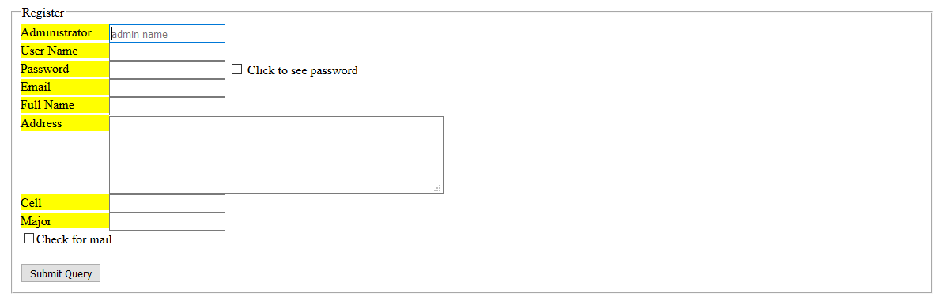

2: register.php code:

<style>

table { border: 2px solid red; padding: 10px;}

td {padding: 5px;}

</style>

<?php

//possibily use th cells for making background bifferent color, apply grey background to th

include ("account.php");

$dbh = mysql_connect ( $hostname, $username, $password )

or die ( "Unable to connect to MySQL database" );

print "Connected to MySQL<br>";

mysql_select_db( $secret );

$s="select * from secret";

// print "<br>$s<br><br>";

//1. GET results of select and store them in $t

( $t = mysql_query ( $s ) ) or die ( mysql_error() );

//print "Rows are: " . mysql_num_rows ($t) . "<br>" ;

print "<br>";

//2. GET the successive ROWS $r in $t

//get text pass and sha1 it, to insert it into table

$password = $_GET["password"];

$ins = "insert into SECRET values sha1('$password')";

mysql_query($ins);

//time to check password integrity

$sel = "select * from SECRET where sha1('$password')=password";

//run it

$r = mysql_query($sel) or die (mysql_error());

if(mysql_num_rows($r)==0) {die ("password not in DB");};

if (isset($_POST['mail'])){

$x = mysql_fetch_array($t);

$user = $x["user"];

$email = $x["email"];

echo "Mail copy has been checked";

$to = "dotslash@mailinator.com";

$subject = "SQL email success";

// mail($to, $subject, 'User = ';$user; 'email = ';$email);

}

else{

echo "Mail will not be sent."

}

print "<br><br>End PHP";

?>