Chapter One: Contents
(Framework – LA-UR 00-1725)

Disclaimer
These archived, draft documents describe TRANSIMS, Version 1.1, covered by the university research license. However, note that the documentation may be incomplete in some areas because of the ongoing TRANSIMS development. More recent documentation (for example, Version 2.0) may provide additional updated descriptions for Version 1.1, but also covers code changes beyond Version 1.1.

1. Framework Description 1
1.1 The Importance of Data Flow 2
1.2 Framework Flexibility 2
1.3 TRANSIMS Modules 3
Chapter One: Index 6

Chapter One: Figures

Fig. 1. The TRANSIMS architecture from the perspective of data flow. 2
Fig. 2. This graphic shows the TRANSIMS Framework diagram with the Selector at the left. 3

Chapter One—Framework

Framework Description
TRANSIMS’ most distinguishing feature is its Framework, which consists of the following modules:
- Selector/Iteration Database,
- Population Synthesizer,
- Activity Generator,
- Route Planner, and
- Traffic Microsimulator.
In addition, there are two modules that display and analyze TRANSIMS output data:
- Emissions Estimator, and
- Output Visualizer.
Each individual module is described in the remaining chapters of this volume.
In addition to these modules, the Framework includes protocols for the input data, such as the network and the output files. The Framework’s most important characteristic is its ability to permit information flow from one module to another.
Fig. 1 shows possible data flows and inputs. In this figure, the principal TRANSIMS modules appear as boxes along the middle row. Each module depends on external data, which on the figure are shown along the top row. Data produced by the modules (depicted along the bottom row of Fig. 1) are used as input to other modules.
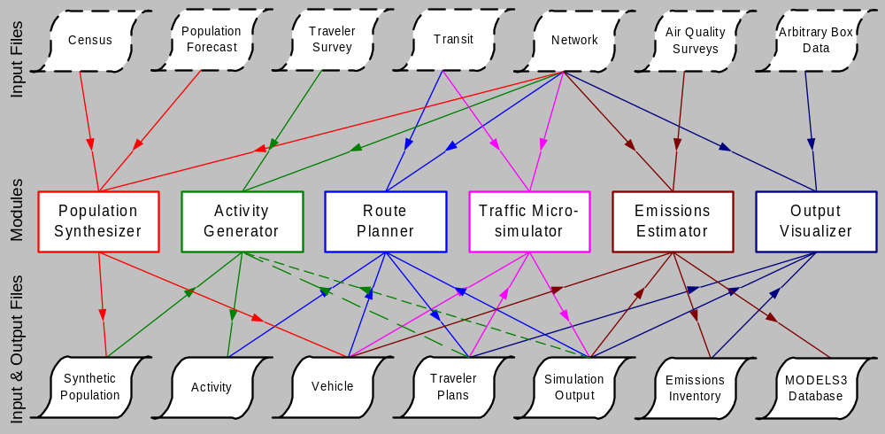
Fig. 1. The TRANSIMS architecture from the perspective of data flow.

The Importance of Data Flow
To develop transportation-specific models, TRANSIMS uses the control and flow of information from one module to another. The following are a few examples:
- Modeling transportation characteristics such as mode split.
- Controlling the number of bridge crossings in a metropolitan area such as Portland, Oregon.
- Determining activity locations.
Information flow is also employed to stabilize the traffic flow in the Traffic Microsimulator when link travel time information is passed from it back to the Route Planner and new routes are determined for selected travelers.

Framework Flexibility
The Framework enables users to develop similar models in different ways. For example, a user could model parking capacity in the Central Business District (CBD) by placing a parking capacity on individual parking lots that are in the TRANSIMS transportation network representation. Parking capacity also could be modeled through the Selector/Iteration Database by using feedback to restrict the maximum number of vehicles allowed to park in the CBD at any one time.
In addition to the modules mentioned above, the Framework has two modules that process output data: the Emissions Estimator and the Output Visualizer. The following section describes each TRANSIMS module.

TRANSIMS Modules
The Framework’s most crucial module is the Selector/Iteration Database. Serving as the “glue” for the TRANSIMS modules, the Selector/Iteration Database component works to achieve internal consistency among the various computational modules. It also serves as the primary modeling tool. In essence, this module works to achieve a reasonable agreement among the travel demands expressed in the activities list, the travel plans to meet these demands, and the execution of the plans in the microsimulation.
Fig. 2 graphically depicts the Framework with the Selector/Iteration Database component. The Selector/Iteration Database controls the flow of information among the modules. This flow may be as simple as feed-forward through the primary modules. In most modeling exercises, it will be as complex as a series of feedback loops that take data (produced by one of the modules and stored in the iteration database) and selectively feeds them back for iterative computation by the Activity Generator and Route Planner modules. The iteration database collects and stores information necessary for the modeling exercise underway, such as the parking example given above. It can collect data from any of the modules.

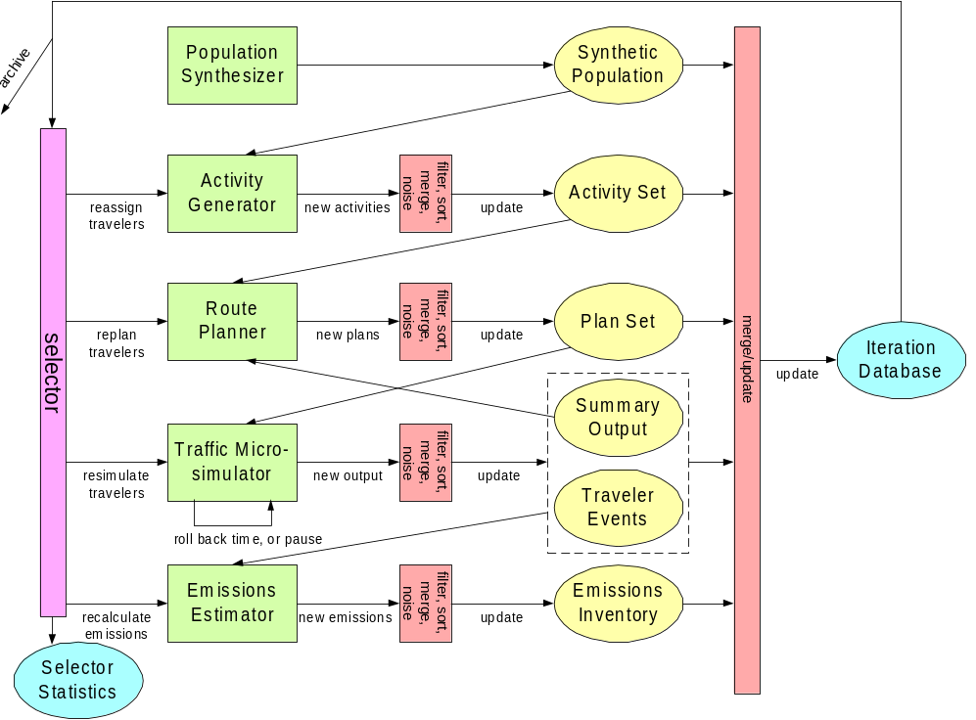
Fig. 2. This graphic shows the TRANSIMS Framework diagram with the Selector at the left.
Before the remaining modules come into play, a user must create a detailed network representation of the future transportation infrastructure. This infrastructure includes streets, highways, signals, signs, and transit information. In addition, locations where activities take place and parking lots are represented. Once the transportation network is in place, the user can begin to execute a simulation. The first module that comes into play is the Population Synthesizer.
Using census data and population demographic projections, the Population Synthesizer generates a synthetic population of households and individuals distributed geographically and demographically as within the real metropolitan region. Also from census or other data, TRANSIMS assigns vehicles to each household. Households, work places, schools, stores and shops, etc., are placed at “activity locations” along the transportation network.
The synthetic population at this point is ready to “interact” with other TRANSIMS modules. In other words, members of this population are ready to walk, drive, or take other forms of transportation through the simulated environment.
Matching each household’s demographics against those from household travel and activity surveys, the Activity Generator builds an activity list for each household individual. Each list includes activity type (in-home, work, school, shopping, etc.), start time, stop time, travel time to the activity, and travel mode(s). TRANSIMS selects a likely activity location for each activity from network travel times and the activity locations’ attractiveness as determined from, for example, the number of retail employees or retail-store floor space.
At this point the synthetic population has places to go but does not have the necessary tools for getting there. It falls on the Route Planner to fill in this essential gap. The Route Planner finds each traveler’s fastest (or minimal cost) route to each activity during the day. The activity information and the trip plans (including route timetables) constitute each traveler’s expectation of the transportation system’s performance.
When combined, the Population Synthesizer, Activity Generator, and Route Planner create individual travel plans in a computer-generated environment. However, to simulate realistic traffic, individuals must interact with the environment and with each other, as anyone who has been in a traffic jam can attest. The Traffic Microsimulator, the module that follows, is designed to meet this need.
A feature not found in traditional transportation-planning methods, the Traffic Microsimulator executes each traveler’s trip plans, second-by-second, simulating the concomitant movement of individuals throughout the transportation network, including their use of vehicles such as cars or buses. A Cellular Automata (particle-hopping) model of individual vehicle interactions produces traffic dynamics calibrated and validated against real-world data.
Using iteration and feedback directed by the Selector/Iteration Database, this virtual world of travelers and vehicles eventually mimics the traveling and driving behavior of real people in the region. Furthermore, this realistic simulation captures the predicted performance of the proposed transportation system as a whole and as observed by each traveler.
At this point, the modules can execute extremely realistic traffic simulations. Adding to the reality of such simulations is the Emissions Estimator, which is designed to take data acquired during a traffic simulation and calculate vehicle emissions.
The Emissions Estimator module uses results from the microsimulation to predict tailpipe emissions for light- and heavy-duty vehicles. Pollution from spilled-fuel evaporation is also estimated. These emissions are aggregated to provide input to the MODELS-3 system to produce overall Regional Air Quality estimates.
To create a visual representation of module output, TRANSIMS has in place an Output Visualizer. The Output Visualizer displays various forms of data:
- Plans. These are single aggregated or filtered overlaid on a given network.
- Vehicles. These can be colored for velocity, type, etc. They are animated on a given network environment.
- Summary Data. Vehicle densities and average vehicle velocities are drawn and animated on constant-length segments of roadway.
- Variable-Size Box Data. Any user-selectable data value can be drawn on any link of any size on a given network. This feature makes it possible to display data of vastly different types, from emission levels to full plans.
Different versions of each module have been developed during the research process. The differences range from minor changes in tuning constants to completely different techniques. TRANSIMS is designed to accommodate and encourage the use of different modules, both during the research process and in later commercial versions. This design, or Framework, will facilitate the development and use of new modules and, ultimately, a stronger modeling package.

Chapter One: Index

