Chapter Five: Contents
(Traffic Microsimulator – LA-UR 00-1725)

Disclaimer
These archived, draft documents describe TRANSIMS, Version 1.1, covered by the university research license. However, note that the documentation may be incomplete in some areas because of the ongoing TRANSIMS development. More recent documentation (for example, Version 2.0) may provide additional updated descriptions for Version 1.1, but also covers code changes beyond Version 1.1.

1. Introduction 4
1.1 Overview 4
1.2 Traffic Microsimulator Major Input/Output 5
2. Traffic Microsimulator Description 7
2.1 Overview 7
2.2 Single-Trip Example 7
2.3 Cellular Automata 9
2.4 Traffic Microsimulator Output 12
3. Algorithm 14
3.1 Overview 14
3.2 Placing Travelers and Vehicles 14
3.3 Updating Traveler Locations 17
3.4 Traffic Dynamics 18
3.5 Transit 21
3.6 Exiting from Parking Places 22
3.7 Movement Check/Intersections 23
3.8 Preparing for a Timestep 28
3.9 Cleaning Up After a Timestep 28
3.10 Supporting Parallel Computation 29
3.11 Transportation Network Partition 29
3.12 Distributed Links and Boundary Information Flow 31
4. Simulation Output Files 37
4.1 Overview 37
4.2 File Format 37
4.3 Traveler Event 37
4.4 Snapshot Data 42
4.5 Output Filtering 46
4.6 Utility Programs 47
4.7 Files 48
4.8 Configuration File Keys 48
4.9 Example 49
Appendix A: Configuration Keys for Snapshot Output 50
Appendix B: Configuration Keys for Event Output 51
Appendix C: Configuration Keys for Summary Output 52
Appendix D: Configuration Keys for the CompareDensity and CompareVelocity Programs 53
Appendix E: Default Output Configuration Keys 54
Appendix F: Examples 56
Chapter Five: Index i

Chapter Five: Figures

Fig. 1. This graphic shows what data go in and what data come out of the Traffic Microsimulator. 6
Fig. 2. Shown from the perspective of the middle peach-colored car, the gap (labeled “1” in the figure) between vehicles determines accelerations and influences lane changes. The gaps (2 and 4 for left-lane change, 6 for right-lane change) to vehicles in other lanes also influence lane changing. The distance +0 the intersection (3) determines the relative importance of changing lanes. The gaps (4, 5, and 6) to upstream vehicles from a parking facility determine whether vehicles can exit the parking facility. 9
Fig. 3. This figure shows the order of execution of processes involving vehicles in each timestep. 11
Fig. 4. The various types of Traffic Microsimulator output. Depicted in this figure are traveler events, snapshot data, and summary data. 13
Fig. 5. A flow chart of the processes and data structures involved in loading vehicles and travelers into the simulation. Vehicles flow through the dotted lines; travelers through the solid lines, both through the dot-dashed lines. 15
Fig. 6. This figure shows interactions among objects during a timestep. Travelers flow along blue lines; vehicles with travelers along green lines. 17
Fig. 7. This graphic shows vehicle behavior at turn pocket lanes. 21
Fig. 8. This figure shows the intersection entry interfering lane gap. 25
Fig. 9. A graphic representation of a transportation network partition. 30
Fig. 10. This figure shows a distributed (split) link. 31
Fig. 11. The rectangular (red) boxes show information flow in a distributed version of the Traffic Microsimulator. 32
Fig. 12. Initialization message traffic. (this figure was formerly labeled 11(a)) 34
Fig. 13. The top part of this figure shows the simulation message traffic. The set of messages in the box is repeated once for every timestep up to the number of steps in the sequence. The lower part of this figure shows termination message traffic. (this figure was formerly labeled 11(b)) 35
Fig. 14. Modifications to the processes enclosed in the dashed box support overlapping computation. Communication computation on local edges (in green) takes place while a CPU waits for information about shared edges (in blue). 36

Chapter Five: Tables

Table 1. Traffic control states and corresponding actions. 24
Table 2. Traveler event record fields. 37
Table 3. Vehicle snapshot record fields. 42
Table 4. Intersection snapshot record fields. 43
Table 5. Traffic control snapshot record fields. 43
Table 6. Link travel times summary field records. 44
Table 7. Link densities summary record fields. 45
Table 8. Link velocities summary record fields. 45
Table 9. Link energy summary record fields. 46
Table 10. Node specification fields. 46
Table 11. Link specification fields. 47
Table 12. Value filtering operators. 47
Table 13. Simulation output library files. 48
Table 14. Configuration file keys for snapshot output. 50
Table 15. Configuration file keys for event output. 51
Table 16. Configuration file keys for summary output. 52
Table 17. Configuration file keys for the CompareDensity and CompareVelocity programs. 53
Table 18. Default output configuration file keys. 54
Table 19. Plan set. 56
Table 20a. Traveler event output. 58
Table 21a. First 30 seconds of vehicle snapshot data. 60
Table 22. Intersection snapshot data.. 62
Table 23. Signal snapshot data. 62
Table 24. Travel time summary data. 63
Table 25. Link density summary table. 64
Table 26. Link velocity summary data. 65

Chapter Five—Traffic Microsimulator

Introduction

Overview
This module simulates the movements and interactions of travelers in a metropolitan region’s transportation system. Using a trip plan provided by the Route Planner, each traveler attempts to execute the plan on the transportation system. The combined traveler interactions produce emergent behaviors such as traffic congestion.
The Traffic Microsimulator simulates
- intermodal travel plans,
- multiple travelers per vehicle,
- multiple trips per traveler, and
- vehicles with different operating characteristics.
Emphasis was initially placed emphasis on roadway transportation because of its high use, complexity, and importance to air quality. The roadway network includes freeways, highways, streets, ramps, turn pocket lanes, and intersections (with and without traffic signals). Drivers executing trip plans accelerate, decelerate, turn, change lanes, pass, and respond to other vehicles and signals.
Using a cellular automata (CA) approach, the Traffic Microsimulator provides the computational speed necessary to simulate an entire region at the individual traveler level. The CA approach provides a means to simulate large numbers of vehicles and maintain a fast execution speed.
Each link in the transportation network is divided into a finite number of cells. At each timestep of the simulation, each cell is examined for a vehicle occupant. If a vehicle is present in the cell, the vehicle may be advanced to another cell using a simple rule set. To increase fidelity, we would decrease the cell size, thus adding vehicle attributes and expanding the rule set results in slower computational speed.
We evaluate the fidelity and performance limits of the CA microsimulation to establish the computational detail that supports the fidelity necessary to meet analysis requirements.
The sheer number of travelers and the level of detail in the microsimulation require that we use multiple CPUs where available. The “Algorithm” section of this chapter provides an explanation of the information flows and scheduling required to support parallel computing. The following sections present an overview of the simulation as it could be carried out on a single CPU.

Step One | A representation of the transportation network is read in. This representation is very similar to a detailed street map; it includes a number of lanes, turn pockets, merging lanes, turn signals, and so on. Vehicles traveling along streets in the road network are simulated in detail. In addition to the streets, there are several kinds of accessories that represent parking lots, activity locations, and transit stops, all of which act like buffers for travelers who are not in a vehicle traveling on a street.
Step Two | Each vehicle’s type and initial location are read in. Once this is complete, each traveler’s plans are read in (as needed).
Step Three | Travelers are placed on the network and are allowed to travel from their point of origin to their final destination. For non-simulated modes, this movement is simple—a traveler is removed from the buffer in one accessory and placed in the buffer on another, with a new departure time reflecting the trip’s estimated duration.  Vehicles move from one grid cell to another by using a modified CA approach. Modifications in this approach support lane changing and plan following for each vehicle until it reaches the end of a link. There the vehicles wait for an acceptable gap in traffic or for protection from a signal before they move through the intersection onto the next link. This continues until each vehicle reaches its destination, where it is removed from the network.

Traffic Microsimulator Major Input/Output
Fig. 1 provides an overview of the input and output involved with the Traffic Microsimulator. At a minimum, TRANSIMS Network information must include
- the location of streets and intersections,
- the number of lanes on the streets,
- the manner in which the lanes are connected, and
- some parking locations on the streets and a collection of activity locations.

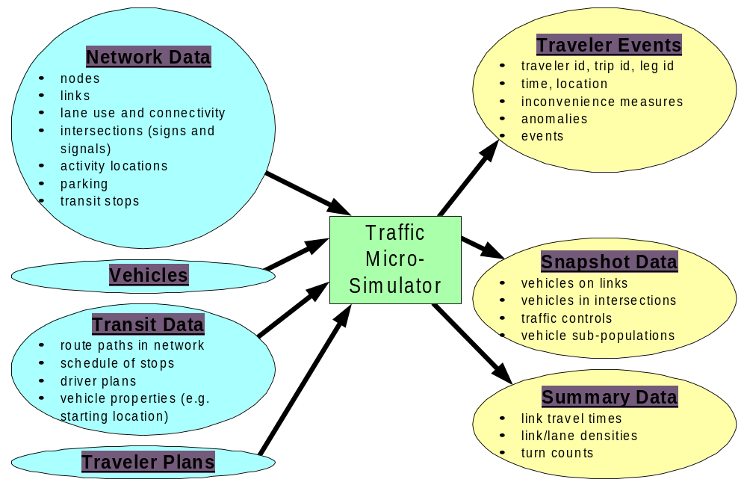
Fig. 1. This graphic shows what data go in and what data come out of the Traffic Microsimulator.
Some studies benefit from, or require more, detailed information about the network. For example, the Traffic Microsimulator is capable of using turn pockets and merge lanes, lane-use restrictions (such as high-occupancy-vehicle lanes), turn prohibitions, and speed limits. Each intersection has a controller (examples include a stop or yield sign, a traffic signal, or even a set of coordinated traffic signals).
Another type of beneficial network information consists of a list of transit stops serviced by each transit route. The actual transit schedule is encoded in the travel plans of transit drivers. Transit drivers stop to pick up or drop off passengers at transit stops.
The simulation must have a complete description of each traveler’s transportation plans. A plan is broken down into a sequential set of trips, which must begin and end at an activity location (such as home, work, or shopping center). A trip is further decomposed into a set of unimodal legs. A traveler can use only a single mode of transportation on a leg. Accordingly, several legs are chained together to form a single trip.

Traffic Microsimulator Description

Overview
As a simulated day progresses, each person follows a predefined plan to move from one activity to the next by using combinations of modes, such as walking, driving a vehicle, and riding in a (private or public) vehicle. The Route Planner provides a link-by-link travel plan of the traveler, including the mode of travel.
All TRANSIMS vehicles are simulated in sufficient detail to include driving on roads, stopping for signals, accelerating, decelerating, changing lanes, stopping to pick up passengers, and so on. Mode changes (e.g., from walking to car or to transit) are explicitly simulated based on information contained in the traveler’s plan.
Vehicles follow a simple set of rules that guarantee no collisions will take place. Phenomena such as reaction times and limited visibility are not simulated explicitly. However, the effects of these phenomena are simulated by the values of parameters used in the driving rules so that the fundamental flow-density diagram matches real, observed traffic.
The simulation can estimate the impact of hypothetical changes on quality of service. It provides answers to questions such as the following:
- If a proposed highway were built, what would be its effects on traffic patterns?
- How would a change in transit schedules affect riders?
- Can changing an intersection’s traffic signals alleviate congestion?
- Are there common demographic characteristics of the subpopulation most affected by a particular infrastructure change?
The Traffic Microsimulator’s analytical power resides in its ability to aggregate the results of millions of interactions within the transportation system. The following sections focus on the level of detail used to simulate a travel plan.

Single-Trip Example
The following example consists of a six-leg multimodal work-to-home trip. It begins and ends at activity locations coded in the TRANSIMS networks.
Leg 1: walk from activity location W to bus stop X, where W is the work activity location and X is a bus stop in the network description.
Leg 2: take route Y to bus stop Z.
Leg 3: walk to parking lot P.
Leg 4: drive to day care at activity location D.
Leg 5: drive (with one passenger) to parking location P2.
Leg 6: walk to activity location H (home).

Walking Legs
For walking legs, TRANSIMS does not explicitly microsimulate the second-to-second locations of pedestrians. The traveler arrives at the destination at a simulation time computed by adding the delay time (contained in the plan) to the start time for the walk-mode leg. No additional information is required or generated for walk-mode legs.

Bus Legs
Bus-leg plans require one piece of additional information: the acceptable route. The precise itinerary of the bus the traveler gets on is determined by the driver’s plan. The traveler simply boards the bus at a bus stop and rides it until his or her desired stop is reached, at which point he or she exits the bus.
The microsimulation explicitly represents bus loading and unloading. Resource constraints are observed, such as vehicle capacity and transit stop capacity. If a bus is full when it reaches the bus stop, a traveler is not permitted to board and will wait for the next bus on the same route. With this level of detail, it is easy to determine how many passengers cannot find space on the bus or how many minutes a traveler must wait for a bus.

Parking Lot
After getting off the bus, the traveler must walk to the parking lot. In this instance, the parking lot is where the traveler left his or her private vehicle. This walking leg is handled as previously described.

Driving Legs
Upon arriving at the parking lot, the traveler is associated with a specific vehicle, which either must have been left in the parking lot earlier in the simulation or placed there during initialization.
The traveler and car exit the parking lot and enter the traffic network. The traveler’s plan specifies exactly which turns he or she will take until he or she arrives at the daycare center. At this point, the traveler waits until the passenger enters the vehicle. The passenger’s plan will specify what vehicle to ride in, and the passenger will be waiting for this vehicle to arrive. The driver’s plan specifies how many passengers to pick up. Once again, the driver re-enters the transportation network, completing the remainder of the planned trip.

Realistic Simulation
As described above, a transit schedule is implemented by providing plans for each transit driver. Like other travelers, a driver can switch vehicles, switch routes (with or without switching vehicles), and take layovers of prescribed duration or ending time at specific control points.
The Traffic Microsimulator enforces physical constraints—travelers cannot be in two places at once and they cannot create vehicles. Information in the plan file initiates and places travelers in their initial start locations, whereas information in the vehicle file places vehicles in their initial locations.

Cellular Automata
Cellular automata simulation yields vehicle movement. Each roadway section is divided into grid cells, each of which is one lane wide and 7.5 meters long (see Fig. 2). Each cell contains either a vehicle (or a part of one) or is empty.

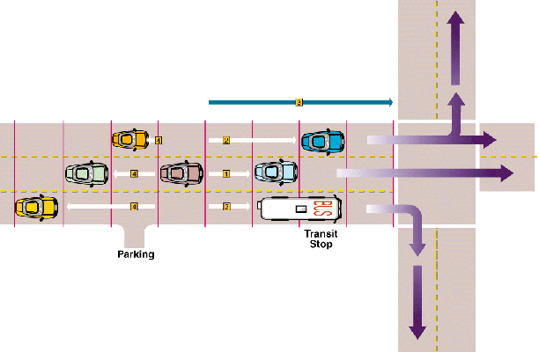
Fig. 2. Shown from the perspective of the middle peach-colored car, the gap (labeled “1” in the figure) between vehicles determines accelerations and influences lane changes. The gaps (2 and 4 for left-lane change, 6 for right-lane change) to vehicles in other lanes also influence lane changing. The distance +0 the intersection (3) determines the relative importance of changing lanes. The gaps (4, 5, and 6) to upstream vehicles from a parking facility determine whether vehicles can exit the parking facility.

The simulation is carried out in discrete timesteps, each simulating one second of real time. On each timestep, a vehicle on the network decides whether to accelerate, brake, or change lanes in response to the occupancy of nearby grid cells. After every vehicle is allowed to make these decisions, they are all moved to new grid cells in accordance with their current velocity.
As part of the lane-changing procedure, transit vehicles scan nearby cells for transit stops, which they must service. The transit vehicles examine the queue at the stop to see if anyone is waiting for the vehicle; they also query their passengers to see if anyone wants to get out at the stop. Finally, a transit driver’s plan may specify a departure time from any stop—the driver must enter the stop if the scheduled departure time has not yet been reached.
If the vehicle must stop, it either stops in the cell next to the transit stop or pulls off the grid (depending on the type of transit stop). Passengers take a fixed time to enter or leave the vehicle.
Each intersection has traffic-control logic that directs the entry of vehicles into the intersection. Traffic controllers examine the traffic in each lane at the intersection. If the intersection is clear, vehicles pass through it in a fixed amount of time and are placed on the next roadway’s link.
Vehicles entering the roadway from parking locations or off-street transit stops can enter any lane with a large enough gap between it and oncoming traffic. The gap must be wide enough to ensure that on the next timestep no vehicles collide with vehicles entering the roadway.
The simulation guarantees that each vehicle makes decisions based on the state of every other vehicle in its local vicinity (i.e., five cells) at the same time. In other words, every vehicle on the network makes its acceleration decision based only on information available at time t, which does not include the time t+1 positions of vehicles that already have made their acceleration decision. This parallel update scheme ensures that the simulation results do not depend on the order in which streets in the network are updated.
To accomplish a simulation update, a single timestep is broken down into several steps (see Fig. 3).

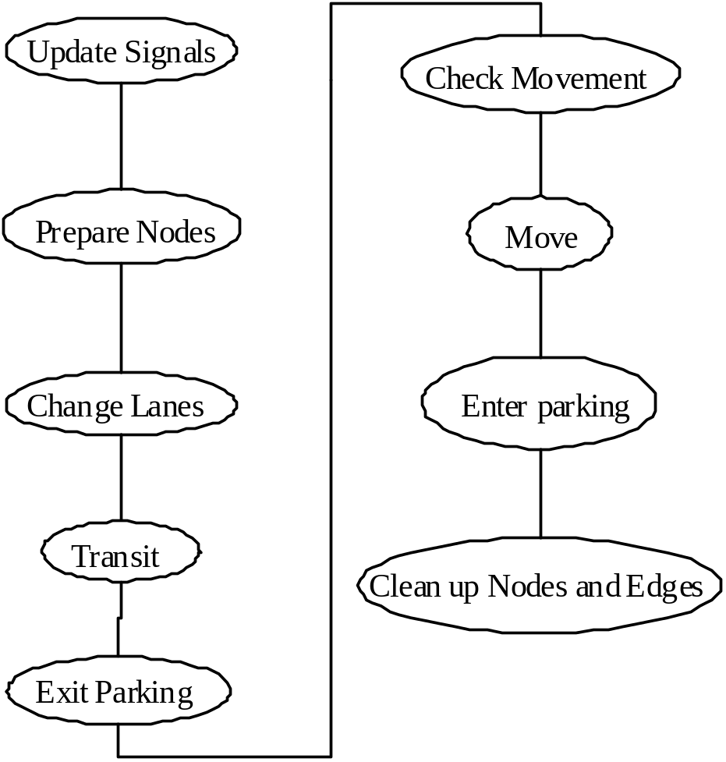

Fig. 3. This figure shows the order of execution of processes involving vehicles in each timestep.

Step One | Update Signals  - Update traffic signals.
Step Two | Prepare Nodes  - Vehicles in the intersection reserve space on their destination link (if possible).
Step Three | Change Lanes  - All vehicles are allowed to change lanes. In this step, transit vehicles are also allowed to enter transit stops.  - To avoid possible collisions when vehicles in two lanes at time t both try to change into the same lane, we alternate the direction of lane changing every timestep.
Step Four | Transit  - Allow transit vehicles to exit transit stops.  - Allow vehicles stopped at transit stops to collect and disembark passengers.
Step Five | Exit Parking  - Vehicles at the head of a queue waiting to leave a parking location are allowed to enter the road.
Step Six | Check Movement  - Those vehicles entering intersections are marked and given instructions from the intersection controller about the availability of their destination link.
Step Seven | Move  - Every vehicle on a grid makes its acceleration decision; all of the vehicles are moved.
Step Eight | Enter Parking  - Vehicles are allowed to exit into parking locations.
Step Nine | Clean up Nodes  - Vehicles leave intersections and appear in the space reserved for them by Prepare Nodes. Various temporary markers are removed from the grid cells.

Traffic Microsimulator Output
The Traffic Microsimulator produces four major kinds of output. Fig. 4 shows these four types:
- summary data (spatial and temporal),
- traveler events, and
- snapshot data.
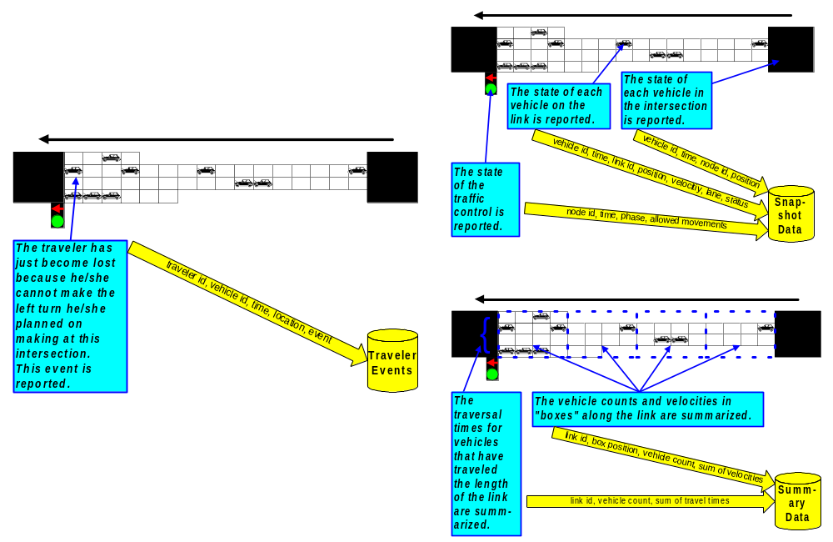
Fig. 4. The various types of Traffic Microsimulator output. Depicted in this figure are traveler events, snapshot data, and summary data.
Spatial summaries include data aggregated over user-defined sections of roadway defined along street networks (e.g., densities and total flow in a 150-meter section).
Temporal summaries include data about travel times along streets at various times of day. Almost anything that happens to a traveler can be reported as a time-stamped event in the event output. Commonly used events include begin/end waiting at a given location (such as a bus stop), begin/end a leg, pass through an intersection, and enter a vehicle.

TRANSIMS can produce traffic animation from snapshot files (if desired), which contain time, position, and velocity information for each vehicle in the simulation. These files also can be used to recover data that have not already been provided in the summary data files. For instance, if some new study requires the average gap between vehicles, it can be computed from snapshot data.

Dumping out the snapshot data for a 24-hour simulation of a major metropolitan area creates extremely large files. Users are allowed to restrict output to smaller portions of the network and specific times during the simulation, as well as to select only a few desired fields or only those records that meet certain criteria. For example, a user may choose only specific events (such as beginning a leg), particular travelers, or vehicles traveling above a given speed. The sampling rate and reporting frequency for each data type are controlled by user-selected parameters. For more information, see the Output System documentation.

Algorithm

Overview
The procedures invoked during each simulation timestep can be placed into one of five broad categories:
- placing travelers and vehicles,
- updating the location of each traveler and vehicle,
- preparing for a timestep,
- cleaning up after a timestep, and
- supporting parallel computation.
The following sections address these five procedures.

Placing Travelers and Vehicles
Fig. 5 shows the processes and data structures involved in loading travelers and vehicles into the Traffic Microsimulator.
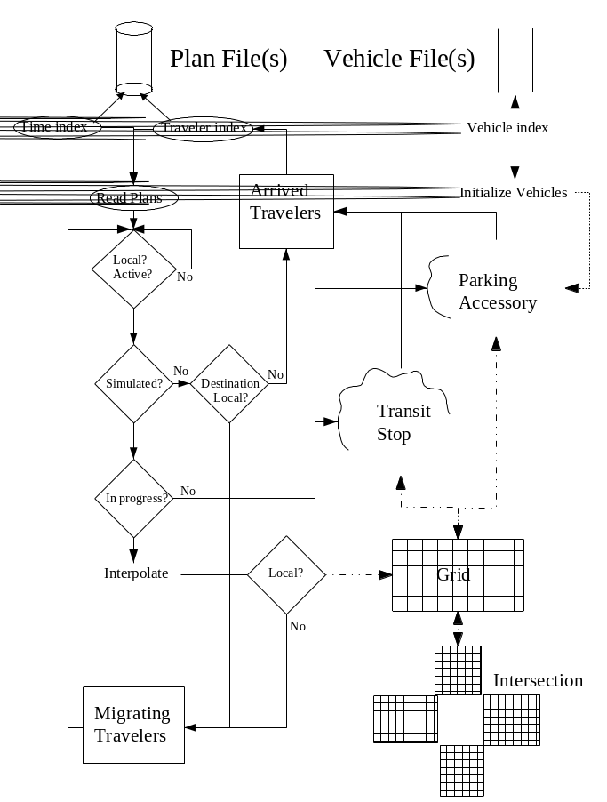
Fig. 5. A flow chart of the processes and data structures involved in loading vehicles and travelers into the simulation. Vehicles flow through the dotted lines; travelers through the solid lines, both through the dot-dashed lines.
The vehicle, vehicle prototype, and transit route files contain all of the information required by the simulation in addition to the network files (not shown in Fig. 4). Vehicle and plan files are accessed through an index, which will be generated from the appropriate file if it does not already exist. Note that an index can refer to more than one data file. Furthermore, there may be a separate index for each processor (if the configuration file key CA_USE_PARTITIONED_ROUTE_FILES is set).
Traveler plans (i.e., legs of a plan) are read using the index sorted by expected departure time until all plans departing before or on the current simulation step have been read. In addition, the IDs of “hibernating” travelers (those who have already executed one leg of their plan and are waiting to depart on another) are popped off the queue of Arrived Travelers.
Each hibernating traveler carries along a minimal required information set that consists of
- traveler ID,
- current trip and leg ID, and
- a set of state flags used in maintaining states required by the output system.
To minimize memory requirements, other non-essential information is deleted from memory while a traveler hibernates. To find the next leg for each of the arrived travelers, the Read Plans process uses an index into the plan file that is sorted by traveler ID. Each plan must pass two tests before the traveler is placed onto the transportation network:
- It must be “local,” meaning that its origin must be an accessory that is a part of the network under the control of the CPU. If the simulation uses only one slave (CA_SLAVES is set to 1), everything is local.
- It must be “active,” meaning that (1) its expected arrival time must be after the simulation start time, and (2) its departure time must be before simulation end time. The following configuration file keys define the simulation start and end times: CA_SIM_START_HOUR, CA_SIM_START_MINUTE, CA_SIM_START_SECOND and CA_SIM_STEPS.
If the plan calls for a non-simulated mode of travel (activity, walk, or bicycle) and the destination is local, the process places the traveler in the Arrived Traveler queue with a departure time specified by the plan. For example, the plan may say to use the later of a 10-minute duration or a specific time (e.g., 8:10 a.m.).
The simulation will add ten minutes to the current simulation time, compare it to 8:10 a.m., and place the traveler into the queue with a departure time equal to the later of the two. If the destination is not local, the traveler must migrate to another CPU, where he or she will be placed into the Arrived Traveler queue for that CPU.
If the traveler is using a simulated mode of transportation (anything involving a vehicle), either as a passenger or a driver, and the plan is not in progress (i.e., its departure and arrival times do not straddle simulation start time), the traveler is placed in a queue in his or her origin accessory. This could be either a transit stop or a parking location. No travelers will be placed in activity locations because the simulated transportation modes do not have paths to or from such locations.
It is desirable for the simulation to reach normal traffic flow conditions as rapidly as possible. To facilitate this, vehicles whose driver’s plans are in progress are placed on the roadway when the simulation is initialized. This is based on where the driver’s plans predict they will be at the simulation starting time.
Once a plan’s geometric length is estimated, a link is selected by interpolating along the path according to the duration of the leg (as estimated by the Route Planner). The length is difficult to determine if the plan is not wholly contained within the part of the network local to the CPU, so this process is not guaranteed to produce the same initial condition when the number of CPUs varies.
If the interpolation process determines that a traveler should be placed on a non-local section of the network, it will add the traveler to the list of migrating travelers. Otherwise, the cell position and lane are randomly selected.
If the selected cell is already occupied, the grid is searched upstream for an available cell. If all cells upstream are occupied, the grid is searched downstream for an unoccupied cell. If all cells on the link are occupied, a warning message is printed and the vehicle is deleted.
No attempt is made to find an available cell on an adjacent link. Because interactions between vehicles are not taken into account, this procedure does not produce the same distribution of traffic that would be found by starting earlier and letting the simulation evolve to the same time.
Furthermore, transit passengers are not placed in transit vehicles, but rather they are placed at their destinations. If this interpolation scheme does not work satisfactorily, the user should start the simulation at an earlier time.

Updating Traveler Locations
After reading in and placing travelers, the simulation executes their plans one step at a time. Each step involves several substeps in the order given in Fig. 3. The major data structures involved and their interactions during a timestep are sketched in Fig. 6.

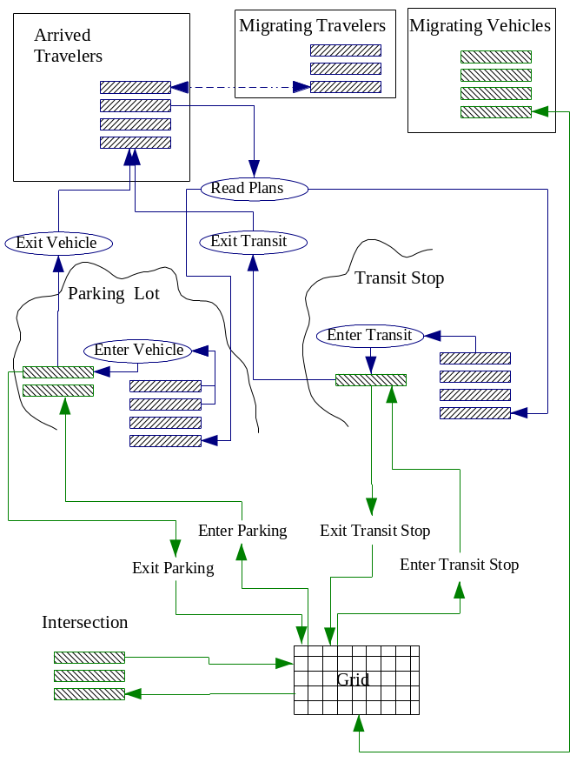
Fig. 6. This figure shows interactions among objects during a timestep. Travelers flow along blue lines; vehicles with travelers along green lines.

Traffic Dynamics
Interactions of individual vehicles on the transportation network produce traffic dynamics in the microsimulator. To determine the position of vehicles on the roadway, a rule set is applied that governs movement and lane changes. This rule set must be as simple as possible to maintain the computational speed necessary for updating positions of the large number of vehicles that could be present in a regional traffic microsimulation.
The rule set imposes a no-collision strategy on the vehicles. Vehicle interactions based on the rule set combine to produce emergent driver behavior. Traffic dynamics require that, for any vehicle v at time t, all position change calculations must be based on other vehicle positions at time t, not at time t+1.

Lane Changes
During the timestep, we examine each vehicle and determine if it will change lanes. To produce realistic traffic dynamics, lane change and movement must take place on the same timestep.
Left and right lane changes are made on alternating timesteps to prevent collisions and to ensure that gap calculations are based on vehicle positions at time t, not t+1. Multilane roadways are processed from left to right when making left lane changes and from right to left when making right lane changes. Vehicles are not allowed to change into a lane if it would violate lane use or HOV restrictions.
A vehicle changes lanes for two reasons:
- to pass a slower vehicle in the current lane, and
- to make turns at intersections to follow its plan.
A vehicle that needs to make a turn at the next intersection (as part of its plan) will consider changing lanes when it is within a set distance from the intersection. As the vehicle approaches the intersection, the urgency to change into a lane increases linearly as the vehicle approaches the intersection (configuration file key CA_PLAN_FOLLOWING_CELLS). Any vehicles that fail to make the required lane changes are marked as off-plan.

Passing Lane Change
Passing lane changes are based on three gap calculations (see Fig. 2):
- gap in the current lane (G_{c}),
- gap forward in the new lane (G_{f}), and
- gap backward in the new lane (G_{b}).
If these gaps satisfy the following constraints, a lane change will be attempted with probability CA_LANE_CHANGE_PROBABILITY:
- V + 1 > G_{c} (i.e., a vehicle ahead in the current lane is preventing acceleration)

- G_{f} > G_{c} (i.e., the gap in the neighboring lane is larger than in the current lane)

- V ≤ G_{f} (i.e., the gap in the neighboring lane is large enough to maintain the vehicle’s current speed)

- G_{b} ≥ V_{GlobalMax} (i.e., if the lane change were made, there would not be a collision).
V_{GlobalMax} is used in constraint 3 rather than the actual speed of the other vehicle for efficiency. Nothing in the lane-changing or CA rules depends on the velocity of any vehicle besides the one under consideration.

Plan Following Lane Change
Acceptable approach lanes that allow a vehicle to transition to the next link in its plan are determined when a vehicle enters a link. A preferred lane is also selected. The preferred lane may change as the vehicle changes lanes. Plan-following considerations are introduced into lane-change calculations when a vehicle is within a set distance from an intersection (D_{PF}). The bias to make a lane change increases as the vehicle nears the intersection. The bias also increases linearly with the number of lanes away from an acceptable lane.
If the vehicle is already in an acceptable approach lane, the vehicle is biased to stay in the correct lane and ignore lane changes to pass slower vehicles (i.e., lane changes based on gaps).
Lane changes are controlled by introducing an additional parameter to the lane-change calculations. This parameter, W, is initially set to zero.
If a vehicle is within the D_{PF} but is not in an acceptable approach lane, W is set based on the distance between the vehicle and the intersection (D_{I}), and the minimum number of lane changes n it will take to reach an acceptable lane,
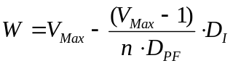
Note that as D_{I} goes from n ⋅ D_{PF} to 0, W goes from 1 to V_{Max}. The parameter W is used to gradually relax constraints 3 and 4. When W reaches V, constraint 3 is completely removed; when W reaches V_{Max} , constraint 4 is removed.
Because only one type of lane change is made during a timestep, the type of lane change needed (left/right) must be the same as the type of lane change (left/right) calculated during this timestep.
It is possible for a vehicle to have more than one approach lane that is acceptable for plan-following. If the vehicle is in an acceptable lane and the new lane (left/right) is also an acceptable approach lane, W = 0, which allows lane changes based on gaps. If the new lane is not acceptable, no lane change is allowed, unless the vehicle must cross the new lane to reach an acceptable one.

Special Cases
This section outlines several special cases involving lane changes.

Mass Transit
The algorithm handles mass transit vehicles separately because they must not become off-plan and because they must have priority in making lane changes. In addition, mass transit vehicles are allowed to enter transit stops during lane changes.
Each transit vehicle enters a transit stop if
- it is not full and there is a queue of people waiting at the stop,
- any passenger wishes to get off at the stop, or
- the driver’s plan includes a scheduled departure time for this step and that time has not yet passed.
The vehicle either will be left occupying the grid cells or taken off the grid entirely, depending on the style of transit stop (e.g., STATION or STOP). If it is left on the grid, it will attempt to get into the rightmost lane. The vehicle’s speed constraint is set to 0 while it is in the STOP style.

Merge Lanes
Merging is handled by using the lane-change logic. Vehicles in merge lanes are forced to make lane changes in the same direction as the merge direction. In some cases, a lane can have a merge pocket and a turn pocket further down the lane toward the intersection. In these cases, vehicles are prohibited from entering the lane until they are past the end point of the merge pocket.

Turn Pocket Lanes
The Traffic Microsimulator imposes speed restrictions on vehicles attempting to enter a turn pocket lane from an adjacent lane. These restrictions prevent movement of the vehicle past the start of the turn pocket, thus causing the vehicles to queue on the adjacent lane until it is a possible to execute a lane change into the turn pocket lane.
In Fig. 7, the vehicle in Lane 2 needs to make a left turn at the next intersection. The left turn pocket (Lane 1) has no vacant cells. At time t, the vehicle’s speed is 3, which will move the vehicle past the start of the turn pocket. The vehicle’s speed is constrained to 2 (the distance from the vehicle’s current position at time t and the start of the turn pocket).
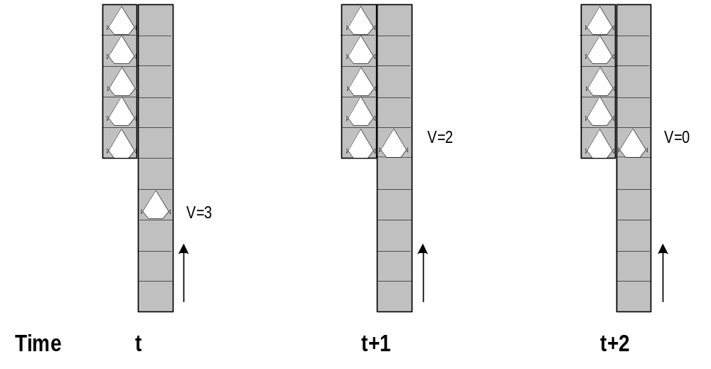
Fig. 7. This graphic shows vehicle behavior at turn pocket lanes.
At time t+1, the vehicle has moved down Lane 2 to the starting cell of the turn pocket. A lane change into the turn pocket is not possible because other vehicles occupy all the cells. By constraining the speed to 0, the vehicle is prevented from traveling further down Lane 2. At time t+2, the vehicle remains in Lane 2 with speed 0. The vehicle’s speed will remain constrained to 0 until a lane change into the turn pocket is possible.

Look Ahead Across Links
Approach lanes can be determined by considering only the connectivity to the next link. However, some vehicles cannot make the required lane changes into acceptable approach lanes on short multilane links with multiple lane connectivity at the intersections. Looking ahead across links increases the time that a vehicle has to make a plan-following lane change.
The Traffic Microsimulator uses plan look-ahead distance (set by the configuration file key CA_LOOK_AHEAD_CELLS) to determine acceptable approach lanes. The distance is used to determine how many links in the plan are considered when determining the approach lanes on the current link.
- A default value of 0.0 means that approach lanes are determined by considering the next link only.

Transit
While a vehicle is in a transit stop, the transit-stop object contains a pointer to the vehicle (implying that the capacity of stops is 1). The object also contains queues of travelers waiting to board transit vehicles. There is a separate queue for each route ID.
If there is a transit vehicle currently servicing the stop and it has been there for at least the number of timesteps specified by the configuration file key CA_TRANSIT_INITIAL_WAIT, travelers are allowed to enter and exit the vehicle. Entry and exit can take place simultaneously, but the mean rate at which travelers enter and exit is set by the configuration file keys CA_ENTER_TRANSIT_DELAY and CA_EXIT_TRANSIT_DELAY, respectively.
Travelers are popped off the traveler queue until it reaches either the maximum number of travelers who can board in a single timestep or a traveler whose next departure time is later than the current simulation time.
If a traveler’s plan calls for him or her to take the route that this vehicle is servicing, and the number of passengers already aboard does not exceed the capacity for this type of vehicle specified by the vehicle prototype file, he or she will enter the vehicle.
Travelers leaving the vehicle have completed a leg of their plan; they are placed in the Arrived Travelers list to trigger the Read Plans process to find the next leg of their plans. If all of the passengers exiting at this stop have been taken care of and either the bus is full or no more passengers are waiting to board, the vehicle is placed back on the grid (if necessary) and its speed constraint removed.

Exiting from Parking Places
A parking place accessory has a list of IDs for the vehicles present (either because they begin the simulation there or they have arrived during the course of the simulation). It also has a queue of travelers and their associated plans. This procedure handles each traveler in the traveler queue whose departure time has arrived.
A vehicle whose ID is on the list will have been instantiated in the simulation only if it has arrived here from somewhere else. Otherwise, a new vehicle with this ID must be created using the type implied by the traveler’s plan.
A traveler cannot leave unless his or her vehicle is present. If the vehicle is not there, the traveler’s departure time is incremented and he or she is replaced in the queue.
Depending on his or her plan, the traveler is added to the vehicle as either a driver or a passenger. If the driver has not yet been added to the vehicle, the next traveler is popped off the queue. Otherwise, the driver determines how many passengers are anticipated. (This information is contained in the driver’s plan, along with the IDs of the expected passengers.)
If any passengers are missing, the driver is placed back in the queue so that the vehicle will try to leave again on the next timestep. If the driver and all passengers are present, the vehicle attempts to find room on the grid in any lane, not in the boundary region (as described in “Distributed Links and Boundaries Information Flow”), traveling at the speed limit.
Once the appropriate grid for the planned direction of travel is determined, the grid is searched upstream for a distance of V_{Max} cells. If a vehicle is found in a lane, that lane and the adjacent lanes are eliminated from consideration. Thus, the maximum number of vehicles that can leave a lot in one timestep is the number of lanes on the grid.
All lanes are searched and if a lane is available, the vehicle is placed on the lane at the cell corresponding to the parking place location. If there is no room on the grid, the driver is returned to the traveler queue.

Movement Check/Intersections
This procedure handles vehicles that leave a link and pass through an intersection. Upon arriving at an intersection, a vehicle’s destination lane on the next link is determined. The current lane is selected if it is allowed on the next link; otherwise, a lane is picked at random from the set of allowed lanes. This set takes into consideration lane use and HOV restrictions.
Unsignalized intersections with stop/yield traffic controls require vehicles to consider oncoming traffic before they can move onto the next link. The vehicles use the gap between the oncoming vehicles and the intersection to determine if they can enter the intersection. If the gap is acceptable, the vehicle traverses the intersection and arrives on the destination link during a single update step in the microsimulation.
Vehicles at signalized intersections have different behaviors from those at unsignalized intersections. When a vehicle enters an intersection, it is placed in a queued buffer, where it resides for a specified time before exiting to the destination link. The time that the vehicle spends in the queued buffer models the time necessary to traverse the intersection. Vehicles with permitted but not protected movements from the intersection traffic control must consider the oncoming traffic before entering the intersection. The configuration file key for this is CA_INTERSECTION_WAIT_TIME.
To enter an intersection, a vehicle must satisfy six conditions, all of which are outlined below.

Condition One | Be the first vehicle on the link in the current lane going toward the intersection. Only one vehicle per lane is allowed to enter the intersection in a single timestep.
Condition Two | Have a current speed greater than or equal to the number of empty cells between the vehicle and the end of the link.
Condition Three | Satisfy the conditions of the traffic control at the intersection. The state of the traffic control indicates if a vehicle must consider oncoming traffic gaps.
Condition Four | Ensure that there is an acceptable gap between the vehicle and oncoming traffic.
Condition Five | Ensure that the intersection buffer for the current lane is not full.
Condition Six | Ensure that the destination cell in the destination lane on the destination link is unoccupied.
A vehicle will attempt to enter an intersection if its current speed is greater than or equal to the number of empty cells between the vehicle and the end of the link. The state of the traffic control (TC) at the intersection is an important factor in determining if a vehicle can enter the intersection.
To enter a signalized intersection, the TC must indicate a permitted, protected, or caution movement for the current lane and the desired movement. At an unsignalized intersection, stop and yield signs impose conditions on intersection entry.
The TC state may require that the distance between the intersection and oncoming traffic (interfering lane gap) meet certain criteria before the vehicle can enter the intersection. Table 1 shows the TC states and their corresponding actions.
Table 1. Traffic control states and corresponding actions.
TC State | Action | Conditions
S* - Protected | Proceed | None
S – Wait | Stop | None
S – Permitted | Evaluate | G_{I} on IL (Interfering Lanes)
S – Caution | Proceed | None
U** -None | Proceed | None
U – Stop | Wait  Evaluate | Stopped < 1 Timestep  G_{I} on IL, Stopped ≥ 1 Timestep
U – Yield | Evaluate | G_{I} on IL

* S = Signalized intersection
** U = Unsignalized intersection
The interfering lane gap (G_{I}) consists of the distance between the oncoming vehicle and the intersection. The oncoming vehicle must be on a link connected to the intersection, which limits the look-back distance for oncoming traffic to the length of a single link.
The oncoming vehicle’s speed (VOV) and the Gap Velocity Factor (GVF), specified by the configuration file key CA_GAP_VELOCITY_FACTOR) are used to calculate the Desired Gap.
Desired Gap (G_{d}) = V_{OV}*GVF
On links in which the desired gap is greater than the number of cells on the link, the number of cells on the link is used as the desired gap.
G_{I} ≥ G_{d}, Interfering Gap Acceptable
G_{I} < G_{d}, Interfering Gap Not Acceptable
Note that for an oncoming vehicle with speed of 0, G_{d} will be 0, which allows movement through intersections in congested conditions in which both G_{d} and G_{I} = 0. If the interfering gap is not acceptable, the vehicle is at a stop or a yield sign, and the interfering lane is also controlled by a stop/yield sign, then there will be a deadlock resolution in which the vehicle will proceed with probability determined by the value of the configuration file key CA_IGNORE_GAP_PROBABILITY.
A shown in Fig. 8, a vehicle can enter the intersection only when the interfering gaps are acceptable (G_{I} ≥ G_{d}).
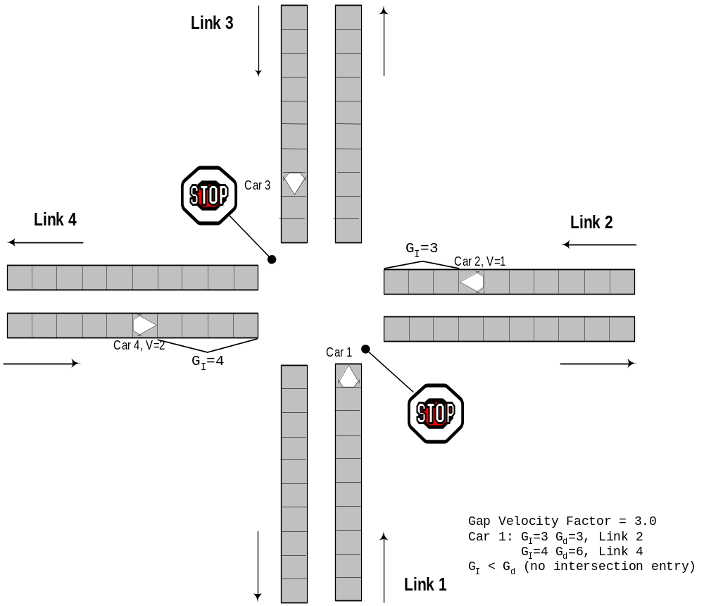
Fig. 8. This figure shows the intersection entry interfering lane gap.
If the traffic control for the intersection is signalized, the vehicle does not traverse the intersection in the current microsimulation timestep. Signalized intersections maintain internal queued buffers in which vehicles are placed to traverse the intersection. Each intersection has one queued buffer for each incoming lane.
If the conditions of the signalized TC have been satisfied, a vehicle must check whether the appropriate buffer has space to receive the vehicle. (The intersection buffer’s capacity is set by the configuration file key CA_INTERSECTION_CAPACITY.) If this is the case, the vehicle is removed from the incoming link and is placed in the intersection buffer for a wait period (specified by the configuration file key CA_INTERSECTION_WAIT_TIME).
After the time period has expired, the vehicle exits from the buffer to the first cell (or Lth cell if the vehicle has length L) on the destination link if the cell is vacant. If it is not, the vehicle waits in the intersection buffer until the cell becomes vacant.
The buffers have a fixed size, so that if the buffer is full the vehicle cannot enter the intersection and must wait on the link.
At unsignalized intersections, vehicles can enter and exit the intersection in a single timestep. Therefore, if the conditions of the unsignalized TC have been satisfied for intersection entry, a vacant cell on the destination link in the destination lane must be available for the vehicle to enter the intersection. The vehicle’s current speed is used to determine which cell to reserve on the destination link.
If the primary destination cell is unavailable, the next cell closer to the intersection is tried. This process continues until an available cell is found or until all the cells between the intersection and the primary destination cell are tried. A marker is placed in the destination cell to reserve the cell.
If a vehicle successfully reserves a place in the queue or on the next link, an internal state variable will be set to indicate that it can proceed. This variable is used during the movement procedure to determine whether to remove a vehicle from a link or decrease its speed. Vehicles traversing unsignalized intersections are placed on their destination link during the cleanup procedure at the end of a timestep.

Off-Plan Vehicles
An off-plan vehicle is one that is not in an acceptable approach lane when it is ready to enter an intersection and thus cannot follow its assigned plan. Vehicles that have not moved for the number of timesteps defined by the configuration file key CA_MAX_WAITING_SECONDS also become off-plan.
The timestep when the vehicle tries to exit from the simulation is calculated using the off-plan exit time (configuration file key CA_OFF_PLAN_EXIT_TIME). Once this is calculated, a new destination link is selected from links connected to the vehicle’s current lane.
New destination links are randomly selected for off-plan vehicles until the current timestep is equal to the calculated exit timestep. Once time is reached, the vehicles are removed from the simulation at the nearest parking place.

Abandon Plan
Vehicles attempting to enter an intersection (and that have not moved for a specified period of time) abandon their plans and, if possible, select a different destination link. The time period is defined by CA_MAX_WAITING_SECONDS.
These vehicles are marked as off-plan and are removed at the nearest parking place. Allowing vehicles to become off-plan after a specified waiting period is necessary to prevent traffic gridlock.

Movement
The movement rule is as follows: accelerate when you can; slow down if you must; sometimes slow down for no reason. The rule is executed to update the speed and position of each vehicle on the roadway.
A gap is defined as the distance between a vehicle and the next car ahead. Each vehicle tries to accelerate up to a desired speed if the gap is greater than the current speed. The desired speed is limited to the speed limit posted on each link and the maximum speed for each vehicle type and subtype (as specified in the vehicle prototype file).
If the gap is smaller than the current speed, the vehicle will slow down until its current speed is equal to the gap, thus imposing the no-collision condition. Each vehicle also has a random probability of slowing down. This is called the deceleration probability (P_{D}) (configuration file key CA_DECELERATION_PROBABILITY). Use of the deceleration probability is essential to produce realistic traffic dynamics (such as jam waves) from individual vehicle interactions.
To compute a vehicle’s speed (Vt+1) and the next position on a link, first compute the speed based on the gap and the vehicle’s speed in the current timestep (V_{t}) as follows:
- Compute Gap
- if (V_{t} < Gap AND V_{t} < V_{Max})
V_{t+1} = V + A_{t}
The acceleration A_{t} is determined separately for each vehicle subtype. For autos, A_{t} is the maximum acceleration as specified in the vehicle prototype file. For other vehicles, acceleration is grade and velocity dependent.
Under the assumption of constant power acceleration, A_{Max} is interpreted as the maximum acceleration at V = 7.5 m/sec = 1 cell/timestep. Then, the velocity dependence is
A = A_{Max}/V.
The grade dependence is handled by taking into account the acceleration caused by gravity, A = A_{Max}/V - gsinθ, where θ is the grade. Negative accelerations are possible, until a vehicle reaches its “crawl speed” of 1 cell/timestep. Fractional accelerations are handled by using the greatest integer part and adding 1 randomly. That is, an acceleration of 1.6 cells/timestep/timestep is implemented as an acceleration of 2 (60% of the time) and 1 (40% of the time).
Each moving automobile (Speed > 0), but not heavy vehicles, has a random probability of decelerating in each timestep. Compute the probability and slow down if the computed probability is less than the deceleration probability.

- if (V_{t+1} > 0) and (N_{Rand} < P_{D})
V_{t+1} = V_{t} + 1
And finally, move the vehicle to its new grid position based on the new speed.

- New Cell = Current Cell + V_{t+1}

Entering Parking Places
To remove vehicles from the roadway at destination parking places, the Traffic Microsimulator checks all of the cells in all lanes downstream from the parking place for a distance of V_{GlobalMax} cells.
If a vehicle is found on the last step of the current leg of its plan and with this parking place as its destination, the vehicle is removed from the roadway. Its ID is placed onto the list of vehicles present at that parking place.

Preparing for a Timestep

Update Signals
Timing tables provided for each signal are used to update them at each timestep. Signalized traffic controls are initialized at the beginning of the simulation to the first interval of the signal cycle’s first phase when the signal offset is 0.0. When the offset is not zero, the signal is initialized to the phase and interval that corresponds to simulation time 0 in the offset cycle.

Prepare Nodes
Find vehicles in each intersection that are ready to be ejected during this timestep. Vehicles exit from the intersection queued buffers when their residence time in the buffer is greater than the intersection residence time specified by the configuration file key CA_INTERSECTION_WAIT_TIME.
Vehicles exit from the queued buffer onto the first cell in the destination lane on the destination link. Exiting vehicles reserve their destination cell before vehicles on links calculate movement, thus giving the vehicles exiting from intersection buffers precedence over vehicles on the links. This procedure places a temporary vehicle marker on the next grid for each vehicle that will leave the intersection on this timestep.

Cleaning Up After a Timestep

Migrate Vehicles
Any vehicle that has passed from a region of a link controlled by a CPU into a region controlled by its neighbor must be encoded in a message and sent to that neighbor. The Migrate Vehicles process is done on a link-by-link basis.

Migrate Travelers
Some travelers not in vehicles may have been placed in the Migrating Travelers list during the timestep. The Migrate Travelers procedure encodes those travelers into messages and passes them on to the desired CPUs, thus clearing out the list as it goes.

Clean up Nodes
The Clean up Nodes procedure causes each intersection to eject the first vehicle in each of its buffers into previously reserved locations on the destination link.
Vehicles are transferred from the buffers to their reserved destination cells during the cleanup phase, which takes place after movement changes for all the vehicles are executed. Vehicle speed does not change during intersection entry/exit at a signalized intersection. Vehicles are placed in the first cell on the destination link with the same velocity that they entered the intersection buffer.

Clean up Edges
The Clean up Edges procedure clears all temporary vehicle markers from the grids. In addition, if the cleanup action state variable for a vehicle is eject, it places the vehicle in the intersection buffer (if buffered; otherwise, place it directly onto the next edge).
If the cleanup action is migrate, it deletes the vehicle (which has already been sent to its destination CPU in the migration step).

Supporting Parallel Computation
The Traffic Microsimulator runs on multiple CPUs to maximize computational speed. Updating vehicle positions then can be done in parallel on individual CPUs. This method is faster than a single, sequential update algorithm on transportation networks with a large number of vehicles.

Transportation Network Partition
The transportation network is partitioned among the CPUs, with each CPU receiving a set of nodes and links (Fig. 9). To partition the network among the CPUs, an orthogonal bisection (OB) algorithm or the METIS graph-partitioning library can be used.
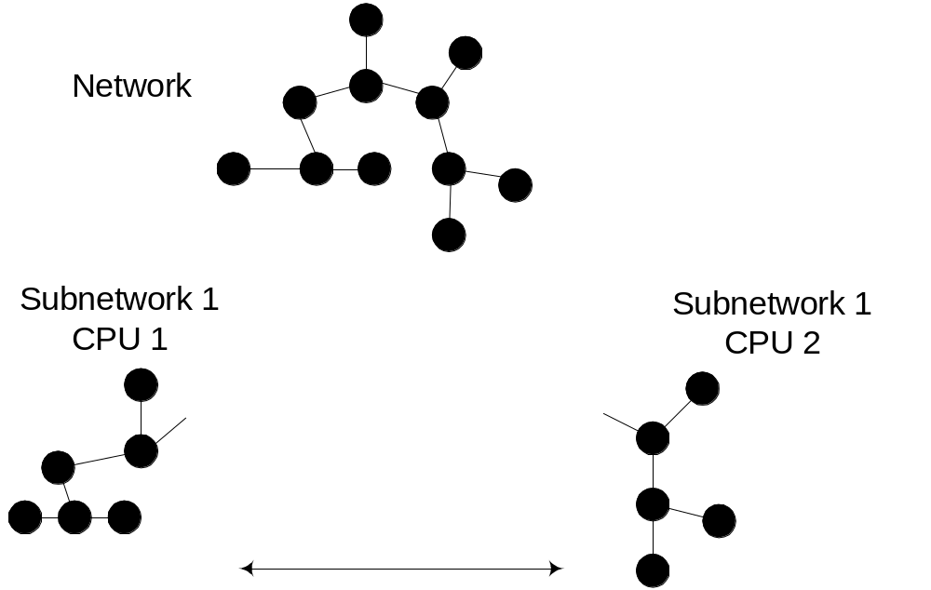
Fig. 9. A graphic representation of a transportation network partition.
METIS is a public domain package. Which algorithm is used is determined at run time by a combination of the configuration file keys PAR_PARTITION_FILE, PAR_USE_METIS_PARTITION, and PAR_USE_OB_PARTITION.
Both algorithms use a cost function for each node. METIS also uses a cost function for each link. These costs can be based on the number of cells on the links attached to the node if no other information is available. As the simulation runs, it collects information on the amount of CPU time devoted to processing each link and node. This information can be saved in a Run Time Measurements file, which can be used to assign costs to the links and nodes in subsequent partitioning calculations.
The configuration file keys that control this process are PAR_RTM_INPUT_FILE and PAR_RTM_PENALTY_FACTOR. It is placed in the directory named by OUT_DIRECTORY in a file named RTM_FEEDBACK_FILE.
Partitioning can be saved for later use by DistributePlans or a subsequent simulation run. This is controlled by the configuration file keys PAR_SAVE_PARTITION and PAR_PARTITION_FILE. If neither METIS nor OB partitioning has been requested, the simulation will look for this partition file.

Distributed Links and Boundary Information Flow
Links that connect nodes residing on different CPUs are split in the middle (Fig. 10). These links are distributed links. Each CPU is responsible for one-half of the link. Each distributed link is assigned a number of active grid cells belonging to a given CPU. Such an assignment is necessary to consistently divide links with an odd number of cells.

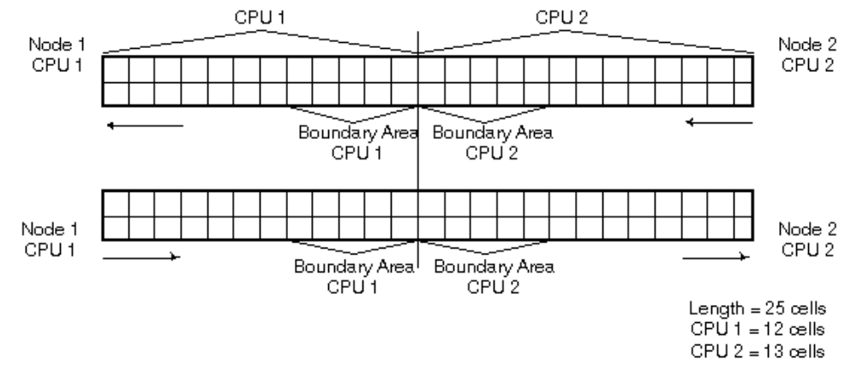
Fig. 10. This figure shows a distributed (split) link.
The area in the middle of the distributed links is called a boundary area. The boundary area’s width is currently V_{GlobalMax} (5) cells. Links shorter than PAR_MIN_CELLS_TO_SPLIT cells will not be split. The maximum distance (forward or backward on a link) that can be used for gap calculations is limited to the boundary width on distributed links.
Vehicles are transferred between CPUs as they traverse these split links. Each split link introduces a message-passing delay during the update sequence because messages must be passed between the CPUs for vehicles that are crossing split links. Two types of messages must be exchanged between CPUs with distributed links:
- Vehicle Migration Messages, which are messages for vehicles transferred to the other part of the link on a different CPU.
- Boundary Exchange Messages, which are messages containing information about vehicle positions in the boundary area of a link.
Vehicle migration messages occur for all vehicles that have completed the traversal of a CPU’s active cells. All information about the vehicle, its occupants, and their plans is put into a message and sent to the CPU that owns the other half of the distributed link, after which the vehicle is removed from the originating CPU.
Upon receipt of the message, the other CPU creates a vehicle and travelers using the information in the message; it then places them at the appropriate position on its half of the distributed link.
Exchange of boundary information between CPUs is called a boundary exchange. Boundary exchange messages are necessary to correctly calculate position changes (movement and lane changes) for vehicles in a CPU’s boundary area. Information about vehicles in the next VGlobalMax cells (or preceding VGlobalMax cells, depending on the direction of traffic flow) is necessary to execute the appropriate gap calculations for lane changes and movement.
Each CPU maintains a list of its distributed links and of the CPU owners of the other half of the links. Boundary exchanges must be conducted before lane changes and again before vehicle movement. Each CPU initiates the exchanges at the appropriate time. Each CPU waits until it receives all of the boundary exchange messages from neighboring CPUs.
Comparison of Fig. 11with Fig. 3 shows how the message passing is interleaved with the simulation update processing.

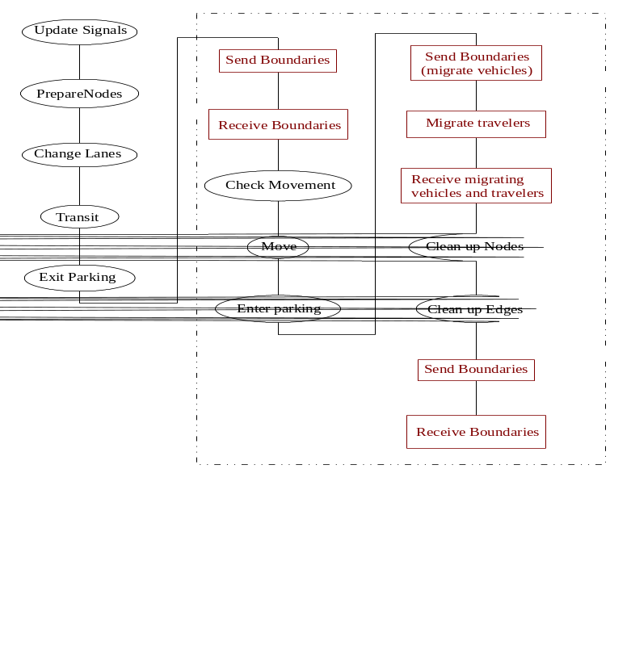
Fig. 11. The rectangular (red) boxes show information flow in a distributed version of the Traffic Microsimulator.

Parallel Computation Sequence and Synchronization Points
A distributed object simulation, the Traffic Microsimulator uses a master/slave(s) paradigm. The master process starts the slave processes, handles the initialization sequence, and serves as a synchronization point for the slave processes.
The slave processes do all of the work in the simulation. After initialization, each slave process completes successive update cycles until the end of the specified simulation run. The slave processes synchronize with the master process at the beginning of each timestep or at the beginning of a sequence of timesteps, depending on the value of the configuration file key CA_SEQUENCE_LENGTH (see Fig. 11).

Initialization Sequence
The master process begins by reading the network information from the database, constructing a copy of the transportation network, and constructing or reading a partition. The master then is ready to create and initialize the following five-step slave process:

Step One | Start slave processes.
Step Two | Send each slave ID lists of its local nodes and links and of those connected to it by distributed links.
Step Three | Send each slave a mapping from node IDs to CPU IDs, and optionally (depending on the setting of the configuration file key CA_BROADCAST_ACC_CPN_MAP) a mapping from accessory IDs to CPU IDs.
Step Four | Tell each slave to construct its transportation subnetwork from database information.
Step Five | Tell slaves to read in the initial plans, queue initial vehicles on parking places, and initially place vehicles on the links at the given simulation start time.

Simulation
After the initialization sequence is complete, the master starts the simulation by telling the slaves to execute the first timestep. The master process waits until all of the slaves complete execution of a fixed number of timesteps. It then sends a message to the slaves to execute the next timestep sequence.

Termination
The master sends messages to the slaves that tell them to shut down the parallel I/O system and then to exit when the requested number of timesteps has been executed.

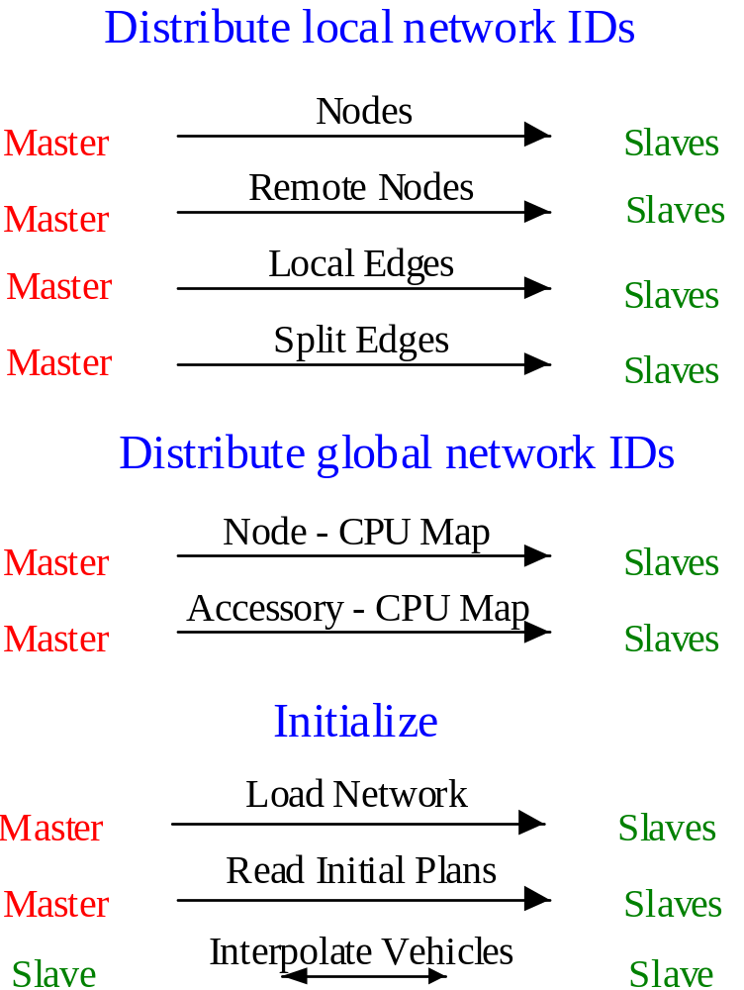

Fig. 12. Initialization message traffic. (this figure was formerly labeled 11(a))

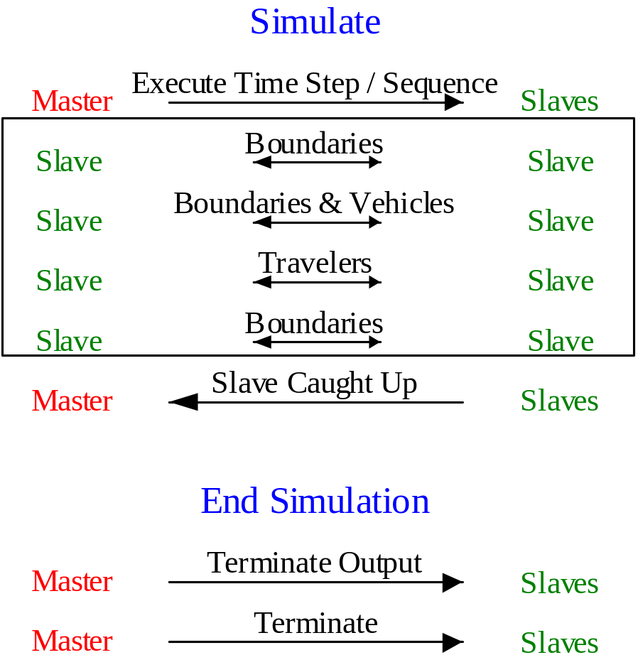

Fig. 13. The top part of this figure shows the simulation message traffic. The set of messages in the box is repeated once for every timestep up to the number of steps in the sequence. The lower part of this figure shows termination message traffic. (this figure was formerly labeled 11(b))

Overlapping Computation and Communication
For efficiency, a parallel code should overlap communication whenever possible. This enables a CPU to continue executing useful work while waiting for responses from other CPUs.
The microsimulator accomplishes this by noting which links are under a single CPU’s control and which are shared. After sending boundary information, each CPU can update all of its non-shared links before it must make use of boundary information received from other CPUs. Fig. 14 shows the sequences of computation and communication in such a modified timestep execution. If the configuration file key CA_LATE_BOUNDARY_RECEPTION is set, the simulation will arrange computations in this manner.
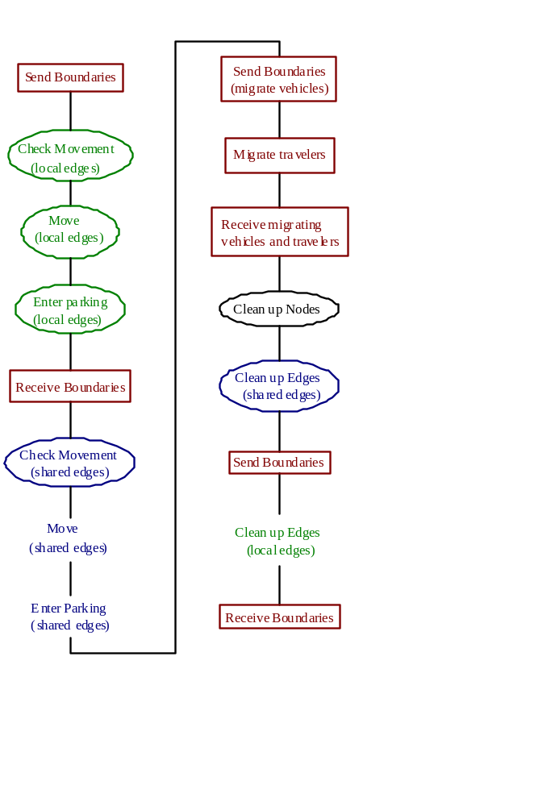

Fig. 14. Modifications to the processes enclosed in the dashed box support overlapping computation. Communication computation on local edges (in green) takes place while a CPU waits for information about shared edges (in blue).

Output Collection
Slaves generate in parallel all output information from the Traffic Microsimulator. Each slave sends a message to the master indicating what sort of information it would like to write and how many bytes the information will require on disk.
The master collates the requests from all the slaves and responds to each, indicating an offset into a file for writing the information. Each slave then writes its information to disk at the indicated location. The message traffic generated by the output system is not shown in figures 11 or 12 for clarity.

Simulation Output Files

Overview
This TRANSIMS Simulation Output subsystem collects data from a running microsimulation and stores it for subsequent examination by the analyst or use by other TRANSIMS software components. It provides a software layer that insulates applications from the details of the file structure and provides great flexibility in the specification of the data to be collected.
A parallel communication library is used to collect data in ASCII format into a single file written by the master simulation process. No post-processing is required with this mechanism.

File Format
This section describes the file formats the eight types of simulation outputs currently implemented. All fields are described, but the filtering capability enables suppression of any output field for which the analyst has no interest, thus resulting in smaller output files.
Applications that read the output produced by the simulation should always use the functions for reading. The functions provided by the output representation automatically handle records with suppressed fields and only attempt to read the fields that were actually written. This enables the implementation of general postprocessing applications that need not be cognizant of the number and order of the fields written by the simulation.

Traveler Event
The Traffic Microsimulator outputs traveler event records each time an event of interest to the analyst takes place. The simulation time interval during which to record events is defined in the input configuration file.
Filtering capabilities are provided so that the analyst can select which of the many potentially interesting events should be recorded. Table 2 provides a list of events that may be of interest; these are specified in the STATUS and ANOMALY output fields. The other fields describe the traveler’s state at the time the event took place.
Table 2. Traveler event record fields.
Field | Description
TIME | Current time (seconds from midnight)
TRAVELER | Traveler ID
TRIP | Traveler’s trip ID
LEG | Traveler’s plan leg ID.
VEHICLE | Vehicle ID; value = 0 if not in a vehicle.
VEHTYPE | Vehicle type:  0 = walk  1 = auto  2 = truck  3 = bicycle  4 = taxi  5 = bus  6 = trolley  7 = streetcar  8 = light rail  9 = rapid rail  10 = regional rail
VSUBTYPE | Vehicle subtype may be unused; value = 0 if not applicable.
ROUTE | Transit route ID; value = -1 if not in a transit vehicle.
STOPS | Count of number of stop signs encountered on current plan leg.
YIELDS | Count of number of yield signs encountered on current plan leg.
SIGNALS | Number of traffic signals encountered on current plan leg.
TURN | Type of last turn made:  0 = straight direction (no turn)  1 = right turn  -1 = left turn  2 = hard right turn  -2 = hard left turn  values 3 to 6 represent increasingly more extreme right turns  values –3 to –6 represent increasingly more extreme left turns  -7 = reverse direction (U-turn)
STOPPED | Time (seconds) spent stopped on current plan leg.
ACCELS | Time (seconds) spent accelerating from 0 on current plan leg.
TIMESUM | Total time (seconds) spent on current plan leg.
DISTANCESUM | Total distance (meters) traveled on current plan leg (see accompanying text for more information).
USER | Analyst-defined field: any integer value is acceptable; definition may vary with each case study.
LINK | Link ID when traveler is in a link or previous link when traveler is at an intersection.
NODE | Node ID traveler is traveling away from a link or node traveler is at an intersection.
ANOMALY | Type of anomaly:  0 = no anomaly occurred  1 = traveler is off plan  2 = traveler cannot find next link in plan  3 = traveler cannot find next parking place in  plan  4 = traveler cannot find next vehicle in plan  5 = traveler cannot find next transit stop in plan  6 = traveler cannot board full transit vehicle  7 = driver of transit vehicle skipped stop that  had passengers waiting to board  8 = driver of vehicle cannot change lanes because  of congestion
STATUS | Traveler’s current status bits: (see accompanying text for a detailed explanation of status bit interpretation).  0x1 = traveler is on a link (persistent)  0x2 = change in traveler’s on-link status  0x4 = traveler is on a leg (persistent)  0x8 = change in traveler’s on-leg status  0x10 = change in traveler’s on-trip status  0x20 = traveler is non-motorized, i.e., walking, bicycling (persistent)  0x40 = traveler is not in the study area (persistent)  0x80 = change in traveler’s in-study area status  0x100 = traveler is in a vehicle (persistent)  0x200 = change in traveler’s vehicle occupancy status  0x400 = traveler is the driver (persistent)  0x800 = change in traveler’s driver status  0x1000 = traveler is waiting at some location (persistent)  0x2000 = change in traveler’s waiting status  0x4000 = location is a parking place (persistent)  0x8000 = location is a transit stop (persistent)  0x10000 = driver of transit vehicle is at a transit stop (persistent)  0x20000 = change in driver’s transit vehicle at stop status  0x40000 = driver of transit vehicle is on a layover (persistent)  0x80000 = change in driver’s transit vehicle on layover status  0x100000 = driver’s transit vehicle is full (persistent)  0x200000 = change in driver’s transit vehicle full status  0x400000 = traveler is off plan (persistent)  0x800000 = change in traveler’s off-plan status  0x1000000 = beginning of simulation  0x2000000 = end of simulation  0x4000000 = location is an activity location (persistent)  0x8000000 = undefined  0x10000000 = undefined  0x20000000 = undefined  0x40000000 = undefined  0x80000000 = undefined
LOCATION | Where traveler is located: parking place ID, transit stop ID, or activity location ID, depending on the event as defined as follows:  EVENT LOCATION value  Begin/End plan leg parking place ID or transit stop ID  Begin/End trip parking place ID or transit stop ID  Enter/Exit vehicle parking place ID or transit stop ID  Begin/End driving parking place ID or transit stop ID  Waiting for transit transit stop ID  Waiting at parking parking place ID  Begin/End activity activity location ID  Transit vehicle at stop transit stop ID  Transit vehicle on layover transit stop ID  Transit vehicle full transit stop ID  Can’t find parking parking place ID  Can’t find vehicle parking place ID  Can’t find transit stop transit stop ID  Can’t board transit transit stop ID  Skipped transit stop transit stop ID  When the traveler is in a link or at an intersection, the LOCATION field is zero.
The STATUS field is bit-oriented. Each bit represents a characteristic about the traveler that is true whenever the bit is set. Multiple bits set means that multiple characteristics are true at this time. Interpretation of the STATUS field involves determining which combination of characteristics is currently true according to the table that describes the individual bits. It is convenient to view the STATUS field in hexadecimal notation because this more clearly illuminates the patterns in the field.
Status values are generally represented in bit pairs. The lower bit of a pair is termed the “persistent bit,” whereas the upper bit is termed the “change bit.”
- The persistent bit is set during the entire time that the condition is true.
- The change bit is set only for the timestep when a change in the persistent bit occurs.
This scheme enables the analyst to identify the beginning and the end of a persistent condition without comparing multiple events.
For example, when a traveler begins a leg, the persistent bit representing on leg (0x4) is set, and the change bit representing change in on leg (0x8) is set. While the traveler is on the leg, the persistent bit (0x4) remains set, and the change bit (0x8) is cleared. When the traveler ends the leg, the persistent bit (0x4) is cleared, and the change bit (0x8) is again set for one timestep. While the traveler is not on a leg (e.g., while waiting somewhere), both the persistent bit and the change bit are cleared.
A few of the status bits take place singly rather than in pairs because both bits are not required. For example, a persistent bit for on trip is not needed because travelers are only simulated while they are on a trip. A persistent bit that is always set provides no additional information and clutters the output, and therefore it is not used. The non-motorized bit (0x20) is used in conjunction with the on leg bits to indicate that the leg does not involve vehicular travel. The location type identification bits (0x4000, 0x8000, and 0x4000000) are used in two ways:
- They are used in conjunction with bits 0x1000 and 0x2000 to identify the type of location at which the traveler is waiting.
- They are also used to specify the type of location when the LOCATION field represents a parking place or transit stop ID. For example, when a traveler begins a leg at a parking place, bit 0x4000 will be set in addition to bits 0x4 and 0x8 to signify that the beginning location of the leg is a parking place.
The DISTANCESUM field accumulates the distance traveled along links and within intersections. Upon entering the intersection, DISTANCESUM is incremented by the setback on the link just left, and when exiting the intersection, DISTANCESUM is incremented by the setback on new link.

Snapshot Data
As the name implies, snapshot data represent a picture of erratic characteristics at a particular simulation timestep.

Vehicle Snapshot
Vehicle snapshot data provide information about vehicles traveling on a link. When collected for every link on every timestep, such data give a complete trajectory for each vehicle in the simulation. Vehicle snapshot data are collected as frequently as the analyst indicates in the input configuration file for the specified links. Table 3 provides a list of vehicle snapshot record fields.
Table 3. Vehicle snapshot record fields.
Field | Interpretation
VEHICLE | Vehicle ID.
TIME | Current time (seconds from midnight).
LINK | Link ID on which the vehicle was traveling.
NODE | Node ID vehicle was traveling away from.
LANE | Number of the lane on which the vehicle is traveling.
DISTANCE | Distance (in meters) the vehicle is away from the setback of the node from which it is traveling away.
VELOCITY | Velocity (in meters per second) of the vehicle.
VEHTYPE | Vehicle type:  0 = walk 6 = trolley  1 = auto 7 = streetcar  2 = truck 8 = light rail  3 = bicycle 9 = rapid rail  4 = taxi 10 = regional rail  5 = bus
ACCELER | Acceleration (in meters per second) the vehicle had in the current timestep.
DRIVER | Driver ID.
PASSENGERS | Count of passengers in vehicle.
EASTING | Vehicle’s x-coordinate (in meters).
NORTHING | Vehicle’s y-coordinate (in meters).
ELEVATION | Vehicle’s z-coordinate (in meters).
AZIMUTH | Vehicle’s orientation angle (degrees from east in the counterclockwise direction).
USER | User-defined field that can be set on a per-vehicle basis.

Intersection Snapshot
Intersection snapshot data provide information about a vehicle as it traverses an intersection. These data are collected as frequently as the analyst indicates in the input configuration file for the specified nodes. Table 4 provides a list of intersection snapshot record fields.
Table 4. Intersection snapshot record fields.
Field | Interpretation
VEHICLE | Vehicle ID.
TIME | Current time (seconds from the midnight).
NODE | Node ID where the vehicle is located.
LINK | Link ID from which the vehicle entered.
LANE | Number of the lane from which the vehicle entered.
QINDEX | Vehicle position in the intersection buffer.

Traffic Control Snapshot
Traffic control snapshot data report the current state of the traffic signal at a node. These data are collected as frequently as the analyst indicates in the input configuration file for the specified nodes. Table 5 lists traffic control snapshot record fields.
Table 5. Traffic control snapshot record fields.
Field | Interpretation
NODE | Node ID, where the signal is located.
TIME | Current time (seconds from midnight).
LINK | Link ID entering the signal.
LANE | Number of the lane entering the signal.
SIGNAL | Type of control present:  0 = None  1 = Stop  2 = Yield  3 = Wait  4 = Caution  5 = Permitted  6 = Protected  7 = Permitted after stop

Link Travel Times Summary
Link travel time summary data report vehicle counts and travel times on links accumulated as vehicles exit the links. These data are collected as frequently as the analyst indicates in the input configuration file for the specified links.
There are separate data records for each turning movement leaving each lane on the link. Table 6 lists link travel times summary field records.
Table 6. Link travel times summary field records.
Field | Interpretation
LINK | Link ID being reported.
NODE | Node ID from which the vehicles were traveling away.
TIME | Current time (seconds from midnight).
COUNT | Number of vehicles leaving the link.
SUM | Sum of the vehicle travel times (in seconds) for vehicles leaving the link. (The time spent in the previous intersection is included in this value.)
SUMSQUARES | Sum of the vehicle travel time squares (in seconds squared) for vehicles leaving the link. (The time spent in the previous intersection is included in this value.)
TURN | Type of turn the vehicle made when leaving the link.
LANE | Lane number.
VCOUNT | Number of vehicles on the link.
VSUM | Sum of vehicle velocities (in meters per second) on the link.
VSUMSQUARES | Sum of the squares of the vehicle velocities (in meters squared per second squared).

Link Densities Summary
Link density summary data report vehicle counts and velocities within “boxes” that partition the link. These data are collected as frequently as the analyst indicates in the input configuration file for the specified links.
There are separate data records for each lane on the link. The box length is specified in the input configuration file. Table 7 lists link densities summary record fields.

Table 7. Link densities summary record fields.
Field | Interpretation
LINK | Link ID being reported.
NODE | Node ID from which the vehicles were traveling away.
DISTANCE | Ending distance of the box (in meters) from the setback of the node from which the vehicles were traveling away.
TIME | Current time (seconds from midnight).
COUNT | Number of vehicles in the box.
SUM | Sum of the vehicle velocities (in meters per second) in the box.
SUMSQUARES | Sum of the squares of the vehicle velocities (in meters squared per second squared).
LANE | Lane number.

Link Velocities Summary
Link velocity summary data report histograms of vehicle velocities within “boxes” that partition the link. These data are collected as frequently as the analyst indicates in the input configuration file for the specified links.
The input configuration file specifies the box length, number of histogram bins, and maximum velocity. The maximum velocity is typically 37.5 m/s and the velocity range is divided into five bins, in addition to an overflow bin that extends to infinity. Histogram intervals are defined to be closed at the lower end of the bin and open at the upper end. Table 8 lists link velocities summary record fields.
Table 8. Link velocities summary record fields.
Field | Interpretation
LINK | Link ID being reported.
NODE | Node ID from which the vehicles were traveling away.
DISTANCE | Ending distance of the box (in meters) from the setback of the node from which the vehicles were traveling away.
TIME | Current time (seconds from midnight).
COUNT0 | Number of vehicles with velocities in the range [0, 7.5).
COUNT1 | Number of vehicles with velocities in the range [7.5, 15).
COUNT2 | Number of vehicles with velocities in the range [15, 22.5).
COUNT3 | Number of vehicles with velocities in the range [22.5, 30).
COUNT4 | Number of vehicles with velocities in the range [30, 37.5).
COUNT5 | Number of vehicles with velocities in the range [37.5, infinity).

Link Energy Summary
Link energy summary data report histograms of vehicle energies (integrated power) accumulated as vehicles enter the links. Energy is defined as the sum of the vehicle’s power over each timestep, where power is defined as the velocity times the acceleration when the acceleration is greater than zero.
Vehicles are assumed to have zero power while they are at intersections. The units for energy are cells-squared per second-squared.
  In this release, the Emissions Estimator does not use link energy summary data.
These data are collected as frequently as the analyst indicates in the input configuration file for the specified links. The number of histogram bins and maximum energy is specified in the input configuration file. Histogram intervals are defined to be closed at the lower end of the bin and open at the upper end. Table 9 lists link energy summary record fields.
Table 9. Link energy summary record fields.
Field | Interpretation
LINK | Link ID being reported.
NODE | Node ID from which the vehicles were traveling away.
TIME | Current time (seconds from midnight).
ENERGY0 | Number of vehicles with integrated power in the range  [0, energy_maximum / number_bins).
ENERGY1 | Number of vehicles with integrated power in the second bin.
ENERGY2 | Number of vehicles with integrated power in the third bin.
ENERGYn | Number of vehicles with integrated power in the range  [energy_maximum, infinity).

Output Filtering
A variety of output filtering capabilities have been designed to limit potentially voluminous output to only those items of interest in a particular simulation run. An unlimited number of output specifications may be included in the simulation configuration file, allowing for very fine-grained control of the output produced.
Time-based filtering may be used to restrict data collection to a subset of the total run time by specifying starting and ending times. The analyst specifies in the input configuration file the frequency of reporting for evolution and summary data and the sampling frequency for summary data.
Collected data may be restricted to a subset of nodes and links in the road network. Table 10 describes the field in the node specification file, and Table 11 describes the field in the link specification file. Regional filtering allows the specification of the corners of a rectangular region in which data should be collected. (Note that the microsimulator does not currently use regional filtering.)
Table 10. Node specification fields.
Field | Description
NODE | Node ID.

Table 11. Link specification fields.
Field | Description
LINK | Link ID.
Data may be filtered by value, with only those items that pass all filters appearing in the output. The supported operators for value filtering are indicated in Table 12. Data fields in a record may be suppressed, resulting in shorter records.
Table 12. Value filtering operators.
Operators | Interpretation
== | equal to
!= | not equal to
< | less than
<= | less than or equal to
> | greater than
>= | greater than or equal to
% | an integer multiple of
!% | not an integer multiple of
@ | included in the list (a list is a string of values starting with the character  [, ending with the character ], and where each value is separated by the character |)
!@ | not included in the list
& | has set bits
!& | has cleared bits

Utility Programs

InterpretStatus
InterpretStatus displays the STATUS field in the traveler event output data as a bit pattern for easier interpretation.
Usage:
InterpretStatus <event file>
InterpretStatus reads the event file and writes the bit patterns representing the STATUS field to standard output. The output may be redirected to a file (if preferred).

SetupOutput
The SetupOutput script copies a set of empty and test output tables into a specified directory. It takes the name of the directory as its only argument.

CleanupOutput
The CleanupOutput script removes a set of tables created by SetupOutput. It takes the name of the directory as its argument.

Files
Table 13 lists simulation output library files.
Table 13. Simulation output library files.
Type | File Name | Description
Binary Files | libTIO.a | TRANSIMS Interfaces library.
Source Files | outio.c | Defines simulation output data structures and interface functions.
 | outio.h | Simulation output interface functions source file.
Utilities | InterpretStatus | Interprets event status field.
 | SetupOutput | Creates empty and test output files.
 | CleanupOutput | Removes empty and test output files.
Example Files | Test*.tbl | Tests output tables.
 | TestConfiguration.tbl | Configuration file for TestSimOutput.

Configuration File Keys
In the simulation output keywords, the trailing n must be replaced by an integer, beginning with 1 for the first set of output of each type (snapshot, event, and summary). If more than one set of output is desired for a particular type, the second set of keywords ends with n=2; the third set uses n=3, etc. There is no restriction to the number of output data sets of each type that may be requested. Default values can be specified for most of the simulation output keywords. Defaults are particularly useful when multiple output files are collected and the values of some keywords are the same for all files. The keywords for specifying default values are described in Appendix E, which follows the descriptions of the output keywords. The user may override any specified default by providing a value for the full keyword in the individual output specifications. The use of default values is optional.
- Appendix A lists keywords that pertain to the snapshot (evolution) type of output.
- Appendix B lists keywords that pertain to the event type of output.
- Appendix C lists keywords that pertain to the summary type of output.
- Appendix D lists keywords used by the CompareDensity and CompareVelocity programs. Only the first of these keywords is used by CompareVelocity.

Example
Appendix F provides an example for review
Appendix A: Configuration File Keys for Snapshot Output
Table 14. Configuration file keys for snapshot output.
Configuration File Key | Description
OUT_SNAPSHOT_BEGIN_TIME_n | The first time (in seconds from the midnight before simulation start) at which to collect data.
OUT_SNAPSHOT_END_TIME_n | The last time (in seconds from the midnight before simulation start) at which to collect data.
OUT_SNAPSHOT_FILTER_n | The list of expressions (of the form FIELD OPERATOR VALUE, and separated by semicolons) for filtering records. Valid values for FIELD are found in tables 2-4 and values for OPERATOT are found in Table 11.
OUT_SNAPSHOT_LINKS_n | The path of the link specification (described in Table 10).
OUT_SNAPSHOT_NAME_n | The file name for snapshot output.
OUT_SNAPSHOT_NODES_n | The path of the node specification (described in Table 9).
OUT_SNAPSHOT_SUPPRESS_n | The list of fields (separated by semicolons) not to include in the output file.
OUT_SNAPSHOT_TIME_STEP_n | The frequency (in seconds) at which to report data (i.e., write it to disk).
OUT_SNAPSHOT_TYPE_n | The types of snapshot output to collect (separated by semicolons) permissible values are VEHICLE; INTERSECTION; SIGNAL.

Appendix B: Configuration File Keys for Event Output
Table 15. Configuration file keys for event output.
Configuration File Key |  | Description
OUT_EVENT_BEGIN_TIME_n | The first time (in seconds from the midnight before simulation start) at which to collect data.
OUT_EVENT_END_TIME_n | The last time (in seconds from the midnight before simulation start) at which to collect data.
OUT_EVENT_FILTER_n | The list of expressions (of the form FIELDNAME OPERATOR VALUE and separated by semicolons) for filtering records. Valid values for FIELD are found in Appendix A. Valid values for OPERATOR are found in Table 11. Valid values for VALUE must be expressed in decimal notation (not hexadecimal).
OUT_EVENT_NAME_n | The file name for event output.
OUT_EVENT_SUPPRESS_n | The list of fields (separated by semicolons) not to include in the output file.
OUT_EVENT_TYPE_n | The types of event output to collect permissible value is TRAVELER.

Valid values for FIELD are found in Table 2; valid values for OPERATOR are found in Table 12; and valid values for VALUE must be expressed in decimal notation (not hexadecimal).
Appendix C: Configuration File Keys for Summary Output
Table 16. Configuration file keys for summary output.
Configuration File Key | Description
OUT_SUMMARY_BEGIN_TIME_n | The first time (in seconds from the midnight before simulation start) at which to collect data.
OUT_SUMMARY_BOX_LENGTH_n | The length of the boxes (in meters).
OUT_SUMMARY_END_TIME_n | The last time (in seconds from the midnight before simulation start) at which to collect data.
OUT_SUMMARY_ENERGY_BINS_n | The number of bins used to cover the range of the energy histogram.
OUT_SUMMARY_ENERGY_MAX_n | maximum energy in the energy histogram.
OUT_SUMMARY_ENERGY_SOAK_n | The single value specifying the soak time for which to collect energy data. Permissible values are SHORT, MEDIUM, or LONG. If key is not specified, all soak times are included in the energy output.
OUT_SUMMARY_FILTER_n | The list of expressions (of the form FIELD OPERATOR VALUE and separated by semicolons) for filtering records. Valid values for FIELD are found in tables 5-6 and values for OPERATOR are found in Table 12.
OUT_SUMMARY_LINKS_n | The path of the link specification file (described in Table 10).
OUT_SUMMARY_NAME_n | The file name for summary output.
OUT_SUMMARY_SAMPLE_TIME_n | The frequency (in seconds) at which to accumulate data.
OUT_SUMMARY_SUPPRESS_n | The list of fields (separated by semicolons) not to include in the output file.
OUT_SUMMARY_TIME_STEP_n | The frequency (in seconds) at which to report data (i.e., write it to disk).
OUT_SUMMARY_TYPE_n | The types of summary output to collect (separated by semicolons) permissible values are DENSITY; TIME; VELOCITY; ENERGY.
OUT_SUMMARY_VEHICLE_TYPE_n | The vehicle type and subtype (separated by colon) for which to collect velocity data. If subtype is zero or not specified, data for all subtypes of type will be included in the velocity output. If key is not specified, all vehicle types will be included in the velocity output.
OUT_SUMMARY_VELOCITY_BINS_n | The number of bins used to cover the range of the velocity histogram (in meters/second).
OUT_SUMMARY_VELOCITY_MAX_n | The maximum velocity in the velocity histogram (in meters/second).
Appendix D: Configuration File Keys for the CompareDensity and CompareVelocity Programs
Table 17. Configuration file keys for the CompareDensity and CompareVelocity programs.
Configuration File Key | Description
OUT_SUMMARY_SPACE_COUNT_TOLERANCE_1 | The difference tolerated between snapshot and summary count data.
OUT_SUMMARY_SPACE_SUM_TOLERANCE_1 | The difference tolerated between snapshot and summary sum data.
OUT_SUMMARY_SPACE_SUMSQUARES_TOLERANCE_1 | The difference tolerated between snapshot and summary sum-of-squares data.

Appendix E: Default Output Configuration File Keys
Table 18. Default output configuration file keys.
Configuration File Key | Description
OUT_BEGIN_TIME_DEFAULT | The first time (in seconds from the midnight before simulation start) at which to collect data.
OUT_EASTING_MAX_DEFAULT | The maximum easting (in meters) for which to report data (currently unused).
OUT_EASTING_MIN_DEFAULT | The minimum easting (in meters) for which to report data (currently unused).
OUT_END_TIME_DEFAULT | The last time (in seconds from the midnight before simulation start) at which to collect data.
OUT_EVENT_FILTER_DEFAULT | The list of expressions (of the form FIELD OPERATOR VALUE and separated by semicolons) for filtering event records.
OUT_EVENT_SUPPRESS_DEFAULT | The list of fields (separated by semicolons) not to include in the event output file.
OUT_LINKS_DEFAULT | The path of the link specification file.
OUT_NODES_DEFAULT | The path of the node specification file.
OUT_NORTHING_MAX_DEFAULTY | The maximum northing (in meters) for which to report data (currently unused).
OUT_NORTHING_MIN_DEFAULTY | The minimum northing (in meters) for which to report data (currently unused).
OUT_SNAPSHOT_FILTER_DEFAULT | The list of expressions (of the form FIELD OPERATOR VALUE and separated by semicolons) for filtering snapshot records.
OUT_SNAPSHOT_SUPPRESS_DEFAULT | The list of fields (separated by semicolons) not to include in the snapshot output file.
OUT_SNAPSHOT_TIME_STEP_DEFAULT | The frequency (in seconds) at which to report snapshot data (i.e., write it to disk).
OUT_SUMMARY_BOX_LENGTH_DEFAULT | The length of the summary data boxes (in meters).
OUT_SUMMARY_ENERGY_BINS_DEFAULT | The number of bins used to cover the range of the energy summary histogram.
OUT_SUMMARY_ENERGY_MAX_DEFAULT | The maximum energy in the energy histogram (in cells-squared per second-squared).
OUT_SUMMARY_FILTER_DEFAULT | The list of expressions (of the form FIELD OPERATOR VALUE and separated by semicolons0 for filtering summary records.
OUT_SUMMARY_SAMPLE_TIME_DEFAULT | The frequency (in seconds) at which to accumulate summary data.
OUT_SUMMARY_SUPPRESS_DEFAULT | The list of fields (separated by semicolons) not to include in the summary output file.
OUT_SUMMARY_TIME_STEP_DEFAULT | The frequency (in seconds) at which to report summary data (i.e., write it to disk).
OUT_SUMMARY_VELOCITY_BINS_DEFAULT | The number of bins used to cover the range of the velocity summary histogram.
OUT_SUMMARY_VELOCITY_MAX_DEFAULT | The maximum velocity in the velocity histogram (in meters per second).

Appendix F: Examples
Table 19 presents a small set of plans that are simulated on the network.
Table 19. Plan set.
Trip/Leg | Plan | Description
Traveler 101, Trip 1, Leg 1 | 101 3 1 1  24600 1002 2 1003 2  400 24600 1 0 0  1 0  6  300 0  8520 14141 8522 8521 | Traveler 10 drives auto 300 from parking 1002 to parking 1003 via nodes 8520, 14141, 8522, 8521.
Traveler 101, Trip 1, Leg 2 | 101 3 1 2  2500 1003 2 3002 3  120 25000 1 0 0  0 2  0 | Traveler 101 walks from parking 1003 to transit stop 3002.
Traveler 1, Trip 1, Leg 1 | 1 10 1 1  25200 1005 2 1006 2  300 25200 1 0 0  1 1 9  1  100 20  8525 8603 14340 8608 | Traveler 1 drives bus 100 along bus route 20 from parking 1005 to parking 1006 via nodes 8525, 8603, 14340, 8608. It will not leave stop 7 until time 25800.
Traveler 101, Trip 1, Leg 3 | 101 3 1 3 7 25800  25200 3002 3 3005 3  300 25300 1  0 1 5  1  20 | Traveler 101 rides bus from transit stop 3002 to transit stop 3005 along bus route 20.
Traveler 1, Trip 1, Leg 2 | 1 10 1 2 0 0  25500 1006 2 1006 2  0 25800 1 0 0  0 4  0 | Traveler 1 has a layover activity at parking 1006 from the time of arrival until time 25800 seconds past midnight.
Traveler 101, Trip 1, Leg 4 | 101 3 1 4  25500 3005 3 1006 2  30 25500 1 0 0  0 2  0 | Traveler 101 walks from transit stop 3005 to parking 1006.
Traveler 1, Trip 1, Leg 3 | 1 10 1 3  25800 1006 2 1005 2  200 25800 1 0 0  1 1  7 0  100 21  8608 14340 8603 8525 | Traveler 1 drives bus 100 along bus route 21 from parking 1006 to parking 1005 via nodes 8608, 14340, 8603, 8525, with no foxed departure time from any stop.

The following is an excerpt of the simulation configuration file that pertains to the output collected:

# directory for simulation output (all output for a simulation is written to a
# single directory)
OUT_DIRECTORY /home/Gershwinoutput1/kpb4jh

# file name for snapshot output
OUT_SNAPSHOT_NAME_1 output.test.evol

# first time (in seconds from the midnight before simulation start) at which to
# collect data
OUT_SNAPSHOT_BEGIN_TIME_1 24610

# last time (in seconds from the midnight before simulation start) at which to
# collect data
OUT_SNAPSHOT_END_TIME_1 86400

# frequency (in seconds) at which to report data (i.e., write it to disk)
OUT_SNAPSHOT_TIME_STEP_1 1

# path of the node specification file
OUT_SNAPSHOT_NODES_1 /home/projects/transims/database/test/Test_Out
put_Node_Specification_Table

# path of the link specification file
OUT_SNAPSHOT_LINKS_1 /home/projects/transims/database/test/Test_Out
put_Link_Specification_Table

# file name for event output
OUT_EVENT_NAME_1 output.test.event

# first time (in seconds from the midnight before simulation start) at which to
# collect data
OUT_EVENT_BEGIN_TIME_1 0

# last time (in seconds from the midnight before simulation start) at which to
# collect data
OUT_EVENT_END_TIME_1 86400

# file name for event output
OUT_SUMMARY_NAME_1 output.test.sum

# first time (in seconds from the midnight before simulation start) at which to
# collect data
OUT_SUMMARY_BEGIN_TIME_1 24610

# last time (in seconds from the midnight before simulation start) at which to
# collect data
OUT_SUMMARY_END_TIME_1 86400

# frequency (in seconds) at which to report data (i.e., write it to disk)
OUT_SUMMARY_TIME_STEP_1 900

# frequency (in seconds) at which to accumulate data
OUT_SUMMARY_SAMPLE_TIME_1 60

# length of the boxes (in meters)
OUT_SUMMARY_BOX_LENGTH_1 150

# path of the link specification file (file is described in Table 56)
OUT_SUMMARY_LINKS_1 /home/projects/transims/database/test/Test_Out
put_Link_Specification_Table

Table 21 (parts a and b) shows the traveler event output that was collected for an 1800-second simulation.
Table 21a. Traveler event output.
 | ACCELS | ANOMALY | DISTANCESUM | LEG | LOCATION | ROUTE | SIGNALS | STATUS | STOPPED | STOPS
A | 0 | 0 | 0 | 1 | 1002 | -1 | 0 | 16412 | 0 | 0
B | 0 | 0 | 307.5 | 1 | 1002 | -1 | 0 | 17156 | 0 | 0
C | 0 | 0 | 307.5 | 1 | 1002 | -1 | 0 | 19716 | 0 | 0
D | 0 | 0 | 135 | 1 | 12384 | -1 | 0 | 16778501 | 0 | 0
E | 0 | 0 | 694 | 1 | 12384 | -1 | 0 | 1286 | 0 | 0
F | 0 | 0 | 2194 | 1 | 28800 | -1 | 1 | 1286 | 59 | 0
G | 0 | 0 | 3194 | 1 | 11487 | -1 | 1 | 1286 | 59 | 0
H | 0 | 0 | 5694 | 1 | 9705 | -1 | 2 | 1286 | 63 | 0
I | 0 | 0 | 6499.5 | 1 | 12407 | -1 | 2 | 1286 | 63 | 0
J | 0 | 0 | 6499.5 | 1 | 1003 | -1 | 2 | 18692 | 63 | 0
K | 0 | 0 | 6499.5 | 1 | 1003 | -1 | 2 | 16900 | 63 | 0
L | 0 | 0 | 6499.5 | 1 | 1003 | -1 | 2 | 16392 | 63 | 0
M | 0 | 0 | 0 | 2 | 1003 | -1 | 0 | 16428 | 0 | 0
N | 0 | 0 | 0 | 2 | 3002 | 20 | 0 | 32808 | 0 | 0
O | 0 | 0 | 0 | 3 | 3002 | 20 | 0 | 32780 | 0 | 0
P | 0 | 0 | 0 | 3 | 3002 | 20 | 0 | 45060 | 0 | 0
Q | 0 | 0 | 0 | 1 | 1005 | 20 | 0 | 16412 | 0 | 0
R | 0 | 0 | 0 | 1 | 1005 | 20 | 0 | 28676 | 0 | 0
S | 0 | 0 | 0 | 1 | 1005 | 20 | 0 | 21252 | 0 | 0
T | 0 | 0 | 0 | 1 | 1005 | 20 | 0 | 23812 | 0 | 0
U | 0 | 0 | 0 | 1 | 1005 | 20 | 0 | 25860 | 0 | 0
V | 1 | 0 | 15 | 1 | 3002 | 20 | 0 | 230661 | 0 | 0
W | 0 | 0 | 7.5 | 3 | 3002 | 20 | 0 | 37636 | 0 | 0
X | 0 | 0 | 7.5 | 3 | 3002 | 20 | 0 | 41220 | 0 | 0
Y | 1 | 0 | 37.5 | 1 | 3002 | 20 | 0 | 132357 | 0 | 0
Z | 2 | 0 | 374.5 | 1 | 2758 | 20 | 0 | 1286 | 0 | 0
AA | 1 | 0 | 367 | 3 | 2758 | 20 | 0 | 262 | 0 | 0
BB | 2 | 0 | 1374.5 | 1 | 2759 | 20 | 0 | 1286 | 0 | 0
CC | 1 | 0 | 1367 | 3 | 2759 | 20 | 0 | 262 | 0 | 0
DD | 21 | 0 | 4874.5 | 1 | 2750 | 20 | 0 | 1286 | 1 | 0
EE | 20 | 0 | 4867 | 3 | 2750 | 20 | 0 | 262 | 1 | 0
FF | 21 | 0 | 5874.5 | 1 | 2751 | 20 | 0 | 1286 | 1 | 1
GG | 20 | 0 | 5867 | 3 | 2751 | 20 | 0 | 262 | 1 | 1
HH | 21 | 0 | 6203 | 1 | 3005 | 20 | 0 | 230661 | 1 | 1
II | 20 | 0 | 6195.5 | 3 | 3005 | 20 | 0 | 33284 | 1 | 1
JJ | 20 | 0 | 6195.5 | 3 | 3005 | -1 | 0 | 32776 | 1 | 1
KK | 0 | 0 | 0 | 4 | 3005 | -1 | 0 | 32812 | 0 | 0
LL | 21 | 0 | 6233 | 1 | 3005 | 20 | 0 | 132357 | 1 | 1
MM | 21 | 0 | 6233 | 1 | 2752 | 20 | 0 | 1286 | 1 | 1
NN | 21 | 0 | 6225.5 | 1 | 1006 | 20 | 0 | 18692 | 1 | 1
OO | 21 | 0 | 6225.5 | 1 | 1006 | 20 | 0 | 16900 | 1 | 1
PP | 21 | 0 | 6225.5 | 1 | 1006 | -1 | 0 | 16392 | 1 | 1
QQ | 0 | 0 | 0 | 2 | 1006 | -1 | 0 | 16428 | 0 | 0
RR | 0 | 0 | 0 | 2 | 1006 | -1 | 0 | 802852 | 0 | 0
SS | 0 | 0 | 0 | 2 | 1006 | 21 | 0 | 540708 | 0 | 0
TT | 0 | 0 | 0 | 2 | 1006 | 21 | 0 | 16424 | 0 | 0
UU | 0 | 0 | 0 | 3 | 1006 | 21 | 0 | 16396 | 0 | 0
VV | 0 | 0 | 0 | 3 | 1006 | 21 | 0 | 28676 | 0 | 0
WW | 0 | 0 | 0 | 3 | 1006 | 21 | 0 | 21252 | 0 | 0
XX | 0 | 0 | 0 | 3 | 1006 | 21 | 0 | 23812 | 0 | 0
YY | 0 | 0 | 0 | 3 | 1006 | 21 | 0 | 25860 | 0 | 0
ZZ | 1 | 0 | 353.5 | 3 | 2752 | 21 | 0 | 1286 | 0 | 0
AAA | 1 | 0 | 1353.5 | 3 | 2751 | 21 | 0 | 1286 | 2 | 0
BBB | 1 | 0 | 4853.5 | 3 | 2750 | 21 | 0 | 1286 | 3 | 1
CCC | 1 | 0 | 5853.5 | 3 | 2759 | 21 | 0 | 1286 | 4 | 1
DDD | 1 | 0 | 6225.5 | 3 | 2758 | 21 | 0 | 1286 | 4 | 1
EEE | 1 | 0 | 6495.5 | 3 | 1005 | 21 | 0 | 18692 | 4 | 1
FFF | 1 | 0 | 6495.5 | 3 | 1005 | 21 | 0 | 16900 | 4 | 1
GGG | 1 | 0 | 6495.5 | 3 | 1005 | 21 | 0 | 16408 | 4 | 1
Table 21b. Traveler output data.
 | TIME | TIMESUM | TRAVELER | TRIP | TURN | USER | VEHICLE | VEHTYPE | VSUBTYPE | YIELDS
A | 24610 | 10 | 101 | 1 | 0 | 3 | 0 | 0 | 0 | 0
B | 24610 | 10 | 101 | 1 | 0 | 3 | 300 | 1 | 0 | 0
C | 24610 | 10 | 101 | 1 | 0 | 3 | 300 | 1 | 0 | 0
D | 24610 | 0 | 101 | 1 | 0 | 3 | 300 | 1 | 0 | 0
E | 24638 | 28 | 101 | 1 | 0 | 3 | 300 | 1 | 0 | 0
F | 24780 | 170 | 101 | 1 | 0 | 3 | 300 | 1 | 0 | 1
G | 24827 | 217 | 101 | 1 | -1 | 3 | 300 | 1 | 0 | 1
H | 24947 | 337 | 101 | 1 | -1 | 3 | 300 | 1 | 0 | 1
I | 24986 | 376 | 101 | 1 | -1 | 3 | 300 | 1 | 0 | 1
J | 24986 | 376 | 101 | 1 | -1 | 3 | 300 | 1 | 0 | 1
K | 24986 | 376 | 101 | 1 | -1 | 3 | 300 | 1 | 0 | 1
L | 24986 | 376 | 101 | 1 | -1 | 3 | 0 | 0 | 0 | 1
M | 24986 | 0 | 101 | 1 | 0 | 3 | 0 | 0 | 0 | 0
N | 25106 | 0 | 101 | 1 | 0 | 3 | 0 | 0 | 0 | 0
O | 25106 | 0 | 101 | 1 | 0 | 3 | 0 | 0 | 0 | 0
P | 25106 | 0 | 101 | 1 | 0 | 3 | 0 | 0 | 0 | 0
Q | 25200 | 0 | 1 | 1 | 0 | 10 | 0 | 0 | 0 | 0
R | 25201 | 0 | 1 | 1 | 0 | 10 | 0 | 0 | 0 | 0
S | 25201 | 0 | 1 | 1 | 0 | 10 | 100 | 5 | 0 | 0
T | 25201 | 0 | 1 | 1 | 0 | 10 | 100 | 5 | 0 | 0
U | 25201 | 0 | 1 | 1 | 0 | 10 | 100 | 5 | 0 | 0
V | 25203 | 2 | 1 | 1 | 0 | 10 | 100 | 5 | 0 | 0
W | 25209 | 103 | 101 | 1 | 0 | 3 | 100 | 5 | 0 | 0
X | 25209 | 103 | 101 | 1 | 0 | 3 | 100 | 5 | 0 | 0
Y | 25209 | 8 | 1 | 1 | 0 | 10 | 100 | 5 | 0 | 0
Z | 25231 | 30 | 1 | 1 | 0 | 10 | 100 | 5 | 0 | 0
AA | 25231 | 125 | 101 | 1 | 0 | 3 | 100 | 5 | 0 | 0
BB | 25304 | 103 | 1 | 1 | 0 | 10 | 100 | 5 | 0 | 0
CC | 25304 | 198 | 101 | 1 | 0 | 3 | 100 | 5 | 0 | 0
DD | 25612 | 411 | 1 | 1 | 0 | 10 | 100 | 5 | 0 | 0
EE | 25612 | 506 | 101 | 1 | 0 | 3 | 100 | 5 | 0 | 0
FF | 25684 | 483 | 1 | 1 | 0 | 10 | 100 | 5 | 0 | 0
GG | 25684 | 578 | 101 | 1 | 0 | 3 | 100 | 5 | 0 | 0
HH | 25708 | 507 | 1 | 1 | 0 | 10 | 100 | 5 | 0 | 0
II | 25712 | 606 | 101 | 1 | 0 | 3 | 100 | 5 | 0 | 0
JJ | 25712 | 606 | 101 | 1 | 0 | 3 | 0 | 0 | 0 | 0
KK | 25712 | 0 | 101 | 1 | 0 | 3 | 0 | 0 | 0 | 0
LL | 25712 | 511 | 1 | 1 | 0 | 10 | 100 | 5 | 0 | 0
MM | 25712 | 511 | 1 | 1 | 0 | 10 | 100 | 5 | 0 | 0
NN | 25712 | 511 | 1 | 1 | 0 | 10 | 100 | 5 | 0 | 0
OO | 25712 | 511 | 1 | 1 | 0 | 10 | 100 | 5 | 0 | 0
PP | 25712 | 511 | 1 | 1 | 0 | 10 | 0 | 0 | 0 | 0
QQ | 25712 | 0 | 1 | 1 | 0 | 10 | 0 | 0 | 0 | 0
RR | 25712 | 0 | 1 | 1 | 0 | 10 | 0 | 0 | 0 | 0
SS | 25712 | 0 | 1 | 1 | 0 | 10 | 0 | 0 | 0 | 0
TT | 25712 | 0 | 1 | 1 | 0 | 10 | 0 | 0 | 0 | 0
UU | 25712 | 0 | 1 | 1 | 0 | 10 | 0 | 0 | 0 | 0
VV | 25800 | 0 | 1 | 1 | 0 | 10 | 0 | 0 | 0 | 0
WW | 25800 | 0 | 1 | 1 | 0 | 10 | 100 | 5 | 0 | 0
XX | 25800 | 0 | 1 | 1 | 0 | 10 | 100 | 5 | 0 | 0
YY | 25800 | 0 | 1 | 1 | 0 | 10 | 100 | 5 | 0 | 0
ZZ | 25823 | 23 | 1 | 1 | 0 | 10 | 100 | 5 | 0 | 0
AAA | 25897 | 97 | 1 | 1 | 0 | 10 | 100 | 5 | 0 | 0
BBB | 26153 | 353 | 1 | 1 | 0 | 10 | 100 | 5 | 0 | 0
CCC | 26225 | 425 | 1 | 1 | 0 | 10 | 100 | 5 | 0 | 0
DDD | 26250 | 450 | 1 | 1 | 0 | 10 | 100 | 5 | 0 | 0
EEE | 26250 | 450 | 1 | 1 | 0 | 10 | 100 | 5 | 0 | 0
FFF | 26250 | 450 | 1 | 1 | 0 | 10 | 100 | 5 | 0 | 0
GGG | 26250 | 450 | 1 | 1 | 0 | 10 | 0 | 0 | 0 | 0

Table 22 (parts a and b) shows the first 30 seconds of collected vehicle snapshot data.
Table 22a. First 30 seconds of vehicle snapshot data.
 | AZIMUTH | DISTANCE | DRIVER | EASTING | ELEVATION | LANE | LINK
A | 90 | 442.5 | 101 | 3005.25 | 1000 | 2 | 12384
B | 90 | 465 | 101 | 3005.25 | 1000 | 2 | 12384
C | 90 | 480 | 101 | 3005.25 | 1000 | 2 | 12384
D | 90 | 502.5 | 101 | 3005.25 | 1000 | 2 | 12384
E | 90 | 517.5 | 101 | 3005.25 | 999.99994 | 2 | 12384
F | 90 | 540 | 101 | 3005.25 | 1000 | 2 | 12384
G | 90 | 562.5 | 101 | 3005.25 | 1000.0001 | 2 | 12384
H | 90 | 577.5 | 101 | 3005.25 | 1000 | 2 | 12384
I | 90 | 600 | 101 | 3005.25 | 1000 | 2 | 12384
J | 90 | 622.5 | 101 | 3005.25 | 1000 | 2 | 12384
K | 90 | 645 | 101 | 3005.25 | 1000 | 2 | 12384
L | 90 | 667.5 | 101 | 3005.25 | 1000 | 2 | 12384
M | 90 | 690 | 101 | 3005.25 | 1000 | 2 | 12384
N | 90 | 712.5 | 101 | 3005.25 | 1000 | 2 | 12384
O | 90 | 735 | 101 | 3005.25 | 1000 | 2 | 12384
P | 90 | 750 | 101 | 3005.25 | 1000 | 2 | 12384
Q | 90 | 765 | 101 | 3005.25 | 1000 | 2 | 12384
R | 90 | 787.5 | 101 | 3005.25 | 1000 | 2 | 12384
S | 90 | 802.5 | 101 | 3005.25 | 1000 | 2 | 12384
T | 90 | 825 | 101 | 3005.25 | 1000 | 2 | 12384
U | 90 | 847.5 | 101 | 3005.25 | 1000 | 2 | 12384
V | 90 | 862.5 | 101 | 3005.25 | 1000 | 2 | 12384
W | 90 | 885 | 101 | 3005.25 | 1000.0001 | 2 | 12384
X | 90 | 900 | 101 | 3005.25 | 1000 | 2 | 12384
Y | 90 | 922.5 | 101 | 3005.25 | 1000 | 2 | 12384
Z | 90 | 937.5 | 101 | 3005.25 | 1000 | 2 | 12384
AA | 90 | 960 | 101 | 3005.25 | 1000 | 2 | 12384
BB | 90 | 982.5 | 101 | 3005.25 | 1000 | 2 | 12384
CC | 90 | 15 | 101 | 3005.25 | 1000 | 2 | 28800
DD | 90 | 30 | 101 | 3005.25 | 1000 | 2 | 28800
EE | 90 | 52.5 | 101 | 3005.25 | 1000 | 2 | 28800

Table 22b. First 30 seconds of vehicle snapshot data.
 | NODE | NORTHING | PASSENGERS | TIME | VEHICLE | VEHTYPE | VELOCITY
A | 14136 | 1948.5 | 0 | 24610 | 300 | 1 | 15
B | 14136 | 1971 | 0 | 24611 | 300 | 1 | 22.5
C | 14136 | 1986 | 0 | 24612 | 300 | 1 | 15
D | 14136 | 2008.5 | 0 | 24613 | 300 | 1 | 22.5
E | 14136 | 2023.4999 | 0 | 24614 | 300 | 1 | 15
F | 14136 | 2046 | 0 | 24615 | 300 | 1 | 22.5
G | 14136 | 2068.5 | 0 | 24616 | 300 | 1 | 22.5
H | 14136 | 2083.5 | 0 | 24617 | 300 | 1 | 15
I | 14136 | 2106 | 0 | 24618 | 300 | 1 | 22.5
J | 14136 | 2128.5 | 0 | 24619 | 300 | 1 | 22.5
K | 14136 | 2151 | 0 | 24620 | 300 | 1 | 22.5
L | 14136 | 2173.5 | 0 | 24621 | 300 | 1 | 22.5
M | 14136 | 2196 | 0 | 24622 | 300 | 1 | 22.5
N | 14136 | 2218.5 | 0 | 24623 | 300 | 1 | 22.5
O | 14136 | 2241 | 0 | 24624 | 300 | 1 | 22.5
P | 14136 | 2256 | 0 | 24625 | 300 | 1 | 15
Q | 14136 | 2271 | 0 | 24626 | 300 | 1 | 15
R | 14136 | 2293.5 | 0 | 24627 | 300 | 1 | 22.5
S | 14136 | 2308.5 | 0 | 24628 | 300 | 1 | 15
T | 14136 | 2331 | 0 | 24629 | 300 | 1 | 22.5
U | 14136 | 2353.5 | 0 | 24630 | 300 | 1 | 22.5
V | 14136 | 2368.5 | 0 | 24631 | 300 | 1 | 15
W | 14136 | 2391 | 0 | 24632 | 300 | 1 | 22.5
X | 14136 | 2406 | 0 | 24633 | 300 | 1 | 15
Y | 14136 | 2428.5 | 0 | 24634 | 300 | 1 | 22.5
Z | 14136 | 2443.5 | 0 | 24635 | 300 | 1 | 15
AA | 14136 | 2466 | 0 | 24636 | 300 | 1 | 22.5
BB | 14136 | 2488.5 | 0 | 24637 | 300 | 1 | 22.5
CC | 8520 | 2515 | 0 | 24638 | 300 | 1 | 22.5
DD | 8520 | 2530 | 0 | 24639 | 300 | 1 | 15
EE | 8520 | 2552.5 | 0 | 24640 | 300 | 1 | 22.5

Table 20 shows the intersection snapshot data collected during the entire simulation. Table 21 shows the signal snapshot data collected during the simulation’s first second.

Table 20. Intersection snapshot data..
LANE | LINK | NODE | QINDEX | TIME | VEHICLE
2 | 28800 | 14141 | 1 | 24780 | 300
1 | 9705 | 8521 | 1 | 24947 | 300

Table 21. Signal snapshot data.
LANE | LINK | NODE | SIGNAL | TIME
1 | 9704 | 8521 | 5 | 24610
2 | 9704 | 8521 | 5 | 24610
1 | 9705 | 8521 | 3 | 24610
1 | 12407 | 8521 | 5 | 24610
2 | 12407 | 8521 | 5 | 24610
3 | 12407 | 8521 | 3 | 24610
1 | 9706 | 8521 | 3 | 24610
1 | 11487 | 14141 | 3 | 24610
2 | 11487 | 14141 | 3 | 24610
3 | 11487 | 14141 | 3 | 24610
4 | 11487 | 14141 | 3 | 24610
5 | 11487 | 14141 | 3 | 24610
6 | 11487 | 14141 | 6 | 24610
1 | 11486 | 14141 | 5 | 24610
2 | 11486 | 14141 | 5 | 24610
3 | 11486 | 14141 | 5 | 24610
1 | 11495 | 14141 | 3 | 24610
2 | 11495 | 14141 | 3 | 24610
3 | 11495 | 14141 | 3 | 24610
4 | 11495 | 14141 | 3 | 24610
5 | 11495 | 14141 | 3 | 24610
6 | 11495 | 14141 | 7 | 24610
1 | 28800 | 14141 | 3 | 24610
2 | 28800 | 14141 | 3 | 24610
3 | 28800 | 14141 | 5 | 24610
4 | 28800 | 14141 | 5 | 24610
5 | 28800 | 14141 | 5 | 24610
6 | 28800 | 14141 | 6 | 24610

Table 22 shows the travel time summary data collected every 15 minutes.
Table 22. Travel time summary data.
COUNT | LANE | LINK | NODE | SUM | SUMSQUARES | TIME | TURN | VCOUNT | VSUM | VSUMSQUARES
1 | 1 | 11487 | 14141 | 47 | 2209 | 25510 | -1 | 0 | 0 | 0
1 | 1 | 9705 | 8522 | 120 | 14400 | 25510 | -1 | 0 | 0 | 0
1 | 2 | 28800 | 8520 | 142 | 20164 | 25510 | -1 | 0 | 0 | 0
1 | 2 | 2759 | 8525 | 73 | 5329 | 25510 | 0 | 0 | 0 | 0
0 | 2 | 2759 | 8525 | 0 | 0 | 26410 | 0 | 0 | 0 | 0
1 | 1 | 2759 | 8603 | 72 | 5184 | 26410 | 0 | 0 | 0 | 0
1 | 2 | 2751 | 14340 | 72 | 5184 | 26410 | 0 | 0 | 0 | 0
1 | 1 | 2751 | 8608 | 74 | 5476 | 26410 | 0 | 0 | 0 | 0
0 | 1 | 11487 | 14141 | 0 | 0 | 26410 | -1 | 0 | 0 | 0
1 | 2 | 2750 | 8603 | 308 | 94864 | 26410 | 0 | 0 | 0 | 0
1 | 1 | 2750 | 14340 | 256 | 65536 | 26410 | 0 | 0 | 0 | 0
0 | 1 | 9705 | 8522 | 0 | 0 | 26410 | -1 | 0 | 0 | 0
0 | 2 | 28800 | 8520 | 0 | 0 | 26410 | -1 | 0 | 0 | 0

Table 23 shows the link density summary table that was collected for one link at the first summary collection time.
Table 23. Link density summary table.
COUNT | DISTANCE | LANE | LINK | NODE | SUM | SUMSQUARES | TIME
0 | 975 | 1 | 2759 | 8525 | 0 | 0 | 25510
0 | 975 | 2 | 2759 | 8525 | 0 | 0 | 25510
0 | 975 | 3 | 2759 | 8525 | 0 | 0 | 25510
0 | 825 | 1 | 2759 | 8525 | 0 | 0 | 25510
0 | 825 | 2 | 2759 | 8525 | 0 | 0 | 25510
0 | 825 | 3 | 2759 | 8525 | 0 | 0 | 25510
0 | 675 | 1 | 2759 | 8525 | 0 | 0 | 25510
0 | 675 | 2 | 2759 | 8525 | 0 | 0 | 25510
0 | 675 | 3 | 2759 | 8525 | 0 | 0 | 25510
0 | 525 | 1 | 2759 | 8525 | 0 | 0 | 25510
1 | 525 | 2 | 2759 | 8525 | 7.5 | 56.25 | 25510
0 | 525 | 3 | 2759 | 8525 | 0 | 0 | 25510
0 | 375 | 1 | 2759 | 8525 | 0 | 0 | 25510
0 | 375 | 2 | 2759 | 8525 | 0 | 0 | 25510
0 | 375 | 3 | 2759 | 8525 | 0 | 0 | 25510
0 | 225 | 1 | 2759 | 8525 | 0 | 0 | 25510
0 | 225 | 2 | 2759 | 8525 | 0 | 0 | 25510
0 | 225 | 3 | 2759 | 8525 | 0 | 0 | 25510
0 | 75 | 1 | 2759 | 8525 | 0 | 0 | 25510
0 | 75 | 2 | 2759 | 8525 | 0 | 0 | 25510
0 | 75 | 3 | 2759 | 8525 | 0 | 0 | 25510
0 | 975 | 1 | 2759 | 8603 | 0 | 0 | 25510
0 | 975 | 2 | 2759 | 8603 | 0 | 0 | 25510
0 | 825 | 1 | 2759 | 8603 | 0 | 0 | 25510
0 | 825 | 2 | 2759 | 8603 | 0 | 0 | 25510
0 | 675 | 1 | 2759 | 8603 | 0 | 0 | 25510
0 | 675 | 2 | 2759 | 8603 | 0 | 0 | 25510
0 | 525 | 1 | 2759 | 8603 | 0 | 0 | 25510
0 | 525 | 2 | 2759 | 8603 | 0 | 0 | 25510
0 | 375 | 1 | 2759 | 8603 | 0 | 0 | 25510
0 | 375 | 2 | 2759 | 8603 | 0 | 0 | 25510
0 | 225 | 1 | 2759 | 8603 | 0 | 0 | 25510
0 | 225 | 2 | 2759 | 8603 | 0 | 0 | 25510
0 | 75 | 1 | 2759 | 8603 | 0 | 0 | 25510
0 | 75 | 2 | 2759 | 8603 | 0 | 0 | 25510

Table 24 shows the link velocity summary data that were collected for one link at the first summary collection time.

Table 24. Link velocity summary data.
COUNT0 | COUNT1 | COUNT2 | COUNT3 | COUNT4 | COUNT5 | DISTANCE | LINK | NODE | TIME
0 | 0 | 0 | 0 | 0 | 0 | 150 | 2759 | 8525 | 25510
0 | 0 | 0 | 0 | 0 | 0 | 300 | 2759 | 8525 | 25510
0 | 0 | 0 | 0 | 0 | 0 | 450 | 2759 | 8525 | 25510
0 | 0 | 1 | 0 | 0 | 0 | 600 | 2759 | 8525 | 25510
0 | 0 | 0 | 0 | 0 | 0 | 750 | 2759 | 8525 | 25510
0 | 0 | 0 | 0 | 0 | 0 | 900 | 2759 | 8525 | 25510
0 | 0 | 0 | 0 | 0 | 0 | 975 | 2759 | 8525 | 25510
0 | 0 | 0 | 0 | 0 | 0 | 150 | 2759 | 8603 | 25510
0 | 0 | 0 | 0 | 0 | 0 | 300 | 2759 | 8603 | 25510
0 | 0 | 0 | 0 | 0 | 0 | 450 | 2759 | 8603 | 25510
0 | 0 | 0 | 0 | 0 | 0 | 600 | 2759 | 8603 | 25510
0 | 0 | 0 | 0 | 0 | 0 | 750 | 2759 | 8603 | 25510
0 | 0 | 0 | 0 | 0 | 0 | 900 | 2759 | 8603 | 25510
0 | 0 | 0 | 0 | 0 | 0 | 975 | 2759 | 8603 | 25510

Chapter Five: Index

