Chapter Seven: Contents
(Emissions Estimator – LA-UR-00-1725)

Disclaimer
These archived, draft documents describe TRANSIMS, Version 1.1, covered by the university research license. However, note that the documentation may be incomplete in some areas because of the ongoing TRANSIMS development. More recent documentation (for example, Version 2.0) may provide additional updated descriptions for Version 1.1, but also covers code changes beyond Version 1.1.

1. Introduction 1
1.1 Overview 1
1.2 LDV Tailpipe Emission Submodule 2
1.3 LDV Aggregate Dynamics Submodule 12
1.4 CMEM Model 12
2. Usage 19
2.1 Overview 19
2.2 Version Notes 19
3. Emissions Estimator Major Input/Output 20
3.1 Overview 20
3.2 Emissions Estimator Files 21
3.3 Files 23
Appendix A: Configuration keys specific to the Emissions Estimator 27
Appendix B: Configuration keys that must be set to a specific value for the Emissions Estimator 28
Appendix C: Link velocity fields in velocity.out 29
Appendix D-1: Fields in the array parameters file 30
Appendix D-2: Fields in the four composite files 30
Appendix E: Fields in the vehicle cold distribution file 31
Appendix F: Fields in vehicle type distribution file 32
Appendix G: Fields in debug.out output file 33
Appendix H: Fields in calcsum debugging output file 36
Appendix I-1: Emissions output for Output Visualizer 37
Appendix I-2: Fields in Traveler Event postprocessed file (traveler.out) 37
Appendix J: Emissions Estimator library files 38
Appendix K: Examples 39
Chapter Seven: Index 48

Chapter Seven: Figures

Fig. 1. This flowchart shows the process used to produce an inventory of a gridded LDV emission. 2
Fig. 2. Emissions from a vehicle with one hour of engine off before the trajectory compared with those from a vehicle with a warm engine and catalyst. 5
Fig. 3. Ratio of cold-engine emissions to warmed-up vehicle emissions as a function of the number of start-stop cycles since the engine was turned on. 6
Fig. 4. The cumulative distribution of accelerations from the EPA’s three-city studies. 9
Fig. 5. The Emissions Estimator data flow. 20
Fig. 6. This graphic depicts velocities. 23
Fig. 7. This graphic depicts NO_{x} (nitrogen oxides) emissions. 24
Fig. 8. This graphic depicts CO (carbon monoxide) emissions. 24
Fig. 9. This graphic depicts HC (hydrocarbon) emissions. 25
Fig. 10. This graphic depicts FE (fuel consumption). 25
Fig. 11. This graphic depicts FLUX (vehicle flux). 26

Chapter Seven—Emissions Estimator

Introduction

Overview
The TRANSIMS Emissions Estimator module translates traveler behavior into emissions (of nitrogen oxides, hydrocarbons, carbon monoxide, and carbon dioxide) and energy consumption. The calculated emissions can then be used with an air-shed model to calculate pollutant concentrations for a metropolitan area.
The present version of TRANSIMS (1.1) estimates:
- tailpipe emissions from light-duty vehicles (LDVs),
- tailpipe emissions from heavy-duty vehicles, and
- evaporative emissions.
With regard to off-cycle conditions, very high emissions take place at high-power demands. The phrase off-cycle refers to conditions outside those that occur in the federal test procedure. Emissions in this context are very sensitive to the precise acceleration that takes place at a specific speed.
Fig. 1 summarizes the information flow of the Emissions Estimator. This module requires information regarding
- the fleet composition developed from the Population Synthesizer,
- inspection and maintenance test results, and
- traffic patterns produced by the Traffic Microsimulator.

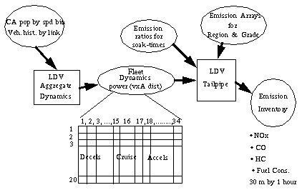
Fig. 1. This flowchart shows the process used to produce an inventory of a gridded LDV emission.
The system’s output consists of emission measurements on 30-meter segments for each one-hour period simulated. Fuel economy and CO₂ emissions are also estimated.
The emission inventory is designed to be used with EPA’s MODELS-3 to produce three-dimensional hourly gridded emissions over the metropolitan area.

LDV Tailpipe Emission Submodule
The LDV Tailpipe submodule treats tailpipe emissions from cars, small trucks, and sport-utility vehicles. The submodule covers a number of scenarios, such as the following:
- malfunctioning vehicles,
- emissions from cold starts,
- emissions from warm starts in which the engine is still warm but the catalyst is cold,
- emissions from off-cycle conditions that render the pollution controls inefficient, and
- normal driving.

There are three major sets of information that must be developed:
- What is the fleet composition?
- What is the fleet status?
- What is the fleet doing?
Once these questions are answered, the LDV Tailpipe submodule can produce the emissions.

Fleet Composition
Fleet composition is developed from vehicle registration data, inspection and maintenance testing, or data developed for the Environmental Protection Agency’s (EPA’s) mobile model runs. Barth and his colleagues have developed techniques to take registration data and produce vehicle populations in each of 23 categories. The categories include factors such as
- low or high engine-to-weight ratio,
- car or truck,
- mileage above or below 50,000,
- type of catalyst (2-way or 3-way),
- carbureted or fuel-injected, and
- high or normal emitting.
The Emissions Estimator produces an improved estimate of the proportion of high-emitting vehicles in cases in which there is a sophisticated inspection and maintenance program that tests vehicles on a dynamometer.
In this model’s current version, the vehicle distribution is used to compute the relationship among emissions and speeds and power (more precisely, velocity acceleration product) for a composite vehicle representative of the fleet in Southern California. The file arrayp.out embodies these relationships and is used in the LDV tailpipe submodule. For other locales, including Portland, mobile model input is used to calculate fleet distribution. The distribution is used to calculate arrayp.out specific to the region being modeled.

Fleet Status
Fleet status is developed from the usage pattern of vehicles traversing a given link. The Traffic Microsimulator keeps track of when and where the vehicles have been operating. Cold engines burn fuel-rich until the engine has burned enough fuel to bring the engine temperature up to normal. Similarly, the catalyst efficiency is reduced until enough fuel has been burned to bring the catalyst up to normal operating ranges. Within a given vehicle category, power demand is the principal determinant of fuel consumption.
To represent the distribution of vehicles in various warm-up stages, we gather the vehicles entering the link into groups based on:
- their integrated product of speed and acceleration since the last start of the engine, and
- the soak-time between the current operation and the end of the last trip.
In this code’s version, there is only one single soak-time, and it was based on a one-hour time between starts. Shorter soak-times (down to 10 minutes) would reduce the highest ratios of cold-to-warm emissions by approximately 10% for hydrocarbons. For NO_{x}, shorter soak-times have a greater effect, but the difference between cold and warm emissions is much less.
There are seven groupings based on velocity-acceleration product, and there is an additional grouping for engines that have been fully warmed-up—for a total of eight groups. The integrated velocity-acceleration product is in units of cells-squared per second-squared; a cell is 7.5 meters.
For each group, we assign a multiplier for each parameter: hydrocarbons, carbon monoxide, nitrogen-oxides, and fuel consumption. The multiplier represents an emissions ratio for vehicles beginning a link in the group to the emissions of a vehicle (with the same driving pattern) with a fully warmed-up engine and catalyst.
A data statement for variables hcr, cor, xnoxr, and fcr provides the ratios for hydrocarbons, carbon-monoxide, oxides of nitrogen, and fuel consumption, respectively. In each case, the first element of the array gives a soak time of 60 minutes and the lowest integrated velocity-acceleration product, whereas the last element is “one” because it represents the ratio of emissions from warmed-up vehicles to emissions of warmed-up vehicles.
To obtain these groupings and values, we took several actual trajectories in which vehicles accelerated from a near stop (less than 5 mph) at a signal and achieved typical speeds on an arterial. The original trajectories were approximately 30 seconds long and covered approximately one-quarter mile.
The ends of these trajectories were replaced with a short-deceleration to the initial speeds, then the trajectories were repeated. In this way, we obtained several trajectories, with 10 cycles of accelerating from a near stop and achieving speeds and decelerating.
The stops were selected to be approximately one-quarter mile apart. These trajectories were analyzed with the Comprehensive Modal Emission Model (CMEM) to obtain emissions for a soak-time of 60 minutes. Fig. 2 shows the hydrocarbon emissions for cold-engine relative to a fully warmed-up engine and catalyst.
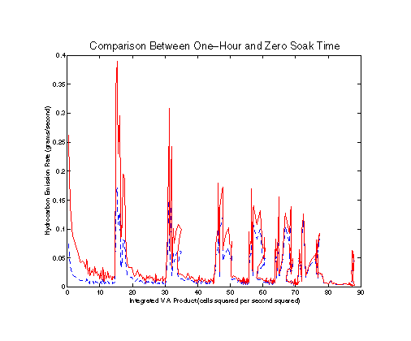
Fig. 2. Emissions from a vehicle with one hour of engine off before the trajectory compared with those from a vehicle with a warm engine and catalyst.
These results were used to construct ratios for each cycle by integrating the emissions curves from the start of one peak to the beginning of the next peak. For example, by integrating from 0 to 15, the cold-engine has approximately three times the emissions of the warm-engine. After several stop-start cycles, the ratios are lower for the other pollutants and the all-approach one. Fig. 3 reports the calculated ratios for various pollutants.

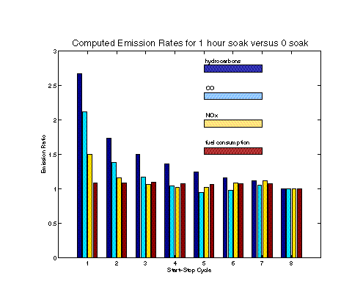
Fig. 3. Ratio of cold-engine emissions to warmed-up vehicle emissions as a function of the number of start-stop cycles since the engine was turned on.
The ratios for the eight combinations of integrated velocity-accelerator product are used to compute a multiplier that converts emissions from warmed-up vehicles into emissions for the fleet on each link.

Fleet Dynamics
To develop fleet dynamics information, we use microsimulation cellular automata (CA) populations grouped into each possible microsimulation speed (called speed bins) and grouped by 30-meter segments. One of the major challenges of appropriately modeling emissions is to account for the effects of different power-demands by different drivers.
With LDVs, there is a range of accelerations available to the driver. The driver who favors harder accelerations may put the vehicle into an “enrichment” mode. During enrichment conditions, the vehicle’s fuel controls switch to a fuel-rich situation that produces high emissions from the engine. Because the catalyst is starved for oxygen, it does not significantly reduce the emissions. Although this fuel-control logic protects the catalyst from getting too hot, it enormously increases the vehicle’s emissions.
Because the federal test procedure was designed at a time when dynamometers could not make measurements during high-power circumstances, most vehicles during the test spent little, if any, time in the enrichment mode. Thus, vehicles can pass EPA emission requirements even though they may have very high emissions on the highway.
Although enrichment episodes take place in a relatively small proportion of the time, the emissions are so much higher than normal that they can produce a significant fraction of the total emissions. Although emissions of pollutants such as NO_{X} are relatively unaffected by enrichment conditions, they nevertheless are quite sensitive to power levels.
The upshot of all this is that it is not enough to describe the power levels demanded by a typical driver. The actual range of driving behavior must be represented. Because enrichment is expected to take place only one to a few percent of the time, the range of power levels must be described for the less than one percent of the people who drive most aggressively.

Driving on Hills
For driving on hills, enrichment becomes much more frequent, with some cars going into enrichment while merely maintaining speed on uphill portions of major highways. In addition, highway speeds significantly higher than those encountered in the federal test procedure can also produce enrichment conditions. There are two options designed to address this challenge.

Option One | Construct a fast, accurate microsimulation that describes traffic and power demands in great detail.
Option Two | Supplement a fast microsimulation that describes traffic properly with empirical information on power demands.
One of the major difficulties with Option One is finding adequate information that describes the range of driving behavior in specific circumstances. There is much more information on traffic than there is on individual driving speeds and accelerations. Because of this, we have selected Option Two.

Traffic Microsimulator
We have developed a Traffic Microsimulator module that describes traffic accurately and efficiently. From the microsimulation, we know the context in which driving occurs, and we have developed a system—the LDV Aggregate Dynamics submodule—to place empirical information into context.
The Traffic Microsimulator provides vehicle populations by discrete speed bins in 30-meter segments from the start of each link in each direction. The first step is to develop a continuous distribution of speeds. We interpret the CA populations in a given segment as follows:
- The integral of a continuous distribution described by the mean value and a slope term proportional to the difference between a given speed in the speed bin and the center of the speed bin.
We have two constants to determine for each speed bin and each segment:
- The CA speed populations, which provide one equation for each speed bin.
- Continuity requirements between sped bins and the restrictions that the density must go to zero at the top of the highest speed bin.
The next question is as follows: How is the distribution of accelerations determined for a given speed in a specific segment? We use two sets of empirical data to help us solve this problem. First, during EPA’s three-city studies, many vehicles were fitted with a data-logger that recorded times and speeds throughout the vehicle’s travels for a significant period.
These data were examined to determine the frequency distribution of accelerations for a given speed. More specifically, we looked for the cumulative frequency of positive accelerations. Fig. 4 shows the cumulative frequency of vehicles traveling faster than one cell per second (7.5 m/s); these vehicles also have positive accelerations against the product of acceleration and speed.

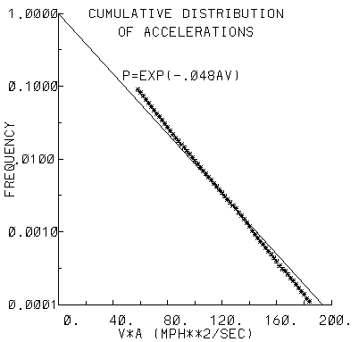
Fig. 4. The cumulative distribution of accelerations from the EPA’s three-city studies.

Power Demands
For higher power levels, the frequency of a given power level falls off exponentially with power. Similar plots can be made for speeds less than one cell per second and for decelerations. In the case of decelerations, the frequency falls off exponentially with the velocity-deceleration product.
These relationships form one of the empirical underpinnings of our approach. We consider all accelerations in one of three groups:
- high power,
- insignificant power, and
- low power.
High-power demands are defined by velocity-accelerations greater than 50 mph squared per second, which corresponds with the 10% point on the cumulative distribution. Conversely, low-power demands are defined by velocity-acceleration products less than
–50 mph squared per second.
In our approach, we begin by estimating the number of vehicles that are demanding high power. We then select 15 different power levels to represent different levels of aggressiveness. These levels are selected from the curve found in Fig. 4; they have equal spacing in power and cover a range from a cumulative frequency of 0.1 to 0.0045. The total vehicle population demanding high power from a given speed then is distributed over the 15 power (or, equivalently, acceleration) levels (in accordance with Fig. 4).
There are two circumstances in which the basic frequency-power curve is significantly different from that of Fig. 4:
- freeway on-ramp driving
- driving at the end of signalized links
In freeway on-ramp driving, the frequency falls off much slower with power. In this case, we use 90 mph squared per second as the definition of a high-power demand and –90 mph squared per second as the definition of a low-power demand. For the ends of signalized links, the curve for frequency versus the deceleration-speed product falls off much slower with negative power than it does for other circumstances.
The next issue involved is determining the fraction of vehicles that have a high-power demand in a given context. We expect that a small fraction of vehicles will be undergoing a hard acceleration, even though most have reached their desired driving speed. We can estimate this low level by looking at uncongested freeways.
We expect that a somewhat larger fraction of the vehicles will undergo hard accelerations if they are driving on a moderately congested freeway in which they are forced to decelerate (to avoid hitting other cars) then accelerate (to regain their speed). If we looked at the speeds accumulated over time of such vehicles, we would find average speeds less than the desired maximum and a range of speeds from low ones to the desired maximum.
Under these circumstances, the standard deviation of the speeds would be relatively large. In this case, we could estimate the frequency of hard accelerations by comparing moderately congested freeways with uncongested freeways.
We also would expect significant hard accelerations to take place when many of the vehicles are accelerating, and as a result, the average speed increases as they proceed along the link. For example, if we look at vehicles leaving an intersection with a stoplight, there will be vehicles going through with a green light and those accelerating from a stop caused by a red light.
To characterize the hard accelerations that result from a stoplight, the Emissions Estimator uses the product of acceleration and speed. Because acceleration is expressed as the velocity times the rate of change of velocity with distance, we require the square of the velocity times its rate of change with distance.
This term is appropriately weighted by the number of vehicles in a spatial segment that have speed v. In this context, we can estimate the fraction of accelerations that are hard by examining an arterial and looking at the vehicles leaving a stop light.

Empirical Data
The Emissions Estimator required empirical data that cover driving on uncongested freeways, moderately congested freeways, and arterials. The second empirical underpinning for our submodule comes from data collected by the California Air Resources Board.
The board’s contractor used a laser range-finder to follow cars and record their speeds under a variety of circumstances. They produced seven sets of individual car trajectories organized by congestion on freeways. They also produced three sets of trajectories that they characterized as slow, medium, and fast arterials.
To construct a two-parameter fit, the data from the fastest freeway, a moderately congested freeway, and the fast arterial were used. In the case of the arterials, the trajectories were selected so that they started (within one-second precision) from a signalized intersection. We selected transformations of the acceleration-velocity product and the standard deviation of speed to the fraction of high-power driving such that when we used the high-power fractions, we would get the same power in high-power driving that we would get by using the original trajectories.
We used a similar approach to estimate the fraction of vehicles in low-power driving. The difference between the two gives the fraction of vehicles in intermediate-power driving. By integrating the high- and low-power curves, we get the total power in low- and high-power driving. The total power in all driving can be estimated from the integrated velocity-acceleration product.
The power in intermediate-power driving is obtained by subtracting the power in high- and low-power driving from the total power. This permits us to calculate the average power in intermediate-power driving because we know (1) the total power in intermediate power, and (2) the number of vehicles demanding intermediate power.

On-ramps
In the case of on-ramps, an investigator collected speed and acceleration distributions on freeway on-ramps in California. We used these data to estimate trajectories for one of the on-ramps. We used a similar approach to the one described above to obtain the calibration constants for freeway on-ramps.
In a similar fashion, we reorganized our arterial trajectories so that all vehicles approached a signalized-intersection at the same spatial position. We used the fast arterial trajectories to obtain the calibration constants for decelerations at the end of a link. We also tested the formulation on the other arterials and on-ramps.

LDV Aggregate Dynamics Submodule
The LDV Aggregate Dynamics submodule carries out the continuous fit and computes the fraction of vehicles in each driving mode and the average power for the vehicles in the intermediate-power mode. When we compared the emissions from the other freeways and the two other arterials from the original trajectories with those obtained from our LDV Aggregate Dynamics submodule, we obtained good agreement.
The output of the LDV Aggregate Dynamics submodule consists of the number of vehicles in each 30-meter segment in each of 20 four-mph speed bins undergoing one of 34 different levels of acceleration-speed power.
The speed-acceleration levels include
- 18 high-power levels,
- one insignificant level, and
- 15 low-power levels.
This two-dimensional array is produced for each 30-meter segment of each link for each one-hour period. The power of the intermediate level is also calculated.

CMEM Model
TRANSIMS uses the CMEM model developed by Matt Barth and his colleagues at the University of California at Riverside and the University of Michigan. Barth and his co-investigators were contracted by the National Cooperative Highway Research Program to develop an improved modal emission model for LDVs.
They carried out extensive tests on more than 300 vehicles selected to represent the major types of emitters in the existing LDV fleet. They also worked with other data to help draw associations between the tested vehicles and the fleet at large.
CMEM computes the tractive power by taking account of
- engine-friction losses,
- rolling resistance,
- wind resistance,
- changes in kinetic energy,
- changes in potential energy, and
- the power necessary to drive accessories such as air conditioning.
It also estimates drivetrain efficiency. With the engine power known, CMEM calculates the rate of fuel consumption and engine-out emissions. It treats enrichment, enleanment, and stoichiometric operations, as well as cold-start operation.
Once the engine-out emissions are calculated, catalyst pass fractions are used to calculate tailpipe emissions. This approach uses a composite vehicle to represent vehicles in the same class.
A regression approach was used to define the parameters required by the model. The vehicles were all tested over cycles involving (1) very high power demands and (2) a variety of driving patterns.
The Emissions Estimator has in place composite vehicles that represent normal-emitting vehicles categorized by technology, low and high power-to-weight ratios, and mileages above or below 50,000. The technology categories are as follows:
- no catalyst,
- two-way catalyst,
- three-way catalyst with carburetor,
- three-way catalyst with fuel injection, and
- Tier 1.
Only the last two technologies are broken into mileage or power-to-weight ratio groupings. There are high-emitting composite vehicles for technologies 3 through 5, but they are not further subdivided into power-to-weight ratios or mileage groupings.
There are composite vehicles representing normal-emitting trucks with the following model year categories:
- pre-1979,
- 1979 to 1983,
- 1984 to 1987,
- 1988 to 1993, and
- 1994 and newer.
In the age groupings pre-1979, 1979 to 1983, and 1984 to 1987, there is only one single composite vehicle for each grouping. For the age grouping 1988 to 1993, there are separate composite vehicles for trucks above 3,750 pounds loaded vehicle weight and below 3,750 pounds loaded weight. For 1994 and newer vehicles, there are two composite vehicles representing vehicles with weights less than 5,750 and vehicles with weights greater than 5,750 but less than 8,500 pounds. There are also composite vehicles representing high-emitting trucks for model years 1984 to 1987, 1988 to 1993, and 1994 and newer. In the high-emitting category, there are no breakdowns by vehicle weight.
The relationships that CMEM produces between speed and acceleration (actually, speed times acceleration) are embodied in the file arrayp.out. This file gives the composite vehicle emissions for four-mph speed bins and 20-mph squared per second squared power bins.
The array was developed by using CMEM for four-second trajectories ending in the specified speed bin and power associated with the selected power bin. The array was calculated for constant power accelerations (if possible). For high power and low speeds, it is not possible to have constant power accelerations without starting speeds less than zero. Consequently, starting speeds were selected to give the best approximation to constant power with the constraint that the starting speed was greater than 0.1 mph.
In addition, we compute arrays (arraypd.out) that give the difference in emissions between constant power trajectories and those with the same speed and power, but with a step change in power over the previous second. We then estimate the fractional change in power between the second of interest and the preceding second. The emissions are obtained by multiplying the fractional power change times the emission difference for the given speed and power, then by adding the result to the emissions at constant power. This approach enables us to address history effects.
The model does not currently treat grade effects, although that is a feature that will be included in future versions. CMEM does have grade effects: recomputing arrayp.out and arraypd.out, with the average grade for the link would give an approximation of grade effects.

Algorithms
The first step in estimating the velocity-acceleration distribution is to make a continuous fit to the densities (number of vehicles per unit speed and per unit space). A simple fit that is of the following form:
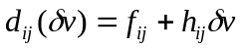
where
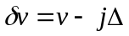and i represents the spatial cell and j represents the speed bin (with Δ being the cell width, 7.5 meters or 7.5 meters per second for the speed bins).
The constant term f_{ij} is given by the following:
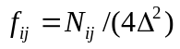
where the length of the box is 4Δ and the width in velocity space is Δ. The gradients slope terms (h_{ij}) are found by setting d_{ij} to zero at the top of the highest speed bin and solving for h_{ij}. Continuity relationships are used to determine the h_{ij}’s for the slower speed bins. However, this procedure may lead to negative densities over a portion of a speed bin.
This problem is solved in one of two ways:
- If the negative value takes place in the slowest of the speed bins that have vehicles, the density relationship is assumed to hold down to a value of δv denoted δvi, where the density falls to zero and remains there. In other words, in the slowest, populated speed-bin, the distribution extends from δv=(Δ/2) to δv=δv_{I} rather than to δv=-Δ/2.
- The second situation takes place where the potential negative values occur in an intermediate speed-bin. In this case, the continuity condition at the speed-bin boundaries is relaxed and h_{ij} is set to zero.
Once the densities are known, the various moments of speed are calculated. Specifically, the following are calculated: the zeroth-moment (average density), first moment (flux), second moment (needed for speed variance), and the third moment whose gradient is related to power.

The flux is divided into thirds and used to calculate the breakpoints between the slowest one-third (j=n13 and δv=δv_{l}), the middle one-third, and the fastest one-third (j=n23 and δv=δv_{h}). Once the breakpoints are determined, the third-moments of speed are calculated for each third of the flux. The probability of a hard-acceleration is then estimated from the following:
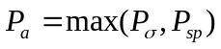
with
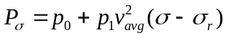

where σ is the standard deviation of speed, v_{avg} is the average speed, and σ_{r} is the standard deviation of speed for an uncongested freeway.

The calibration constants p₀ and p₁ are determined separately for each third of the flux (slowest, intermediate, and fastest), but the standard deviation and the average speed refer to the entire vehicle flow in the segment. The foregoing treatment associated with the standard deviation of speed dominates when the average speed along the link does not change or is changing very slowly.

When there are significant speed changes along the link, the second component, P_{sp}, is given by
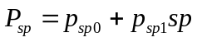
with the speed gradient parameter, which in turn is defined by
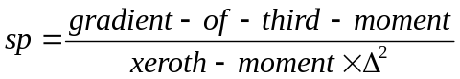
dominates. In this case, the moments and the calibration constants are calculated for each third of the flux. The calibration constants were selected based on maximum gradients for vehicles leaving a signal on a fast arterial.
The calibration constants were determined from a power-balance (for each third of the vehicles: slowest, middle, and fastest), for high and low power. Regression relationships were developed of the following form:
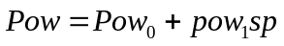
or, in the case of situations where |sp| is small, the form was as follows:
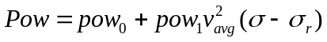
The powers (Pow) refer to the continuous trajectories and are calculated on a per-trajectory basis. In our formulation, a single trajectory produces a flux of one-cell per second (or 16.7 mph). Consequently, the power for a given segment is given by the flux for that segment divided by 16.7 mph. The power of vehicles in the high-power mode is as follows:
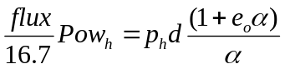 ,
where α is the exponent in cumulative distribution for power, e_{o} is the threshold for high-power driving, and d is the density of vehicles in the segment and the third of the vehicles under consideration.
With Pow_{h} provided by the regression relations, we can solve for P_{h}. We also can calculate the total power for each third of the vehicle flux as follows:
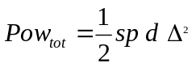
The average power of the intermediate driving is then estimated as follows:
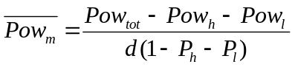
The code also accounts for vehicles that do not reach the end of link. We assumed that these vehicles fall into the slowest third of the vehicles. Before the gradient is calculated, we add sufficient flux among the slowest third of the vehicles in the segment upstream (of the segment under concern). This procedure requires that the cutoff points between the various thirds of the flux be recalculated for the downstream segment. The underlying assumption for this procedure is that the flux should be approximately constant if all vehicles complete the link.
We estimate the fractional change in power as follows:
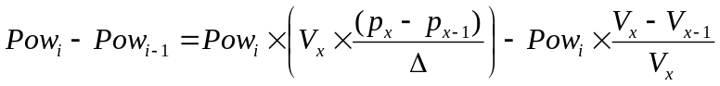
This expression is developed from the relation between the power (Pow) and the probability of a high-power event (P), whereas the subscript i refers to time and the subscript x refers to position.

Scripts
TRANSIMS uses three scripts to construct the emission arrays. The first script produces the file arrayp.out. This script constructs input files for cmemCore from sample input for cmemCore; the files are test-ctr and test-act.
The new file batch-ctr provides the vehicle type and the soak time to cmemCore; it could also provide auxiliary power loads and changes in the vehicle parameters (if desired). The new file batch-act provides second-by-second speeds and grades for a four-second trajectory.
The third second of the trajectory is calculated for the desired power level and ending speed. The speeds for the preceding seconds are derived from a constant power-level assumption. If this leads to unrealistically low speeds, we use a value of 0.1 mph. The script runs cmemCore with the following command:
cmemCore batch> cntr.out .
One of the output files from cmemCore is batch-sbs, which gives second-by-second emissions and fuel consumption. The script extracts the results from the third second of the trajectory and stores them in the file batch.out. There are three loops within the script:
- the outermost is on the vehicle type,
- the intermediate loop is on power (or more precisely, the product of speed and acceleration), and
- the innermost loop is on speed.
With iv the speed index and ia the power index, the speeds for each second of the trajectory are calculated as follows:
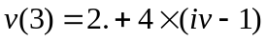

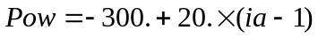

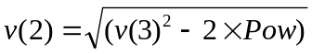

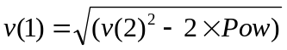

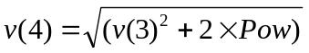

The file batch.out, which is renamed as batchtotpc, then contains the emissions for
- constant power with each line giving the speed,
- acceleration (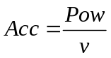),
- hydrocarbon emissions,
- CO emissions,
- NO_{x} emissions,
- fuel consumption, and
- vehicle type.
The file arrayp.out is constructed by weighting the vehicle-type-specific emissions by the fraction of vehicles of that type in the fleet and summing over all vehicle types.
In a similar fashion, the file batchtotpj is constructed, which gives the emissions by vehicle type when there is a step change in power between the second and the third seconds. The preceding equations apply, except that the speed for the first second is given by the following:
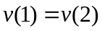
The resulting file batch.out is renamed batchtotpj. Another script takes the difference in emissions and fuel consumption between those in batchtotpj and those in batchtotpc and stores the results in the same format in a new file called batchtotpd. When weighted by vehicle type fraction and summed over all vehicle types, the result is the file arraypd.out.

Usage

Overview
Much like EPA’s MODELS-3, the TRANSIMS Emissions Estimator is designed to produce emissions appropriate for simulations of air quality over a metropolitan area. It does not produce intersection emissions in this version.
It is designed to produce fleet average emissions rather than emissions from individual vehicles. It uses continuous approximations for densities, and thus requires that many vehicles be considered over at least a one-hour period in order for appropriate statistics to be developed.

Version Notes
In this version (TRANSIMS 1.1), the Emissions Estimator does not consider grades. In future versions, grades will be treated by producing versions of the input file arrayp.out appropriate to the link under consideration.
The current version of the model considers only one category of soak-time. Future versions will consider three representative soak-times.
There are a number of assumptions in the current version of the code:
- The number of 30-meter segments on a link populated with vehicles must be at least three—all of which must have vehicles.
- There can be empty cells before and after a set of populated ones, but there must not be any unpopulated segments interspersed with populated ones.
- The speed histograms should be constructed from one-second sampling, summed over one hour or more. The direction of travel on the links is important.

Emissions Estimator Major Input/Output

Overview
Fig. 5 summarizes the data flow of the Emissions Estimator. The Emissions Estimator requires information on the fleet composition, which is developed from the Population Synthesizer, vehicle loads, and traffic patterns. The Population Synthesizer provides vehicle fleet characteristics, including the fraction of the fleet that is malfunctioning. The Traffic Microsimulator produces the traffic patterns.

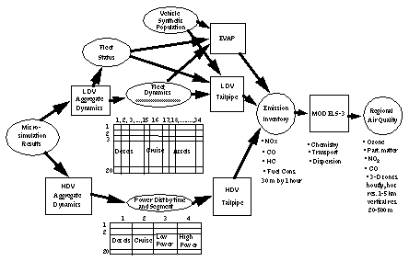

Fig. 5. The Emissions Estimator data flow.
The Traffic Microsimulator produces the bulk of the information required by the Emissions Estimator. The following items are included in this category:
- spatial summaries of vehicle velocities over 30-meter sections of roadway,
- histograms of the number of vehicles entering a link grouped by velocity-acceleration product summed over time since the vehicles were parked.
Emissions Estimator output data is aggregated on 30-meter segments for each simulated one-hour period. Fuel economy and CO₂ emissions are also estimated. The emission inventory is designed to be used with the MODELS-3 code, which was developed by the EPA to produce three-dimensional, hourly, gridded emissions values over the metropolitan area. Appendix A lists the TRANSIMS configuration file keys specific to the Emissions Estimator.
Appendix B lists the TRANSIMS configuration file keys that must be set to a specific value for the Emissions Estimator to calculate emissions correctly.

Emissions Estimator Files
The TRANSIMS Emission Estimator module calculates emissions in 30-meter segments along a link for selected time periods (normally 1 hour). It gives estimates of tailpipe emissions of nitrogen oxides (NO_{x}), carbon monoxide (CO), and hydrocarbons from LDVs. It also gives fuel-consumption that can be used to calculate emissions of carbon dioxide (CO₂).

File Format
This section describes file formats for each of the six input files for the LDV Tailpipe submodule and the three output files that it produces. The file names are defined in the code but may be changed by using the Emissions Estimator configuration file keys.

velocity.out
The file velocity.out contains the link velocity summary data produced by the Traffic Microsimulator and reformatted for input into the Emissions Estimator. The transformation is performed by using the ConvertVELfile program. This file is an input file for the LDV Tailpipe submodule.
The first six items described in Appendix C (NV through DISTANCE2) appear in a single record, followed by NV records containing the six COUNT fields in order of each record. This sequence is repeated for each LINK, NODE, and TIME step in the original file.

ARRAYP.INP
The file ARRAYP.INP is used in conjunction with arrayp.out and contains parameters describing the number of records and increments used in arrayp.out. Several fields are unused by the Light-Duty Tailpipe submodule. Appendix D-1 provides these fields.

arrayp.out and arraypd.out
The file arrayp.out gives composite vehicle emissions in 4-mph speed bins and 20-mph squared per second power bins. The file arraypd.out gives the difference in emissions between constant power trajectories and those with the same speed and power but with a step change in power. The files are input files for the LDV Tailpipe submodule. The data in this file are for cases in which there are no grades in the roadway. The first two lines of the files contain header information that is ignored. Only the data fields are described in Appendix D-2.

vehcold.dis
The file vehcold.dis is an input file for the LDV Tailpipe submodule. It contains the distribution of vehicles entering the link, stratified by the time-integrated, velocity-acceleration product and by the time the engine was idle before the start of the current trip.
Note that negative accelerations are ignored in the calculation of the time-integrated, velocity-acceleration products. This distribution is used to determine which cold/warm emission ratios should be used. Appendix E lists fields used in this file.

vehdist
The file vehdist contains the distribution of the 23 light-duty vehicle subtypes.
Appendix F lists fields in the vehicle type distribution file.

debug.out
An output file produced by the LDV Tailpipe submodule, debug.out is a debugging file that provides intermediate output for the emission calculations.
Appendix G provides fields for this program. Appendix H provides fields in the calcsum debugging output file.

emissions.out
The file emissions.out is an output file produced by the LDV Tailpipe submodule. This file is written using the variable-size box format and is ready to be visualized with the Output Visualizer. Each record contains the five fields required by this format plus six data values (as described in Appendix I-1).

Utility Programs

ConvertVELfile
The ConvertVELfile program transforms the link-velocity summary output into the format required by the emissions module. The link is partitioned into boxes of a constant size, except that the last box on the link may be shorter than the others.
The ConvertVELfile program proportionally inflates the values for the last box to what might be expected if the box were full sized.
Note that ConvertVELfile includes some assumptions that are more restrictive than the generality in the output available from the Traffic Microsimulator. For example, the program assumes that the boxes that partition the link are 30-meters long; a value other than 30 for the microsimulation parameter OUT_SUMMARY_BOX_LENGTH used when collecting velocity data will result in velocity summary data that cannot be correctly processed by ConvertVELfile.
The ConvertVELfile program assumes that exactly six velocity histogram bins are defined. The simulation needs to be run with the configuration file key OUT_SUMMARY_VELOCITY_BINS set to “5” in order for this to be accomplished. An overflow bin will be created automatically.

Files
Appendix J provides library files for the Output Visualizer. Appendix K provides examples that used the calibration 2 network, which is the intersection calibration network. Fig. 6 through Fig. 11 show examples of emission visualizations calculated for the intersection calibration network.

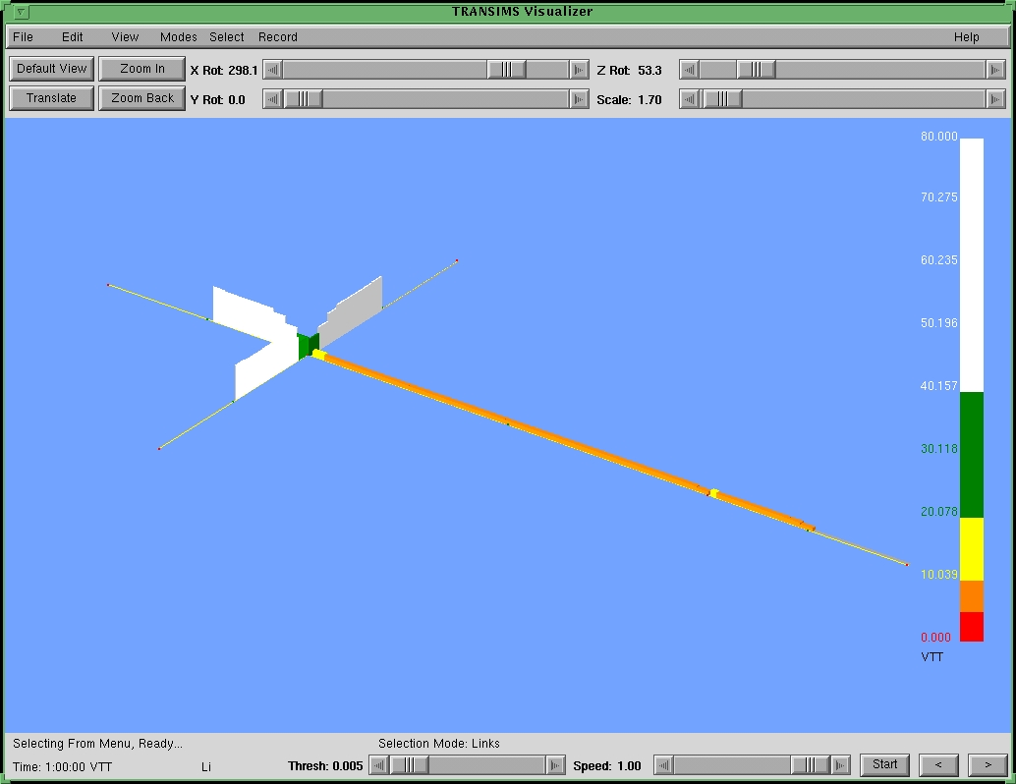
Fig. 6. This graphic depicts velocities.

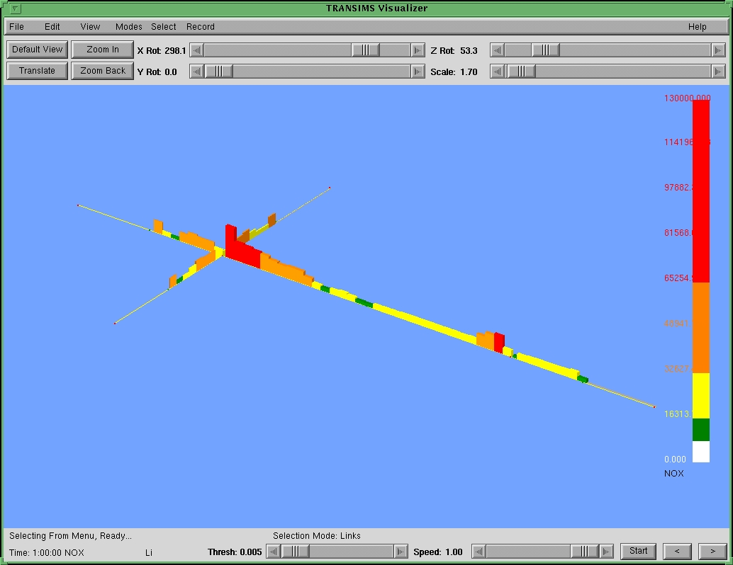
Fig. 7. This graphic depicts NO_{x} (nitrogen oxides) emissions.

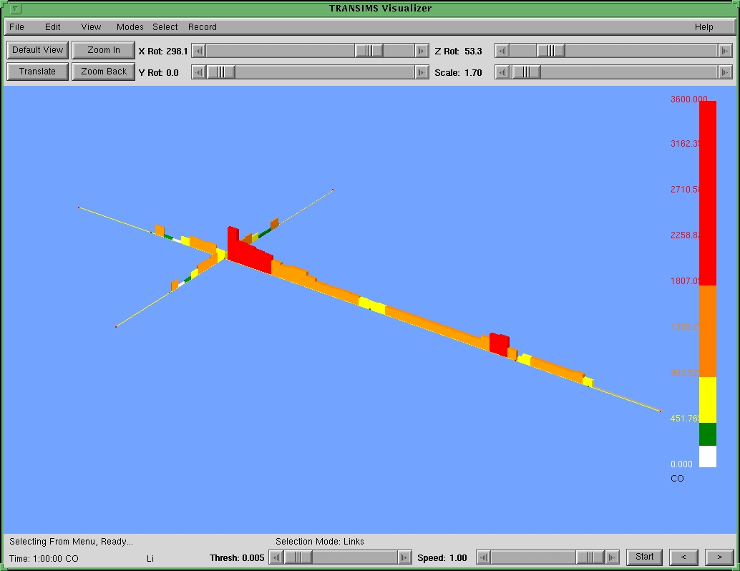
Fig. 8. This graphic depicts CO (carbon monoxide) emissions.

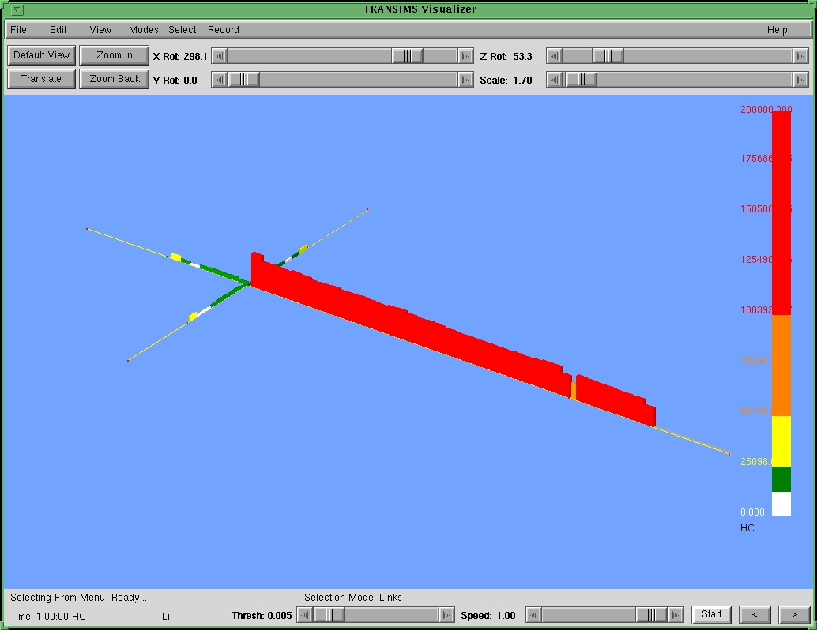
Fig. 9. This graphic depicts HC (hydrocarbon) emissions.

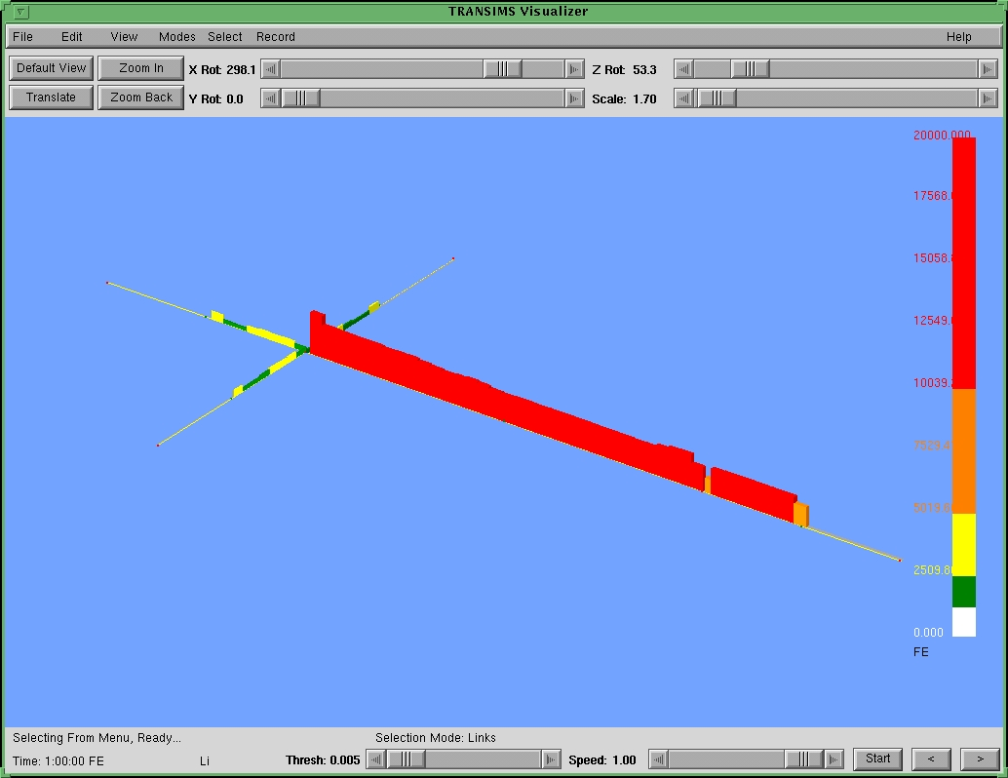
Fig. 10. This graphic depicts FE (fuel consumption).

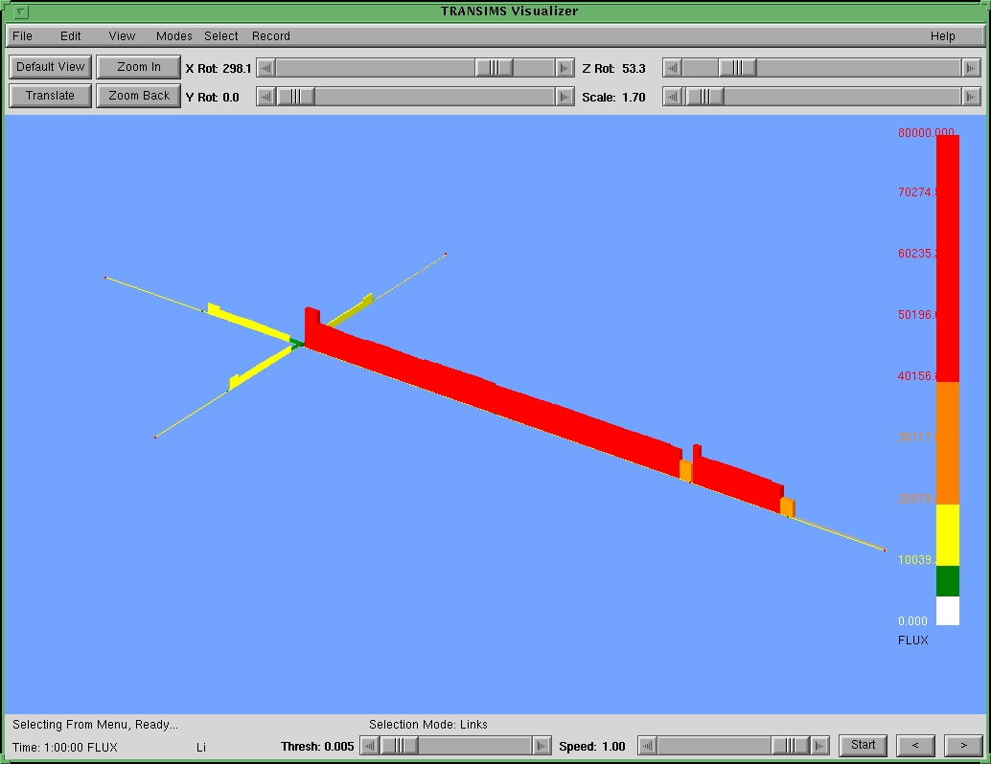
Fig. 11. This graphic depicts FLUX (vehicle flux).

Appendix A: Configuration File Keys Specific to the Emissions Estimator

Configuration File Key | Description
EMISSIONS_ARRAY_PARAMETERS_FILE | Contains the parameters describing the number of records and increments used in composite input files.  Default = ARRAYP.INP
EMISSIONS_COMPOSITE_DIFF_INPUT_FILE | Contains the composite emissions for the differences in emissions and fuel consumption for current versus last timestep. Default = arraypd.out
EMISSIONS_COMPOSITE_INPUT_FILE | Composite vehicle emissions in  4-mph speed bins and 20-mph squared per second power bins.  Default = arrayp.out
EMISSIONS_COMPOSITE_TYPE_DIFF_INPUT_FILE | Composite emissions for the difference in emissions and fuel consumption versus last timestep for 23 LDV subtypes.  Default = batchtotpd
EMISSIONS_COMPOSITE_TYPE_INPUT_FILE | Composite emissions for 20 speeds, 34 power levels, and 23 LDV types.  Default = batchtotpc
EMISSIONS_MICROSIM_VELOCITY_FILE | File name for the readca.out file (produced by Readca), which contains the reformatted microsimulation velocity summary data.
EMISSIONS_VEHICLE_COLD_DISTRIBUTION | Contains the distribution of LDVs entering a link stratified by the time-integrated, velocity-acceleration product (power) and by soak time.  Default = vehcold.dis
EMISSIONS_VEHICLE_TYPE_DISTRIBUTION | Contains distributions by 23 LDV types. Default = vehdist
EMISSIONS_WRITE_DEBUG_OUTPUT | If this flag is set, the debugging files (debug.out and calcsum) will be written out. Default = 0 (do not write out debugging files)

Appendix B: Configuration File Keys That Must Be Set to a Specific Value for the Emissions Estimator

Configuration File Key | Description
NET_DIRECTORY | Full path name to directory containing the network tables.
NET_LINK_TABLE | Name of the link table.
NET_NODE_TABLE | Name of network’s node table.
OUT_SUMMARY_BOX_LENGTH_n  or  OUT_SUMMARY_BOX_LENGTH_DEFAULT | Length of the summary boxes (in meters). Must be set to 30.
OUT_SUMMARY_ENERGY_BINS_n  or  OUT_SUMMARY_ENERGY_BINS_DEFAULT | Number of bins to cover range of energy histogram.  Must be set to 7.
OUT_SUMMARY_ENERGY_MAX_n  or  OUT_SUMMARY_ENERGY_MAX_DEFAULT | Maximum energy for range of energies found in energy histograms.  Must be set to 105.
OUT_SUMMARY_SAMPLE_TIME_n  or  OUT_SUMMARY_SAMPLE_TIME_DEFAULT | Frequency (in seconds) at which to accumulate data. Must be set to 1.
OUT_SUMMARY_TIME_STEP_n  or  OUT_SUMMARY_TIME_STEP_DEFAULT | Frequency (in seconds) at which to report data. Must be set to 3600.
OUT_SUMMARY_TYPE_n | Type of summary output to collect.  Must be set to at lease VELOCITY.
OUT_SUMMARY_VELOCITY_BINS_n  or  OUT_SUMMARY_VELOCITY_BINS_DEFAULT | Number of bins used to cover the range of the velocity histogram.  Must be set to 5.
OUT_SUMMARY_VELOCITY_MAX_n  or  OUT_SUMMARY_VELOCITY_MAX_DEFAULT | Maximum velocity for range of velocities found in velocity histograms. Must be set to 37.5.

Appendix C: Link velocity fields in velocity.out (assuming the microsimulation was running with OUT_SUMMARY_VELOCITY_BINS set to 5)

Field | Description
NV | Number of velocity records for this link, equivalent to the number of boxes that partition the link.
TIME | Current time (seconds from midnight).
LINK | Link ID being reported.
NODE | Node ID from which the vehicles were traveling away.
DISTANCE1 | Ending distance, from the setback of the node from which vehicles were traveling away, of the 1st box with data in it).
DISTANCE2 | Ending distance, from the setback of the node from which vehicles were traveling away, of the last box with data in it.
COUNT0 | Number of vehicles with velocities in the range [0, 7.5).
COUNT1 | Number of vehicles with velocities in the range [7.5, 15).
COUNT2 | Number of vehicles with velocities in the range [15, 22.5).
COUNT3 | Number of vehicles with velocities in the range [22.5, 30).
COUNT4 | Number of vehicles with velocities in the range [30, 37.5).
COUNT5 | Number of vehicles with velocities in the range [37.5, infinity).

Appendix D-1: Fields in the array parameters file

Field | Description
T0 | Time since engine start; not used.
RGRADE0 | Representative minimum grade; not used.
DRGRADE | Spacing in grade arrays; not used.
V0ARRAY | Representative speed for the lowest speed index (mph); not used.
DVARRAY | Speed bin size (mph).
A0ARRAY | Representative power for the lowest power index (mph squared per sec).
DACCARAY | Acceleration bin size (mph**2/sec).
NGRADE | Number of grades in the emission arrays; not used.
NVARRY | Number of velocity bins in the emission arrays.
NAARRAY | Number of power bins in the emission arrays.

Appendix D-2: Fields in the four composite files

Field | Description
VARRAY | Representative speed (mph) for emissions calculation; not used.
ACARRAY | Representative acceleration for emissions calculation; not used.
HCTIJK | Hydrocarbon tailpipe emission rate (grams/sec).
COTIJK | Carbon monoxide tailpipe emission rate (grams/sec).
NOXTIJK | Nitrogen oxides tailpipe emission rate (grams/sec).
FECON | Fuel consumption rate (grams/sec).

Appendix E: Fields in the vehicle cold distribution file.

Field | Description
VCOLD1 | Fraction of the vehicles entering the link that have had time-integrated, velocity-acceleration products in the range of 0-18 cells squared per second squared after being idle for an hour or more. Eighteen cells squared per second cubed is the typical amount for a vehicle to accelerate to speed on an arterial from a stop; a cell is 7.5 meters.
VCOLD2 | Fraction of the vehicles entering the link that have had time-integrated, velocity-acceleration products in the range of 19-36 cells squared per second squared after being idle for an hour or more.
VCOLD3 | Fraction of the vehicles entering the link that have had time-integrated, velocity-acceleration products in the range of 37-54 cells squared per second squared after being idle for an hour or more.
VCOLD4 | Fraction of the vehicles entering the link that have had time-integrated, velocity-acceleration products in the range of 55-72 cells squared per second squared after being idle for an hour or more.
VCOLD5 | Fraction of the vehicles entering the link that have had time-integrated, velocity-acceleration products in the range of 73-90 cells squared per second squared after being idle for an hour or more.
VCOLD6 | Fraction of the vehicles entering the link that have had time-integrated, velocity-acceleration products in the range of 91-108 cells squared per second squared after being idle for an hour or more.
VCOLD7 | Fraction of the vehicles entering the link that have had time-integrated, velocity-acceleration products in the range of 109-126 cells squared per second squared after being idle for an hour or more.
VCOLD8 | Fraction of the vehicles entering the link that have had time-integrated, velocity-acceleration products greater than 126 cells squared per second squared after being idle for an hour or more or were idle for less than one hour.

Appendix F: Fields in vehicle type distribution file

Field | Description
FRACTION1 | Fraction of LDVs of subtype 1.
FRACTION2 | Fraction of LDVs of subtype 2.
FRACTION3 | Fraction of LDVs of subtype 3.
FRACTION4 | Fraction of LDVs of subtype 4.
FRACTION5 | Fraction of LDVs of subtype 5.
FRACTION6 | Fraction of LDVs of subtype 6.
FRACTION7 | Fraction of LDVs of subtype 7.
FRACTION8 | Fraction of LDVs of subtype 8.
FRACTION9 | Fraction of LDVs of subtype 9.
FRACTION10 | Fraction of LDVs of subtype 10.
FRACTION11 | Fraction of LDVs of subtype 11.
FRACTION12 | Fraction of LDVs of subtype 12.
FRACTION13 | Fraction of LDVs of subtype 13.
FRACTION14 | Fraction of LDVs of subtype 14.
FRACTION15 | Fraction of LDVs of subtype 15.
FRACTION16 | Fraction of LDVs of subtype 16.
FRACTION17 | Fraction of LDVs of subtype 17.
FRACTION18 | Fraction of LDVs of subtype 18.
FRACTION19 | Fraction of LDVs of subtype 19.
FRACTION20 | Fraction of LDVs of subtype 20.
FRACTION21 | Fraction of LDVs of subtype 21.
FRACTION22 | Fraction of LDVs of subtype 22.
FRACTION23 | Fraction of LDVs of subtype 23.

Appendix G: Fields in debug.out output file

Field |  | Description
ICX | Segment of which the calculations are made.
DELTAF | Width of the highest speed bin (always 24.6 feet per second).
COUNTS | Number of vehicles at different velocities for this segment.
DEN | Fitted average number of vehicles per 7.5-meter cell.
FIJ | Estimated average vehicle densities per spatial cell (24.6 feet) and per speed cell (24.6 feet per second).
HIJ | Gradient in estimated average vehicle density in units of number per spatial cell squared per speed cell.
VEHFLUX | Estimated vehicle flux in each speed bin for speed bins 0-5 in units of number times feet per second.
VEHFT | Total estimated vehicle flux in speed bins per cell.
VEHD | Estimated number of vehicles in each speed bin in each cell
VEHDT | Estimated total number of vehicles in a spatial cell.
VBAR | Estimated mean speed in feet per second.
SDEVRAT | Estimated ratio of the standard deviation of speed to mean speed.
VLOWRI | Cutoff speed for the slowest one-third of the vehicles defined by flux in feet per second.
VUPPRI | Cutoff speed for the slowest two-thirds of the vehicles defined by flux in feet per second.
V2SDEV | Product of the square of the mean speed and the difference between the speed standard deviation and its low-congestion reference value in units of feet cubed per second cubed.
VEHFLUXL | Estimated vehicle flux for the slowest third of the vehicles for the current segment, followed by that of the next four segments down the link.
VEHFLUXM | Estimated vehicle flux for the middle third of the vehicles for the current segment, followed by that of the next four segments down the link.
VEHFLUXH | Estimated vehicle flux for the fastest third of the vehicles for the current segment, followed by that of the next four segments down the link.
VCUBEDL | Estimated average cube of the velocity in units of feet cubed per second cubed for the slowest third of the vehicle for the current segment followed by that of four following segments down the link.
VCUBEDM | Estimated average cube of the velocity in units of feet cubed per second cubed for the middle third of the vehicle for the current segment followed by that of four following segments down the link.
VCUBEDH | Estimated average cube of the velocity in units of feet cubed per second cubed for the fastest third of the vehicle for the current segment followed by that of four following segments down the link.
VCUBEDLN | The adjusted third moment of the velocity distribution for the slowest third of the flux.
VCUBEDMN | The adjusted third moment of the velocity distribution for the middle third of the flux.
VCUBEDHN | The adjusted third moment of the velocity distribution for the fastest third of the flux.
SPDC | Estimated gradient in the cube of the speed normalized by the cube of a spatial cell per second (24.6**3) in units of inverse feet.
IREF | The distance index for the higher fluxes.
ITAR | The distance index for the lower fluxes.
PIJ | First three values give the probability of a hard acceleration for the slowest third, the middle third, and the fastest third of the vehicles for the segment, while the 7th through the 9th give the probability for insignificant accelerations for the slowest, middle, and fastest thirds respectively. Currently, hard decelerations are not included, they would occupy the 13th through 15th slots.
PDL | The fraction of the vehicles in the slowest third of the flux that undergo a hard deceleration.
PL | Probability of a hard acceleration in the slowest third.
PNS | The fraction of vehicles in the third under consideration that have insignificant acceleration or deceleration.
PTOTFL | Total power in the third that is under consideration.
PTOTMI | Power in the hard-decelerating vehicles in the third under consideration.
PTOTPP | Power in the high-power vehicles in the third under consideration.
PPNS | The average power of vehicles in the insignificant power category.
PDC | The fraction of vehicles in the middle third of the flux that undergo a hard deceleration.
PCC | Probability of a hard acceleration in the middle third.
PDH | The fraction of vehicles in the fastest third of the flux that undergo a hard deceleration.
PH | Probability of a hard acceleration in the fastest third.
ICX | Segment for which the output is reported.
XNOSUL | Estimated NO_{x} emissions for the slowest third in units of grams per 7.5-meter cell.
XNOSUC | Estimated NO_{x} emissions for the middle third in units of grams per 7.5-meter cell.
XNOSUH | Estimated NO_{x} emissions for the fastest third in units of grams per 7.5-meter cell.
COSUL | Estimated CO emissions for the slowest third in units of grams per 7.5-meter cell.
COSUC | Estimated CO emissions for the middle third in units of grams per 7.5-meter cell.
COSUH | Estimated CO emissions for the fastest third in units of grams per 7.5-meter cell.
V2SDEV | Product of the square of the mean speed and the difference between the speed standard deviation and its low congestion reference value in units of feet cubed per second cubed.
SDEV | Standard deviation of speed derived from the estimated distribution.
PL | Probability of a hard acceleration in the slowest third; unlike the earlier reference, this includes an adjustment if the slowest one-third is in the first speed bin.
PCC | Probability of a hard acceleration in the middle third; unlike the earlier reference, this includes an adjustment if the middle one-third is in the first speed bin.
PH | Probability of a hard acceleration in the fastest third; unlike the earlier reference, this includes an adjustment if the fastest one-third is in the first speed bin.

Appendix H: Fields in calcsum debugging output file

Field | Description
ICX | Segment for which output is reported.
DSUMLF | Power of hard-decelerating vehicles in the slowest third of the flux.
ZSUMLF | Power of insignificant-power vehicles in the slowest third of the flux.
ASUMLF | Power of high-power vehicles in the slowest third of the flux.
DSUMCF | Power of hard-decelerating vehicles in the middle third of the flux.
ZSUMCF | Power of insignificant-power vehicles in the middle third of the flux.
ASUMCF | Power of the high-power vehicles in the middle third of the flux.
DSUMHF | Power of the hard-decelerating vehicles in the fastest third of the flux.
ZSUMHF | Power of the insignificant-power vehicles in the fastest third of the flux.
ASUMHF | Power of the high-power vehicles in the fastest third of the flux.
PDL | The fraction of the vehicles in the slowest third of the flux that undergo a hard deceleration.
PL | Probability of a hard acceleration in the slowest third.
PDC | The fraction of vehicles in the middle third of the flux that undergo a hard deceleration.
PCC | Probability of a hard acceleration in the middle third.
PDH | The fraction of vehicles in the fastest third of the flux that undergo a hard deceleration.
PH | Probability of a hard acceleration in the fastest third.
V2SDEV | Product of the square of the mean speed and the difference between the speed standard deviation and its low congestion reference value in units of feet cubed per second cubed.
SPDCL | Speed parameter (spdc) for the slowest third of the flux.
SPDCM | Speed parameter (spdc) for the middle third of the flux.
SPDCH | Speed parameter (spdc) for the fastest third of the flux.
SDEV | Standard deviation for speed derived from estimated distribution.
VEHDL | Average density for slowest one-third of vehicles per 7.5-meter cell.
VEHDM | Average density for middle one-third of vehicles per 7.5-meter cell.
VEHDH | Average density for fastest one-third of vehicles per 7.5-meter cell.
SPDCT | Speed parameter (spdc) for the entire flux.

Appendix I-1: Emissions output for Output Visualizer

Field | Description
TIME | Current time (seconds from midnight).
LINK | Link ID being reported.
NODE | Node ID vehicles were traveling away from.
DISTANCE | Ending distance of the box (in meters) from the setback of the node from which the vehicles were traveling away.
LENGTH | Length of box.
VTT | Average speed in feet per second.
NOX | Nitrogen oxides emissions (milligrams per 30-meter segment).
CO | Carbon monoxide emissions (grams per 30-meter segment).
HC | Hydrocarbon emissions (milligrams per 30-meter segment).
FE | Fuel consumption (grams per 30-meter segment).
FLUX | Vehicle flux in number times speed in feet per second.

Appendix I-2: Fields in Traveler Event postprocessed file (traveler.out)

Field | Description
VEHICLE | Vehicle ID of vehicle for this record.
START-PA | Parking location ID in which vehicle started this particular trip from.
START-TIME | Time (in seconds since midnight) the vehicle began this particular trip at the START-PA (-1 if the vehicle started before the simulation start-time).
END-PA | Parking location ID in which the vehicle ended this particular trip (-1 if simulation ended before the trip ended).
END-TIME | Time (in seconds since midnight) the vehicle ended this particular trip at the END-PA (-1 if simulation ended before the trip ended).
VEHSEC | The number of seconds the vehicle spent on this particular trip (END-TIME–START-TIME) [-1 if trip began before simulation start-time or if simulation ended before the trip ended).

Appendix J: Emissions Estimator library files

Type | File Name | Description
Binary Files | libTIO.a | TRANSIMS Interfaces library
 | libGlobals.a | TRANSIMS Global library.
 | LibNetwork.a | TRANSIMS Network library.
Source Files | emissionsEstimator.C | Main emissions module that takes microsimulation velocity summary data and outputs emissions that can be displayed in the Output Visualizer.
 | ENVConfigKeys.h | Defines emissions configuration file keys.
 | convertVELfile.C | Reads in a microsimulation velocity summary output file and outputs the velocity data in a format that can be inputted to the main emissions module.
 | convertENRfile.C | Reads in a microsimulation energy file and converts the counts into ratios.
 | convertTRVfile.C | Reads in a microsimulation traveler event file and creates an output file (used in the evaporative emissions module) that contains individual vehicle trip start and stop locations and time information.
 | CreateComposites.C | Application used to convert the composite arrays by vehicle subtype into composite arrays with only on vehicle type.  batchtotpc → arrayp.out  batchtotpd → arraypd.out

Appendix K: Examples

Example 1 presents some of the configuration parameters that pertain to the Emissions Estimator.
Example 1. Configuration parameters.
PLAN_FILE $TRANSIMS_ROOT/data/calibration/tee/data/plans
VEHICLE_FILE $TRANSIMS_ROOT/data/calibration/tee/data/vehicles

OUT_DIRECTORY $TRANSIMS_ROOT/data/calibration/tee/output
OUT_SUMMARY_NAME_1 tee.sum
OUT_SUMMARY_LINKS_1 $TRANSIMS_ROOT/data/calibration/tee/data/output_links
OUT_SUMMARY_BOX_LENGTH_1 30
OUT_SUMMARY_TYPE_1 VELOCITY
OUT_SUMMARY_SAMPLE_TIME_1 1
OUT_SUMMARY_TIME_STEP_1 3600
OUT_SUMMARY_VELOCITY_BINS_1 5
OUT_SUMMARY_VELOCITY_MAX_1 37.5
OUT_SUMMARY_ENERGY_BINS_1 7
OUT_SUMMARY_ENERGY_MAX_1 105

NET_DIRECTORY $TRANSIMS_ROOT/data/calibration/tee/network
NET_NODE_TABLE Calibration_2_Nodes
NET_LINK_TABLE Calibration_2_Links

EMISSIONS_ARRAY_PARAMETERS_FILE $TRANSIMS_ROOT/data/emissions/ARRAYP.INP
EMISSIONS_COMPOSITE_INPUT_FILE $TRANSIMS_ROOT/data/emissions/arrayp.out
EMISSIONS_COMPOSITE_DIFF_INPUT_FILE $TRANSIMS_ROOT/data/emissions/arraypd.out
EMISSIONS_COMPOSITE_TYPE_INPUT_FILE $TRANSIMS_ROOT/data/emissions/batchtotpc
EMISSIONS_COMPOSITE_TYPE_DIFF_INPUT_FILE $TRANSIMS_ROOT/data/emissions/batchtotpd
EMISSIONS_VEHICLE_TYPE_DISTRIBUTION $TRANSIMS_ROOT/data/emissions/vehhist
EMISSIONS_VEHICLE_COLD_DISTRIBUTION $TRANSIMS_ROOT/data/emissions/vehcold.dis
EMISSIONS_MICROSIM_VELOCITY_FILE $TRANSIMS_ROOT/data/calibration/tee/output/velocity.out

Example 2 shows a portion of a microsimulation velocity summary file. These data were collected on the intersection calibration network by using the configuration parameters set to the values in Example 2. The data consist of the velocity bins for link 1, starting at node 6 at time step 3600. There are seventeen boxes on that particular link, seven of which are never entered. Notice that the last box is only 15 meters long instead of 30 meters.
Example 2. Velocity summary file outputted from the Traffic Microsimulator.
COUNT0 | COUNT1 | COUNT2 | COUNT3 | COUNT4 | COUNT5 | DISTANCE | LINK | NODE | TIME
0 | 0 | 0 | 0 | 0 | 0 | 30 | 1 | 6 | 3600
0 | 0 | 0 | 0 | 0 | 0 | 60 | 1 | 6 | 3600
0 | 0 | 0 | 0 | 0 | 0 | 90 | 1 | 6 | 3600
0 | 0 | 0 | 0 | 0 | 0 | 120 | 1 | 6 | 3600
0 | 0 | 0 | 0 | 0 | 0 | 150 | 1 | 1 | 3600
0 | 0 | 0 | 0 | 0 | 0 | 180 | 1 | 6 | 3600
0 | 0 | 0 | 0 | 0 | 0 | 210 | 1 | 6 | 3600
3968 | 0 | 0 | 0 | 0 | 0 | 240 | 1 | 6 | 3600
16381 | 5346 | 551 | 218 | 722 | 0 | 270 | 1 | 6 | 3600
17431 | 5086 | 764 | 293 | 675 | 0 | 300 | 1 | 6 | 3600
17640 | 5015 | 827 | 268 | 679 | 0 | 330 | 1 | 6 | 3600
17733 | 5084 | 791 | 314 | 651 | 0 | 360 | 1 | 6 | 3600
17985 | 5135 | 802 | 274 | 665 | 0 | 390 | 1 | 6 | 3600
18042 | 5099 | 857 | 259 | 654 | 0 | 420 | 1 | 6 | 3600
18083 | 5141 | 835 | 288 | 620 | 0 | 450 | 1 | 6 | 3600
18157 | 5328 | 807 | 299 | 605 | 0 | 480 | 1 | 6 | 3600
9156 | 3107 | 358 | 184 | 234 | 0 | 495 | 1 | 6 | 3600

Example 3 shows a portion of a velocity.out file. The velocity.out file is created by the ConvertVELfile program, which reformats the Traffic Microsimulator output into a format that can be read in by the Emissions Estimator. Example 3 contains the output from the sample data in Example 2. Notice that the counts for the last box have been multiplied by 2. This is done in order to convert the 15-meter segment into a 30-meter segment. Also notice that data for the 8th segment is missing. The Emissions Estimator module is unable to handle a segment that has counts in only the lowest velocity bin.
Example 3. velocity.out file.
nv= | 9 | 3600.0 | 1 | 6 | 270.0 | 495.0
 | 1.6381E+04 | 5.3460E+03 | 5.5100E+02 | 2.1800E+02 | 7.2200E+02 | 0.0000E+00
 | 1.7431E+04 | 5.0860E+03 | 7.6400E+02 | 2.9300E+02 | 6.7500E+02 | 0.0000E+00
 | 1.7640E+04 | 5.0150E+03 | 8.2700E+02 | 2.6800E+02 | 6.7900E+02 | 0.0000E+00
 | 1.7733E+04 | 5.0840E+03 | 7.9100E+02 | 3.1400E+02 | 6.5100E+02 | 0.0000E+00
 | 1.7985E+04 | 5.1350E+03 | 8.0200E+02 | 2.7400E+02 | 6.6500E+02 | 0.0000E+00
 | 1.8042E+04 | 5.0990E+03 | 8.5700E+02 | 2.5900E+02 | 6.5400E+02 | 0.0000E+00
 | 1.8083E+04 | 5.1410E+03 | 8.3500E+02 | 2.8800E+02 | 6.2000E+02 | 0.0000E+00
 | 1.8157E+04 | 5.3280E+03 | 8.0700E+02 | 2.9900E+02 | 6.0500E+02 | 0.0000E+00
 | 1.8312E+04 | 6.2140E+03 | 7.1600E+02 | 3.6800E+02 | 4.6800E+02 | 0.0000E+00

Example 4 shows the contents of the array parameters (ARRAYP.INP) file that is used as input by the Emissions Estimator. It contains the parameters describing the number of records and increments used in the four composite files.
Example 4. ARRAYP.INP file.
600. -8.00 1.0 2.0 4. -300. 20
17 20 34

Example 5 shows a portion of the contents of the arrayp.out file, which is used as input to the Emissions Estimator. The arrayp.out file contains the composite vehicle emissions in 4-mph speed bins and 20 mph squared per sec bins. In this version of the Emissions Estimator, there are 34 power bins and 20 velocity bins. Example 5 contains data for all the velocity bins for the first two power bins (power = υ*acc).
Example 5. arrayp.out file.
array for no grade Riverside region by power
v | acc | hc | co | nox | fuel
2.0000 | -150.0000 | 0.2411 | 0.0276 | 0.0009 | 0.4753
6.0000 | -50.0000 | 0.1486 | 0.0276 | 0.0009 | 0.4753
10.0000 | -30.0000 | 0.0825 | 0.0276 | 0.0009 | 0.4753
14.0000 | -21.4286 | 0.0429 | 0.0276 | 0.0009 | 0.4753
18.0000 | -16.6667 | 0.0192 | 0.0276 | 0.0008 | 0.4753
22.0000 | -13.6364 | 0.0278 | 0.0276 | 0.0008 | 0.4753
26.0000 | -11.5385 | 0.0273 | 0.0276 | 0.0008 | 0.4753
30.0000 | -10.0000 | 0.0269 | 0.0276 | 0.0007 | 0.4753
34.0000 | -8.8235 | 0.0264 | 0.0276 | 0.0006 | 0.4753
38.0000 | -7.8947 | 0.0263 | 0.0276 | 0.0006 | 0.4753
42.0000 | -7.1429 | 0.0262 | 0.0276 | 0.0006 | 0.4753
46.0000 | -6.5217 | 0.0262 | 0.0276 | 0.0006 | 0.4753
50.0000 | -6.0000 | 0.0262 | 0.0276 | 0.0007 | 0.4753
54.0000 | -5.5556 | 0.0261 | 0.0276 | 0.0006 | 0.4753
58.0000 | -5.1724 | 0.0293 | 0.0276 | 0.0009 | 0.4753
62.0000 | -4.8387 | 0.0262 | 0.0276 | 0.0006 | 0.4753
66.0000 | -4.5455 | 0.0261 | 0.0276 | 0.0006 | 0.4753
70.0000 | -4.2857 | 0.0262 | 0.0276 | 0.0006 | 0.4753
74.0000 | -4.0541 | 0.0264 | 0.0276 | 0.0006 | 0.4753
78.0000 | -3.8462 | 0.0266 | 0.0276 | 0.0007 | 0.4753
2.0000 | -140.0000 | 0.2209 | 0.0276 | 0.0009 | 0.4753
6.0000 | -46.6667 | 0.1305 | 0.0276 | 0.0009 | 0.4753
10.0000 | -28.0000 | 0.0686 | 0.0276 | 0.0009 | 0.4753
14.0000 | -20.0000 | 0.0319 | 0.0276 | 0.0009 | 0.4753
18.0000 | -15.5556 | 0.0168 | 0.0276 | 0.0008 | 0.4753
22.0000 | -12.7273 | 0.0260 | 0.0276 | 0.0008 | 0.4753
26.0000 | -10.7692 | 0.0269 | 0.0276 | 0.0007 | 0.4753
30.0000 | -9.3333 | 0.0266 | 0.0276 | 0.0007 | 0.4753
34.0000 | -8.2353 | 0.0265 | 0.0276 | 0.0007 | 0.4753
38.0000 | -7.3684 | 0.0261 | 0.0276 | 0.0006 | 0.4753
42.0000 | -6.6667 | 0.0262 | 0.0276 | 0.0006 | 0.4753
46.0000 | -6.0870 | 0.0263 | 0.0276 | 0.0006 | 0.4753
50.0000 | -5.6000 | 0.0262 | 0.0276 | 0.0006 | 0.4753
54.0000 | -5.1852 | 0.0262 | 0.0276 | 0.0006 | 0.4753
58.0000 | -4.8276 | 0.0265 | 0.0276 | 0.0007 | 0.4753
62.0000 | -4.5161 | 0.0262 | 0.0276 | 0.0007 | 0.4753
66.0000 | -4.2424 | 0.0260 | 0.0276 | 0.0006 | 0.4753
70.0000 | -4.0000 | 0.0293 | 0.0276 | 0.0009 | 0.4753
74.0000 | -3.7838 | 0.0261 | 0.0276 | 0.0006 | 0.4753
78.0000 | -3.5897 | 0.0261 | 0.0276 | 0.0006 | 0.4753
79.0000 | 8.1816 | -0.7544 | 0.0424 | 0.0016 | 0.4867

Example 6 shows the contents of the vehicle cold distribution (vehcold.dis) file that is inputted into the Emissions Estimator. It contains the distribution of vehicles entering the link stratified by the time integrated, velocity-acceleration power product and by the time the engine was idle before the start of the current trip (soak time). In future releases, this file will be created from the microsimulation’s outputted energy summary files.
Example 6. vehcold.dis file.
0.00
0.00
0.00
0.00
0.00
0.00
0.00
1.00

Example 7 shows a portion of the contents of an emissions.out file that is created by the Emissions Estimator. The emissions.out file is used as input into the Output Visualizer. This table contains the data for timestep 3600 link 1 running from node 6 as seen in the above examples.
Example 7. emissions.out file.
TIME | LINK | NODE | DISTANCE | LENGTH | VTT | NOX | CO | HC | FE | FLUX
3600 | 1 | 6 | 270.0 | 30.0 | 5.8 | 14744.1 | 700.7 | 103707.1 | 9265.5 | 29227.0
3600 | 1 | 6 | 300.0 | 30.0 | 8.3 | 31011.0 | 1049.0 | 132505.5 | 12106.2 | 49689.0
3600 | 1 | 6 | 330.0 | 30.0 | 8.5 | 25329.8 | 938.8 | 131359.7 | 12032.4 | 51538.0
3600 | 1 | 6 | 360.0 | 30.0 | 8.5 | 24075.1 | 920.5 | 130882.1 | 11993.9 | 51946.0
3600 | 1 | 6 | 390.0 | 30.0 | 8.4 | 23597.8 | 921.7 | 134132.2 | 12038.1 | 52291.0
3600 | 1 | 6 | 420.0 | 30.0 | 8.4 | 23492.8 | 918.7 | 133920.6 | 12043.7 | 52298.0
3600 | 1 | 6 | 450.0 | 30.0 | 8.3 | 22160.3 | 910.7 | 135504.6 | 11946.1 | 51661.0
3600 | 1 | 6 | 480.0 | 30.0 | 8.1 | 20037.3 | 888.2 | 137929.4 | 11775.9 | 50520.0
3600 | 1 | 6 | 495.0 | 15.0 | 9.8 | 8227.4 | 456.7 | 89945.5 | 6629.9 | 70347.0

Example 8 shows a portion of the contents of a debugging (debug.out) file that is created by the Emissions Estimator. The debug.out file is a debugging file used to provide immediate output for the emissions calculations. Example 8 contains the output for calculations done on the link seen in Example 2 and Example 3 for the first box that actually contains vehicle velocities.
Example 8. debugging (debug.out) file.
icx= 9 deltaf= 24.6
18312.0 6214.0 716.0 368.0 468.0 0.0
18312.0 6214.0 716.0 368.0 468.0 0.0
7.565 2.567 0.296 0.152 0.193 0.000
0.000 -0.173 -0.012 0.000 -0.016 -0.000

0.000 32937.348 8450.101 6789.600 11033.100 0.000 59210.148
4578.000 1553.500 179.000 92.000 117.000 0.000 6519.500
9.08 2.11662 24.68 54.52 595.79
19736.809 0.000 0.000 0.000 0.000
19736.627 0.000 0.000 0.000 0.000
19736.713 0.000 0.000 0.000 0.000
7054794. 0. 0. 0. 0.
25410062. 0. 0. 0. 0.
143652608. 0. 0. 0. 0.
7054794. 7613480. -0.0007 9 8
25410062. 31685120. -0.2687 9 8
143652608. 159005856. -1.8885 9 8
0.003 0.053 0.081 0.000 0.000 0.000
0.995 0.767-0.733 0.000 0.000 0.000
0.001 0.180 1.652 0.000 0.000 0.000
0.001 0.003 0.995 -568.5 -540.6 1121.9 -0.2
0.180 0.053 0.767 -22390.7 -15056.1 2254.5 -21.0
0.899 0.001 0.100 -63979.5 -30510.4 9.5 -30.0

9. 1.83 1.50 0.78 164.2 48.3 15.9 595.8 19.2 0.003 0.053 0.001

Example 9 shows a portion of the contents of a debugging file (calcsum) that is created by the Emissions Estimator. The calcsum file is also used to provide immediate output for emissions calculations. Example 9 contains the output for calculations performed one the link seen in Example 2 and Example 3.
Example 9. debugging file (calcsum).
1. | 0.00 | 20.50 | 0.36 | 0.0 | 0.3 | 2.0 | 0.0 | -0.0 | 0.0 | 0.002
0.003 | 0.023 | 0.245 | 0.332 | 0.091 | 823. | 0.00 | 0.29 | -0.42 | 20.92 | 5109. | 495. | 200. | 0.013
2. | -0.01 | 22.99 | 0.47 | -0.1 | 1.6 | 2.5 | -1.3 | -0.5 | 0.7 | 0.002
0.003 | 0.023 | 0.096 | 0.159 | 0.091 | 802. | 0.00 | 0.14 | -0.21 | 20.89 | 5369. | 483. | 210. | 0.005
3. | -0.01 | 23.10 | 0.48 | -0.1 | 2.2 | 0.6 | -0.7 | -0.7 | 0.7 | 0.002
0.003 | 0.024 | 0.065 | 0.101 | 0.093 | 789. | -0.00 | -0.01 | -0.14 | 20.85 | 5414. | 482. | 211. | -0.006
4. | -0.02 | 23.26 | 0.48 | -0.1 | 1.5 | 0.5 | -0.4 | -0.7 | 0.7 | 0.002
0.003 | 0.024 | 0.065 | 0.059 | 0.092 | 773. | -0.00 | -0.04 | -0.09 | 20.76 | 5446. | 485. | 213. | -0.006
5. | -0.02 | 23.56 | 0.49 | -0.1 | 0.8 | 0.5 | -0.3 | -0.8 | 0.7 | 0.002
0.003 | 0.035 | 0.065 | 0.032 | 0.091 | 744. | -0.00 | -0.06 | -0.06 | 20.62 | 5511. | 492. | 212. | -0.007
6. | -0.02 | 23.59 | 0.48 | -0.1 | 0.8 | 0.5 | -0.1 | -0.8 | 0.7 | 0.002
0.003 | 0.023 | 0.063 | 0.205 | 0.091 | 735. | -0.00 | -0.04 | -0.26 | 20.54 | 5520. | 495. | 214. | -0.012
7. | -0.02 | 23.67 | 0.48 | -0.1 | 0.8 | 0.5 | -0.9 | -0.6 | 0.7 | 0.001
0.003 | 0.019 | 0.063 | 0.263 | 0.091 | 709. | -0.00 | -0.06 | -0.30 | 20.38 | 5530. | 497. | 215. | -0.015
8. | -0.02 | 23.92 | 0.48 | -0.1 | -0.1 | 0.5 | -1.8 | -0.5 | 0.6 | 0.001
0.003 | 0.092 | 0.053 | 0.890 | 0.001 | 694. | -0.00 | -0.16 | -1.04 | 20.23 | 5568. | 513. | 218. | -0.049
9. | -0.02 | 25.19 | 0.42 | -1.1 | 1.2 | 0.9 | -16.7 | -0.2 | 0.1 | 0.001
0.003 | 0.180 | 0.053 | 0.899 | 0.001 | 596. | -0.00 | -0.27 | -1.89 | 19.22 | 5682. | 596. | 242. | -0.095

Example 10 shows the Output Visualizer emissions colormaps used, with the data seen in these examples to color the network’s boxes. Thresholds and their colors are defined in the colormaps. See the section on Visualization for interpretation of this file.
Example 10. Output Visualizer emissions colormaps.
5 0.0 80.0 Emissions Velocity Map 2
5.0 3
10.0 5
20.0 9
40.0 0
80.0 8
5 0.0 130000.0 Emissions Nitrogen Oxide Map 3
8125.0 8
16250.0 0
32500.0 9
65000.0 5
130000.0 3
5 0.0 3600.0 Emissions Carbon Monixide Map 4
225.0 8
450.0 0
900.0 9
1800.0 5
3600.0 3
5 0.0 200000.0 Emissions Hydrocarbons Map 5
12500.0 8
25000.0 0
50000.0 9
100000.0 5
200000.0 3
5 0.0 20000.0 Emissions Fuel Economy Map 6
1250.0 8
2500.0 0
5000.0 9
10000.0 5
20000.0 3
5 0.0 80000.0 Emissions Flux Map 7
5000.0 8
10000.0 0
20000.0 9
40000.0 5
80000.0 3

Chapter Seven: Index

FPT (1989). Code of Federal Regulations. Title 40, Parts 86-99 (portion of CFR that contains the Federal Test Procedure), Office of the Federal Register.
Novak, J.H., R.L. Dennis, D.W. Byun, J.E. Pleim, K.J. Galluppi, C.J. Coats, S. Chall, and M.A. Vouk, “EPA Third-Generation Air Quality Modeling System: Volume 1 Concept,” EPA600/R95/082, 1995, US Environmental Protection Agency, Research Triangle Park, NC 27711.
Barth, M., T. Younglove, T. Wenzel, G. Scora, F. An, M. Ross, and J. Norbeck (1997), “Analysis of Modal Emissions for a Diverse in-use Vehicle Fleet.” Transportation Research Record, No. 1587, Transportation Research Board, National Academy of Science, pp 73-84.
Barth, M., T. Younglove, T. Wenzel, G. Scora, F. An, M. Ross, and J. Norbeck (1997), “Analysis of Modal Emissions for a Diverse in-use Vehicle Fleet.” Transportation Research Record, No. 1587, Transportation Research Board, National Academy of Science, pp 73-84.
FTP (1989) Code of Federal Regulations. Title 40. Parts 86-99 (portion of CFR that contains the Federal Test Procedure), Office of the Federal Register.
USEPA (1993), “Federal Test Procedure Review Project: Preliminary Technical Report,” EPA 420-R-93-007, 1993, Office of Air and Radiation, Washington, DC.
Effa, Robert C. and Lawrence C. Larson, “Development of Real-World Driving Cycles for Estimating Facility-Specific Emissions from Light-Duty Vehicles,” California Environmental Protection Agency – Air Resources Board – presented at the Air and Waste Management Association Specialty Conference on Emission Inventory 1993, Pasadena, California.
Sullivan, Edward C. and Alypios Chatzijoanou (1993), “Vehicle Speeds and Accelerations Along On-Ramps: Input to Determine the Emissions Effects of Ramp Metering – Final Report,” prepared for Caltrans Office of Traffic Improvement, Sacramento, California, California’s Polytechnic State University, San Luis Obispo, California.
Barth, M., T. Younglove, T. Wenzel, G. Scora, F. An, M. Ross, and J. Norbeck (1997), “Analysis of Modal Emissions for a Diverse in-use Vehicle Fleet.” Transportation Research Record, No. 1587, Transportation Research Board, National Academy of Science, pp 73-84.

