Chapter Eight: Contents
(Output Visualizer – LA-UR-00-1725)

Disclaimer
These archived, draft documents describe TRANSIMS, Version 1.1, covered by the university research license. However, note that the documentation may be incomplete in some areas because of the ongoing TRANSIMS development. More recent documentation (for example, Version 2.0) may provide additional updated descriptions for Version 1.1, but also covers code changes beyond Version 1.1.

1. Introduction 3
1.1 Overview 3
1.2 Requirements 3
2. Using the Output Visualizer 4
2.1 Graphical User Interface 4
2.2 Menu Functionality 6
2.3 Troubleshooting 22
3. Visualization Files 23
3.1 Input Files 23
3.2 Output Visualizer Library Files 27
3.3 Configuration File Keys 27
4. Utility Programs 28
4.1 vehtobin 28
4.2 indexvehtobin 28
4.3 Plan2BoxSummary 28
4.4 mkmap 29
4.5 mkallbinmaps 30
4.6 mk1binmap 30
4.7 Color Index 31
Appendix A: Output Visualizer Library Files 32
Appendix B: Output Visualizer Configuration File Parameters 33
Appendix C: Plan2BoxSummary Example 36
Appendix D: Default Colormap Input File Format 37
Appendix E: Single Colormap Input File 40
Chapter Eight: Index 41

Chapter Eight: Figures

Fig. 1. This figure shows the Output Visualizer graphical user interface. 4
Fig. 2. The File Selector dialog box. 8
Fig. 3. The File Name For Image dialog box. 9
Fig. 4. The Text Label dialog box. 10
Fig. 5. The Color Selector dialog box. 11
Fig. 6. The Find Link by ID dialog box. 11
Fig. 7. The Find Vehicle Parameters dialog box. 12
Fig. 8. The Go To Timestep dialog box. 12
Fig. 9. The Vehicle Memory Usage dialog box. 13
Fig. 10. The Network Viewing Parameters dialog box. 16
Fig. 11. The Variable-Size Box Data Viewing Parameters dialog box. 17
Fig. 12. The Vehicle Viewing Parameters dialog box. 17
Fig. 13. The Recording Control dialog box. 21

Chapter Eight: Tables

Table 1. Output Visualizer buttons. 5
Table 2. Output Visualizer pull-down menus. 5
Table 3. File menu functionality. 6
Table 4. Edit menu functionality. 9
Table 5. View menu functionality. 13
Table 6. Modes menu functionality. 18
Table 7. Select menu functionality. 19
Table 8. Record menu functionality. 20
Table 9. Troubleshooting the Output Visualizer. 22
Table 10. Binary Vehicle Snapshot format data structure fields. 24
Table 11. Indexed Binary Vehicle Snapshot format data structure fields. 24
Table 12: Output Visualizer library files. 32
Table 13. Mandatory configuration file keys. 33
Table 14. Optional configuration file keys. 34

Chapter Eight—Output Visualizer

Introduction

Overview
The TRANSIMS Output Visualizer module enables users to display various input and output data sets; it also provides tools to facilitate the analysis of these data sets. Among the data types the Output Visualizer displays/analyzes are the following:
- Plans—single aggregated or filtered overlaid on a given network.
- Vehicles—can be colored by velocity, type, etc., and animated on a given network.
- Signals—traffic controls are drawn and animated on a given network.
- Intersection queues—queues are drawn and colored by the vehicles in a given queue.
- Variable-size box data—any user-selectable data value can be drawn on any link of any size on a given network; this makes it possible to display data of vastly different types (from emissions levels to plans).

Requirements
The Output Visualizer currently runs under Sun Solaris and Linux operating systems. Hardware requirements include only a three-dimensional capable graphics board, such as a Sun Creator 3D or better for Sun workstations, or an OpenGL-compatible graphics board for systems running Linux.
OpenGL-compatible graphics boards for Intel/Linux systems add very little to the cost of machines; in fact, most laptops will run the Output Visualizer without the addition of a graphics-board upgrade. A three-button mouse is also required for Sun Solaris systems. A three-button mouse is preferred for Linux systems, although a two-button mouse may be configured to emulate a three-button mouse. Software requirements include the following:
- OpenGL or Mesa3D-graphics library
- GLUT, a multi-platform windowing system library

Using the Output Visualizer

Graphical User Interface
The Output Visualizer graphical user interface enables users to manipulate three-dimensional objects. As shown in Fig. 1 , the toolbar within the interface consists of buttons and sliders designed to achieve this purpose.

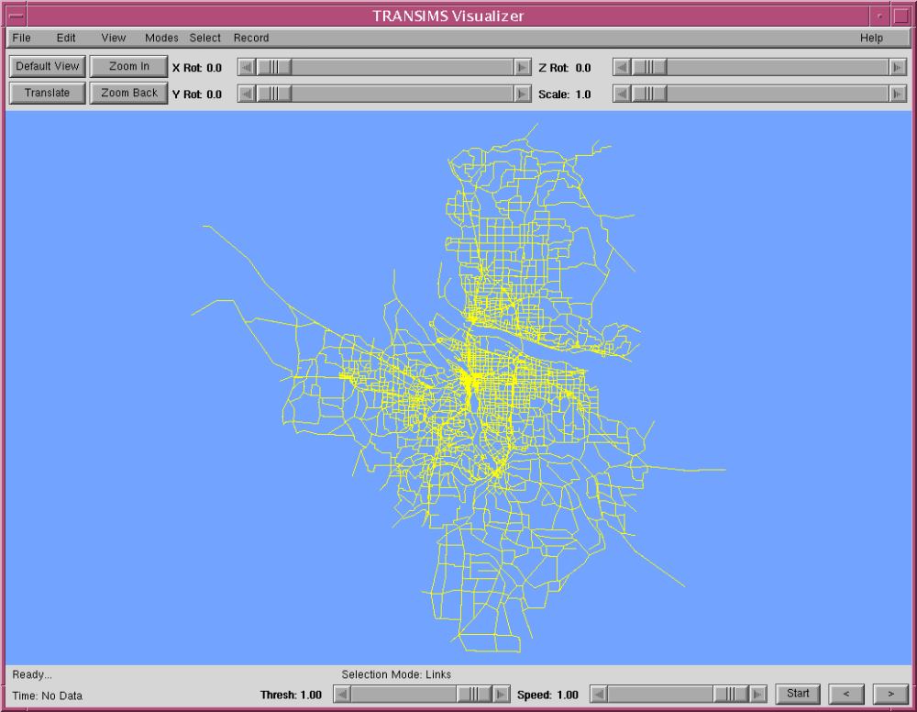

Fig. 1. This figure shows the Output Visualizer graphical user interface.
The sliders rotate the object about any axis and can also be used to scale the object about the current center of the display. Table 1 describes the buttons.
Table 1. Output Visualizer buttons.
Button | Description
Default View | Resets the viewing transformations to their default values.
Translate | Enables users to drag objects to a new location by  - clicking on the button,  - clicking on any point in the viewing area,  - dragging it to another point, and  - releasing the left-mouse button.
Zoom-in | Enables users to magnify the display of a selected area by  - clicking on the button, then  - using the left-mouse button to click and drag on the display area and thus provide more detail
Zoom-back | Resets the viewing transformations to those that existed before the last zoom-in command. A stack of 50 zooms is implemented in the Output Visualizer.
Just below the viewing window is the status line, which shows whether the display is animating or ready for commands. It also displays warnings and error messages.
To the right of the status line is the selection status line, which displays the current selection mode and the data retrieved from selections. The bottom edge of the display is used to display the current timestep and variable being displayed, as well as certain mode indicators.
Just to the right is the Thresh slider, which controls the transparency of vehicles or the cycling of colormaps, depending on what type of data are being viewed (vehicles or box data, respectively).
The Animation-speed slider is to the right and defaults to the fastest animation speed of 1.0. The start button resets the currently shown timestep to the first available timestep in the currently loaded data. The “>” and the “<” buttons increase and decrease the currently displayed timestep.
The Output Visualizer user interface has seven pull-down menus. These menus are described in Table 2.
Table 2. Output Visualizer pull-down menus.
Menu | Description
File | Opens and closes data files and saves the viewing area to a file.
Edit | Finds objects, allows labeling, and changes the background color.
View | Enables users to select what type of data to view, as well as the data’s display style.
Modes | Selects various viewing modes, such as whether to use the lighting model, overlay mode, two- or three-dimensional network, etc.
Select | Enables users to change what types of objects are searched for when the middle mouse button is clicked in the viewing area.
Record | Allows for the automated saving of images in a user-selected sequence of transformations and time-series displays in standard video sizes.
Help | Allows the user to access the help facility.

Note: Initially, the Output Visualizer displays the network described in the configuration file.

Menu Functionality

File Menu
The File menu provides options (Table 3) for opening and closing data files, saving the current viewing area as a sun-raster image file, and exiting the Output Visualizer.
Table 3. File menu functionality.
Menu Option | Description
Open Indexed Vehicles | Reads in and displays vehicle snapshot data from an indexed binary file that summarizes vehicle locations, types, velocities, etc. Refer to the File Formats section for additional information on the indexed binary-vehicle snapshot file format. Files in this format are produced with the indexvehtobin utility. A dialog box is displayed that enables the user to select the file.  Note: Do not double-click on the File Selector; when a directory is selected, the contents of that directory will be displayed.  The amount of data kept in memory can be adjusted when the Edit→Vehicle Memory Usage menu option has been selected.
Open Intersection Queues | Reads in and displays intersection queue data. The intersection queue file is created by the output system. Refer to the File Formats section for additional information on the intersection queue file format. A dialog box is displayed that enables the user to select the file.  Note: Do not double-click on the File Selector; when a directory is selected, the contents of that directory will be displayed.  The intersection queues will be displayed and synchronized with the vehicle snapshot file if one is currently loaded. Text output of intersection queues can be obtained by clicking the middle mouse button on an intersection when the Select→Intersection Queues menu option has been selected.
Open Traffic Controls | Reads in and displays traffic control data. The traffic control file is created by the output system. Refer to the File Formats section for additional information on the traffic control file format. A dialog box is displayed that enables the user to select the file.  Note: Do not double-click on the File Selector; when a directory is selected, the contents of that directory will be displayed.
Open Variable-Size Box Data | Opens a text-based data file with variable box sizes. This option is used for emissions, summary data, and any type of data that are displayable on links. The File Selector dialog box (Fig. 2) is displayed, which enables the user to select the file.  Note: Do not double-click on the File Selector; when a directory is selected, the contents of that directory will be displayed.
Open Vehicles | Reads in and displays vehicle-snapshot data from a binary file that summarizes the vehicle locations, types, velocities, etc. The binary files are converted from the output system with the vehtobin utility. This format should not be used because the Edit→Open Indexed Vehicles menu option reads in a file format that manages memory better and provides more viewing options.  This menu option is provided solely to retain backward compatibility with older files. Refer to the File Formats section for additional information on the vehicle evolution file format. A dialog box is displayed that enables users to select the file.  Note: Do not double-click on the File Selector; when a directory is selected, the contents of that directory will be displayed.
Close Indexed Vehicles | Deallocates memory used for the current indexed vehicle snapshot data; the data will no longer be accessible. This menu option should be selected before reading in a new indexed vehicle snapshot file or in recovering memory for use in displaying another data type.
Close Intersection Queues | Deallocates memory used for the current intersection queue evolution data; the data will no longer be accessible. This menu option should be selected before reading in a new intersection queue file or in recovering memory for use in displaying another type of data.
Close Traffic Signals | Deallocates memory used for the current traffic signal snapshot data; the data will no longer be accessible. This should be selected before reading in a new traffic signal snapshot file or in recovering recover memory for use in displaying another type of data.
Close Variable Size Box Data | Deallocates memory used for the current variable box data; the data will no longer be accessible.
Close Vehicles | Deallocates memory used for the current vehicle snapshot data; the data will no longer be accessible. This option should be selected before reading in a new vehicle snapshot file or in recovering memory for use in displaying another type of data.
Save View to File | Saves the current viewing window to a sun raster file in the current working directory. The File Name For Image dialog box (Fig. 3) is displayed, which allows the user to enter a name for the file.
Exit | Terminates the Output Visualizer.

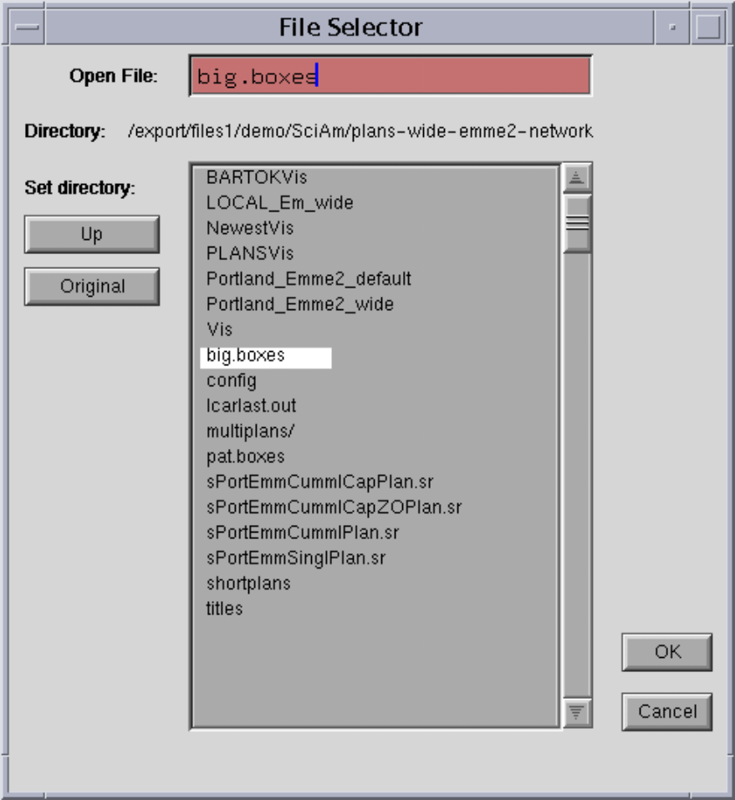
Fig. 2. The File Selector dialog box.

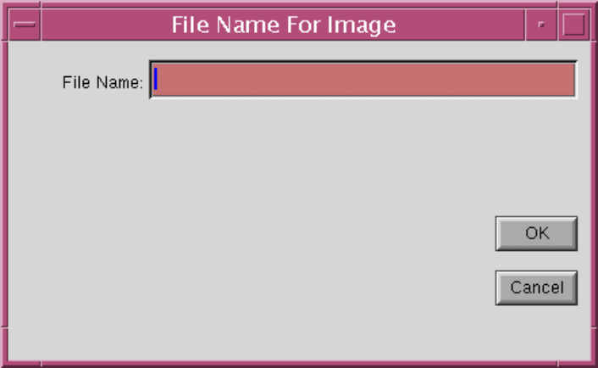
Fig. 3. The File Name For Image dialog box.

Edit Menu
The Edit menu options (Table 4) enable users to find objects, create labels, and change background color.
Table 4. Edit menu functionality.
Menu Option | Description
Add Label | Allows for the setting of a user input text label of a given selectable color at a user-selected point within the current viewing area. This is useful in making transparencies for presentations.  The Text Label dialog box is shown in Fig. 4.  After clicking [OK] in this dialog box, you will be prompted on the status line to select a location for the lower-left corner of the beginning of the string you have entered with the left-mouse button.
Background Color | Allows the user to change the current background color.  The Color Selector dialog box is shown in Fig. 5.  Note: The Color Selector dialog box has its own menu; it is used to select primary colors without having to adjust the sliders. Click [OK] to accept the current background color setting that you have selected.
Change All Colormaps | Allows the user to change, all at once, the colormaps used by the Output Visualizer. The File Selector dialog box will be displayed, allowing for the selection of a binary colormaps file. This file is produced with the mkallbinmaps utility.  Note: Do not double-click on the File Selector; when a directory is selected, the contents of that directory will be displayed.
Find Link | Marks a selected link with an orange “X” and a larger red “X.”  The Find Link by ID dialog box (Fig. 6) is displayed , which allows the input of a Link ID to be marked. Enter ‘0’ for the link ID if you do not want to mark a link.
Find Vehicle | Finds a given vehicle by its ID Number and colors it in a user-selectable color and a user-selectable point size (when vehicles are displayed as points). This is useful in tracing a single vehicle through the network. The Box Size Fraction numeric input box allows the user to select the size of an area that the chosen vehicle will remain in if the Mode→Follow Vehicle menu option is selected.  The value input to the Box Size Fraction input box should be between 0.001 and 0.5. The value is the fraction of the window size from the center of the viewing window that the vehicle may stray from without re-centering the vehicle in the window.  The Find Vehicle Parameters dialog box is shown in Fig. 7.
Go To Timestep | Allows for the selection of a user-selected timestep to display. The Go To Timestep dialog box (Fig. 8) is displayed, which allows for the input of a given timestep. The dialog box will not disappear until either a valid timestep is selected or you click [Cancel].
Vehicle Memory Use | Allows for the adjustment of the amount of data kept in memory when an indexed vehicle snapshot file is currently in memory. The Vehicle Memory Usage dialog (Fig. 9) is displayed, which shows the time range of data currently in memory. It allows for the selection of an initial timestep, a final timestep, and the number of times to increment for the animation (Step Time). Optionally, you may click [Update] to calculate how much memory will be used with the settings currently in the text-input boxes.

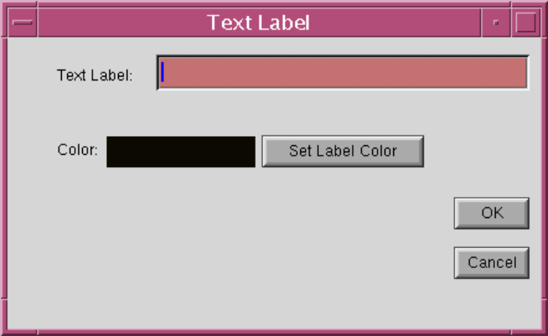
Fig. 4. The Text Label dialog box.
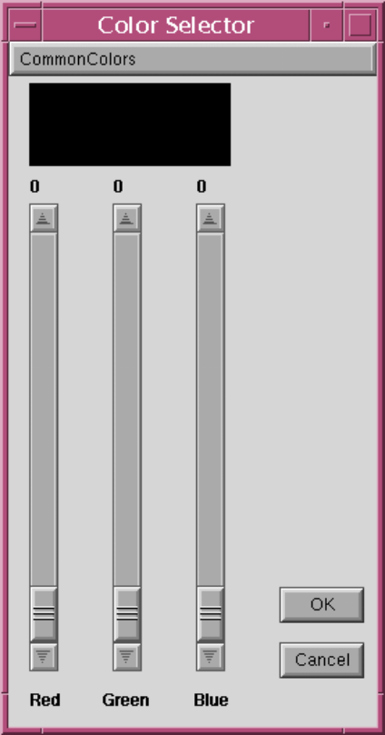
Fig. 5. The Color Selector dialog box.

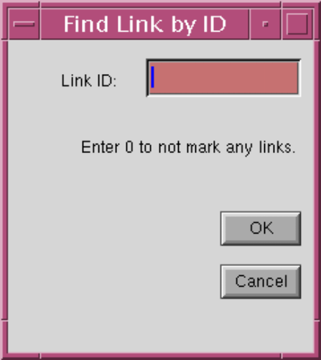
Fig. 6. The Find Link by ID dialog box.

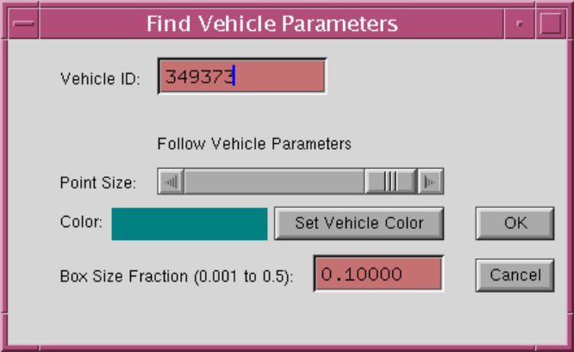
Fig. 7. The Find Vehicle Parameters dialog box.

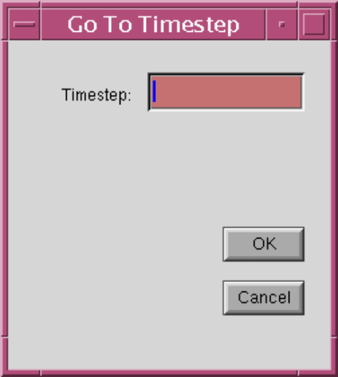
Fig. 8. The Go To Timestep dialog box.

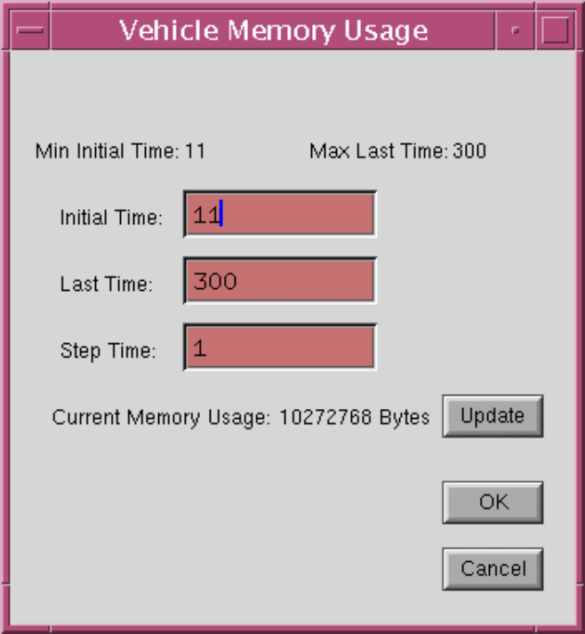
Fig. 9. The Vehicle Memory Usage dialog box.

View Menu
The View menu option (Table 5) enables users to select what type of data they wish to view. It also allows users to select the display style for the data.
Table 5. View menu functionality.
Menu Option | Description
Increment Data Column | Increments the column number to be shown when viewing the variable-size box data in 2-D mode (if you have not clicked [OK] in the Variable-Size Box Data Viewing Parameters dialog box). This is provided as a more convenient way of looking at variable-size box data columns without having to change values in a dialog box.
Labels | Toggles whether Labels should be drawn.
Lane Dividers | Toggles whether the lane dividers, drawn as dotted lines, will be shown.
Legend | Toggles whether the colormap legend will be shown. Currently, the proper legend will be shown only when variable-size box data is being displayed.
Network | Allows for setting the current network viewing options. The Network Viewing Parameters dialog box (Fig. 10) is displayed.  Clicking on the check boxes enables the user to select whether to display the Activity Locations, Barriers, Detectors, Nodes, Transit Stops, Parking Accessories, Links, and Boxes.  Checked boxes indicate that the item will be displayed. The point size can be altered when viewing the Activity Locations, Barriers, Detectors, Nodes, Transit Stops, and Parking Accessories. All colors are user selectable and may be changed by clicking the appropriate Set Color buttons. Click [OK] when the viewing options are set to your liking.
Variable-Size Boxes | Link- and box-based data can be shown as 3-D bar heights or transparency; it can also be mapped to one or two colormaps. This option enables the user to select how he or she would like to view the data in a given column or columns.  The data in any given column can be mapped to 3-D bar heights, to transparency, or to a specific color. Selecting the 2 Colormaps option allows one column to be represented by mapping the data value from black to another selectable color, and another value to be mapped with a complementary colormap. For example, densities could be mapped with the Black->Red colormap, whereas velocities could be mapped with the RGB: Right->Left (Blue to Green) colormap.  Links where both values are low would be displayed as dark blue and as yellow where both values are high. The column labels of the current variable-size box data file are listed in the Column # - Labels section at the top of the dialog box.  The Variable-Size Box Data Viewing Parameters dialog box (Fig. 11) is displayed when the View→Variable Size Boxes menu option is selected.  The 3-D scale factor is user selectable and determines the heights of the bars for a given numerical value by multiplying the scale factor by the data value. This number should always be a floating-point number. The transparency Min Val setting indicates that all data values falling below this threshold should be drawn fully transparent. The transparency Max Val setting indicates that all data values above this threshold should be drawn without transparency. Values that lie between are rendered with a proportional degree of transparency.
 | The Min Val settings for the colormap settings indicate that all data values that fall below this number should be mapped to the first value in the selected colormap. Likewise, the Max Val settings indicate that all data values above this number should be mapped to the last value in the selected colormap.
Vehicles | Allows for setting the current vehicle viewing options. Fig. 12 shows the Vehicle Viewing Parameters Dialog Box. Clicking on the check boxes enables the user to color the vehicles. Each mode is discussed below:  - The Same Color Mode colors all of the vehicles in the same user-selectable color.  - The Color by Type Mode colors vehicles according to their vehicle type and also renders buses larger than standard vehicle types. Buses are rendered in orange, with the rear section rendered in purple (according to how many passengers are currently aboard the bus).  - The Color by Passengers Mode colors vehicles according to the number of passengers in the vehicle by a given colormap that is user selectable.  - The Color by Velocity Mode colors vehicles according to their current velocity by a given colormap that is user selectable.  - The Color by User Field Mode colors vehicles according to their current user field data value by a given colormap that is user selectable. The minimum and maximum values to use for the colormap are also user selectable.  - The Color by Random Colors Mode colors vehicles according to their vehicle ID by a range of colors.  Vehicles often are too small to be seen at lesser scales; at these lesser scales the vehicles will be drawn as points. The point size for vehicles is user selectable with the use of the Point Size slider.  Vehicles are drawn in three dimensions if the 3-D Vehicles radio box is checked (it will turn yellow when it is checked).  Click [OK] when you are satisfied with the current vehicle-coloring mode.

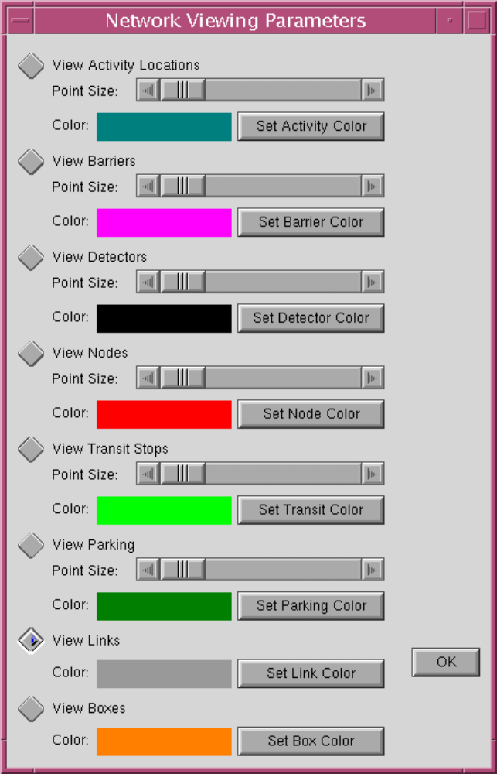
Fig. 10. The Network Viewing Parameters dialog box.

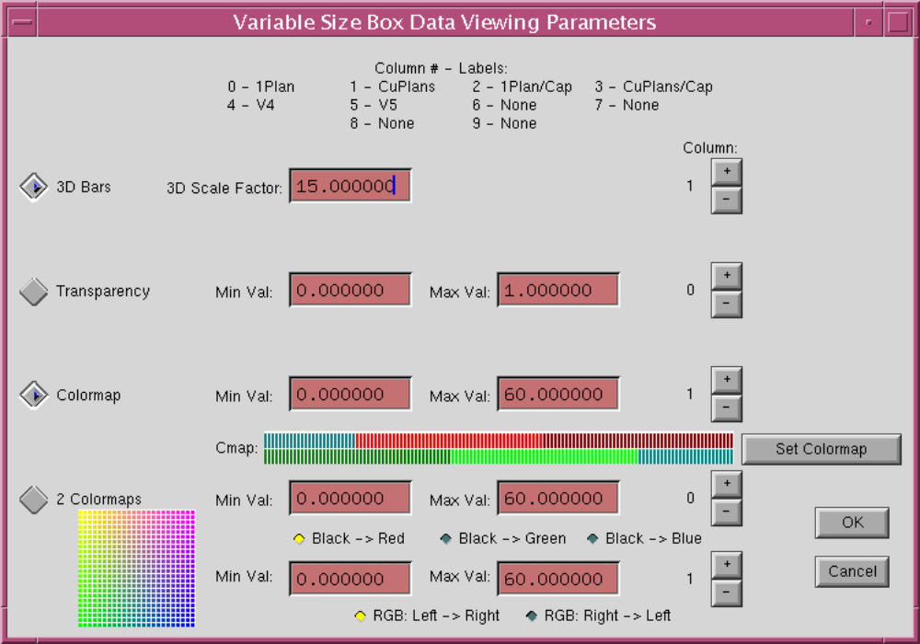
Fig. 11. The Variable-Size Box Data Viewing Parameters dialog box.

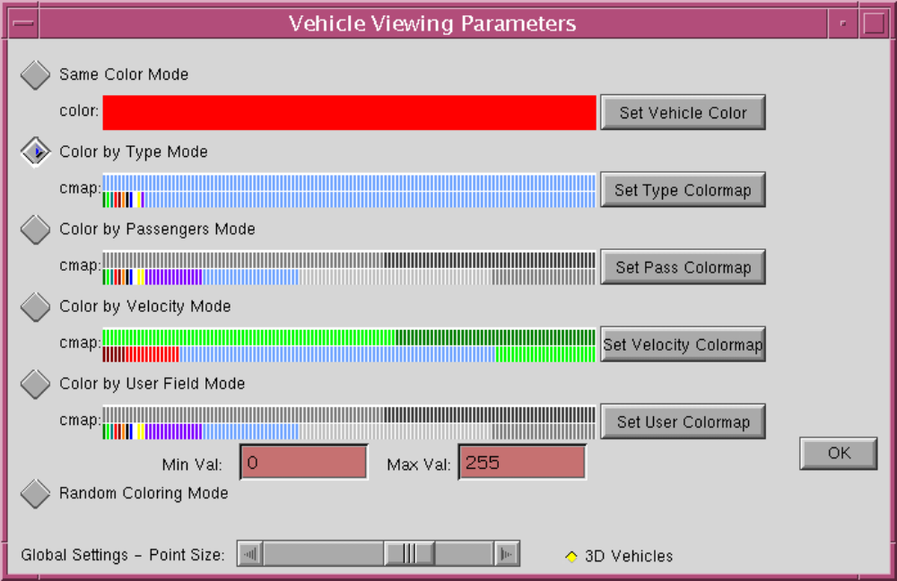
Fig. 12. The Vehicle Viewing Parameters dialog box.

Modes Menu
The Modes menu option (Table 6) enables users to select various modes, such as whether to use the lighting model, overlay mode, 3-D or 2-D network, etc.
Table 6. Modes menu functionality.
Menu Option |  | Description
3-D Network | Toggles whether the z-axis values are used when drawing the network. This is useful because the user may want to display the topography of the network at times and not display the topography when drawing 3-D boxes (and thus the boxes are compared more easily).  Note: Turn pocket lanes at this time are not updated to be drawn in 3-D; they always appear flat at a z value of 0.0.
Follow Vehicle | Translates the current view (if necessary), making sure that the vehicle chosen with the Edit→Find Vehicle menu option is always visible.  Note: Currently, the Follow Vehicle mode does not work properly when rotated viewing angles (non-zero) are selected.
Lights On/Off | Toggles the lighting model on and off. When viewing in 3-D mode, the lights should be switched on to correctly render the faces of 3-D polygons. Without the lighting model switched on, all of the sides of a box will be drawn in the exact same color. Therefore, the user cannot distinguish the separate faces on the box.
Overlay On/Off | Toggles whether the overlay mode is on or off. If overlay mode is on, the network is not redrawn for each frame and the pixels of the viewing area are transferred from an area in memory, which was saved after the network was drawn with the current viewing transformations. This saves a large amount of time in drawing complex scenes and makes high-frame-rate animation possible.  It is usually faster to draw small networks than to move the pixels with overlay mode. Therefore, this mode should be used only with larger networks (approximately 3,000 links or more).
Ride in Vehicle | Toggles the viewpoint from the default viewpoint above the network and centered to the viewpoint from within the currently selected vehicle as set from the Edit→Find Vehicle menu option. A warning light comes on if the selected vehicle ID is not present in any of the data currently loaded on the status line. In most cases, the selected vehicle ID will not be present in all of the timesteps of the currently loaded data. This is handled in several ways:  - If the vehicle does not appear in the first timestep of the currently loaded data, the viewpoint is set to where the vehicle first appears in the data.  - If the vehicle does not appear in the last timestep of the currently loaded data, the viewpoint is set to where the vehicle last appears in the data.  - If the vehicle does not appear in a given timestep (where it appears in both previous and subsequent timesteps), the most previous viewpoint will be kept. This happens frequently when vehicles are in intersection queues.  - The sliders above the viewing area are also relabeled in this mode to Roll, Pitch, Yaw, and Height. The buttons above the viewing area should not be used in this mode; results are undefined if they are used.

Select Menu
The Select menu option (Table 7) enables the user to select which type of object will be searched for when the middle mouse button is clicked in the viewing area. A special measurement mode can also be selected from this menu.
Table 7. Select menu functionality.
Menu Option | Description
Intersection Queues | Looks for the intersection queue data when the middle mouse button is clicked in the viewing area. You must click on a link near a node where there is intersection data for the queue data to be displayed. A warning message is displayed if there are no queue data or if you have not clicked on a link.
Links and Nodes | Looks for the link ID when the middle mouse button is clicked in the viewing area. You must click on a link for the link data to be displayed. A warning message is displayed if you have not clicked on a link.  Note: The link you attempt to select must be visible as a polygon for you to select it. Use the scale slider to zoom in if you are unable to select the link because it is too thin.
Measurement | Returns the distances between the down click and the release of the middle mouse button. The three-dimensional distance will be displayed, as well as the changes in the x, y, and z coordinates.
Vehicles | Looks for the vehicle when the middle mouse button is clicked in the viewing area. If the vehicles are displayed as points, you must click within five scaled meters of the vehicle location to return valid data.  If the vehicles are represented as polygons, you must click inside the triangle area in the front of the vehicle (this is the entire area of the vehicle except for buses, which have a rectangular back end). A warning message is displayed if there is no vehicle present where you have clicked the middle mouse button.

Record Menu
The Record menu option (Table 8) enables the user to select various resolutions to save animated sequences. It displays a Recording Control dialog box (Fig. 13) to facilitate the control of saving animated sequences to files.
Table 8. Record menu functionality.
Option |  | Description
NTSC Record | Sets the viewing area to an NTSC-compatible 720 x 486 pixels. It also displays a Recording Control dialog box(Fig. 13), which enables the user to select start and end frames with the total number of frames to save to a sequence of sun-raster files. The Recording Control dialog box also enables users to reverse any of the standard directions of rotation and allows for previewing of the user-set sequence. Click [Done] to close the recording control box. Resize the window to reset the viewing area to its standard size.
PAL Record | Sets the viewing area to a PAL-compatible 720 x 576 pixels. It also displays the Recording Control dialog box(Fig. 13), which enables the user to select start and end frames with the total number of frames to save to a sequence of sun-raster files. The Recording Control dialog box enables users to reverse any of the standard directions of rotation and allows for previewing of the user-set sequence. Click [Done] to close the recording control box. Resize the window to reset the viewing area to its standard size.
16 x 9 NTSC Record | Sets the viewing area to a 16 x 9 NTSC-compatible 864 x 486 pixels. It also displays the Recording Control dialog box (Fig. 13), which enables the user to select start and end frames with the total number of frames to save to a sequence of sun-raster files. The Recording Control dialog box enables users to reverse any of the standard directions of rotation and allows for previewing of the user-set sequence. Click [Done] ]to close the recording control box. Resize the window to reset the viewing area to its standard size.
16 x 9 PAL Record | Sets the viewing area to a 16 x 9 PAL-compatible 1024 x 576 pixels.  It also displays the Recording Control dialog box (Fig. 13), which enables the user to select start and end frames with the total number of frames to save to a sequence of sun-raster files. The Recording Control dialog box also enables users to reverse any of the standard directions of rotation and allows for previewing of the user-set sequence. Click [Done] to close the recording control box. Resize the window to reset the viewing area to its standard size.

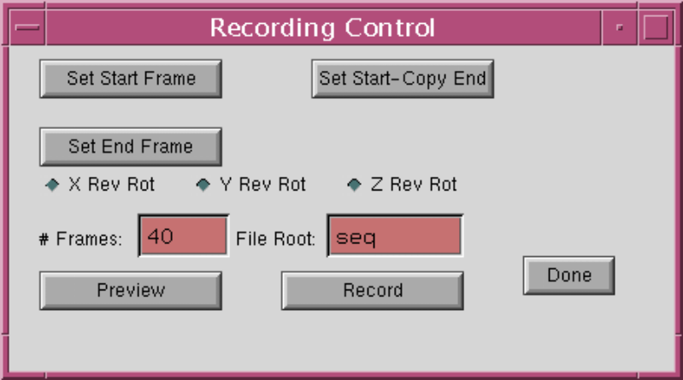
Fig. 13. The Recording Control dialog box.

Help Menu
The Help menu option is reserved for future use in implementing a help facility.

Troubleshooting
Potential Output Visualizer problems and their solutions are outlined in Table 9.
Table 9. Troubleshooting the Output Visualizer.
1 | Problem | The Output Visualizer is not working. It returns something like the following error message:  X Error of failed request: BadMatch (invalid parameter attributes)  Major opcode of failed request: 1 (X_Create_Window)  Serial number of failed request: 21  Current serial number in output stream: 23
 | Solution | A part of the X server is functioning improperly. Therefore, logout and login again to solve the problem. To date, this problem has occurred only on Sun Workstations with Solaris.
2 | Problem | A menu appears when I clicked on something else.
 | Solution | Although this problem shows up frequently, it is not disastrous in nature. Simply click on the menu bar when a menu is not located. This should take care of the problem within a few mouse clicks.
3 | Problem | I am using the Record menu option and the user interface area is damaged and needs to be redrawn. However, it is not getting redrawn.
 | Solution | This problem is caused because the Record menu option is not completely debugged as of this release. If you are trying to record an animated sequence, you need to record a sequence then exit and restart the Output Visualizer to record each subsequent sequence.
4 | Problem | I try to select a vehicle or intersection queue or link, but I keep getting the following message:  ERROR: Object not found.
 | Solution | This problem is caused by the way the selection is performed. You must click inside the polygonal region of the object for the object to be found. At lesser scales, the objects are less than the thickness of a pixel and, therefore, they cannot be selected by this method. The solution is to use the scale slider to enlarge the object, and then to select the object again.
5 | Problem | The legend is partially/completely obscured by the image.
 | Solution | The TRANSIMS team is presently working on resolving this problem. At this time, there is no solution; however, it can be minimized by setting a small scale and by translating the image to the left.

Visualization Files

Input Files

Variable-Size Box Format
Fields in the variable-size box format are tab-delimited. Each line of the variable-size box format contains at least six mandatory fields:
- Time
- Link ID
- Node ID
- Distance (the distance where the described box ends from the beginning of the link at Node ID)
- Length (the total length of the box being described)
- Data Value
Moreover, it is possible to add up to nine more data-value columns. We suggest that you provide a labeling line on the first line of the file. This line should describe each column (as shown below):

TIME LINK NODE DISTANCE LENGTH DataVal1 DataVal2 DataVal3 DataVal4... DataVal10

Format:

<TIME> <Link ID> <Node ID> <Distance> <Length> <Data Value 1> [<Data Value 2> … <Data Value 10>]
Example:

TIME LINK NODE DISTANCE LENGTH DataVal1 DataVal2 DataVal3
800 1400 1256 24.75 12.50 10.2 0.4 35.6

At time 800 of the simulation, a box should be drawn of length 12.5 that ends 24.75 meters from node 1256 of link 1400. The data values for each of the first three columns are 10.0, 20.4, and 35.6, respectively.

Binary Vehicle Snapshot Format
Table 10 contains the data structure fields for the Binary Vehicle Snapshot format (non-indexed). Note that this is a binary file format that consists of a single data structure type. The vehicle snapshot file must be sorted by time.
Table 10. Binary Vehicle Snapshot format data structure fields.
Field | Description | Allowed Values
Status | Vehicle type number in the lower 8 bits and number of passengers in the upper 8 bits. | Integer (16 bits)
Theta | Number of degrees from due east in which the vehicle is pointed. The angle is calculated counterclockwise from due east. | Integer (16 bits)
Time | Current simulation time for which this current record has been collected. | Integer (32 bits)
Velocity | Current vehicle velocity. | Decimal (32 bits)
X | Current x position of the front middle of the vehicle. | Decimal (32 bits)
Y | Current y position of the front middle of the vehicle. | Decimal (32 bits)
Z | Current z position of the front middle of the vehicle. | Decimal (32 bits)
Vehicle ID | Vehicle ID. | Integer (32 bits)
Link ID | Current link ID on which the vehicle is traveling. | Integer (32 bit)

Indexed Binary Vehicle Snapshot Format
Table 11 lists the data structure fields for each vehicle record. The output file can be converted with indexvehtobin. The usage of the indexvehtobin command is as follows:

indexvehtobin inputfilename outputfilename
Table 11. Indexed Binary Vehicle Snapshot format data structure fields.
Field | Description | Allowed Values
Status | Vehicle type number in the lower 8 bits and number of passengers in the upper 8 bits. | Integer (16 bits)
Theta | Number of degrees from due east in which the vehicle is pointed. The angle is calculated counterclockwise from due east. | Integer (16 bits)
User | A user settable field. | Integer (32 bits)
Time | Current simulation time for which this current record has been collected. | Integer (32 bits)
Velocity | Current vehicle velocity. | Decimal (32 bits)
X | Current x position of the front middle of the vehicle. | Decimal (32 bits)
Y | Current y position of the front middle of the vehicle. | Decimal (32 bits)
Z | Current z position of the front middle of the vehicle. | Decimal (32 bits)
Vehicle ID | Vehicle ID. | Integer (32 bits)
Link ID | Current link ID on which the vehicle is traveling. | Integer (32 bit)
File Header:
f = one character lowercase f to signify a file header
# = the number of timesteps in this file (a 64-bit integer)
Time Header:
t = one character lowercase t to signify a timestep header
# = the timestep (a 32-bit integer)
# = the number of data records in this timestep (a 64-bit integer)

Link Evolution Format
Fields in the Link Evolution format are tab-delimited. Each line of the variable-size box format contains at least five mandatory fields:
- Time
- Link
- Node
- Lane
- Data value
It is also possible to add up to nine more data-value columns. We suggest that you provide a labeling line on the first line of the file. This line should describe each column (as shown below):

TIME LINK NODE LANE DataVal1 DataVal2 DataVal3 DataVal4... DataVal10
Format:

<TIME> <LINK> <NODE> <LANE> <Data Value 1> [<Data Value 2> ... <Data Value 10>]

LANE field is –1 for all lanes otherwise it is the lane number.
Example:

TIME LINK NODE LANE DataVal1 DataVal2
800 200 400 -1 5.0 25.9
800 300 321 2 8.4 23.5

Arbitrary Point Evolution Format
Fields in the Arbitrary Point Evolution format are tab-delimited. Each line of the variable-size box format contains at least five mandatory fields:
- Time
- Point X Value
- Point Y Value
- Point Z Value
- Data value
It is also possible to add up to nine more data-value columns. We suggest that you provide a labeling line on the first line of the file. This line should describe each column (as shown below):

TIME X Y Z DataVal1 DataVal2 DataVal3 DataVal4... DataVal10
Format:

<TIME> <X> <Y> <Z> <Data Value 1> [<Data Value 2> ... <Data Value 10>]
Example:

TIME X Y Z DataVal1 DataVal2 DataVal3
800 200 400 100 -1 5.0 25.9
800 300 321 120 2 8.4 23.5

Polygonal Region Evolution Format
Fields in the Polygonal Region Evolution format are tab-delimited. Polygonal regions are defined first in the file; thereafter, data are assigned to each region at a specific time. Defining polygonal regions is done with the following fields at the beginning of the file:
- NumberOfPolygons
- PolygonNumber NumberOfVerticesInPolygon x0 y0 z0 x1 y1 z1 … xn yn zn
Data lines for the Polygonal Region Evolution format contain at least four mandatory fields:
- Time
- Polygonal Region #1 ID
- Polygonal Region #2 ID
- Data value
A time of –1 indicates that the polygons should be drawn in all timesteps.
It is also possible to add up to nine more data-value columns. We suggest that you provide a labeling line on the first line of the file. This line should describe each column (as shown below):

TIME PID1 PID2 DataVal1 DataVal2 DataVal3 DataVal4... DataVal10
Format:

<TIME> <PID1> <PID2> <Data Value 1> [<Data Value 2> … <Data Value 10>]

Example:

4
1 3 1 1 0 1 2 0 1 3 0
2 3 1 2 0 2 2 0 2 3 0

TIME PID1 PID2 DataVal1 DataVal2 DataVal3
800 200 400 -1 5.0 25.9
800 300 321 2 8.4 23.5

Output Visualizer Library Files
Appendix A lists the Output Visualizer library files.

Configuration File Keys
Appendix B lists the Output Visualizer configuration file keys.

Utility Programs

vehtobin
The vehtobin utility uses less memory and is much faster at converting files. Moreover, it does not care about the ordering of the columns in the vehicle snapshot input file.
The vehtobin utility converts IOC-2 text format to the binary format (non-indexed) required by the Output Visualizer.
Usage is as follows:

Vehtobin inputfilename outputfilename

The vehtobin utility is provided as a quicker alternative to convcars in translating to the binary vehicle file format. The newer indexed vehicle format should be used in almost all cases to maximize the options for viewing vehicles in the Output Visualizer. This format is included as a means of keeping compatibility with a previous file format. In almost all cases, indexvehtobin should be used as the utility for converting text vehicle snapshot files to the indexed vehicle file format used by the Output Visualizer.

indexvehtobin
The indexvehtobin utility creates indexed vehicle file formats from the text vehicle snapshot files. This utility should be used to maximize the capabilities of the Output Visualizer when viewing vehicles. It also does not care about the ordering of the columns in the vehicle snapshot input file.
The indexvehtobin utility converts IOC-2 text format to the indexed binary vehicle format required by the Output Visualizer. Usage is as follows:

indexvehtobin inputfilename outputfilename

Plan2BoxSummary
The Plan2BoxSummary utility prepares a TRANSIMS plan file for display in the Output Visualizer as variable-size box data. The utility prepares several different views of the plans, one in each column of the output file. This permits easy viewing of all plans that
- start during a particular time interval,
- cumulative plans accumulated across time intervals, and
- cumulative plans normalized by the capacity of each link.
The plans can be displayed either by individual traveler or summarized over all travelers.
Usage of Plan2BoxSummary is as follows:

Plan2BoxSummary [-f ] [-s startTime] [-e endTime] [-i incTime] [-u userFieldValue] [-t travId]* [-r travIdFile] [-h ] <configFile> <planFile>

where incTime is in seconds. All other times are in seconds since midnight.
The following are options:
-f Plans will be written one at a time and will be indexed by traveler ID.
-s Only legs that start on or after this time are written (default = 0).
-e Only legs that end (as estimated in plan) on or before this time are written (default = 86400).
-i Put plans into incTime second long bins. (Plan file must be sorted by time.)
-u Only plans with a specified value in the user field will be written.
-t Only specified traveler IDs will be written. (The -t option must appear before each ID.)
-r Specifies a file of white-space-separated IDs to use
(in addition to any specified by –t).
-h Gives this message and exits.
The configuration and plan file names are both required and must appear in the order shown. Output is placed in a file named after the plan file argument with the extension . boxes.
When the -f flag is used, the Output Visualizer interprets the traveler ID as a time. To reconstruct the traveler ID, convert the time into a number of seconds past midnight. Currently, only vehicle driver legs are handled. This utility has not yet been integrated with the file-indexing system. The plan file should be sorted by departure time or by traveler ID.
Note that the configuration file should contain all NET_ keys. The plan file name is specified on the command line (and not taken from the PLAN_FILE variable in the configuration file).
Appendix C contains a Plan2BoxSummary example.

mkmap
The mkmap utility produces any number of colormaps from a text-input file for compilation into the Output Visualizer. All colormaps have 256 colors.
Usage of mkmap is as follows:

mkmap inputfile outputfile
where inputfile consists of a file of the format described above, and the output file is an ASCII text file that can be pasted into the colormaps.h file for compiling into the Output Visualizer.
Appendix D provides the default colormap input file format. In this format, the first line is the number of colormaps followed by the total number of lines in the file (minus the first line). Each colormap is followed by the number of colors in the colormap, as well as by the minimum and maximum value (followed by a text string that is ignored). A color number as given in the mkmap source file follows each colormap threshold value.
The colormaps in Appendix D are default maps compiled into the application. The first two colormaps are used for summary box data. The third colormap is used for the first variable-size box data column; the fourth colormap is used for the second variable-size box data column; and so on. The last four colormaps are used to color vehicles by type, passengers, velocity and user field. In all, there are 16 colormaps in the Output Visualizer.

mkallbinmaps
The mkallbinmaps utility produces any number of binary colormaps from a text-input file. All colormaps have 256 colors
Usage of mkallbinmaps is as follows:

Mkallbinmaps inputfile outputfile ,
where inputfile consists of a file of the format described above, and the output file is a binary colormaps file that can be read into the Output Visualizer to change all of the colormaps interactively through the Edit→Change All Colormaps menu option.
Appendix D contains the default colormap input file format.

mk1binmap
The mk1binmap utility produces a single binary colormap file for use in describing a single colormap that can be read into the Output Visualizer.
Usage of mk1binmap is as follows:

Mk1binmap inputfile outputfile ,

where inputfile consists of a description of a single colormap file of the format described above, and the output file is a binary colormap file that can be read into the Output Visualizer.
Changing a single colormap in the Output Visualizer is done by clicking [Change XXX Colormap] in a dialog box and selecting the file produced by the mk1binmap utility from the File Selector dialog box that is displayed.
Appendix E contains an example single colormap text input file.

Color Index
The index of colors used in mkmap and other colormap utilities is as follows:

0 = | Dark Green |  | 7 = | Blue
1 = | Light Green |  | 8 = | White
2 = | Teal |  | 9 = | Yellow
3 = | Light Red |  | 10 = | Purple
4 = | Dark Red |  | 11 = | Background Blue
5 = | Orange |  | 12 = | Light Grey
6 = | Black |  | 13 = | Grey

Appendix A: Output Visualizer Library Files
Table 12: Output Visualizer library files.
Type | File Name | Description
Binary Files | libTIO.a | TRANSIMS Interfaces library.
Vehtobin  Source Files | vehtobin.c | converts IOC-2 text data files into binary vehicle snapshot files (non-indexed) for use with the Output Visualizer.
Indexehtobin  Source Files | Indexvehtobin.c | converts IOC-2 text data files into indexed binary vehicle snapshot files for use with the Output Visualizer.
Convcars Source Files | Convcars.c | converts IOC-1 or IOC-2 text data files with limited column output into the binary vehicle snapshot files (non-indexed) for use with the Output Visualizer.
Mkmap Source Files | Mkmap.c | converts a text input colormap description file with 16 colormaps into a text output file suitable for pasting into the colormaps.h file and compiling into the Output Visualizer.
Mk1binmap Source Files | Mk1binmap.c | converts a text input colormap description file with only one colormap into a binary colormap input file readable by the Output Visualizer.
Mkallbinmaps  Source Files | Mkallbinmaps.c | converts a text input colormap description file with 16 colormaps into a binary colormap file suitable for changing all the colormaps used by the Output Visualizer at once.

Appendix B: Output Visualizer Configuration File Parameters
Table 13. Mandatory configuration file keys.
Configuration File Key | Description
CA_CELL_LENGTH | The length of a cell in meters. Default = 7.5
NET_ACTIVITY_LOCATION_TABLE | The name of the network activity location table or an empty activity location table.
NET_BARRIER_TABLE | The name of a network barrier table or an empty barrier table.
NET_BARRIER_TABLE | The name of a network detector table or an empty detector table.
NET_DIRECTORY | Name of directory containing the network tables.
NET_LANE_WIDTH | The width of a lane in meters. Default = 3.5  (Note: The settings for NET_LANE_WIDTH used by the Output Visualizer must be the same as those used by the output system for the vehicles to be placed properly on the network.)
NET_LINK_MEDIAN_HALFWIDTH | The distance that the links are offset from the node; must be set to ½ of NET_LANE_WIDTH.  (Note: this key must be the same for collecting output and running the Output Visualizer; otherwise, vehicles will not be centered properly in lanes.)
NET_LINK_TABLE | The name of the network link table.
NET_NODE_TABLE | The name of the network node table.
NET_PARKING_TABLE | The name of the network parking table or an empty parking table.
NET_POCKET_LANE_TABLE | The name of the network pocket lane table or an empty pocket lane table.
NET_TRANSIT_STOP_TABLE | The name of network transit stop table or an empty transit stop table .
OUT_SNAPSHOT_SUPPRESS_1 | These keys determine what fields to suppress in the snapshot output file. Nothing needs to be suppressed, but the text vehicle evolution file size will be reduced if the key is set to:  ACCELER;DRIVER;USER;LANE;NODE;DISTANCE.
VIS_BOX_LENGTH | The summary box length in meters; should be 150 (meters).

Table 14. Optional configuration file keys.
Configuration File Key | Description
VIS_COLORMAPS | The full path and file name of a set of colormaps produced with the mkallbinmaps utility to use in the Output Visualizer.
VIS_NETWORK_ACTIVITY_LOCATION_POINTSIZE | Size of an activity location point, 0.5 to 10.0.
VIS_NETWORK_BARRIER_POINTSIZE | Size of a barrier point, 0.5 to 10.0..
VIS_NETWORK_DETECTOR_POINTSIZE | Size of a detector point, 0.5 to 10.0
VIS_NETWORK_NODE_POINTSIZE | Size of a node point, 0.5 to 10.0.
VIS_NETWORK_PARKING_POINTSIZE | Size of a parking accessory point, 0.5 to 10.0.
VIS_NETWORK_TRANSIT_POINTSIZE | Size of a transit stop point,  0.5 to 10.0.
VIS_NETWORK_VIEW_ACTIVITY_LOCATIONS | 0 not to view activity locations,  1 to view activity locations.
VIS_NETWORK_VIEW_BARRIERS | 0 not to view barriers,  1 to view barriers.
VIS_NETWORK_VIEW_BOXES | 0 not to view boxes,  1 to view boxes.
VIS_NETWORK_VIEW_DETECTORS | 0 not to view detectors,  1 to view detectors.
VIS_NETWORK_VIEW_LANE_DIVIDERS | 0 not to view lane dividers,  1 to view lane dividers.
VIS_NETWORK_VIEW_LINKS | 0 not to view links,  1 to view links.
VIS_NETWORK_VIEW_NODES | 0 not to view nodes,  1 to view nodes.
VIS_NETWORK_VIEW_PARKING | 0 not to view parking,  1 to view parking.
VIS_NETWORK_VIEW_TRANSIT | 0 not to view transit stops,  1 to view transit stops
VIS_SINGLE_BUFFERED | 0 for double buffered (default), 1 for single buffered. Should always be 0 unless the videoadapter will not allow double buffering.
VIS_SLIDER_SCALE | Initial scale, 1.0 and larger;  default = 1.0
VIS_SLIDER_SPEED | Initial speed, 0.005 to 1.0;  default = 1.0
VIS_SLIDER_THRESHOLD | Initial threshold, 0.005 to 1.0; default = 1.0
VIS_SLIDER_XROT | Initial X rotation, 0.0 to 360.0; default = 0.0
VIS_SLIDER_YROT | Initial Y rotation, 0.0 to 360.0; default = 0.0
VIS_SLIDER_ZROT | Initial Z rotation, 0.0 to 360.0; default = 0.0
VIS_VEHICLE_DRAW3D | 0 for 2D vehicles,  1 for 3D vehicles
VIS_VEHICLE_DRAWMODE | Coloring method for vehicles, 0 to  0 – Same color mode  1 – Color by Type mode  2 – Color by Passengers mode  3 – Color by Velocity mode  4 – Random coloring by vehicle ID  5 – Color by User field mode
VIS_VEHICLE_POINTSIZE | Size of a vehicle when it is a point, 0.5 to 10.0
VIS_XSLIDER_360DEFAULT | 0 for default X rotation of 0.0,  1 for default X rotation of 360.0

Appendix C: Plan2BoxSummary Example

% $TRANSIMS_HOME/bin/Plan2BoxSummary -i 900 config plans
Initializing network ... done
Box summaries written in file plans.boxes
% head plans.boxes
TIME link node distance length Single_Plan Cumul_Plans Cap_Normed
12150 1 1 750 750 1864 1864 0.266286
12150 2 2 750 750 1864 1864 0.266286
12150 3 3 750 750 1860 1860 0.265714
12150 4 4 750 750 1860 1860 0.265714
12150 5 5 750 750 1876 1876 0.268
12150 6 6 750 750 1876 1876 0.268
12150 7 7 750 750 1901 1901 0.271571
12150 8 8 750 750 1901 1901 0.271571
12150 9 9 750 750 1890 1890 0.27

% $TRANSIMS_HOME/bin/Plan2BoxSummary -f -i 600 config plans
Initializing network ... done
Box summaries written in file plans.boxes
% head plans.boxes

TIME link node distance length Single_Plan Cumul_Plans Cap_Normed
167 1 1 750 750 2 2 0.000285714
167 2 2 750 750 2 2 0.000285714
167 3 3 750 750 2 2 0.000285714
167 4 4 750 750 2 2 0.000285714
167 5 5 750 750 2 2 0.000285714
167 6 6 750 750 2 2 0.000285714
167 7 7 750 750 2 2 0.000285714
167 8 8 750 750 2 2 0.000285714
167 9 9 750 750 2 2 0.000285714

Appendix D: Default Colormap Input File Format

15 92
5 0.0 37.5 Summary Velocity Map 0
1.0 4
3.0 3
15.0 11
30.0 1
35.0 0
5 0.0 1.0 Summary Density 1
0.1 11
0.2 1
0.3 5
0.5 3
1.0 4
5 0.0 49.0 Emissions Velocity Map 2
1.5 4
4.5 3
22.5 11
45.0 1
50.0 0
5 0.0 25.0 Emissions Nitrogen Oxide Map 3
5.0 0
10.0 1
15.0 2
20.0 3
25.0 4
5 0.0 620.0 Emissions Carbon Monixide Map 4
120.0 0
240.0 1
360.0 2
480.0 3
615.0 4
5 0.0 13.2 Emissions Hydrocarbons Map 5
2.6 0
5.2 1
7.8 2
10.4 3
13.0 4
5 0.0 18.0 Emissions Fuel Economy Map 6
3.6 0
7.2 1
10.8 2
14.4 3
18.0 4
5 0.0 26000.0 Emissions Flux Map 7
5000.0 4
10000.0 3
15000.0 2
20000.0 1
25000.0 0
5 0.0 26000.0 Unused Map 8
5000.0 4
10000.0 3
15000.0 2
20000.0 1
25000.0 0
5 0.0 18.0 Unused Map 9
3.6 0
7.2 1
10.8 2
14.4 3
18.0 4
5 0.0 18.0 Unused Map 10
3.6 0
7.2 1
10.8 2
14.4 3
18.0 4
5 0.0 18.0 Unused Map 11
3.6 0
7.2 1
10.8 2
14.4 3
18.0 4
12 0.0 255.0 Vehicles by Type Map 12
1.0 0 Walk
2.0 1 Auto
3.0 2 Truck
4.0 3 Bicycle
5.0 4 Taxi
6.0 5 Bus
7.0 6 Trolley
8.0 7 Streetcar
9.0 8 Light Rail
10.0 9 Rapid Rail
11.0 10 Regional Rail
255.0 11 Unknown type
15 0.0 255.0 Vehicles by Passengers Map 13
1.0 0 0 passengers
2.0 1 1
3.0 2 2
4.0 3 3
5.0 4 4
6.0 5 5
7.0 6 6
8.0 7 7
9.0 8 8
11.0 9 10
26.0 10 25
51.0 11 50
101.0 12 100
201.0 13 200
255.0 14 255
5 0.0 37.5 Vehicles by Velocity Map 14
1.0 4
3.0 3
15.0 11
30.0 1
35.0 0
15 0.0 255.0 Vehicles by User Field Map 15
1.0 0 0
2.0 1 1
3.0 2 2
4.0 3 3
5.0 4 4
6.0 5 5
7.0 6 6
8.0 7 7
9.0 8 8
11.0 9 10
26.0 10 25
51.0 11 50
101.0 12 100
201.0 13 200
255.0 14 255
Appendix E: Single Colormap Text Input File

5 0.0 18.0 // number of colors, minimum value and maximum value
3.6 0 // 0.0 to 3.6 should be in color 0
7.2 1 // > 3.6 to 7.2 should be in color 1
10.8 2 // > 7.2 to 10.8 should be in color 2
14.4 3 // > 10.8 to 14.4 should be in color 3
18.0 4 // > 14.4 should be in color 4

Single colormap text files are used to produce binary single colormap files for use in the Output Visualizer. They are converted with the mk1binmap utility.
Chapter Eight: Index

