# Greeshma Chowdary Peddineni

library(dplyr)

##   
## Attaching package: 'dplyr'

## The following objects are masked from 'package:stats':  
##   
## filter, lag

## The following objects are masked from 'package:base':  
##   
## intersect, setdiff, setequal, union

library(ggplot2)  
library(lubridate)

##   
## Attaching package: 'lubridate'

## The following objects are masked from 'package:base':  
##   
## date, intersect, setdiff, union

library(readr)  
library(forcats)

new_now_covid_22 <- readRDS("C:/Users/Dell/Downloads/covid22.rds")

Let’s find how many different vaccine manufacturers are there?

uniq_manufacturers <- unique(new_now_covid_22$VAX_MANU)  
num_manufacturers <- length(uniq_manufacturers)  
  
cat("There are", num_manufacturers, "different COVID-19 vaccine manufacturers:\n")

## There are 5 different COVID-19 vaccine manufacturers:

cat(paste("", uniq_manufacturers), sep = "\t")

## JANSSEN PFIZER\BIONTECH UNKNOWN MANUFACTURER MODERNA NOVAVAX

Create a plot to show adverse events by month for each manufacturer

new_now_covid_22 <- new_now_covid_22 %>%  
 mutate(RECVDATE = as.Date(RECVDATE, format="%Y-%m-%d"),  
 Month = floor_date(RECVDATE, "month"))   
  
monthly_events <- new_now_covid_22 %>%  
 group_by(Month, VAX_MANU) %>%  
 summarise(Event_Count = n(), .groups = 'drop')  
  
ggplot(monthly_events, aes(x = Month, y = Event_Count, color = VAX_MANU)) +  
 geom_line(size = 2) +   
 labs(title = "Monthly Adverse Events Reported by month for each Vaccine Manufacturer",  
 x = "Reported Month",  
 y = "Number of Adverse Events",  
 color = "Vaccine Manufacturer") +  
 theme_light() +   
 scale_x_date(date_labels = "%b %Y", date_breaks = "3 months") +   
 scale_color_manual(values = c("MODERNA" = "orange",  
 "PFIZER\\BIONTECH" = "yellow",   
 "JANSSEN" = "green",  
 "NOVAVAX" = "red",  
 "UNKNOWN MANUFACTURER" = "violet"),  
 na.translate = FALSE) +   
 theme(plot.title = element_text(face = "bold", size = 10),   
 axis.text.x = element_text(angle = 45, hjust = 1))

## Warning: Using `size` aesthetic for lines was deprecated in ggplot2 3.4.0.  
## ℹ Please use `linewidth` instead.  
## This warning is displayed once every 8 hours.  
## Call `lifecycle::last_lifecycle_warnings()` to see where this warning was  
## generated.

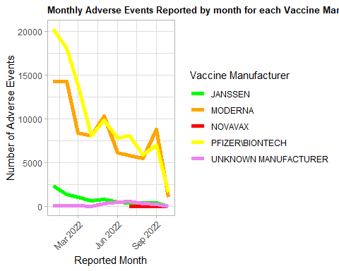

Let’s see which state had the highest number of events?

new_now_covid_22 <- new_now_covid_22 %>%  
 mutate(  
 STATE = as.character(STATE),   
 STATE = trimws(STATE)   
 )  
  
invisible(unique(new_now_covid_22$STATE))  
  
state_event_counts <- new_now_covid_22 %>%  
 filter(!is.na(STATE) & STATE != "") %>%   
 group_by(STATE) %>%  
 summarise(Event_Count = n(), .groups = 'drop') %>%  
 arrange(desc(Event_Count))   
  
highest_state <- state_event_counts[1, ]  
  
cat("The state with the highest number of reported events is", highest_state$STATE,   
 "with", highest_state$Event_Count, "events.\n")

## The state with the highest number of reported events is CA with 16444 events.

For Idaho, Texas, and Michigan, show number of events by gender?

selected_states <- c("TX", "MI", "ID")  
filtered_data <- new_now_covid_22 %>% filter(STATE %in% selected_states)  
  
  
gender_counts <- filtered_data %>%  
 group_by(STATE, SEX) %>%  
 summarise(Event_Count = n(), .groups = 'drop')  
  
gender_counts

## # A tibble: 9 × 3  
## STATE SEX Event_Count  
## <chr> <fct> <int>  
## 1 ID F 545  
## 2 ID M 388  
## 3 ID U 26  
## 4 MI F 6012  
## 5 MI M 4608  
## 6 MI U 143  
## 7 TX F 4802  
## 8 TX M 3099  
## 9 TX U 187

Let’s find how many ER/ED visits were reported?

er_ed_visits_count <- new_now_covid_22 %>%  
 filter(!is.na(ER_ED_VISIT) & ER_ED_VISIT != "") %>%  
 nrow()  
  
cat("Total ER/ED visits reported:", er_ed_visits_count, "\n")

## Total ER/ED visits reported: 21669

Which manufacturer is associated with the lowest number of reported ER/ED visits?

manufacturer_er_ed_counts <- new_now_covid_22 %>%  
 filter(ER_ED_VISIT == TRUE | ER_ED_VISIT == "Y") %>%  
 group_by(VAX_MANU) %>%  
 summarise(ER_ED_Visit_Count = n(), .groups = 'drop')  
  
  
low_manufacturer <- manufacturer_er_ed_counts %>%  
 arrange(ER_ED_Visit_Count) %>%  
 slice(1)  
  
cat(low_manufacturer$VAX_MANU, "manufacturer is associated with the lowest number of reported ER/ED with", low_manufacturer$ER_ED_Visit_Count, "visits.")

## NOVAVAX manufacturer is associated with the lowest number of reported ER/ED with 9 visits.