Delivery Software Architecture

Overview
The storefront will implement a representative state transfer (RESTful) resource oriented architecture (ROA) and web service clients that rely on resources defined by the ROA. (http://en.wikipedia.org/wiki/Resource_Oriented_Architecture) The definition of “what it means to be a RESTful architecture” is still a topic of debate; however as documented by Leonard Richardson and Sam Ruby in the book, “RESTful Web Services,” the following properties apply to resource orientated architectures (RESTful Web Services p105):

- Addressability
- Statelessness
- Connectedness
- A uniform interface

More specifically, the storefront contains four (4) top level software components, namely: storefront-core, storefront-ria, storefront-lb, and storefront-d. Each of these components represents an artifact(s) from the storefront build system and is a self contained testable and deployable unit. The storefront-core component implements all resources provided by the storefront resource oriented architecture. Storefront-ria, storefront-d, and storefront-lb are web service clients to storefront-core. Please note in the context of this document a component refers to a CSC; however, we prefer the use of UML terms. A component represents a set of code that implements a major piece of functionality; a component may or may not contain sub-components. A component may also contain packages; however, packages cannot contain components. Below is a storefront component diagram:

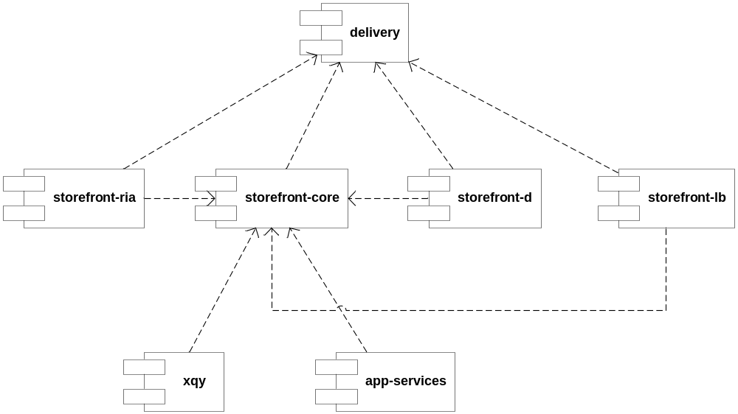

Software Components
- storefront-core
  - Storefront-core, as the name indicates, is implements the core functionality of the delivery sub-system. It implements resources that support the content portal, the content viewer, the content reader. <<add thin thread plans>> The storefront-core component is a set of xquery modules that implement storefront resources defined later in this document. The xquery modules are deployed in MarkLogic Server v4.2. Resources are available over the HTTP protocol and must have at least one URI. Additionally, resources may provide multiple server representations and accept multiple client representations. Specifically, for the case of low bandwidth access, special lightweight server representations of a given resource may be implemented.
- storefront-d
  - Storefront-d is a web service client to storefront-core that provides dissemination and tailoring services for the storefront. More specifically storefront-d uses the dissemination resource provided by storefront-core to disseminate reports to external systems. Storefront-d is deployed on separate hardware to isolate system dissemination tasks from user requests.
- storefront-lb
  - Storefront-lb is a web service client to storefront-core that provides low bandwidth access storefront-resources. This component will either be written in ruby or a UNIX scripting shell (sh/csh/bash/tcsh/etc) however; this implementation decision has not yet been determined. If storefront-d is written in ruby the client will utilize ruby’s http and xml facilities to interact with storefront-core. If storefront-d is written in a shell script the client will utilize curl (http://curl.haxx.se/) to interact over HTTP with storefront-core.
- storefront-ria
  - The storefront-ria component is a java web archive (WAR) that implements the storefront Rich Internet Application. (RIA) The component is a web service client to resources provided by storefront-core. The component is implemented primarily in JavaScript and uses EXT-JS 3.2 as the primary JavaScript framework. At a high level storefront-ria contains an application, an event framework, page groups, pages, views, and view components.

Design Methodology
Although software components in the delivery sub-system fulfill slightly different needs and may be implemented in different programming languages, all components generally take an object oriented analysis and object oriented design approach. The following sections explain the design approach that was taken for each major component and describe design artifacts produced from the corresponding component design.

Storefront-core
Storefront core generally follows the object oriented design technique of breaking a system down into its nouns. However, the distinction between resource oriented design and object oriented design becomes most prevalent when the uniform interface is examined in relationship to the systems nouns. For example, HTTP only provides two potential methods to create data namely, POST and PUT; however, in object oriented analysis of storefront we may talk about a user subscribing to an RSS feed. Therefore, a programmer could potentially define an instance method on the user object (resource) named subscribe that takes the id of the RSS feed the user would like to subscribe to. This pattern violates resource oriented design because the user object (resource) no longer conforms to the uniform interface; in this case the uniform interface is constrained by methods that HTTP provides. This case calls for a third object (resource) that handles subscriptions, namely a subscription resource. (This example was modified from RESTful Web Services p.109)

The following design approach was taken: (RESTful Web Services p. 109-110)
- Figure out the data set
- Split the data set into resources
- For each kind of resource repeat steps 4 – 9
- Name the resources with URIs
- Expose a subset of the uniform interface
- Design the representation(s) accepted from the client
- Design the representation(s) served to the client
- Integrate this resource into existing resources, using hypermedia links and forms
- Consider the typical course of events: what’s supposed to happen?
- Consider error conditions: what might go wrong?

It is also important to note that top level services, /storefront, /feeds, /category, /report, /page, /view, and /user pre-pended with a version path variable. For example, the /storefront resource is located at the URI, /{version}/storefront. The version path variable is defined by the following BNF:

{version} => {major-version}.{minor-version}

{major-version} => any number (should be incremented by one for major releases)

{minor-version} => any decimal greater than or equal to .01

The version number omitted in some diagrams for brevity; however, assumed to be present for top-level resources.

Storefront Core Design Artifacts (storefront-core)

Component that depicts Storefront resources

Resource Design Artifacts

Additionally, because storefront-core is comprised resources, it is necessary to provide design artifacts for each resource. The following resource design artifacts are produced for each storefront core resource.

Resource Definition Table

The resource definition table provides pertinent resource summary information. A sample resource definition table follows with a brief description of each field:

<<Should this table contain rows for interesting HTTP request/response headers>>

Resource Definition Table
Name (URI) | Enter the name (URI) to the resource. For example: “/my-resource/{user}
Description | Provide a short description of the resource and its purpose
HTTP Methods | List methods from the uniform interface (HTTP) that the resource supports
Supporting Modules | List any xquery modules that support this resource
Subordinate Resources | List resources that are subordinate to this resource.  For example, if this resource is named: “/my-resource”, there may also be subordinate resources named “/my-resource/my-subordinate-resource1” and “/my-resource/my-subordinate-resource2”. In this case the this cell would contain:  - /my-subordinate-resource1  - /my-subordinate-resource2
Authentication Requirements | List HTTP methods supported by the resource and indicate authentication requirements. (if applicable)  - GET => none  - PUT => user must be authenticated  - DELETE => user must be authenticated  - HEAD => none
Authorization Requirements | List HTTP methods supported by the resource and indicate authorization requirements. (if applicable)  - GET => none  - PUT => can only put when authenticated user matches URI  - DELETE => can only delete when authenticated user matches URI  - HEAD => none
Base execution | List HTTP methods supported by the resource and all corresponding HTTP status codes that are returned during normal execution. (no error conditions) For example:  - GET => 200 (ok)  - PUT => 201 (created) 301 (moved permanently)  - DELETE => 200 (ok)  - HEAD => 200 (ok)
Error conditions | List HTTP methods supported by the resource and all corresponding HTTP status codes that may be returned in an error condition. For example:  - GET => 400 (bad request)  - PUT => 401 (unauthorized) 403 (forbidden) 409 (conflict)  - DELETE => 401 (unauthorized) 403 (forbidden) 404 (not found)  - HEAD => 400 (bad request)

Resource Table of Operations

The table of operations contains a list that describes the operations, http methods, and URIs that the resource supports.

Resource Connectedness Diagram

The resource connectedness diagram depicts how this resource is connected to other resources in storefront core.

Resource Activity Diagram

The resource activity diagram depicts the general execution path for a given storefront resource and error conditions that may occur during execution. This diagram should define and display HTTP status codes (normal execution and error condtions) that are returned from the resource.

Storefront Rich Internet Application (storefront-ria)

The storefront-ria component uses an abject oriented analysis and design methodology.

Add:

Description of xtypes.

Registering components with component manager.

Artifacts
- High level class diagram
- Anatomy of a page diagram
- Anatomy of a view diagram
- Short description of all pages and views on a given page
- Pages wire diagram
- Notional screen shots
- Completed “View Definition Template”
- Incremental view reviews – should this be done?

Storefront Dissemination storefront-d

Object oriented analysis and design. (Nothing interesting to mention here)

Storefront Low Bandwidth storefront-lb

The design methodology for storefront-lb cannot yet be described, because implementation specifics have not been determined. If storefront-lb implementation uses a UNIX shell the design will follow a procedural methodology, the client will be broken into “verbs.” If the storefront-lb implementation uses ruby the design will be object oriented analysis and design. (Need to also determine if there are open source clients that can work with storefront-core, besides a web browser)

Design

Storefront Domain Class Diagram
The following diagram depicts domain objects as they relate to the delivery sub system and storefront components:

<<INSERT DOMAIN DIAGRAM HERE>>

Storefront Core Design (storefront-core)
The following sections describe resources in the storefront-core component. This section is divided into two main sections, namely the resources that storefront-core provides and the xquery modules that implement the resources.

Storefront Core Modules
Core modules contain xquery library modules that support Storefront core resources

Storefront Core Resources

Storefront Resource

Resource Definition Table

<<INSERT RESOURCE DEFINITION TABLE>>

Table of Operations
Operation | HTTP action
Lists all top level resources in storefront | GET /{version}/storefront
Returns HTTP header meta-data about the storefront resource | HEAD /{version}/storefront

Connectedness Diagram
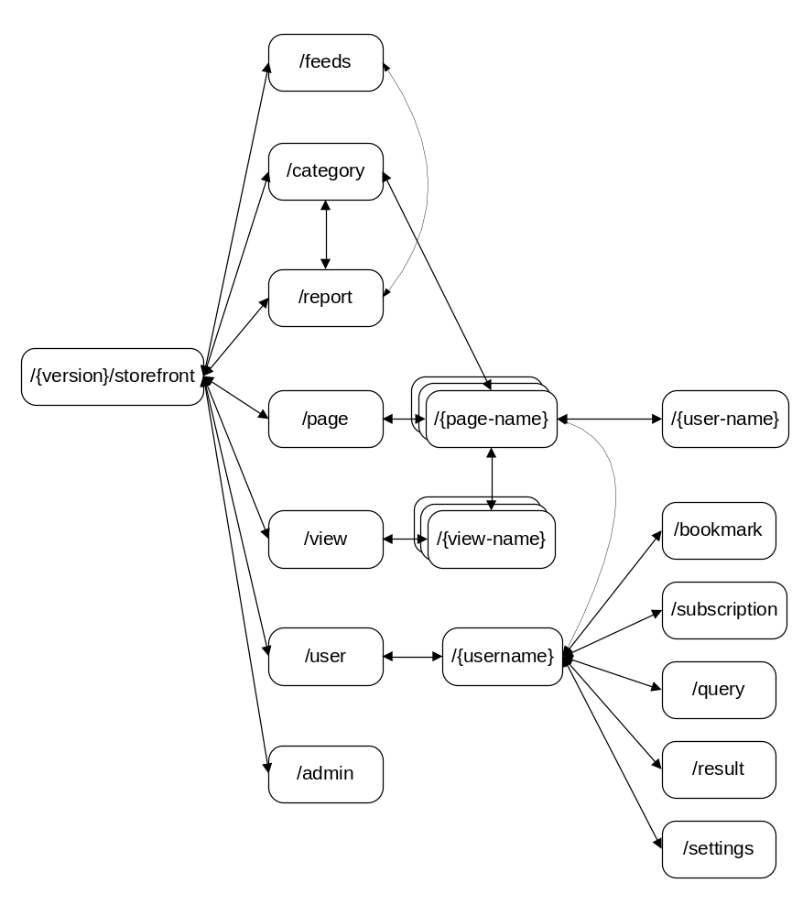

Server Representation
<?xml version="1.0" encoding="utf-8"?>
<rss version="2.0">
<channel>
<title>Storefront Resources</title>
<link>http://{domain}/{version}/storefront</link>
<description>This is my rss 2 feed description</description>
<lastBuildDate>Mon, 12 Sep 2005 18:37:00 GMT</lastBuildDate>
<language>en-us</language>
<item>
<title>Title of an item</title>
<link>http://example.com/item/123</link>
<guid>http://example.com/item/123</guid>
<pubDate>Mon, 12 Sep 2005 18:37:00 GMT</pubDate>
<description>[CDATA[ This is the description. ]]</description>
</item>
</channel>
</rss>

Activity Diagram

Feeds Resource
Resource Definition Table

Table of Operations
Operation | HTTP action
Lists all RSS feeds | GET /feed
Creates a new feed | POST /feed
Updates a feed | DELETE /feed/{id}
Lists all feeds that match params | GET /feed?q={params}
Lists all feeds that match country(s) | GET /feed/country/{cn0};{cn1};…;(cnn}
Lists all feeds that match topic(s) | GET /feed/topic/{tn0};{tn1};…;{tnn}
Lists all feeds that match non-state actor(s) | GET /feed/actors/{an0};{an1};…;{ann}

Connectedness Diagram
Activity Diagram

Category Resource
Resource Definition Table

Table of Operations
Operation | HTTP action
Available categories | GET /category
List all countries | GET /category/country
Counties that match parameters | GET /category/country?q={params}
Lists recommended countries | GET /category/country/recommended
Lists most viewed countries | GET /category/country/mostviewed
List all topics | GET /category/topic
Topics that match parameters | GET /category/topic?q={params}
Lists recommended topics | GET /category/topic/recommended
Lists most viewed topics | GET /category/topic/mostviewed
List all non-state actors | GET /category/actor
Actors that match parameters | GET /category/actor?q={params}
Lists recommended actors | GET /category/actor/recommended
Lists most viewed actors | GET /category/actor/mostviewed
Lists NIPFs | GET /category/nipf
Lists NIPFs constrained by country | GET /category/nipf/{cn}
Lists NIPFs constrained by topic | GET /category/nipf/{tn}
Lists NIPFs constrained by non-state actor | GET /category/nipf/{na}
Searches for a NIPF | GET /category/nipf?q={params}
List all region | GET /category/region
Add/Update a region | PUT /category/region/{region-name}
Delete a region | DELETE /category/region/{region-name}

Connectedness Diagram
The following diagram depicts how client representations of the category resource and its subordinate actor, country, nipf, and topic resources are connected to top level storefront resources.

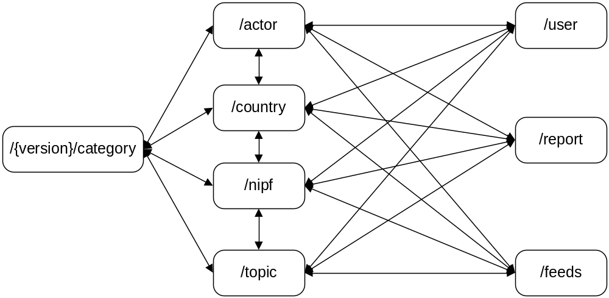

Activity Diagram

Report Resource
Resource Definition Table

Table of Operations
Note the following conventions used for brevity:
cn = country name
tn = topic name
sn = serial number
ns = non-state actor

Reports in country | GET /report/country/{cn}
Reports in list of specified countries | GET /report/country/{cn1};{cn2};…;{cnn}
Recommended reports for country | GET /report/country/{cn}/recommended
Lists most viewed reports for country | GET /report/country/{cn}/popular
Newest reports for country | GET /report/country/{cn}/new
Query criteria constrained by country name | GET /report/country/{cn}?q={params}
Reports in topic | GET /report/topic/{topic-name}
Reports that match criteria | GET /report/topic?show={tn|top20|new}
Lists all years | GET /report/date
Reports written on date | GET /report/date?show={date}
Lists reports written between dates | GET /report/date/{start-date}-{end-date}
Lists months in year | GET /report/date/{year}
Lists days in month | GET /report/date/{year}/{month}
Reports written on date | GET /report/date/{year}/{month}/{day}
Report that matches serial number | GET /report/serialnumber?show={sn}
List of how to search for reports | GET /report
Lists reports in NIPFs | GET /report/nipf/{tn1|na1}:{cn1};…;{tnn|nan}:{cnn}
Report with given URI | GET /report/{report-uri}

Connectedness Diagram
The following diagram depicts how client representations of the report resource and its subordinate comment and feedback resources are connected to top level storefront resources.
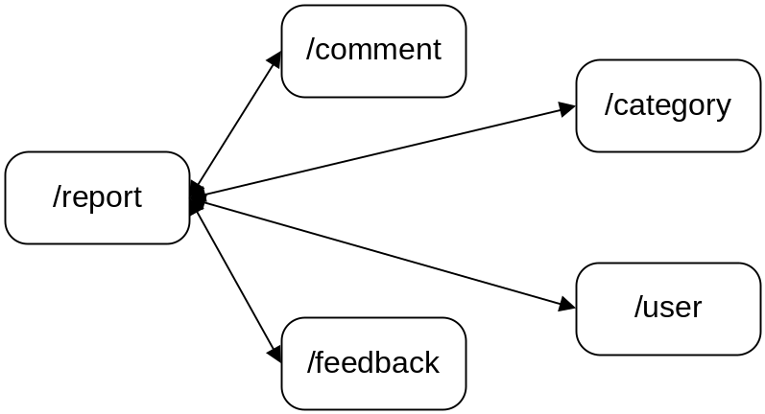

Activity Diagram

User Resource
Operation | HTTP action
Get a user information | GET /user/{username}
Create a user | PUT /user/{username}
Delete a user | DELETE /user/{username}

Report Comments Resource

Operation | HTTP action
Lists report comments | GET /report/{report-uri}/comment
Update a comment | PUT /report/{report-uri}/comment/{comment}
Create a comment | POST /report/{report-uri}/comment/{comment}
Delete a comment | DELETE /report/{report-uri}/comment/{comment}

Subscription Resource

Query Resource

Result Resource

Bookmarks Resource

Admin Resource
Operation | HTTP action
Lists admin recommended categories | GET /admin/recommended
Returns a list of recommended countries | GET /admin/recommended/country
Create a recommended country | PUT /admin/recommended/country/{cn}
Delete a recommended country | DELETE /admin/recommended/country/{cn}
Returns a list of recommended topics | GET /admin/recommended/topic
Create a recommended topic | PUT /admin/recommended/topic/{tn}
Delete a recommended topic | DELETE /admin/recommended/topic/{tn}
Returns a list of recommended actors | GET /admin/recommended/actor/{an}
Create a recommended actor | PUT /category/recommended/actor/{an}
Delete a recommended actor | DELETE /category/recommended/actor/{an}

Storefront Core XQuery Modules

Storefront Rich Internet Application (storefront-ria)
Is a full featured “heavy-weight” java-script library required for the storefront? The application is just listing data and displaying reports. It is highly desirable for the site to be indexed by web-crawlers

Implementation tradeoffs
- Storefront-core resources only produce xhtml and ext-js is generated from existing markup
  - Pros
  - Cons
- Storefront-core resources produce JSON and XHTML ext-js is written in java-script and uses JSON readers to populate views and pages
  - Pros
  - Cons

Storefront Dissemination (storefront-d)

How to add a resource (controller) Developer guide

