CS 1300

Redesign

The Brown CS website provides information for to users interested in learning more about the department. It offers resources for prospective students, current students, faculty, staff, visitors, prospective faculty and staff, alumni, and industry partners, among others.

Home Page

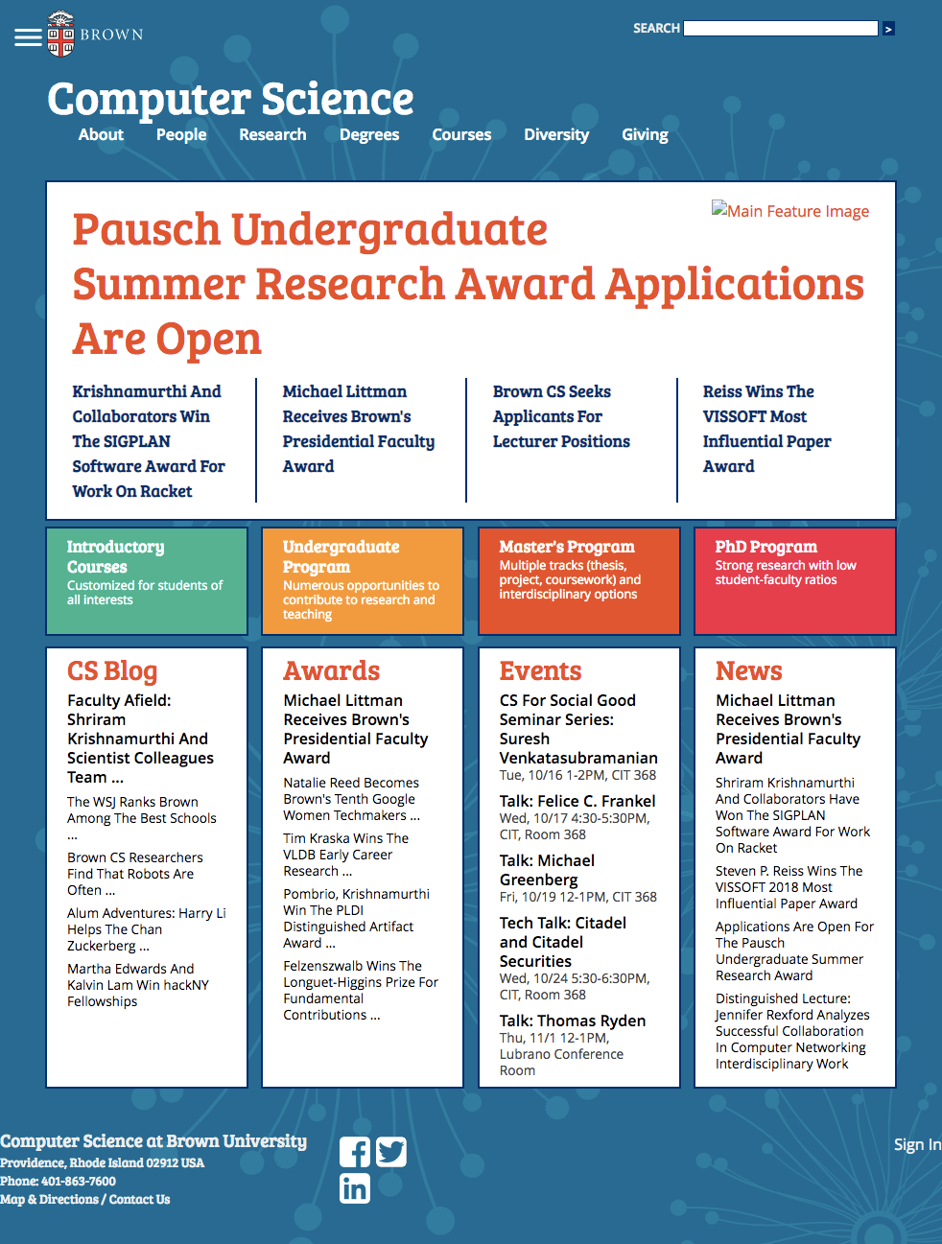

About > Events

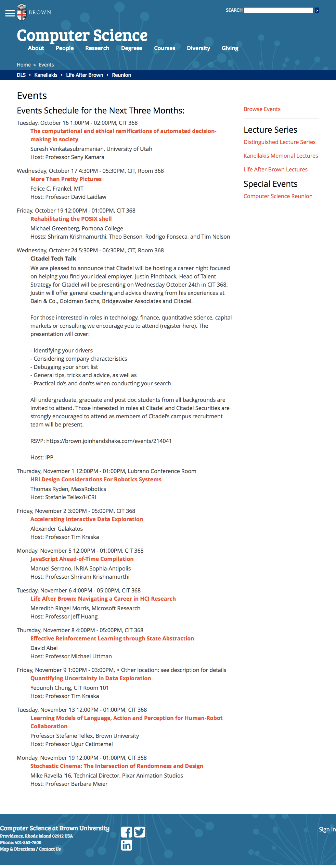

About > Rooms

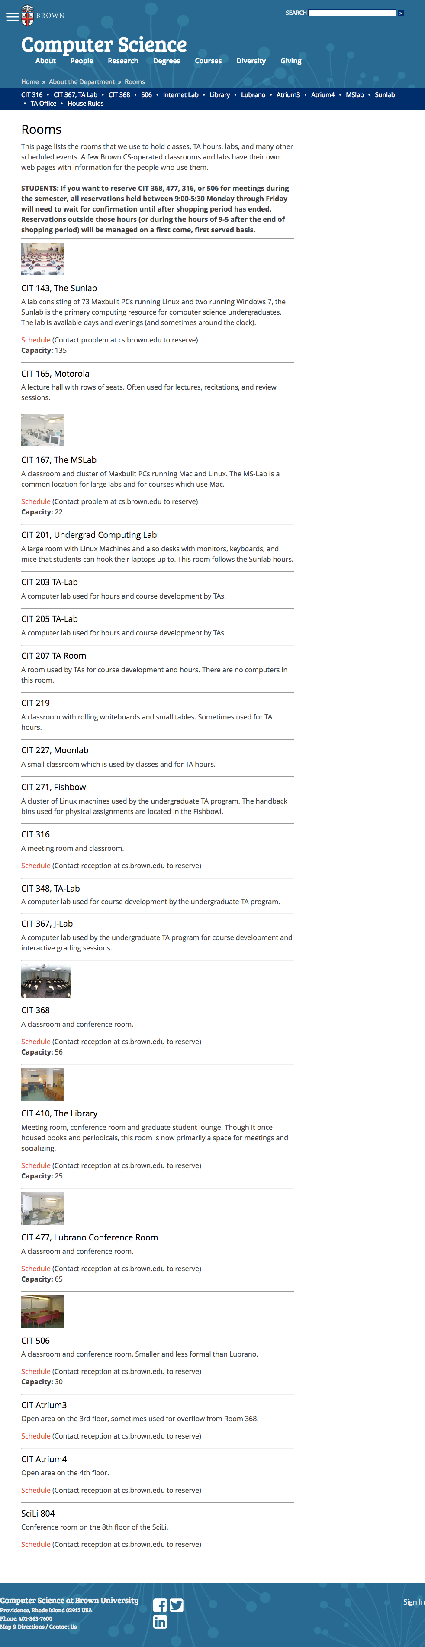

About > Partners

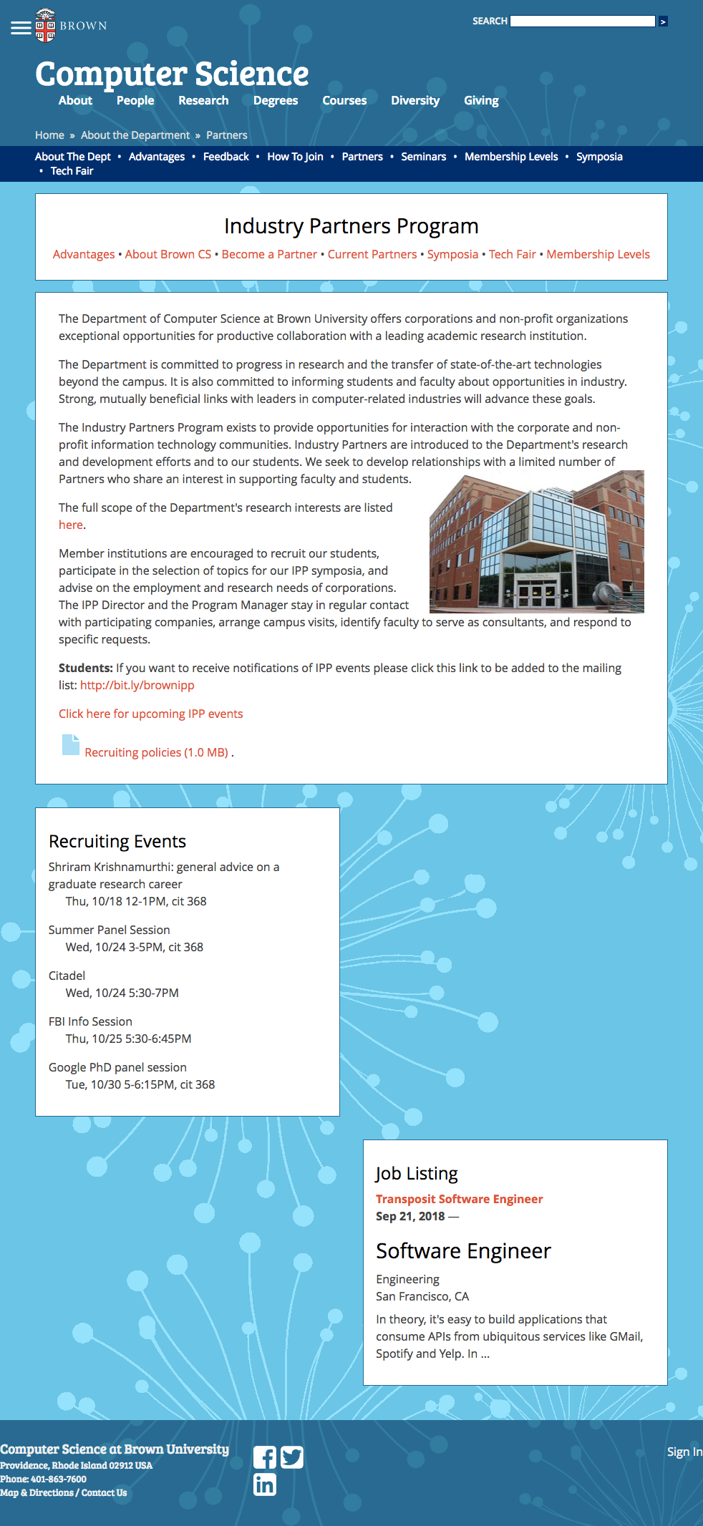

Degrees > Undergraduate Program

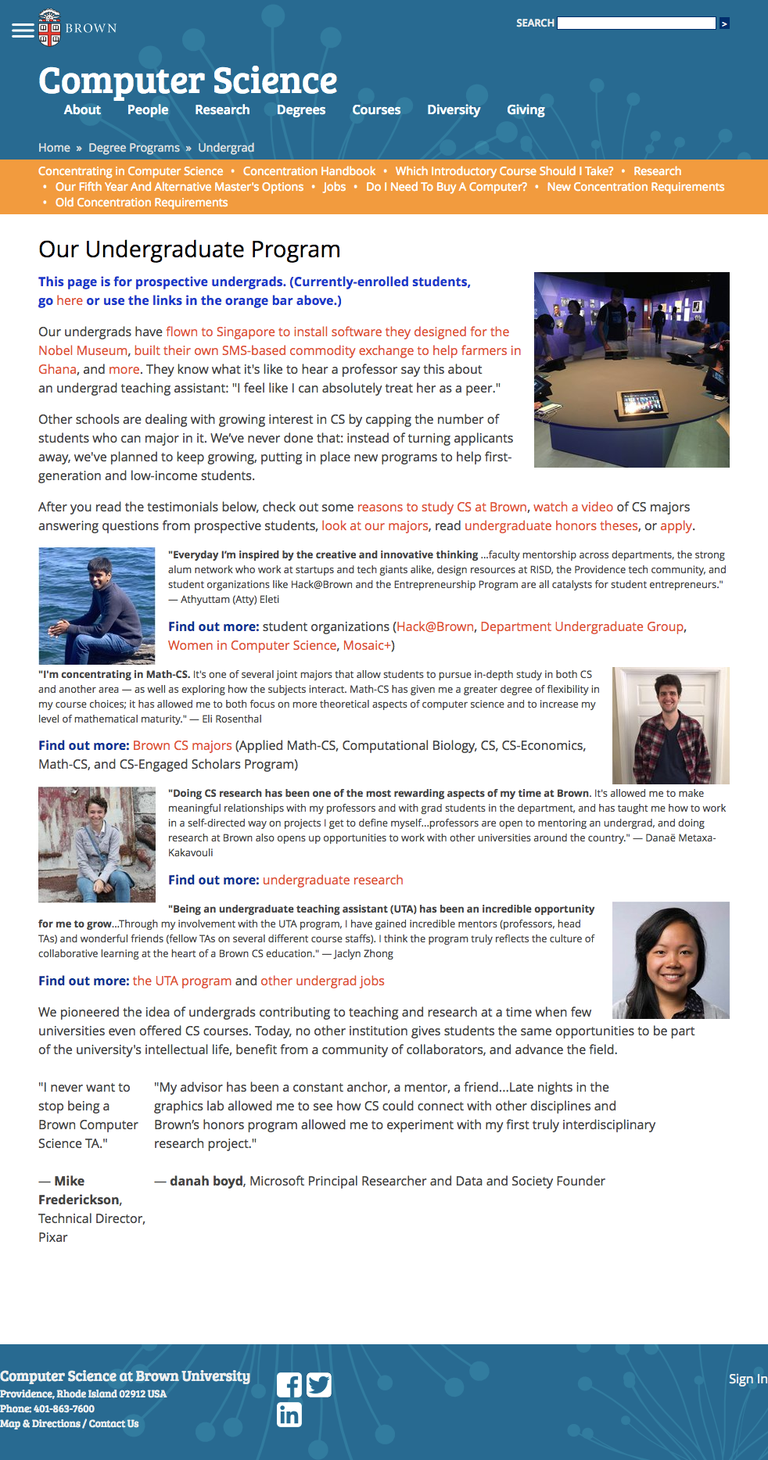

**Part 1**

Please see Lo-Fi.png in attached folder for five lo-fi redesigns and navigation.

Write-Up:

|  |  |  |
| --- | --- | --- |
|  | Original interface | Redesigned interface |
| Intuitive Design | With a lack of icons/clear visuals, too little whitespace, and cluttered layouts, it’s often hard to quickly identify what information appears on any given page. | Calendars and calendar icons have been added to several different site pages where events or room reservations are being highlighted so users can more quickly identify what they’re being shown. The layout has been cleaned up, especially with the use of additional spacing (e.g., the “Undergraduate Degree” and “Rooms” pages). |
| Ease of Learning | While it’s obvious what the search bar and main navbar are meant to be used for, there is often so much going on in the header of any given page (e.g., the current “Industry Partners Program” page) that much of the site content is hard to locate. There is also a fair amount of redundant information throughout the site (e.g., all “Awards” are also listed under “News”), which adds unnecessarily to the cognitive load of users trying to learn to navigate the site. | The number of links in the main navbar has been cut down and sub-submenus have been added to the submenus to make the content easier to digest (see how “About” > “Facilities” expands into “Rooms” and “Services” when clicked, as indicated on the homepage). The hamburger menu that links to specific pages on the Brown University website and other redundant/unnecessary content (e.g., the “Awards” section of the homepage) were removed, and the remaining content in the site header was consolidated and placed in a single horizontal line. Breadcrumbs now appear in their own section directly beneath the header and any page-specific links that appeared at the top of any particular page have been moved elsewhere. |
| Efficiency of Use | The fact that there are dropdown submenus for the links in the navbar that have subpages often makes the site faster to navigate than, say, having to go to a page like “About” and then click a link that only appears on that page to get to “Rooms.” The page-specific links at the top of pages (e.g., on the current “Undergraduate Program Page” or “Industry Partners” page) often hard to read through in part because they’re next to the already messy header and are laid out horizontally. The links for current students in the orange box atop the “Undergraduate Program” page, in particular, distract from the page’s main purpose (to inform prospective undergrads about the department), as does the blue disclaimer directly below the same that says the page is for prospective undergraduates, not current students. | A “Quick Links” section would added to certain pages (e.g., the “Industry Partners” page) and removed when they weren’t appropriate for a particular page (“Undergrad Program”), and redundant, unnecessary information (e.g., the links for current students on the “Undergraduate Program” page) were cut. The fact that calendars were integrated into multiple pages where appropriate means users don’t have to click an additional link when they want to view a schedule pertinent to the page they’re currently on. The addition of a filter for the calendar on the “Events” page (to be used for “Distinguished Lecture Series” events, for example) saves the user additional clicks. |
| Memorability | Given the number of options users are presented with in the main navbar/its accompanying submenus and the fact that so many of the website’s subpages (e.g., those linked to on the “Industry Partners Page”) are only accessible through other subpages (i.e., through the “Industry Partners Program” page in the above example) makes it fairly difficult to remember how to navigate back to certain pages on future site visits. There is often also a lack of consistency between the links to and headers on a given page (e.g., one has to click on a link for “Partners” under “About” in the main navbar to get to the “Industry Partners Page”). | Certain links in the navbar were removed, and certain subpages (e.g., the reservation schedule page for the Sunlab) that were only accessible through other subpages (e.g., the “Rooms” page in the above example) were consolidated into the single subpage through which they were accessible (e.g., the Sunlab reservation calendar was integrated into the “Rooms” page). The links to and titles of different subpages (e.g., the link to and header of “Industry Partners”) were made to match one another. |
| Error Frequency and Severity | There are numerous broken links on the site, including the “Interdisciplinary” link under “Degrees” in the navbar. The disorganization of the same navbar means that users may end up failing to find the page they want at all or else end up on the wrong page. Although breadcrumbs do appear on nearly all site pages, they do not always provide the user with a link back to “Home.” | All broken links have been removed, the navbar and its submenus have been streamlined, and the breadcrumbs on all pages include a link back to “Home.” |
| Subjective Satisfaction | Design is often way too cluttered (as on the top of the “Industry Partners Program” page) or haphazard (e.g., on the “Undergraduate Program” page). There is often too little white space, repetitive content, and inconsistent design choices (compare the separating lines in “Rooms” with the lack thereof in “Undergraduate Program”). The photos are often so small that it’s hard to tell what’s being shown. | Design is made (a) cleaner through the use of whitespace and removal of redundant content and (b) more consistent from page to page. More photos were added (on the “Events” page, for example) and larger photos were used (e.g., on the “Undergraduate Degree” page). |

**Part 3**

Please see Hi-Fi.pdf for redesign.

Justification: By using a three-column grid instead of the sometimes four-column/sometimes three-column layout (as is currently used on the Brown CS homepage), readability has been improved somewhat because more text can now be fit into each column. (The layout was also chosen so as to retain the same look with minor changes in content.) Alignment has also been improved; for example, there are no issues like the Brown hamburger menu cutting into the page margin in the header (as is currently the case). The color palette was cleaned up by using a much smaller range of colors (four in total, with three gray scale tones and a single red tone as an accent color to parallel the red found in the Brown logo at top left). The red tone was used to highlight primary points of interest on the page, including the link to “News” (which was felt to be the most important content on the Brown homepage given that the contents of the home page appear duplicated in a section above all the other content) and the “Sign In” link in the footer (which is important for internal use but not important enough that I thought it made sense to move it out of the footer). The navigation flow has been consolidated by narrowing the total number of options in the main navigation bar from seven down to five and eliminating the hamburger menu that’s specific to the general Brown University website, as opposed to the CS-specific site. Apart from the font of the site title (Didot), only a single font (Avenir Next Condensed) was used throughout the page; it was chosen both because it was legible, combined well with Didot (Avenir Next Condensed was designed by a designer who revitalized Didot), came in many different weights (of which four different weights were used), and had more of a sense of gravitas than the Bree Serif font currently used on the Brown CS website.

**Part 4**

Please see AnnotatedHi-Fi.pdf for annotated mockup and redesign.html for webpage.

Justification: Mobile- and tablet-sized versions of the site feature a hamburger menu that—when clicked—opens up the navigation links in a vertical dropdown below the main header. Based on the visual flow patterns we looked at in class, it is appropriate for the hamburger menu to appear to the right of the site title and have the dropdown navigation directly below that since a user would typically scan the upper left-hand corner before scanning the upper-right and would move somewhat lower and to the left after that. In the vertical dropdown, we have the search appear below all the other elements because we would hope users would review all the links before trying to search the site for what they’re trying to find.

Laptop- and desktop-sized versions of the site allow for us to streamline the site title, links, and search bar all into a single line and they appear in that order because, again, a user’s eyes are expected to scan the page from left to right.

The hero image just below the header always stretches to fill the width of the container for all the content on the page.

The main content appears in two columns on laptop-sized screens and up because we wanted both “News” and “Events” to appear above the fold. “News” appears to the left (where users can be expected to look first) since it is probably somewhat more important (given how it currently appears on the Brown CS website and similar CS department websites for other schools). To make it more likely that users also see “Events,” the column beginning with “Events” is twice as wide as the “News” header (and, for that reason, does not exactly appear in the same spot that ads normally would in a two-column layout). This two-column display changes to a one-column display for mobile and tablet (where it would be harder to fit content inside two containers rather than just one). Again, because “News” is of slightly higher priority, it superimposes the column beginning with “Events,” so users can be expected to see this information first. Also, when it superimposes “Events,” the last two of the five headlines that are otherwise shown in the news section are hidden so that the “Events” section appears higher on the page than it would otherwise.

On 4K screens, “Degrees” and “Blog,” which normally appear in the same column as “Events” get broken out into a third column of width equal to that of “Events.” By breaking this content out into a third column and heading that column with “Degrees” (so it appears above the fold), the layout affords almost as much priority to “Degrees” as it does to “News” and “Events” and allows us to more easily present the user with additional information at a screen size where the information would not appear too cluttered. Furthermore, because the columns for (1) “News,” (2) “Events,” and (3) “Degree/Blog” now each take up a third of the width of their container, our content still appears in a three-column grid. In this layout, the two images that normally appear in a row at the top of the “Events” section are made to appear on top of one another instead, so that the amount of content in the column containing only “Events” is closer in length to that of the “News” column and the “Degrees”/”Blog” column.

The whole page’s content container plus each of the three columns therein are also made bigger on 4K screens so as to improve readability.

On laptop-sized screens and up, there is enough horizontal whitespace to spread the footer content across three columns (and in, fact fit the last two of these columns to the left and right of the rightmost third of our grid). On mobile and tablet, there is too little horizontal whitespace for the same, so the content of all three columns is made to appear in a single column instead.