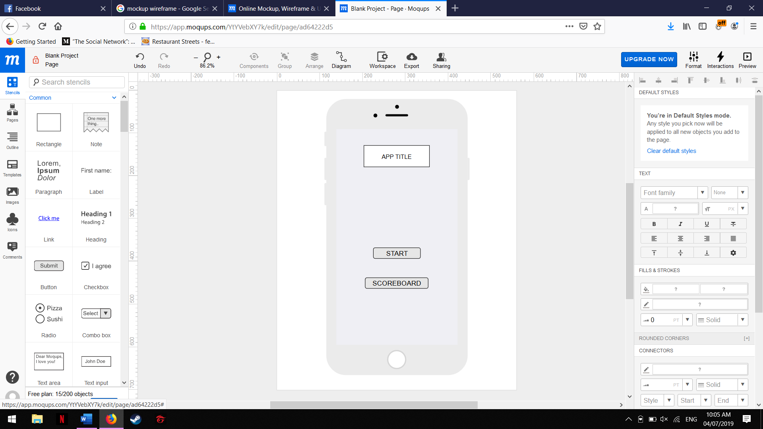

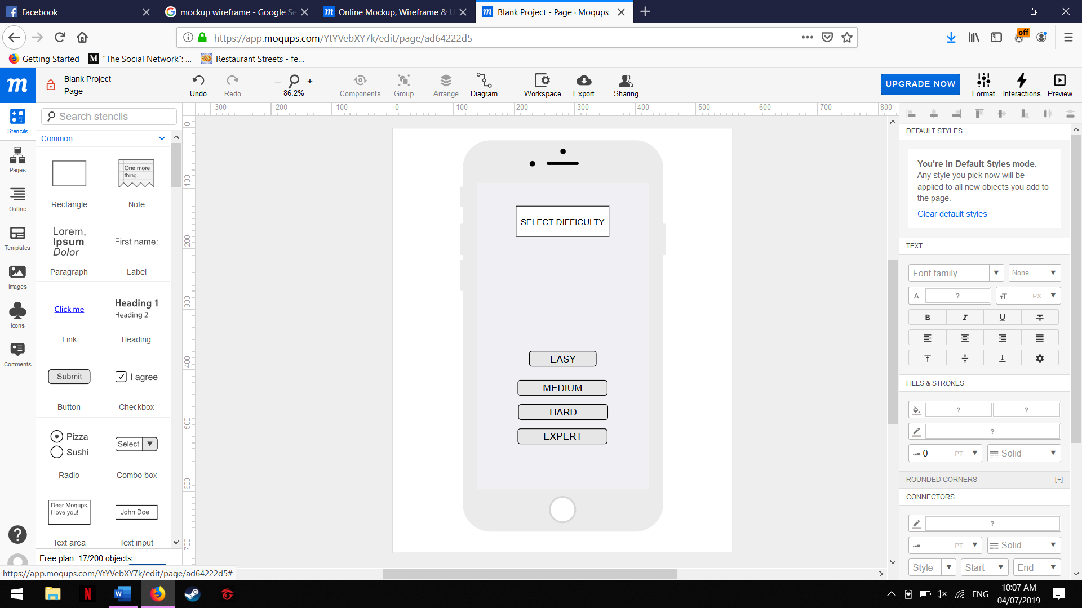

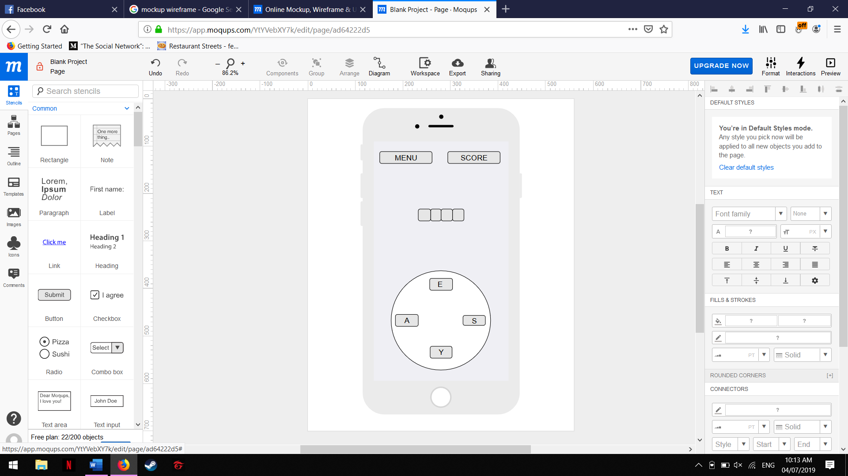

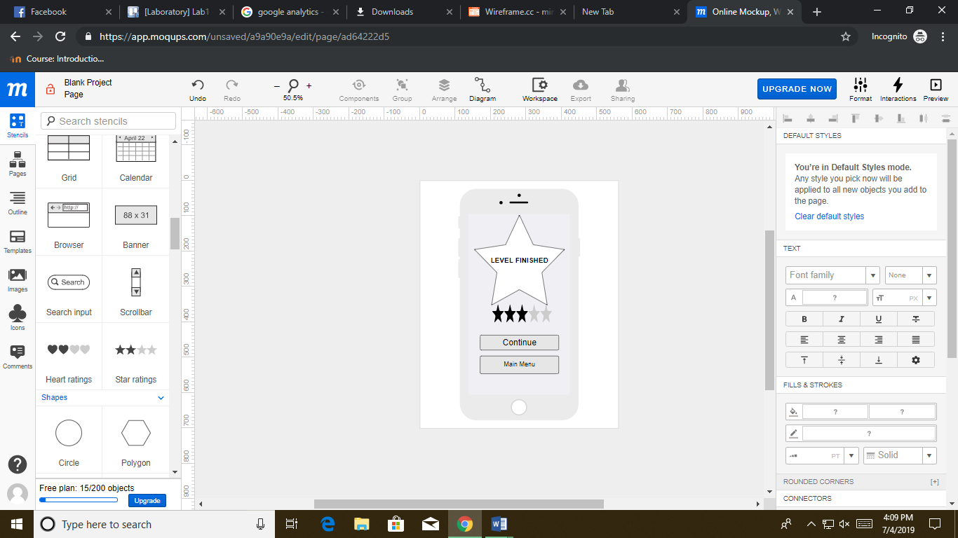

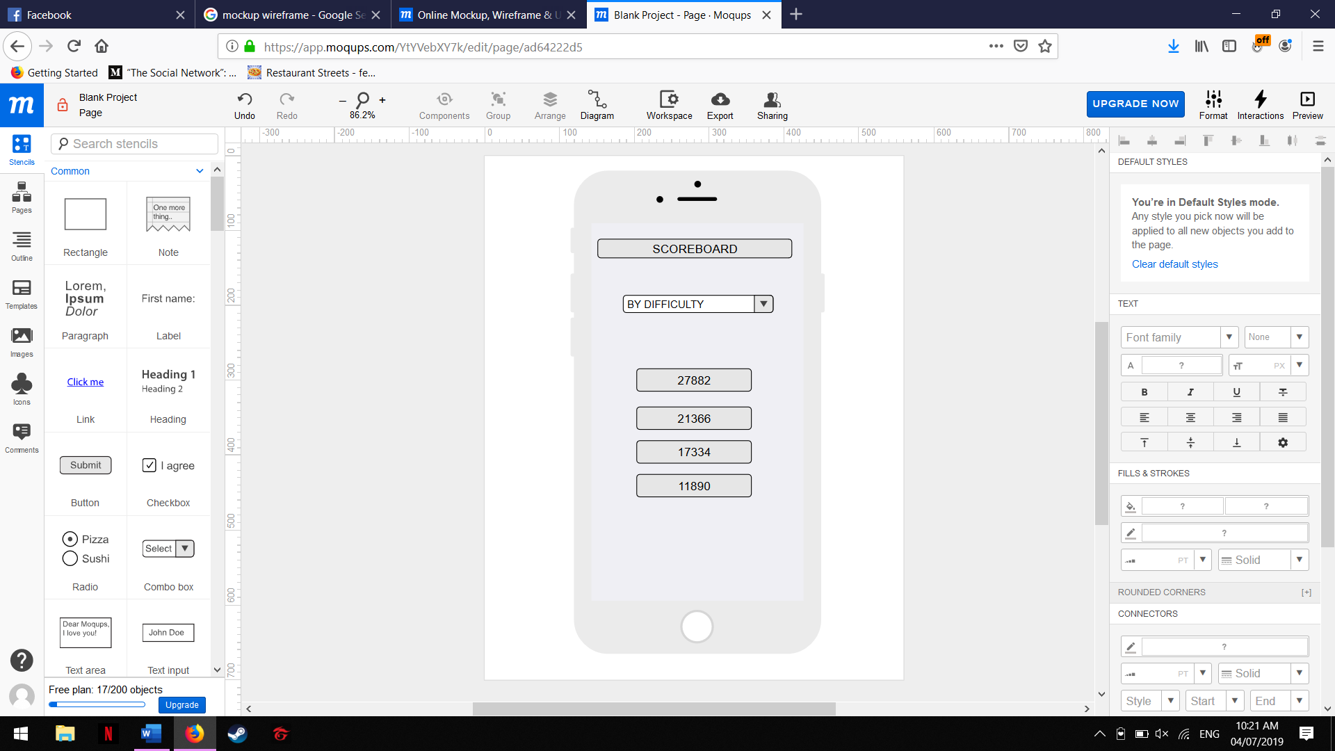

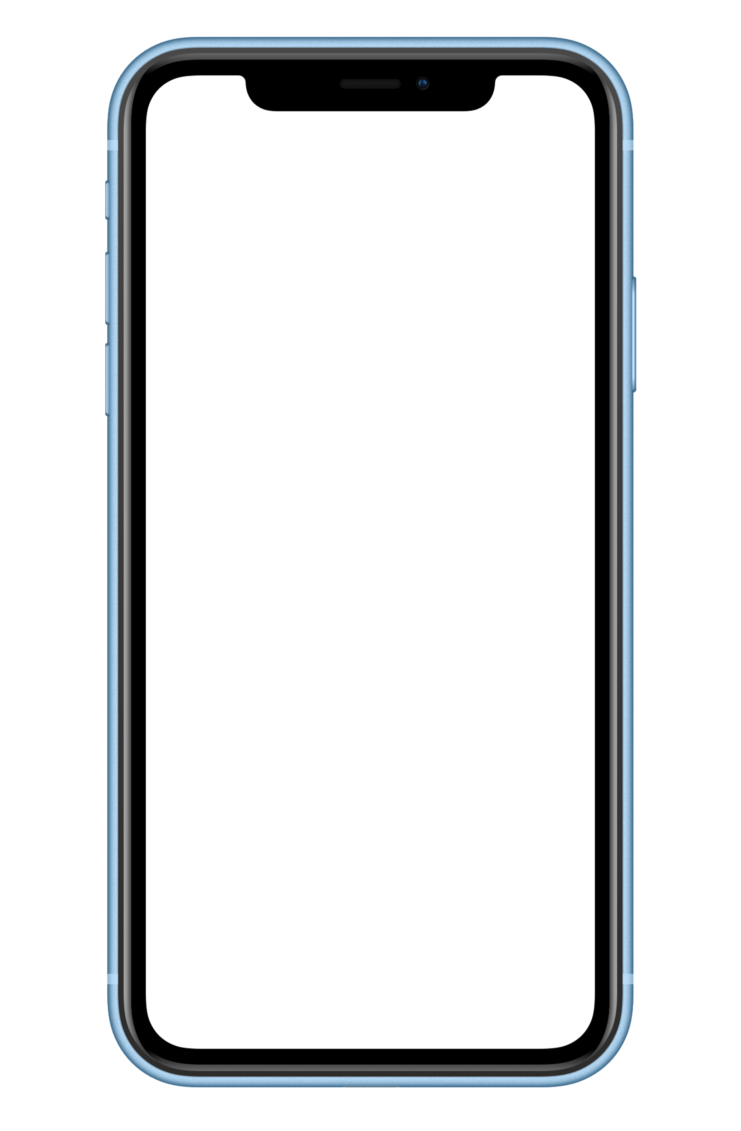

App name

Start

Scoreboard

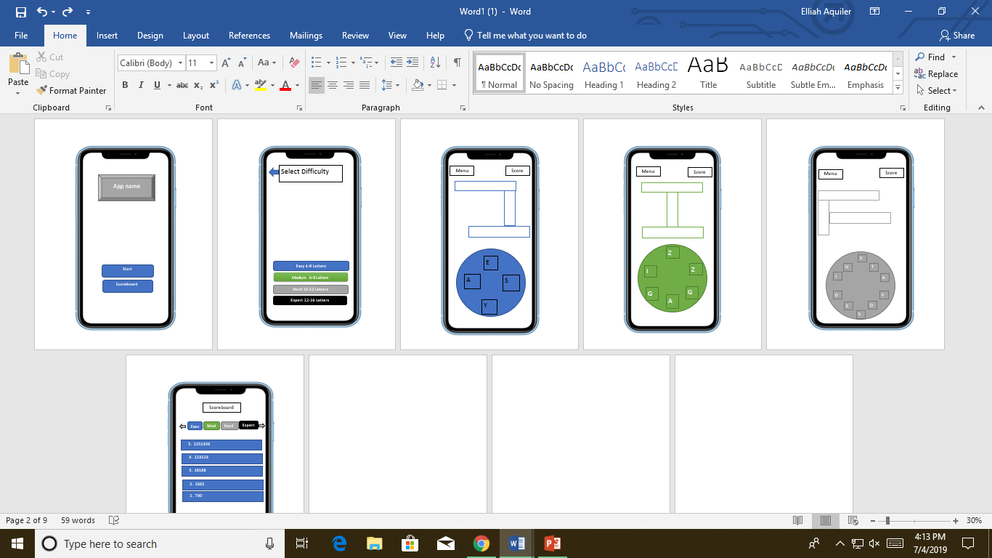







**Main menu**

**CONTINUE**

**Level Finished**

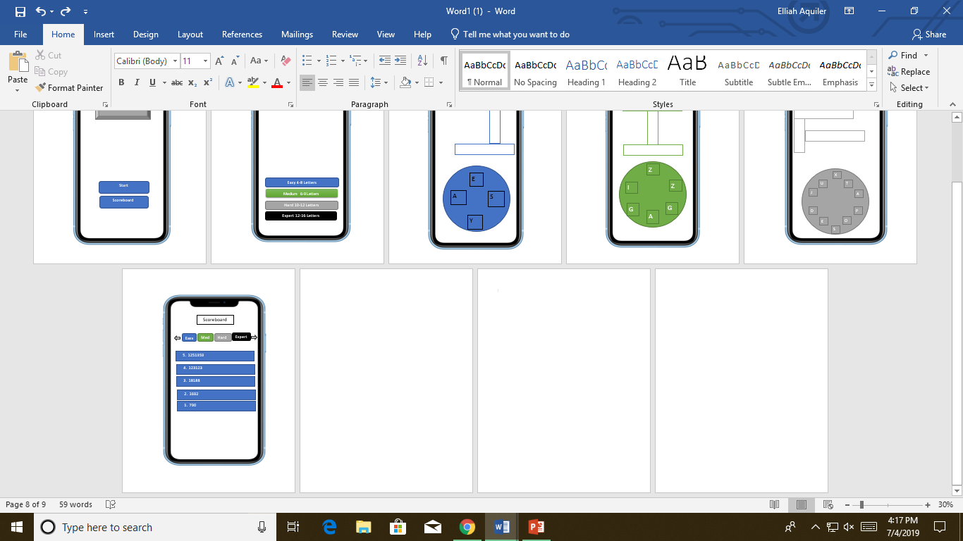



Upon opening the application, it will direct the user to the starting screen or main menu. The starting screen also has the Scoreboard in which the ratings are stored



App name

Start

Scoreboard



After the starting screen, the user can choose from different difficulties ranging from Easy to Expert.



The game screen shows: the puzzle to be answered, with the shuffled letters provided in each levels.



After finishing any levels the app will show the rating of the users, the users will also given a chance to continue, or proceed to main menu

**Level Finished**

**CONTINUE**

**Main menu**