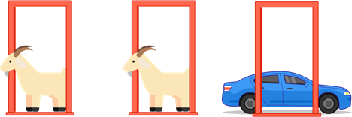

You are playing on a game show and have made it to the last round.

You have a chance to win a car!

The game show host shows you three doors.

Behind one of the doors is the car, and behind the other two are goats.

The game show host asks you to pick a door.

**Before** your door is opened, the host opens one of the other two doors **at random**.

If that door reveals the car, you automatically win it!

If it turns out to reveal a goat, the host offers you the option to **switch** your chosen door and open the door you didn't originally choose.

We will make the following assumptions:

1. The host must always open a door that was not picked by the contestant.
2. The host must always open a door to reveal a goat and never the car.
3. The host must always offer the chance to switch between the originally chosen door and the remaining closed door.

**Do you switch, stay or think it doesn’t matter?**