Electronic Equivalent Time Exchange Protocol (EEP)
  - Specification
2026
Table of Contents
Revision History 1
Introduction 2
Purpose 2
Design Goals 2
Workflow 2
HTTP Interface 3
EEP Document 4
Root Object 4
Root Object Example 4
Race Object 4
Race Object Example 5
Competitor Object 5
Competitor Object Example 5
JSON Object Hierarchy 6
Validation Rules 6
Protocol Examples 7
Initial Request 7
Initial Response 9
Optional Secondary Request 9
Secondary Response 10
Appendix A — JSON Naming Conventions 11

Revision History
Version | Date | Description
1.0 | 2026 | Initial public release.

Introduction

Purpose
The Electronic Equivalent Time Exchange Protocol (EEP) defines a simple HTTP/JSON protocol for exchanging the data required to calculate an Equivalent Electronic Time (EET).
The protocol enables timing systems and EET calculation software to exchange a standardized JSON document through HTTP requests. It reduces manual data entry while preserving user control over the calculation process.
EEP specifies:
- the JSON document structure;
- the HTTP message exchange;
- the validation rules required for interoperability.
The protocol is independent of any timing software or EET calculation implementation. It defines only the exchange of data required to perform an EET calculation.
The protocol does not define the EET calculation itself.

Design Goals
EEP has been designed with the following objectives:
- simple implementation;
- minimal manual data entry;
- backward-compatible extensibility.

Workflow
The EEP workflow consists of one mandatory exchange and one optional exchange.
The Initial Request creates a new EET calculation and provides the electronic timing data available from the timing system.
The Manual Time (MT) may then be provided either through the EET Calculator user interface or by an Optional Secondary Request.
The user reviews the calculation data before validating the final Equivalent Electronic Time (EET).

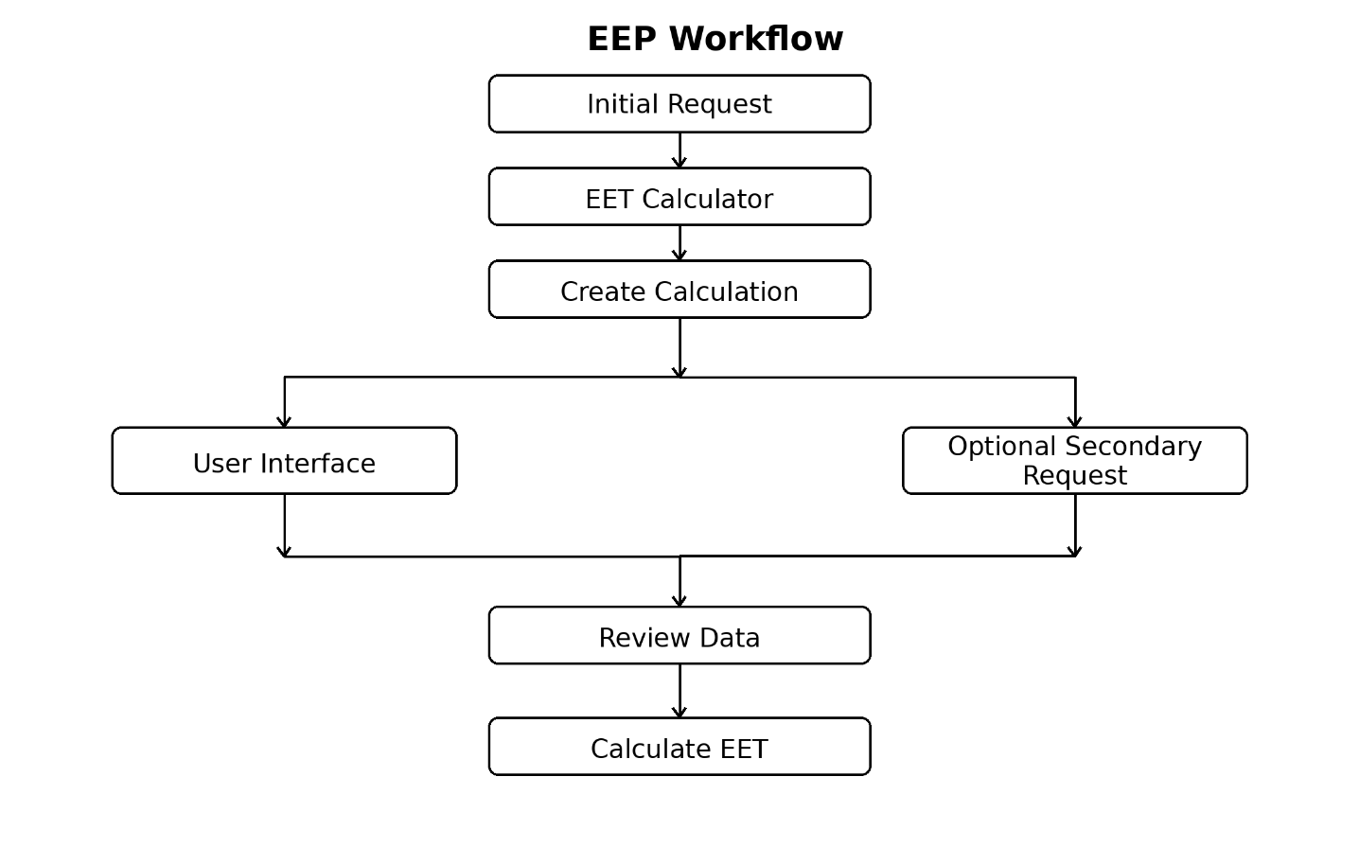
EEP Workflow

HTTP Interface
EEP uses HTTP POST requests with JSON payloads.
The endpoint URL is implementation-specific.
All requests and responses SHALL use the following content type:
Content-Type: application/json
The protocol defines four message types.
Message | Purpose
Initial Request | Create a new EET calculation.
Initial Response | Return the assigned calculation_id.
Optional Secondary Request | Provide the previously missing Manual Time.
Secondary Response | Confirm the successful update.
A successful Initial Response assigns a unique calculation_id that SHALL be used in all subsequent requests related to the calculation.

EEP Document
The EEP document is a JSON object exchanged between a timing system and an EET Calculator.
It consists of a root object containing race information and a list of competitors.
Optional members provide additional information intended to improve the presentation of the EET calculation result.
Member ordering has no semantic meaning.

Root Object
The root object contains the calculation identifier, processing mode, race information and competitor list.
Member | Type | Required | Description
calculation_id | string | Yes | Unique calculation identifier. Empty in the Initial Request.
mode | string | No | Processing mode. The value TEST enables test mode. When omitted, production mode is assumed.
race | object | Yes | Race information.
competitors | array | Yes | List of competitors.

Root Object Example
{
"calculation_id": "",
"mode": "TEST",
"race": {
...
},
"competitors": [
...
]
}

Race Object
The race object identifies the competition associated with the calculation.
Member | Type | Required | Description
season | string | Yes | Competition season.
codex | string | Yes | Competition codex.
run | string | Yes | Competition run number.
missing_impulse | string | Yes | Missing timing impulse (START or FINISH).
name | string | No | Competition name.
discipline | string | No | Competition discipline.
date | string | No | Competition date.
location | string | No | Competition location.

Race Object Example
{
"season": "2026",
"codex": "1234",
"run": "1",
"missing_impulse": "START",
"name": "National Championships",
"discipline": "SL",
"date": "2026-02-14",
"location": "Val d'Isère"
}

Competitor Object
Each element of the competitors array represents one competitor included in the EET calculation.
The competitor whose electronic timing impulse is missing is identified by an empty et_tod value in the Initial Request.
Member | Type | Required | Description
bib | string | Yes | Competitor bib number.
et_tod | string | Yes | Electronic Time expressed as Time of Day.
name | string | No | Competitor first name.
surname | string | No | Competitor surname.
nation | string | No | Competitor nation.
club | string | No | Competitor club.

Competitor Object Example
{
"bib": "14",
"et_tod": "",
"name": "John",
"surname": "Smith",
"nation": "FRA",
"club": "SC Val d'Isère"
}

JSON Object Hierarchy
The following hierarchy summarizes the structure of the EEP JSON document.
Root Object
|
+-- calculation_id
|
+-- mode
|
+-- race
| |
| +-- season
| +-- codex
| +-- run
| +-- missing_impulse
| +-- name
| +-- discipline
| +-- date
| +-- location
|
+-- competitors[]
|
+-- bib
+-- et_tod
+-- name
+-- surname
+-- nation
+-- club

Validation Rules
The following rules define the minimum validation requirements for protocol interoperability.
Implementations MAY perform additional business validation without affecting interoperability.
Rule | Description
VR-01 | The root object SHALL contain calculation_id, race and competitors.
VR-02 | The race object SHALL contain season, codex, run and missing_impulse.
VR-03 | Each competitor SHALL contain bib and et_tod.
VR-04 | The competitors array SHALL contain exactly eleven competitors.
VR-05 | In an Initial Request, exactly one competitor SHALL have an empty et_tod value.
VR-06 | In an Optional Secondary Request, no et_tod value SHALL be empty.
VR-07 | Every non-empty et_tod value SHALL contain at least three decimal places.
VR-08 | season SHALL consist of exactly four digits.
VR-09 | missing_impulse SHALL be either START or FINISH.
VR-10 | Unknown members SHALL be ignored to preserve forward compatibility.

Protocol Examples
The following examples illustrate the HTTP messages exchanged between a timing system and an EET Calculator.
The Optional Secondary Request differs from the Initial Request only by:
- the assigned calculation_id;
- the previously missing et_tod value.
For clarity, the examples include optional members. Implementations MAY omit any optional member.
Optional competitor members are shown only for the competitor whose electronic timing impulse is missing.

Initial Request
POST /eet HTTP/1.1
Content-Type: application/json
{
"calculation_id": "",
"mode": "TEST",
"race": {
"season": "2026",
"codex": "1234",
"run": "1",
"missing_impulse": "START",
"name": "National Championships",
"discipline": "SL",
"date": "2026-02-14",
"location": "Val d'Isère"
},
"competitors": [
{
"bib": "11",
"et_tod": "10:16:12.481"
},
{
"bib": "12",
"et_tod": "10:16:24.106"
},
{
"bib": "13",
"et_tod": "10:16:32.547"
},
{
"bib": "14",
"et_tod": "",
"name": "John",
"surname": "Smith",
"nation": "FRA",
"club": "SC Val d'Isère"
},
{
"bib": "15",
"et_tod": "10:16:51.234"
},
{
"bib": "16",
"et_tod": "10:17:03.118"
},
{
"bib": "17",
"et_tod": "10:17:14.904"
},
{
"bib": "18",
"et_tod": "10:17:26.431"
},
{
"bib": "19",
"et_tod": "10:17:39.055"
},
{
"bib": "20",
"et_tod": "10:17:52.601"
},
{
"bib": "21",
"et_tod": "10:18:05.227"
}
]
}

Initial Response
HTTP/1.1 200 OK
Content-Type: application/json
{
"status": "ok",
"calculation_id": "A7F4K2"
}

Optional Secondary Request
POST /eet HTTP/1.1
Content-Type: application/json
{
"calculation_id": "A7F4K2",
"mode": "TEST",
"race": {
"season": "2026",
"codex": "1234",
"run": "1",
"missing_impulse": "START"
},
"competitors": [
{
"bib": "11",
"et_tod": "10:16:12.481"
},
{
"bib": "12",
"et_tod": "10:16:24.106"
},
{
"bib": "13",
"et_tod": "10:16:32.547"
},
{
"bib": "14",
"et_tod": "10:16:40.216",
"name": "John",
"surname": "Smith",
"nation": "FRA",
"club": "SC Val d'Isère"
},
{
"bib": "15",
"et_tod": "10:16:51.234"
},
{
"bib": "16",
"et_tod": "10:17:03.118"
},
{
"bib": "17",
"et_tod": "10:17:14.904"
},
{
"bib": "18",
"et_tod": "10:17:26.431"
},
{
"bib": "19",
"et_tod": "10:17:39.055"
},
{
"bib": "20",
"et_tod": "10:17:52.601"
},
{
"bib": "21",
"et_tod": "10:18:05.227"
}
]
}

Secondary Response
HTTP/1.1 200 OK
Content-Type: application/json
{
"status": "ok",
"calculation_id": "A7F4K2"
}
Implementation Note
During processing of an Optional Secondary Request, implementations SHOULD update only the previously missing et_tod value. All other document members SHOULD be ignored.

Appendix A — JSON Naming Conventions
EEP follows common JSON naming conventions.
Convention | Rule
Member names | lowercase
Word separator | underscore (_)
Arrays | plural nouns
Boolean values | JSON true / false
Null values | JSON null
Date format | ISO 8601 (YYYY-MM-DD)
Time of Day | HH:MM:SS.sss (minimum three decimal places)
These conventions are recommendations intended to improve readability and consistency across implementations.

