Coupling of plasmons to the two-magnon continuum in antiferromagnets
Pieter M. Gunnink^{1*}, Alexander Mook¹

¹ Institute of Physics, Johannes Gutenberg-University Mainz, Staudingerweg 7, Mainz 55128, Germany
*pgunnink@uni-mainz.de

The coupling of magnons and plasmons offers a promising avenue for hybrid quantum systems, facilitating coherent energy and information transfer between magnetic and charge excitations. However, existing mechanisms often depend on weak spin-orbit coupling or temperature-activated processes, limiting their robustness for low-temperature quantum technologies. Here [1], we propose a novel coupling mechanism between plasmons and the two-magnon continuum in antiferromagnetic insulators, which operates at zero temperature and does not require spin-orbit coupling. Using a model system consisting of a two-dimensional electron gas on an insulating antiferromagnetic substrate, we show that the electric field of the plasmons interacts with the magnetically mediated electric polarization in the antiferromagnet [2], arising from bonds with broken inversion symmetry. This interaction enables strong coupling to the spin-conserving two-magnon continuum, allowing for efficient hybridization.

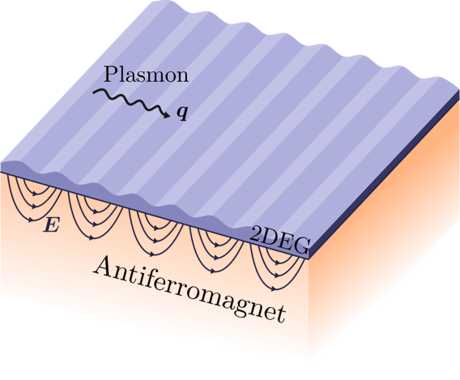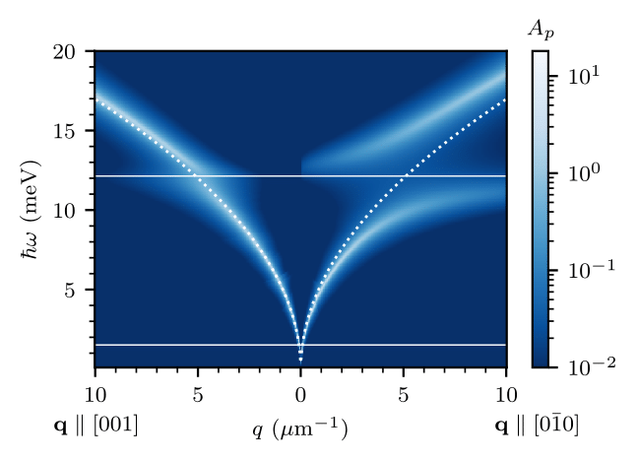

Figure 1. (Left) The setup considered, where a two-dimensional electron gas (2DEG) is placed on top of a semi-infinite insulating antiferromagnet. The 2DEG supports gapless plasmons, and their electric field extends into the antiferromagnet, where they couple to the two-magnon continuum. (Right) The plasmon spectral function. The lower and upper edges of the spin-zero two-magnon continuum are indicated by the horizontal white lines. The bare plasmon dispersion is given by the dotted white line. As the plasmon reaches the upper edge of the spin-zero two-magnon continuum, it decays into the continuum, demonstrating the coupling between plasmons and the two-magnon continuum.

References
[1] P.M. Gunnink and A. Mook, arXiv:2501.12873 (2025)
[2] T. Moriya, Journal of the Physical Society of Japan 23, 490 (1967).

