Coupling of plasmons to the two-magnon continuum in antiferromagnets
Pieter M. Gunnink¹, Alexander Mook¹
¹ Institute of Physics, Johannes Gutenberg-University Mainz, Staudingerweg 7, Mainz 55128, Germany
pgunnink@uni-mainz.de

The coupling of magnons and plasmons offers a promising avenue for hybrid quantum systems, facilitating coherent energy and information transfer between magnetic and charge excitations. However, existing mechanisms often depend on weak spin-orbit coupling or temperature-activated processes, limiting their robustness for low-temperature quantum technologies [1-6]. Here, we propose a novel coupling mechanism between plasmons and the two-magnon continuum in antiferromagnetic insulators, which operates at zero temperature and does not require spin-orbit coupling [7]. Using a model system consisting of a two-dimensional electron gas on an insulating antiferromagnetic substrate shown in Fig. 1, we show that the electric field of the plasmons interacts with the magnetically mediated electric polarization in the antiferromagnet, arising from bonds with broken inversion symmetry. This interaction enables strong coupling to the spin-conserving two-magnon continuum, allowing for efficient hybridization, as demonstrated in Fig. 2.

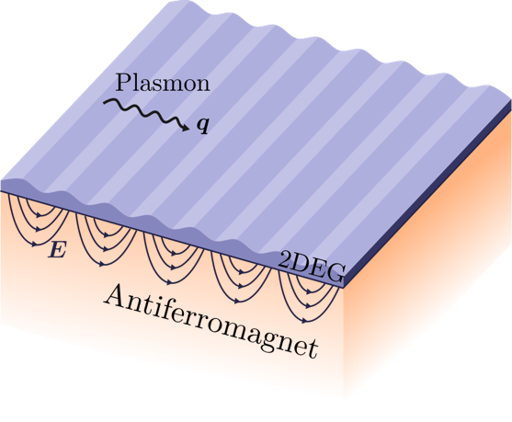
Figure 1. A two-dimensional electron gas (2DEG) is placed on top of a semi-infinite insulating antiferromagnet. The 2DEG supports gapless plasmons, and their electric field extends into the antiferromagnet, where they couple to the two-magnon continuum. | Figure 2. The plasmon spectral function, demonstrating coupling between plasmons and the two-magnon continuum. The lower and upper edges of the spin-zero two-magnon continuum are indicated by the horizontal white lines.

This work is in part funded by the Deutsche Forschungsgemeinschaft (DFG, German Research Foundation), Project No. 504261060 (Emmy Noether Programme). P.G. acknowledges financial support from the Alexander von Humboldt postdoctoral fellowship.

[1] D. K. Efimkin and M. Kargarian, PRB 104, 075413 (2021).
[2] A. Dyrdał, et al., PRB 108, 045414 (2023).
[3] A. T. Costa, et al., Nano Letters 23, 4510 (2023).
[4] S. Ghosh, et al., PRB 107, 195302 (2023).
[5] H. Y. Yuan, et al., arXiv:2409.09710 (2024).
[6] H. Y. Yuan and Y. M. Blanter, PRL 133, 156703 (2024).
[7] P. M. Gunnink and A. Mook, arXiv:2501.12873 (2025).

