Lab 3: Multiplier Design

Name: Peng Guo

GTID: 903424176

1. **Tables**
   1. **Resources**
      1. **Slice Logic**

* From multiplier_utilization_placed.rpt

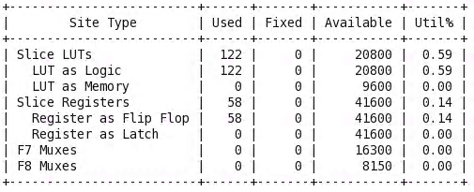

* From multiplier_updated_utilization_placed.rpt

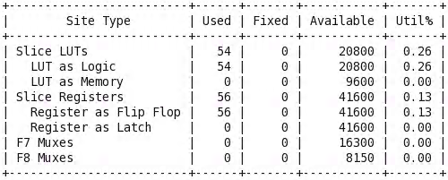

* + 1. **DSP**
* From multiplier_utilization_placed.rpt

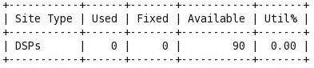

* From multiplier_updated_utilization_placed.rpt

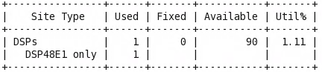

* + 1. **IO and GT Specific**
* From multiplier_utilization_placed.rpt

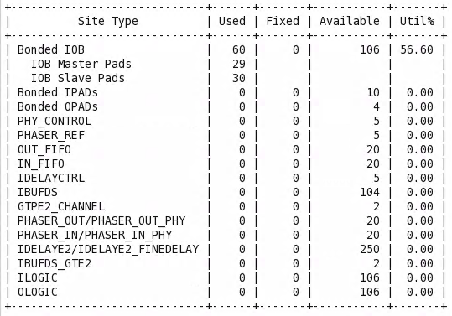

* From multiplier_updated_utilization_placed.rpt

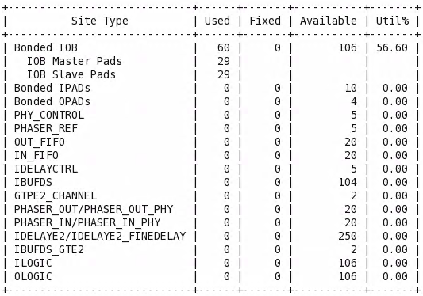

* + 1. **Primitives**
* From multiplier_utilization_placed.rpt

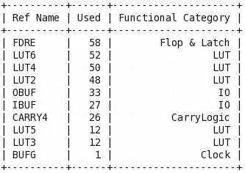

* From multiplier_updated_utilization_placed.rpt

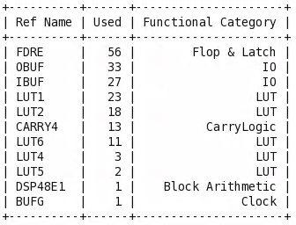

* 1. **Power**
* From multiplier_power_placed.rpt

Dynamic: 0.03W

Static: 0.1 – 0.03 = 0.07W

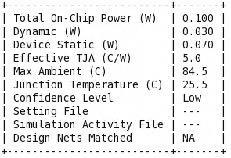

* From multiplier_updated_power_placed.rpt

Dynamic: 0.033W

Static: 0.07W

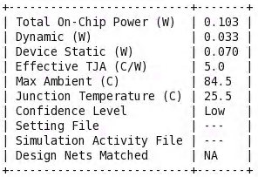

* 1. **Worst Negative Slack**
* From multiplier_timing_summary.rpt

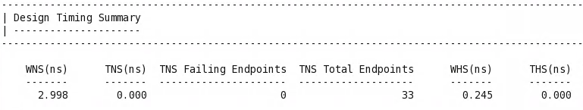

* From multiplier_updated_timing_summary.rpt

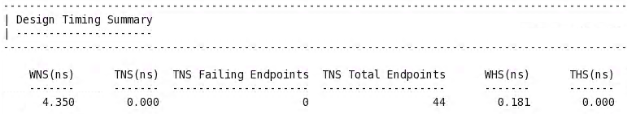

1. **Answers**
   1. Compare the tables above and briefly explain the difference between two designs. (Answer should not exceed 4 sentences)

Compared with the original design, the updated one uses DSP and fewer LUTs, consumes a little bit more power, and has larger worst negative slack.

* 1. What is the advantage of using DSP instead of LUTs on FPGA? (Answer should not exceed 4 sentences)

The DSP has multiplication operation unit, also called mac unit, it can finish a multiplication and addition in a cycle. Also, the operation speed is quicker and the wasted resources is less.