Lab 4: Area-optimized Multiplier and Handshake Protocol Design on Datapath

Name: Peng Guo

GTID: 903424176

1. **Diagram**

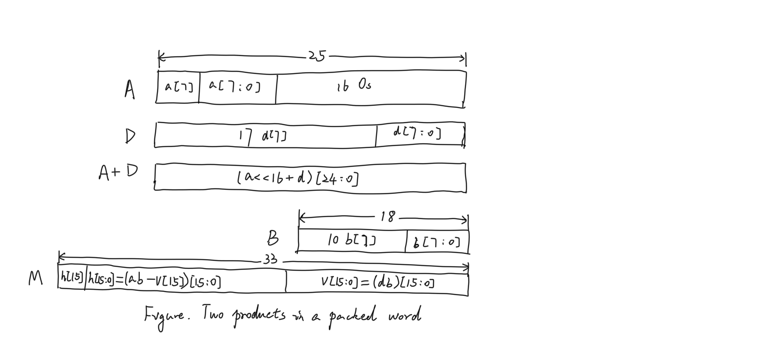

1. **Tables**
   1. **Resources**
      1. Slice Logic

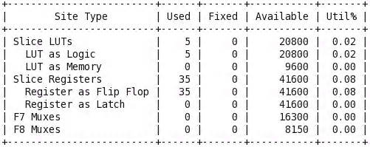

* + 1. DSP

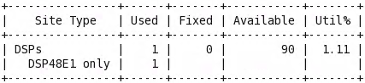

* + 1. IO and GT Specific

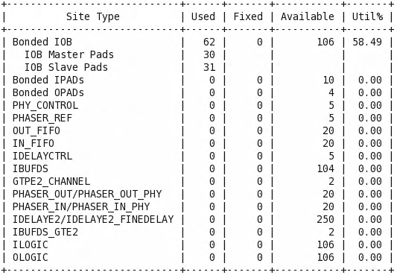

* + 1. Primitives

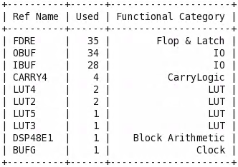

* 1. **Power**

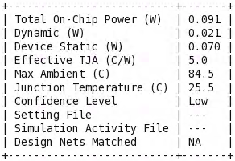

Dynamic: 0.021W Static: 0.070W

* 1. **Worst Negative Slack**

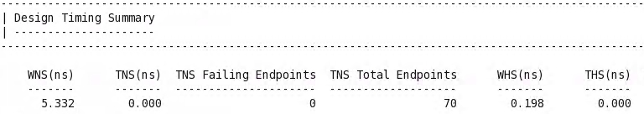



1. **Answer the question**

Why don’t we immediately stall the current stage if the next stage is stalled but instead take into consideration of the valid signal? Use scenarios to explain your thought. (Answer should not exceed 6 sentences)

We assume the scenario of counter-example as following. If the valid signal from current stage is 0, the data in current stage that is not useful and valid should be thrown away. Thus, if we do not take the valid signal into consideration, then there may be some junk data held in the producer, which results in a wasteful use of resources. If we take the valid signal into consideration, then there is only valid data kept by the producer, which is a more reasonable design.