**Lab 5: FIR Filter Design**

Name: Peng Guo

GTID: 903424176

1. **Tables**
   1. **Resources**
      1. Slice Logic

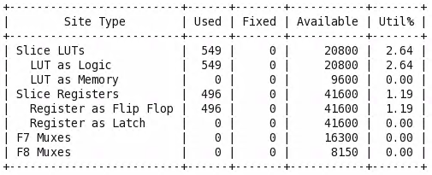

* + 1. IO and GT Specific

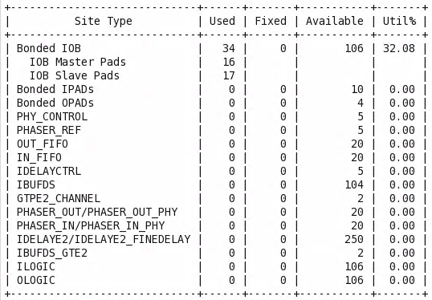

* + 1. Primitives

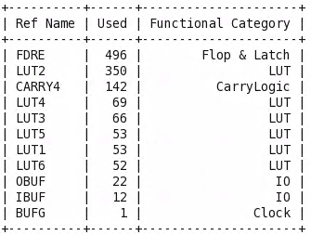

* 1. **Power**

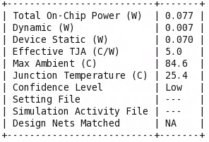

Dynamic: 0.007W

Static: 0.070W

* 1. **Worst Negative Slack**

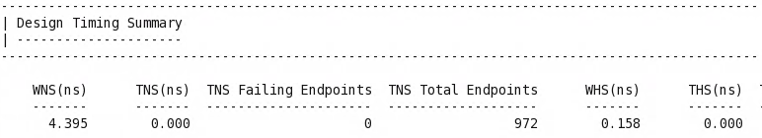



1. **Question and Answer**

Question: Why do you think we need to do right shift operation? And why do we do it at the end? (Answer should not exceed 6 sentences)

Answer: For the convenience of design, we have previously expanded the coefficient by 512 to facilitate the calculation, so finally divide the result by 512, that is, shift 9 bits to the right. If we do the operation in the middle process, it may affect the accuracy of subsequent calculations, and the number in the middle process may be too small after dividing by 512, which is not convenient for subsequent calculations.