**Lab 6: Distributed Arithmetic**

Name: Peng Guo

GTID: 903424176

1. **Tables**
   1. **Resources**
      1. *Slice Logic*

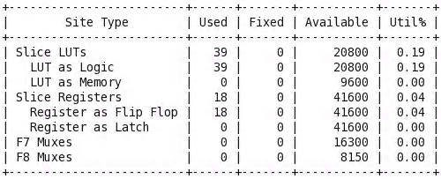

* + 1. *IO and GT Specific*

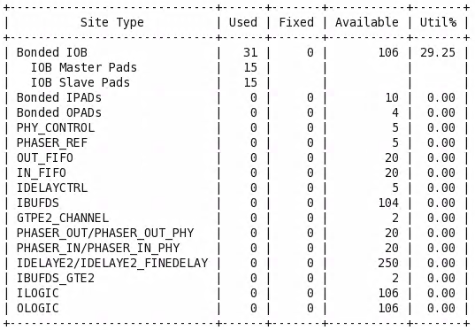

* + 1. *Primitives*

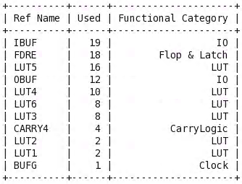

* 1. **Power**

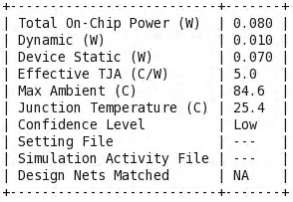

Dynamic: 0.010W Static: 0.070W

* 1. **Worst Negative Slack**

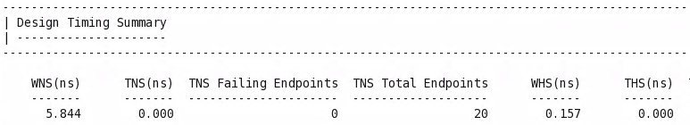



1. **Questions and Answers**

Is there an area-efficient way to do the left-shift which is after the output of LUT?

Yes.

* 1. **If yes, draw the updated block diagram starting from the LUT on the left to the output data_out on the right.**

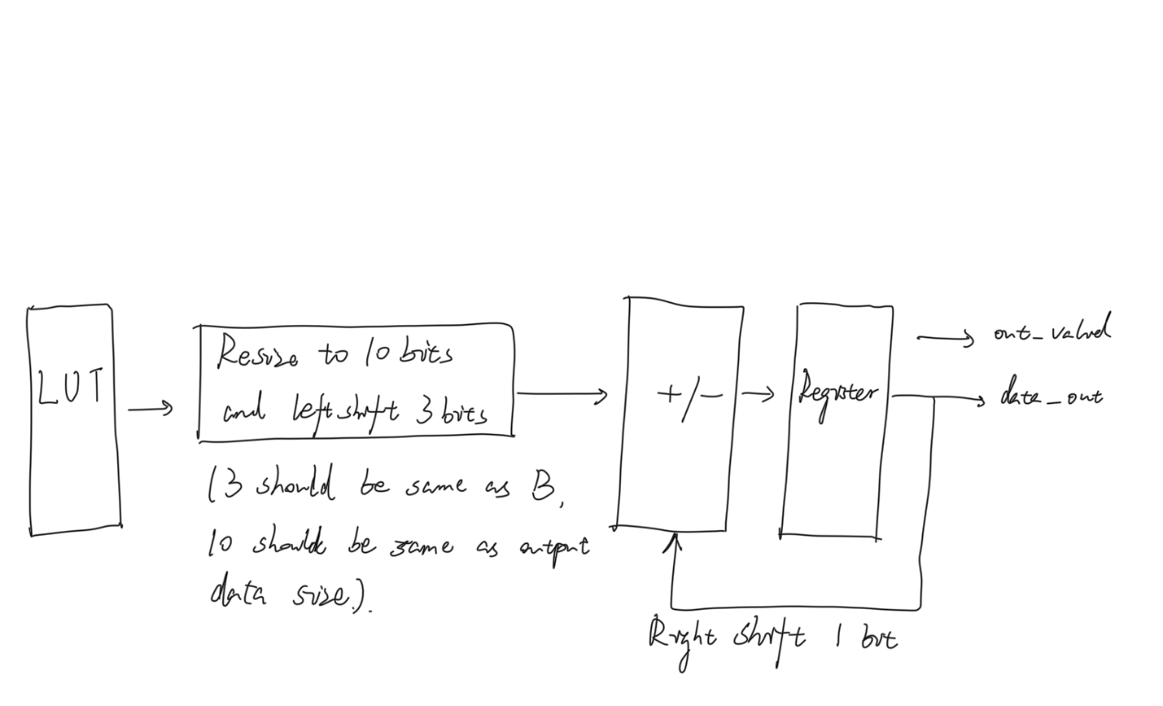

* 1. **Write down the mathematical recurrence relation induced from Eq. 3 that proves your thought above.**

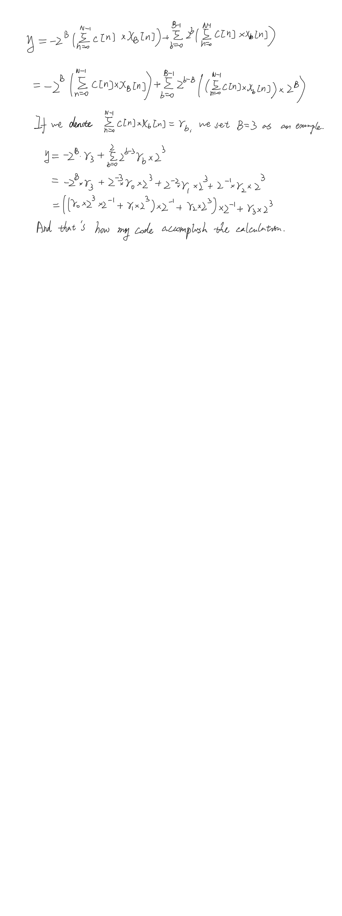

* 1. **Why the original left-shift is not a good idea and why the updated one is area-efficient? (Answer should not exceed 4 sentences)**

Because the original left-shift requires different shift bits, which requires different shift registers with more area to do it. As for the updated one, it uses the same bits shift, so it is area-efficient.