**Lab 7: Decimated-in-frequency FFT using the Butterfly Technique**

Name: Peng Guo

GTID: 903424176

1. **Tables**
   1. **Resources**
      1. CLB Logic

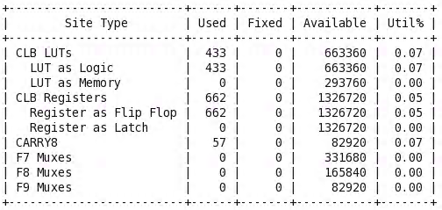

* + 1. IO and GT Specific

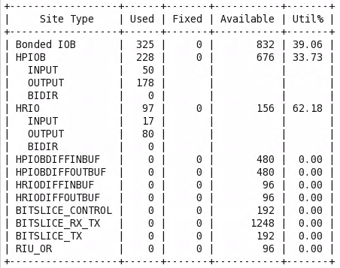

* + 1. Primitives

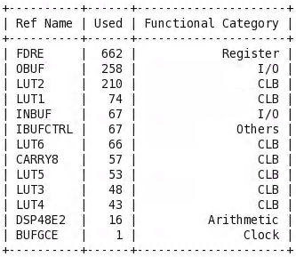

* 1. **Power**

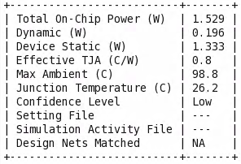

* 1. **Worst Negative Slack**

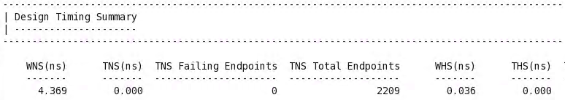



1. **Question and Answer**

What is the rationale behind choosing the values of the twiddle factor as given in the table? Note that the twiddle factors are signed numbers of resolution 1.8.

* 1. Write down the decimal fractional format of the twiddle factors.

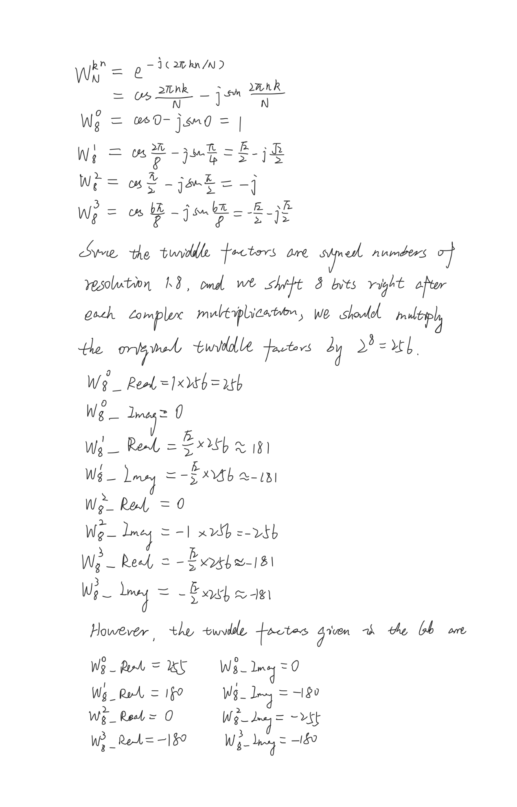

* 1. Consider what is the limit of such 1.8 resolution?

It is not that precise to use 1.8 resolution, and we have no method to denote integer 1 multiplied by 256.

* 1. Consider for some twiddle factor(s), is the value not precise as it could have been? And why are we doing that?

Because we have to keep the modulus of the twiddle factors the same. The twiddle factor 256 is adjusted to 255, so the twiddle factor 181 is adjusted to 180 as well.